Measured Waste Classification Results
Results supplement for the waste classification manuscript. Review measured outputs, replace the proposal wording and integrate these tables and figures with your introduction, methodology and references.

Experimental status
Completed runs: 12. Full standard 4-model × 3-seed study: True. CPU latency available for all runs: True.

Classification performance
Model | Accuracy | Macro precision | Macro recall | Macro F1
custom_cnn | 0.5635 ± 0.0347 | 0.5879 ± 0.0387 | 0.5728 ± 0.0302 | 0.5354 ± 0.0295
efficientnetb0 | 0.8739 ± 0.0122 | 0.8465 ± 0.0156 | 0.8653 ± 0.0190 | 0.8526 ± 0.0166
mobilenetv2 | 0.8466 ± 0.0092 | 0.8176 ± 0.0176 | 0.8260 ± 0.0094 | 0.8193 ± 0.0134
resnet50 | 0.8951 ± 0.0076 | 0.8786 ± 0.0090 | 0.8786 ± 0.0149 | 0.8771 ± 0.0125

Metrics are fractions. Values are mean ± sample standard deviation across completed training seeds on a common fixed test split.

Computational measurements
Model | Parameters | Size MiB | Training minutes | CPU median ms
custom_cnn | 110,534 | 0.47 | 12.68 | 15.95
efficientnetb0 | 4,057,257 | 16.30 | 22.31 | 19.58
mobilenetv2 | 2,265,670 | 9.22 | 16.25 | 12.76
resnet50 | 23,600,006 | 90.67 | 91.27 | 93.98

Training duration includes validation macro F1 and checkpoint I/O. Inference uses float32 and batch size one. Consult environment files and latency sample CSVs for settings and variability. Uncertainty in timing and image sampling is not represented by this compact table.

Results paragraph for review
Among the completed configurations, resnet50 obtained the highest mean test macro F1 (0.8771). This ranking is specific to the fixed dataset split and training protocol. Class-wise metrics and paired uncertainty analysis should be considered before interpreting a small difference as meaningful. No practical sorting reliability is established by this result alone.
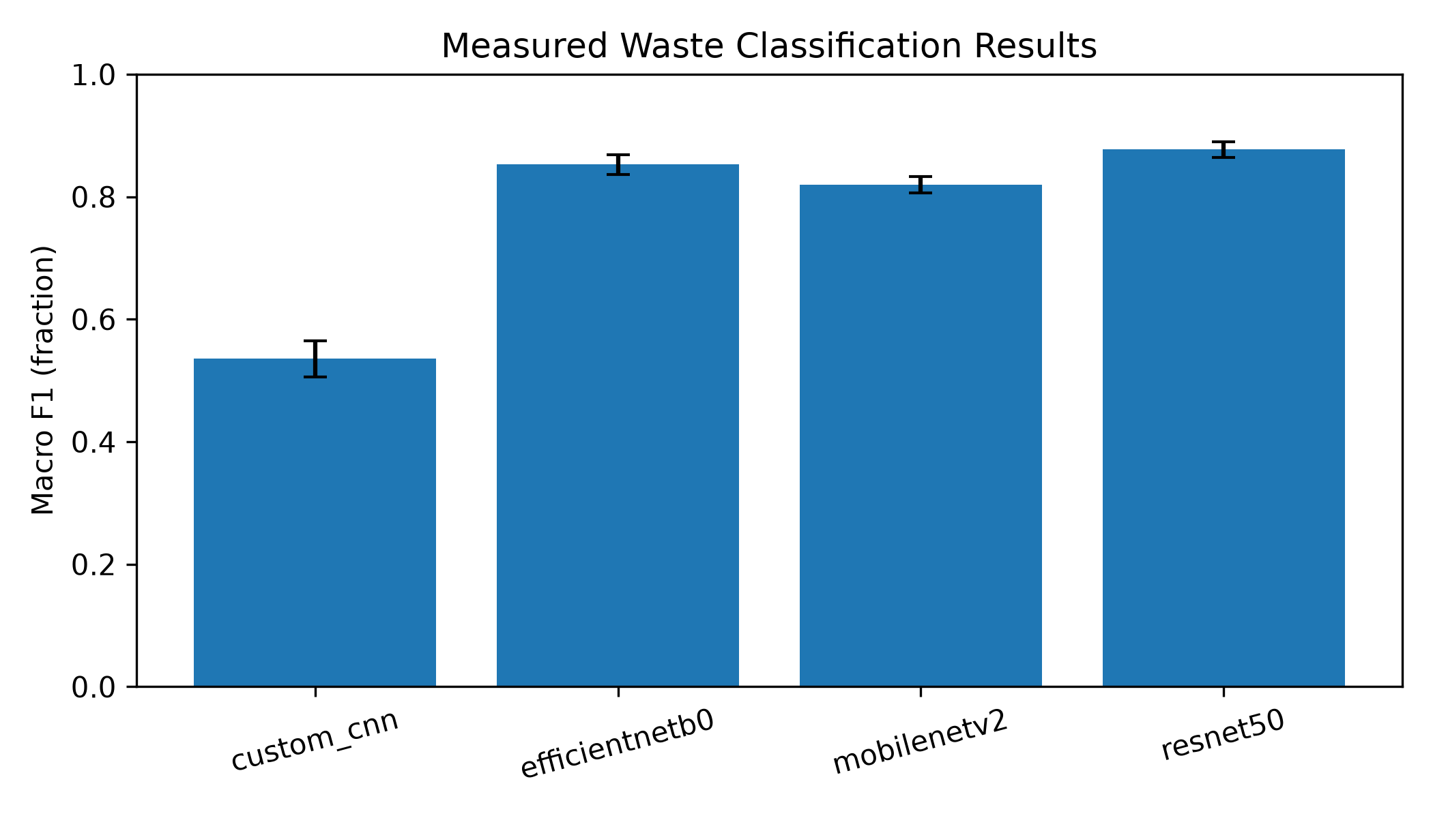
comparison_macro_f1.png
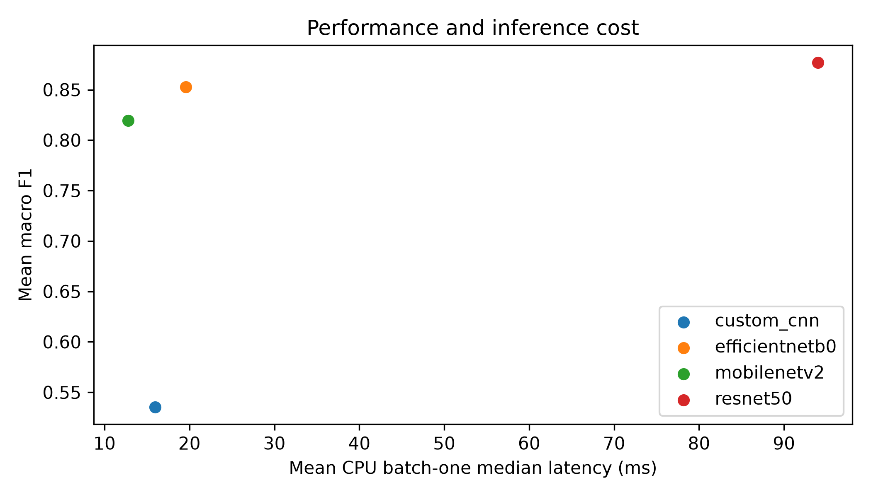
performance_vs_latency.png

custom cnn seed42
Seed 42 is a predeclared illustrative run. Use aggregate metrics for model ranking. Epoch indices start at zero; transfer curves concatenate head training and fine-tuning.
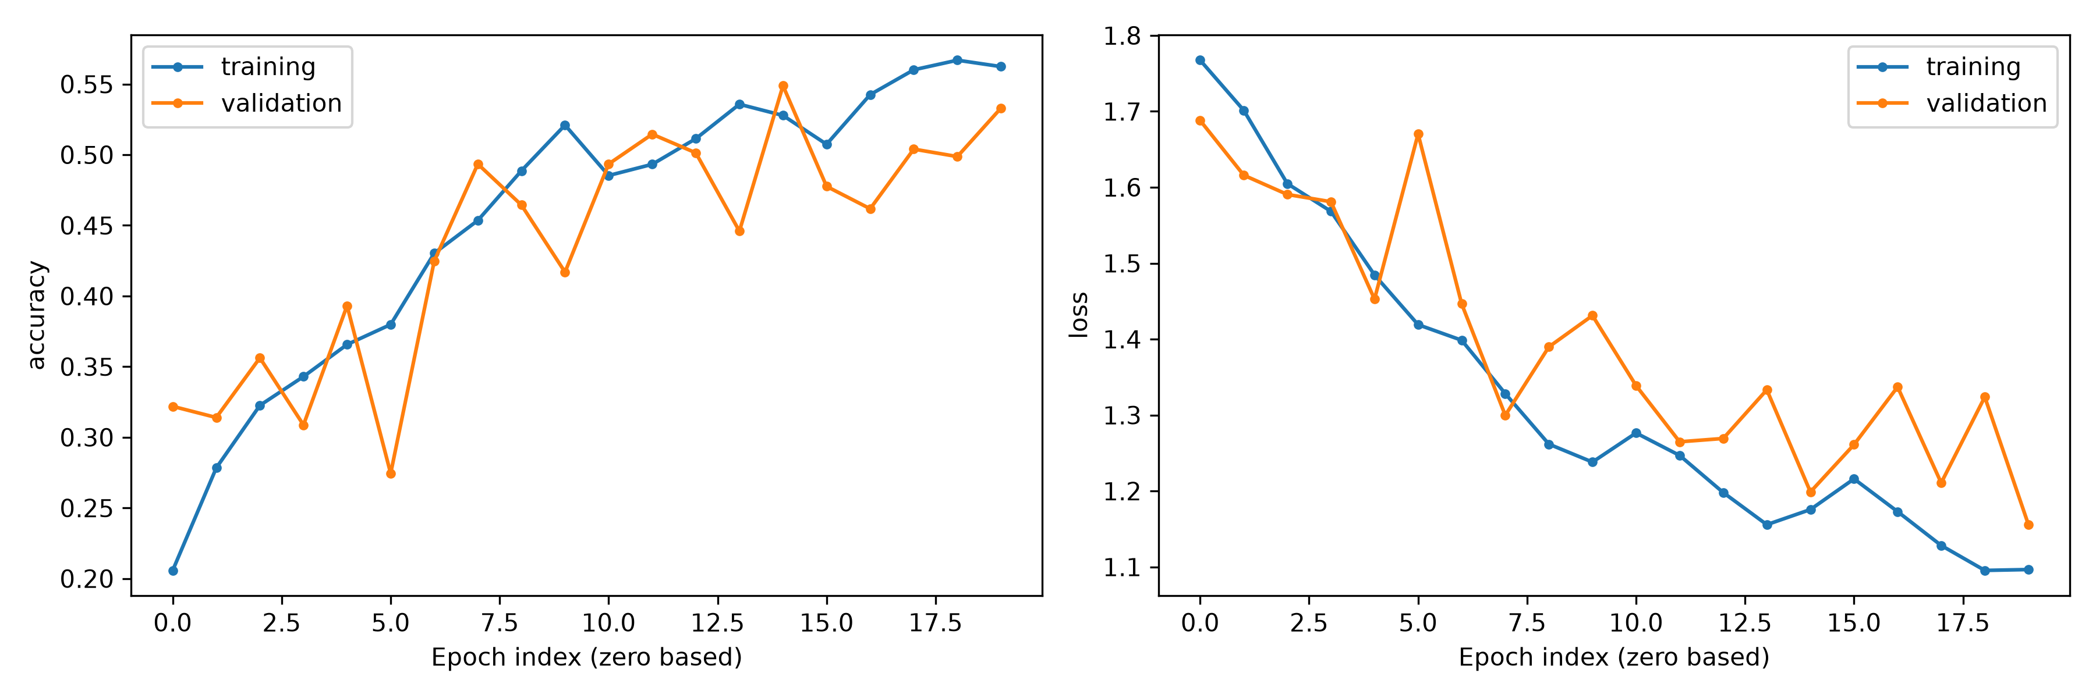
Training and validation accuracy and loss
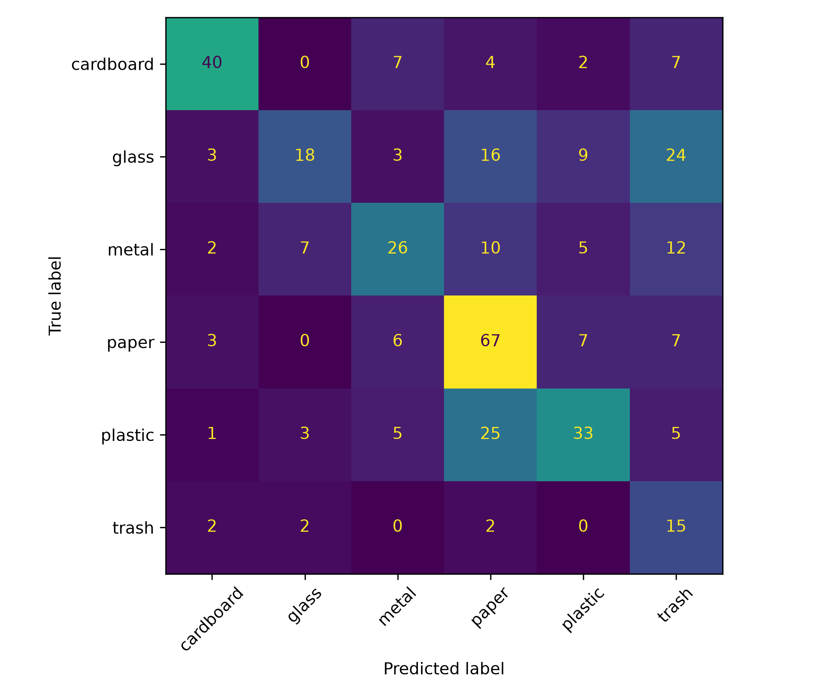
Confusion matrix on held-out images

efficientnetb0 seed42
Seed 42 is a predeclared illustrative run. Use aggregate metrics for model ranking. Epoch indices start at zero; transfer curves concatenate head training and fine-tuning.
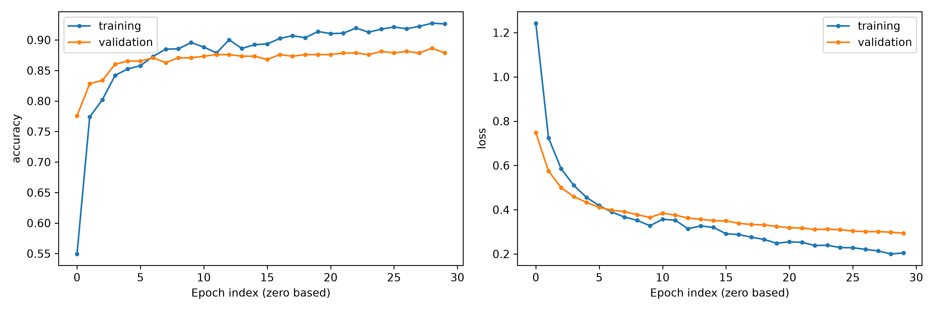
Training and validation accuracy and loss
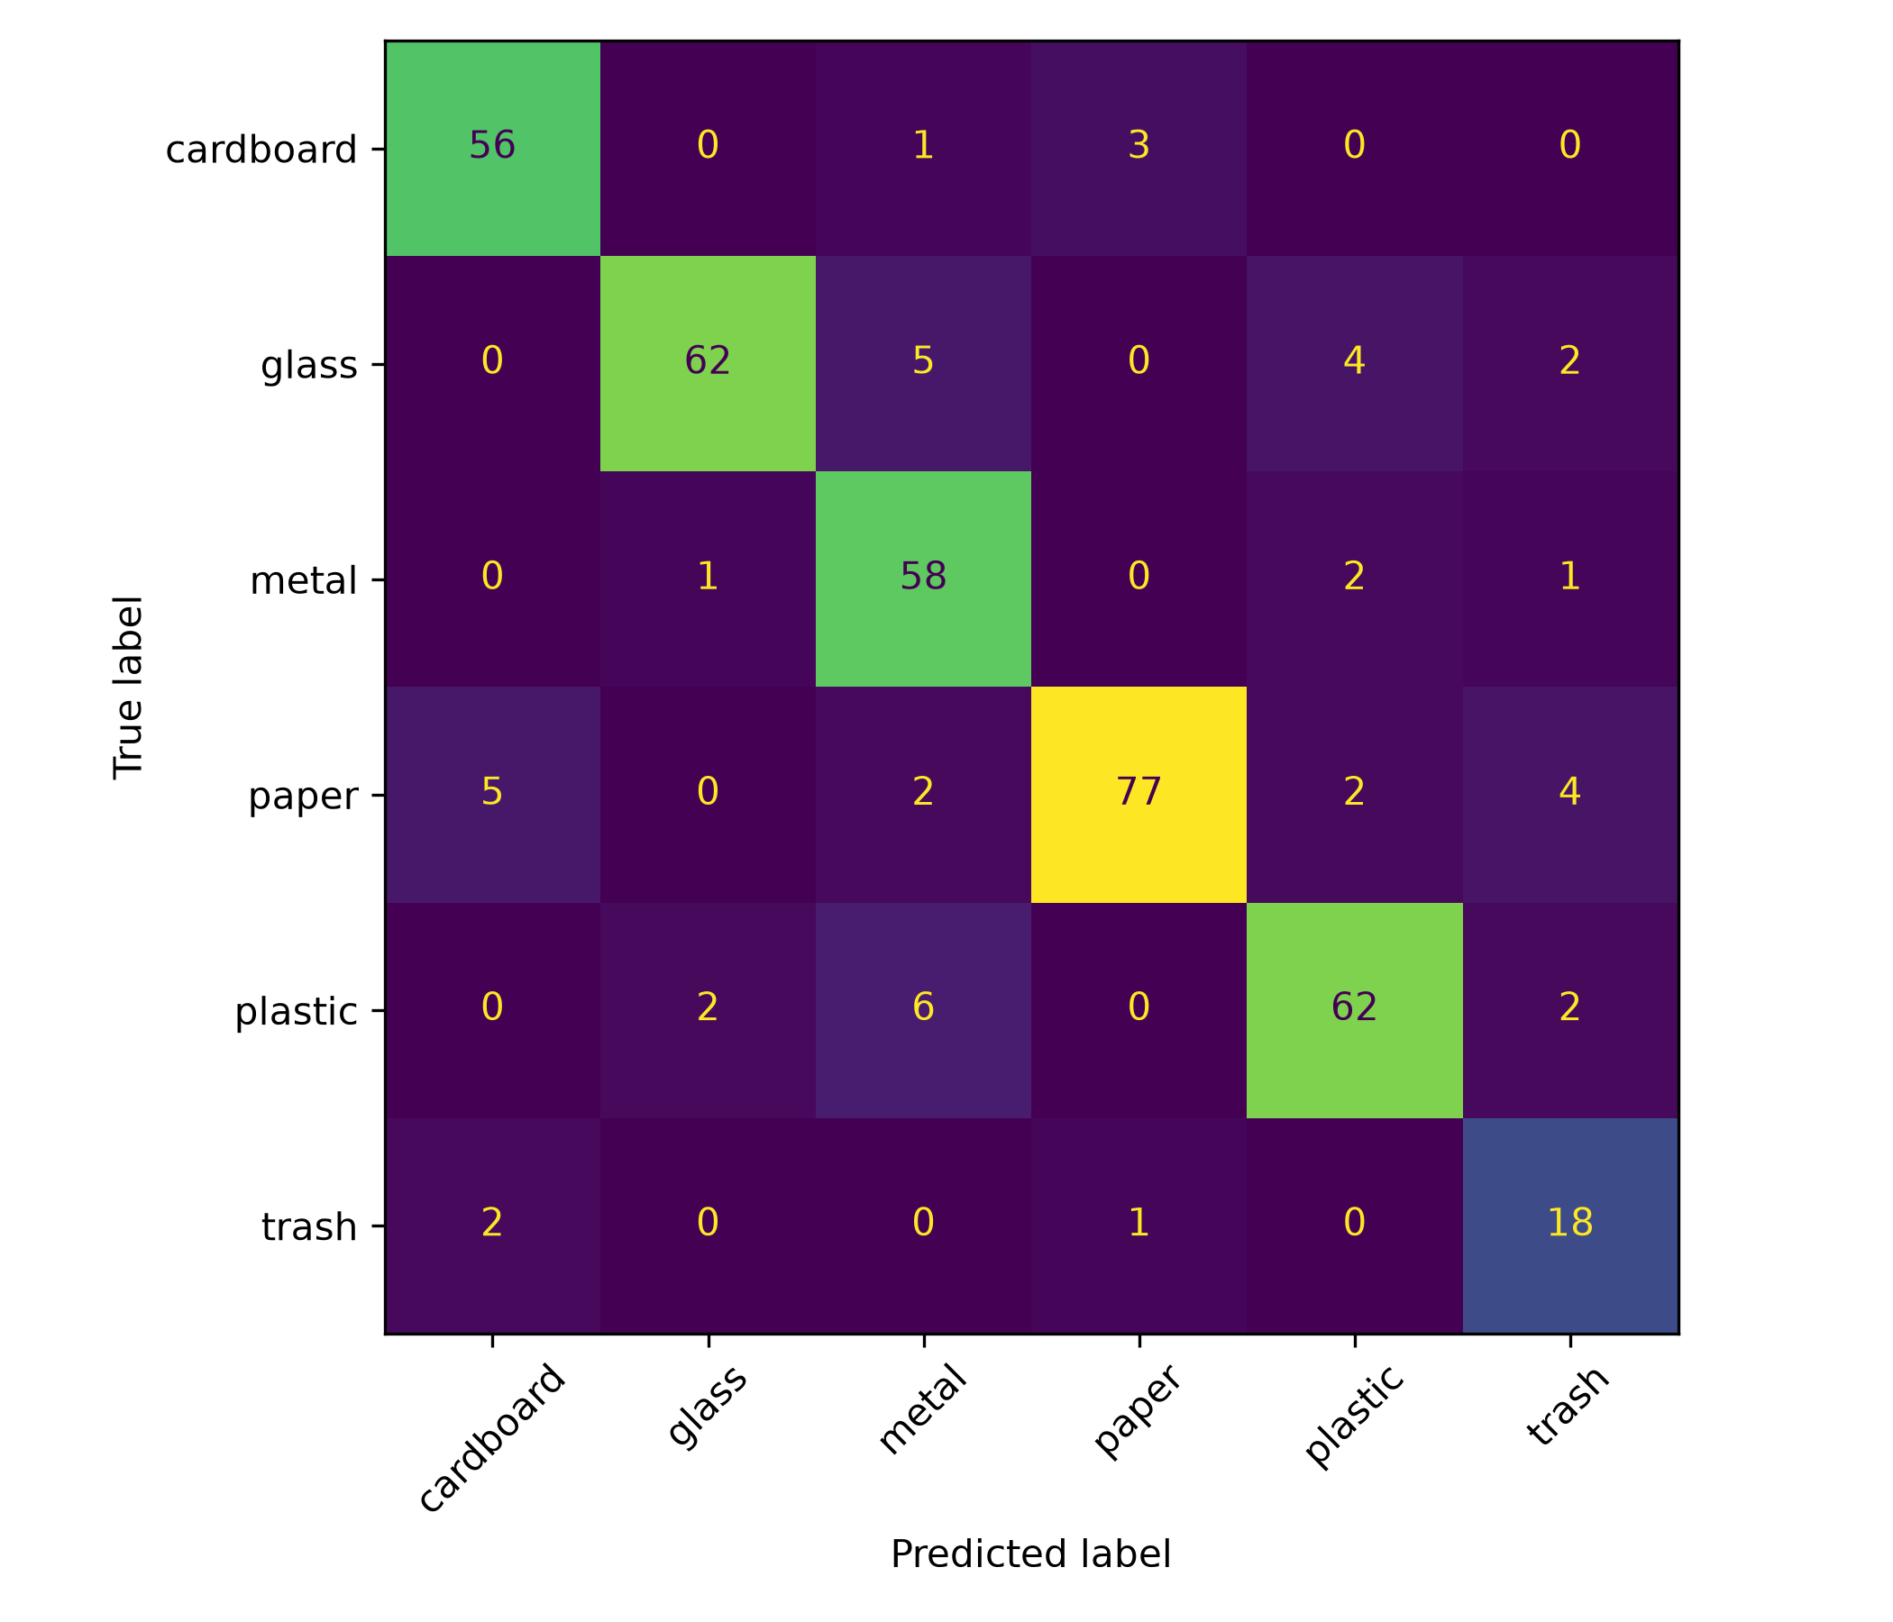
Confusion matrix on held-out images

mobilenetv2 seed42
Seed 42 is a predeclared illustrative run. Use aggregate metrics for model ranking. Epoch indices start at zero; transfer curves concatenate head training and fine-tuning.
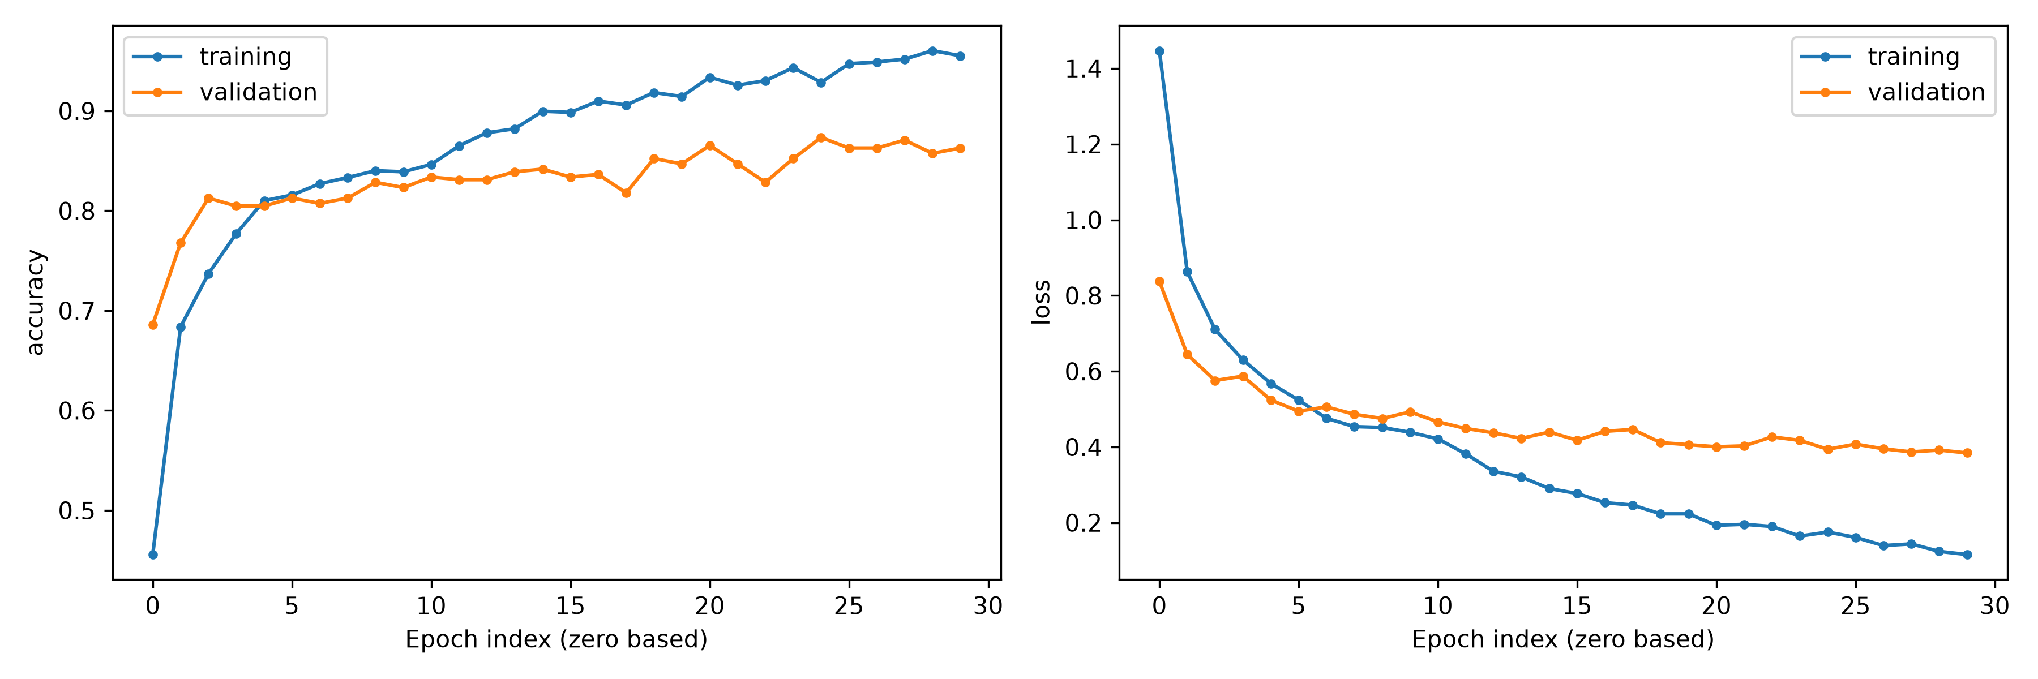
Training and validation accuracy and loss
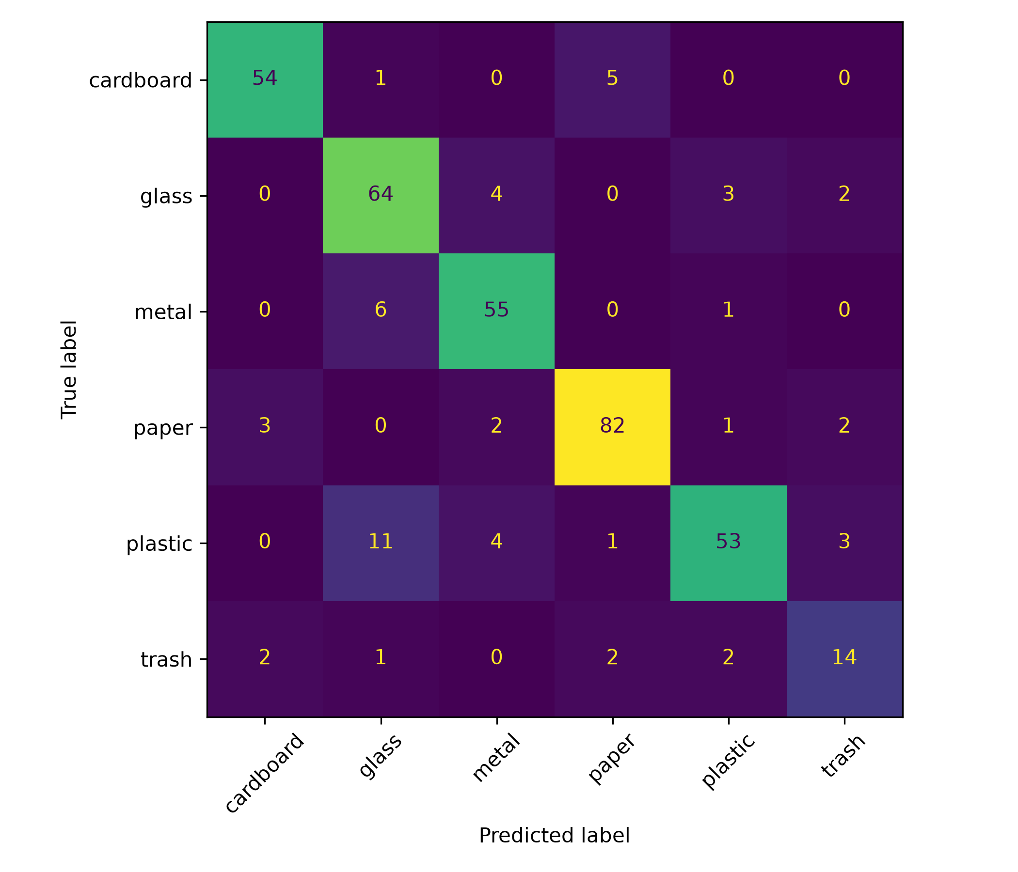
Confusion matrix on held-out images

resnet50 seed42
Seed 42 is a predeclared illustrative run. Use aggregate metrics for model ranking. Epoch indices start at zero; transfer curves concatenate head training and fine-tuning.
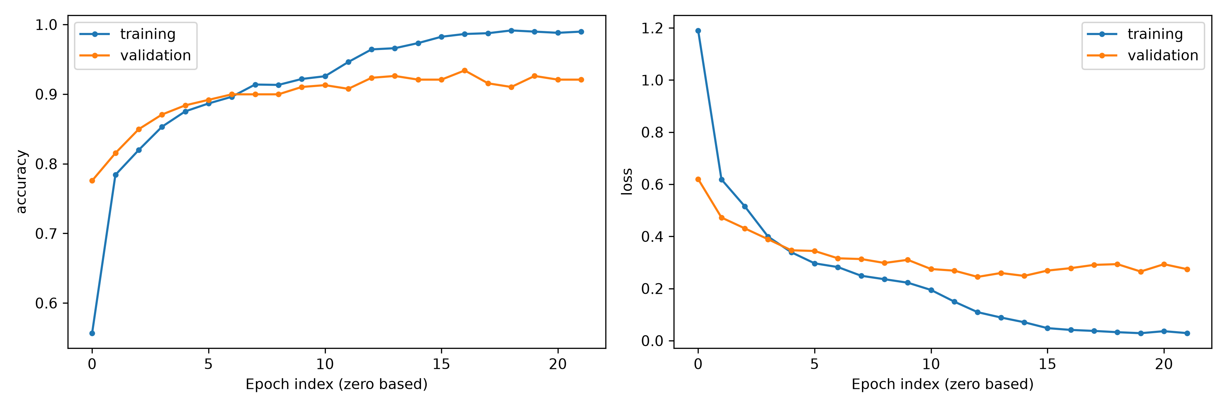
Training and validation accuracy and loss
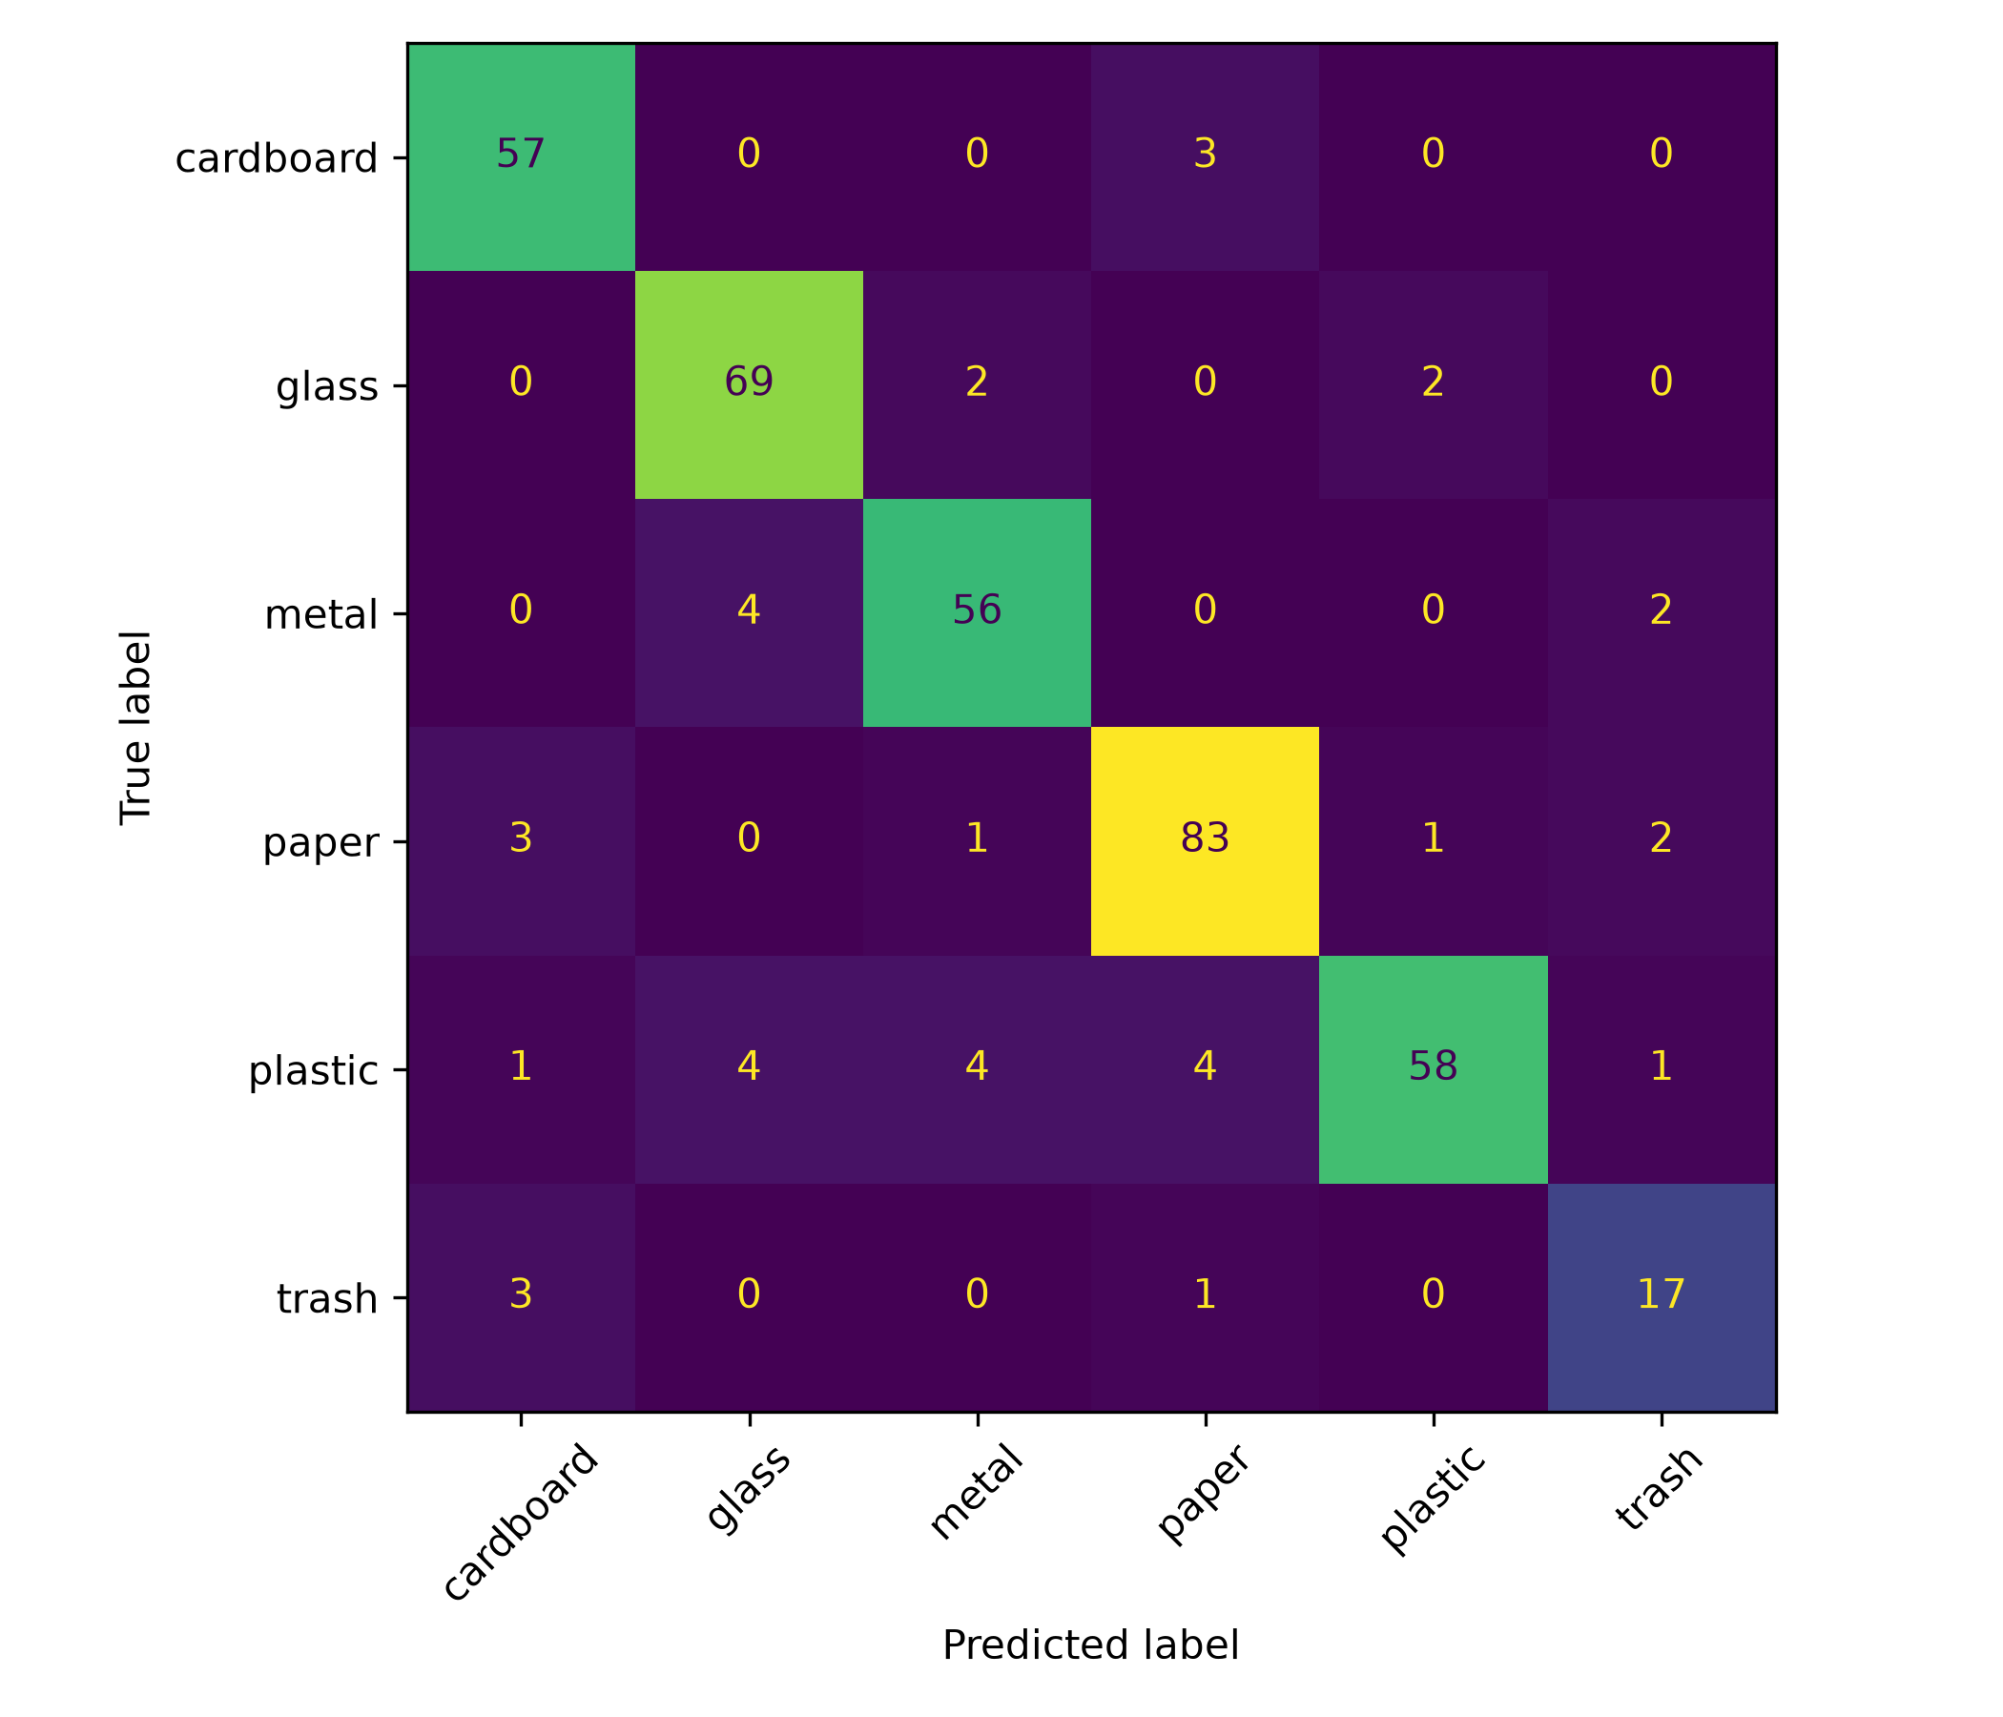
Confusion matrix on held-out images

Limitations
The evaluation uses a small dataset with controlled backgrounds and an imbalanced trash category. Three seeds share one split. Controlled corruptions simulate image degradation and do not demonstrate cross-dataset generalization. Inference timings apply only to the recorded CPU and software configuration. The scratch baseline and pretrained networks differ in architecture as well as initialization, so this experiment does not isolate a causal transfer-learning effect.

