Beyond the Higgs: Why the World's Largest Particle Accelerator Needs a Four-Year Pause
-Aniket
Introduction
Imagine shutting down the world’s most powerful scientific machine for four years – not because it’s broken, but because scientists think it will help them answer even more profound questions about our universe.
At first glance, the decision may seem paradoxical. Why take the very engine that transformed modern physics offline just when it continues to push the edges of human knowledge? Yet this is the path being taken for the Large Hadron Collider (LHC), the crown jewel of CERN and the most powerful particle accelerator ever conceived. Hidden in a 27km circular tunnel just beneath the Franco-Swiss border, this colossal machine has enabled physicists to simulate the conditions in fractions of a second after the Big Bang, leading to fundamental discoveries like the Higgs boson and providing strong evidence for the standard model of particle physics.

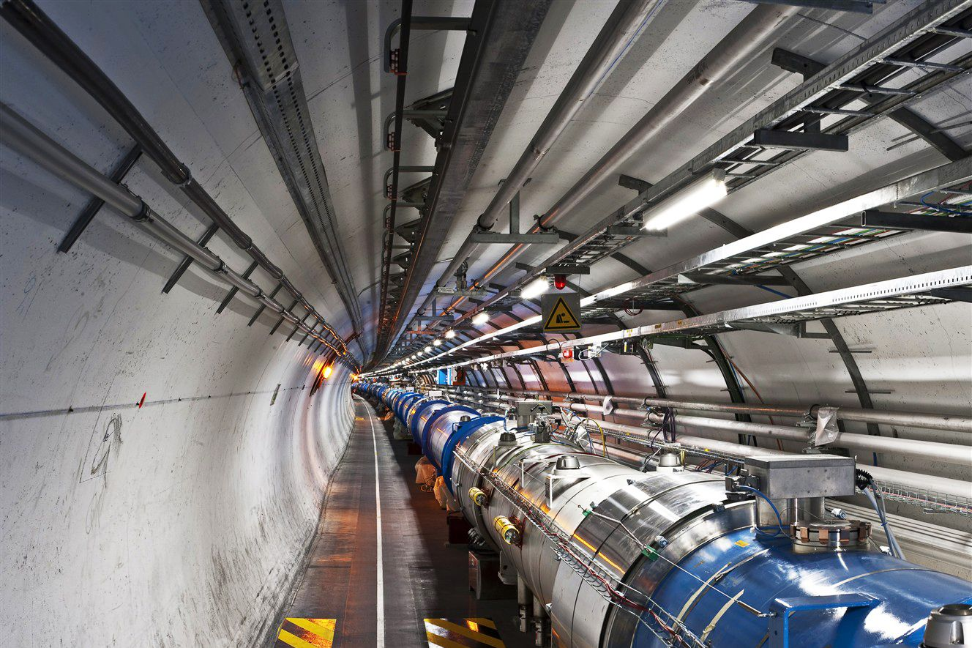
LHC tunnel sector 3-4.CERN “Earth's Most Powerful Physics Machine Gets Back in Action” WIRED

CERN itself is an extraordinary undertaking for humanity. More than simply a research laboratory, it is an international collaboration where thousands of scientists, engineers, and technicians from over a hundred nations pool their expertise to explore the fundamental constituents of matter. Beyond pushing the boundaries of physics, the technology and ideas developed here have already yielded significant advances in fields like medicine, computing, and engineering.
However, for now, the headlines aren't about a new discovery, but about a planned hiatus. The LHC is undergoing one of its most significant upgrades to date to become the High-Luminosity Large Hadron Collider (HL-LHC). This powerful instrument will be able to generate more particle collisions than it ever could before. The upgrade process involves replacing critical parts such as the superconducting magnets, the cooling systems, the detectors, and the computing infrastructure. While it’s a challenging engineering task that takes many years, the end goal is to usher in an entirely new era of precision in particle physics.
This leaves us with a central question:
Why pause one of humanity's greatest scientific achievements for years when it is already one of the most successful scientific instruments ever constructed?
The answer lies in the nature of scientific progress itself. Every major breakthrough depends not only on bold ideas but also on better instruments capable of testing those ideas. The temporary silence of the Large Hadron Collider is therefore not a sign of stagnation but of preparation—a calculated investment in the future of discovery. As the upgraded collider prepares to resume operations in the coming years, physicists hope it will reveal phenomena that lie beyond the current boundaries of the Standard Model, bringing us closer to answering some of the deepest mysteries of the cosmos, from the nature of dark matter to the imbalance between matter and antimatter, and perhaps even uncovering entirely new laws of physics.

The World's Most Powerful Particle Accelerator
For most scientific instruments, a shutdown lasting several months would already be considered significant. For the Large Hadron Collider, however, routine maintenance alone is not enough. The machine operates under some of the most extreme conditions ever engineered by humanity. Every second, two beams containing trillions of protons circulate through a 27-kilometre ring at speeds exceeding 99.999999% of the speed of light. Guiding these beams requires over a thousand superconducting magnets cooled to just 1.9 K (-271.3 °C)—a temperature even colder than outer space. Every collision produces an enormous amount of data while exposing the surrounding equipment to intense radiation and mechanical stress.
It is, for many, akin to keeping a Formula One car on a track for the past fifteen years, around the clock. Like any large mechanical device, pieces age. High energy physics detectors start to degrade after years of intense radiation, superconductive elements begin to fail and must be checked. And much of the LHC is underground, so parts cannot simply be replaced during an operational shutdown. So when the LHC is brought to a stand still, it is not for a rest - it's an necessity.
However, this shutdown is far more ambitious than routine maintenance. Rather than simply repairing worn-out equipment, CERN is transforming the LHC into the High-Luminosity Large Hadron Collider (HL-LHC), a substantially more capable scientific instrument. Interestingly, the objective is not to increase the energy of each proton collision. Instead, the focus is on increasing the luminosity of the collider—the number of particle collisions that occur every second.
In experimental particle physics, the rate at which a particular process is observed is given by
$$R=Lσ$$

where (R) is the event rate, (L) is the luminosity of the collider, and (\sigma) is the interaction cross-section, a quantity that measures the probability of a particular particle interaction occurring.
This simple equation highlights an important idea. Some of the phenomena physicists hope to observe are extraordinarily rare. Certain hypothetical particles may be produced only once in trillions of proton-proton collisions. Increasing the collision energy alone cannot guarantee their discovery. Instead, scientists improve the odds by dramatically increasing the total number of collisions, much like buying millions of additional lottery tickets increases the chance of winning without changing the rules of the lottery itself.
Achieving this increase in luminosity is far from straightforward. It requires replacing key sections of the accelerator with more powerful superconducting magnets capable of focusing the proton beams into much smaller cross-sectional areas before they collide. New radio-frequency cavities will precisely rotate and compress the particle bunches to maximize the overlap between the two beams. The detectors surrounding the collision points must also be upgraded with faster, radiation-resistant electronics capable of handling data rates several times larger than those produced during previous runs.
Together, these improvements are expected to increase the collider's integrated luminosity by nearly an order of magnitude over its remaining lifetime. In practical terms, this means collecting far more experimental data than has been gathered since the LHC first began operations in 2008. More data translates directly into more precise measurements of known particles and a significantly greater chance of observing rare processes that could reveal physics beyond the Standard Model.
Such an extensive transformation cannot be completed within a few months. Every magnet must be manufactured to microscopic tolerances, every detector calibrated with extraordinary precision, and every subsystem tested extensively before the first proton beam can safely circulate again. In a machine where particles travel at nearly the speed of light, even the slightest imperfection can compromise years of scientific effort. The lengthy shutdown is therefore not a delay in scientific progress but a prerequisite for the discoveries that physicists hope to make in the decades ahead.
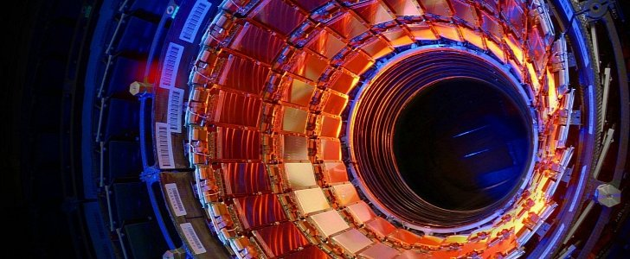
The Accelerator of The Large Hadron Collider “The Large Hadron Collider”, the Biggest Machine Ever Made” autoevolution

Beyond the Collider
The Large Hadron Collider seems to have little connection to our everyday lives. The vast majority of us won’t go on to study particle physics, engineer superconducting magnets or analyse collisions between protons. So one might ask, is it worth spending decades of work and billions of dollars on this machine? History, however, teaches us that major leaps in human technology often begin as attempts to tackle apparently abstract scientific problems.
Perhaps the most famous example of this phenomenon is the World Wide Web. It was developed by particle physicist Tim Berners-Lee at CERN in 1989 as an information management system to facilitate communication among scientists globally and in 1990 he released the first web browser and web server. It began as a solution for physicists and rapidly blossomed into the transformative invention it has become today – revolutionizing communication, education, commerce and entertainment. The creation of the web is a reminder that basic science discoveries have far-reaching impacts beyond the lab.
The technologies developed for the LHC are a similar story. Building the machine required innovation in everything from superconducting magnets, cryogenics and ultra high vacuum systems, to radiation hardened electronics and high performance computing. This technology has found its way into a host of applications in medicine, from advanced MRI and particle beam therapy for cancer to precise detectors and new forms of medical imaging. Meanwhile the massive scale of the LHC data generation is driving advancements in computing and AI which support science from climate modelling to genomic research.
The scientific community itself is, perhaps more profoundly, also a beneficiary. When fully upgraded the High-Luminosity Large Hadron Collider will produce around 10 times the amount of data as today’s accelerator over its lifetime. For particle physicists this offers a remarkable opportunity to make ever more precise measurements of fundamental particles, like the Higgs boson, searching for tiny deviations from established physics or the tantalisation of new physics. Researchers will also improve searches for dark matter, rare particle processes and previously unseen particles that may re-write our understanding of the universe.
For scientists worldwide it’s the dawn of a new era of discovery. Thousands of researchers – from physicists to computer scientists, software developers and mathematicians will design and build experiments, analyze data, develop new theories and the computational tools necessary to analyse the biggest scientific data set ever generated. Every enhancement to the machine creates new scientific questions, and every question creates new work and new ideas.
And perhaps, in the longer run, it’s the students of today who will reap the most significant benefits. Those of us graduating with science and engineering degrees over the next decade may have the chance to analyse data generated from the most sophisticated particle machine in the history of humanity. We may learn skills from high-speed digital electronics to scientific machine learning and statistical analysis, from the nuances of cryogenics to detector physics, that are valuable across all fields.
CERN also embodies an important lesson about the nature of modern science: that breakthroughs are rarely made in isolation by a lone genius, but are the fruit of the collective endeavour of thousands of people with diverse scientific, technical, national and cultural backgrounds – physicists working with engineers, chemists and computer scientists who work alongside mathematicians, to name but a few. For a young person aspiring to a career in science, CERN offers more than just a research facility – it offers a model for collaborative and multidisciplinary working.
And for all the fascinating discoveries we may make within the tunnel at the border of France and Switzerland the ultimate impact of the LHC will be felt well beyond. With every technological problem we solve and every piece of code we write or, even, every young student who is inspires to come and study STEM subjects, CERN adds to a broader body of knowledge and has, through the technologies developed and applied in the search for answers, already changed our world and continues to change our future.

Conclusion
The temporary pause of the Large Hadron Collider is far more than a routine shutdown—it is a testament to humanity's unwavering commitment to scientific progress. While the silence of the collider may appear to mark a halt in discovery, it instead represents years of careful planning, engineering, and innovation aimed at building an even more powerful instrument for exploring the universe. Every upgraded magnet, detector, and computing system brings scientists one step closer to answering questions that have challenged humanity for generations.

Yet, the significance of CERN extends well beyond particle physics. The technologies developed in pursuit of fundamental knowledge continue to transform medicine, computing, engineering, and countless other fields, often in ways that were never anticipated. Equally important, CERN serves as a reminder that the greatest scientific achievements are born from international collaboration, where thousands of researchers work together toward a common goal that transcends borders and politics.

For students, researchers, and anyone passionate about STEM, the next chapter of the Large Hadron Collider represents more than an engineering milestone—it is an invitation to participate in one of humanity's greatest intellectual adventures. As the upgraded collider enters the High-Luminosity era, it carries with it the possibility of discoveries that could redefine our understanding of matter, energy, and the universe itself. Sometimes, the greatest leap forward begins with the courage to pause, rebuild, and dream even bigger.

References

Official CERN Resources
CERN Homepage
https://home.cern/
Large Hadron Collider (LHC)
https://home.cern/science/accelerators/large-hadron-collider
High-Luminosity Large Hadron Collider (HL-LHC) Project
https://hilumilhc.web.cern.ch/
CERN Accelerators
https://home.cern/science/accelerators
How the LHC Works
https://home.cern/science/accelerators/how-large-hadron-collider-works
The Higgs Boson
https://home.cern/science/physics/higgs-boson
The Standard Model
https://home.cern/science/physics/standard-model
Dark Matter
https://home.cern/science/physics/dark-matter
Antimatter
https://home.cern/science/physics/antimatter
The Worldwide LHC Computing Grid (WLCG)
https://wlcg.web.cern.ch/
Cryogenics at CERN
https://home.cern/science/engineering/cryogenics-low-temperatures-high-performance
Superconducting Magnets at CERN
https://home.cern/science/engineering/superconducting-magnets
History of CERN
https://home.cern/about/who-we-are/our-history
The World Wide Web at CERN
https://home.cern/science/computing/birth-web

CERN Experiments
ATLAS Experiment
https://atlas.cern/
CMS Experiment
https://cms.cern/
ALICE Experiment
https://alice.cern/
LHCb Experiment
https://lhcb-public.web.cern.ch/

Wikipedia Articles
CERN
https://en.wikipedia.org/wiki/CERN
Large Hadron Collider
https://en.wikipedia.org/wiki/Large_Hadron_Collider
High-Luminosity Large Hadron Collider
https://en.wikipedia.org/wiki/High-Luminosity_Large_Hadron_Collider
Standard Model
https://en.wikipedia.org/wiki/Standard_Model
Higgs Boson
https://en.wikipedia.org/wiki/Higgs_boson
Particle Accelerator
https://en.wikipedia.org/wiki/Particle_accelerator
Luminosity (scattering theory)
https://en.wikipedia.org/wiki/Luminosity_(scattering_theory)
Cross Section (Physics)
https://en.wikipedia.org/wiki/Cross_section_(physics)
Superconductivity
https://en.wikipedia.org/wiki/Superconductivity
Cryogenics
https://en.wikipedia.org/wiki/Cryogenics
Dark Matter
https://en.wikipedia.org/wiki/Dark_matter
Antimatter
https://en.wikipedia.org/wiki/Antimatter
Proton Therapy
https://en.wikipedia.org/wiki/Proton_therapy
World Wide Web
https://en.wikipedia.org/wiki/World_Wide_Web
Tim Berners-Lee
https://en.wikipedia.org/wiki/Tim_Berners-Lee

Additional Scientific Sources
Physics World – CERN News
https://physicsworld.com/
CERN Courier
https://cerncourier.com/
Nature Physics
https://www.nature.com/nphys/
Nature Reviews Physics
https://www.nature.com/natrevphys/
Symmetry Magazine (Fermilab & SLAC)
https://www.symmetrymagazine.org/
Scientific American – Physics
https://www.scientificamerican.com/physics/

Image Sources (for the figures used)
LHC Tunnel Image (CERN Image Gallery)
https://cds.cern.ch/
CERN Media Library
https://mediatheque.cern.ch/
"Earth's Most Powerful Physics Machine Gets Back in Action" (WIRED)
https://www.wired.com/story/large-hadron-collider-restarts/
"The Large Hadron Collider, the Biggest Machine Ever Made" (autoevolution)
https://www.autoevolution.com/news/the-large-hadron-collider-the-biggest-machine-ever-made-77148.html

