The Ultimate Obligation of the Universe: Why Do Conservation Laws Exist?
-Aniket

Introduction
Every student of physics encounters conservation laws early in their journey. Energy cannot be created or destroyed. Momentum remains unchanged in an isolated system. Angular momentum persists unless acted upon by an external torque. These principles become so familiar that they eventually feel less like scientific discoveries and more like unquestionable truths.
Yet an uncomfortable question often goes unasked.
Why should the universe conserve anything at all?
Nature is under no apparent obligation to preserve energy, momentum, or matter. There is no cosmic accountant ensuring that every joule is returned, no universal lawgiver enforcing a perfect balance after every physical interaction. And yet, from the motion of planets to the decay of atomic nuclei, conservation appears with astonishing consistency.

A closeup picture of a classic Newtons Cradle crafted to demonstrate the conservation of momentum (a photograph by Ktsdesign / Sciencephotolibrary)
For centuries, physicists regarded these laws as fundamental axioms—rules that described the behavior of the universe but required no deeper explanation. However, as the twentieth century unfolded, this seemingly solid foundation began to crack. Experiments in nuclear physics revealed that matter could disappear, transforming into immense amounts of energy. Later, Einstein's theory of relativity unified mass and energy into a single physical entity, forcing physicists to abandon the notion that mass and energy were independently conserved quantities.
But the surprises did not end there.
Modern cosmology presents scenarios in which even the conservation of energy becomes a subtle and context-dependent concept. In an expanding universe, photons lose energy as their wavelengths are stretched across the fabric of spacetime. Unlike a ball rolling uphill or a pendulum slowing down, there is no obvious reservoir receiving this lost energy. The question becomes unavoidable:
if energy itself is not universally conserved, what exactly is the universe preserving?
This article follows the evolution of one of physics' most profound ideas. We begin with the classical picture, where mass and energy appear to be the universe's fundamental currencies. We then examine how relativity reshaped that picture, revealing mass to be another manifestation of energy.
Finally, we arrive at an even deeper realization—one that transformed conservation laws from fundamental principles into mathematical consequences of something far more profound.
The universe does not conserve energy because it values energy. Perhaps it conserves energy only because it remains faithful to something even more fundamental.
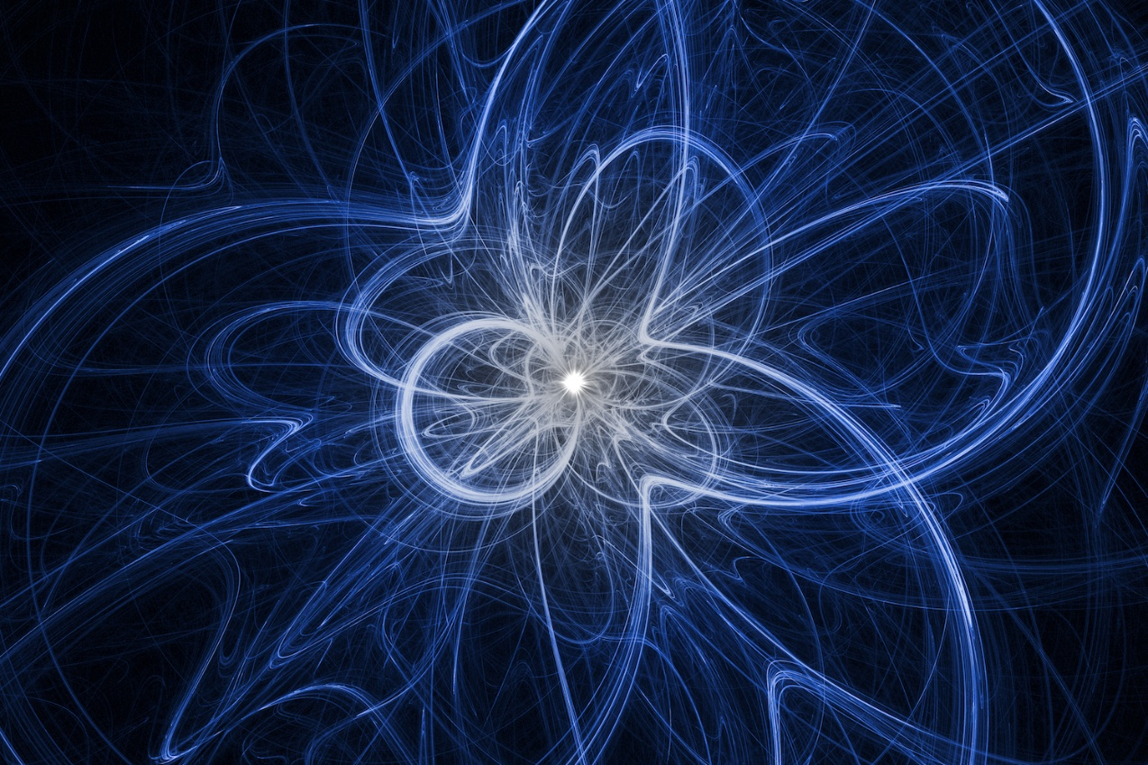
An artist's rendition of subatomic particle movement. Neutrino physicists examined neutrinos detected by the IceCube Observatory, and found that they adhere to Einstein's theory of relativity. (Source: Space.com, Image credit: Shutterstock)

Mass Is Energy Wearing a Different Name
For much of scientific history, mass and energy were regarded as entirely different entities. Matter was thought to be the substance from which the universe was built, while energy was viewed as an abstract quantity that described motion, heat, light, and work. Each appeared to obey its own conservation law. Matter could neither be created nor destroyed, and neither could energy.
This picture remained remarkably successful until the advent of relativity.
In 1905, Albert Einstein proposed an idea that forever altered our understanding of nature:
$$E = mc^{2}$$
This equation is often interpreted as saying that mass can be converted into energy. While this statement is correct, it only captures part of its significance. A deeper interpretation is that mass is itself a form of energy. Even an object completely at rest possesses an intrinsic amount of energy known as its rest energy, given by

$$E_{0} = mc^{2}$$

The enormous factor of (c^2), where (c) is the speed of light in vacuum, reveals why even a tiny amount of mass corresponds to an extraordinary amount of energy. Nuclear fusion inside the Sun, radioactive decay, and matter-antimatter annihilation all demonstrate this principle. In each case, a decrease in rest mass is accompanied by an equivalent increase in other forms of energy, such as radiation or kinetic energy.
Relativity extends this idea even further. A moving particle possesses not only rest energy but also kinetic energy and momentum. These quantities are united through the relativistic energy-momentum relation,

$$E = p^{2}c^{2}+{(mc^{2})}^{2}$$

where (E) is the total energy, (p) is the relativistic momentum, and (m) is the invariant (rest) mass of the particle. This elegant equation shows that mass and motion are inseparable aspects of a single relativistic framework.
Historically, the concept of relativistic mass was introduced to emphasize that an object's inertia appears to increase with velocity,
$$m_{rel}=γm_{0},$$
where
$$γ=\frac{1}{\sqrt{1-\frac{v^{2}}{c^{2}}}},$$

and m₀ is the rest mass. Although modern physics generally avoids the term relativistic mass in favor of invariant mass and total energy, the equation illustrates an important idea: as an object's speed approaches the speed of light, increasingly large amounts of energy are required to continue accelerating it. The distinction between mass and energy becomes progressively less meaningful.
At first glance, relativity appears to resolve the mystery of conservation. Classical physics conserved mass and energy separately; relativity simply unifies them into a single conserved entity. Matter may transform into radiation, and radiation may produce matter, but the total energy—including the energy associated with mass—remains unchanged.
It is an elegant and compelling picture.
Unfortunately, it is still not the whole story.

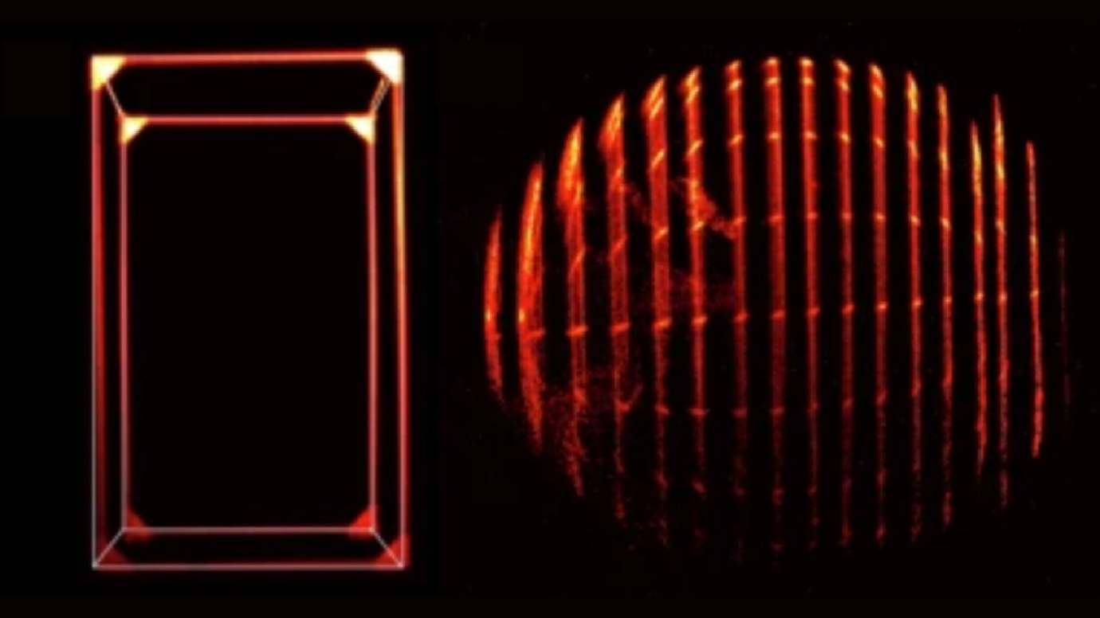
The Vienna team stitched together slices of light to create snapshots. At rest (left), the cube looks normal. But when simulated at 99.9% of light speed (right), a sphere still looks round but reveals parts of its far side. “Physicists capture rare illusion of an object moving at 99.9% the speed of light” Live Science Plus

Conservation Is Not the Fundamental Law
If relativity unified mass and energy into a single conserved quantity, one might reasonably conclude that the mystery has finally been solved. Matter is no longer sacred; energy is the true currency of the universe. Every physical process is merely an exchange between different forms of the same underlying quantity.
Remarkably, even this picture is incomplete.
Consider a photon travelling through our expanding universe. As space itself stretches, the photon's wavelength increases—a phenomenon known as cosmological redshift. Since the energy of a photon is given by

$$E=hf=\frac{hc}{λ},$$
an increase in wavelength necessarily implies a decrease in energy. The obvious question follows:
Where did the missing energy go?
Unlike the kinetic energy that a pendulum transfers into potential energy or the power that a battery gives to an electric circuit, there is no hidden reservoir into which the energy flows. The question does not have a universal answer in the framework of general relativity. There is generally no global law that requires the total energy of the expanding universe to be constant.
It is almost heretical to conclude this. Modern physics shows that after centuries of treating conservation of energy as an immutable law, its validity depends on the structure of space-time itself.
The resolution to this paradox was not the work of Einstein but of one of the greatest mathematical discoveries of the twentieth century. In 1918 the mathematician Emmy Noether proved a theorem that changed forever our understanding of physical law.
Her theorem can be stated in a single sentence:
Every continuous symmetry of the laws of physics gives rise to a conserved quantity.
This simple statement explains why conservation laws exist without assuming them from the outset.
If the laws of physics remain unchanged as time advances,
$$t→t+ϵ,$$
then energy is conserved.
If the laws remain unchanged when an experiment is performed at a different location,
$$x→x+ϵ,$$
then linear momentum is conserved.
Conservation is therefore not a fundamental command imposed upon nature. It is the mathematical consequence of a deeper invariance.
This also explains why cosmology is different. An expanding universe generally lacks a global time-translation symmetry. The universe today is physically different from the universe billions of years ago. Since the symmetry responsible for energy conservation is absent, Noether's theorem does not require a globally conserved energy to exist. The realization is profound.
For generations, physicists searched for the quantities that nature refused to change. Noether revealed that they had been asking the wrong question. The true foundation of physical law is not what remains constant, but what remains unchanged under transformation.
Symmetry is not merely a feature of the universe. Symmetry is the reason conservation exists at all.

The Universe's Only Obligation
The history of conservation laws represents the history of physics as well. Initially, there were only observations that showed us that energy, momentum, and matter remain constant. Over time these observations grew into an important aspect of today's physics. Mass and energy are not two different physical properties created by nature, they are manifestations of a single physical reality, as Einstein proved; thus dissolving one of classical physics' oldest distinctions. While the unification of mass and energy answered many questions, it didn't provide an answer to all things. The true explanation regarding conservation of energy was provided by Noether's Theorem: The safety of the laws of conservation is no longer reliant upon some absolute authority or command outside of the universe because the laws of conservation are a conclusion of the underlying symmetries of the universe.
Our understanding of this idea gives us a much different interpretation about conservation. Conservation laws are not theories that the universe created and operates by; rather, whenever the underlying symmetries of the universe exists as it relates to the fabric of spacetime, the laws of conservation will exist. Similarly, where the underlying symmetries of the universe do not exist with respect to the fabric of spacetime, conservation will not exist in a fully global form.
The universe has neither any fixed amounts nor any hidden records for each interaction nor any requirement to maintain concepts which we perceive as being reasonable on an intuitive level. The universe does, however, exhibit internal consistency via symmetry. As such, conservation does not represent the language of the universe, but rather one of many consistent statements written in a much deeper language of symmetry within the universe.

Aniket Dinda
(The Indian Association for the Cultivation of Sciences)

References
Books
- Griffiths, David J. Introduction to Electrodynamics (4th Edition). Pearson Education.
- Carroll, Sean M. Spacetime and Geometry: An Introduction to General Relativity. Cambridge University Press.
- Goldstein, Herbert, Poole, Charles P. Jr., & Safko, John L. Classical Mechanics (3rd Edition). Addison-Wesley.
- Feynman, Richard P., Leighton, Robert B., & Sands, Matthew. The Feynman Lectures on Physics. Addison-Wesley.
- Penrose, Roger. The Road to Reality: A Complete Guide to the Laws of the Universe. Jonathan Cape.

Wikipedia Articles
The following Wikipedia articles were used for background information and verification.
- Conservation Law
https://en.wikipedia.org/wiki/Conservation_law
- Noether's Theorem
https://en.wikipedia.org/wiki/Noether%27s_theorem
- Symmetry (Physics)
https://en.wikipedia.org/wiki/Symmetry_(physics)
- Mass–Energy Equivalence
https://en.wikipedia.org/wiki/Mass%E2%80%93energy_equivalence
- Special Relativity
https://en.wikipedia.org/wiki/Special_relativity
- General Relativity
https://en.wikipedia.org/wiki/General_relativity
- Energy–Momentum Relation
https://en.wikipedia.org/wiki/Energy%E2%80%93momentum_relation
- Invariant Mass
https://en.wikipedia.org/wiki/Invariant_mass
- Mass in Special Relativity (Relativistic Mass)
https://en.wikipedia.org/wiki/Mass_in_special_relativity
- Photon Energy
https://en.wikipedia.org/wiki/Photon_energy
- Redshift
https://en.wikipedia.org/wiki/Redshift
- Cosmological Redshift
https://en.wikipedia.org/wiki/Redshift#Cosmological_redshift
- Lagrangian Mechanics
https://en.wikipedia.org/wiki/Lagrangian_mechanics
- Principle of Least Action
https://en.wikipedia.org/wiki/Stationary-action_principle
- Euler–Lagrange Equation
https://en.wikipedia.org/wiki/Euler%E2%80%93Lagrange_equation
- Time Translation Symmetry
https://en.wikipedia.org/wiki/Time_translation_symmetry
- Lorentz Transformation
https://en.wikipedia.org/wiki/Lorentz_transformation
- Four-Momentum
https://en.wikipedia.org/wiki/Four-momentum
- Action (Physics)
https://en.wikipedia.org/wiki/Action_(physics)

NASA Resources
- NASA Science
https://science.nasa.gov/
- NASA Universe
https://science.nasa.gov/universe/
- NASA Astrophysics Division
https://science.nasa.gov/astrophysics/
- NASA Black Holes
https://science.nasa.gov/universe/black-holes/
- NASA Galaxies and Cosmic Expansion
https://science.nasa.gov/universe/galaxies/
- NASA Image and Video Library
https://images.nasa.gov/
- NASA Astronomy Picture of the Day (APOD)
https://apod.nasa.gov/apod/

Additional Scientific Resources
- Live Science — Physicists Capture Rare Illusion of an Object Moving at 99.9% the Speed of Light
https://www.livescience.com/physics-mathematics/physicists-capture-rare-illusion-of-an-object-moving-at-99-9-percent-the-speed-of-light
- Space.com
https://www.space.com/
- Science Photo Library
https://www.sciencephoto.com/
- Nature Communications — Extending Noether's Theorem by Quantifying the Asymmetry of Quantum States
https://www.nature.com/articles/ncomms4821
- ScienceDirect — Noether's Theorem
https://www.sciencedirect.com/topics/mathematics/noethers-theorem
- arXiv — E. Noether's Discovery of the Deep Connection Between Symmetries and Conservation Laws (Nina Byers)
https://arxiv.org/abs/physics/9807044
- CERN — Special Relativity and Particle Physics Resources
https://home.cern/science/physics
- CERN — Symmetry in Physics
https://home.cern/science/physics
- Britannica — Noether's Theorem
https://www.britannica.com/science/Noethers-theorem
- Britannica — Special Relativity
https://www.britannica.com/science/special-relativity
- Britannica — General Relativity
https://www.britannica.com/science/general-relativity

Image Credits
- Newton's Cradle Image — Science Photo Library
https://www.sciencephoto.com/
- Space and Astronomy Images — NASA Image and Video Library
https://images.nasa.gov/
- Astronomy Pictures — NASA Astronomy Picture of the Day (APOD)
https://apod.nasa.gov/apod/
- Relativistic Motion Illustration — Live Science
https://www.livescience.com/physics-mathematics/physicists-capture-rare-illusion-of-an-object-moving-at-99-9-percent-the-speed-of-light
- Additional Astronomy Images — NASA Science
https://science.nasa.gov/

