Dark Matter: Unraveling the Universe's Greatest Invisible Mystery
-Aniket
Introduction
Imagine walking into a room where only a few pieces of furniture are visible. You see a chair, a table, and a lamp, and at first glance the room appears mostly empty. As you begin to walk, however, you repeatedly bump into objects that you cannot see. Although invisible, these hidden obstacles clearly occupy space and influence your movement. You may not know what they are made of or why they cannot be seen, but their presence is undeniable because of the effects they produce.
Astronomers face a remarkably similar situation when they observe the universe. Through powerful telescopes, they can see stars, planets, glowing gas clouds, and distant galaxies—the "visible furniture" of the cosmos. Yet careful measurements reveal that these luminous objects behave as though they are being influenced by an enormous amount of unseen matter. Stars orbit galaxies too quickly, galaxy clusters remain bound when they should fly apart, and light from distant galaxies bends more than visible matter alone can explain. In each case, gravity points to the existence of something hidden.
This mysterious substance, known as dark matter, neither emits nor reflects light, making it invisible to every telescope. Although its true nature remains unknown, its gravitational influence has transformed our understanding of the universe, making dark matter one of the most compelling mysteries in modern astronomy and cosmology.


How Does Dark Matter Affect the Evolution of the Universe? | Rubin Observatory

What Is Dark Matter, and Why Is It a Mystery?
Dark matter is a hypothetical form of matter that does not emit, absorb or reflect electromagnetic radiation, rendering it completely undetectable by even the most advanced telescopes. While ordinary matter, interacting with light, forms anything from stars and planets to life, dark matter seems to interact only via gravity. Though undetectable, it exerts a gravitational pull on stars, galaxies and clusters of galaxies across the entire universe.
It is ‘dark’ in the sense that it does not interact with light, not that it’s black or empty.
Modern cosmology models estimate it makes up 27% of the total mass-energy content of the universe, whereas we, along with everything we know of as ‘stuff’, constitute only 5%. 68% is made up of something else even stranger, a phenomenon called ‘dark energy’. The big question is not whether this invisible mass exists, but what it is made up of. Scientists have mountains of observational evidence showing there’s a great amount of invisible mass throughout the universe, seen through the rotation speeds of galaxies, the orbits of galaxy clusters, through gravitational lenses, the distribution of large scale structure, and from the CMB. It seems to all add up consistently across these entirely different observations, and dark matter has become one of the strongest conclusions in cosmology.
So too, with dark energy – through analysis of faraway Type Ia supernovae, astronomers realized that the universe's expansion was accelerating rather than decelerating (something predicted under the expectation that the Universe's gravity should slow expansion down).
The implication was the existence of some form of energy throughout the universe pushing space outwards, and it's since been baked into the standard model of cosmology, even if no-one knows what it is. We know there are definitely two things out there having observable effects but we have no direct detections of them. We know they exist, but we just don't know what they are.
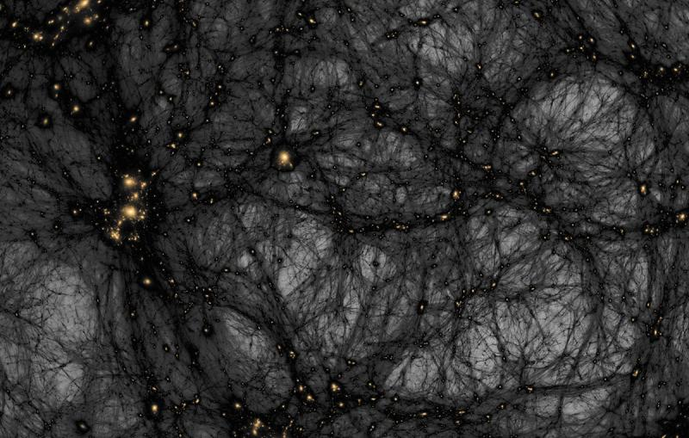
A simulation of the formation of dark matter structures from the early universe until today.
Ralf Kaehler/SLAC National Accelerator Laboratory, American Museum of Natural History
Clues Hidden in Plain Sight
History is filled with stories of science that progressed by focusing on effects long before causes could be explained. Over the ages, people stumbled upon many occurrences, of which they were sure existed but lacked the tools and knowledge to grasp their essence. Everything was in place; all that was missing was a explanation. Whether the wind we cannot see but whose force we feel on our skin as leaves blow through the trees, or flags flutter on flagpoles, and waves build upon the sea, nobody is doubt its existence and inferring it from its actions.
A police officer arriving on a crime scene faces the same situation, the prints, footprints, and discarded items are not clear evidence, they speak for themselves by helping form a strong argument for an existence beyond our sight. These types of scenarios happen frequently throughout history, including in the scientific field. Prior to the discoveries of bacteria, people were puzzled by illnesses, unaware that micro organisms caused those diseases to be present. Prior to the existence of Neptune, it was known that Uranus was following the wrong trajectory to explain its orbital path, thus an unknown planet existed beyond Uranus that gravitationally caused the anomaly.
When that theory was proven by astronomers in the telescope, Neptune was found precisely where theory suggested.
The scientific enigma of dark matter bears resemblance to those phenomena. Although the entity that constitutes dark matter has never been observed or identified in laboratory experiments, the universe produces its own clues. Galaxies orbit more rapidly, groups of galaxies are held together by more gravity than accounted for by visible mass, and light is more affected than possible by the amount of visible mass. Each of those instances provides us with evidence pointing toward an existence that is influencing matter gravitationally though that entity has not been detected. Therefore, it’s not an educated guess at filling a vacancy, but it is the title assigned to an undetectable entity indicated by numerous observational results, including how galaxies move, their interactions, the presence of gravitational lensing and dark energy’s relationship.

Invisible dark matter makes up most of the universe – but we can only detect it from its gravitational effects. CERN
Following the Clues: The Global Search for Dark Matter
If dark matter is not visible, how do we look for it? Scientists are designing experiments sensitive enough to observe the slightest possible interactions between dark matter and ordinary matter. Around the world, astronomers, engineers, and physicists are in a race that has been underway for many decades.
Among the most challenging is the pursuit in large underground particle detectors. Hidden deep in the earth, in old mines or beneath mountains, these are laboratory-style environments designed to exclude background radiation-such as cosmic rays-that would overwhelm a measurement designed to observe feeble events. Experimenters are using massive detectors-including XENONnT in Italy’s Gran Sasso National Laboratory, the LUX-ZEPLIN (LZ) in the U.S., and PandaX in China-which hold large volumes of ultra-pure liquid xenon. If a dark matter particle should bump into one of these xenon nuclei, scientists hope to observe the resulting tiny flash of light. Although no such light signal has yet been detected, subsequent generations of these instruments are already placing stronger and stronger limits on dark matter’s possible nature.
Another approach to seeking dark matter is to produce it in particle-smasher experiments. At CERN’s Large Hadron Collider near Geneva, scientists collide beams of protons, accelerated close to the speed of light, with each other. Dark matter particles, should they be generated, could pass through the experiment’s detectors without interacting, carrying off a signature pattern of missing energy. Despite a spectacular string of scientific discoveries at the LHC-including the Higgs boson-no conclusive evidence for dark matter has been seen yet.
Astronomers are continuing the hunt by observing the cosmos. At present, the James Webb Space Telescope (JWST) is peering back to the earliest galaxies, giving scientists information about structure formation in the young universe. Meanwhile, the European Space Agency’s Euclid space telescope is constructing an exquisitely detailed, three-dimensional map of the universe, studying how the apparent bending of light from galaxies caused by the presence of dark matter, or gravitational lensing, varies on scales spanning billions of light-years. Over the next decade, the Vera C. Rubin Observatory, being built in Chile, is expected to survey billions of galaxies and to provide unprecedented insights into galactic motions and the distribution of invisible matter in large-scale cosmic structure.
Despite decades of scientific effort, no experiment has succeeded in identifying the particle of dark matter. This is not a cause for disappointment. Rather, it means that all the experimental and observational efforts to date have helped to eliminate or disfavor particular candidates. There is still, and the evidence has only grown stronger over the years, overwhelming astrophysical and cosmological evidence that dark matter exists. The problem has been to determine its identity.
The search for dark matter, therefore, is not an act of searching in the dark with no guide. It is an active and progressive investigation, driven by both observations and experiments and enhanced with increasing technology. Each observatory, experiment, and particle accelerator is making a contribution to one of the most profound mysteries of our time: what is the stuff that apparently binds the universe together?

Conclusion
For centuries, humanity has looked toward the night sky seeking answers to questions that once seemed impossible to answer. The story of dark matter reminds us that science is not merely a collection of facts but an ever-evolving journey of discovery. Every unexplained observation, every failed experiment, and every new telescope contributes another piece to a puzzle that spans the entire universe. Although we have yet to uncover the true identity of dark matter, the evidence for its existence continues to grow stronger with each passing year.
Perhaps the greatest excitement lies not in the answers we already possess, but in those still waiting to be found. The next breakthrough may come from a particle detector deep beneath the Earth, a space telescope observing the distant cosmos, or an idea from a young scientist who dares to question the unknown. Until then, dark matter remains one of the universe's greatest secrets—silent, invisible, and elusive—inviting humanity to continue its pursuit of understanding the cosmos beyond what the eye can see.

-Aniket Dinda (IACS Kolkata)

