The Great Attractor: The Invisible Destination of Our Galaxy
Following a Cosmic Current
Imagine placing a small leaf on the surface of a calm river. At first, it appears motionless, but if you watch carefully, you notice it slowly drifting downstream. You cannot see the force moving it, yet you know the river's current is carrying it toward a destination. Now imagine replacing that tiny leaf with an entire galaxy—billions of stars, planets, nebulae, and black holes—floating through the vastness of space. Surprisingly, this is not merely an analogy; it is remarkably close to what astronomers have discovered about our own galaxy.
For centuries, humans believed that the universe was largely static, with galaxies occupying fixed positions in an immense cosmic landscape. The twentieth century transformed this understanding. Edwin Hubble's observations revealed that the universe is expanding, with distant galaxies generally moving away from one another. It seemed that the motion of galaxies could be explained simply by this universal expansion. However, as astronomers began measuring the velocities of nearby galaxies with increasing precision, they encountered an unexpected puzzle.
It seems that while the universe is expanding, the Milky Way, our galaxy, is moving with a speed of 600 kilometres per second compared to the background of the expanding universe. Other galaxies seem to be moving in the same direction as well, thousands of them all swarming towards one general point. Something huge must be pulling on them all to create such a large pattern of motion.
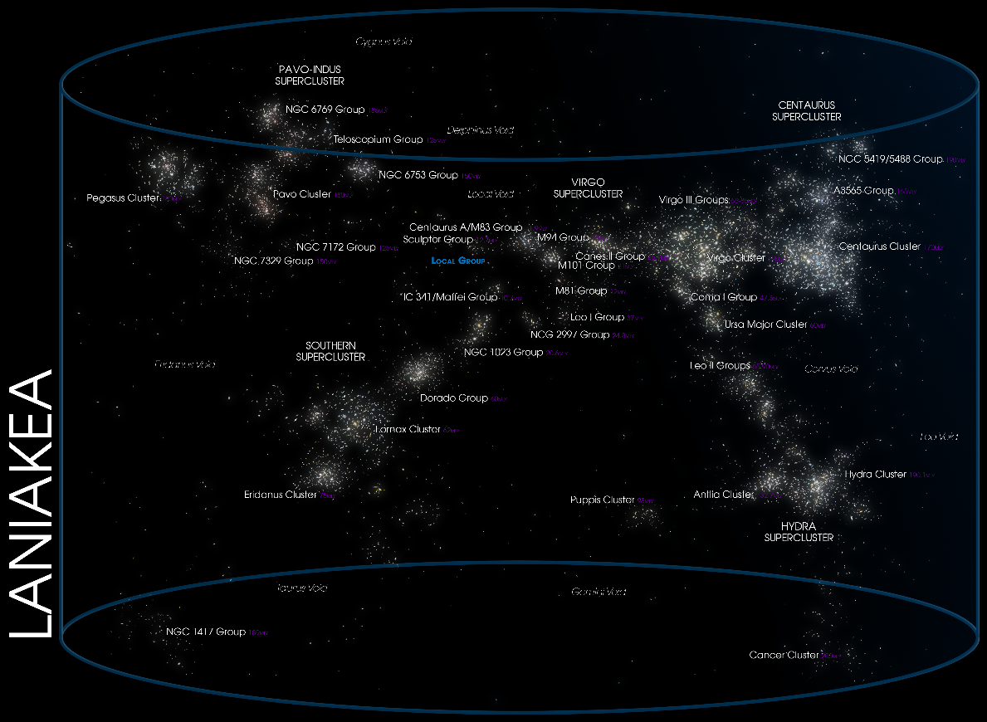
The Laniakea Supercluster, our cosmic home, contains nearly 100,000 galaxies, including the Milky Way. The arrows represent the gravitational flow of galaxies toward massive regions such as the Great Attractor
What astronomers have named this mysterious point of motion is the Great Attractor. The Great Attractor isn't anything specific like a star or galaxy, but instead is a region of spacetime with an extremely high mass that seems to be hidden by the Milky Way. This area is so far away that it takes light hundreds of millions of years to travel through it, but there are so many intervening dust, gas clouds, and stars that it makes the Great Attractor virtually invisible to observers on Earth. But it doesn't mean it isn't affecting us and our galaxy. In fact, the motion of galaxies around us is like footprints in freshly fallen snow, providing evidence for the unseen Great Attractor.
Great Attractors are interesting to astronomers because they show us something really special about our universe; that something can be there, but just unseeable, and we can use physics to find it. This is very similar to dark matter, a substance we can't see but know is there through the effects of gravity. By looking at the motion of galaxies we can find the fingerprints of unseen mass and determine what it may be.

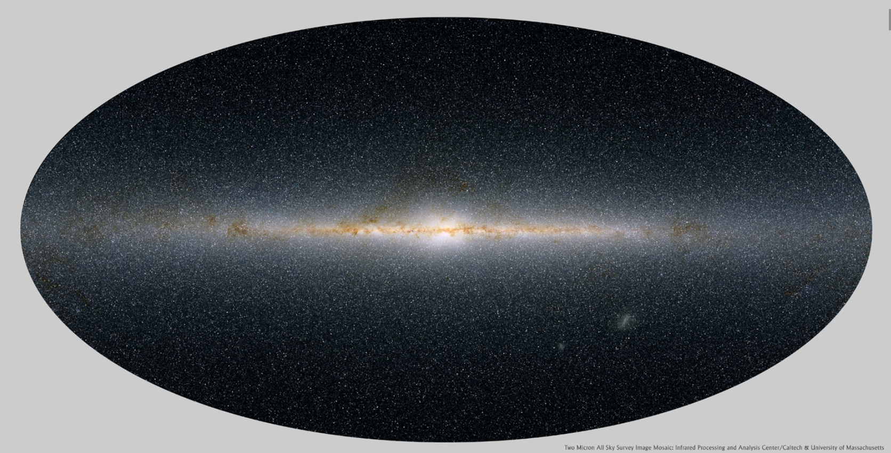
The dense plane of the Milky Way obscures our view of distant galaxies, creating the "Zone of Avoidance" where the Great Attractor is believed to lie.

A Mystery Revealed Through Motion
The search for the Great Attractor began not with a telescope pointed at an extraordinary object, but with a simple question: Why are galaxies moving the way they do?
If the universe were expanding perfectly uniformly, every galaxy would simply recede from every other galaxy according to Hubble's law. In reality, galaxies also possess what astronomers call peculiar velocities—additional motions caused by the gravitational pull of nearby concentrations of matter. These motions are typically much smaller than the overall expansion of the universe, but they carry invaluable information about the invisible distribution of mass.
When astronomers measured the peculiar velocities of hundreds and eventually thousands of galaxies, they found a surprising pattern. Instead of moving randomly, many galaxies within our local cosmic neighbourhood were converging toward the same region of space. The Milky Way, the Andromeda Galaxy, and thousands of other galaxies appeared to be participating in a vast gravitational flow, as though carried by an invisible cosmic current.
This remarkable discovery raised an obvious question: What could possibly possess enough mass to pull entire galaxy clusters across hundreds of millions of light-years? The search for that answer continues today, and it has led scientists to explore some of the largest structures ever discovered in the observable universe.
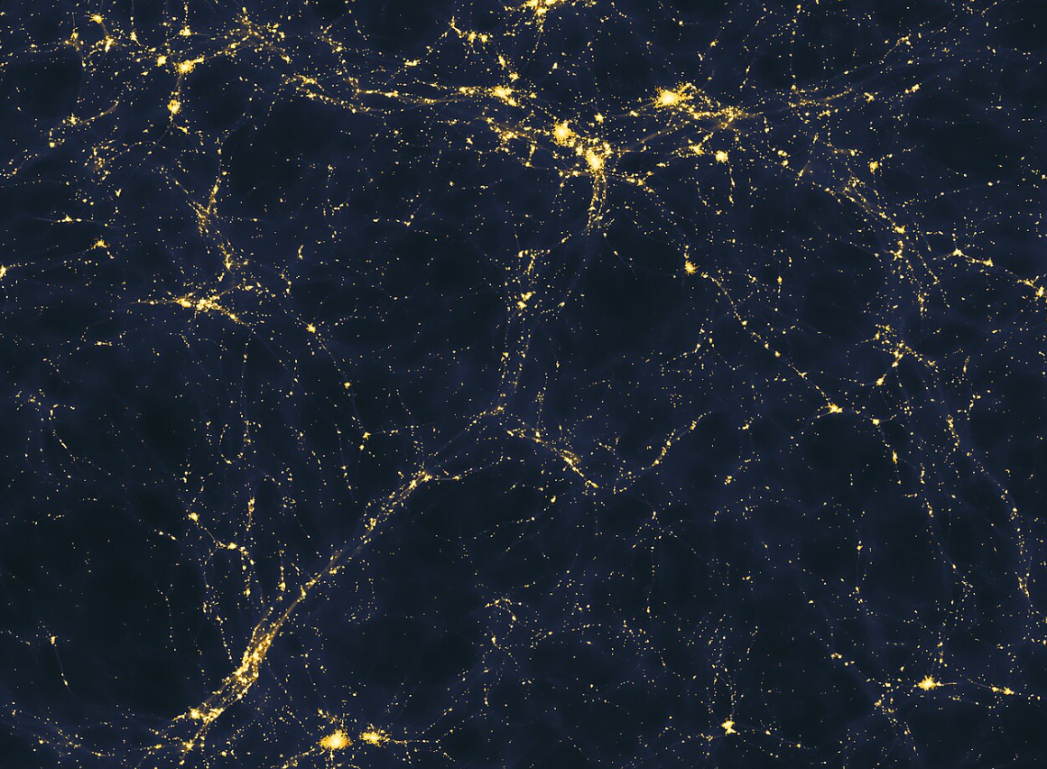
A simulation of the cosmic web showing galaxies, dark matter, and enormous filaments that shape the large-scale structure of the universe and influence galactic motion.

Modern-Day Research: Mapping an Invisible Giant
More than four decades after postulating its existence, astronomers are finally getting to grips with what the Great Attractor actually is. Giant systems of galaxies, dark matter, and cosmic filaments exert a powerful force on other galaxies, drawing them in over hundreds of millions of years. And now, thanks to advanced technology, astronomers can finally see through the fog of gas and dust to peer into this mysterious region.
Researchers believe this area may include large concentrations of galaxies, gas, and dark matter that exert a powerful attractive force on neighboring galaxies. Due to the great distance, it is extremely challenging to study the Great Attractor. First, it is located in a region of the sky known as the Zone of Avoidance, a thick band of dust that obscures all-optical telescopes. So, astronomers are having to use radio, infrared, and X-ray telescopes to penetrate the murk. Researchers think these wavelengths will help us see galaxies, normally invisible to us.
Many different observatories around the world have participated. The Parkes Radio Telescope located in Australia and the MeerKAT Radio Telescope located in South Africa have been used to track hydrogen gas from galaxies hidden by the Milky Way. Meanwhile, 2MASS has been used for an infrared survey, spotting galaxies that appear to be hanging out in the Zone of Avoidance.
Space-based observatories have provided another valuable perspective. The European Space Agency's Euclid mission, launched to investigate dark matter and dark energy, is producing one of the most detailed three-dimensional maps of the large-scale universe ever created. By measuring the shapes and positions of billions of galaxies, Euclid enables astronomers to trace the invisible distribution of matter through gravitational lensing. These observations are expected to refine our understanding of how mass is distributed around the Great Attractor and throughout the cosmic web.
Researchers are also turning to powerful computer simulations. Modern cosmological simulations, such as the Millennium Simulation and more recent large-scale numerical models, recreate the evolution of the universe from shortly after the Big Bang to the present day. These virtual universes allow scientists to compare simulated galaxy motions with real observations. If the simulations reproduce the peculiar velocities observed around the Great Attractor, they provide valuable clues about the amount and distribution of visible matter and dark matter responsible for those motions.
An important breakthrough in recent years has been the realization that the Great Attractor may not be the ultimate destination of our galaxy after all. Large-scale surveys indicate that our Local Group belongs to an enormous structure known as the Laniakea Supercluster, which contains approximately one hundred thousand galaxies spread across more than 500 million light-years. Within this immense supercluster, the Great Attractor appears to function as one of several major gravitational hubs rather than the final endpoint of cosmic motion. Even farther away lies the Shapley Supercluster, an extraordinarily massive concentration of galaxies whose gravitational influence may extend over an even greater distance than previously believed.
Despite these remarkable advances, the mystery remains unsolved. Astronomers continue to debate how much of the observed galactic motion is caused by the Great Attractor itself, how much results from the pull of the Shapley Supercluster, and how dark matter shapes this intricate cosmic landscape. Every new survey adds another piece to the puzzle, revealing that the universe is far more interconnected than once imagined. With next-generation observatories and increasingly sophisticated simulations, scientists hope that the coming decades will finally reveal the true nature of the invisible structures guiding the motion of galaxies across the cosmos.

Conclusion
The story of the Great Attractor is indeed an intriguing one, demonstrating that even in the twenty-first century, there are still things in our universe that we do not fully understand. After first being discovered by noticing that galaxies are gravitating in a certain unexpected direction, people have been wondering ever since exactly what this mysterious feature actually is. Scientists have come a long way in terms of understanding it, but even today, they are still not entirely sure of any of the existing theories. It is, however, an exciting example of human curiosity at its best, as well as determination and innovation. One can only hope that one day, astronomers will be able to announce to the world the true nature of the Great Attractor, and until that day comes, they work tirelessly in their pursuit of knowledge about the universe that surrounds us all.
The Great Attractor is an important mystery in the history of science, and the main reason why is simply due to its implications for understanding of the bigger picture. It can be argued that it is not so much about the attractor itself, but rather about the broader forces of nature that we perceive through it. After all, it can be said with a high degree of certainty that it is but one force among many. However, the process of scientists trying to observe and calculate it is fascinating, perhaps even more so than the object of research itself.
Astronomers are some of the most driven people in the world, and they never give up when it comes to trying to further their knowledge and understanding of the universe. This is evident not only in their theories concerning the Great Attractor, but also in the practical applications of these theories. Scientists do not work blindly, in the sense that they do not randomly make up hypotheses without testing them. Rather, they methodically and persistently observe, analyze and, eventually, prove or debunk these hypotheses.
The Great Attractor can serve as a great motivator for further scientific research and discovery, as astronomers from around the globe work together to further understand the phenomenon. It shows people that the universe has a certain mysterious beauty, and that even the most inaccessible parts of it are still within the grasp of human curiosity. After all, despite the long and difficult journey that lies ahead for science concerning the study of the Great Attractor, the veil surrounding it has already begun to lift, revealing fascinating secrets one by one.

References
- NASA – The Universe
https://science.nasa.gov/universe/
- NASA – Dark Matter
https://science.nasa.gov/universe/dark-matter/
- NASA – Cosmic Background Explorer (COBE)
https://lambda.gsfc.nasa.gov/
- European Space Agency (ESA) – Euclid Mission
https://www.esa.int/Science_Exploration/Space_Science/Euclid
- ESA Euclid Mission Website
https://www.euclid-ec.org/
- CERN – Exploring the Universe
https://home.cern/science
- National Radio Astronomy Observatory (NRAO)
https://public.nrao.edu/
- CSIRO Astronomy and Space Science – Parkes Radio Telescope
https://www.csiro.au/en/about/facilities-collections/atnf/parkes-radio-telescope
- MeerKAT Radio Telescope (SARAO)
https://www.sarao.ac.za/science-engineering/meerkat/
- Two Micron All-Sky Survey (2MASS)
https://old.ipac.caltech.edu/2mass/
- The Millennium Simulation Project
https://wwwmpa.mpa-garching.mpg.de/galform/virgo/millennium/
- Harvard–Smithsonian Center for Astrophysics
https://www.cfa.harvard.edu/
- European Southern Observatory (ESO)
https://www.eso.org/
- NASA/IPAC Extragalactic Database (NED)
https://ned.ipac.caltech.edu/
- SIMBAD Astronomical Database
https://simbad.cds.unistra.fr/simbad/
- Astrophysics Data System (NASA ADS)
https://ui.adsabs.harvard.edu/
- Encyclopaedia Britannica – Great Attractor
https://www.britannica.com/science/Great-Attractor
- Wikipedia – Great Attractor
https://en.wikipedia.org/wiki/Great_Attractor
- Wikipedia – Laniakea Supercluster
https://en.wikipedia.org/wiki/Laniakea_Supercluster
- Wikipedia – Shapley Supercluster
https://en.wikipedia.org/wiki/Shapley_Supercluster
- Wikipedia – Zone of Avoidance
https://en.wikipedia.org/wiki/Zone_of_Avoidance
- Google Scholar (for research papers)
https://scholar.google.com/
- arXiv e-Print Archive (Astrophysics)
https://arxiv.org/archive/astro-ph
- Nature Astronomy
https://www.nature.com/natastron/
- Astronomy & Astrophysics Journal
https://www.aanda.org/
- The Astrophysical Journal
https://iopscience.iop.org/journal/0004-637X
- Monthly Notices of the Royal Astronomical Society (MNRAS)
https://academic.oup.com/mnras

