The Rise and Fall of a Star
From cosmic birth to stellar death: a newsletter feature on how stars live, shine and die
Introduction
For thousands of years, people have looked up at the stars. They guided travellers across oceans, gave poets something to write about, and pushed early astronomers to ask what the night sky really was. To the naked eye a star is a pinprick of light. In reality it is an enormous ball of hot plasma, powered by nuclear fusion. Some stars outshine the Sun by a factor of millions; others are so faint that only a large telescope can pick them out.
Stars are not permanent, though. Much like living things, they have a life cycle. They form from clouds of gas and dust, spend most of their existence making energy, and then change dramatically or vanish. The difference is that a star's story is written by gravity, thermodynamics, nuclear physics and quantum mechanics rather than biology.
Following that story tells us more than how stars behave. It also tells us where the chemical elements in our planet, and in our own bodies, came from.

1. Birth: from dust to light
Every star begins in a nebula, a vast cloud of gas and dust made mostly of hydrogen and helium, with a small share of heavier elements and tiny dust grains. Under the right conditions, gravity makes part of the cloud collapse. The trigger might be a shock wave from a nearby supernova, or two interstellar clouds colliding.
As the cloud shrinks, gravitational potential energy turns into heat, and the centre warms up. The collapsing material settles into a dense, spinning object called a protostar. It is not yet a true star, because sustained hydrogen fusion has not started.
Contraction continues, and the core gets hotter and denser. Once it reaches several million kelvin, hydrogen nuclei begin to fuse into helium and release a great deal of energy. In stars like the Sun, the proton–proton chain does most of the work. In more massive stars, the carbon–nitrogen–oxygen (CNO) cycle takes over.
When steady fusion begins, the star has arrived on the main sequence, the longest and calmest chapter of its life.

2. The main sequence: a balancing act
On the main sequence, two forces are in a standoff. Gravity pulls the star's material inward, trying to crush it. The pressure of the extremely hot interior pushes back. This rough balance is called hydrostatic equilibrium, and it keeps the star stable for millions or billions of years.
Energy made in the core works its way outward, carried by radiation and, in many stars, by convection too, until it escapes into space as starlight.
A star's luminosity, surface temperature, radius and colour all depend strongly on its mass and composition. Heavier stars have hotter cores, shine far more brightly, and live much shorter lives.
The Sun is a good example. It will spend about ten billion years on the main sequence, is now roughly 4.6 billion years old, and has about five billion years to go. A massive star may burn through its core hydrogen in just a few million years. It starts with far more fuel, but it spends that fuel at a vastly higher rate.
That points to the central rule of stellar evolution: a star's mass is the main factor in how it lives and how it dies.

3. The beginning of the end: running out of hydrogen
No star can stay on the main sequence forever. As core hydrogen turns into helium, the supply dwindles, and eventually the centre can no longer sustain fusion. What happens next depends mostly on mass.
In a Sun-like star, the helium-rich core contracts under gravity while hydrogen keeps fusing in a shell around it. The extra energy pushes the outer layers outward, and the star swells into a red giant: far larger, and cooler at the surface. When the Sun does this, it will swallow Mercury and Venus. Earth's fate is less certain, since it depends on how the Sun's expansion, its mass loss and the planets' changing orbits play out.
The red giant stage is not just decline. Deep inside, temperatures and pressures become high enough for helium nuclei to fuse into carbon through the triple-alpha process, and some of that carbon captures more helium to make oxygen. A star of the Sun's mass, however, never gets hot enough to fuse carbon into anything heavier.
Massive stars go much further. After hydrogen and helium, their cores can fuse carbon, neon, oxygen and silicon, with each stage lasting less time than the one before. In the end the core fills with iron-group elements. Fusing these nuclei does not release net energy under these conditions, so the star reaches a critical turning point.

4. Death: three possible destinies
A star's final fate is set mostly by the mass of its remaining core. Mass loss, rotation, composition and a companion star can all change the outcome.

White dwarfs: the quiet ending
Stars up to several times the Sun's mass generally do not explode as core-collapse supernovae when they evolve on their own. A Sun-like star sheds its outer layers after the red giant phase and forms an expanding shell of gas called a planetary nebula. The name is a historical accident; these nebulae have nothing to do with planets.
The exposed core that remains is a white dwarf, an extremely dense object about the size of Earth. It no longer produces significant energy by fusion and simply radiates its stored heat as it cools. Electron degeneracy pressure, a quantum effect that follows from the Pauli exclusion principle, holds it up against gravity.
Cooling takes billions of years. In theory a white dwarf would eventually become a cold, dark "black dwarf", but the universe is not yet old enough for any to exist.

Neutron stars: matter under extreme conditions
For sufficiently massive stars, the ending is far more violent. When the iron-rich core can no longer support itself, it collapses rapidly. In the resulting core-collapse supernova the outer layers are blasted away, and the central region becomes extraordinarily dense.
The leftover core may become a neutron star: roughly one to a little over two solar masses squeezed into a sphere only about 20–25 kilometres across. The exact size and maximum mass depend on the still-uncertain physics of ultra-dense matter. Neutron degeneracy pressure and the strong nuclear force hold these objects up.
Some neutron stars send out beams of radiation that sweep across Earth as they spin. When we see these as regular pulses, we call them pulsars. Neutron stars show how thoroughly gravity can transform matter into a state that cannot exist under ordinary conditions on Earth.

Black holes: the ultimate collapse
If the remnant core is massive enough, no known form of pressure can stop its collapse, and a black hole can form. Its event horizon marks the boundary beyond which light cannot escape to distant observers.
Black holes are not always the bright, swirling objects of popular imagery. Nothing emerges from inside the horizon, although gas falling toward it can become intensely hot and luminous. Astronomers detect black holes by their effect on nearby matter, by the motion of companion stars, by gravitational lensing, and by the gravitational waves released when they merge.
Not every massive star ends up as a black hole, either. The line between making a neutron star and making a black hole is not set by one universal mass threshold.

5. Supernovae: death that makes new beginnings
Supernovae are among the most energetic events in the universe. Some come from the collapse of massive stellar cores; others happen when white dwarfs undergo thermonuclear explosions.
Core-collapse supernovae throw huge amounts of material into interstellar space, enriching their surroundings with elements made during the star's life and in the explosion itself. Oxygen, silicon and many others are forged through stellar nucleosynthesis. Elements heavier than iron come from several processes, including neutron capture in different environments. Mergers of neutron stars are an especially important source of heavy elements, including a large share of the gold and platinum we know.
That material does not disappear. It mixes into new interstellar clouds, which may later collapse into new stars, planets and other bodies. The atoms in Earth's rocks, the oxygen we breathe and many of the elements life depends on all have histories tied to generations of stars that lived and died before the Solar System existed.
In that sense, the death of a star is not only an ending. It is part of how new things come to be.

6. How do astronomers study stellar life cycles?
A single star evolves over millions or billions of years, far too slowly to watch. Astronomers get around this by combining observations with physical models.
- Spectroscopy breaks starlight into its component wavelengths. Absorption and emission lines reveal a star's composition, surface temperature and motion.
- The Hertzsprung–Russell diagram plots luminosity against surface temperature or spectral type, and shows the main sequence, the red giant branch and the white dwarf region at a glance. We look at it more closely at the end of this issue.
- Stellar evolution models use the equations of gravity, energy transport, nuclear reactions and changing interior composition to predict how stars develop.
- Telescopes, in space and on the ground, observe at many wavelengths and let astronomers study stellar nurseries, supernova remnants, neutron stars and black holes.
Star clusters are one of the most useful testing grounds. The stars in a cluster formed at about the same time from similar material, but have different masses. Comparing how far along each one is gives a direct check on theoretical predictions.
It is a good example of mathematical models, laboratory physics and astronomical observation working together to explain things that no experiment could ever reproduce directly.

In Focus: The Hertzsprung–Russell Diagram
If you remember one tool from this issue, make it the Hertzsprung–Russell (H–R) diagram. Named after Ejnar Hertzsprung and Henry Norris Russell, who developed the idea independently in the early twentieth century, it plots each star's luminosity against its surface temperature. Temperature is drawn increasing to the left, which looks backwards at first but is a historical convention.
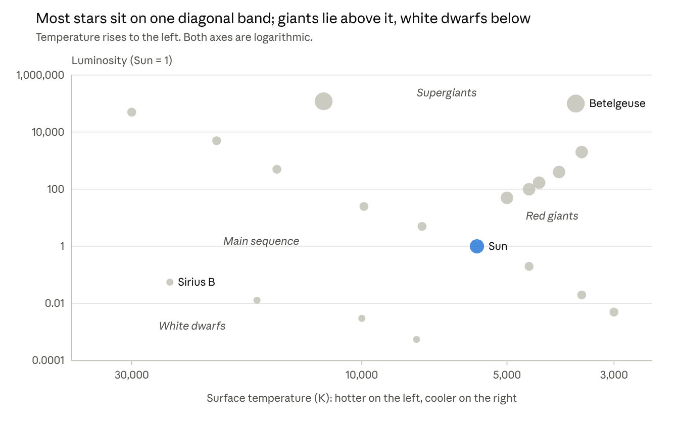
Illustrative, approximate values for well-known stars and typical spectral types
Each dot is one star, and the Sun is highlighted in blue.
Four regions are worth knowing:
- The main sequence is the broad diagonal band running from hot, bright stars at upper left to cool, dim stars at lower right. Most stars, including the Sun, are here, burning hydrogen in their cores.
- Red giants and supergiants sit at upper right. They are cool but very luminous, which means they must be enormous.
- White dwarfs sit at lower left. They are hot but faint, which means they must be tiny.
- A star's path across the diagram traces its life. A Sun-like star leaves the main sequence, climbs into the giant region, and finally drops down toward the white dwarf region as it cools.
The diagram works because it turns an abstract idea, that mass sets a star's fate, into a picture. Plot a whole star cluster and you can even read its age from the point where the main sequence turns off toward the giants.

Conclusion: The universe, written in starlight
The story of a star is governed by a few fundamental laws. Gravity gathers matter from interstellar clouds. Nuclear fusion keeps stars burning for millions or billions of years. When the fuel runs out, they become something else entirely.
Some end as white dwarfs, slowly giving off their last heat. Others explode as supernovae and leave behind neutron stars or black holes. The endings differ, but each one feeds the ongoing evolution of the universe.
It also says something about us. The Solar System formed from material that earlier stars had enriched, which ties our planet to a cosmic history that started long before Earth did.
The next time you look at the night sky, remember what you are seeing: stars at different stages of their lives. Some are being born, some are in their prime, and some sent out light that has been travelling for centuries or millennia to reach you.
Stars rise because gravity gathers matter, shine because nuclear physics releases energy, and fall when the balance holding them up can no longer be kept. Yet through their remnants and the elements they scatter, their influence continues long after their light fades.

Aniket Dinda
(Indian Association for the Cultivation of Science)

