Physics' Greatest Search: The Quest for a Theory of Everything
-Aniket
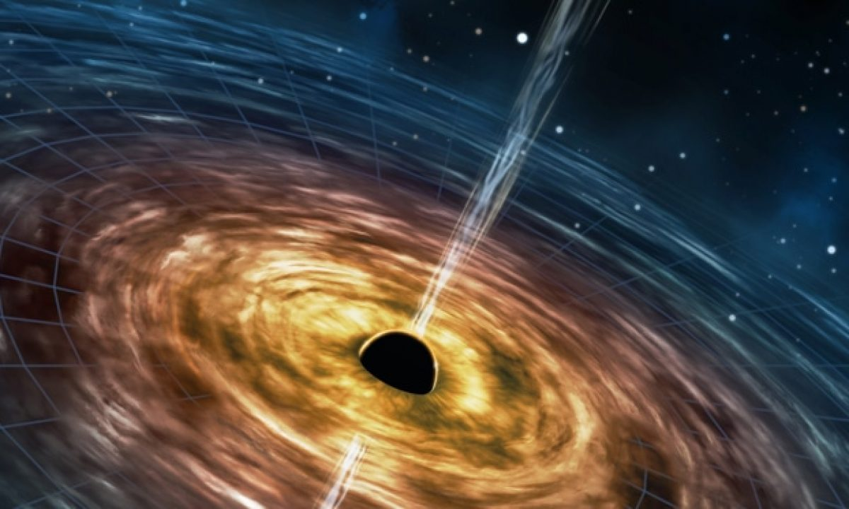
A visualization of a black hole from general relativity: “Unifying quantum mechanics with Einstein’s general relativity”-Research outreach

Introduction
"The most incomprehensible thing about the universe is that it is comprehensible."
— Albert Einstein
For thousands of years, humanity has searched for the hidden order behind nature. From the motions of the planets to the behavior of atoms, every scientific revolution has revealed that the universe is not governed by chaos, but by elegant and remarkably consistent laws. Each discovery has brought us closer to answering one of the oldest questions ever asked: What are the fundamental rules that govern reality?
Today, physics stands at a remarkable crossroads. Armed with centuries of observation and experimentation, scientists have developed two theories that together explain nearly every known phenomenon in the universe. One describes the microscopic realm of elementary particles with astonishing precision, while the other explains the evolution of stars, galaxies, black holes, and the very fabric of spacetime. Yet, despite their extraordinary success, these two pillars of modern physics refuse to fit together. In the most extreme environments in the cosmos, where immense gravity meets the quantum world, their mathematical descriptions become incompatible. It is here that modern physics reaches the edge of its understanding.
This unresolved conflict has become what many consider the greatest search in modern science: the quest to discover a deeper theory capable of unifying quantum mechanics and general relativity into a single description of nature. It is a journey that has challenged generations of physicists and may ultimately reshape our understanding of space, time, matter, and reality itself.
This divide is not merely an abstract problem confined to theoretical physics—it stands in the way of answering some of the most profound questions about our universe. What truly exists at the heart of a black hole, where gravity becomes overwhelmingly strong and quantum effects can no longer be ignored? What occurred during the first fraction of a second after the Big Bang, when the universe was compressed into an unimaginably dense state? Is spacetime itself a fundamental feature of reality, or does it emerge from something even more elementary? Could gravity, unlike the other fundamental interactions, be a manifestation of a deeper quantum phenomenon that we have yet to uncover? These questions remain unanswered not because they are beyond human curiosity, but because our two most successful theories cease to work together precisely where they are both expected to apply. If the universe itself is made up of matter then why should the physics of the constituents of matter be any different from the physics of the universe itself. It’s like the scientists are missing a puzzle piece in the entire course of clues to describe reality. Until this missing bridge is found, our understanding of the universe will remain remarkably powerful, yet fundamentally incomplete.
In the pages that follow, we will trace the remarkable journey that led to this scientific impasse—from the birth of quantum mechanics and Einstein's revolutionary conception of gravity to the modern search for quantum gravity and a unified Theory of Everything. Along the way, we will explore the leading ideas proposed by physicists, the experiments pushing the boundaries of observation, and the philosophical implications of a universe whose deepest secrets continue to elude even our most successful theories. The search is far from over, but it is precisely this unfinished quest that makes modern physics one of humanity's greatest intellectual adventures.
The two foundational pillars of physics have greatly been studied and both have progressed considerably over the past years but a bridge between the two is still yet to be fully uncovered. The theory of the two domains need to converge in order to make physics and reality itself make sense.

A brief History of the Two Paths to Understand Reality
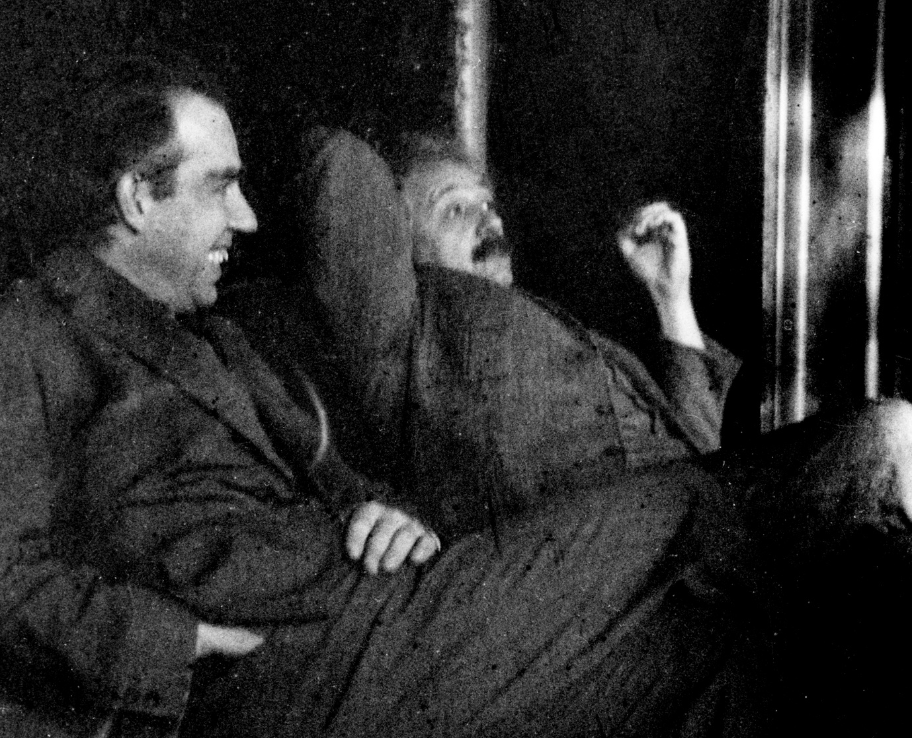
Niels Bohr (left) with Albert Einstein (right) at Paul Ehrenfest's home in Leiden (December 1925), “Bohr-Einstein debates”-Wikipedia

The story of modern physics spans more than four centuries, beginning with the Scientific Revolution of the seventeenth century. During this period, humanity's understanding of nature shifted from philosophical speculation to precise mathematical description, laying the foundations for modern science.
In 1609, Galileo Galilei turned one of the earliest astronomical telescopes toward the heavens and observed mountains on the Moon, the four largest moons of Jupiter, and the phases of Venus. These discoveries challenged centuries of Aristotelian thought and demonstrated that the universe could be understood through careful observation, experimentation, and mathematics. Galileo's investigations into falling bodies and accelerated motion established the experimental approach that remains the cornerstone of scientific inquiry.
This foundation culminated in 1687, when Sir Isaac Newton published Philosophiæ Naturalis Principia Mathematica. Newton unified terrestrial and celestial mechanics by introducing his three laws of motion and the law of universal gravitation. For the first time, the same mathematical framework explained both the falling of an apple and the orbit of the Moon. This remarkable achievement established the idea that nature obeys universal mathematical principles.
Nearly two centuries later, between 1861 and 1865, James Clerk Maxwell unified electricity and magnetism into a single theory through his four famous equations, revealing that light itself is an electromagnetic wave. Maxwell's work represented another great triumph of unification and strengthened the belief that all of nature might ultimately be explained through a single mathematical framework.
However, by the end of the nineteenth century, cracks had begun to appear in classical physics. Certain experimental observations—most notably black-body radiation—could not be explained by Newtonian mechanics or classical electromagnetism. In 1900, Max Planck proposed that energy is emitted and absorbed in discrete packets called quanta. What began as an attempt to solve a single experimental puzzle unknowingly marked the birth of quantum theory.
The year 1905, often referred to as Einstein's Annus Mirabilis or Miracle Year, transformed physics forever. In a remarkable series of papers, Albert Einstein explained the photoelectric effect using Planck's quantum hypothesis, demonstrated the existence of atoms through Brownian motion, and introduced the Special Theory of Relativity, fundamentally changing humanity's understanding of space, time, and motion.
The quantum revolution accelerated rapidly over the following decades. Niels Bohr proposed his atomic model in 1913, Louis de Broglie introduced the wave nature of matter in 1924, Werner Heisenberg formulated matrix mechanics in 1925, and Erwin Schrödinger developed wave mechanics in 1926, providing quantum mechanics with one of its most powerful mathematical foundations. Shortly afterward, Paul Dirac unified quantum mechanics with special relativity in 1928, predicting the existence of antimatter—a prediction spectacularly confirmed by the discovery of the positron in 1932.
One of the earliest signs that the foundations of modern physics were becoming philosophically divided emerged during the famous debates between Albert Einstein and Niels Bohr throughout the 1920s and 1930s, particularly at the Solvay Conferences. Einstein, despite being one of the pioneers of quantum theory through his explanation of the photoelectric effect, remained deeply uncomfortable with its probabilistic interpretation. He believed that the universe should ultimately be governed by deterministic laws, famously remarking, "God does not play dice with the universe." Bohr, however, defended the emerging Copenhagen Interpretation, arguing that probability and uncertainty were not imperfections of the theory but intrinsic features of nature itself. Their exchanges became some of the most influential scientific debates in history, with Einstein repeatedly proposing thought experiments intended to expose inconsistencies in quantum mechanics and Bohr carefully demonstrating why the theory remained self-consistent. Although experiments over the following decades consistently supported quantum mechanics, Einstein's concerns were never entirely dismissed. Many of the conceptual questions he raised—about reality, determinism, locality, and the completeness of quantum theory—continue to influence modern research, particularly in quantum information science and the ongoing search for a unified theory of physics.
While quantum mechanics was revolutionizing the microscopic world, Einstein pursued an entirely different vision of gravity. In 1915, he published the General Theory of Relativity, replacing Newton's concept of gravitational force with the revolutionary idea that gravity arises from the curvature of spacetime itself. The theory successfully explained the anomalous precession of Mercury's orbit, predicted the bending of starlight during a solar eclipse—confirmed by Arthur Eddington's expedition in 1919—and laid the theoretical foundations for black holes, gravitational lensing, the expanding universe, and gravitational waves.

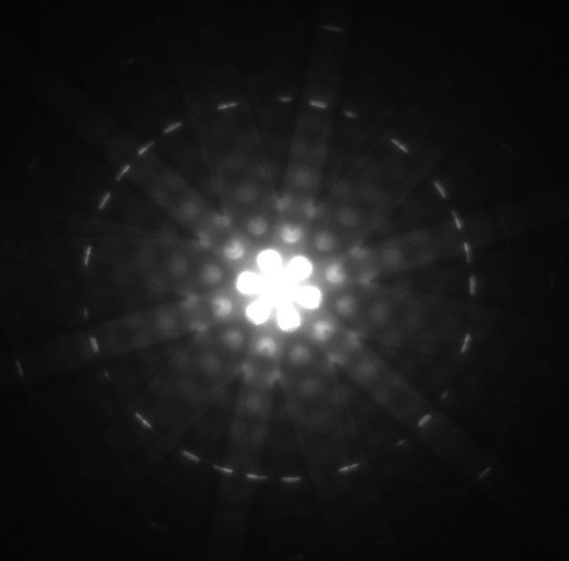
A picture of a microscopic view of a photon illuminated slit. 12.5 The Wave Nature of Matter Texas Gateway

Throughout the second half of the twentieth century, these two revolutionary theories matured independently. Quantum mechanics evolved into Quantum Field Theory, eventually giving rise to the Standard Model of Particle Physics, completed during the 1970s, which successfully describes three of the four known fundamental interactions. General relativity became the cornerstone of cosmology and astrophysics, receiving spectacular confirmation through the indirect discovery of gravitational waves in 1974 and their first direct detection by the LIGO Scientific Collaboration in 2015.
By the beginning of the twenty-first century, physics possessed two extraordinarily successful descriptions of reality. Quantum mechanics governs the microscopic world of atoms and elementary particles with astonishing precision, while general relativity explains the behavior of planets, stars, galaxies, black holes, and the evolution of the universe itself. Each theory has survived every experimental test within its own domain.

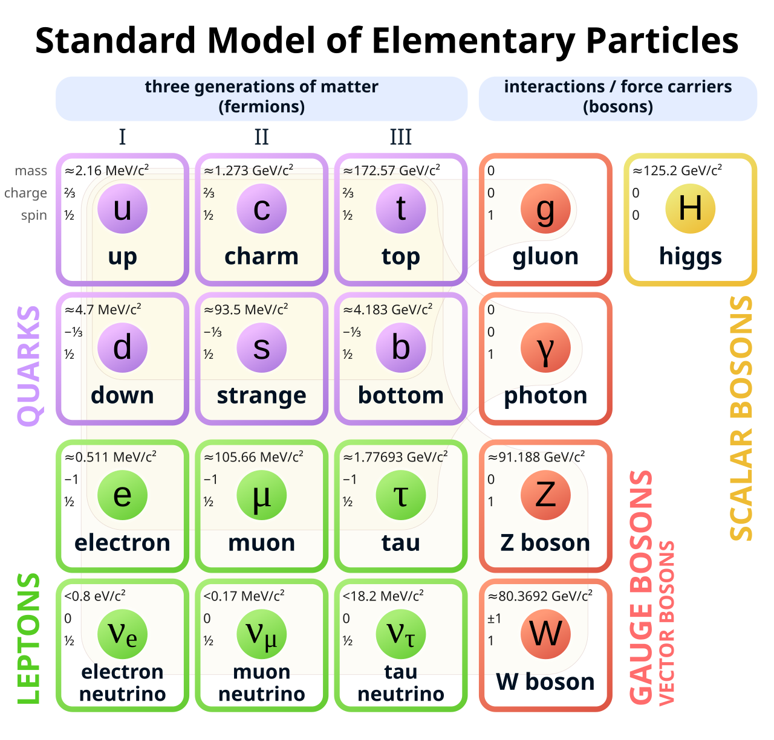
Elementary particles of the Standard Model. “Standard Model” Wikipedia

Yet beneath this remarkable success lies one of the deepest paradoxes in science. Quantum mechanics describes nature through probabilities and discrete quantum states, whereas general relativity treats spacetime as a smooth, continuous geometric structure. When physicists attempt to apply both theories simultaneously—inside black holes, during the earliest moments after the Big Bang, or at the Planck scale—the mathematical framework breaks down. The two greatest achievements in modern physics, each extraordinarily successful on its own, refuse to merge into a single coherent description of reality.
The realization that nature appears to obey two remarkably successful yet fundamentally incompatible frameworks has become the defining challenge of modern theoretical physics. Building the missing bridge between these two pillars of science is no longer merely an ambitious goal—it is the central quest toward a deeper understanding of the universe itself.

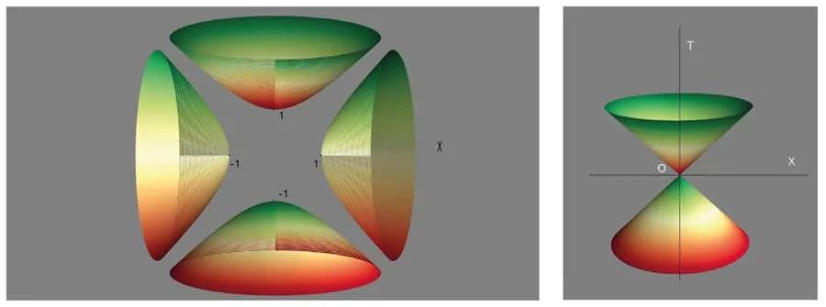
Fig. 1 (left): The quantum light-cone in a space-time diagram (time is the vertical axis). Fig. 2 (right): The known classical light-cone (future and past) of classical relativity in a space-time diagram is a special case of Fig. 1. Copyright Norma Sanchez. “Unifying quantum mechanics with Einstein’s general relativity” Research Outreach

The Great Divide
For more than a century, modern physics has rested upon two monumental achievements. General relativity describes the universe on the largest scales, explaining the motion of planets, the evolution of stars, the expansion of the universe, and the behaviour of black holes. Quantum mechanics, on the other hand, governs the microscopic world of atoms, electrons, quarks, and the fundamental forces that bind matter together. Individually, each theory has been tested to extraordinary precision and has never failed within its intended domain.
Yet these theories describe reality in profoundly different ways.
General relativity presents a universe that is smooth and continuous. Space and time are woven together into a four-dimensional fabric known as spacetime, which bends and curves in response to mass and energy. Gravity is not treated as a force acting across space, but as the very geometry of spacetime itself. Objects simply follow the natural curves created by this geometry.
Quantum mechanics paints an entirely different picture. At the smallest scales, nature is inherently probabilistic. Particles do not possess definite positions or velocities until they are measured, but are instead described by wavefunctions representing probabilities. Empty space is not truly empty but filled with incessant quantum fluctuations, where virtual particles continuously appear and disappear. The microscopic world is governed not by certainty, but by uncertainty.
Remarkably, both descriptions have been confirmed countless times through experiment. The contradiction only emerges when both theories are required to describe the same physical system.
One of the clearest examples lies at the centre of a black hole. According to general relativity, the gravitational collapse of a sufficiently massive star inevitably leads to the formation of a singularity—a point of infinite density where spacetime curvature becomes infinite. Infinite quantities are often a warning sign in physics that a theory has reached the limits of its applicability. Quantum mechanics, however, strongly suggests that such infinities should not exist in a complete physical theory. At this point, neither theory can provide a satisfactory description of reality.
A much more fundamental contradiction appears when trying to explain how the universe came into being. The cosmological picture according to the general theory of relativity suggests that the universe originated about 13.8 billion years ago from a very hot and dense stage called the Big Bang. If we push the equations of Einstein backwards to the beginning of time, then there will be another singularity point – an instant at which density, temperature and curvature of space-time go infinite. However, on such infinitesimally small scales, quantum effects play a crucial role and thus the general theory of relativity cannot be used anymore. Unfortunately, neither can quantum mechanics be applied as it requires a constant background space-time manifold, while the space-time itself is evolving dramatically.
Gravity itself presents another mystery. The Standard Model of particle physics, one of the most successful theories ever constructed, successfully describes three of the four known fundamental interactions: the electromagnetic, weak, and strong nuclear forces. Every experimentally confirmed elementary particle has found its place within this framework. Yet one force remains conspicuously absent.
Gravity.
Unlike the other three interactions, gravity has resisted every attempt to be described as a quantum field. Physicists have long hypothesized the existence of a quantum particle called the graviton, analogous to the photon that mediates electromagnetism. Despite decades of theoretical work, no experimental evidence for the graviton has ever been found, and incorporating gravity into the Standard Model leads to mathematical infinities that cannot be removed using the same techniques that successfully tame the other forces.
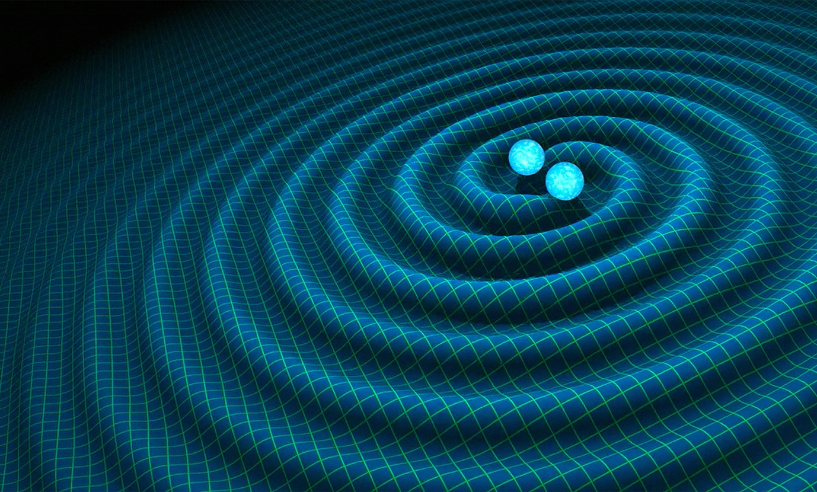
An artist’s impression of gravitational waves generated by binary neutron stars. R. Hurt/Caltech-JPL.
“Gravitational waves will bring the extreme universe into view”- Aeon

This failure is not merely an inconvenience—it is unprecedented in the history of modern physics. Previous revolutions, such as Maxwell's unification of electricity and magnetism or Einstein's extension of Newtonian gravity, expanded existing theories without rendering them fundamentally incompatible. The divide between quantum mechanics and general relativity is different. These theories are not simply incomplete; they are built upon incompatible mathematical foundations. One assumes a smooth, dynamic spacetime, while the other requires a fixed quantum framework upon which probabilities evolve.
Perhaps the most unsettling realization is not that we lack answers, but that we know exactly where our understanding ends. We can predict the collision of black holes billions of light-years away, manipulate individual atoms in quantum computers, and measure gravitational waves smaller than the diameter of a proton. Yet when we ask seemingly simple questions—
What truly exists at the centre of a black hole? What happened during the first instant of the universe? Is spacetime itself made of something more fundamental?—our greatest theories fall silent.
It is here, at the boundary between the infinitely small and the unimaginably large, that physics encounters its greatest mystery. The missing bridge is not merely another scientific problem waiting to be solved. It is the point at which humanity's deepest understanding of reality comes to an abrupt and undeniable end.

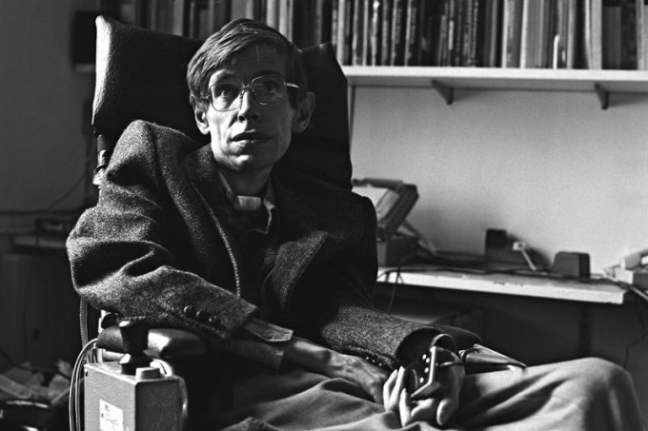
Stephen Hawking (Photograph: Gemma Levine)

A Trail of Hope
If there is one name that has become synonymous with humanity's search for a unified understanding of the universe, it is Stephen Hawking. Despite living much of his life with amyotrophic lateral sclerosis (ALS), Hawking transformed some of the most abstract questions in theoretical physics into one of the greatest scientific quests of the modern era. His work did not merely seek to explain black holes or the origins of the universe; it sought to answer a far deeper question:
Can the laws governing the infinitely small and the unimaginably large be united into a single, coherent description of reality?
In his entire career, one thing that was common with Hawking was his interest in studying the places at which quantum mechanics and general relativity meet. What initially seemed like a straightforward result of gravitational collapse in black holes later became his laboratory for this purpose. As per Einstein's General Theory of Relativity, nothing - neither light nor any other object can come out from inside a black hole's event horizon. However, according to quantum mechanics, there is another side to the phenomenon. In 1974, Hawking came up with what has been considered to be one of the most outstanding discoveries of modern physics in the past 150 years. He discovered that black holes are not completely black.
This discovery fundamentally changed our understanding of black holes. They were no longer purely gravitational objects described only by Einstein's equations. Instead, they obeyed the laws of quantum mechanics and, remarkably, the laws of thermodynamics. Hawking's work built upon the pioneering ideas of Jacob Bekenstein, who had proposed that black holes possess entropy proportional to the area of their event horizons. Together, these discoveries revealed a profound and unexpected connection between gravity, quantum theory, and thermodynamics—three branches of physics that had previously appeared almost entirely unrelated.

$T_{H}=\frac{ℏc^{3}}{8πGMk_{B}}$ ( Hawking Temperature )
$S=\frac{k_{B}Ac^{3}}{4Gℏ}$ (Bekenstein-Hawking Entropy)

Among these connections, the Second Law of Thermodynamics assumed a particularly significant role. The law states that the total entropy, or disorder, of an isolated system can never decrease over time. Hawking regarded this principle as one of the deepest and most universal laws in nature. His work demonstrated that even black holes, once believed to destroy all information, must obey a generalized version of the Second Law, in which the entropy of ordinary matter and the entropy associated with black holes together never decrease. This realization suggested that thermodynamics is not merely a theory describing heat and energy, but may reflect something profoundly fundamental about the structure of the universe itself.
$\frac{dS}{dt}≥0$ (Second law of Thermodynamics)
All this lead ultimately to one of the world's most famous unresolved puzzles of theoretical physics – the Black Hole Information Paradox: What happens to all the information of everything that ever fell into a black hole, once it slowly evaporates via the mechanism known as Hawking radiation? It cannot be annihilated, as quantum mechanics asserts. At the same time it appears to vanish, as general relativity dictates. It has become one of the biggest motivators for a quantum theory of gravity.
Most of modern ideas - from the holographic principle to current efforts in quantum information theory – actually arose directly from trying to understand this riddle. Although the Theory of Everything that he had set out to formulate never materialized, he nonetheless mapped the territory it must occupy. Instead of giving us the missing bridge, Hawking showed us exactly where it had to be built.
For him, the black hole was not a cosmic oddity. It was a nexus where quantum physics, gravity, thermodynamics, and information theory came together. Most researchers believe that the first truly undeniable traces of a successful unified theory will come from the study of these mind-boggling celestial objects. That pursuit is ongoing today via ever more sophisticated theories, including string theory, loop quantum gravity, holographic duality, and emergent spacetime. New experiments-from telescopes detecting the faint ripples of spacetime from merging black holes, to machines accelerating particles close to the speed of light, to tests of quantum entanglement at ever higher scales-are probing the very fabric of reality.
Each observation brings a solution closer by the narrowing down the possibilities, the search for that elusive missing link continuing century after century. And it is with good reason, Hawking remained hopeful over the years; he wrote the search for a complete theory would be "the ultimate triumph of human reason.” Almost six decades since his seminal work on black holes, the dream remains elusive. Yet over history, when we look closely, almost every great mystery in physics has eventually succeded the quest of humanity to understand the cosmos deeply by our persistence, our imagination, and our curiosity.
The infinite scale of the universe still holds back several clues that bring us closer to the evidence of reality veiled through quantum mechanics and relativity. We have uncovered several theories to explain the corellation between the two fields but have lacked a proper evidence supporting our claims. Perhaps the greatest secret of the rules of nature are being gate keeped not by the diversety and depths of the domains but rather by the bridges between them exposing the simple yet elegant rules of the universe.

“What we are looking for is how everything works” -Richard Feynman
The search continues
For centuries, every great breakthrough in physics has revealed that the universe is far stranger—and far more elegant—than humanity once imagined. From Newton's laws that united the heavens and the Earth, to Einstein's curved spacetime and the bewildering probabilities of quantum mechanics, each discovery has peeled back another layer of reality. Yet with every answer came a deeper question, and today we stand before perhaps the greatest of them all: why do our two most successful theories refuse to become one?

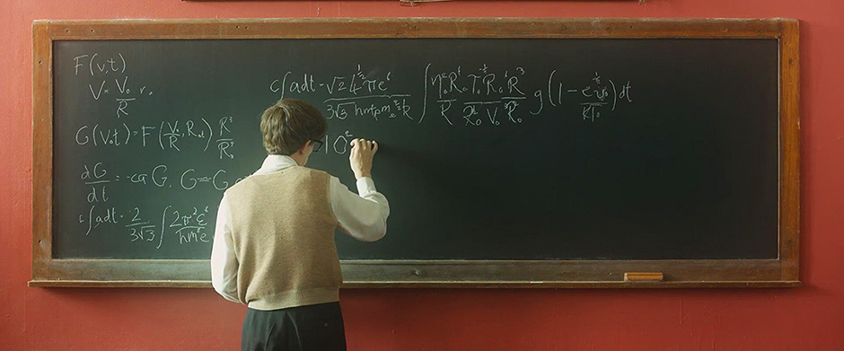
A still from the movie “The Theory of Everything” a biopic drama celebrating the life of Stephen Hawking.

The search for a Theory of Everything is not merely the pursuit of a final equation. It is a reflection of humanity's enduring desire to understand its place in a universe that continues to challenge every assumption we make about space, time, matter, and existence itself. Whether the missing bridge lies within strings, quantum geometry, holography, or an idea yet to be imagined, its discovery would mark one of the greatest intellectual triumphs in human history.
But perhaps the most humbling realization is this: the universe has already written its laws. It is only we who have yet to learn how to read them. Somewhere, hidden beyond the limits of our current understanding, reality remains patiently waiting—not to be invented, but to be discovered. Until then, physics' greatest search continues, reminding us that the deepest mystery of the cosmos may not be what we do not know, but how much still remains beyond the reach of everything we think we understand.

"Remember to look up at the stars and not down at your feet. Try to make sense of what you see, and wonder about what makes the universe exist. Be curious."
— Stephen Hawking

Author:
Aniket Dinda
( The Indian Association for the Cultivation of Sciences (IACS) )

References:
Books
- Hawking, S. W. (1988). A Brief History of Time. Bantam Books.
- Hawking, S. W. (2002). The Theory of Everything. Phoenix Books.
- Greene, B. (1999). The Elegant Universe. W. W. Norton & Company.
- Penrose, R. (2004). The Road to Reality. Jonathan Cape.
- Smolin, L. (2001). Three Roads to Quantum Gravity. Basic Books.
- Kiefer, C. (2012). Quantum Gravity (3rd ed.). Oxford University Press.
- Misner, C. W., Thorne, K. S., & Wheeler, J. A. (1973). Gravitation. W. H. Freeman.
- Griffiths, D. J., & Schroeter, D. F. (2018). Introduction to Quantum Mechanics (3rd ed.). Cambridge University Press.
- Schutz, B. (2009). A First Course in General Relativity (2nd ed.). Cambridge University Press.
- Weinberg, S. (1995). The Quantum Theory of Fields. Cambridge University Press.

Research Papers
- Einstein, A. (1905). On the Electrodynamics of Moving Bodies.
- Einstein, A. (1915). The Field Equations of Gravitation.
- Planck, M. (1901). On the Law of Distribution of Energy in the Normal Spectrum.
- Hawking, S. W. (1975). Particle Creation by Black Holes. Communications in Mathematical Physics.
- Bekenstein, J. D. (1973). Black Holes and Entropy. Physical Review D.
- Maldacena, J. (1999). The Large N Limit of Superconformal Field Theories and Supergravity.
- Rovelli, C. (1998). Loop Quantum Gravity. Living Reviews in Relativity.
- Carlip, S. (2001). Quantum Gravity: A Progress Report.

Websites and Articles
- Research Outreach – "Unifying Quantum Mechanics with Einstein's General Relativity"
https://researchoutreach.org/articles/unifying-quantum-mechanics-einsteins-general-relativity/
- Wikipedia – "Bohr–Einstein Debates"
https://en.wikipedia.org/wiki/Bohr%E2%80%93Einstein_debates
- Texas Gateway – "12.5 The Wave Nature of Matter"
https://www.texasgateway.org/
- Wikipedia – "Standard Model"
https://en.wikipedia.org/wiki/Standard_Model
- Aeon – "Gravitational Waves Will Bring the Extreme Universe into View"
https://aeon.co/
- CERN
https://home.cern/
- NASA Science
https://science.nasa.gov/
- ESA (European Space Agency)
https://www.esa.int/
- LIGO Scientific Collaboration
https://www.ligo.org/
- Event Horizon Telescope Collaboration
https://eventhorizontelescope.org/
- Perimeter Institute for Theoretical Physics
https://perimeterinstitute.ca/
- Kavli Institute for Theoretical Physics
https://www.kitp.ucsb.edu/

Background Reading
- Wikipedia – General Relativity
- Wikipedia – Quantum Mechanics
- Wikipedia – Quantum Field Theory
- Wikipedia – Theory of Everything
- Wikipedia – Hawking Radiation
- Wikipedia – Black Hole Information Paradox
- Wikipedia – Bekenstein–Hawking Entropy
- Wikipedia – Holographic Principle
- Wikipedia – Loop Quantum Gravity
- Wikipedia – String Theory
- Wikipedia – Planck Length
- Wikipedia – Gravitational Waves
- Wikipedia – Standard Model
- Wikipedia – Hawking Radiation
- Wikipedia – Event Horizon
- Wikipedia – Schwarzschild Black Hole
- Wikipedia – Special Relativity
- Wikipedia – Maxwell's Equations
- Wikipedia – Dirac Equation
- Wikipedia – Schrödinger Equation

Documentary and Film References
- The Theory of Everything (2014), directed by James Marsh.
- A Brief History of Time (1991), documentary directed by Errol Morris.
- Into the Universe with Stephen Hawking (2010).
- The Universe (History Channel Documentary Series).
- Cosmos: A Spacetime Odyssey (2014), presented by Neil deGrasse Tyson.
Image Credits
- Research Outreach – "Unifying Quantum Mechanics with Einstein's General Relativity"
- Wikipedia Commons (Einstein, Bohr, Heisenberg, Galileo, Newton, Maxwell, Planck, Dirac, Hawking)
- LIGO Scientific Collaboration
- Event Horizon Telescope Collaboration
- Perimeter Institute for Theoretical Physics
- Aeon Magazine
- Texas Gateway
- Wikimedia Commons

Acknowledgements
This article draws upon the pioneering contributions of Galileo Galilei, Sir Isaac Newton, James Clerk Maxwell, Max Planck, Albert Einstein, Niels Bohr, Werner Heisenberg, Erwin Schrödinger, Paul Dirac, Jacob Bekenstein, Stephen Hawking, Roger Penrose, Brian Greene, Carlo Rovelli, Juan Maldacena, Lee Smolin, and countless physicists whose work continues to advance humanity's understanding of the universe.

