# 

Name : Muralikarthick.S.S



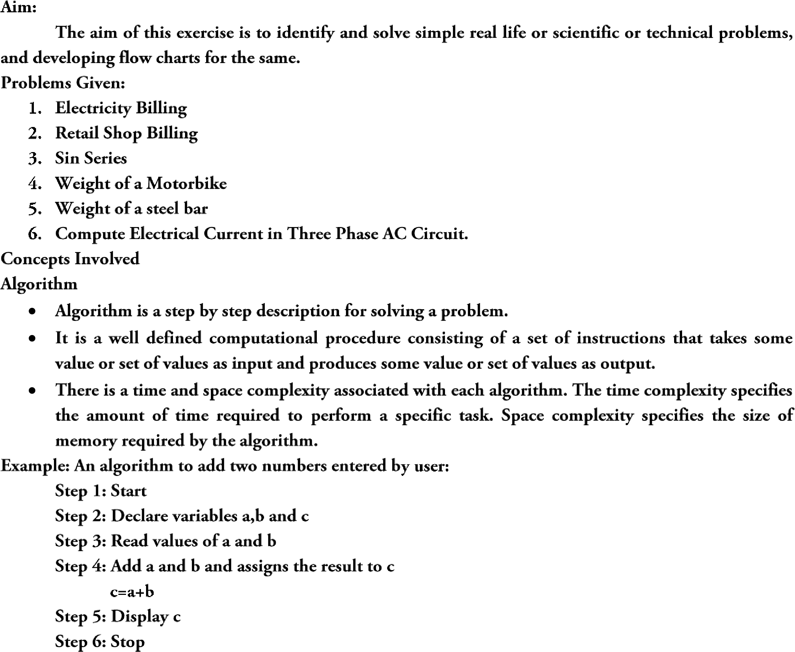



•

Name : Muralikathick.S.S

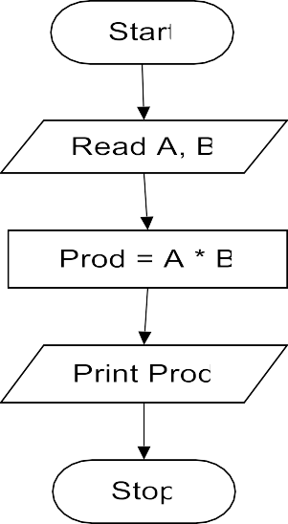





















# Name:Muralikarthick.S.S















































# Name:Muralikarthick.S.S









•



•

•





























# Name:Muralikarthick.S.S

























# Name:Muralikarthick.S.S

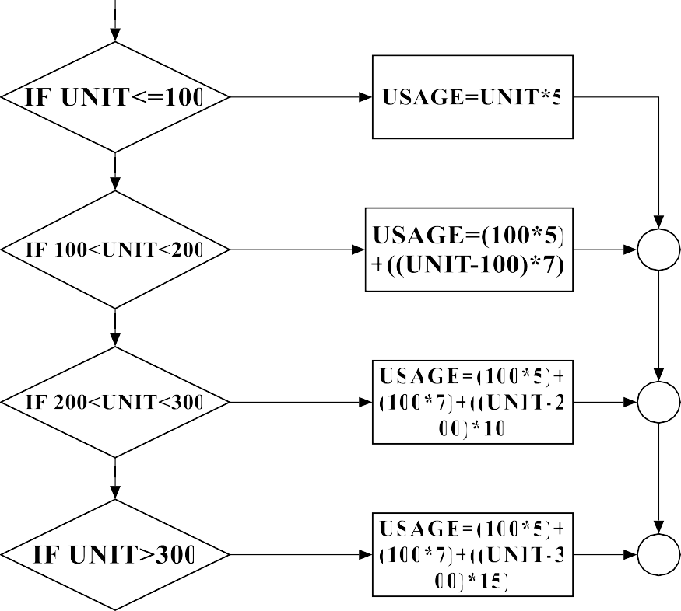

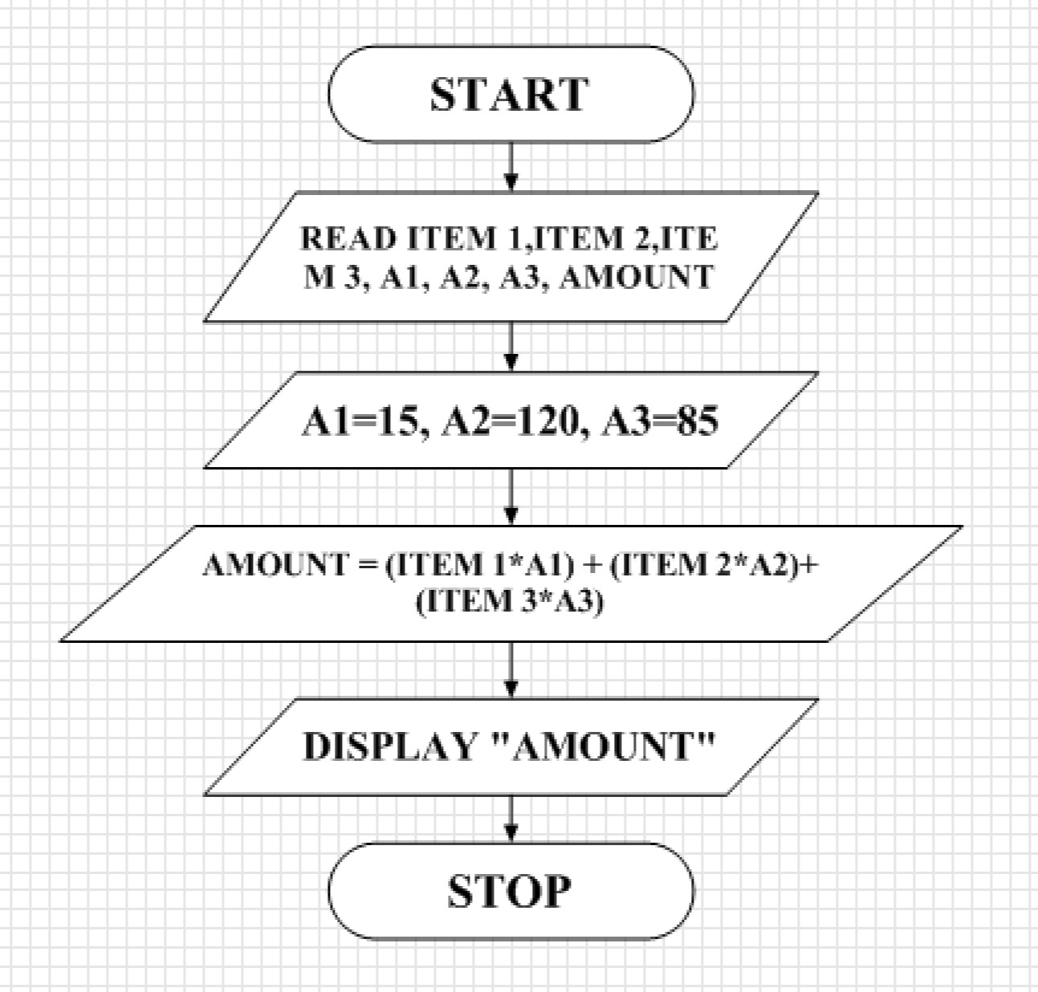



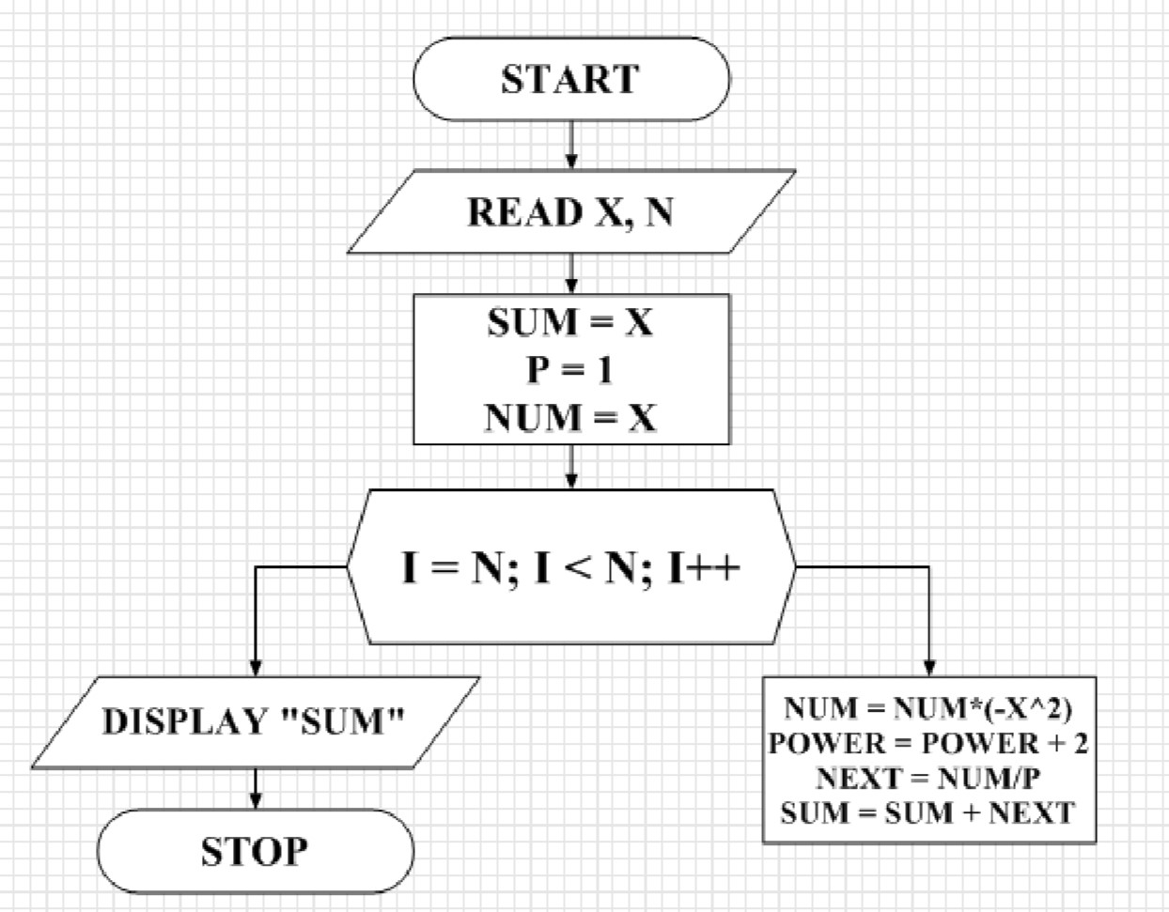



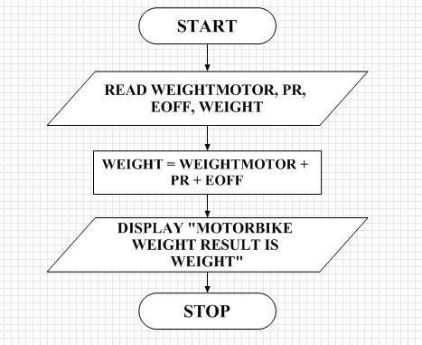



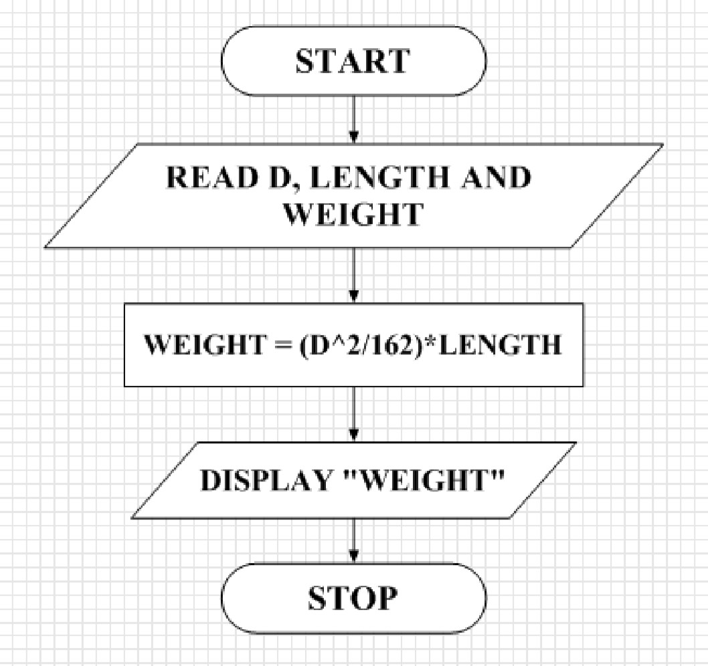



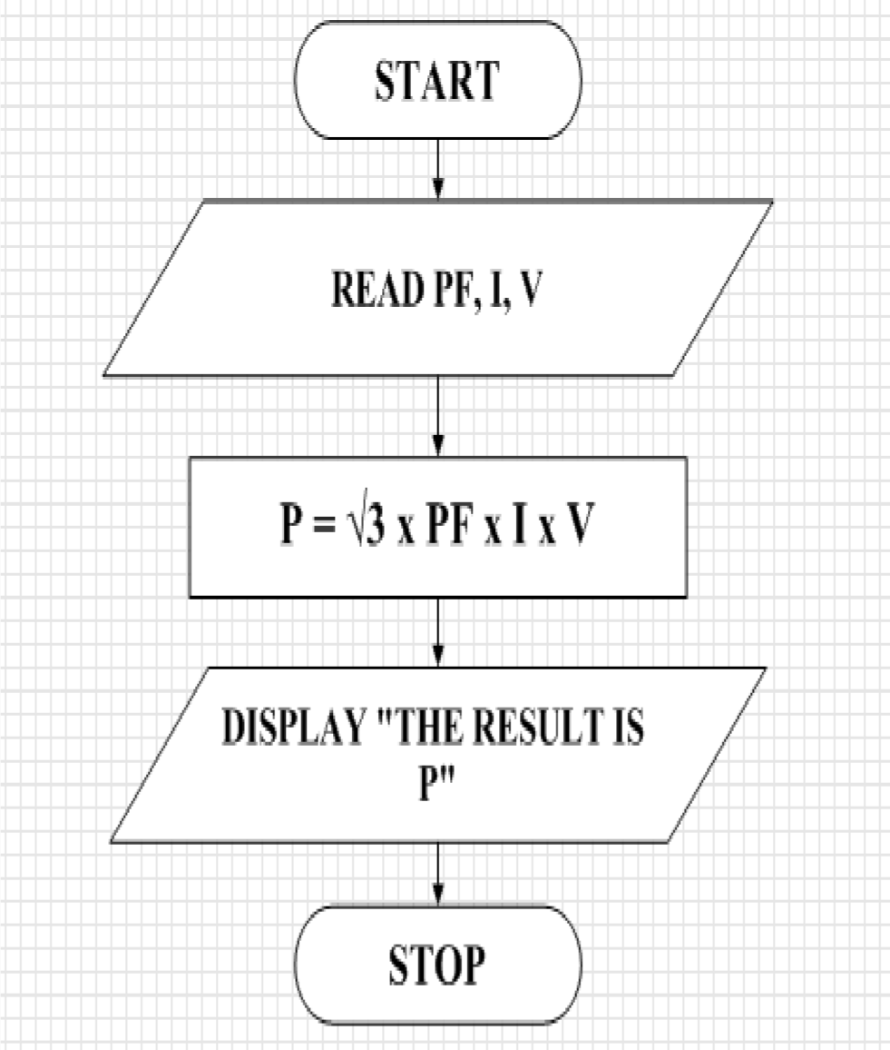

Name: MURALIKARTHICK.S.S

