If you want to enable profile editing on your application, you use a **profile editing** policy. This policy describes the experiences that customers will go through during profile editing and the contents of tokens that the application will receive on successful completion.

[!INCLUDE [active-directory-b2c-portal-navigate-b2c-service](vscode-resource://c:/Users/mimart/azure-docs-pr/includes/active-directory-b2c-portal-navigate-b2c-service.md)]

Under **Manage**, select **User flows** and click **+ New user flow**.

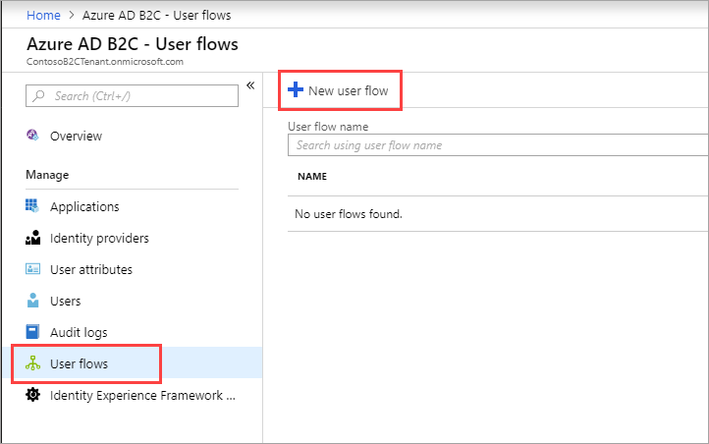

On the **Recommended** tab, select **Profile editing**.

Enter a policy **Name** for your application to reference. For example, enter SiPe.

Under **Identity providers**,  check **Local Account Signin**. Optionally, you can also select social identity providers, if already configured.

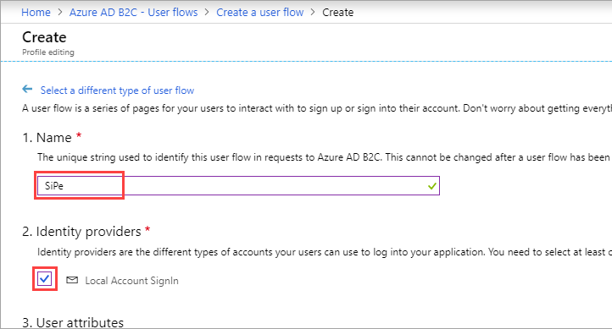

Under **User attributes**, click **show more**. In the **Collect** attribute column, choose attributes the consumer can view and edit in their profile. For example, check **Country/Region**, **Display Name**, and **Postal Code**.

In the **Return claim** column, choose claims you want returned in the authorization tokens sent back to your application after a successful profile editing experience. For example, select **Display Name**, **Postal Code**. Click **OK**.

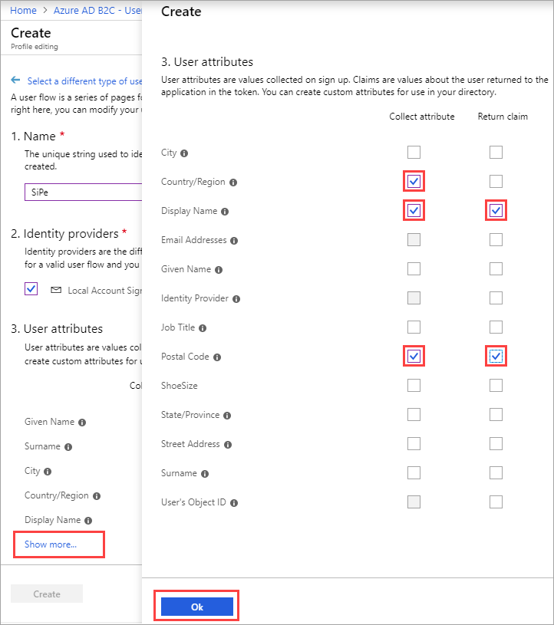

Click **Create** to add the user flow. The user flow is listed as **B2C_1_SiPe**. The **B2C_1_** prefix is appended to the name.

Open the user flow by selecting **B2C_1_SiPe**. Verify the settings specified in the table then click **Run user flow**.

| **Setting** | **Value** |
| --- | --- |
| **Applications** | Contoso B2C app |
| **Reply url** | https://localhost:44316/ |

A new browser tab opens, and you can verify the profile editing consumer experience as configured.

[!NOTE] It takes up to a minute for policy creation and updates to take effect.