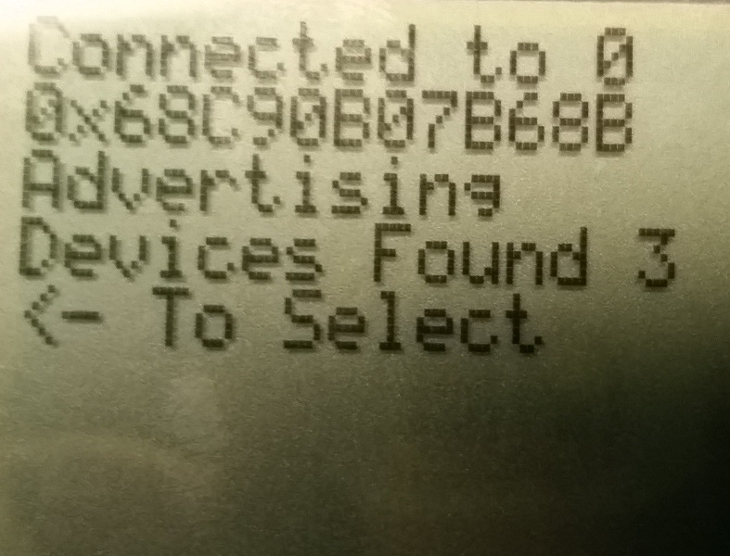

More Activity Info

Current Activity Info

Advertising Status

Connection Info

MultiRole Address

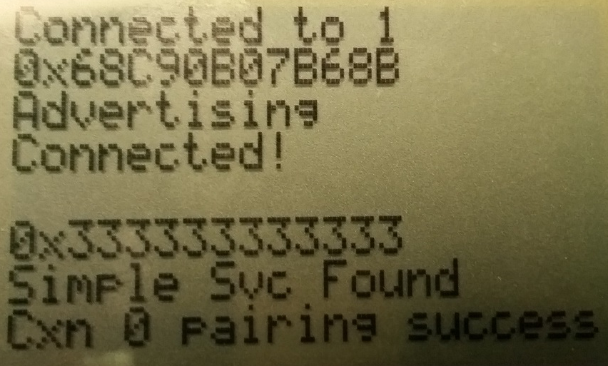

Security Status

Service Discovery Status

Connected Device Address

Current Activity Info

Advertising Status

MultiRole Address

Connection Info

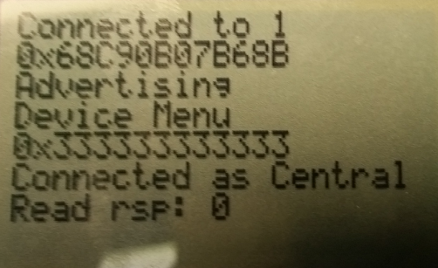

Action Info

Connection Role

Device to Perform Action On

Active Menu

Advertising Status

MultiRole Address

Connection Info