**Mini Project**

**Student Name: Amit Kumar Thakur UID: 23MCA20079**

**Branch: UIC Section/Group: 23MCA6/B**

**Semester: 3rd Date of Performance: 26/10/2024**

**Subject Name: Business Analytics Subject Code: 23CAH-701**

1. **Title of the project: Analysis of data of a shop and make a report.**
2. **Task to be done:** In this experiment I have taken the data of a shop that sells it’s products on online platforms. And I have to analyze the data of that shop and make a report basis on important things and give analysis to the shop owner so that he can take business driven decisions.
3. **Tools used: MS Excel**
4. **Steps/Commands involved to perform practical:**

**Step 1:** Open your dataset in the excel.

**Step 2:** Understand is the need of the customer or user. And perform analysis on the basis of customer need. Like in this case Shap owner want to make business driven decisions so for that I have to analyse the data on the basis of following questions:

Compare the sales and order using single chart?

Which month got the highest sales and orders?

Who purchased more- Men or Women?

List top 5states contributing to sales?

Which channel is contributing to maximum sales?

**Step 3:** Clean the data in there is inconsistent data is present. So the result will be crystal clear**.**

**Step 4:** Make pivot charts and create pivot chart on the basis of customer needs.

**Step 5:** Create a dashboard using the pivot charts that we have make.

**Step 6:** Add slicers and make report connection of every slicers to every pivot table that you have created so that you can get information of every single things.

1. **Results/Screenshot:**

**Dataset:**

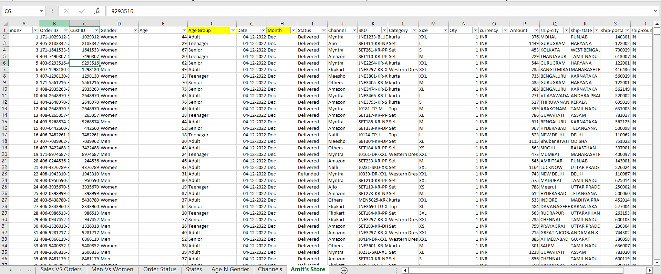

**1st pivot table:**

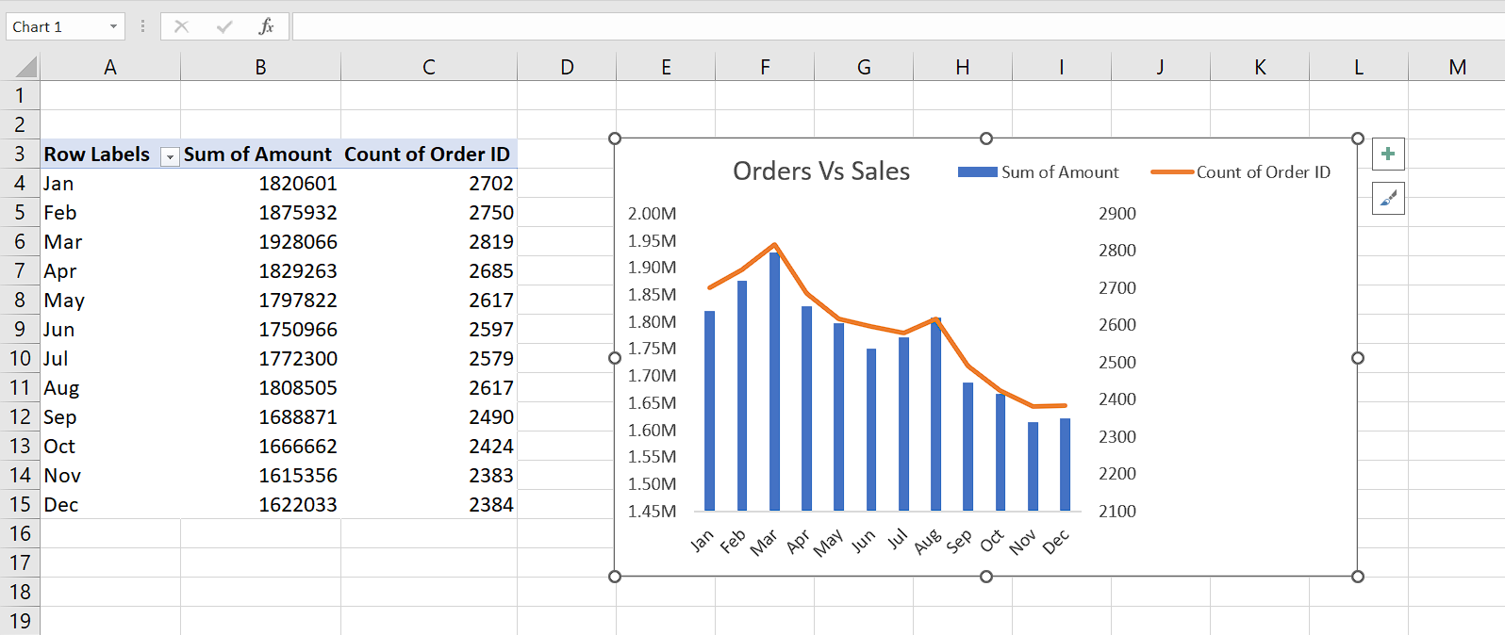

**2nd pivot table:**

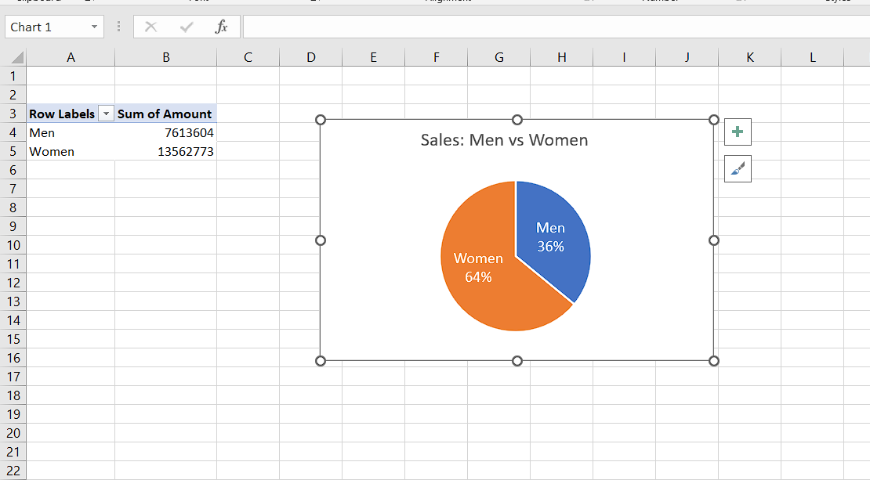

**3rd pivot table:**

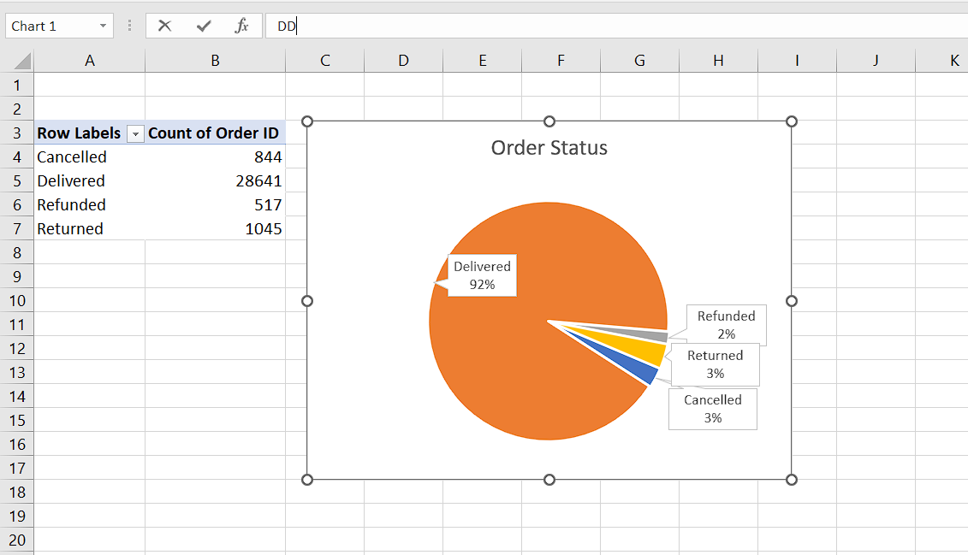

**4th pivot table:**

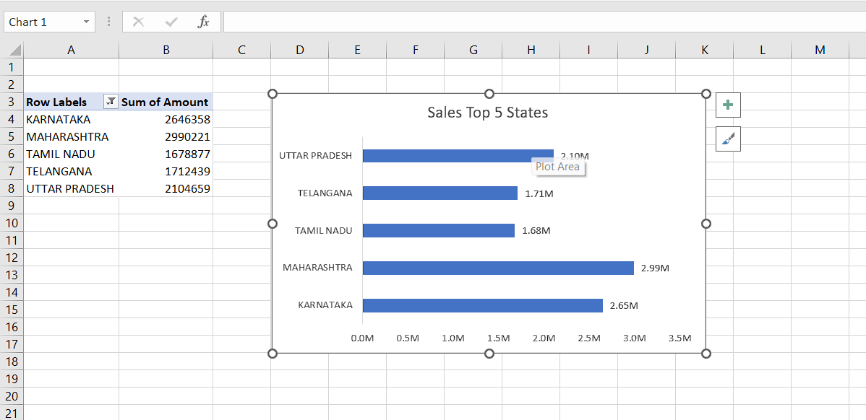

**5th pivot table:**

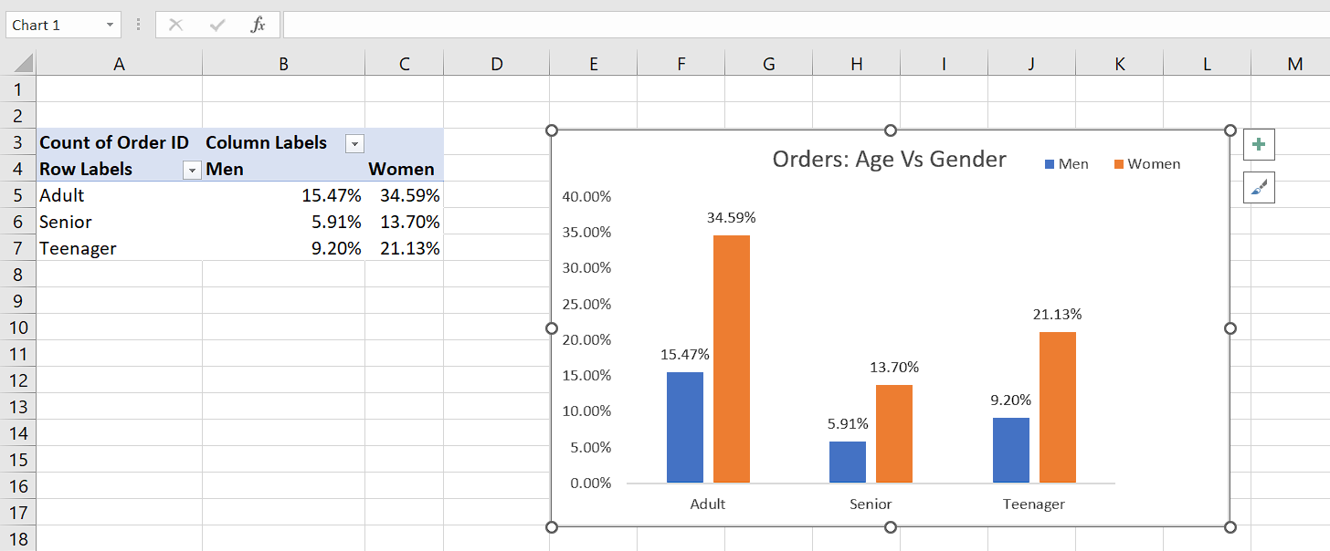

**6th picot table:**

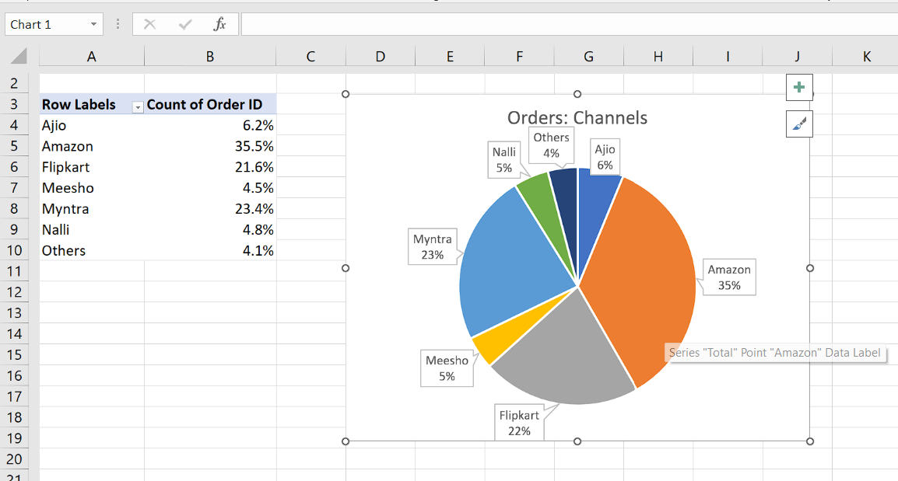

**Report/Dashboard:**

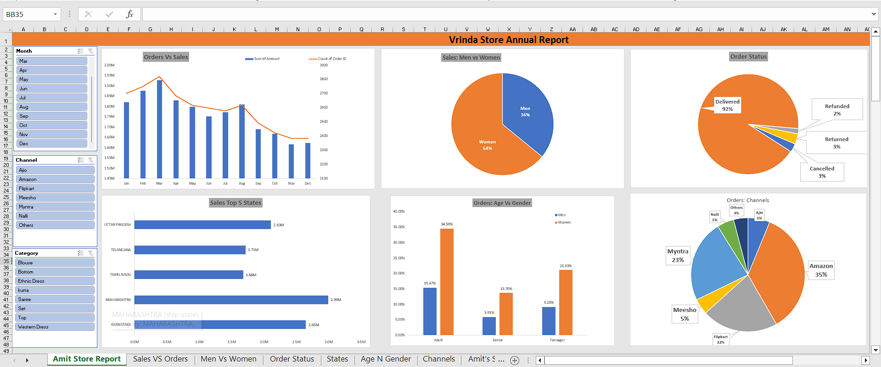

**Insights gain from the data after analysis:**

* Women are more likely to buy as compared to men.
* Karnataka, Maharashtra and Tamil-Nadu are the top 3 states.
* Adult age group is max contributing.
* Amazon, Flipkart and Myntra channels are max contributing.

**Report to the shop Owner:**

* Target women customers of age group(30-49) living in the states Karnataka, Maharashtra and Tamil-Nadu by showing ads, offers and coupons available on Amazon, Flipkart and Myntra.

**Learning outcomes (What I have learnt):**

**1. I have learned how to clean the data.**

**2. I have learned how to perform analysis on data and gain valuable insights.**

**3. I have learned how to take business driven decisions based on the insights after data analysis.**