## MINI PROJECT REPORT

### 

### Submitted by

Amit K. Thakur (23MCA20079)

***in partial fulfillment for the award of the degree of***

# Masters of Computer Application

**IN**

Computer Science



## Chandigarh University

Nov 2024

**Mini Project**

**Student Name: Amit Kumar Thakur UID: 23MCA20079**

**Branch: UIC Section/Group: 23MCA6/B**

**Semester: 4th  Date of Performance: 14/04/2025**

**Subject Name: Web Analytics Subject Code: 23CAH-751**

1. **Title of the project: Portfolio Website**
2. **Task to be done:** In this experiment, I have created a portfolio website to showcase my personal information, skills, and projects. I have also integrated Google Ads into the website to explore monetization options and understand how online advertisements work.
3. **Tools used: Google ads, Blogger.com**
4. **Steps/Commands involved to perform practical:**

**Step 1:** Open your Vs code/blogger.com

**Step 2:** Write code for the site if you are using Vs code. Or if you are using blogger.com to make your website than you can choose themes based on how your site should look. And then you can add different posts based on you website .

**Step 3:** Add different posts. In posts you can provide backlink also.

**Step 4:** Before publish a post to the website make sure that you have take a preview of that post. So you will get to know how that post looks on website. If there is any mistake than you can solve that.

**Step 5:** After preview you can publish your post.

**Step 6:** Now you can integrate your site to google adds for monetization.

**Step 7:** To integrate you have to make a account on goolge adds. And then make a campaign according to your need. Click on create campaign and then new campaign.

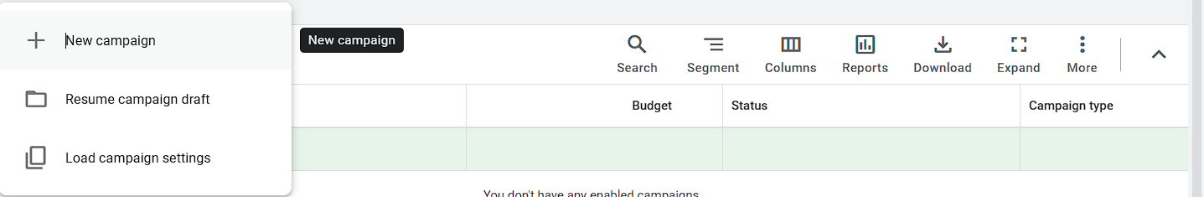

**Step 8: Choose your objective**

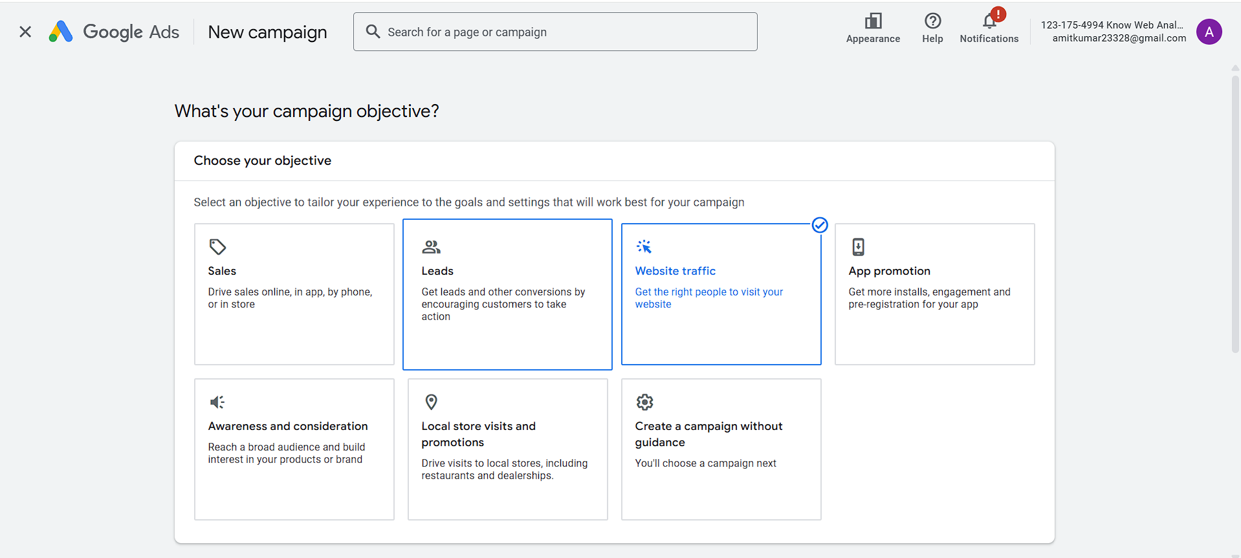

**Step 9:Select a campaign type**

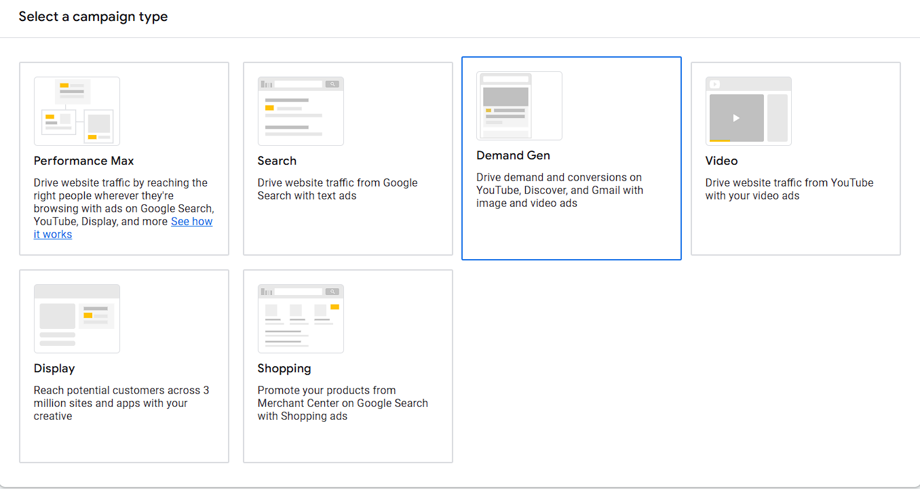

**Step 10: Give your campaign a name.**

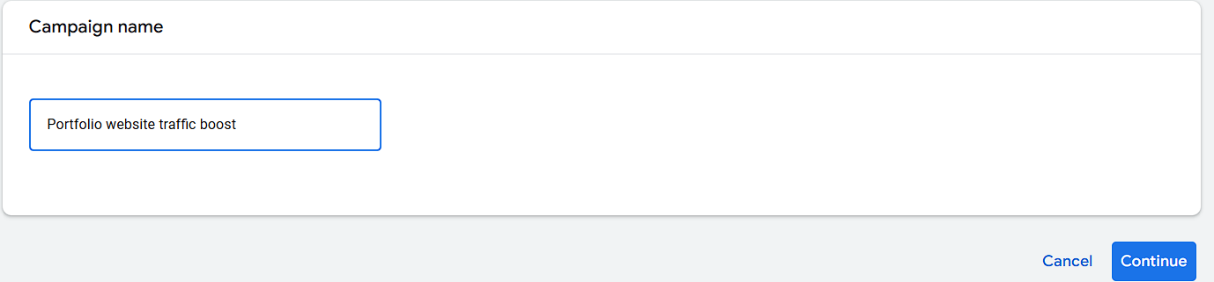

**Step 11: Add bidding and network and locations for your campaign.  
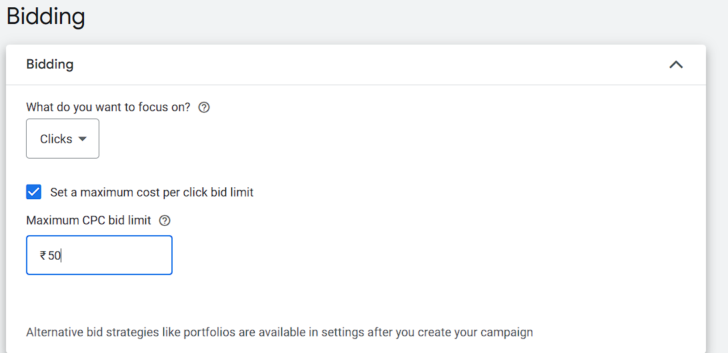**

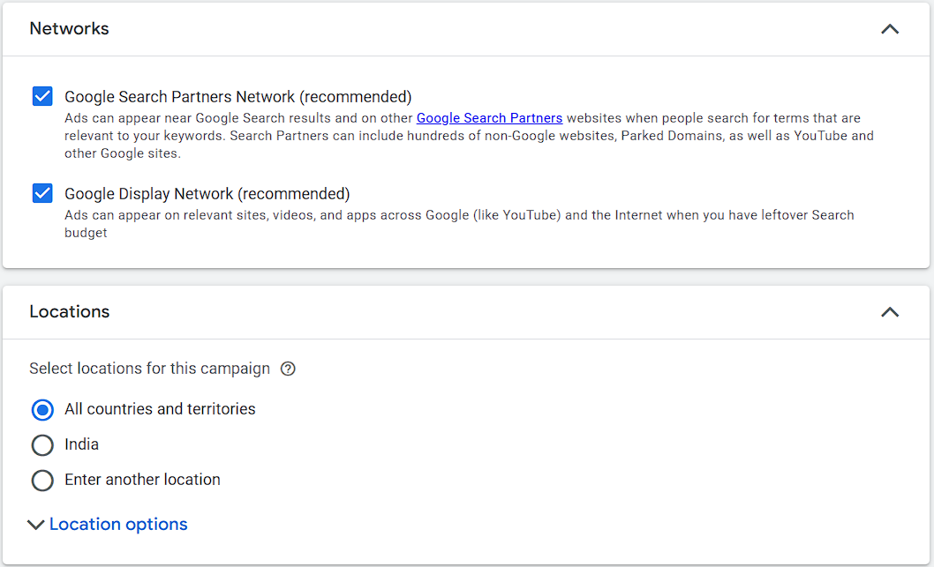

**Step 12: Provide link to you website.**

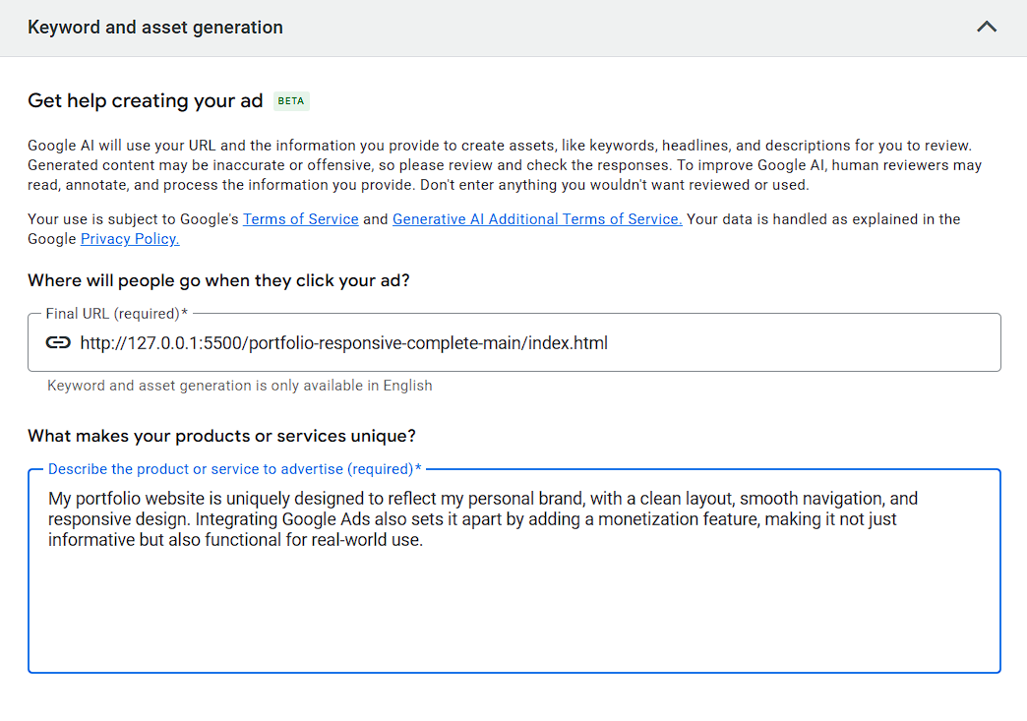

**Step 13: Enter keywords and generate sitelinks and also preview your adds.  
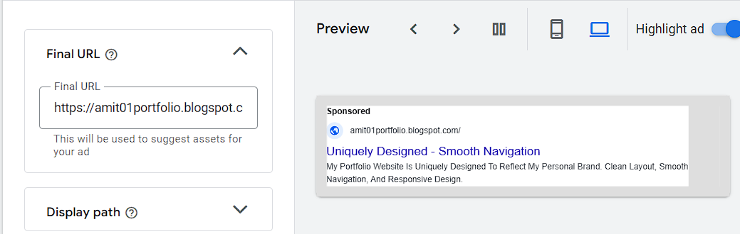**

**Step 14:Set budget**

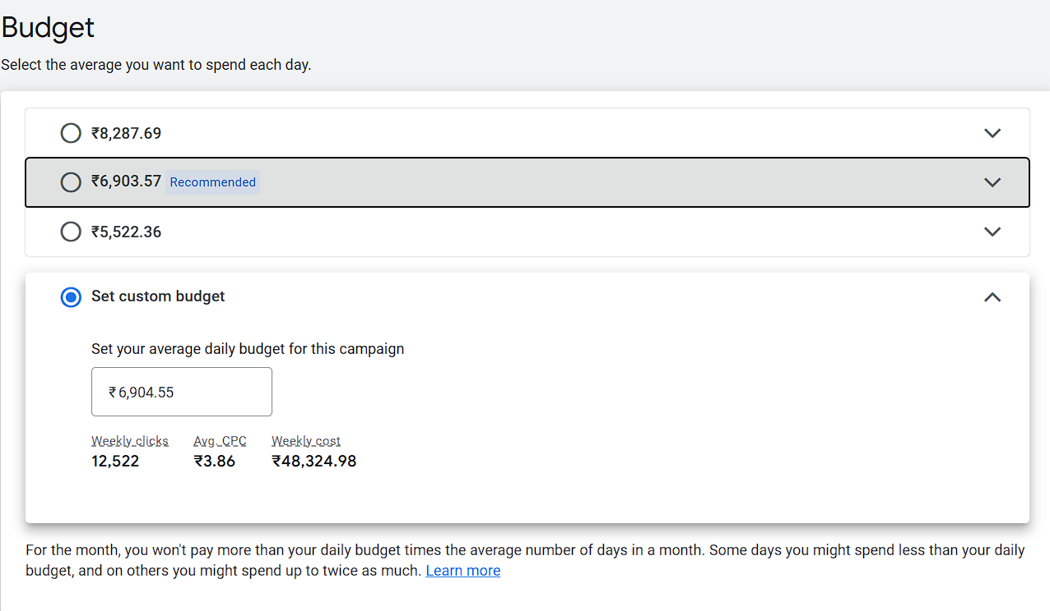

**Step 15:Preview your campaign and publish**

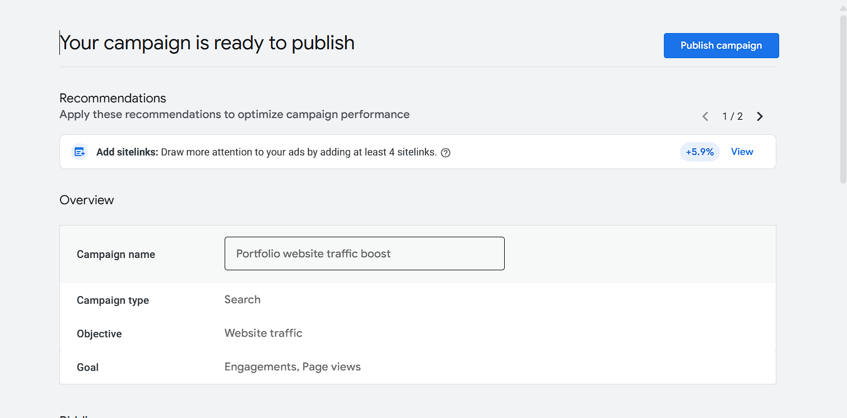

**Now the campaign is successfully created.  
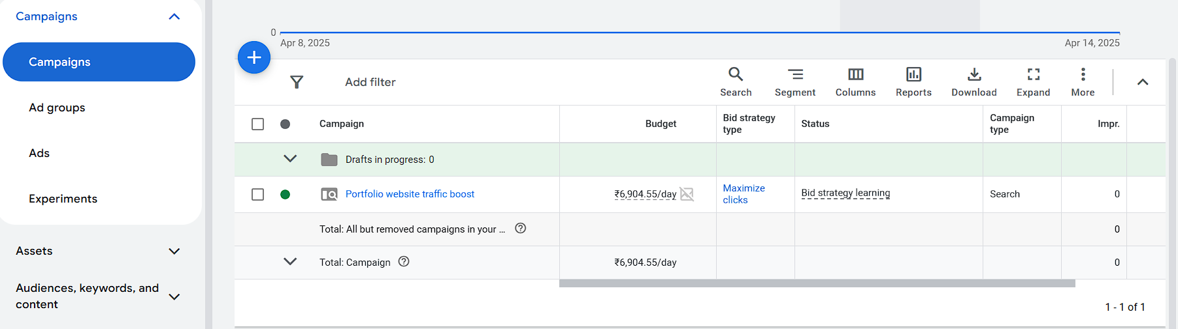**

1. **Results/Screenshot:**

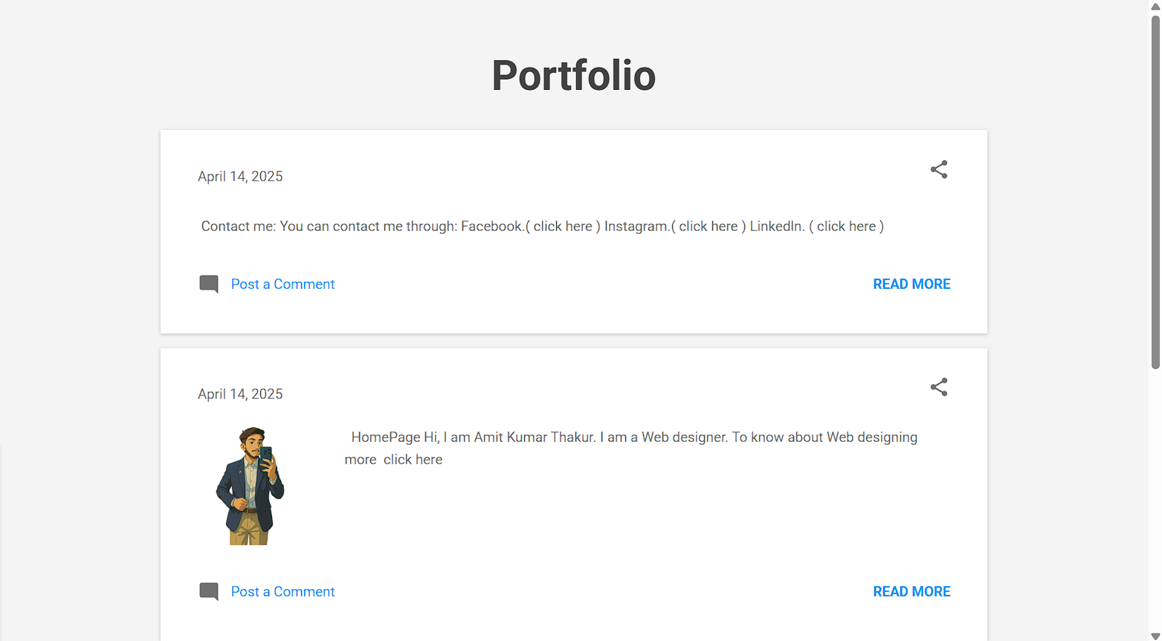

**Online Platform:**

**Link to Github File:** [**https://github.com/001Amit/Web-Analytics**](https://github.com/001Amit/Web-Analytics)

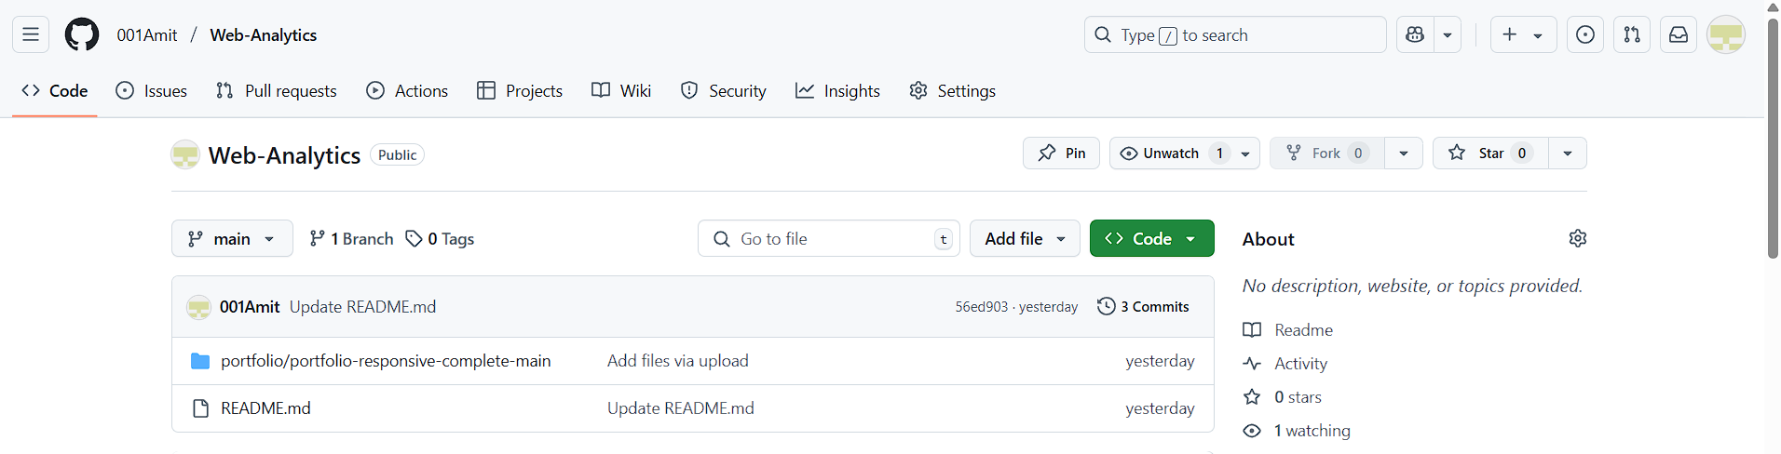

**Readme File:**

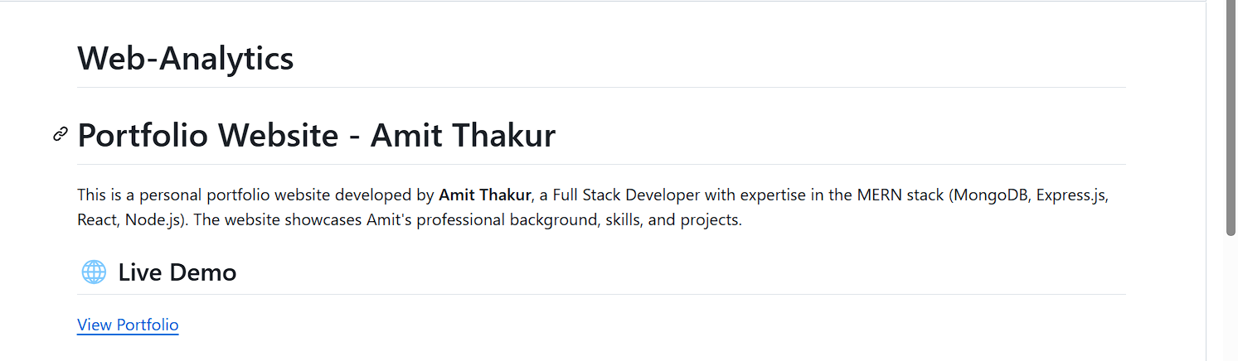 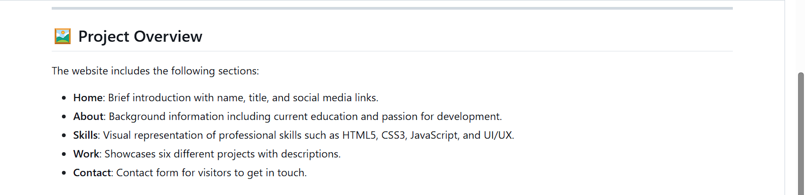 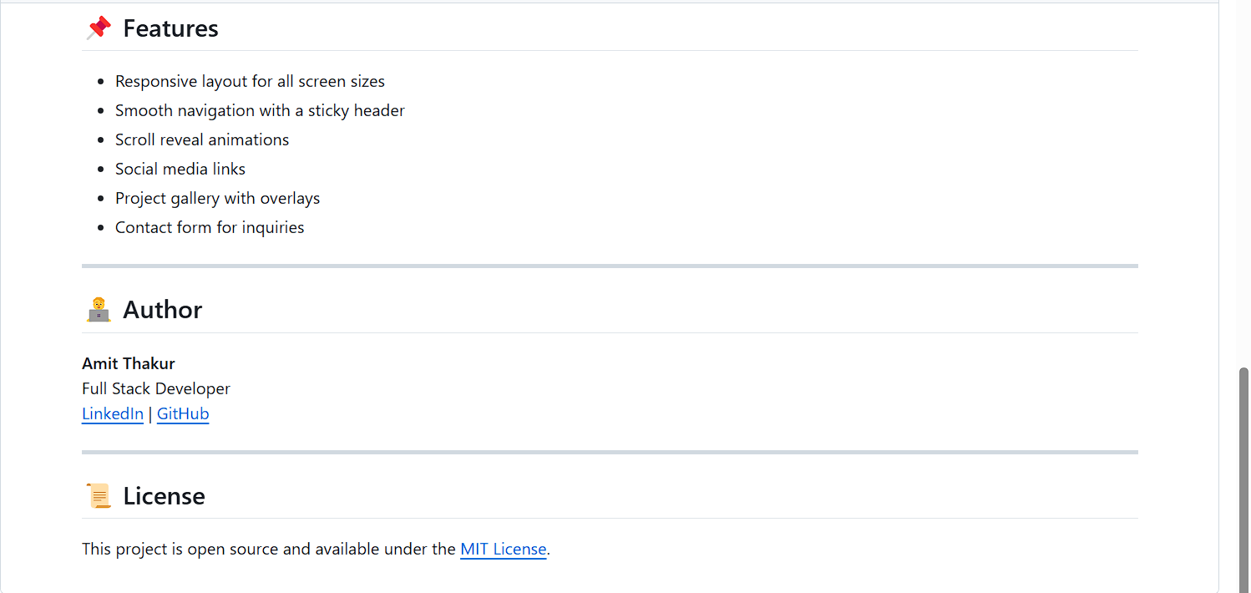

**Learning outcomes (What I have learnt):**

**1. I have about google adds**

**2. I have learned how to create a bog.**

**3. I have learned how to integrate google adds into a website for monetization.**