Contents

Slinger Player 1

Overview 1

Windows 1

Installing 2

Android 3

Installing 3

Firestick 3

Installing 3

# Slinger Player

## Overview

In an act of self-preservation to try to stem the constant stream of “I did something wrong on my stream Player (I’m talking about you VLC) and I can’t connect to Slinger” discussions. I’ve written a Player customized for accessing Slinger. With Slinger Player (SP) and Slinger V4.0, SP will search for Slinger on the LAN and auto populate a list of valid URLs to access Slinger with.

## Windows

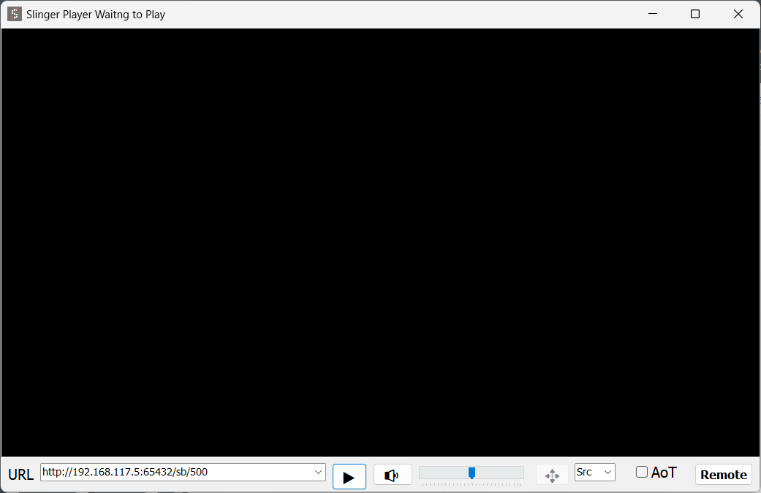

You can select one of the probed URLs to start playing it or type a new one into the dialog box and then press the play button. Valid URLs are saved on disk so any sites that aren’t on your LAN will be saved.

There is a minimal user interface following the well know “KISS” principal. There are a Play, Mute, Volume, Full Screen, Aspect Ratio, AlwaysOnTop and Remote controls. The Remote button will pop up a minimal browser window and automatically load the remote control page for the selected URL.

SP is configured with minimal buffering and knows in advance what kind of video stream it is connecting to, so it starts up faster than VLC and has minimal latency. The latency is ~ 1 second compared to 4-5+ seconds that VLC buffers out of the box. The one second-ish lag now makes it usable for most scenarios, FF and REW are still a little problematic but if you are aware of the lag you can do a much better job of getting it almost right.

In full screen mode there are some keyboard shortcuts you can use if your keyboard/PC doesn’t have Volume and Mute function keys. In fullscreen mode the keys +,-,m,r map to Vol+,Vol1, Mute and Remote respectively. The “shifted” version of those keys also work for the keyboard challenged (me). You can press “Esc” or Double-Click the video window to exit fullscreen mode. A single click will bring up the remote.

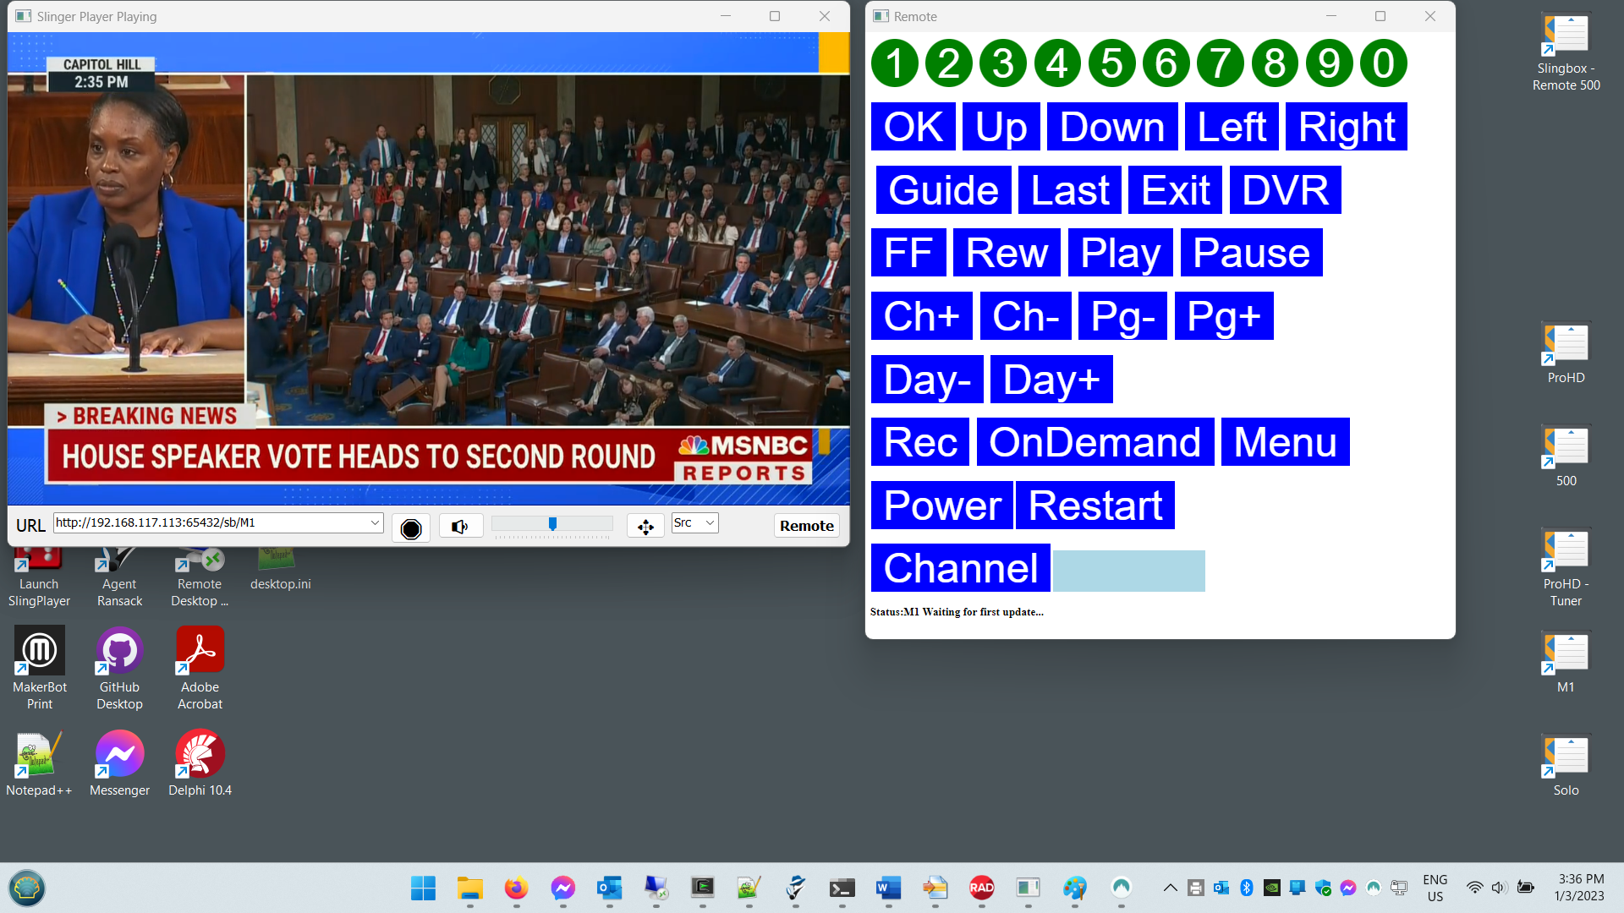

SP will accept two different command line options. One for the URL you want to connect to automatically. I.E. SlingerPlayer <http://192.168.117.102:65432/sb/500>.

The second option is if you want to get your configuration from a Slinger not on your LAN. In this case put this on your command line. wan://IPAddressOfSlinger:PortNumber I.E. wan://192.169.232.22:65432  
Note: You can use a FQDN here which might be useful if your using a Dynamic DNS service to connect to a remote Slinger. I.E. wan://MyDDNS.org:65432

The drop down URL list is saved in the Sites.dat file. You can clear out superfluous entries by editing that file.

You can easily make shortcuts to SP on the Desktop so different configurations are just a double click away.

### Installing

Grab all the files from the Windows folder and put them all in a single folder on your PC.

You do not have to use Slinger V4.0 along with SlingerPlayer. If you don’t you will lose the auto-populate functionality but it will still work with manually entered URLs.

## Android

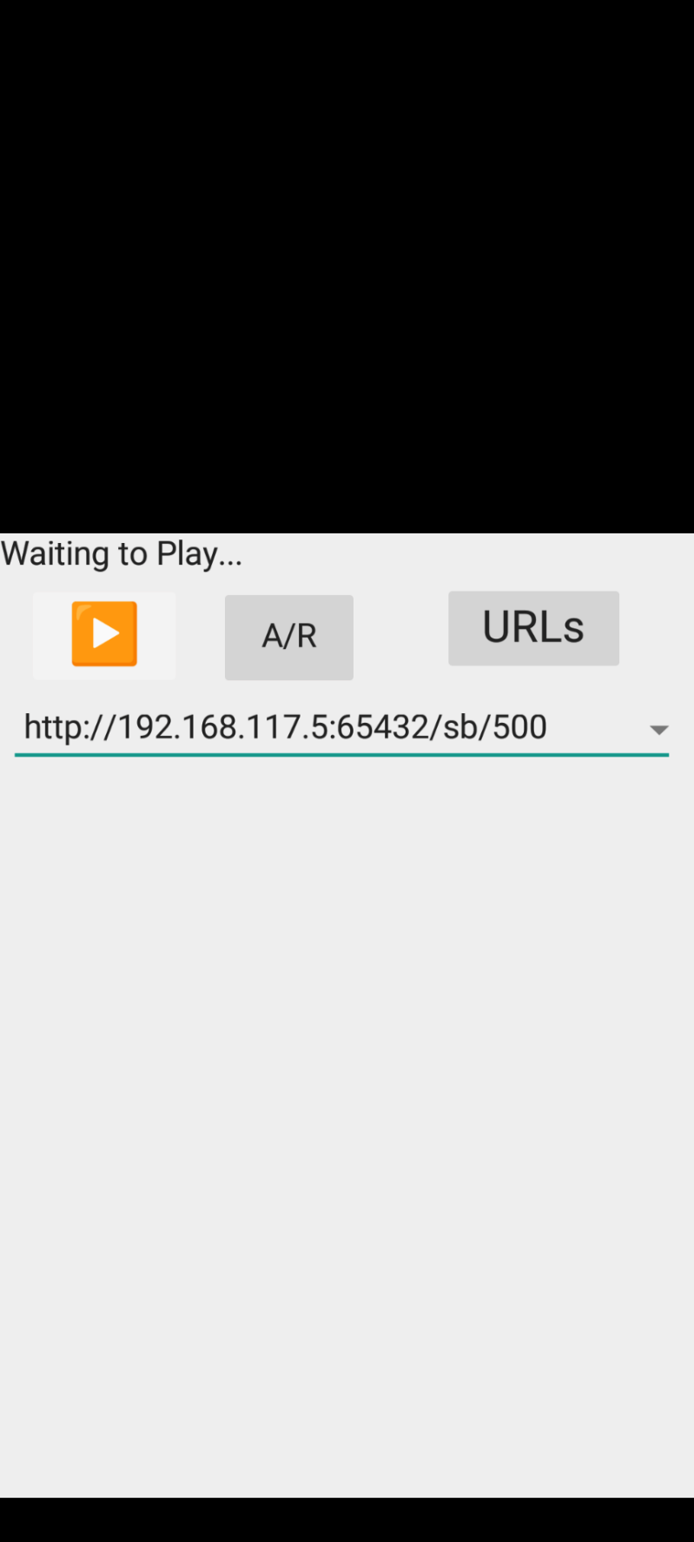

Because of the different UI on an Android device SP for Android needed some changes. In particular it needed a way to edit the “sites.dat” file where SP maintains the list of configured URLs. You can access the list and edit its content by pressing the URLs button on the home screen. To delete entries just leave them blank or just http://. They will be discarded when the edited list saved.

To play a stream click on the URL line and select an entry from the drop-down list displayed, then press Play. SP will automatically display the remote for the active stream.

To get a “full screen” view of the video rotate your phone screen 90 degrees.

### Installing

To put the APK on your phone you’ll need to use a process called “side-loading” because the app in not in the Google app store. There are many good examples on the Web describing how to do this.

## Firestick

When in app, use round ring for navigation in menus. Left right to pick icons and move to URL field, up and down to select URL if you configure more than one. OK to select.

To enter the URL's that are not on your LAN, navigate to URL field and press the menu button "3 dashes". Use navigation ring to navigate and OK to select. The keyboard will pop up as usual. Once entered, select next and then press "return", it will prompt you to save changes.

URL'(s) are remembered between app launches.

The “+” like button changes the view to Full Screen, click on the screen in full screen mode to get back to “Management” mode.

### Installing

To put the APK on your phone you’ll need to use a process called “side-loading” because the app in not in the Google app store. There are many good examples on the Web describing how to do this.