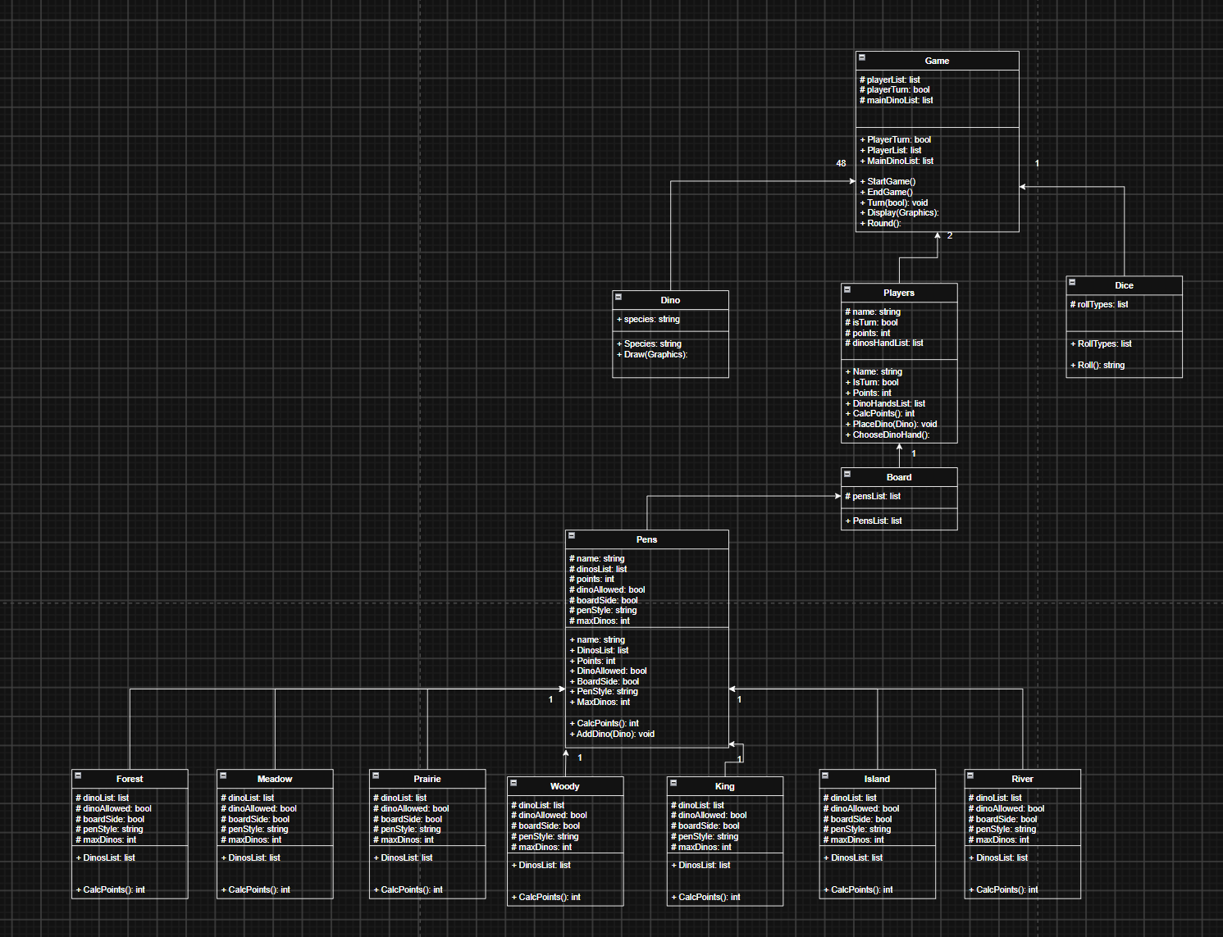
Human Class Diagram:

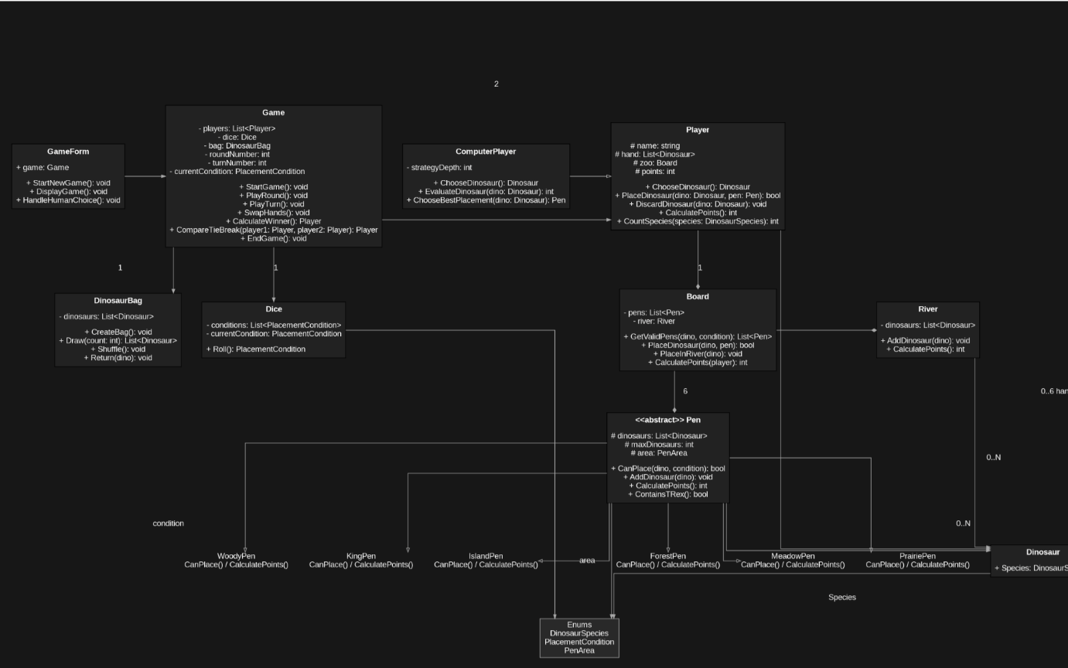
AI Class Diagram:

Differences:
Some of the key differences between my class diagram and the AI generated one was the addition of a specific computer player class. This is a good addition in my opnion as this class will be acting on its own as the second player every time and so has its own methods of playing as I wan this to be specifically constructed to the design of the players strategic.
Secondly the AI class diagram placed the river class as its own class and not as a subclass of the pen class. I think this is a good descion as the river class should also be able to accept a dino and thus does not utilize a lot of the methods implemented in the pen super class.
The AI class did however not implement a lot of the draw methods for which I am going to need. So I will add these to my final class diagram.

