WESTERN PACIFIC UNIVERSITY
CMN224 / CMP224 Software Engineering — Week 5
Homework: Defend One Architectural Decision
Formative (ungraded) · Moodle submission · ~45 minutes · due before Week 6
Item | Details
Linked to | Week 5 lecture and Lab 4 (ULO2, ULO4)
Length | 250–350 words plus one small diagram (may be a photo of a hand drawing)
Submission | Moodle → Week 5 → Homework. Also commit to week05/ in your portfolio.
Why | Task 4 is marked on the quality of design decisions, not diagram neatness. This is that skill, practised once, cheaply.

The task
Pick ONE architectural decision you made in Lab 4 — the pattern, where the data lives, how sync works, where authorisation is enforced, or how failure is handled. Write a short justification a client could read.

Structure — use these four headings
Heading | What goes here
1. The decision | The decision I’ve decided is that each depot laptop should store its own local database in the device and synchronize it with the central database whenever the internet connection becomes available.
2. What forced it | I made this selection because one of the gadget's non-practical requirements become that the depot must preserve operating even if net connectivity is unavailable. Since the depots are in faraway areas where network connections may be unreliable, workforce still want to document purchases and access records with out depending on the net. A nearby database permits the gadget to keep operating during community outages.
3. What I rejected | I rejected the opportunity of using an unmarried significant database server that every one depot get entry to thru the internet. Although this technique could simplify facts management due to the fact all facts are stored in one place, it might fail for this customer. If the internet connection goes down, depot personnel might be not able to report purchases, view farmer data, or whole transactions. This might interrupt business operations and decrease productivity.
4. What it costs me | The downside of my selection is that synchronization will become more complicated. Because statistics is stored in multiple locations, there's a danger of duplicate or conflicting information while facts are synchronized. Additional effort is needed to control those issues and make sure all databases continue to be correct and up to date. Despite this cost, I general the change-off due to the fact keeping the depot operational constantly is greater important for the client.
Diagram: Local Database Synchronisation Architecture | 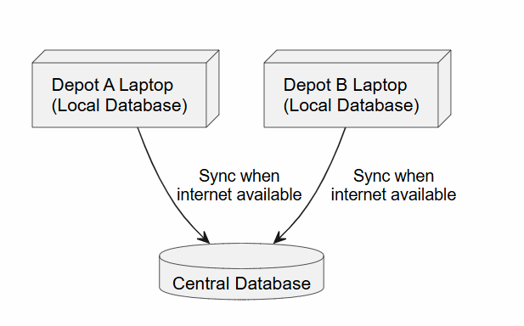

What a strong answer looks like
- Section 2 quotes an actual requirement, with its number if you have one.
- Section 3 names an alternative a competent engineer would genuinely have considered — not a straw man.
- Section 4 is honest. An answer with no downside listed has not thought hard enough.
- The diagram is small and supports the argument. One package or deployment sketch is plenty.

What a weak answer looks like
- “I chose layered architecture because it is best practice.” — best practice for whom, forced by which requirement?
- “PNG has bad internet so I made it offline.” — which requirement, which alternative rejected, at what cost?
- A large diagram with no argument attached.
Feedback: this is ungraded, but written feedback returns before the Week 7 clinic so you can carry it into Task 2 Part 2 and Task 4. The habit being built — decision, driver, alternative, cost — is exactly how the Task 4 rubric reads.

