 WESTERN PACIFIC UNIVERSITY

CMN224 / CMP224 Software Engineering

Task 4: Design & Modelling Deliverable

Student Name: Raygan KUTA
Student ID: 00271
Lecturer: Mr. Hombiku
Submitted Date: October 9, 2026

Semester II, 2026

Introduction
The following report is about the design and modelling artifacts of the Fee Payment System at Kina Ridge Primary School. It incorporates the software architecture designed in Week 5 with the behavioural and structural UML diagrams prepared in Week 9. These include an outline architecture, deployment diagram, use case diagram, class diagram, state diagram, activity diagram and a design pattern. This set of diagrams explains how the system fulfils the system requirements stated in the System Requirement Specification (SRS).
Design Consistency Statement
All diagrams in this report were derived from the Fee Payment System requirements specified in the SRS. The use case, class, state, activity, deployment and architecture views are consistent and describe the same business processes from different perspectives.

1. Package Diagram (Architecture)
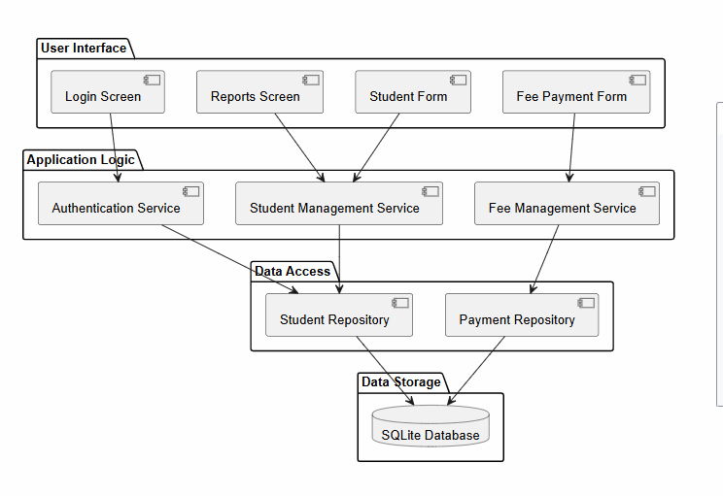
Explanation
The package diagram shows how the Fee Payment System has a layered architecture. The User Interface layer consists of screens which will be utilized by the staff members of the school such as login screen, report screen, students' details screen, and fee payment screen. Application Logic Layer consists of the services which implement the business logic and perform processing of the users' requests. Data Access Layer consists of the repositories which facilitate communication with the database. Lastly, Data Storage Layer includes the SQLite database which stores information about students and payments.

2. Deployment Diagram
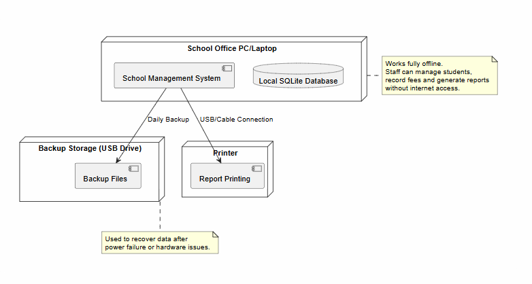
Explanation
Deployment diagram illustrates the physical architecture of the system. The School Office PC/Laptop acts as the server that runs School Management System and the SQLite database. Reports are printed by using a connected printer while backup files are saved on the attached USB storage device. As all major tasks are carried out in-house, the system can continue to run even without internet connection. This deployment structure was selected because of unreliable internet connection in the school environment.

3. Use Case Diagram
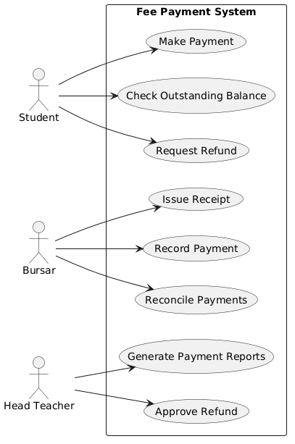
Explanation
From the use case diagram, there is interaction between the various actors and the Fee Payment System as they try to achieve their objectives. The students can pay their fees, check balance status, and ask for a refund. The bursars, on the other hand, are supposed to record the payments, print receipts, reconcile the payment details, and prepare the necessary reports. The Head Teacher is supposed to authorize the refund requests when needed. The use cases came about because of the requirements of the system.

4. Class Diagram
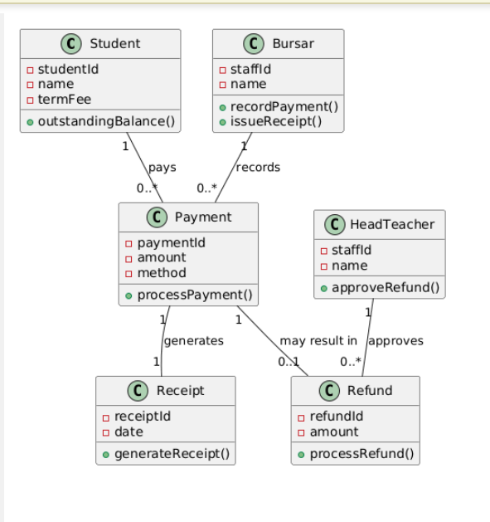
Explanation
Class Diagram represents the static structure of the Fee Payment System. The important classes are the following: Student, Payment, Receipt, Refund, Bursar, and Head Teacher. The relationships among the classes represent the business relationships like payment of fees by students and transaction processing by the bursars. The multiplicities represent the business rules of the real world, like making several payments by one student.

5. State Diagram
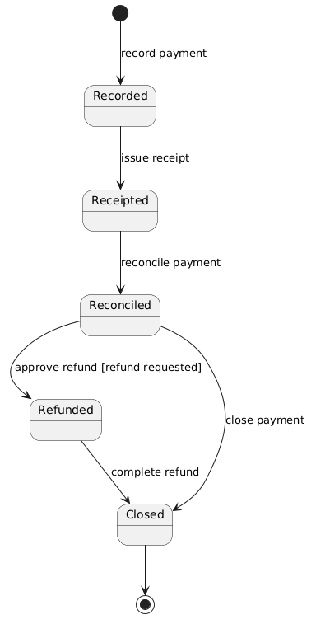
Explanation
The State Diagram shows the life cycle of the payment process in the Fee Payment System. A payment starts from Recorded state once the bursar has made the entry of the payment. Upon issuance of the receipt, the payment goes into Receipted state. Post reconciliation, the payment moves into the Reconciled state. In case the refund request has been made and approved by the Head Teacher, the payment moves to the Refunded state before moving to the Closed state. The guard condition [refund requested] reflects the business rule which mandates that the payment must have an approved refund request.

6. Activity Diagram
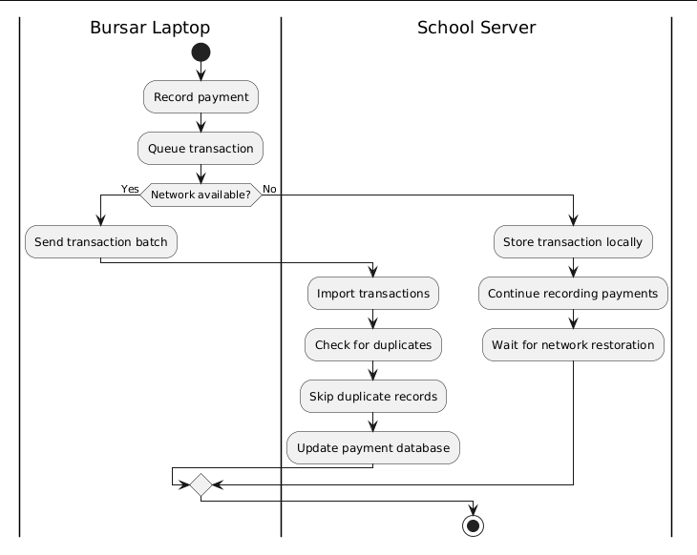
Explanation
The activity diagram presents how the process of recording and synchronizing payments is done. The bursar records the payment and puts it in a transaction queue. There is a decision point that verifies whether there is network connectivity or not. In case there is network connectivity, then the transaction details are synchronized, imported into the central payment database, duplicates are checked, and the payment is updated successfully. Otherwise, if there is no network connectivity, then the transaction details are saved locally, and recording of the payment is done till network connectivity is established.

7. Applied Design Pattern
Repository Pattern
The Repository Pattern is utilized in the Data Access layer using the Student Repository and the Payment Repository modules. They serve as go-betweens for the business logic and the SQLite database. Instead of letting the services access the stored data directly, repositories offer access points to retrieve and update the data.
It enhances the system's maintainability, decreases coupling, and allows for further enhancement. For instance, in case the database technology will change in the future, any changes will only take place in the repository layer and not affect the user interface or business logic layer. Thus, the Repository Pattern fits in well with the chosen layered architecture.

What you already have
Component | Where it came from | Have I got it?
Outline architecture | Lab 4, Week 5 — package diagram | Yes
Deployment view | Lab 4, Week 5 — deployment diagram | Yes
Use case model | Lab 6, Week 9 | Yes
Class diagram | Lab 6, Week 9 | Yes
State diagram | Lab 6, Week 9 | Yes
Activity diagram | Lab 6, Week 9 | Yes
Design pattern applied | Weeks 13–14 teach patterns — see the note below | Yes
Consistency checks — this is where the marks are
Task 4 is marked on the correctness and consistency of your models with the requirements — not on neatness. Run these checks before you submit.
# | Check | Fixed?
1 | Every use case traces to a user requirement in my SRS | Yes
2 | Every class attribute appears somewhere in my requirements | Yes
3 | At least one multiplicity encodes a real business rule | Yes
4 | At least one state transition carries a guard from a business rule | Yes
5 | My activity diagram has a branch for the offline / no-power case | Yes
6 | The swimlanes match the devices in my deployment diagram | Yes
7 | Every class is placed on some machine in the deployment view | Yes
8 | No package has an upward dependency arrow | Yes
9 | One scenario traces cleanly through all five views | Yes
10 | The design pattern is named, located and justified | Yes

Conclusion
The chosen architecture and UML designs make it possible to achieve a full-fledged design for the fee payment system of the Kina Ridge Primary School. The layered architecture enables proper separation of duties, whereas the deployment diagram makes it possible for the system to run efficiently without being online. These diagrams combined with the repository pattern allow for efficient behaviour, structure, and workflow of the system.

AI Use Declaration
UML models have been prepared using Microsoft Copilot. This program has helped me prepare UML descriptions, review model consistency, and prepare explanations in written form. All diagrams have been developed, reviewed, and verified against SRS and the requirements set in the assessment task. All decisions on final designs and modelling have been made by me.

