Joel Lantigua

Linux Administrator

Cron Job

11/17/22

Ubuntu Cronjob

Before creating a cron job I used the command **su – root** to change into the root user. To create a cron job I use the command **crontab -e**  to open the crontab editor. After the editor opens you can scroll all the way to the bottom and begin inserting your cron job commands. The first cron job command I inserted was **0 */2 * * * /var/backups/home.tgz /home/.**  This command allows all users accounts to be backed up every 2 hours. The next cron job command that I used was **0 */2 * * * /usr/bin** this command allows the cron job to take a snapshot of all executable files every 2 hours. Lastly I added **0 0 * * * /root/Backups/back.sh** this command allows my back up script that I created called **back.sh** to be ran everyday. I chose to run my script everyday because at any time or any day my server can crash and be corrupted so with my back up I can go in and reboot the server using one of my back ups

To view the cron job I used the command **crontab -l** to view any cron jobs under the user you are in.

CentOS CronJob

Before creating a cron job I used the command **su – root** to change into the root user. To create a cron job I use the command **crontab -e**  to open the crontab editor. Keep in mind my CentOS server used vim to edit the cronjob. After the editor vim opened up I hit the “I” key to insert new text. On the top I inserted the same cron job commands as my ubuntu server. The first cron job command I inserted was **0 */2 * * * /var/backups/home.tgz /home/.**  This command allows all users accounts to be backed up every 2 hours. The next cron job command that I used was **0 */2 * * * /usr/bin** this command allows the cron job to take a snapshot of all executable files every 2 hours. Lastly I added **0 0 * * * /root/Backups/back.sh** this command allows my back up script that I created called **back.sh** to be ran everyday. Now with vim to save the cron job I used **“:”** follwed by **x** this allows me to save the cron job in vim.

To view the cron job after it’s done, I used the command **crontab -l** 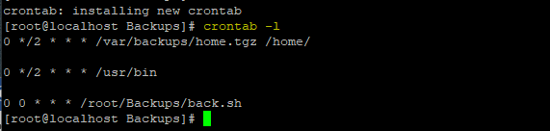

Work cited

<https://www.digitalocean.com/community/tutorials/how-to-use-cron-to-automate-tasks-ubuntu-1804>