Joel Lantigua

Linux Administrator

Installing Repository

10/6/22

**Ubuntu Server**

The first installation we are going to do is install **Tmux**. First I use **sudo apt-get install** and then the package you want**.** For this installation we want to install the packages to tmux.This command allows you to install the package you want like tmux. **sudo apt-get install tmux.**  As you can see below my package was already pre-installed.

The second installation we are going to do is install **emacs**. For this installation we are going to use the same command as the first installation we did above, but instead of tmux we are going to use **emacs**. This will will install your emacs packages that you need as shown below. **Sudo apt-get install emacs**

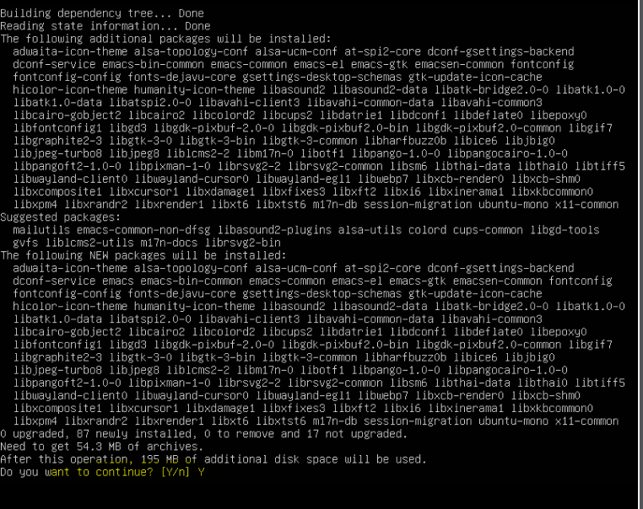

For third installation we are going to install **Fail2ban**. Use the same command from the last two installations we did. **Sudo apt-get install fail2ban.** Once fail2ban was installed I checked the status of the Repository by using the command **systemctl status fail2ban.** After checking and seeing that it wasn’t active I used the command **systemctl start fail2ban** to start up the repository.

**

Now we are going to install cowsay: Installing this package is simple we are going use the command **sudo apt-get install cowsay**, As you can see in the image below.

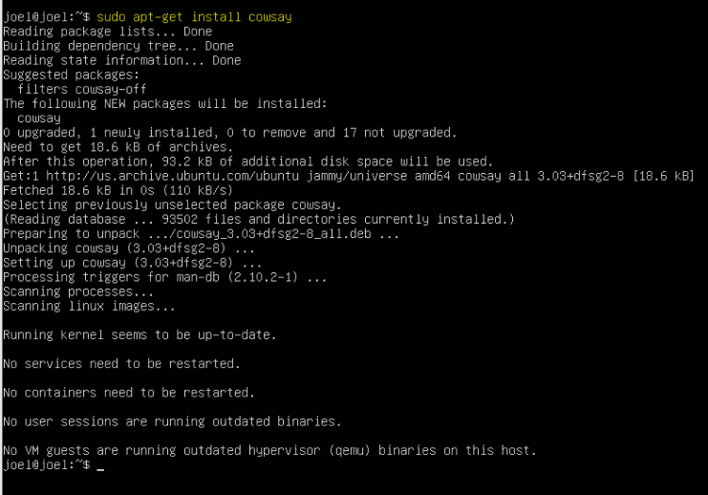

This next installation will be **lolcat**: For this installation we are going to do the same as cowsay. **Sudo apt-get install lolcat** ,this is the command used to install the packages to lolcat as shown in the image below.

Next, we are going to install vim: For this installation we are going to do the same as we did for the other installations and use the command **sudo apt-get install vim**.

**CentOS Server**

Now we are going to install **tmux** for CentOS: first we are going to change into root by using in the command **su – root**. After that is done and you have changed into root we are going to install **tmux** by using **yum install tmux**. Notice instead of using sudo we are going to use yum.

Next we are going to install emacs: for this is installation it’s similar to the first installation for CentOS, we are going to use **yum install emacs**



This next intallation will be **fail2ban**: We are going to use **yum install fail2ban**. Once fail2ban was installed I checked the status of the program by using the command **systemctl status fail2ban.** Notice that at first fail2ban was inactive. To activate it I used the command **systemctl start fail2ban** then I rechecked it and this time it was active and running.

**(Fail2ban activate)**

Next intsallation we are going to do is install **cowsay**: Installing cowsay is simple, just like the other installations we are going to use **yum -y insatll cowsay**. The **-y** in the command is for yum to answer “yes” to any questions promted during the installation.

Next we are going to install **lolcat**: To install lolcat I had to install snapd first and to do so I would used the command **yum install snapd.** Once that was done I used the command **sudo snap install lolcat-c**. Snapd is used to manage and maintain the snaps on the operating system.

The last installation we are going to do is **vim**: for this installation we are going to use **yum install vim** as you can see below my operating system had vim per-installed.

