Joel Lantigua

Linux Administrator

Using Sed command

9/28/22

**Sed**

Before I started on this assignment, I had to download the **SedLab** file onto my host computer. Once the download was completed, I then needed to open the command prompt so that I can send the file to my Ubuntu server using the command **scp -r SedLab joel@192.168.241.136:/home/joel/Sharetoserver** As you can see below the data file named **SedLab** was successfully sent to my **Sharetoserver** folder.



Next, I switched over to my ubuntu server and use the command **ls** to check if the **Sharetoserver** folder is there. Once I see that the folder is there, I use the command **cd Sharetoserver** to change into the directory. Now if I use the command **ls** I should be able to see the **SedLab** data file.

Question 1, Change the name Jo to Josephine? For this question I used the **command sed s/Jo/Josephine/ SedLab**. This command allows you to change the name of a person in the file. The **s** in the command means to substitue. So in this case we substituted the name Jo for Josephine.

Question2, Delete the last 5 lines? For this question I used the command **Sed ‘$d’ SedLab | sed ‘$d’ | sed ‘$d’| sed ‘$d’ | sed ‘$d’**. The “$d” in this comand means to delete the last line. So if we run that command 5 times it will delete the last 5 lines as shown below. It delete 3 users and the other 2 lines were blank lines that were deleted.

Question 3, Print lines 3-15? For this question I used the command **sed -n ‘3,15’p SedLab**. In this command the –n is used to count lines in this case we wanted lines 3-15.The **“p”** is another way to print the results.

Question 4, Delete lines for people who live in CA? for this question I used the command **sed /CA/d SedLab**. In this command since we wanted to delete people that lived in California so we used the abbreviation of the state, in this case it was /CA/d. The d is used to delete.

Question 5, Print all lines where the birthdays are in the first week of the month? for this question I used the command **sed -rn ‘/:[1-12]\/[0-7]\/[00-99]/p’** SedLab. The numbers in the brackets represents the format to the birthdate. For example **[1-12]** mean the months of the year. So, since we are looking for the first week of the month in the middle bracket, we only did **[0-7]** representing the first 7 days of the month. Last bracket **[00-99]** means the years in the birthdays.

Question 6, Append three asterisks to the end of lines starting with Sir? For this question we used the command **sed -e ‘/sir/a\***’ SedLab**. Since we want to add “***” to the end of the lines that start with sir, we used -e to execute multiple sed commands. After we identified that we want lines that start with **sir** so we use **/sir/a\***.** The “**a**” mean to append, then we add the three “***” we want to the end of the line.

Question 7, Replace the line containing "Westley Pirate" with the phrase "As you wish.”: For this question I used the command **sed -e ‘s/.*Westley Pirate.*/As you wish\./g’ SedLab.** In this command I used the **“s”** subsite Westley Pirate for As you wish. Next, I used the “**/.*”**  this is used to determine what is going to be substituted. In this case we want to change Westley Pirate so I would do **/.*Westley Pirate.*/** Next I added the text that was going to replace Westley Pirate which was “As you wish” so it would look like **‘s/.*Westley Pirate.*/As you wish\./g’** The “g” stands for global substitution.

Question 8, Change Minerva McGonagall's birthday to 12/25/1960: for this question I used the command **sed ‘/^Minerva McGonagall:/s/:[^:]*\(:[^:\/]*\)$/:10\/04\/35\1/’ SedLab**. For this command we want to change the birthday so we would start with the **‘/^Minerva McGonagall:** the “^” infront of the name means to match. followed by the pattern that leads up to the birthday on the file format. The first pattern would be **/s/:[^:]*\(:[^:\/]*\)$/:** This pattern stands for everything that’s in between the name of the person and their birthday that I don’t want to change so like the phone number and the address. Next I used **10\/04\/35/1/’** to represent the birthdate I wanted to add. At the end the **\1/** would be used to reference the first set of patterns we did in the beginning for the phone number and address.

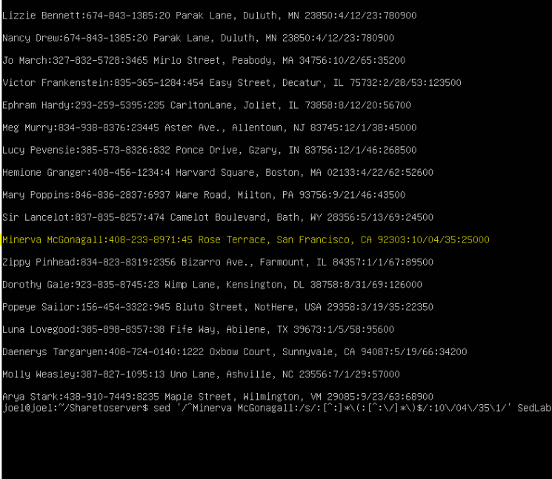

Question 9, Delete all blank lines? for this question I used the command **sed ‘/^$/d’ SedLab**. since we want to delete all blank lines, we use /^$/d the “^” means substitution delimiter which can be any character. Followed by the $ which means to match last line in the file which was blank. After you need the add “d” which means delete. This allows me to delete all lines matching the last one which was blank.

Question 10, Write a sed script that will (actual sed script, NOT just the commands on the command line) (a) Insert above the first line the title - Great Literary Characters -. (b) Print the contents of the file with only the last name then the phone number. (c) Append at the end of the file “Happily Ever after. The End” For this script I started by using **nano script.ed** once the file editor opened up I inserted **#!/bin/sed -Ef** I inserted this in the beginning because this is a sed script that is going to run sed command. Next, I added **1i “Great Literary Characters”** the **1i** is used to insert at the beginning of the file. Next, I used **$a Happily Ever After, The End** the **$a** allows me to insert the text at the end of the file. After I saved the file, I gave the file executable right by using **chmod +x script.sed** once the file has the executable rights I then used **./script.sed SedLab** to run the script on the **SedLab** file. After numerous tries I could not figure out how to print the contents of the file with only the last name then the phone number.



Work Cited

<https://dasher.wustl.edu/chem478/software/unix-tools/sed.html>

<https://www.gnu.org/software/sed/manual/html_node/The-_0022s_0022-Command.html>

<https://quickref.me/sed>