Project Report Template

1.INTRODUCTION

  - Overview

Staying informed about the latest headlines and breaking news is essential in today's fast-paced world. Whether you are interested in politics, business, technology, entertainment, or any other topic, keeping up with the latest developments can provide valuable insights into the world around us. With the rise of digital media and social networks, it has become easier than ever to access news and information from around the globe. By staying up-to-date with the latest headlines, you can make informed decisions, engage in meaningful conversations, and stay ahead of the curve. In this era of information overload, it is more important than ever to develop healthy habits of consuming news and staying informed.

  - Purpose
The purpose of keeping up with the latest headlines is to stay informed about the latest developments and events happening in the world. By keeping up-to-date with the latest news, we can better understand the world around us, make informed decisions, and engage in meaningful conversations with others. Additionally, keeping up with the latest headlines can help us stay ahead of the curve, anticipate future trends and developments, and prepare ourselves for the challenges that lie ahead. It is also important to note that staying informed about the latest headlines can help us develop a more nuanced and informed perspective on important issues, and foster a greater sense of empathy and understanding towards those who may have different perspectives or experiences than our own. Overall, the purpose of keeping up with the latest headlines is to become a more informed, engaged, and aware member of our global community..

2.Problem Definition & Design Thinking

2.1 Empathy Map
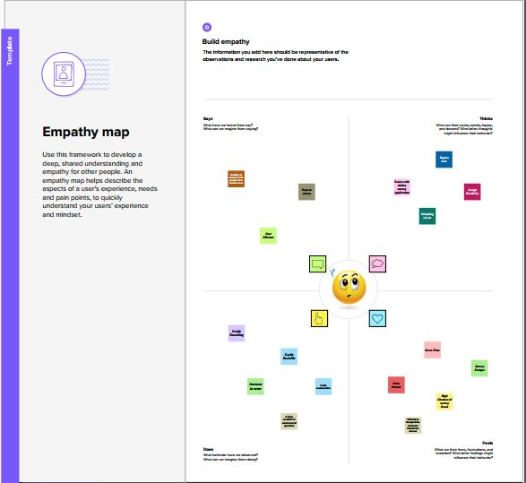

2.2 Ideation & Brainstorming Map

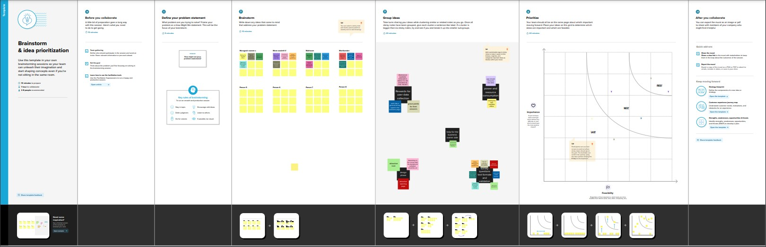

3.Result
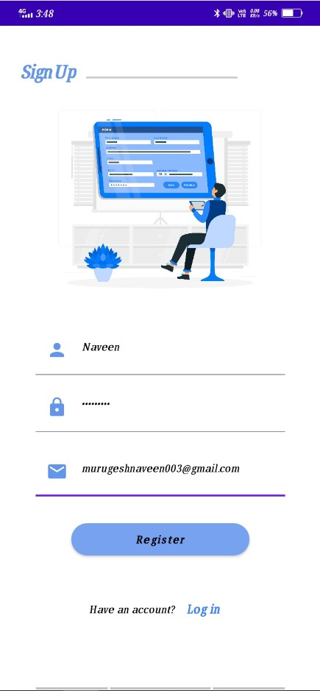
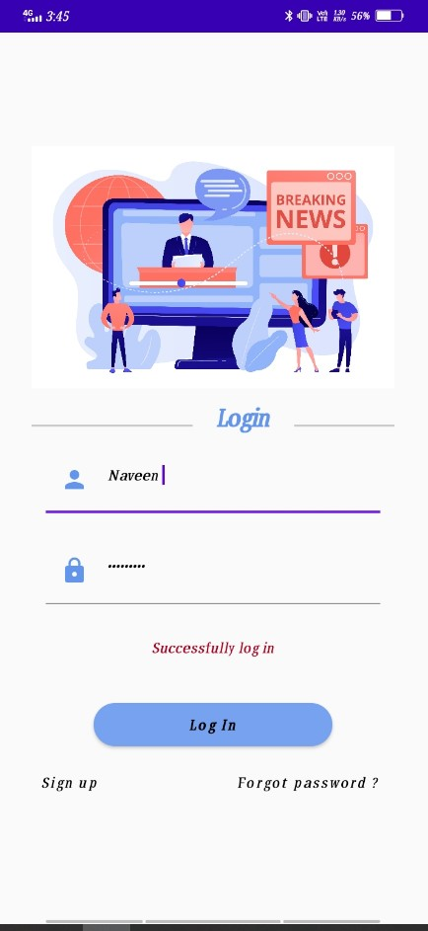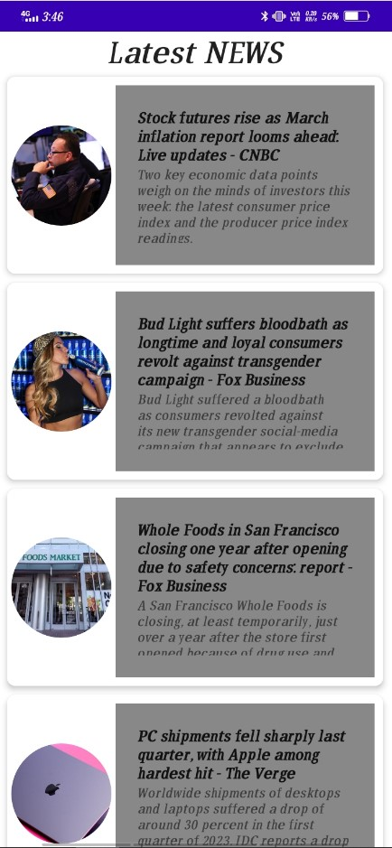
4.ADVANTAGES & DISADVANTAGES

4.1 Advantages
• Stay informed: Keeping up with the latest headlines helps us stay informed about the latest developments and events happening around the world. It helps us gain a better understanding of different issues and topics, and stay up-to-date with the latest trends and developments.
• Make informed decisions: Staying up-to-date with the latest headlines can help us make more informed decisions about our personal and professional lives. It can help us stay ahead of the curve, anticipate future trends and developments, and prepare ourselves for the challenges that lie ahead.
• Engage in meaningful conversations: Keeping up with the latest headlines can also help us engage in meaningful conversations with others, whether it's with friends, family members, colleagues, or acquaintances. It can help us build stronger relationships and connect with others on a deeper level.
4.2 Disadvantages
• Information overload: With so much news and information available, it's easy to become overwhelmed by the sheer volume of content. This can make it difficult to distinguish between important and unimportant news, and can lead to feelings of stress, anxiety, and confusion.
- Bias and sensationalism: Some news outlets may have biases or engage in sensationalist reporting in order to attract more viewers or readers. This can make it difficult to trust the news and can lead to a distorted view of the world.

• Time-consuming: Keeping up with the latest headlines can be time-consuming, especially if you're trying to stay informed about multiple topics or areas of interest. This can make it difficult to balance work, personal life, and staying informed.
6. Conclusion

At the end of the day, email is still one of the most effective forms of marketing. If you use it correctly, you can target prospective customers with relevant information, at precisely the right time - gaining brand loyalists for life.

7. Future Scope
7.1: Real-time updates:
- The ability to receive the latest news as soon as it is available, without any delays.
Customizable preferences:

Users can set their preferences for the type of news they want to receive, such as breaking news, sports, politics, or entertainment.

Push notifications:

Users can receive push notifications on their mobile devices whenever a new headline is published.

7.2: Filtering options:

Users can filter news based on topics, sources, or keywords to help them focus on the news that interests them the most.

7.3 :Personalization:

Users can create personalized news feeds based on their interests, reading history, or social media activity.

User-friendly interface:

The app or website should have an easy-to-use interface that allows users to quickly and easily browse through the latest headlines.
- Multimedia content: The ability to include images, videos, or audio clips with news stories to provide more context and enhance the user experience.
- Sharing options: Users can easily share news stories with their friends or family via social media, email, or other messaging apps.
- Local news coverage: The app or website should provide local news coverage that is relevant to the user's location.
- Reliable sources: The app or website should only provide news from reputable sources to ensure accuracy and credibility.

8.Appendix

Source code:-

Code

Email data base helper.kt

package com.example.emailapplication

import android.annotation.SuppressLint
import android.content.ContentValues
import android.content.Context
import android.database.Cursor
import android.database.sqlite.SQLiteDatabase
import android.database.sqlite.SQLiteOpenHelper

class EmailDatabaseHelper(context: Context) :
SQLiteOpenHelper(context, DATABASE_NAME, null,DATABASE_VERSION){

companion object {
private const val DATABASE_VERSION = 1
private const val DATABASE_NAME = "EmailDatabase.db"

private const val TABLE_NAME = "email_table"
private const val COLUMN_ID = "id"
private const val COLUMN_RECEIVER_MAIL = "receiver_mail"
private const val COLUMN_SUBJECT = "subject"
private const val COLUMN_BODY = "body"
}

override fun onCreate(db: SQLiteDatabase?) {
val createTable = "CREATE TABLE $TABLE_NAME (" +
"${COLUMN_ID} INTEGER PRIMARY KEY AUTOINCREMENT, " +
"${COLUMN_RECEIVER_MAIL} Text, " +
"${COLUMN_SUBJECT} TEXT ," +
"${COLUMN_BODY} TEXT " +
")"

db?.execSQL(createTable)
}

override fun onUpgrade(db: SQLiteDatabase?, oldVersion: Int, newVersion: Int) {
db?.execSQL("DROP TABLE IF EXISTS $TABLE_NAME")
onCreate(db)
}

fun insertEmail(email: Email) {
val db = writableDatabase
val values = ContentValues()
values.put(COLUMN_RECEIVER_MAIL, email.recevierMail)
values.put(COLUMN_SUBJECT, email.subject)
values.put(COLUMN_BODY, email.body)
db.insert(TABLE_NAME, null, values)
db.close()
}

@SuppressLint("Range")
fun getEmailBySubject(subject: String): Email? {
val db = readableDatabase
val cursor: Cursor = db.rawQuery("SELECT * FROM $TABLE_NAME WHERE $COLUMN_SUBJECT = ?", arrayOf(subject))
var email: Email? = null
if (cursor.moveToFirst()) {
email = Email(
id = cursor.getInt(cursor.getColumnIndex(COLUMN_ID)),
recevierMail = cursor.getString(cursor.getColumnIndex(COLUMN_RECEIVER_MAIL)),
subject = cursor.getString(cursor.getColumnIndex(COLUMN_SUBJECT)),
body = cursor.getString(cursor.getColumnIndex(COLUMN_BODY)),
)
}
cursor.close()
db.close()
return email
}
@SuppressLint("Range")
fun getEmailById(id: Int): Email? {
val db = readableDatabase
val cursor: Cursor = db.rawQuery("SELECT * FROM $TABLE_NAME WHERE $COLUMN_ID = ?", arrayOf(id.toString()))
var email: Email? = null
if (cursor.moveToFirst()) {
email = Email(
id = cursor.getInt(cursor.getColumnIndex(COLUMN_ID)),
recevierMail = cursor.getString(cursor.getColumnIndex(COLUMN_RECEIVER_MAIL)),
subject = cursor.getString(cursor.getColumnIndex(COLUMN_SUBJECT)),
body = cursor.getString(cursor.getColumnIndex(COLUMN_BODY)),
)
}
cursor.close()
db.close()
return email
}

@SuppressLint("Range")
fun getAllEmails(): List<Email> {
val emails = mutableListOf<Email>()
val db = readableDatabase
val cursor: Cursor = db.rawQuery("SELECT * FROM $TABLE_NAME", null)
if (cursor.moveToFirst()) {
do {
val email = Email(
id = cursor.getInt(cursor.getColumnIndex(COLUMN_ID)),
recevierMail = cursor.getString(cursor.getColumnIndex(COLUMN_RECEIVER_MAIL)),
subject = cursor.getString(cursor.getColumnIndex(COLUMN_SUBJECT)),
body = cursor.getString(cursor.getColumnIndex(COLUMN_BODY)),
)
emails.add(email)
} while (cursor.moveToNext())
}
cursor.close()
db.close()
return emails
}

}

Email.kt

package com.example.emailapplication

import androidx.room.ColumnInfo
import androidx.room.Entity
import androidx.room.PrimaryKey

@Entity(tableName = "email_table")
data class Email(
@PrimaryKey(autoGenerate = true) val id: Int?,
@ColumnInfo(name = "receiver_mail") val recevierMail: String?,
@ColumnInfo(name = "subject") val subject: String?,
@ColumnInfo(name = "body") val body: String?,
)

Login activity.kt

package com.example.emailapplication

import android.content.Context
import android.content.Intent
import android.os.Bundle
import androidx.activity.ComponentActivity
import androidx.activity.compose.setContent
import androidx.compose.foundation.Image
import androidx.compose.foundation.background
import androidx.compose.foundation.layout.*
import androidx.compose.material.*
import androidx.compose.runtime.*
import androidx.compose.ui.Alignment
import androidx.compose.ui.Modifier
import androidx.compose.ui.graphics.Color
import androidx.compose.ui.layout.ContentScale
import androidx.compose.ui.res.painterResource
import androidx.compose.ui.text.font.FontFamily
import androidx.compose.ui.text.font.FontWeight
import androidx.compose.ui.text.input.PasswordVisualTransformation
import androidx.compose.ui.tooling.preview.Preview
import androidx.compose.ui.unit.dp
import androidx.compose.ui.unit.sp
import androidx.core.content.ContextCompat
import com.example.emailapplication.ui.theme.EmailApplicationTheme

class LoginActivity : ComponentActivity() {
private lateinit var databaseHelper: UserDatabaseHelper
override fun onCreate(savedInstanceState: Bundle?) {
super.onCreate(savedInstanceState)
databaseHelper = UserDatabaseHelper(this)
setContent {

LoginScreen(this, databaseHelper)
}
}
}
@Composable
fun LoginScreen(context: Context, databaseHelper: UserDatabaseHelper) {

var username by remember { mutableStateOf("") }
var password by remember { mutableStateOf("") }
var error by remember { mutableStateOf("") }

Column(
modifier = Modifier.fillMaxSize().background(Color.White),
horizontalAlignment = Alignment.CenterHorizontally,
verticalArrangement = Arrangement.Center
) {
Image(
painterResource(id = R.drawable.email_login), contentDescription = ""
)

Text(
fontSize = 36.sp,
fontWeight = FontWeight.ExtraBold,
fontFamily = FontFamily.Cursive,
text = "Login"
)
Spacer(modifier = Modifier.height(10.dp))

TextField(
value = username,
onValueChange = { username = it },
label = { Text("Username") },
modifier = Modifier.padding(10.dp)
.width(280.dp)
)

TextField(
value = password,
onValueChange = { password = it },
label = { Text("Password") },
visualTransformation = PasswordVisualTransformation(),
modifier = Modifier.padding(10.dp)
.width(280.dp)
)

if (error.isNotEmpty()) {
Text(
text = error,
color = MaterialTheme.colors.error,
modifier = Modifier.padding(vertical = 16.dp)
)
}

Button(
onClick = {
if (username.isNotEmpty() && password.isNotEmpty()) {
val user = databaseHelper.getUserByUsername(username)
if (user != null && user.password == password) {
error = "Successfully log in"
context.startActivity(
Intent(
context,
MainActivity::class.java
)
)
//onLoginSuccess()
}

} else {
error = "Please fill all fields"
}
},
colors = ButtonDefaults.buttonColors(backgroundColor = Color(0xFFd3e5ef)),
modifier = Modifier.padding(top = 16.dp)
) {
Text(text = "Login")
}
Row {
TextButton(onClick = {context.startActivity(
Intent(
context,
RegisterActivity::class.java
)
)}
)
{ Text(color = Color(0xFF31539a),text = "Sign up") }
TextButton(onClick = {
})

{
Spacer(modifier = Modifier.width(60.dp))
Text(color = Color(0xFF31539a),text = "Forget password?")
}
}
}
}
private fun startMainPage(context: Context) {
val intent = Intent(context, MainActivity::class.java)
ContextCompat.startActivity(context, intent, null)
}
EmailDao.kt

package com.example.emailapplication

import androidx.room.*

@Dao
interface EmailDao {

@Query("SELECT * FROM email_table WHERE subject= :subject")
suspend fun getOrderBySubject(subject: String): Email?

@Insert(onConflict = OnConflictStrategy.REPLACE)
suspend fun insertEmail(email: Email)

@Update
suspend fun updateEmail(email: Email)

@Delete
suspend fun deleteEmail(email: Email)
}

Main Activity.kt

package com.example.emailapplication

import android.content.Context
import android.content.Intent
import android.os.Bundle
import androidx.activity.ComponentActivity
import androidx.activity.compose.setContent
import androidx.compose.foundation.Image
import androidx.compose.foundation.background
import androidx.compose.foundation.layout.*
import androidx.compose.material.*
import androidx.compose.runtime.Composable
import androidx.compose.ui.Alignment
import androidx.compose.ui.Modifier
import androidx.compose.ui.graphics.Color
import androidx.compose.ui.layout.ContentScale
import androidx.compose.ui.res.painterResource
import androidx.compose.ui.text.font.FontWeight
import androidx.compose.ui.tooling.preview.Preview
import androidx.compose.ui.unit.dp
import androidx.compose.ui.unit.sp
import androidx.core.content.ContextCompat
import androidx.core.content.ContextCompat.startActivity
import com.example.emailapplication.ui.theme.EmailApplicationTheme

class MainActivity : ComponentActivity() {
override fun onCreate(savedInstanceState: Bundle?) {
super.onCreate(savedInstanceState)
setContent {
// A surface container using the 'background' color from the theme
Surface(
modifier = Modifier.fillMaxSize().background(Color.White),
) {
Email(this)
}

}
}
}

@Composable
fun Email(context: Context) {
Text(
text = "Home Screen",
modifier = Modifier.padding(top = 74.dp, start = 100.dp, bottom = 24.dp),
color = Color.Black,
fontWeight = FontWeight.Bold,
fontSize = 32.sp
)

Column(
horizontalAlignment = Alignment.CenterHorizontally,
verticalArrangement = Arrangement.Center
) {
Image(
painterResource(id = R.drawable.home_screen), contentDescription = ""
)

Button(onClick = {
context.startActivity(
Intent(
context,
SendMailActivity::class.java
)
)
},
colors = ButtonDefaults.buttonColors(backgroundColor = Color(0xFFadbef4))
) {
Text(
text = "Send Email",
modifier = Modifier.padding(10.dp),
color = Color.Black,
fontSize = 15.sp
)
}

Spacer(modifier = Modifier.height(20.dp))

Button(onClick = {
context.startActivity(
Intent(
context,
ViewMailActivity::class.java
)
)
},
colors = ButtonDefaults.buttonColors(backgroundColor = Color(0xFFadbef4))
) {
Text(
text = "View Emails",
modifier = Modifier.padding(10.dp),
color = Color.Black,
fontSize = 15.sp
)
}

}
}

RegisterActivity.kt

package com.example.emailapplication

import android.content.Context
import android.content.Intent
import android.os.Bundle
import androidx.activity.ComponentActivity
import androidx.activity.compose.setContent
import androidx.compose.foundation.Image
import androidx.compose.foundation.background
import androidx.compose.foundation.layout.*
import androidx.compose.material.*
import androidx.compose.runtime.*
import androidx.compose.ui.Alignment
import androidx.compose.ui.Modifier
import androidx.compose.ui.graphics.Color
import androidx.compose.ui.layout.ContentScale
import androidx.compose.ui.res.painterResource
import androidx.compose.ui.text.font.FontFamily
import androidx.compose.ui.text.font.FontWeight
import androidx.compose.ui.text.input.PasswordVisualTransformation
import androidx.compose.ui.tooling.preview.Preview
import androidx.compose.ui.unit.dp
import androidx.compose.ui.unit.sp
import androidx.core.content.ContextCompat
import com.example.emailapplication.ui.theme.EmailApplicationTheme

class RegisterActivity : ComponentActivity() {
private lateinit var databaseHelper: UserDatabaseHelper
override fun onCreate(savedInstanceState: Bundle?) {
super.onCreate(savedInstanceState)
databaseHelper = UserDatabaseHelper(this)
setContent {

RegistrationScreen(this, databaseHelper)
}
}
}

@Composable
fun RegistrationScreen(context: Context, databaseHelper: UserDatabaseHelper) {

var username by remember { mutableStateOf("") }
var password by remember { mutableStateOf("") }
var email by remember { mutableStateOf("") }
var error by remember { mutableStateOf("") }

Column(
modifier = Modifier.fillMaxSize().background(Color.White),
horizontalAlignment = Alignment.CenterHorizontally,
verticalArrangement = Arrangement.Center
) {
Image(
painterResource(id = R.drawable.email_signup), contentDescription = "",
modifier = Modifier.height(300.dp)
)
Text(
fontSize = 36.sp,
fontWeight = FontWeight.ExtraBold,
fontFamily = FontFamily.Cursive,
text = "Register"
)

Spacer(modifier = Modifier.height(10.dp))
TextField(
value = username,
onValueChange = { username = it },
label = { Text("Username") },
modifier = Modifier
.padding(10.dp)
.width(280.dp)

)

TextField(
value = email,
onValueChange = { email = it },
label = { Text("Email") },
modifier = Modifier
.padding(10.dp)
.width(280.dp)
)

TextField(
value = password,
onValueChange = { password = it },
label = { Text("Password") },
visualTransformation = PasswordVisualTransformation(),
modifier = Modifier
.padding(10.dp)
.width(280.dp)
)

if (error.isNotEmpty()) {
Text(
text = error,
color = MaterialTheme.colors.error,
modifier = Modifier.padding(vertical = 16.dp)
)
}

Button(
onClick = {
if (username.isNotEmpty() && password.isNotEmpty() && email.isNotEmpty()) {
val user = User(
id = null,
firstName = username,
lastName = null,
email = email,
password = password
)
databaseHelper.insertUser(user)
error = "User registered successfully"
// Start LoginActivity using the current context
context.startActivity(
Intent(
context,
LoginActivity::class.java
)
)

} else {
error = "Please fill all fields"
}
},
colors = ButtonDefaults.buttonColors(backgroundColor = Color(0xFFd3e5ef)),
modifier = Modifier.padding(top = 16.dp)
) {
Text(text = "Register")
}
Spacer(modifier = Modifier.width(10.dp))
Spacer(modifier = Modifier.height(10.dp))

Row() {
Text(
modifier = Modifier.padding(top = 14.dp), text = "Have an account?"
)
TextButton(onClick = {
context.startActivity(
Intent(
context,
LoginActivity::class.java
)
)
})

{
Spacer(modifier = Modifier.width(10.dp))
Text(color = Color(0xFF31539a),text = "Log in")
}
}
}
}
private fun startLoginActivity(context: Context) {
val intent = Intent(context, LoginActivity::class.java)
ContextCompat.startActivity(context, intent, null)
}

SendMailActivity.kt

package com.example.emailapplication

import android.annotation.SuppressLint
import android.content.Context
import android.content.Intent
import android.os.Bundle
import androidx.activity.ComponentActivity
import androidx.activity.compose.setContent
import androidx.compose.foundation.layout.*
import androidx.compose.material.*
import androidx.compose.runtime.*
import androidx.compose.ui.Alignment
import androidx.compose.ui.Modifier
import androidx.compose.ui.graphics.Color
import androidx.compose.ui.platform.LocalContext
import androidx.compose.ui.text.TextStyle
import androidx.compose.ui.text.font.FontWeight
import androidx.compose.ui.text.style.TextAlign
import androidx.compose.ui.tooling.preview.Preview
import androidx.compose.ui.unit.dp
import androidx.compose.ui.unit.sp
import com.example.emailapplication.ui.theme.EmailApplicationTheme

class SendMailActivity : ComponentActivity() {
private lateinit var databaseHelper: EmailDatabaseHelper
@SuppressLint("UnusedMaterialScaffoldPaddingParameter")
override fun onCreate(savedInstanceState: Bundle?) {
super.onCreate(savedInstanceState)
databaseHelper = EmailDatabaseHelper(this)
setContent {

Scaffold(
// in scaffold we are specifying top bar.
topBar = {
// inside top bar we are specifying
// background color.
TopAppBar(backgroundColor = Color(0xFFadbef4), modifier = Modifier.height(80.dp),
// along with that we are specifying
// title for our top bar.
title = {
// in the top bar we are specifying
// title as a text
Text(
// on below line we are specifying
// text to display in top app bar.
text = "Send Mail",
fontSize = 32.sp,
color = Color.Black,

// on below line we are specifying
// modifier to fill max width.
modifier = Modifier.fillMaxWidth(),

// on below line we are
// specifying text alignment.
textAlign = TextAlign.Center,
)
}
)
}
) {
// on below line we are
// calling method to display UI.
openEmailer(this,databaseHelper)
}
}
}
}
@Composable
fun openEmailer(context: Context, databaseHelper: EmailDatabaseHelper) {

// in the below line, we are
// creating variables for URL
var recevierMail by remember {mutableStateOf("") }
var subject by remember {mutableStateOf("") }
var body by remember {mutableStateOf("") }
var error by remember { mutableStateOf("") }

// on below line we are creating
// a variable for a context
val ctx = LocalContext.current

// on below line we are creating a column
Column(
// on below line we are specifying modifier
// and setting max height and max width
// for our column
modifier = Modifier
.fillMaxSize()
.padding(top = 55.dp, bottom = 25.dp, start = 25.dp, end = 25.dp),
horizontalAlignment = Alignment.Start
) {

// on the below line, we are
// creating a text field.
Text(text = "Receiver Email-Id",
fontWeight = FontWeight.Bold,
fontSize = 16.sp)
TextField(
// on below line we are specifying
// value for our text field.
value = recevierMail,

// on below line we are adding on value
// change for text field.
onValueChange = { recevierMail = it },

// on below line we are adding place holder as text
label = { Text(text = "Email address") },
placeholder = { Text(text = "abc@gmail.com") },

// on below line we are adding modifier to it
// and adding padding to it and filling max width
modifier = Modifier
.padding(16.dp)
.fillMaxWidth(),

// on below line we are adding text style
// specifying color and font size to it.
textStyle = TextStyle(color = Color.Black, fontSize = 15.sp),

// on below line we are
// adding single line to it.
singleLine = true,
)
// on below line adding a spacer.
Spacer(modifier = Modifier.height(10.dp))

Text(text = "Mail Subject",
fontWeight = FontWeight.Bold,
fontSize = 16.sp)
// on the below line, we are creating a text field.
TextField(
// on below line we are specifying
// value for our text field.
value = subject,

// on below line we are adding on value change
// for text field.
onValueChange = { subject = it },

// on below line we are adding place holder as text
placeholder = { Text(text = "Subject") },

// on below line we are adding modifier to it
// and adding padding to it and filling max width
modifier = Modifier
.padding(16.dp)
.fillMaxWidth(),

// on below line we are adding text style
// specifying color and font size to it.
textStyle = TextStyle(color = Color.Black, fontSize = 15.sp),

// on below line we are
// adding single line to it.
singleLine = true,
)

// on below line adding a spacer.
Spacer(modifier = Modifier.height(10.dp))

Text(text = "Mail Body",
fontWeight = FontWeight.Bold,
fontSize = 16.sp)
// on the below line, we are creating a text field.
TextField(
// on below line we are specifying
// value for our text field.
value = body,

// on below line we are adding on value
// change for text field.
onValueChange = { body = it },

// on below line we are adding place holder as text
placeholder = { Text(text = "Body") },

// on below line we are adding modifier to it
// and adding padding to it and filling max width
modifier = Modifier
.padding(16.dp)
.fillMaxWidth(),

// on below line we are adding text style
// specifying color and font size to it.
textStyle = TextStyle(color = Color.Black, fontSize = 15.sp),

// on below line we are
// adding single line to it.
singleLine = true,
)

// on below line adding a spacer.
Spacer(modifier = Modifier.height(20.dp))

// on below line adding a
// button to send an email
Button(onClick = {

if( recevierMail.isNotEmpty() && subject.isNotEmpty() && body.isNotEmpty()) {
val email = Email(
id = null,
recevierMail = recevierMail,
subject = subject,
body = body

)
databaseHelper.insertEmail(email)
error = "Mail Saved"
} else {
error = "Please fill all fields"
}

// on below line we are creating
// an intent to send an email
val i = Intent(Intent.ACTION_SEND)

// on below line we are passing email address,
// email subject and email body
val emailAddress = arrayOf(recevierMail)
i.putExtra(Intent.EXTRA_EMAIL,emailAddress)
i.putExtra(Intent.EXTRA_SUBJECT,subject)
i.putExtra(Intent.EXTRA_TEXT,body)

// on below line we are
// setting type of intent
i.setType("message/rfc822")

// on the below line we are starting our activity to open email application.
ctx.startActivity(Intent.createChooser(i,"Choose an Email client : "))

},
colors = ButtonDefaults.buttonColors(backgroundColor = Color(0xFFd3e5ef))
) {
// on the below line creating a text for our button.
Text(
// on below line adding a text ,
// padding, color and font size.
text = "Send Email",
modifier = Modifier.padding(10.dp),
color = Color.Black,
fontSize = 15.sp
)
}
}
}

UserDao.kt

package com.example.emailapplication

import androidx.room.*

@Dao
interface UserDao {

@Query("SELECT * FROM user_table WHERE email = :email")
suspend fun getUserByEmail(email: String): User?

@Insert(onConflict = OnConflictStrategy.REPLACE)
suspend fun insertUser(user: User)

@Update
suspend fun updateUser(user: User)

@Delete
suspend fun deleteUser(user: User)
}

User.kt

package com.example.emailapplication

import androidx.room.ColumnInfo
import androidx.room.Entity
import androidx.room.PrimaryKey

@Entity(tableName = "user_table")
data class User(
@PrimaryKey(autoGenerate = true) val id: Int?,
@ColumnInfo(name = "first_name") val firstName: String?,
@ColumnInfo(name = "last_name") val lastName: String?,
@ColumnInfo(name = "email") val email: String?,
@ColumnInfo(name = "password") val password: String?,

)

UserDataBase.kt

package com.example.emailapplication

import android.content.Context
import androidx.room.Database
import androidx.room.Room
import androidx.room.RoomDatabase

@Database(entities = [User::class], version = 1)
abstract class UserDatabase : RoomDatabase() {

abstract fun userDao(): UserDao

companion object {

@Volatile
private var instance: UserDatabase? = null

fun getDatabase(context: Context): UserDatabase {
return instance ?: synchronized(this) {
val newInstance = Room.databaseBuilder(
context.applicationContext,
UserDatabase::class.java,
"user_database"
).build()
instance = newInstance
newInstance
}
}
}
}

UserDatabaseHelper.kt

package com.example.emailapplication

import android.annotation.SuppressLint
import android.content.ContentValues
import android.content.Context
import android.database.Cursor
import android.database.sqlite.SQLiteDatabase
import android.database.sqlite.SQLiteOpenHelper

class UserDatabaseHelper(context: Context) :
SQLiteOpenHelper(context, DATABASE_NAME, null, DATABASE_VERSION) {

companion object {
private const val DATABASE_VERSION = 1
private const val DATABASE_NAME = "UserDatabase.db"

private const val TABLE_NAME = "user_table"
private const val COLUMN_ID = "id"
private const val COLUMN_FIRST_NAME = "first_name"
private const val COLUMN_LAST_NAME = "last_name"
private const val COLUMN_EMAIL = "email"
private const val COLUMN_PASSWORD = "password"
}

override fun onCreate(db: SQLiteDatabase?) {
val createTable = "CREATE TABLE $TABLE_NAME (" +
"$COLUMN_ID INTEGER PRIMARY KEY AUTOINCREMENT, " +
"$COLUMN_FIRST_NAME TEXT, " +
"$COLUMN_LAST_NAME TEXT, " +
"$COLUMN_EMAIL TEXT, " +
"$COLUMN_PASSWORD TEXT" +
")"

db?.execSQL(createTable)
}

override fun onUpgrade(db: SQLiteDatabase?, oldVersion: Int, newVersion: Int) {
db?.execSQL("DROP TABLE IF EXISTS $TABLE_NAME")
onCreate(db)
}

fun insertUser(user: User) {
val db = writableDatabase
val values = ContentValues()
values.put(COLUMN_FIRST_NAME, user.firstName)
values.put(COLUMN_LAST_NAME, user.lastName)
values.put(COLUMN_EMAIL, user.email)
values.put(COLUMN_PASSWORD, user.password)
db.insert(TABLE_NAME, null, values)
db.close()
}

@SuppressLint("Range")
fun getUserByUsername(username: String): User? {
val db = readableDatabase
val cursor: Cursor = db.rawQuery("SELECT * FROM $TABLE_NAME WHERE $COLUMN_FIRST_NAME = ?", arrayOf(username))
var user: User? = null
if (cursor.moveToFirst()) {
user = User(
id = cursor.getInt(cursor.getColumnIndex(COLUMN_ID)),
firstName = cursor.getString(cursor.getColumnIndex(COLUMN_FIRST_NAME)),
lastName = cursor.getString(cursor.getColumnIndex(COLUMN_LAST_NAME)),
email = cursor.getString(cursor.getColumnIndex(COLUMN_EMAIL)),
password = cursor.getString(cursor.getColumnIndex(COLUMN_PASSWORD)),
)
}
cursor.close()
db.close()
return user
}
@SuppressLint("Range")
fun getUserById(id: Int): User? {
val db = readableDatabase
val cursor: Cursor = db.rawQuery("SELECT * FROM $TABLE_NAME WHERE $COLUMN_ID = ?", arrayOf(id.toString()))
var user: User? = null
if (cursor.moveToFirst()) {
user = User(
id = cursor.getInt(cursor.getColumnIndex(COLUMN_ID)),
firstName = cursor.getString(cursor.getColumnIndex(COLUMN_FIRST_NAME)),
lastName = cursor.getString(cursor.getColumnIndex(COLUMN_LAST_NAME)),
email = cursor.getString(cursor.getColumnIndex(COLUMN_EMAIL)),
password = cursor.getString(cursor.getColumnIndex(COLUMN_PASSWORD)),
)
}
cursor.close()
db.close()
return user
}

@SuppressLint("Range")
fun getAllUsers(): List<User> {
val users = mutableListOf<User>()
val db = readableDatabase
val cursor: Cursor = db.rawQuery("SELECT * FROM $TABLE_NAME", null)
if (cursor.moveToFirst()) {
do {
val user = User(
id = cursor.getInt(cursor.getColumnIndex(COLUMN_ID)),
firstName = cursor.getString(cursor.getColumnIndex(COLUMN_FIRST_NAME)),
lastName = cursor.getString(cursor.getColumnIndex(COLUMN_LAST_NAME)),
email = cursor.getString(cursor.getColumnIndex(COLUMN_EMAIL)),
password = cursor.getString(cursor.getColumnIndex(COLUMN_PASSWORD)),
)
users.add(user)
} while (cursor.moveToNext())
}
cursor.close()
db.close()
return users
}

}

ViewMailActivity.kt

package com.example.emailapplication

import android.annotation.SuppressLint
import android.os.Bundle
import android.util.Log
import androidx.activity.ComponentActivity
import androidx.activity.compose.setContent
import androidx.compose.foundation.Image
import androidx.compose.foundation.layout.*
import androidx.compose.foundation.layout.R
import androidx.compose.foundation.lazy.LazyColumn
import androidx.compose.foundation.lazy.LazyRow
import androidx.compose.foundation.lazy.items
import androidx.compose.material.*
import androidx.compose.runtime.Composable
import androidx.compose.ui.Modifier
import androidx.compose.ui.graphics.Color
import androidx.compose.ui.layout.ContentScale
import androidx.compose.ui.res.painterResource
import androidx.compose.ui.text.font.FontWeight
import androidx.compose.ui.text.style.TextAlign
import androidx.compose.ui.tooling.preview.Preview
import androidx.compose.ui.unit.dp
import androidx.compose.ui.unit.sp
import com.example.emailapplication.ui.theme.EmailApplicationTheme

class ViewMailActivity : ComponentActivity() {
private lateinit var emailDatabaseHelper: EmailDatabaseHelper
@SuppressLint("UnusedMaterialScaffoldPaddingParameter")
override fun onCreate(savedInstanceState: Bundle?) {
super.onCreate(savedInstanceState)
emailDatabaseHelper = EmailDatabaseHelper(this)
setContent {

Scaffold(
// in scaffold we are specifying top bar.
topBar = {
// inside top bar we are specifying
// background color.
TopAppBar(backgroundColor = Color(0xFFadbef4), modifier = Modifier.height(80.dp),
// along with that we are specifying
// title for our top bar.
title = {
// in the top bar we are specifying
// title as a text
Text(
// on below line we are specifying
// text to display in top app bar.
text = "View Mails",
fontSize = 32.sp,
color = Color.Black,

// on below line we are specifying
// modifier to fill max width.
modifier = Modifier.fillMaxWidth(),

// on below line we are
// specifying text alignment.
textAlign = TextAlign.Center,
)
}
)
}
) {
val data = emailDatabaseHelper.getAllEmails();
Log.d("swathi", data.toString())
val email = emailDatabaseHelper.getAllEmails()
ListListScopeSample(email)
}
}
}
}
@Composable
fun ListListScopeSample(email: List<Email>) {
LazyRow(
modifier = Modifier
.fillMaxSize(),
horizontalArrangement = Arrangement.SpaceBetween
) {
item {

LazyColumn {
items(email) { email ->
Column(
modifier = Modifier.padding(
top = 16.dp,
start = 48.dp,
bottom = 20.dp
)
) {
Text("Receiver_Mail: ${email.recevierMail}", fontWeight = FontWeight.Bold)
Text("Subject: ${email.subject}")
Text("Body: ${email.body}")
}
}
}
}

}
}

Build.gradile

plugins {
id 'com.android.application'
id 'org.jetbrains.kotlin.android'
}

android {
namespace 'com.example.emailapplication'
compileSdk 33

defaultConfig {
applicationId "com.example.emailapplication"
minSdk 21
targetSdk 33
versionCode 1
versionName "1.0"

testInstrumentationRunner "androidx.test.runner.AndroidJUnitRunner"
vectorDrawables {
useSupportLibrary true
}
}

buildTypes {
release {
minifyEnabled false
proguardFiles getDefaultProguardFile('proguard-android-optimize.txt'), 'proguard-rules.pro'
}
}
compileOptions {
sourceCompatibility JavaVersion.VERSION_1_8
targetCompatibility JavaVersion.VERSION_1_8
}
kotlinOptions {
jvmTarget = '1.8'
}
buildFeatures {
compose true
}
composeOptions {
kotlinCompilerExtensionVersion '1.2.0'
}
packagingOptions {
resources {
excludes += '/META-INF/{AL2.0,LGPL2.1}'
}
}
}

dependencies {

implementation 'androidx.core:core-ktx:1.7.0'
implementation 'androidx.lifecycle:lifecycle-runtime-ktx:2.3.1'
implementation 'androidx.activity:activity-compose:1.3.1'
implementation "androidx.compose.ui:ui:$compose_ui_version"
implementation "androidx.compose.ui:ui-tooling-preview:$compose_ui_version"
implementation 'androidx.compose.material:material:1.2.0'
implementation 'androidx.room:room-common:2.5.0'
implementation 'androidx.room:room-ktx:2.5.0'
testImplementation 'junit:junit:4.13.2'
androidTestImplementation 'androidx.test.ext:junit:1.1.5'
androidTestImplementation 'androidx.test.espresso:espresso-core:3.5.1'
androidTestImplementation "androidx.compose.ui:ui-test-junit4:$compose_ui_version"
debugImplementation "androidx.compose.ui:ui-tooling:$compose_ui_version"
debugImplementation "androidx.compose.ui:ui-test-manifest:$compose_ui_version"
}

