SOFTWARE ENGINEERING DEPARTMENT

Total Marks: 20

Obtained Marks:

IDS - Project

Last date of Submission: 03 June 2026

Submitted To

Shakeel Ahmad

Group No. & Scenario

Group 1 – Car Rental Management System

Submitted By

(BSSE/F24)
Iqbal Hassan Tariq - 4361,
M. Hasnain Baig - 4372,
Habib Ullah Kashmiri - 4380,
Nasrullah Malik - 4583

EER Diagram - 1

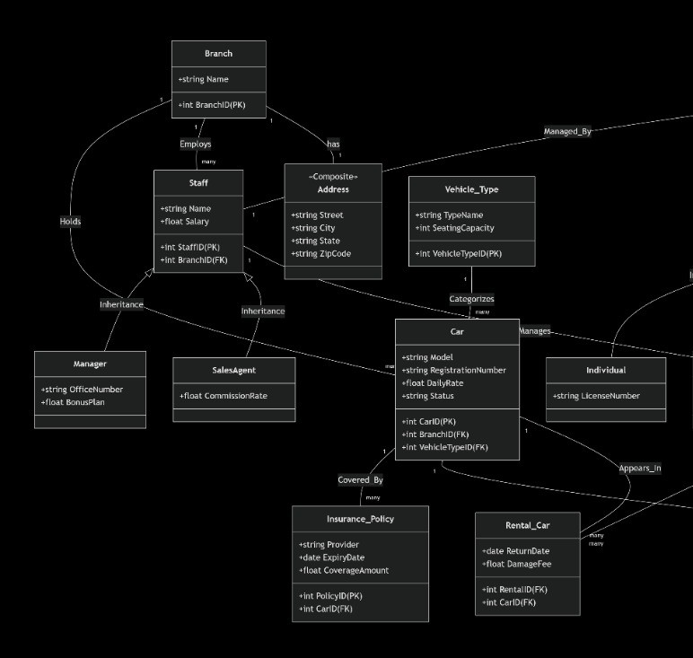

EER Diagram - 2

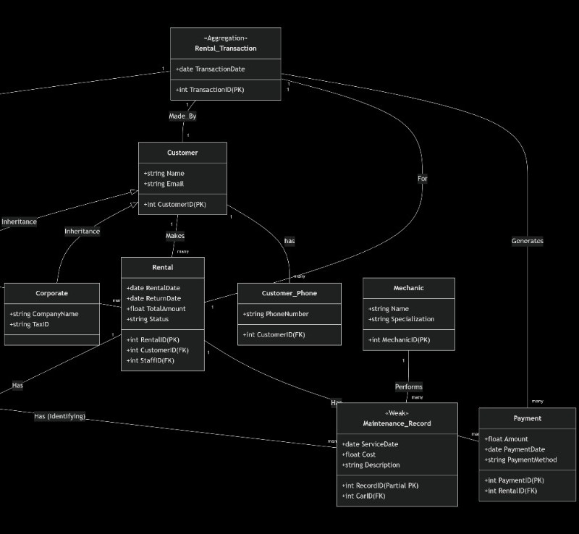

Finalized 3NF Schema

# | Table Name | Primary Key | Foreign Key(s)
1 | Customer | CustomerID | –
2 | Customer_Phone | (CustomerID, PhoneNumber) | CustomerID → Customer
3 | Individual | CustomerID | CustomerID → Customer
4 | Corporate | CustomerID | CustomerID → Customer
5 | Staff | StaffID | BranchID → Branch
6 | Manager | StaffID | StaffID → Staff
7 | SalesAgent | StaffID | StaffID → Staff
8 | Branch | BranchID | –
9 | Address | BranchID | BranchID → Branch
10 | Car | CarID | BranchID → Branch,  VehicleTypeID → Vehicle_Type
11 | Vehicle_Type | VehicleTypeID | –
12 | Rental | RentalID | CustomerID → Customer,  StaffID → Staff
13 | Rental_Car | (RentalID, CarID) | RentalID → Rental,  CarID → Car
14 | Payment | PaymentID | RentalID → Rental
15 | Insurance_Policy | PolicyID | CarID → Car
16 | Mechanic | MechanicID | –
17 | Maintenance_Record | (CarID, RecordID) | CarID → Car
18 | Rental_Transaction | TransactionID | StaffID → Staff,  CustomerID → Customer,  RentalID → Rental

SQL Code Repository

Schema_Design.sql

-- ==============================================================================
-- PART 1: DATA DEFINITION LANGUAGE (DDL) SCRIPT
-- RDBMS: Microsoft SQL Server (SSMS) / T-SQL
-- ==============================================================================

-- ------------------------------------------------------------------------------
-- 1. DROP EXISTING TABLES (Reverse Dependency Order to prevent FK errors)
-- ------------------------------------------------------------------------------
DROP TABLE IF EXISTS Rental_Transaction;
DROP TABLE IF EXISTS Payment;
DROP TABLE IF EXISTS Rental_Car;
DROP TABLE IF EXISTS Rental;
DROP TABLE IF EXISTS Maintenance_Record;
DROP TABLE IF EXISTS Insurance_Policy;
DROP TABLE IF EXISTS Car;
DROP TABLE IF EXISTS Vehicle_Type;
DROP TABLE IF EXISTS Mechanic;
DROP TABLE IF EXISTS SalesAgent;
DROP TABLE IF EXISTS Manager;
DROP TABLE IF EXISTS Staff;
DROP TABLE IF EXISTS Address;
DROP TABLE IF EXISTS Branch;
DROP TABLE IF EXISTS Corporate;
DROP TABLE IF EXISTS Individual;
DROP TABLE IF EXISTS Customer_Phone;
DROP TABLE IF EXISTS Customer;

-- ------------------------------------------------------------------------------
-- 2. CREATE TABLES (Dependency Order)
-- ------------------------------------------------------------------------------

-- ==========================================
-- LEVEL 0: Foundation Tables (Independent)
-- ==========================================

CREATE TABLE Customer (
CustomerID INT PRIMARY KEY,
Name VARCHAR(100) NOT NULL,
Email VARCHAR(100) UNIQUE NOT NULL
);

CREATE TABLE Branch (
BranchID INT PRIMARY KEY,
Name VARCHAR(100) NOT NULL
);

CREATE TABLE Vehicle_Type (
VehicleTypeID INT PRIMARY KEY,
TypeName VARCHAR(50) NOT NULL,
SeatingCapacity INT CHECK (SeatingCapacity > 0)
);

CREATE TABLE Mechanic (
MechanicID INT PRIMARY KEY,

Name VARCHAR(100) NOT NULL,
Specialization VARCHAR(100)
);

-- ==========================================
-- LEVEL 1: First-Degree Dependents
-- ==========================================

CREATE TABLE Customer_Phone (
CustomerID INT,
PhoneNumber VARCHAR(20),
PRIMARY KEY (CustomerID, PhoneNumber),
CONSTRAINT fk_custphone_customer FOREIGN KEY (CustomerID)
REFERENCES Customer(CustomerID)
ON DELETE CASCADE
ON UPDATE CASCADE
);

CREATE TABLE Individual (
CustomerID INT PRIMARY KEY,
LicenseNumber VARCHAR(50) UNIQUE NOT NULL,
CONSTRAINT fk_individual_customer FOREIGN KEY (CustomerID)
REFERENCES Customer(CustomerID)
ON DELETE CASCADE
ON UPDATE CASCADE
);

CREATE TABLE Corporate (
CustomerID INT PRIMARY KEY,
CompanyName VARCHAR(100) NOT NULL,
TaxID VARCHAR(50) UNIQUE NOT NULL,
CONSTRAINT fk_corporate_customer FOREIGN KEY (CustomerID)
REFERENCES Customer(CustomerID)
ON DELETE CASCADE
ON UPDATE CASCADE
);

CREATE TABLE Address (
BranchID INT PRIMARY KEY, -- 1:1 Relationship with Branch
Street VARCHAR(150),
City VARCHAR(50),
State VARCHAR(50),
ZipCode VARCHAR(20),
CONSTRAINT fk_address_branch FOREIGN KEY (BranchID)
REFERENCES Branch(BranchID)
ON DELETE CASCADE
ON UPDATE CASCADE
);

CREATE TABLE Staff (
StaffID INT PRIMARY KEY,
BranchID INT NOT NULL,
Name VARCHAR(100) NOT NULL,
Salary DECIMAL(10, 2) CHECK (Salary > 0),
CONSTRAINT fk_staff_branch FOREIGN KEY (BranchID)
REFERENCES Branch(BranchID)
ON DELETE CASCADE
ON UPDATE CASCADE
);

-- ==========================================

-- LEVEL 2: Second-Degree Dependents
-- ==========================================

CREATE TABLE Manager (
StaffID INT PRIMARY KEY,
OfficeNumber VARCHAR(20),
BonusPlan VARCHAR(50),
CONSTRAINT fk_manager_staff FOREIGN KEY (StaffID)
REFERENCES Staff(StaffID)
ON DELETE CASCADE
ON UPDATE CASCADE
);

CREATE TABLE SalesAgent (
StaffID INT PRIMARY KEY,
CommissionRate DECIMAL(5, 2) CHECK (CommissionRate >= 0),
CONSTRAINT fk_salesagent_staff FOREIGN KEY (StaffID)
REFERENCES Staff(StaffID)
ON DELETE CASCADE
ON UPDATE CASCADE
);

CREATE TABLE Car (
CarID INT PRIMARY KEY,
BranchID INT NOT NULL,
VehicleTypeID INT NOT NULL,
Model VARCHAR(100) NOT NULL,
RegistrationNumber VARCHAR(50) UNIQUE NOT NULL,
DailyRate DECIMAL(10, 2) CHECK (DailyRate > 0),
Status VARCHAR(20) DEFAULT 'Available' CHECK (Status IN ('Available', 'Rented', 'Maintenance')),
CONSTRAINT fk_car_branch FOREIGN KEY (BranchID)
REFERENCES Branch(BranchID)
ON DELETE CASCADE
ON UPDATE CASCADE,
CONSTRAINT fk_car_vehicletype FOREIGN KEY (VehicleTypeID)
REFERENCES Vehicle_Type(VehicleTypeID)
ON DELETE CASCADE
ON UPDATE CASCADE
);

-- ==========================================
-- LEVEL 3 & 4: Operations & Transactions
-- ==========================================

CREATE TABLE Insurance_Policy (
PolicyID INT PRIMARY KEY,
CarID INT NOT NULL,
Provider VARCHAR(100) NOT NULL,
ExpiryDate DATE NOT NULL,
CoverageAmount DECIMAL(15, 2),
CONSTRAINT fk_insurance_car FOREIGN KEY (CarID)
REFERENCES Car(CarID)
ON DELETE CASCADE
ON UPDATE CASCADE
);

CREATE TABLE Maintenance_Record (
CarID INT,
RecordID INT,

ServiceDate DATE NOT NULL,

Cost DECIMAL(10, 2) CHECK (Cost >= 0),
Description VARCHAR(255),
PRIMARY KEY (CarID, RecordID),
CONSTRAINT fk_maintenance_car FOREIGN KEY (CarID)
REFERENCES Car(CarID)
ON DELETE CASCADE
ON UPDATE CASCADE
);

CREATE TABLE Rental (
RentalID INT PRIMARY KEY,
CustomerID INT NOT NULL,
StaffID INT NOT NULL,
RentalDate DATE NOT NULL,
ReturnDate DATE,
TotalAmount DECIMAL(12, 2),
Status VARCHAR(20) DEFAULT 'Active' CHECK (Status IN ('Active', 'Completed', 'Cancelled')),
CONSTRAINT fk_rental_customer FOREIGN KEY (CustomerID)
REFERENCES Customer(CustomerID)
ON DELETE CASCADE
ON UPDATE CASCADE,
CONSTRAINT fk_rental_staff FOREIGN KEY (StaffID)
REFERENCES Staff(StaffID)
ON DELETE NO ACTION -- NO ACTION prevents SSMS multiple cascade path error
ON UPDATE NO ACTION
);

CREATE TABLE Rental_Car (
RentalID INT,
CarID INT,
ReturnDate DATE,
DamageFee DECIMAL(10, 2) DEFAULT 0 CHECK (DamageFee >= 0),
PRIMARY KEY (RentalID, CarID),
CONSTRAINT fk_rentalcar_rental FOREIGN KEY (RentalID)
REFERENCES Rental(RentalID)
ON DELETE CASCADE
ON UPDATE CASCADE,
CONSTRAINT fk_rentalcar_car FOREIGN KEY (CarID)
REFERENCES Car(CarID)
ON DELETE NO ACTION -- NO ACTION prevents SSMS multiple cascade path error
ON UPDATE NO ACTION
);

CREATE TABLE Payment (
PaymentID INT PRIMARY KEY,
RentalID INT NOT NULL,
Amount DECIMAL(10, 2) NOT NULL CHECK (Amount > 0),
PaymentDate DATE NOT NULL,
PaymentMethod VARCHAR(50),
CONSTRAINT fk_payment_rental FOREIGN KEY (RentalID)
REFERENCES Rental(RentalID)
ON DELETE CASCADE
ON UPDATE CASCADE
);

CREATE TABLE Rental_Transaction (
TransactionID INT PRIMARY KEY,
StaffID INT NOT NULL,

CustomerID INT NOT NULL,
RentalID INT NOT NULL,

TransactionDate DATE NOT NULL,
CONSTRAINT fk_rentaltx_staff FOREIGN KEY (StaffID)
REFERENCES Staff(StaffID)
ON DELETE NO ACTION -- NO ACTION prevents SSMS multiple cascade path error
ON UPDATE NO ACTION,
CONSTRAINT fk_rentaltx_customer FOREIGN KEY (CustomerID)
REFERENCES Customer(CustomerID)
ON DELETE NO ACTION
ON UPDATE NO ACTION,
CONSTRAINT fk_rentaltx_rental FOREIGN KEY (RentalID)
REFERENCES Rental(RentalID)
ON DELETE CASCADE
ON UPDATE CASCADE
);

Data_Population.sql

-- ==============================================================================
-- PART 2: DATA MANIPULATION LANGUAGE (DML) SCRIPT
-- RDBMS: Microsoft SQL Server (SSMS) / T-SQL
-- Rules Applied: Minimum 10 rows per table, Parent-first sequence, Realistic data
-- ==============================================================================

-- ==========================================
-- LEVEL 0: Foundation Tables
-- ==========================================

INSERT INTO Customer (CustomerID, Name, Email) VALUES
(1, 'Alice Smith', 'alice.smith@email.com'), (2, 'Bob Johnson', 'bjohnson@email.com'),
(3, 'Charlie Brown', 'cbrown@email.com'), (4, 'Diana Prince', 'dprince@email.com'),
(5, 'Evan Wright', 'ewright@email.com'), (6, 'Fiona Gallagher', 'fgallagher@email.com'),
(7, 'George Costanza', 'gcostanza@email.com'), (8, 'Hannah Abbott', 'habbott@email.com'),
(9, 'Ian Malcolm', 'imalcolm@email.com'), (10, 'Julia Roberts', 'jroberts@email.com'),
(11, 'Acme Corp', 'contact@acme.com'), (12, 'Globex Inc', 'billing@globex.com'),
(13, 'Initech', 'admin@initech.com'), (14, 'Umbrella Corp', 'fleet@umbrella.com'),
(15, 'Stark Industries', 'transport@stark.com'), (16, 'Wayne Enterprises', 'logistics@wayne.com'),
(17, 'Massive Dynamic', 'info@massivedynamic.com'), (18, 'Cyberdyne', 'accounts@cyberdyne.com'),
(19, 'Hooli', 'travel@hooli.com'), (20, 'Pied Piper', 'operations@piedpiper.com');

INSERT INTO Branch (BranchID, Name) VALUES
(1, 'Downtown Central'), (2, 'International Airport'), (3, 'Westside Suburbs'),
(4, 'Eastside Business Park'), (5, 'North Station'), (6, 'Southside Highway'),
(7, 'University Campus'), (8, 'Harbor District'), (9, 'Financial District'),
(10, 'Midtown Mall');

INSERT INTO Vehicle_Type (VehicleTypeID, TypeName, SeatingCapacity) VALUES
(1, 'Economy', 4), (2, 'Compact', 5), (3, 'Mid-Size', 5),
(4, 'Full-Size', 5), (5, 'Luxury Sedan', 5), (6, 'Compact SUV', 5),
(7, 'Full-Size SUV', 7), (8, 'Minivan', 7), (9, 'Pickup Truck', 4),

(10, 'Cargo Van', 2);

INSERT INTO Mechanic (MechanicID, Name, Specialization) VALUES
(1, 'Mike Torque', 'Engine Diagnostics'), (2, 'Sarah Tread', 'Tires & Alignment'),
(3, 'John Spark', 'Electrical Systems'), (4, 'Dave Brake', 'Braking Systems'),
(5, 'Lisa Shift', 'Transmission'), (6, 'Tom Body', 'Bodywork & Paint'),
(7, 'Rick Filter', 'Routine Maintenance'), (8, 'Ann Cool', 'AC Systems'),
(9, 'Paul Axle', 'Suspension'), (10, 'Tina Glass', 'Windshield & Glass');

-- ==========================================
-- LEVEL 1: First-Degree Dependents
-- ==========================================

INSERT INTO Individual (CustomerID, LicenseNumber) VALUES
(1, 'DL-1001-TX'), (2, 'DL-1002-NY'), (3, 'DL-1003-CA'), (4, 'DL-1004-FL'),
(5, 'DL-1005-WA'), (6, 'DL-1006-OR'), (7, 'DL-1007-NV'), (8, 'DL-1008-AZ'),
(9, 'DL-1009-UT'), (10, 'DL-1010-CO');

INSERT INTO Corporate (CustomerID, CompanyName, TaxID) VALUES
(11, 'Acme Corp', 'TAX-9001'), (12, 'Globex Inc', 'TAX-9002'),
(13, 'Initech', 'TAX-9003'), (14, 'Umbrella Corp', 'TAX-9004'),
(15, 'Stark Industries', 'TAX-9005'), (16, 'Wayne Enterprises', 'TAX-9006'),
(17, 'Massive Dynamic', 'TAX-9007'), (18, 'Cyberdyne', 'TAX-9008'),
(19, 'Hooli', 'TAX-9009'), (20, 'Pied Piper', 'TAX-9010');

INSERT INTO Customer_Phone (CustomerID, PhoneNumber) VALUES
(1, '555-0101'), (2, '555-0102'), (3, '555-0103'), (4, '555-0104'),
(5, '555-0105'), (11, '555-0201'), (12, '555-0202'), (13, '555-0203'),
(14, '555-0204'), (15, '555-0205');

INSERT INTO Address (BranchID, Street, City, State, ZipCode) VALUES
(1, '100 Main St', 'Metropolis', 'NY', '10001'), (2, '500 Airport Blvd', 'Metropolis', 'NY', '10002'),
(3, '250 West Ave', 'Gotham', 'NJ', '07001'), (4, '789 Tech Parkway', 'San Jose', 'CA', '95112'),
(5, '45 North Blvd', 'Chicago', 'IL', '60601'), (6, '99 South Rd', 'Houston', 'TX', '77001'),
(7, '101 College Way', 'Boston', 'MA', '02115'), (8, '88 Pier St', 'Seattle', 'WA', '98101'),
(9, '200 Wall St', 'Metropolis', 'NY', '10005'), (10, '300 Center Plaza', 'Denver', 'CO', '80202');

INSERT INTO Staff (StaffID, BranchID, Name, Salary) VALUES
(1, 1, 'Manager Mark', 85000.00), (2, 2, 'Manager Mary', 88000.00),
(3, 3, 'Manager Matt', 82000.00), (4, 4, 'Manager Megan', 90000.00),
(5, 5, 'Manager Miles', 80000.00), (6, 6, 'Manager Molly', 84000.00),
(7, 7, 'Manager Mason', 81000.00), (8, 8, 'Manager Mia', 86000.00),
(9, 9, 'Manager Max', 92000.00), (10, 10, 'Manager Maya', 83000.00),
(11, 1, 'Agent Andy', 45000.00), (12, 2, 'Agent Anna', 46000.00),
(13, 3, 'Agent Alex', 44000.00), (14, 4, 'Agent Amy', 47000.00),
(15, 5, 'Agent Aaron', 43000.00), (16, 6, 'Agent Alice', 45500.00),
(17, 7, 'Agent Adam', 44500.00), (18, 8, 'Agent Ava', 46500.00),
(19, 9, 'Agent Alan', 48000.00), (20, 10, 'Agent Aria', 45000.00);

-- ==========================================
-- LEVEL 2: Second-Degree Dependents
-- ==========================================

INSERT INTO Manager (StaffID, OfficeNumber, BonusPlan) VALUES
(1, 'M-101', 'Standard 10%'), (2, 'M-102', 'Premium 15%'), (3, 'M-103', 'Standard 10%'),

(4, 'M-104', 'Corporate 20%'), (5, 'M-105', 'Standard 10%'), (6, 'M-106', 'Standard 10%'),
(7, 'M-107', 'University 12%'), (8, 'M-108', 'Premium 15%'), (9, 'M-109', 'Corporate 20%'),
(10, 'M-110', 'Standard 10%');

INSERT INTO SalesAgent (StaffID, CommissionRate) VALUES
(11, 0.05), (12, 0.06), (13, 0.05), (14, 0.07), (15, 0.04),
(16, 0.05), (17, 0.05), (18, 0.06), (19, 0.08), (20, 0.05);

INSERT INTO Car (CarID, BranchID, VehicleTypeID, Model, RegistrationNumber, DailyRate, Status) VALUES
(1, 1, 1, 'Toyota Corolla', 'REG-1001', 35.00, 'Available'),
(2, 2, 5, 'Mercedes C-Class', 'REG-1002', 120.00, 'Rented'),
(3, 3, 6, 'Honda CR-V', 'REG-1003', 55.00, 'Available'),
(4, 4, 3, 'Nissan Altima', 'REG-1004', 45.00, 'Maintenance'),
(5, 5, 8, 'Dodge Grand Caravan', 'REG-1005', 70.00, 'Available'),
(6, 6, 9, 'Ford F-150', 'REG-1006', 85.00, 'Rented'),
(7, 7, 2, 'Hyundai Elantra', 'REG-1007', 40.00, 'Available'),
(8, 8, 7, 'Chevrolet Tahoe', 'REG-1008', 110.00, 'Available'),
(9, 9, 5, 'BMW 5 Series', 'REG-1009', 130.00, 'Rented'),
(10, 10, 4, 'Toyota Camry', 'REG-1010', 50.00, 'Available');

-- ==========================================
-- LEVEL 3 & 4: Operations & Transactions
-- ==========================================

INSERT INTO Insurance_Policy (PolicyID, CarID, Provider, ExpiryDate, CoverageAmount) VALUES
(1, 1, 'Geico', '2026-12-31', 50000.00), (2, 2, 'Progressive', '2026-11-30', 100000.00),
(3, 3, 'State Farm', '2027-01-15', 75000.00), (4, 4, 'Allstate', '2026-10-20', 50000.00),
(5, 5, 'Geico', '2026-12-31', 75000.00), (6, 6, 'Progressive', '2027-03-01', 80000.00),
(7, 7, 'State Farm', '2026-09-15', 50000.00), (8, 8, 'Allstate', '2027-05-10', 100000.00),
(9, 9, 'Geico', '2026-12-31', 150000.00), (10, 10, 'Progressive', '2027-02-28', 50000.00);

INSERT INTO Maintenance_Record (CarID, RecordID, ServiceDate, Cost, Description) VALUES
(1, 1, '2026-01-15', 50.00, 'Oil Change'), (2, 2, '2026-02-10', 120.00, 'Brake Pad Replacement'),
(3, 3, '2026-03-05', 400.00, 'New Tires'), (4, 4, '2026-05-25', 150.00, 'Battery Replacement'),
(5, 5, '2026-04-12', 60.00, 'Air Filter and Fluids'), (6, 6, '2026-01-20', 80.00, 'Alignment'),
(7, 7, '2026-02-28', 45.00, 'Oil Change'), (8, 8, '2026-03-15', 250.00, 'Detailing and Deep Clean'),
(9, 9, '2026-04-02', 300.00, 'Scheduled 30k Mile Service'), (10, 10, '2026-05-18', 55.00, 'Wiper Blades and Fluids');

-- Note: StaffIDs 11-20 are used here, representing the Sales Agents who process rentals
INSERT INTO Rental (RentalID, CustomerID, StaffID, RentalDate, ReturnDate, TotalAmount, Status) VALUES
(1, 1, 11, '2026-05-01', '2026-05-03', 70.00, 'Completed'),
(2, 12, 12, '2026-05-20', '2026-05-25', 600.00, 'Active'),
(3, 3, 13, '2026-04-10', '2026-04-12', 110.00, 'Completed'),
(4, 14, 14, '2026-05-22', NULL, 0.00, 'Active'),

(5, 5, 15, '2026-03-15', '2026-03-20', 350.00, 'Completed'),
(6, 16, 16, '2026-05-24', '2026-05-26', 170.00, 'Active'),
(7, 7, 17, '2026-02-01', '2026-02-05', 160.00, 'Completed'),
(8, 18, 18, '2026-04-20', '2026-04-25', 550.00, 'Completed'),
(9, 9, 19, '2026-05-25', '2026-05-28', 390.00, 'Active'),
(10, 20, 20, '2026-01-10', '2026-01-12', 100.00, 'Completed');

INSERT INTO Rental_Car (RentalID, CarID, ReturnDate, DamageFee) VALUES
(1, 1, '2026-05-03', 0.00), (2, 2, NULL, 0.00),
(3, 3, '2026-04-12', 0.00), (4, 4, NULL, 0.00),
(5, 5, '2026-03-20', 50.00), (6, 6, NULL, 0.00),
(7, 7, '2026-02-05', 0.00), (8, 8, '2026-04-25', 0.00),
(9, 9, NULL, 0.00), (10, 10, '2026-01-12', 0.00);

INSERT INTO Payment (PaymentID, RentalID, Amount, PaymentDate, PaymentMethod) VALUES
(1, 1, 70.00, '2026-05-01', 'Credit Card'), (2, 2, 300.00, '2026-05-20', 'Corporate Account'),
(3, 3, 110.00, '2026-04-10', 'Debit Card'), (4, 4, 100.00, '2026-05-22', 'Corporate Account'),
(5, 5, 400.00, '2026-03-20', 'Credit Card'), (6, 6, 170.00, '2026-05-24', 'Corporate Account'),
(7, 7, 160.00, '2026-02-01', 'Cash'), (8, 8, 550.00, '2026-04-20', 'Corporate Account'),
(9, 9, 390.00, '2026-05-25', 'Credit Card'), (10, 10, 100.00, '2026-01-10', 'Corporate Account');

INSERT INTO Rental_Transaction (TransactionID, StaffID, CustomerID, RentalID, TransactionDate) VALUES
(1, 11, 1, 1, '2026-05-01'), (2, 12, 12, 2, '2026-05-20'),
(3, 13, 3, 3, '2026-04-10'), (4, 14, 14, 4, '2026-05-22'),
(5, 15, 5, 5, '2026-03-15'), (6, 16, 16, 6, '2026-05-24'),
(7, 17, 7, 7, '2026-02-01'), (8, 18, 18, 8, '2026-04-20'),
(9, 19, 9, 9, '2026-05-25'), (10, 20, 20, 10, '2026-01-10');

Business_Queries.sql

-- ==============================================================================
-- PART 3: DATABASE QUERYING & OPTIMIZATION (10 Business Queries)
-- RDBMS: Microsoft SQL Server (SSMS) / T-SQL
-- ==============================================================================

-- ------------------------------------------------------------------------------
-- REQUIREMENT 1: MULTI-TABLE JOINS (Minimum 3 Queries)
-- ------------------------------------------------------------------------------

-- Query 1: INNER JOIN (4 Tables)
-- Business Question: "Generate a comprehensive list of all active rentals, showing the customer name, the staff member who processed it, and the branch location."
SELECT
r.RentalID,
c.Name AS CustomerName,
s.Name AS ProcessedBy_Agent,
b.Name AS BranchLocation,
r.RentalDate
FROM Rental r
INNER JOIN Customer c ON r.CustomerID = c.CustomerID
INNER JOIN Staff s ON r.StaffID = s.StaffID
INNER JOIN Branch b ON s.BranchID = b.BranchID
WHERE r.Status = 'Active';

-- Query 2: LEFT JOIN
-- Business Question: "Review our vehicle catalog to see which vehicle types we currently have in our fleet, including vehicle types we offer but currently have zero cars for (e.g., Cargo Vans)."
SELECT
vt.TypeName,
vt.SeatingCapacity,
c.Model,
c.RegistrationNumber
FROM Vehicle_Type vt
LEFT JOIN Car c ON vt.VehicleTypeID = c.VehicleTypeID
ORDER BY vt.TypeName;

-- Query 3: INNER JOIN (Targeting Sub-types)
-- Business Question: "Create a direct contact directory specifically for our Corporate clients, including their phone numbers and Tax IDs."
SELECT
corp.CompanyName,
corp.TaxID,
c.Email,
cp.PhoneNumber
FROM Corporate corp
INNER JOIN Customer c ON corp.CustomerID = c.CustomerID
INNER JOIN Customer_Phone cp ON c.CustomerID = cp.CustomerID;

-- ------------------------------------------------------------------------------
-- REQUIREMENT 2: DATA AGGREGATION WITH GROUP BY & HAVING (Minimum 2 Queries)
-- ------------------------------------------------------------------------------

-- Query 4: SUM, GROUP BY, HAVING
-- Business Question: "Calculate the total revenue generated by each branch, but only display the top-performing branches that have generated more than $300 in total payments."
SELECT
b.Name AS BranchName,
SUM(p.Amount) AS TotalRevenue
FROM Branch b
INNER JOIN Staff s ON b.BranchID = s.BranchID
INNER JOIN Rental r ON s.StaffID = r.StaffID
INNER JOIN Payment p ON r.RentalID = p.RentalID
GROUP BY b.Name
HAVING SUM(p.Amount) > 300;

-- Query 5: AVG, COUNT, GROUP BY, HAVING
-- Business Question: "What is the average daily rental rate for each vehicle type? Only show vehicle types where we own at least 2 cars of that type."
SELECT
vt.TypeName,
COUNT(c.CarID) AS NumberOfCarsOwned,
AVG(c.DailyRate) AS AverageDailyRate
FROM Vehicle_Type vt
INNER JOIN Car c ON vt.VehicleTypeID = c.VehicleTypeID
GROUP BY vt.TypeName
HAVING COUNT(c.CarID) >= 2;

-- ------------------------------------------------------------------------------
-- REQUIREMENT 3: SUBQUERIES (Minimum 2 Queries)
-- ------------------------------------------------------------------------------

-- Query 6: Subquery using IN
-- Business Question: "Identify all customers who have rented premium/large

vehicles (Luxury Sedans or Full-Size SUVs) so we can target them for an upcoming VIP promotion."
SELECT
Name AS VIP_Customer,
Email
FROM Customer
WHERE CustomerID IN (
SELECT r.CustomerID
FROM Rental r
INNER JOIN Rental_Car rc ON r.RentalID = rc.RentalID
INNER JOIN Car c ON rc.CarID = c.CarID
INNER JOIN Vehicle_Type vt ON c.VehicleTypeID = vt.VehicleTypeID
WHERE vt.TypeName IN ('Luxury Sedan', 'Full-Size SUV')
);

-- Query 7: Scalar Subquery
-- Business Question: "List the specific car models and their daily rates that are priced higher than the overall average daily rate of our entire fleet."
SELECT
Model,
RegistrationNumber,
DailyRate
FROM Car
WHERE DailyRate > (
SELECT AVG(DailyRate)
FROM Car
);

-- Query 8: Subquery using EXISTS
-- Business Question: "Which branches currently have cars undergoing maintenance? (This helps logistics know which branches might be short on inventory)."
SELECT
Name AS Branches_With_Cars_In_Shop
FROM Branch b
WHERE EXISTS (
SELECT 1
FROM Car c
WHERE c.BranchID = b.BranchID
AND c.Status = 'Maintenance'
);

-- ------------------------------------------------------------------------------
-- REQUIREMENT 4: ADDITIONAL BUSINESS QUERIES (To meet the 10 total minimum)
-- ------------------------------------------------------------------------------

-- Query 9: Date Functions & Filtering
-- Business Question: "Which vehicle insurance policies are expiring in the year 2026 and need to be flagged for renewal by the fleet manager?"
SELECT
ip.Provider,
c.Model,
c.RegistrationNumber,
ip.ExpiryDate,
ip.CoverageAmount
FROM Insurance_Policy ip
INNER JOIN Car c ON ip.CarID = c.CarID
WHERE YEAR(ip.ExpiryDate) = 2026
ORDER BY ip.ExpiryDate ASC;

-- Query 10: MAX / Complex Analytics
-- Business Question: "What was the single largest payment amount we have received,

and which rental transaction and customer was it associated with?"
SELECT TOP 1
p.Amount AS LargestPayment,
p.PaymentDate,
p.PaymentMethod,
c.Name AS CustomerName,
r.RentalID
FROM Payment p
INNER JOIN Rental r ON p.RentalID = r.RentalID
INNER JOIN Customer c ON r.CustomerID = c.CustomerID
ORDER BY p.Amount DESC;

-- ==============================================================================
-- MUST ADD THIS 'GO' STATEMENT HERE
-- ==============================================================================
GO

-- ==============================================================================
-- ADVANCED OBJECT 1: DATABASE VIEW
-- Business Use: Simplifies a 5-table join to instantly view all active rentals.
-- ==============================================================================

CREATE VIEW vw_ActiveRentalDetails AS
SELECT
r.RentalID,
c.Name AS CustomerName,
c.Email,
car.Model,
car.RegistrationNumber,
r.RentalDate,
r.ReturnDate,
s.Name AS ProcessedBy_Agent
FROM Rental r
INNER JOIN Customer c ON r.CustomerID = c.CustomerID
INNER JOIN Rental_Car rc ON r.RentalID = rc.RentalID
INNER JOIN Car car ON rc.CarID = car.CarID
INNER JOIN Staff s ON r.StaffID = s.StaffID
WHERE r.Status = 'Active';

-- ==============================================================================
-- MUST ADD ANOTHER 'GO' STATEMENT HERE
-- ==============================================================================
GO

-- ==============================================================================
-- ADVANCED OBJECT 2: DATABASE TRIGGER
-- Business Use: Automates fleet inventory management by updating car status.
-- ==============================================================================

CREATE TRIGGER trg_UpdateCarStatusOnRental
ON Rental_Car
AFTER INSERT
AS
BEGIN
UPDATE Car
SET Status = 'Rented'
WHERE CarID IN (SELECT CarID FROM inserted);

PRINT 'Trigger Executed: Car status automatically updated to Rented.';
END;
GO

Business Query Executions

