

NAME : S.SATHISH
REGNO: 121012013764
COURSE CODE: XCSHD04
COURSE NAME: INTERNET OF THINGS
DEPARTMENT: B.TECH-CSE
YEAR: 3rd YEAR

MQTT Protocol

MQTT (Message Queuing Telemetry Transport) is a lightweight, publish-subscribe messaging protocol designed for constrained devices and low-bandwidth, high-latency or unreliable networks. It was developed by IBM in the late 1990s and later standardized by OASIS. MQTT operates on top of the TCP/IP protocol, but it can also work on other transport layers like UDP, WebSocket, etc.

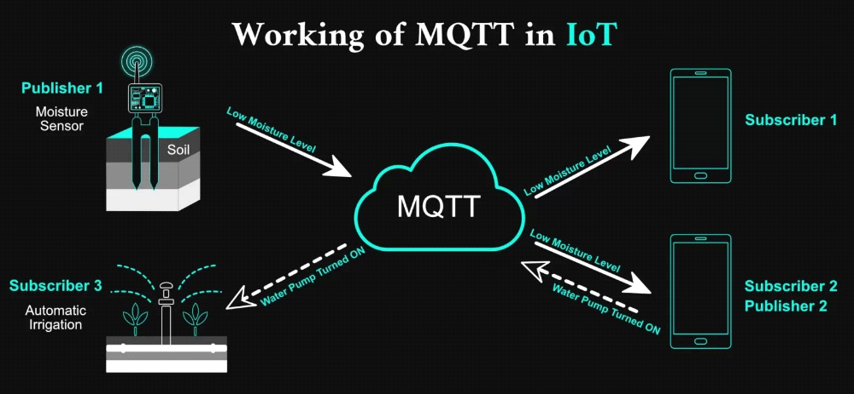

Key Components of MQTT:

1. Client: MQTT clients are devices or applications that connect to an MQTT broker to send or receive messages.

2. Broker: The MQTT broker is a server that acts as an intermediary between clients. It receives messages from clients, processes them, and then sends them to other clients based on the topic subscriptions.

3. Topic: Messages in MQTT are published to a specific topic. Clients can subscribe to topics to receive messages that are published to them.

4. Message: The payload of information transmitted between MQTT clients via the broker. It can be any arbitrary data.

Pros of MQTT:

1. Lightweight: MQTT is designed to be lightweight and efficient, making it suitable for resource-constrained devices and low-bandwidth networks.

2. Asynchronous Communication: MQTT operates on a publish-subscribe model, enabling asynchronous communication between clients. This decouples publishers from subscribers, improving scalability and flexibility.

3. Reliability: MQTT supports Quality of Service (QoS) levels, allowing publishers to specify the level of message delivery assurance required. This ensures reliable message delivery even in unreliable networks.

4. Scalability: MQTT brokers can handle a large number of clients simultaneously, making it suitable for scalable IoT deployments.

5. Low Overhead: MQTT has minimal protocol overhead, reducing network bandwidth and power consumption, which is crucial for IoT devices.

Cons of MQTT:

1. Security: While MQTT supports basic security mechanisms like username/password authentication and TLS encryption, it may not provide comprehensive security features out-of-the-box. Additional measures may be required to ensure secure communication.
2. Complexity in QoS Levels: While QoS levels provide flexibility in message delivery, they can add complexity to the implementation and may increase network overhead.

3. Connection Overhead: Establishing and maintaining a connection with the MQTT broker can introduce overhead, especially for devices with limited resources or intermittent connectivity.

4. Lack of Built-in Support for Some Features: MQTT does not provide built-in support for features like message persistence, message queuing, or request-response patterns. These functionalities may need to be implemented separately if required.
Applications of MQTT:

- Internet of Things (IoT): Enables efficient communication between IoT devices in applications like smart homes, industrial automation, and agriculture.

- Telemetry and Remote Monitoring: Used for real-time data collection and monitoring in fields such as asset tracking, energy management, and healthcare.

- Home Automation: Facilitates seamless control and automation of smart devices in homes and buildings.

- Asset Tracking and Management: Enables real-time tracking and management of assets in logistics, supply chain, and fleet management.

- Energy Management: Helps monitor and optimize energy consumption in buildings, factories, and facilities.

- Healthcare Monitoring: Supports remote patient monitoring, medical device connectivity, and healthcare asset management.

- Industrial Automation and Control: Used for monitoring and controlling manufacturing processes, machinery, and equipment in industrial settings.

- Smart Agriculture: Facilitates monitoring of environmental conditions, crop health, and irrigation systems in agriculture.

- Smart Cities: Supports various smart city applications such as traffic management, waste management, and environmental monitoring.

- Mobile and Web Applications: Integrated into applications to enable real-time messaging and notifications for enhanced user experiences.

CoAP Protocol

CoAP (Constrained Application Protocol) is a lightweight and efficient application layer protocol designed for constrained devices and constrained networks, particularly in IoT applications. It is RESTful and operates over UDP, offering similar functionalities to HTTP but with optimizations for resource-constrained environments. CoAP is defined in RFC 7252.

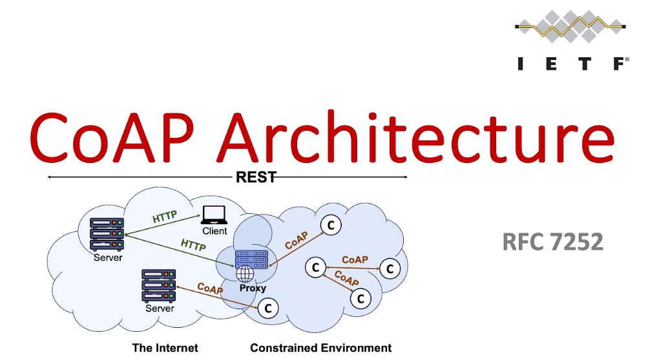

Key Features of CoAP:

1. Lightweight Messaging: CoAP uses compact binary messages for communication, reducing overhead and conserving bandwidth. This makes it suitable for devices with limited resources and low-power networks.

2. Request-Response Model: CoAP follows a request-response model similar to HTTP, allowing clients to send requests to servers to retrieve or modify resources.

3. Low Power Consumption: CoAP is designed to minimize energy consumption, making it suitable for battery-operated devices and IoT deployments.

4. Support for Proxying and Caching: CoAP supports proxying and caching mechanisms, enabling scalability and efficient communication between clients and servers.

5. Reliability: CoAP provides optional reliability mechanisms using acknowledgments and retransmissions, ensuring reliable message delivery over unreliable networks.

6. Observing Resources: CoAP supports resource observation, allowing clients to subscribe to resources and receive notifications when their state changes. This is useful for real-time monitoring and event-driven applications.

7. Security: CoAP can be secured using Datagram Transport Layer Security (DTLS) for encryption and authentication, providing secure communication between devices and servers.

Pros of CoAP:

1. Efficiency: CoAP's lightweight design minimizes message size and protocol overhead, making it suitable for resource-constrained devices and low-bandwidth networks.

2. Scalability: CoAP supports proxying and caching mechanisms, enabling scalable communication between clients and servers in large-scale deployments.

3. Interoperability: CoAP is designed to be interoperable with existing web technologies, allowing seamless integration with HTTP-based systems and services.

4. Low Latency: CoAP's UDP-based communication and optional reliability mechanisms help minimize latency, making it suitable for real-time applications.

5. RESTful Design: CoAP follows a RESTful architecture, simplifying the development of web-like interfaces for IoT devices and applications.

6. Support for Observing Resources: CoAP's support for resource observation allows efficient event-driven communication between clients and servers, reducing polling overhead.

Cons of CoAP:

1. Limited Adoption: CoAP adoption is not as widespread as other protocols like MQTT, particularly in certain industries and application domains.

2. Complexity in Reliability: While CoAP provides optional reliability mechanisms, managing retransmissions and acknowledgments can add complexity to implementations.

3. Security Challenges: Securing CoAP communications with DTLS can be challenging, particularly for resource-constrained devices with limited processing power and memory.

4. Less Mature Ecosystem: Compared to protocols like HTTP and MQTT, CoAP has a less mature ecosystem in terms of tooling, libraries, and developer community support.

Applications of CoAP:

1. IoT Device Communication: CoAP is widely used for communication between IoT devices and gateways in various industries, including home automation, industrial IoT, and smart cities.

2. Sensor Networks: CoAP is used in sensor networks for collecting and transmitting sensor data from distributed sensors to central servers or cloud platforms.

3. Smart Grids: CoAP is employed in smart grid applications for monitoring and controlling energy distribution, managing renewable energy sources, and optimizing energy consumption.

4. Healthcare Monitoring: CoAP is used in healthcare applications for remote patient monitoring, medical device connectivity, and healthcare data exchange.

5. Asset Tracking: CoAP facilitates real-time tracking and management of assets in logistics, supply chain, and fleet management applications.

6. Environmental Monitoring: CoAP is used for monitoring environmental conditions such as air quality, temperature, and humidity in smart cities and environmental monitoring systems.

7. Home Automation: CoAP is employed in home automation systems for controlling smart devices such as lights, thermostats, and security cameras.

8. Industrial Automation: CoAP is used in industrial automation and control systems for monitoring and controlling machinery, equipment, and manufacturing processes.

9. Smart Agriculture: CoAP facilitates monitoring and control of agricultural processes, including irrigation systems, soil moisture levels, and crop health.

10. Vehicle-to-Vehicle Communication: CoAP can be used for communication between vehicles in intelligent transportation systems (ITS), enabling vehicle-to-vehicle (V2V) and vehicle-to-infrastructure (V2I) communication for improved traffic management and safety.

HTTP (Hypertext Transfer Protocol)

HTTP is an application layer protocol commonly used for communication between web browsers and servers. It is the foundation of data communication on the World Wide Web. HTTP operates over TCP/IP and defines how messages are formatted and transmitted, as well as how web servers and browsers respond to various commands.

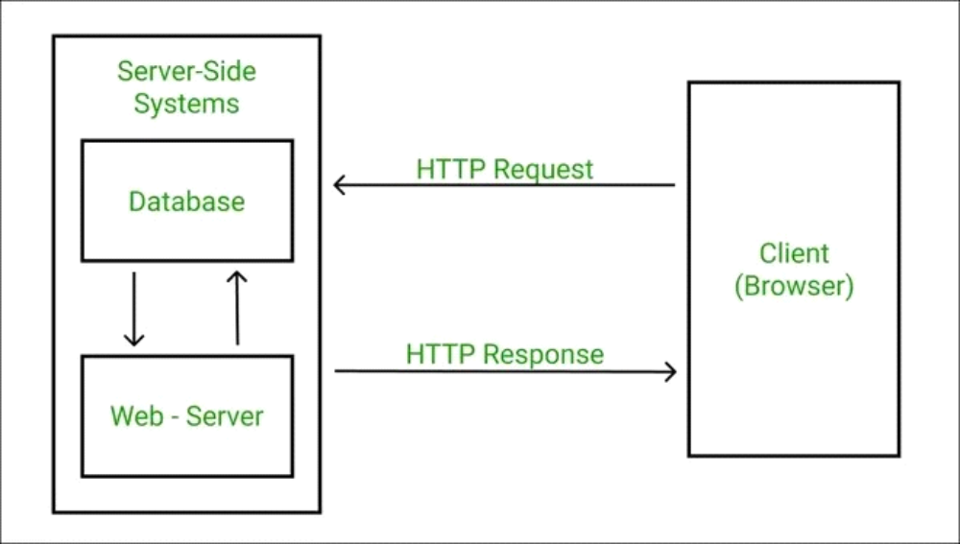

Key Features of HTTP:

1. Stateless Protocol: HTTP is stateless, meaning each request from a client to a server is independent and does not retain any information from previous requests. Sessions and state management are typically handled using cookies or other mechanisms.

2. Request-Response Model: HTTP follows a request-response model, where a client sends a request to a server, and the server responds with the requested resource or an error message.

3. Text-based Protocol: HTTP messages are human-readable and typically transmitted in plain text format, making it easy to debug and understand. However, this can result in larger message sizes compared to binary protocols.

4. Support for Various Methods: HTTP supports several request methods such as GET, POST, PUT, DELETE, etc., allowing clients to perform various operations on resources hosted on web servers.

5. Support for Headers: HTTP headers allow clients and servers to pass additional information along with requests and responses, such as authentication credentials, content type, caching directives, etc.

Pros of HTTP:

1. Widely Adopted: HTTP is the foundation of the World Wide Web and is supported by virtually all web servers, browsers, and web applications. It is a standardized protocol that has been widely adopted across the internet.

2. Simple and Easy to Use: HTTP is relatively simple and easy to understand, making it accessible to developers for building web-based applications and services.

3. Flexibility: HTTP supports various request methods and content types, allowing clients and servers to exchange a wide range of data and perform different types of operations.

4. Caching Support: HTTP includes built-in support for caching, allowing web browsers and proxies to store copies of resources locally to improve performance and reduce bandwidth usage.

5. Compatibility: HTTP works seamlessly with existing web technologies and infrastructure, making it compatible with a wide range of systems and services.

Cons of HTTP:

1. Performance Overhead: HTTP's text-based nature and verbose headers can introduce performance overhead, especially for high-volume and latency-sensitive applications.

2. Security Concern: HTTP messages are transmitted in plain text, making them vulnerable to interception and eavesdropping. This can pose security risks, especially when transmitting sensitive information such as passwords or financial data.

3. Statelessness: HTTP's stateless nature requires additional mechanisms (e.g., cookies, sessions) for managing user state and maintaining continuity between requests, which can complicate application development.

4. Limited Support for Asynchronous Communication: HTTP's request-response model is inherently synchronous, making it less suitable for real-time or event-driven applications that require asynchronous communication.

5. Connection Overhead: HTTP requires establishing and maintaining a separate TCP connection for each request, which can introduce connection overhead and latency, particularly for short-lived connections.

Applications of HTTP:

1. Web Browsing: HTTP is primarily used for fetching web pages, images, scripts, and other resources from web servers to web browsers, enabling users to navigate the World Wide Web.

2. Web Services: HTTP is used for building web services and APIs that allow applications to communicate and exchange data over the internet. This includes RESTful APIs, SOAP services, and GraphQL endpoints.

3. Content Delivery: HTTP is used for delivering various types of content, including static assets (e.g., images, videos), dynamic web pages, streaming media, and downloadable files.

4. E-commerce: HTTP is used for facilitating e-commerce transactions, such as browsing product catalogs, adding items to shopping carts, and processing payments securely over the internet.

5. Social Media: HTTP is used for accessing and interacting with social media platforms, including posting updates, sharing content, and communicating with other users in real-time.

6. Cloud Computing: HTTP is used for accessing cloud-based services and platforms, including cloud storage, compute resources, and software as a service (SaaS) applications.

7. Mobile Applications: HTTP is used for communication between mobile applications and backend servers, enabling features such as data synchronization, push notifications, and remote configuration.

8. API Integration: HTTP is used for integrating with third-party APIs and services, enabling applications to leverage external functionalities such as mapping services, payment gateways, social media authentication, etc.

9. Internet of Things (IoT): HTTP is used for communication between IoT devices and cloud-based platforms, enabling data collection, device management, and remote control of IoT deployments.

10. Web-based Applications: HTTP is used for building and deploying various web-based applications, including content management systems (CMS), blogging platforms, online collaboration tools, and more.

AMQP (Advanced Message Queuing Protocol)

AMQP is an open standard application layer protocol for message-oriented middleware that facilitates the reliable exchange of messages between systems. It enables communication between clients and servers in a decoupled and asynchronous manner, supporting various messaging patterns such as point-to-point, publish-subscribe, and request-response. AMQP is designed for scalability, reliability, and interoperability across different messaging systems and platforms.
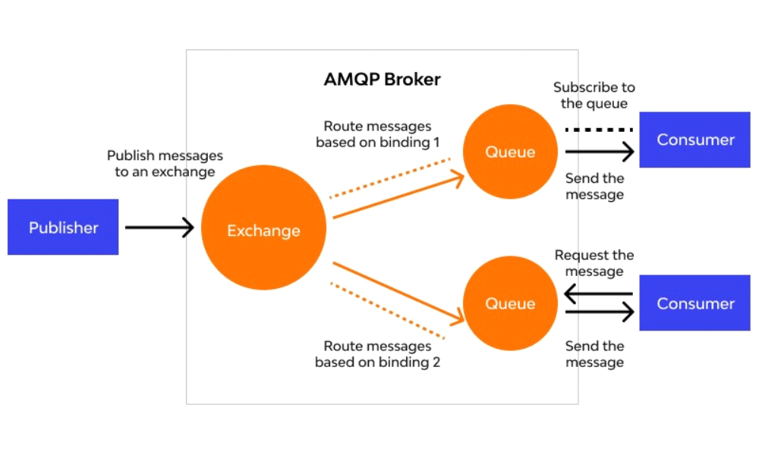
Key Features of AMQP:

1. Message Queuing: AMQP provides robust message queuing capabilities, allowing messages to be stored in queues until they are consumed by clients. This ensures reliable message delivery and decouples producers from consumers.

2. Routing and Exchange: AMQP defines the concept of exchanges and routing keys, allowing messages to be selectively routed to specific queues based on predefined criteria. This enables flexible message routing and filtering based on message attributes.

3. Reliability and Persistence: AMQP supports message acknowledgments and durable queues, ensuring reliable message delivery even in the presence of network failures or system crashes. Messages can be persisted to disk to prevent data loss.

4. Transactional Support: AMQP supports transactions, allowing multiple message operations to be grouped together and executed atomically. This ensures message integrity and consistency in complex messaging scenarios.

5. Security: AMQP provides built-in security features such as authentication, authorization, and encryption to ensure secure communication between clients and servers. It supports various authentication mechanisms and can be integrated with existing security infrastructures.

Pros of AMQP:

1. Interoperability: AMQP is an open standard protocol supported by multiple messaging systems and middleware platforms, ensuring interoperability and vendor neutrality. This allows clients and servers from different vendors to communicate seamlessly.

2. Reliability: AMQP's message queuing and acknowledgment mechanisms ensure reliable message delivery, even in the presence of network failures or system crashes. Messages can be persisted to disk for durability, reducing the risk of data loss.

3. Scalability: AMQP is designed for scalability and can handle large volumes of messages and clients efficiently. It supports distributed messaging architectures and can be deployed in clustered or federated configurations to scale horizontally.

4. Flexibility: AMQP supports various messaging patterns and delivery semantics, including point-to-point, publish-subscribe, and request-response. This flexibility allows developers to choose the most suitable messaging pattern for their application requirements.

5. Security: AMQP provides robust security features, including authentication, authorization, and encryption, to protect message data and ensure secure communication between clients and servers. It supports industry-standard security protocols and can be integrated with existing security infrastructures.

Cons of AMQP:

1. Complexity: AMQP implementations can be complex to set up and configure, especially for users unfamiliar with messaging systems and middleware. Configuring exchanges, queues, bindings, and routing rules requires careful planning and understanding of messaging concepts.

2. Performance Overhead: AMQP's reliability and persistence features can introduce performance overhead, especially in high-throughput scenarios. Persistent message storage and transactional support may impact message throughput and latency.

3. Learning Curve: Developers new to AMQP may face a learning curve when understanding its concepts and APIs. Familiarity with messaging patterns, exchanges, queues, and routing may be required to effectively use AMQP in applications.

4. Resource Consumption: AMQP implementations may consume significant system resources, including memory, CPU, and disk space, especially in scenarios with large message volumes or complex messaging topologies. Careful resource management and optimization may be necessary to ensure efficient operation.

Applications of AMQP:

1. Enterprise Messaging: AMQP is widely used in enterprise messaging systems for integrating disparate systems, applications, and services. It enables reliable and scalable communication between distributed components in large organizations.

2. Financial Services: AMQP is used in financial services for real-time data processing, trading systems, and market data distribution. It provides low-latency messaging capabilities and supports complex messaging workflows in trading environments.

3. Telecommunications: AMQP is used in telecommunications for managing network infrastructure, service orchestration, and real-time communications. It enables efficient message exchange between network elements, applications, and services.

4. Healthcare: AMQP is used in healthcare for exchanging patient data, medical records, and healthcare information systems. It supports interoperability between different healthcare systems and ensures secure and reliable communication of sensitive information.

5. Internet of Things (IoT): AMQP is used in IoT applications for connecting and managing IoT devices, collecting sensor data, and enabling real-time analytics. It provides a scalable and reliable messaging infrastructure for IoT deployments.

6.Supply Chain Management: AMQP is used in supply chain management for coordinating logistics, inventory management, and order processing. It facilitates communication between suppliers, distributors, and retailers in global supply chains.

7. Cloud Computing: AMQP is used in cloud computing environments for building scalable and resilient cloud-native applications. It provides messaging capabilities for asynchronous communication between cloud services and components.

8.Media and Entertainment: AMQP is used in media and entertainment for content distribution, digital asset management, and video streaming. It enables efficient delivery of multimedia content and supports real-time interactions in digital media platforms.

9. Government and Public Sector: AMQP is used in government and public sector applications for citizen services, e-government platforms, and public safety systems. It provides secure and reliable messaging infrastructure for government agencies and public institutions.

10. Retail and E-commerce: AMQP is used in retail and e-commerce for managing inventory, order processing, and customer engagement. It supports real-time communication between online stores, payment gateways, and logistics providers.

