Billing System

- Active your account
User can visit https://my.madeiracloud.com to active your account so that you can use our monitor service.

- Input credit card information to chargify
We use the 3rd party named Chargify.com to store users’ credit card information. The first time you suscribe our product, we need to charge $0.1 to valid your credit card.
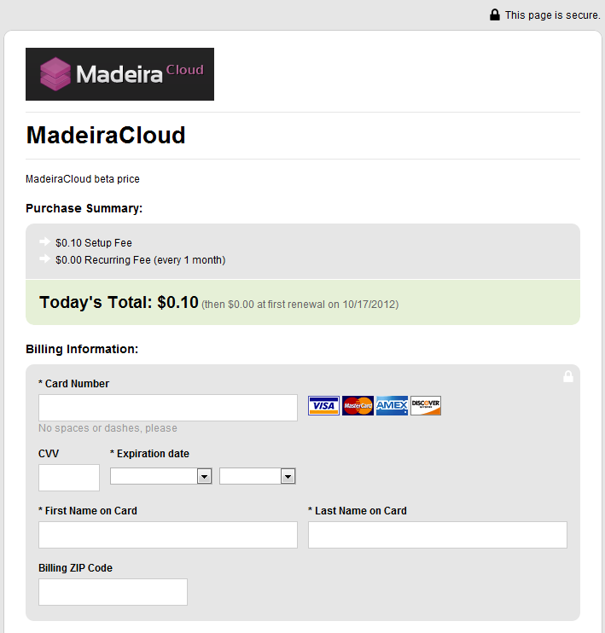
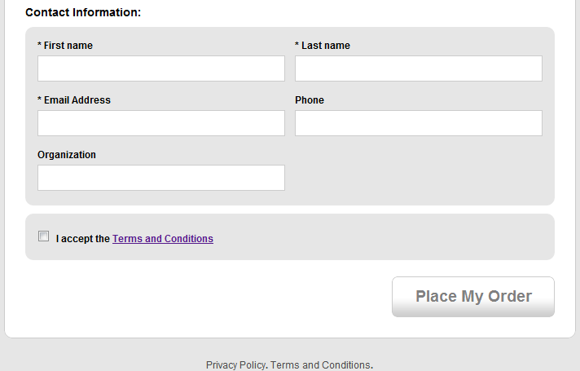
- User detail
Users can monitor their usage in madeiracloud after active their account. Or user can cancel the plan and we will not charge you any more after at the end of this period.
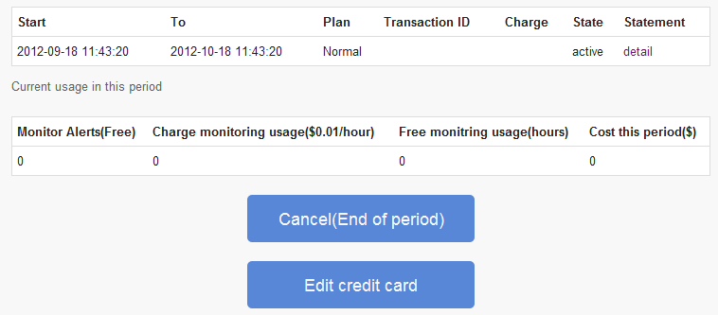
- Reactive account
User can reactive the account without input credit card again.
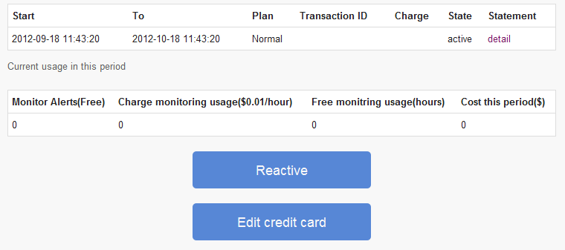
- Edit credit card
User can edit their credit card at any time.
