MadeiraCloud is a visual tool to simplify building, monitoring, and managing cloud applications. Unlike the AWS Console or other cloud management services, our unique GUI presents and manages infrastructure resources graphically as architecture topologies.

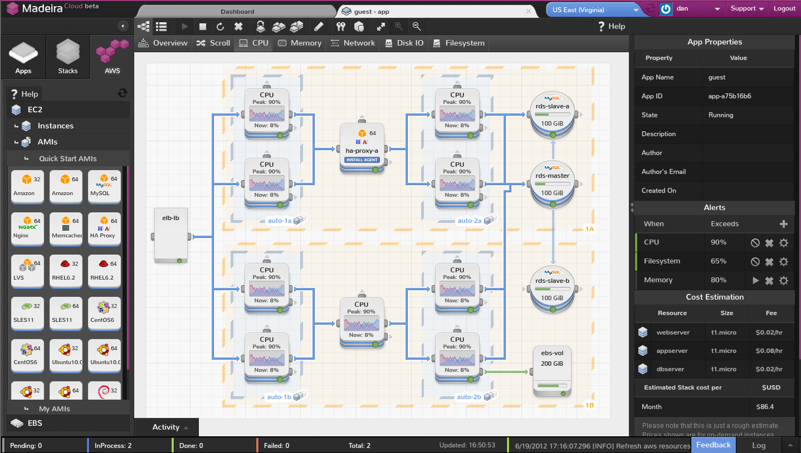

MadeiraCloud brings the familiar concept of an IDE to cloud management, offering the world’s first Visual Integrated Management Environment (VIME) for cloud applications. This concept offers a powerful, visual, extendable, integrated solution to managing infrastructure resources.

Our WYSIWYG builder lets users simply drag-and-drop resources to a canvas and connect them visually to configure the network. Simply click ‘Run’ and our back-end takes care of the rest, provisioning and configuring the entire unit exactly as designed.

Once running, the architecture design doesn’t become a relic, the running application is still presented as a “living diagram”, allowing users to add and remove resources on the fly, change properties, update packages or deploy the latest code. The diagram is always up to date whether changes are made manually or automatically, and easy to understand at a glance, saving time by overlaying near real time (5 second) monitoring on top of the architecture map allowing you to quickly isolate where in an application performance issues are arising.

Running applications can be saved back to reusable stack templates in just a few clicks. These stacks can then be launched into multiple, identical copies of the original applications, again in a few clicks, without having to make any changes to the application. Our Intelligent Network Management agent, combined with our backend engine, automatically resolves the hostnames to the newly created instances. This allows anyone in the organisation to be able to launch a ready-to-go environment in a few minutes whenever it’s needed, for demos, training, QA, or development.

Enterprises need to manage teams, deliver products, demos, and training environments to their clients. We enable them to easily share their environments via email, then it will only be launched once the invitation has been accepted. This makes it incredibly easy for a salesperson to send a full hands on demo environment to potential clients without having to wait for IT at all. These shared environments have fully customisable access controls, so they are automatically terminated once a budgetary maximum has been hit. It can also be used to schedule environments for the dev or testing team, so they are up and running by the time they enter the office and automatically stopped when they leave at night, saving organisations operational costs.

Our software is currently available as a service, accessed through the browser, for AWS but we will be adding support for other public cloud providers as well as private and hybrid clouds. MadeiraCloud simplifies managing multiple cloud platforms from a single, unified management environment.

Moving forward with our vision to create an easy to use, unified, integrated, cross cloud management console we will be adding to our vertical offerings like basic monitoring, with drag and drop DevOps extension for an integrated Chef, user management and governance, budget management, to provide the basics for each area that cover the majority’s needs, and then integrating with dedicated partners to provide for specialist needs.

For more information, please email contact@madeiracloud.com

