**A**

**Summer Internship Report**

**On**

**"Web Development technology"**

(CE446 – Summer Internship - II)

**Prepared by**

Aswani Darsh Hemrajbhai (21CE006)

**Under the Supervision of**

Prof. Aayushi Chaudhari

**Submitted to**

Charotar University of Science & Technology (CHARUSAT)

for the Partial Fulfillment of the Requirements for the

Degree of Bachelor of Technology (B.Tech.)

for Semester 7

**Submitted at**



**Accredited with Grade A by NAAC**

**Accredited with Grade A by KCG**

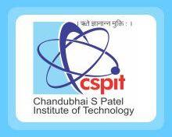

**U & P U. PATEL DEPARTMENT OF COMPUTER ENGINEERING**

**Chandubhai S. Patel Institute of Technology (CSPIT)**

**Faculty of Technology & Engineering (FTE), CHARUSAT**

**At: Changa, Dist: Anand, Pin: 388421.**

**July 2024**