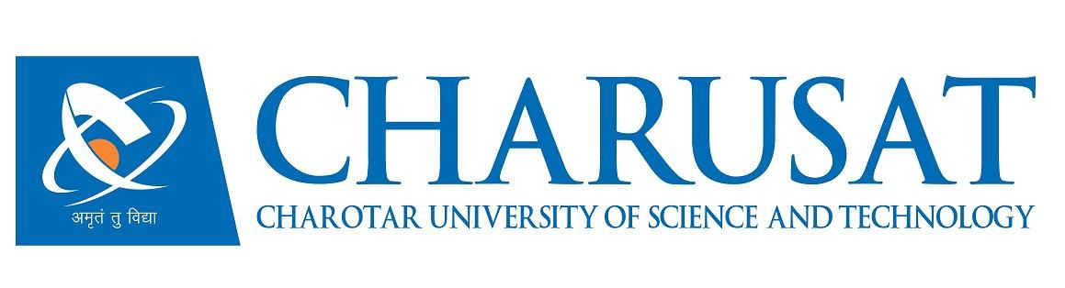

**Accredited with Grade A by NAAC**

**Accredited with Grade A by KCG**

**CERTIFICATE**

This is to certify that the report entitled “**HTML/CSS/Js/Node.js/Express.js/React.js/MongoDB**” is a bonafied work carried out by **Aswani Darsh Hemrajbhai (21CE006)** under the guidance and supervision of **Prof. Aayushi Chaudhari** for the subject **Summer Internship – II (CE446)** of 7th Semester of Bachelor of Technology in **Computer Engineering** at Chandubhai S. Patel Institute of Technology (CSPIT), Faculty of Technology & Engineering (FTE) – CHARUSAT, Gujarat.

To the best of my knowledge and belief, this work embodies the work of candidate himself, has duly been completed, and fulfills the requirement of the ordinance relating to the B.Tech. Degree of the University and is up to the standard in respect of content, presentation and language for being referred by the examiner(s).

|  |  |
| --- | --- |
| Under the supervision of,  Prof. Aayushi Chaudhari  Assistant Professor  U & P U. Patel Dept. of Computer Engineering  CSPIT, FTE, CHARUSAT, Changa, Gujarat | Mr. FAHIM SK  Team Lead  Development  CodSoft |
| Dr. Nikita Bhatt  Head - U & P U. Patel Department of Computer Engineering,  CSPIT, FTE, CHARUSAT, Changa, Gujarat. | |



**Chandubhai S. Patel Institute of Technology (CSPIT)**

**Faculty of Technology & Engineering (FTE), CHARUSAT**

At: Changa, Ta. Petlad, Dist. Anand, Pin: 388421. Gujarat.