

Date: 16th June 2023

**SUMMER INTERNSHIP COMPLETION CERTIFICATE**

This is to certify that **Mr. Kansagara Kush HiteshBhai, bearing ID No: 21CE051**, B. Tech (CE) students of Chandubhai S. Patel Institute of Technology, CHARUSAT, Changa successfully completed the internship on technology from **08th May 2023 to 16th June 2023**.

During the period of internship, He had worked in different phases of system development.

We wish him all the best for his bright career.

Thank you.

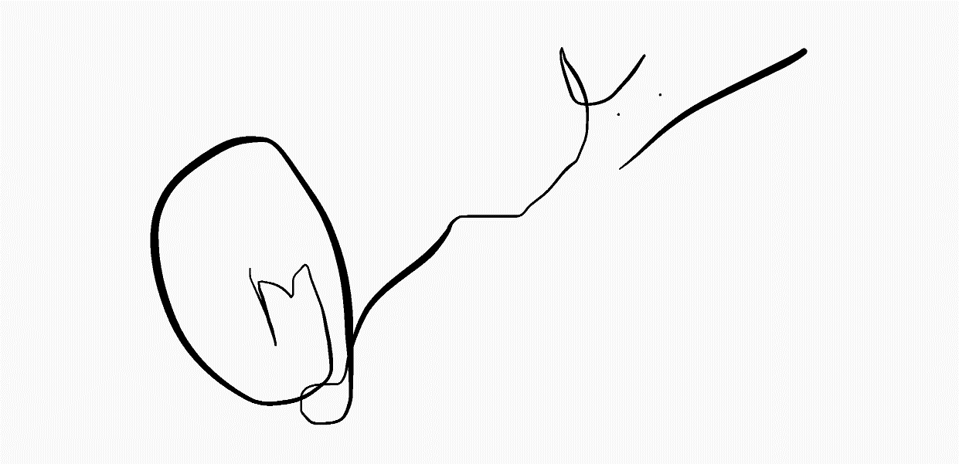

Mehul Javia

Director, Rainstreamweb