Automated Testing Software User Guide
Step 1: Launch the Software
The current example uses: the Yixing chamber in the China lab, two Alicat MFCs, and a microsensor.
First run start.exe in the root directory, check the programs corresponding to the three devices above, and also check task_manager.
Then click Start to launch the checked programs.
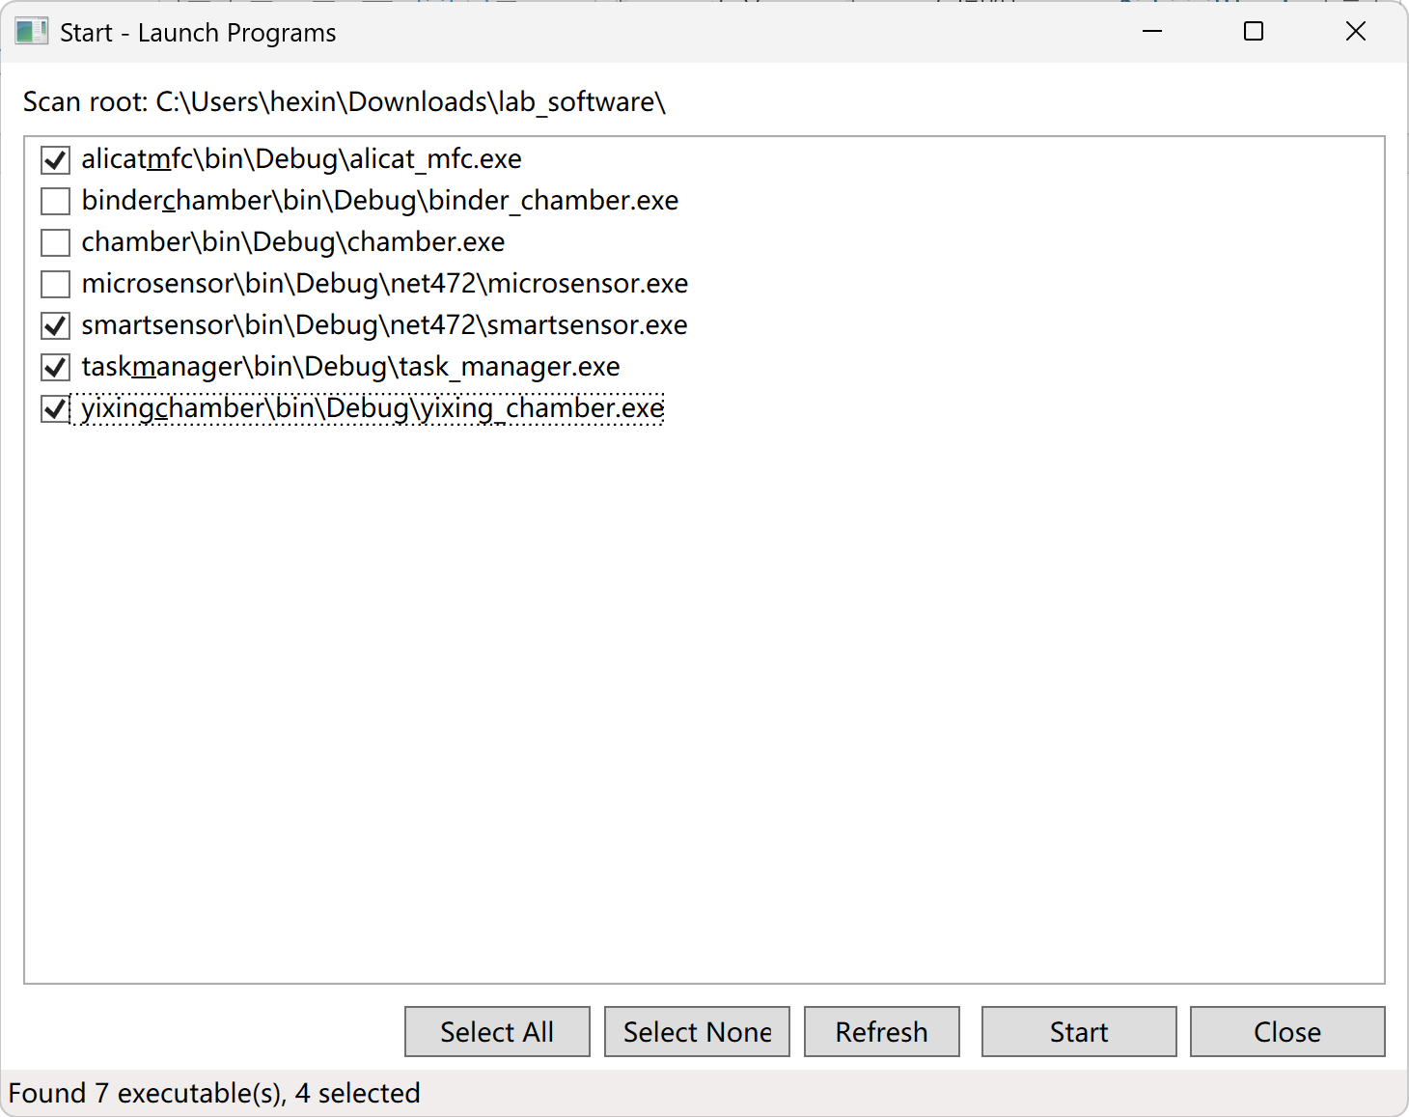
Then select the correct serial port and click the Connect button for the chamber and the MFC, so that the software connects to the devices successfully.
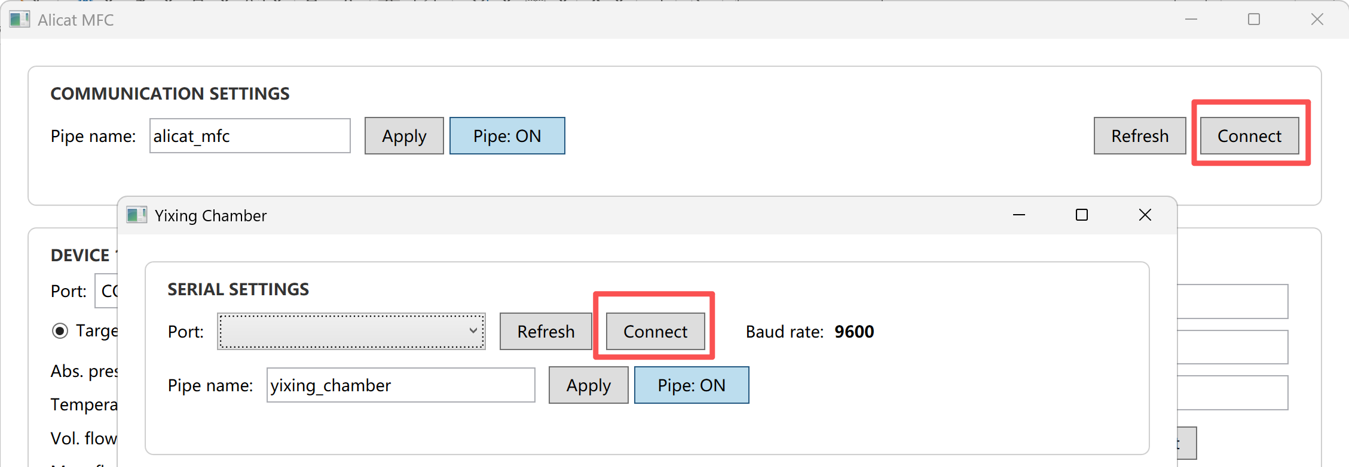
Then open Task Manager.
Make sure the MFC pipe and chamber pipe names are the same as the pipe names used in the two programs above, so that Task Manager can communicate normally with the MFC and chamber control software.
Task Manager is responsible for connecting to and controlling the MFC and the chamber (environmental control).
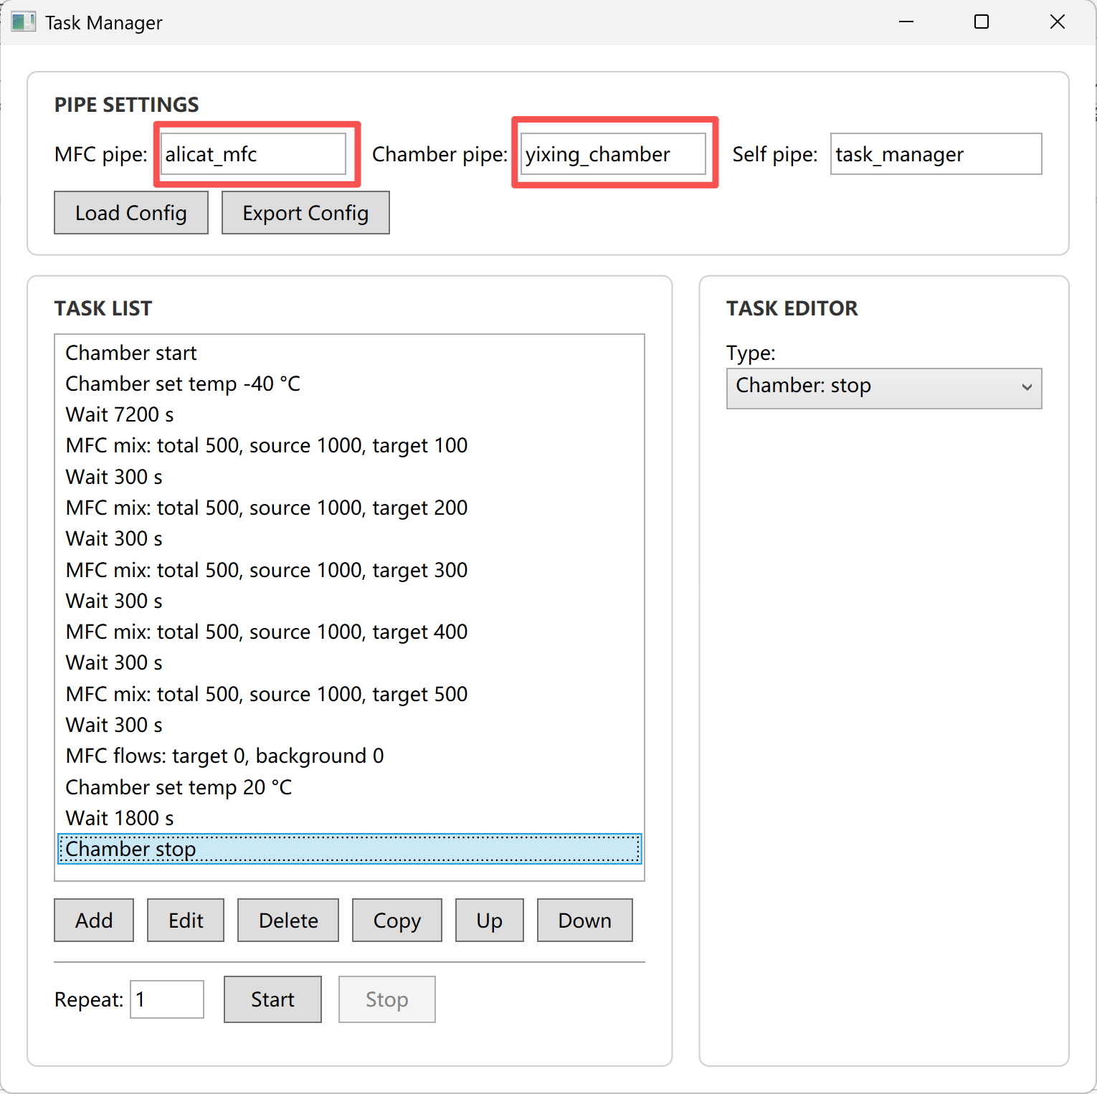
Then edit the task list, as shown in the figure above: first set the chamber temperature to -40°C and hold it for two hours, so that the temperature inside the chamber drops to -40°C; then control the MFC to feed the target gas at concentrations of 100, 200, 300, 400, and 500 in sequence, holding each gas feed for 5 minutes. After the test is completed, set all MFC flows to 0 and set the chamber temperature to 20°C, wait for the chamber to return to 20°C, and then shut down the chamber.
Once everything is configured, you can click the Export Config button to save the current configuration and task list as a JSON file, so that you can load it next time by clicking Load Config.

Data Acquisition Method:
Open smartsensor.exe. The program will detect the connected smartsensor test board. Make sure the correct task manager pipe name is entered. Clicking the Clear button erases the historical data.
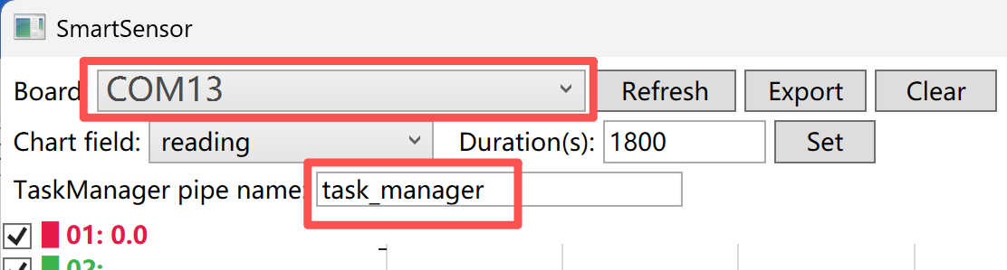
Then click the Start button to begin collecting data from the smartsensor test board.
Then open Task Manager and click the Start button to begin executing the tasks in the task list. You can now go do something else and wait for the tasks to finish.
After the tasks have finished, click the Stop button in smartsensor.exe to stop collecting data. Click the Export button to export the data as a CSV file.

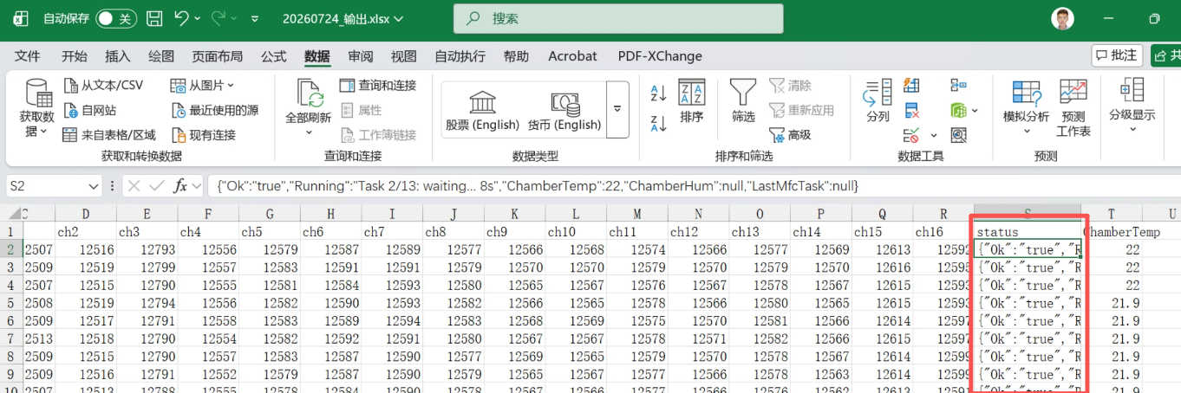
Data is collected once per second. The last status column of each record stores the environment information from Task Manager:
for example:
{"Ok":"true","Running":"Task 2/13: waiting... 8s","ChamberTemp":22,"ChamberHum":null,"LastMfcTask":null}
Here, running indicates the task that is currently being executed.
ChamberTemp indicates the temperature inside the chamber.
ChamberHum indicates the humidity inside the chamber.
LastMfcTask indicates the last task that controlled the MFC (that is, the current gas concentration).

