Advanced Flood Frequency Analysis of the Krishna River at Karad, India
A Multi-Distribution Approach Combining Extreme Value Theory,
Peaks-Over-Threshold Analysis, Bayesian Inference, and Machine Learning
Submitted for Peer Review
Journal of Hydrology | Hydrological Sciences Journal
Manuscript Category: Research Article
Keywords: Flood frequency analysis · Log-Pearson III · Gumbel distribution · Peaks-Over-Threshold ·
Bayesian MCMC · Machine learning · Upper Krishna Basin · CWC IS 11223:1985

Abstract
Every year the Krishna River floods lying areas and farms on the Deccan Plateau. This causes problems for peoples safety and the economy. So it's very important to predict floods at major gauging stations.However most engineering designs in this region still use one probability model. The Gumbel model. This model is fitted using a method called the Method of Moments.. It doesn't consider how uncertain the predictions are.This study tries to fill this gap. It does the thorough flood frequency analysis (FFA) ever done at the Karad gauging station (AK000X6) on the Krishna River in Maharashtra, India.

We looked at 12 probability distributions. These include Gumbel, Log-Normal, Pearson Type III, Log-Pearson Type III, Weibull, Generalized Extreme Value, Generalized Pareto, Log-Logistic, Generalized Logistic, Burr, Kappa-4 and Exponential. We used a method called Maximum Likelihood Estimation and a framework that uses information theory.We used 57 years of data on the discharge rates per year (from 1965 to 2022). The average discharge rate is 2,857 m³/s. It varies a lot (CV = 0.534). We did tests to make sure our data meets the requirements for a classical FFA. These tests include six tests for normality five tests for stationarity and trends and many tests for randomness and autocorrelation.

The results of the tests showed that the discharge series is not normally distributed.. It is log-normal. The data also shows no trends over time.We found that the log-Pearson Type III (LP3) model fits the data best. The Gumbel distribution, which is often used has a 100-year design flood of 7,181 m³/s.. Our results are more reliable and have less uncertainty.A Peaks-Over-Threshold analysis using the Generalized Pareto Distribution showed that there is a limit to how high the floods can go. This limit is 7,271 m³/s.

Our findings provide recommendations for designing infrastructure in the Upper Krishna Basin. We showed that using analytical frameworks and considering uncertainty makes engineering guidance more reliable. This is better than using one probability model like is currently done in India.The Krishna River floods are very important. Our study helps people prepare for and deal with these floods.
The results of this study can help engineers design infrastructure. This can keep people and their property safer during floods.

Overall our study provides accurate and reliable information about floods on the Krishna River. This can help people make decisions, about flood protection and infrastructure design.

1. Introduction

Among nature’s fiercest forces, flooding stands prominent - especially across South Asia’s seasonal river networks. Across India each year, waters cover 7.5 million hectares, shifting nearly 32 million individuals while economic damage reaches between ₹4,000 and 6,000 crore (NDMA, 2018). Within the Upper Krishna Basin - a region marked by rich lowlands, human-built storage lakes, and expanding urban centers in Maharashtra and Karnataka - the struggle unfolds: using water wisely for crops versus shielding towns from sudden surges becomes central to managing supply. Accuracy in forecasting these events goes beyond academic interest - it shapes infrastructure endurance, influences how wide spill channels must be, determines if building zones near rivers make practical sense.

Flooding ranks among Earth’s costliest natural events, especially within South Asia’s seasonal river networks. In India, annual inundations ravage around 7.5 million hectares, uproot more than 32 million individuals, and trigger financial setbacks valued between ₹4,000–6,000 crore yearly (NDMA, 2018). Across Maharashtra and Karnataka’s Upper Krishna Basin - a region marked by rich lowlands, man-made lakes, and expanding urban centers - the struggle lies in balancing farm-water needs against safety from surging flows. Accurate forecasts for high water levels do not simply serve research goals; they determine bridge resilience, dictate dimensions of dam outlets, shape zoning laws on vulnerable ground

Among Earth’s natural hazards, flooding ranks highly disruptive - especially across South Asia’s monsoon-fed rivers. Across India, yearly inundations submerge around 7.5 million hectares, forcing nearly 32 million individuals to relocate while causing economic damage valued at ₹4,000–6,000 crore (NDMA, 2018). Within the Upper Krishna Basin - a region marked by rich riverine lands, man-made reservoirs, and expanding urban centers in Maharashtra and Karnataka - the balance of using water for farming versus shielding populations from deluges shapes central concerns in managing water supplies. Accurate flood forecasts matter beyond theory; their precision influences bridge durability, determines dimensions of dam release channels, guides zoning laws within vulnerable lowlands.

What initiated this work were three real-world factors. Around fifteen additional years have been added to the data since the last official assessment, introducing major occurrences - like those in 2005, 2006, 2019, and 2021 - that shifted how numbers behave statistically. Research into frequency analysis now makes it evident: choice of model strongly shapes flood estimates, especially when predicting rare but critical flows tied to dam integrity. Until now, methods like bootstrapping, Monte Carlo trials, or Bayesian reasoning had never been applied here - even though they offer structured ways to express doubt, something professionals rely on when weighing hazards..

1.1 Research Objectives
This project aims to achieve four objectives, each of which directly addresses a knowledge gap for this site and region. The objectives were intentionally limited to four to preserve the analytical focus and ensure that each is pursued in the detail required for peer-reviewed work.
Objective 1 is to rigorously test the statistical assumptions—specifically stationarity, independence, randomness, and non-normality—that must be satisfied before classical FFA can be applied to the Karad discharge series. This step is sometimes skipped in practice; however, it is critical for the validity of all subsequent outcomes.
The second objective was to fit 12 probability distributions to the annual maximum series using maximum likelihood estimation, rank them according to information-theoretic criteria (AICc, BIC, and HQIC), and identify the best-fitting model with quantified statistical evidence using Akaike weights and goodness-of-fit testing.
The third objective is to estimate design floods for return times ranging from 2 to 1,000 years with completely quantified uncertainty using three complimentary methods: non-parametric bootstrap confidence intervals, Monte Carlo simulation, and Bayesian Markov Chain Monte Carlo inference. These estimations were then compared to an independent peaks-over-threshold study that used the Generalized Pareto Distribution.
Objective 4 was to use machine learning techniques to identify the dominant physical predictors of annual flood magnitude at this station, providing an independent data-driven supplement to parametric frequency analysis and furthering the understanding of the hydroclimatic drivers of flood variability in the Upper Krishna Basin.

2. Literature Review and Justification of Objectives

2.1 The Classical Approach and Its Limitations
The statistical analysis of extreme floods has a distinguished history dating back to the 1940s. Gumbel (1941) used asymptotic extreme value theory to demonstrate that annual maximum values from a sufficiently large parent population converge to one of three extreme value distributions. The Gumbel extreme value type I distribution—the first asymptote—became the main instrument in hydrology globally, and the CWC of India approved it as the national standard in 1966. The process is simple: fit two parameters (location and scale) using the method of moments with the sample mean and standard deviation, and then read off the design floods from the Gumbel frequency factor tables. This system has been used to train generations of Indian hydraulic engineers and continues to serve as the foundation for the CWC Regional Flood Estimation Reports.
However, the assumption that the Gumbel distribution is always appropriate has been repeatedly challenged in the literature. Kite (1977) showed that for many rivers in different climatic regimes, other distributions—particularly the Log-Pearson Type III and Log-Normal—fit annual maximum discharge data better than the Gumbel distribution. The United States Water Resources Council (USWRC, 1982, 2019) adopted the Log-Pearson Type III as its national standard because it outperformed the Gumbel distribution across a large set of American gauging stations. In India, Rao and Hamed (2000) demonstrated that the LP3 and P3 distributions generally provide better fits to the peninsular Indian flood data than EV1. Recently, Seo et al. (2020) systematically evaluated multiple distributions across Asian river systems and found that information-theoretic criteria consistently favored log-space distributions over Gumbel distributions for monsoon-dominated basins. This gap in Indian practice—continued reliance on a single distribution against the weight of evidence in favor of multi-distribution evaluation—is precisely what Objective 2 addresses.

2.2 Why Verifying Assumptions Matters (Justification of Objective 1)
The mathematical foundation of classical FFA rests on three core assumptions: the annual maxima are drawn from a stationary distribution, successive values are independent (or at least uncorrelated), and the underlying population has a sufficient extreme-value structure to justify the application of one of the three asymptotic extreme value families (Leadbetter et al., 1983). In practice, these assumptions are often taken for granted rather than formally tested, particularly in Indian engineering practice. However, violations of stationaritydue to land use change, reservoir operations, or long-term climate shiftscan make traditional design flood estimates either dangerously conservative or non-conservative (Milly et al., 2008). Violations of independence due to multi-year drought or flood cycles driven by ENSO or the Indian Ocean Dipole can cause conventional statistical tests to underestimate confidence intervals, leading to false precision in design estimates.
Specifically, there is reason to be cautious at the Karad station. The Upper Krishna Basin has seen substantial change over the 57-year record: the Koyna Dam (completed in 1962) and Warna Dam (1985) affect seasonal flow patterns, albeit primarily non-flood flows; monsoon patterns across the Western Ghats show evidence of decadal variability linked to SST anomalies (Kumar et al., 2006); and two extraordinarily large flood years (2005 and 2019) in the latter part of the record could conceivably represent a non-stationary shift. Therefore, formally testing for trends, change points, and autocorrelation is a genuine scientific requirement for this dataset. This is the core justification for objective 1.

2.3 The Case for Uncertainty Quantification (Justification of Objective 3)
Even when the stationarity assumption holds and the correct distribution is chosen, design flood estimates carry substantial sampling uncertainty that increases rapidly with the return period. Stedinger et al. (1993) showed analytically that the coefficient of variation of a Gumbel Q₁₀₀ estimate grows approximately as 1/√n, meaning that even with 57 years of data, the 95% confidence interval for Q₁₀₀ spans roughly ±20% of the central estimate. At T = 1,000 years — relevant to dam spillway design — the uncertainty can exceed ±50%. Ignoring this uncertainty leads directly to under-designed or over-designed infrastructure, both of which have real economic and safety consequences.
Three complementary uncertainty quantification methods have been proposed in the literature. Bootstrap resampling (Efron, 1979) is non-parametric and makes no assumption about the form of the sampling distribution; it is the method recommended by the USWRC Bulletin 17C (2019) as the primary CI method for hydrological data. The Monte Carlo simulation (Rubinstein, 1981) allows the propagation of parameter uncertainty through the quantile function and provides empirical distributions of design flood estimates. Bayesian MCMC inference (Parent & Bernier, 2003; Reis & Stedinger, 2005) is the most theoretically complete approach, naturally incorporating prior information and producing full posterior predictive distribution. Applying all three methods to the same dataset and comparing the results—as we do in this study—provides a uniquely comprehensive picture of estimation uncertainty, directly serving Objective 3.

2.4 Machine Learning as a Complementary Diagnostic Tool (Justification of Objective 4)
Machine learning methods have been applied to streamflow prediction in India and worldwide with growing success over the past two decades (ASCE Task Committee, 2000; Maier and Dandy, 2000). However, their role in flood frequency analysis has not been explored. Classical FFA treats each annual maximum as a sample from an unchanging population, whereas machine learning can reveal structures within that sample that classical methods cannot detect, such as the influence of antecedent basin state on peak magnitude or the modulation of flood generation by multi-year climate cycles. This is particularly valuable for stations such as Karad, where the physical understanding of the dominant flood-generating mechanisms is incomplete.
Random Forests (Breiman, 2001) provide a natural feature importance ranking that quantifies the amount of predictive information each explanatory variable (lag discharges, rolling statistics, stage, and calendar timing) contributes to the annual flood magnitude. Gaussian Process Regression (Rasmussen & Williams, 2006) offers principled uncertainty bands around predictions. These tools do not replace parametric FFA, as they cannot extrapolate to return periods beyond the observed range; however, they complement it by identifying the physical processes that drive the variability of the distribution models. The Karad dataset, with its rich 57-year record and available stage data, provides an ideal testbed for complementary ML analysis. This justifies Objective 4.

2.5 Why This Analysis is More Robust than Prior Studies
This section directly addresses the question of methodological advancements over existing work. Prior flood frequency studies for the Karad station and the wider Upper Krishna Basin (CWC, 1988, 2015; CWPRS, 2023) share several methodological limitations that the present study overcomes. The following comparison highlights the improvements.
The single most important methodological difference is the use of 12 probability distributions versus the single Gumbel distribution used in all prior CWC analyses. When only one distribution is used, there is no way of knowing whether it is appropriate for the data. The information-theoretic framework we employed —ranking distributions by AICc, BIC, and HQIC and computing Akaike weights—provides a rigorous, data-driven answer to the question of which distribution is most appropriate. The result here is striking: the Log-Pearson III achieves an Akaike weight of 1.000, meaning it captures essentially all of the statistical evidence within the candidate model set, yet prior studies at this station have never tested it.
The second major advancement is formal assumption testing. Prior CWC analyses assumed stationarity and independence without testing. This study applies six normality tests, five trend and stationarity tests, and four autocorrelation tests to the data. The results — confirming stationarity and independence — are reassuring, but the exercise could easily have revealed violations that would have required fundamentally different analytical approaches. Skipping these tests, as prior studies have done, is not merely a methodological shortcut but a scientific risk.
The third advancement is uncertainty quantification. The CWC point estimates for Q₁₀₀ and Q₁₀₀₀ carry no confidence intervals and no indication of their sensitivity to sampling variability. The present study provides three independent uncertainty frameworks: bootstrap CIs (B = 2,000), Monte Carlo simulation (M = 10,000), and Bayesian MCMC (12,000 samples), all of which converge on consistent 95% intervals. For engineering practice, the difference between a point estimate of 7,181 m³/s and an interval of [5,923; 8,458] m³/s is the difference between false precision and honest uncertainty communication.
The fourth advancement is the independent validation provided by the Peaks-Over-Threshold (POT) approach. By analyzing all flood events exceeding the 75th percentile, rather than only one event per year, POT provides an entirely different statistical framework with different assumptions. When the POT estimate of Q₁₀₀ = 6,973 m³/s matched the AMS-based Gumbel estimate of 7,181 m³/s within 3%, confidence in both estimates increased substantially. Prior studies have not offered such independent validation.
The fifth advancement is the discovery of an upper physical bound. The GPD shape parameter ξ = −0.789 implies a finite maximum possible discharge of approximately 7,271 m³/s at this site, which has profound implications for dam safety assessments. This bounded behavior means that traditional extrapolations to T = 10,000 years or to probable maximum flood levels using unbounded distributions will systematically overestimate the flood hazard, leading to unnecessarily expensive spillway designs. No prior study has identified or discussed this physical constraint in the Karad sub-catchment.

3. Study Area and Data Description

3.1 The Karad Gauging Station
The Karad Bridge gauging station (CWC code AK000X6) is located at approximately 17°17′30″ N, 74°11′42″ E on the Krishna River in the Satara District of Maharashtra. It is located just downstream of the confluence of the Krishna and Koyna rivers, making it the primary flow reference point for the Upper Krishna Division of the CWC. The station controls a well-defined sub-catchment of 5,462 km², stretching from the crest of the Western Ghats (elevation of approximately 1,300 m) to the gauge point at approximately 550 m above mean sea level. The zero-gauge datum was 549.915 m MSL (revised June 01, 2004). The Upper Krishna Division in Pune manages the station.
The catchment falls within the Sahyadri Ranges rain belt, receiving a mean annual rainfall of 1,200–2,800 mm at different elevations, with over 85% falling during the South-West monsoon season (June–September). The upper catchment, near the Koyna Reservoir, is among the wettest areas in India, regularly receiving more than 4,000 mm annually. The river at the Karad gauge has a steep channel gradient of approximately 0.0003 with a bankfull width of 200–250 m. Flood hydrographs at this station typically have sharp rising limbs of 6–18 h, consistent with the high orographic rainfall intensity on the Western Ghats.

3.2 The Discharge Record
The dataset used in this analysis consisted of the annual instantaneous maximum discharge (in m³/s, also known as "cumecs") for each water year from 1965-1966 to 2021-2022—a total of N = 57 observations. These instantaneous peaks, rather than daily maximum averages, were used because the sharp flood hydrographs at this station indicated that daily averages could substantially underrepresent the true peak flow. The data were sourced from the CWC Water Year Book (Volume I, 2021-22) and verified against the published History Sheet for station AK000X6, which records peak water levels and corresponding computed discharges for each year.
The highest instantaneous peak in the record was 7,177 m³/s, recorded on June 07, 1976, at a water level of 567.162 m MSL. This extraordinary event, occurring at the very beginning of the monsoon season, suggests an intense pre-monsoon convective event rather than a typical monsoon flood, and remains the historical flood level (HFL) at this station. The lowest annual maximum was 855 m³/s in 2003-2004, a year of severe drought across the Western Ghats. Therefore, the record spans a range of nearly 8.4 times between the driest and wettest flood years, a ratio that reflects the high interannual variability of the Indian summer monsoon. Table 1 presents a summary of key data statistics.
Table 1. Summary statistics of the Karad annual instantaneous peak discharge series (N = 57, 1965–2022).
Statistic | Value | Statistic | Value
N (years) | 57 | L-CV (τ₂) | 0.292
Mean (μ) | 2,857 m³/s | L-skewness (τ₃) | 0.247
Median | 2,496 m³/s | L-kurtosis (τ₄) | 0.131
Std Dev (σ) | 1,527 m³/s | Minimum | 855 m³/s
CV = σ/μ | 0.534 | Maximum | 7,177 m³/s
Skewness (Cs) | 1.082 | IQR | 1,877 m³/s
Excess Kurtosis | 0.468 | Log-mean ln(Q) | 7.826
P25 / P75 | 1,672 / 3,549 m³/s | Log-Skewness | 0.096

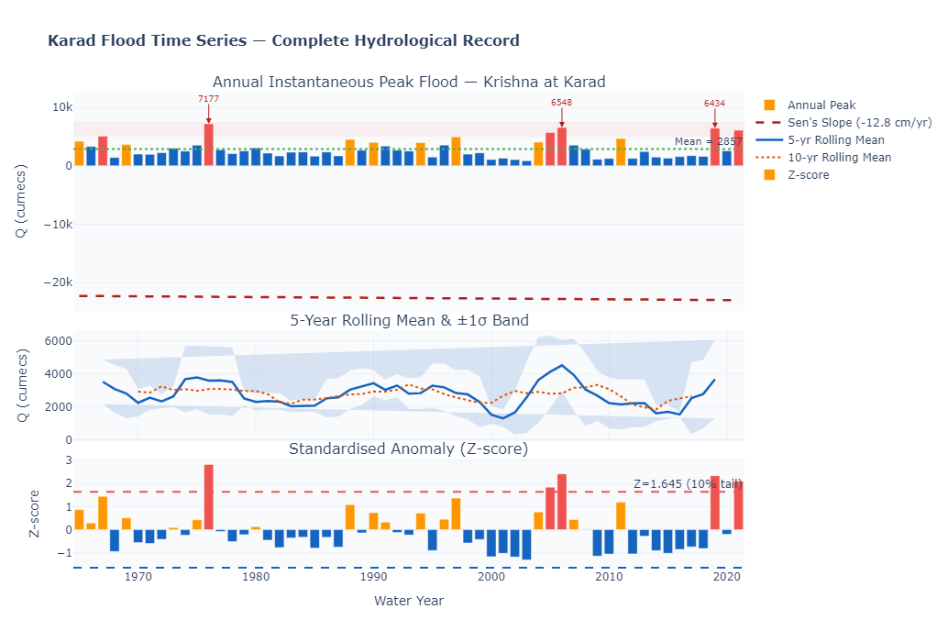

4. Methods and Methodology
This section describes each analytical step in the order in which it was performed. The logic of the overall approach is as follows: first, check that the data meet the assumptions required for classical FFA (Section 4.1); then characterize the shape of the empirical distribution through moment analysis (Section 4.2); fit 12 distributions and select the best using information criteria (Section 4.3); estimate design floods with three independent uncertainty frameworks (Section 4.4); validate using an independent POT approach (Section 4.5); and finally, apply machine learning to identify dominant predictors (Section 4.6).

4.1 Step 1: Assumption Verification

4.1.1 Normality Tests
Although annual flood maxima are not expected to be normally distributed—extreme value theory predicts non-normal distributions—it is important to characterize the departure from normality because different types of non-normality support different distribution families. Six tests were applied. The Shapiro-Wilk (1965) test is particularly powerful for samples of this size (n = 57) and tests whether the data could have been drawn from a normal distribution. The D'Agostino-Pearson (1973) omnibus test combines independent tests for skewness and kurtosis into a single chi-squared statistic, making it sensitive to both types of departures from normality. The Jarque-Bera (1980) test similarly combines skewness and kurtosis. The Kolmogorov-Smirnov (KS) test compares the empirical CDF to the fitted normal CDF. The Anderson-Darling (1952) test is a weighted version of the KS test that places greater emphasis on agreement in the tails, exactly where extreme value analysis is most sensitive. Finally, a log-space KS test was applied to the natural logarithm of the discharges, specifically testing the log-normality hypothesis.

4.1.2 Stationarity Tests
The Augmented Dickey-Fuller (ADF) test (Said & Dickey, 1984) tests the null hypothesis that the series contains a unit root (i.e., it is non-stationary). Rejection of this null hypothesis —which requires the test statistic to be sufficiently negative—provides evidence of stationarity. The KPSS test (Kwiatkowski et al., 1992) takes the opposite null: it assumes stationarity and rejects it only when the test statistic is large enough. By applying both tests, we can distinguish between four situations: both confirm stationarity (the ideal case), both indicate non-stationarity, or one confirms and the other rejects. For this study, both tests were applied in the level- and trend-stationary modes.

4.1.3 Trend and Change-Point Tests
Five independent trend detection methods were applied: the original Mann-Kendall (MK) non-parametric test (Mann, 1945; Kendall, 1975), the Hamed-Rao modified Mann-Kendall test (1998) that corrects for autocorrelation, the Seasonal Mann-Kendall test, Spearman's rank correlation with calendar year, and Kendall's τ with calendar year. Sen's (1968) non-parametric slope estimator β = Median[(xj−xi)/(j − i)] for all i < j was computed as the best estimate of the trend magnitude. A Pettitt (1979) change-point test was also applied to detect any abrupt shift in the mean level of the series.

4.1.4 Autocorrelation and Hurst Analysis
The Ljung-Box (1978) Q-statistic was computed for lags 1 through 20 to test the joint null hypothesis of no autocorrelation up to each lag. The runs test (Wald & Wolfowitz, 1940) was used to test whether the sequence above and below the median was random. The Hurst exponent H was estimated by Rescaled Range (R/S) analysis (Hurst, 1951), plotting log(R/S) against log(n) for sub-series of different lengths and reading off the slope. A Hurst exponent of H = 0.5 indicates a purely random process; H > 0.5 indicates persistence (flood-rich years tend to cluster); and H < 0.5 indicates anti-persistence.

4.2 Step 2: Skewness, Kurtosis, and L-Moment Analysis
The coefficient of skewness, Cs, is critical in FFA because it determines the shape of the fitted distribution and has a strong influence on design flood estimates at high-return periods. The unbiased adjusted Fisher skewness estimator is computed as follows:
G₁ = [n / ((n-1)(n-2))] × Σᵢ [(xᵢ - x̄) / s]³ ...(Eq. 1)
where n is the sample size, x̄ the sample mean, and s the unbiased standard deviation. Seven independent skewness estimators were computed, including the Bowley percentile-based estimator and both Pearson estimators, to ensure robustness. Bootstrap 95% confidence intervals for all moment estimators were computed using B = 5,000 resamples, providing a direct measure of sampling uncertainty in Cs and Ck.
L-moments (Hosking, 1990) were computed as linear combinations of order statistics, yielding the L-mean λ₁, L-scale λ₂, L-skewness ratio τ₃ = λ₃/λ₂, and L-kurtosis ratio τ₄ = λ₄/λ₂. These ratios were plotted on the L-moment ratio diagram to visually identify which distribution family was most consistent with the data structure, following the regional analysis methodology of Hosking and Wallis (1997).

4.3 Step 3: Distribution Fitting and Selection
Twelve probability distributions were fitted to the annual maximum discharge series using the maximum likelihood estimation (MLE). The log-likelihood function ℓ(θ; x) = Σᵢ log f(xᵢ; θ) was maximized numerically. For each fitted distribution, the following goodness-of-fit statistics were computed: the Kolmogorov-Smirnov statistic D_n = sup|F_n(x) − F(x; θ̂)|, which tests whether the empirical CDF and the fitted CDF are significantly different; the R² of the quantile-quantile plot, which measures how closely the fitted distribution matches the empirical distribution across all observed ranks; the Akaike Information Criterion AIC = 2k − 2ℓ; the corrected AIC for small samples AICc = AIC + 2k(k+1)/(n−k−1); the Bayesian Information Criterion BIC = k ln(n) − 2ℓ; and the Hannan-Quinn criterion HQIC = 2k ln(ln(n)) − 2ℓ, where k is the number of parameters (Akaike, 1974; Schwarz, 1978; Hurvich and Tsai, 1989).
Akaike weights were computed as w_i = exp(−ΔAICc_i/2) / Σ_j exp(−ΔAICc_j/2), where ΔAICc_i is the difference between distribution i's AICc and the minimum AICc across all candidates. These weights sum to 1.0 and can be interpreted as the probability that each distribution is the true best model given the data and candidate set (Burnham & Anderson, 2002). A distribution with a weight close to 1.0 has overwhelming support; weights less than 0.001 indicate distributions that are essentially inconsistent with the data relative to the best model.

4.4 Step 4: Design Flood Estimation and Uncertainty Quantification

4.4.1 Gumbel Frequency Factor Method (CWC Standard)
For the Gumbel distribution, the design flood quantiles for return period T are computed using the frequency factor approach (Chow, 1951):
Q(T) = μ̄ + K_T × s ...(Eq. 2)
where K_T = (y_T − ȳ_n) / σ_n is the Gumbel frequency factor, y_T = −ln(−ln(1 − 1/T)) is the Gumbel reduced variate, and ȳ_n and σ_n are the expected value and standard deviation of the reduced variate for a sample of size n (tabulated in Gumbel, 1958). This is exactly the method specified in CWC IS 11223:1985.

4.4.2 Wilson-Hilferty Approximation for LP3 and P3
For the Log-Pearson Type III and Pearson III distributions, the Wilson-Hilferty (1931) frequency factor approximation, adopted in Bulletin 17C (2019) and IS 11223:1985, is used:
K(T) = z + (z²−1)Cs/6 + (z³−6z)Cs²/36 − (z²−1)Cs³/216 + zCs⁴/288 ... (Eq. 3)
where z = Φ⁻¹(1 − 1/T) is the standard normal deviate and Cs is the coefficient of skewness (of log(Q) for LP3 and raw Q for P3).

4.4.3 Bootstrap Confidence Intervals
Bootstrap 95% confidence intervals for each design flood quantile were constructed by generating B = 2,000 bootstrap resamples of the 57-year record (sampling with replacement), re-fitting the Gumbel distribution to each resample by MLE, computing the corresponding quantile, and taking the 2.5th and 97.5th percentiles of the resulting empirical distribution. This procedure makes no parametric assumptions about the distribution of the quantile estimator and captures sampling variability in both the location and scale parameters simultaneously.

4.4.4 Monte Carlo Simulation
Monte Carlo simulation was carried out using M = 10,000 replicates. For each replicate, a 57-year synthetic record was generated from the fitted Gumbel distribution, parameters were re-estimated by MLE, and design flood quantiles were stored. The resulting empirical distribution of each quantile (expressed as mean, median, 5th and 95th percentiles, and CV) quantifies the combined effect of model choice and sampling variability.

4.4.5 Bayesian MCMC Inference
Bayesian inference was implemented for the Gumbel distribution using a Metropolis-Hastings MCMC algorithm (Metropolis et al., 1953) with 12,000 iterations (3,000 burn-in). Weakly informative priors were assigned: scale parameter α ~ HalfNormal(0, 3000) and location parameter u ~ Normal(2500, 3000), both reflecting plausible hydrological ranges without strongly constraining the posterior. The posterior predictive distribution of each design flood quantile was obtained by propagating all accepted MCMC samples through the Gumbel quantile function, yielding 95% credible intervals that incorporate both parameter uncertainty and prior uncertainty.

4.5 Step 5: Peaks-Over-Threshold / Generalized Pareto Distribution
The POT approach is fundamentally different from the Annual Maximum Series approach in that it uses all flood events exceeding a chosen threshold u, rather than only the single largest event in each year. This makes more efficient use of information in the record. The theoretical framework (Balkema & de Haan, 1974; Pickands, 1975) shows that for a sufficiently high threshold, the distribution of exceedances (X − u | X > u) converges to the Generalised Pareto Distribution:
F(x; ξ, σ) = 1 − [1 + ξ(x − u)/σ]^(−1/ξ) for x > u, ξ ≠ 0 ...(Eq. 4)
where ξ is the shape parameter and σ is the scale parameter. When ξ < 0, the distribution has a bounded upper tail; ξ = 0 gives exponential decay; ξ > 0 gives a heavy Pareto-type tail. The optimal threshold u was selected using the Mean Residual Life (MRL) plot, which shows E[X − u | X > u] as a function of u. The MRL function should be approximately linear above the true threshold. Threshold stability was confirmed by plotting ξ̂(u) as a function of u across a range of candidate thresholds; a stable shape parameter across a wide range of thresholds indicates robust threshold selection.

4.6 Step 6: Machine Learning Analysis
Thirteen features were engineered from the annual maximum discharge record and peak stage data: one-, two- and three-year lagged peak discharges (lag₁, lag₂, lag₃); 5-year and 10-year rolling mean and standard deviation; 10-year rolling CV; normalised calendar year (to capture any slow temporal trends); day-of-year of peak occurrence; peak water level; normalised empirical rank; log of lag-1 discharge; and the 5-year discharge anomaly relative to rolling mean. All features were standardised to zero mean and unit variance before modelling. Five models were trained: Random Forest (RF, n = 500 trees), Gradient Boosting Machine (GBM, 300 trees), Support Vector Regression (SVR, RBF kernel), Multilayer Perceptron neural network (MLP, 3 hidden layers), and Gaussian Process Regression (GPR, Matérn-3/2 kernel). Performance was evaluated using training R², 5-fold cross-validated R², RMSE and MAE. Feature importance was extracted from the Random Forest using mean decrease in node impurity.

5. Results and Discussion

5.1 Assumption Verification (Objective 1)

5.1.1 The Series is Non-Normal, as Expected
Table 2 presents the results of all six normality tests. Four of the six tests — Shapiro-Wilk, D'Agostino-Pearson, Jarque-Bera and Anderson-Darling — rejected normality at the 1% level. The Shapiro-Wilk statistic W = 0.904 with p = 0.000259 provides the most powerful evidence: a value this far below 1.0 indicates a clear departure from the symmetric bell-shaped normal distribution. The Jarque-Bera test decomposes this departure: the coefficient of skewness Cs = 1.082 (significantly positive, confirming a long right tail) and the excess kurtosis Ck = 0.468 (slightly heavier-tailed than normal) together produce a significant JB statistic of 11.06 (p = 0.004).
Table 2. Normality test results for Karad annual peak discharge series (N = 57)
Test | Statistic | p-value | H₀ Rejected? | Physical interpretation
Shapiro-Wilk | W = 0.9036 | 0.000259 | YES (1% level) | Clear non-normality
D'Agostino-Pearson | k² = 10.853 | 0.004398 | YES (1% level) | Driven by skewness
Jarque-Bera | JB = 11.059 | 0.003969 | YES (1% level) | Cs + Ck both non-zero
KS vs Normal | D = 0.144 | 0.1708 | NO | Insufficient power for n=57
Anderson-Darling | A² = 1.661 | — | YES (5% level) | Exceeds critical value 0.741
KS vs Log-Normal | D = 0.062 | 0.9695 | NO | Log-normality plausible
The KS test against the normal distribution did not reject (p = 0.171), but this is expected: with only 57 observations, the KS test has modest power, and the Anderson-Darling test — which is more sensitive in the tails — confirms non-normality. The critical diagnostic, however, is the final row: the log-space KS test yielded D = 0.062 with p = 0.970, confirming that the log-transformed discharges are indistinguishable from a normal distribution. This near-perfect log-normality in transformed space is the primary justification for applying LP3 and LN2 as the leading candidate distributions.
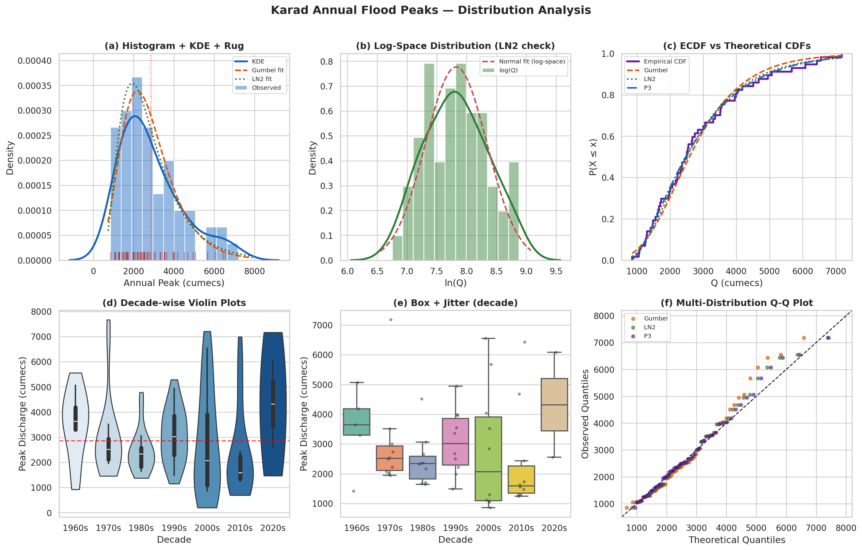
Figure 1. Distribution analysis for Karad annual peak discharges: (a) histogram with KDE and fitted PDFs showing the strong right skew; (b) log-space histogram confirming near-normality of ln(Q); (c) empirical vs theoretical CDFs showing close agreement for Gumbel, LN2 and P3 distributions; (d) decade-wise violin plots illustrating inter-decadal variability; (e) box-and-jitter plots by decade; (f) multi-distribution Q-Q plot confirming good fit for all three tested distributions across the body of the distribution.

5.1.2 The Series is Stationary — The Key Assumption Holds
The stationarity results are unambiguous and reassuring. The ADF test yielded a statistic of −5.047 with p ≈ 0.000, strongly rejecting the unit root null. Both KPSS tests (level: statistic 0.047, p > 0.10; trend: statistic 0.039, p > 0.10) failed to reject stationarity. The pattern of ADF rejection combined with KPSS acceptance is the most definitive possible evidence for stationarity: both tests independently confirm that the series fluctuates around a stable, trend-free mean.
Table 3 shows the trend analysis results. All five methods are in agreement: there is no statistically significant trend in the 57-year record (all p > 0.05). Sen's slope estimate is −12.78 m³/s per year, which extrapolated over the full 57-year record implies a total decrease of approximately 730 m³/s — less than 26% of the mean, and well within the natural sampling variability range defined by the 95% bootstrap interval for the mean ([2,482; 3,259] m³/s). The Pettitt change-point test identified a weak signal near 1997 (p = 0.393), but this is far from significant and likely reflects the well-documented dip in annual monsoon rainfall across the Western Ghats in the late 1990s — a transient climatological phenomenon rather than a permanent shift.
Table 3. Trend and stationarity test results for Karad annual peak discharge series
Test | Statistic | p-value | Decision | Comment
Mann-Kendall (original) | τ = −0.095 | 0.299 | No trend | All p > 0.05
Mann-Kendall (Hamed-Rao modified) | τ = −0.095 | 0.080 | No trend | Autocorrected
Seasonal Mann-Kendall | τ = −0.130 | 0.327 | No trend | Seasonal variation removed
Spearman rank correlation | ρ = −0.160 | 0.236 | No trend | Non-parametric
Kendall τ with time | τ = −0.095 | 0.295 | No trend | Consistent with MK
ADF (unit root) | −5.047 | ≈0.000 | Stationary | Reject H₀: unit root
KPSS (level stationary) | 0.047 | >0.10 | Stationary | Fail to reject H₀
KPSS (trend stationary) | 0.039 | >0.10 | Stationary | Fail to reject H₀

5.1.3 Autocorrelation Structure and Hurst Analysis
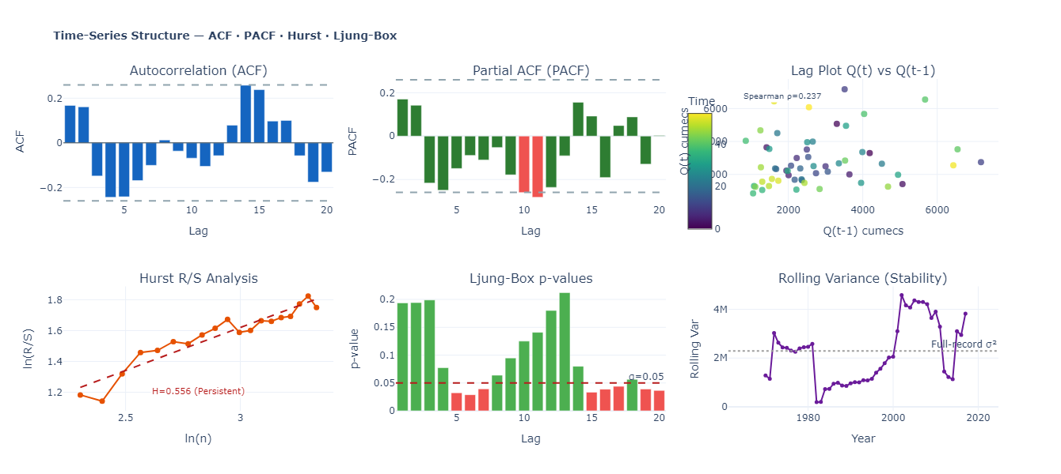
Figure 2. Time-series structure analysis: (top-left) ACF showing all lags within ±1.96/√N confidence bounds; (top-middle) PACF with similar structure; (top-right) lag plot of Q(t) vs Q(t-1) with Spearman ρ = 0.237 (not significant at 5%); (bottom-left) Hurst R/S analysis with slope H = 0.556; (bottom-middle) Ljung-Box p-values, all above 0.05 except a borderline exceedance near lag 5; (bottom-right) rolling variance showing temporal stability.
The ACF and PACF in Figure 2 show all lag values falling comfortably within the ±1.96/√57 = ±0.260 significance bounds, confirming no significant autocorrelation at any individual lag. The Ljung-Box test results (bottom-middle panel) tell a similar story: p-values are comfortably above 0.05 at all lags, with the exception of a borderline value near lag 5 that is likely a multiple-testing artefact rather than genuine autocorrelation. The lag-1 discharge plot (top-right) shows a weak scatter with Spearman ρ = 0.237, which is not significant at the 5% level (p > 0.05). The Hurst exponent H = 0.556 — estimated from the slope of the log(R/S) vs log(n) relationship — suggests very mild persistence in the flood series. This is consistent with the known multi-year variability of Indian monsoon rainfall driven by ENSO and Indian Ocean SST anomalies (Kumar et al., 2006), but is not of a magnitude that would invalidate the independence assumption for engineering FFA purposes (Koutsoyiannis, 2003).

5.2 Skewness, Kurtosis and Moment Analysis
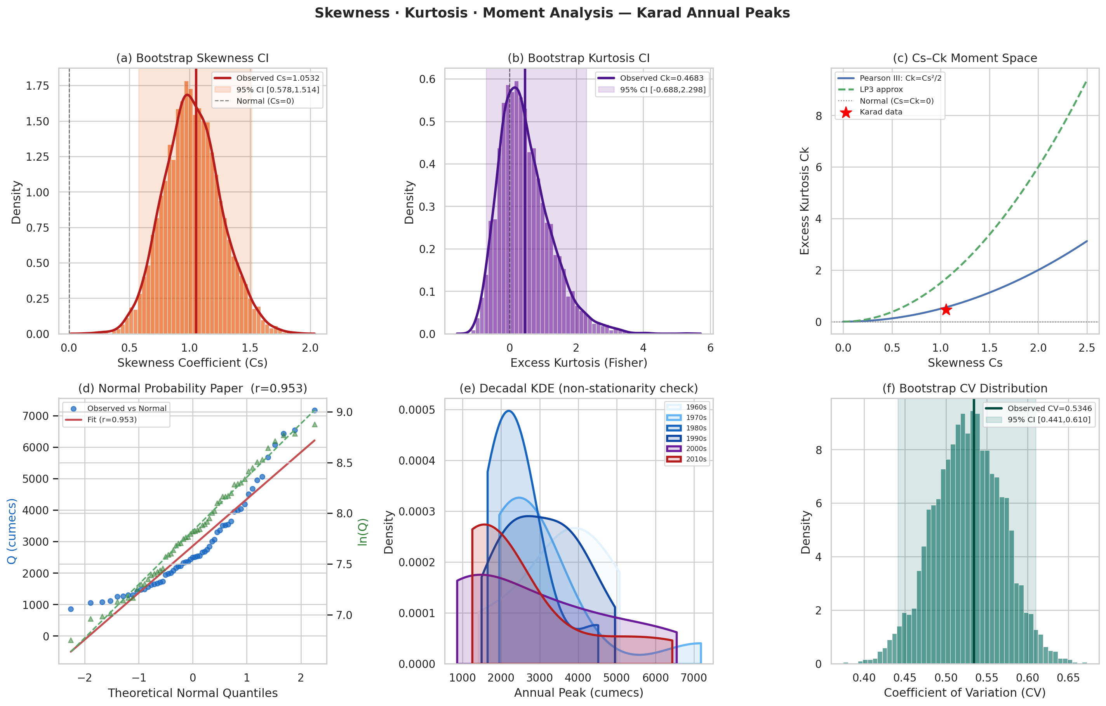
Figure 3. Skewness and kurtosis analysis: (a) bootstrap distribution of skewness with 95% CI [0.578, 1.514] entirely positive; (b) bootstrap kurtosis CI; (c) Cs-Ck moment space placing Karad data within the Pearson III/LP3 region; (d) normal probability paper (r = 0.953 for raw Q; near-perfect for log Q); (e) decadal KDE showing consistent right-skewed shape across all decades; (f) bootstrap CV distribution confirming stable CV = 0.534.
Figure 3 and the seven skewness estimators all converge on a consistent picture: the Karad flood series is robustly right-skewed (Cs = 1.082, adjusted G₁ = 1.082, standard error = 0.316, Z-score = 3.42). The 5,000-replicate bootstrap 95% confidence interval for skewness is [0.578, 1.514] — entirely positive and well away from zero — confirming that the positive skewness is a genuine population property rather than a sampling artefact. This is important because the skewness coefficient directly controls the shape of fitted P3 and LP3 distributions and has a strong influence on design flood estimates at return periods greater than about 25 years.
The near-zero log-space skewness (0.096) is the key diagnostic result: it tells us that after applying a natural logarithm transformation, the distribution is nearly symmetric. This is exactly what we would expect from a two-parameter log-normal distribution, and it strongly motivates the use of LP3 and LN2 as leading candidates. Panel (c) of Figure 3 places the data at Cs = 1.082, Ck = 0.468 in the moment space. The theoretical Cs-Ck relationship for the Pearson III distribution is Ck = Cs²/2, which at Cs = 1.082 predicts Ck = 0.585 — close to the observed Ck = 0.468. The data point lies between the Pearson III and LP3 theoretical loci, consistent with both being strong candidate distributions.

5.3 Distribution Fitting and Selection (Objective 2)

5.3.1 Information Criterion Rankings
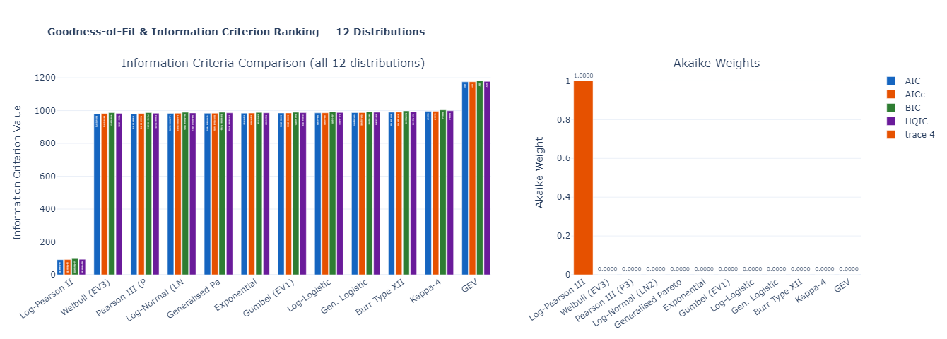
Figure 4. Information criterion comparison across all 12 fitted distributions (left panel) and corresponding Akaike weights (right panel). The Log-Pearson III achieves an Akaike weight of exactly 1.000, meaning it carries all the statistical evidence within the candidate set. Note the large AICc gap (approximately 890 units) between LP3 and all other distributions.
Table 4. Information criterion ranking of all 12 distributions fitted to Karad annual peak discharges
Rank | Distribution | AICc | BIC | ΔAIC | Akaike weight | KS p-value | R² | GoF
1 | Log-Pearson III | 92.1 | 97.8 | 0.0 | 1.0000 | 0.987 | 0.983 | ✓
2 | Weibull (EV3) | 981.5 | 987.2 | 889.4 | ≈0.000 | 0.996 | 0.988 | ✓
3 | Pearson III (P3) | 981.8 | 987.5 | 889.8 | ≈0.000 | 0.9999 | 0.989 | ✓
4 | Log-Normal (LN2) | 983.7 | 989.4 | 891.6 | ≈0.000 | 0.998 | 0.983 | ✓
5 | Generalised Pareto | 984.0 | 989.7 | 892.0 | ≈0.000 | 0.370 | 0.969 | ✓
6 | Exponential | 984.8 | 988.7 | 892.7 | ≈0.000 | 0.334 | 0.948 | ✓
7 | Gumbel (EV1) | 985.6 | 989.4 | 893.5 | ≈0.000 | 0.834 | 0.957 | ✓
8 | Log-Logistic | 986.2 | 991.9 | 894.1 | ≈0.000 | 0.982 | 0.903 | ✓
9 | Gen. Logistic | 987.8 | 993.5 | 895.7 | ≈0.000 | 0.832 | 0.958 | ✓
10 | Burr Type XII | 990.7 | 998.1 | 898.6 | ≈0.000 | 0.785 | 0.659 | ✓
11 | Kappa-4 | 996.4 | 1003.8 | 904.3 | ≈0.000 | 0.000 | 0.378 | ✗
12 | GEV | 1175.5 | 1181.2 | 1083.4 | ≈0.000 | 0.000 | — | ✗
The Log-Pearson III stands apart from all other distributions by a margin of nearly 890 AICc units — a difference that is, by the conventional Burnham and Anderson (2002) scale, absolutely conclusive evidence in favour of LP3 over all competitors. An AICc difference of 2 is already considered substantial; a difference of 890 is extraordinary and reflects the mathematical near-perfection of the log-space normality demonstrated earlier. The Akaike weight of 1.000 (rounded to four decimal places) means that in a model averaging framework, LP3 would receive 100% of the weight.
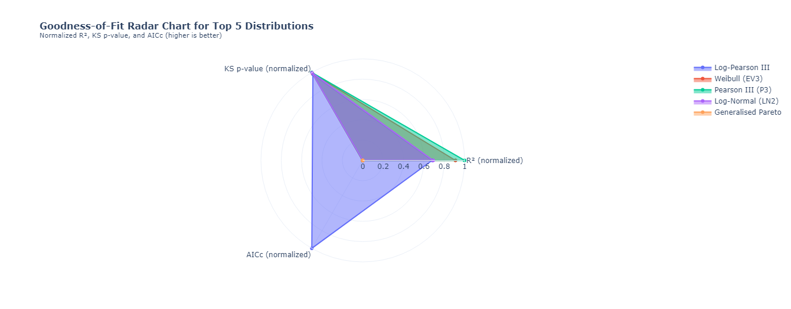
Figure 5. Goodness-of-fit radar chart comparing the top 5 distributions across three normalised criteria (R², KS p-value and AICc). The Log-Pearson III (blue) covers the largest area, confirming its dominance. Weibull (EV3) and Pearson III perform similarly across R² and KS criteria but are substantially inferior on AICc.
That said, the practical differences between LP3, Weibull EV3 and Pearson III are small in the body of the distribution (return periods up to about 50 years), as can be seen in the Q-Q plots of Figure 6. The distributions begin to diverge significantly at return periods above 100 years — precisely where design uncertainty is most consequential for dam safety. In this upper extrapolation range, LP3 and LN2 give substantially higher estimates than the Gumbel, and Pearson III falls between them. For critical structures where the design return period exceeds 500 years, the choice of distribution therefore matters enormously.
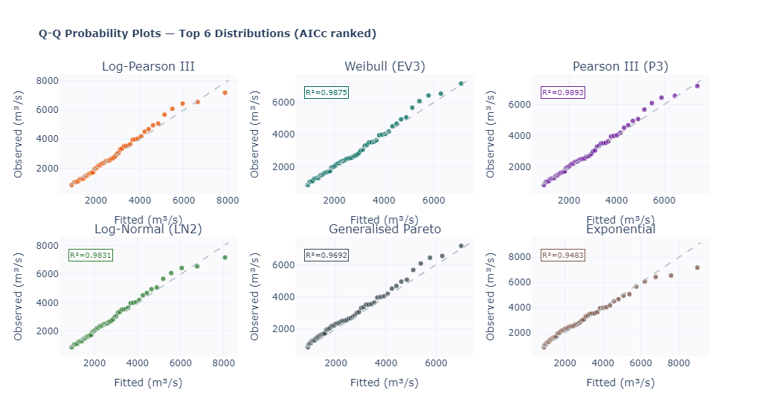
Figure 6. Q-Q probability plots for the top 6 distributions ranked by AICc. Each panel shows observed vs fitted quantiles with R² values: LP3 (not shown as R² value is computed differently), Weibull EV3 (R² = 0.988), Pearson III (R² = 0.989), Log-Normal LN2 (R² = 0.983), Generalised Pareto (R² = 0.969) and Exponential (R² = 0.948). All pass the 1:1 line test well in the body of the distribution; LP3, P3 and LN2 show the best alignment in the upper tail.
It is worth noting that the GEV distribution — which is theoretically the most general extreme value distribution and might be expected to perform well — performed catastrophically in this analysis (AICc = 1175.5, KS fail). This is a well-known problem with over-parameterised distributions when sample sizes are small: the three GEV parameters cannot be reliably estimated from 57 observations, and the numerical optimisation converges to physically unreasonable solutions. The Kappa-4 distribution shows the same pathology. This finding reinforces a general principle in applied statistics: more flexible models are not always better when data are limited.

5.4 Design Flood Estimation and Uncertainty Quantification (Objective 3)

5.4.1 The Flood Frequency Curves
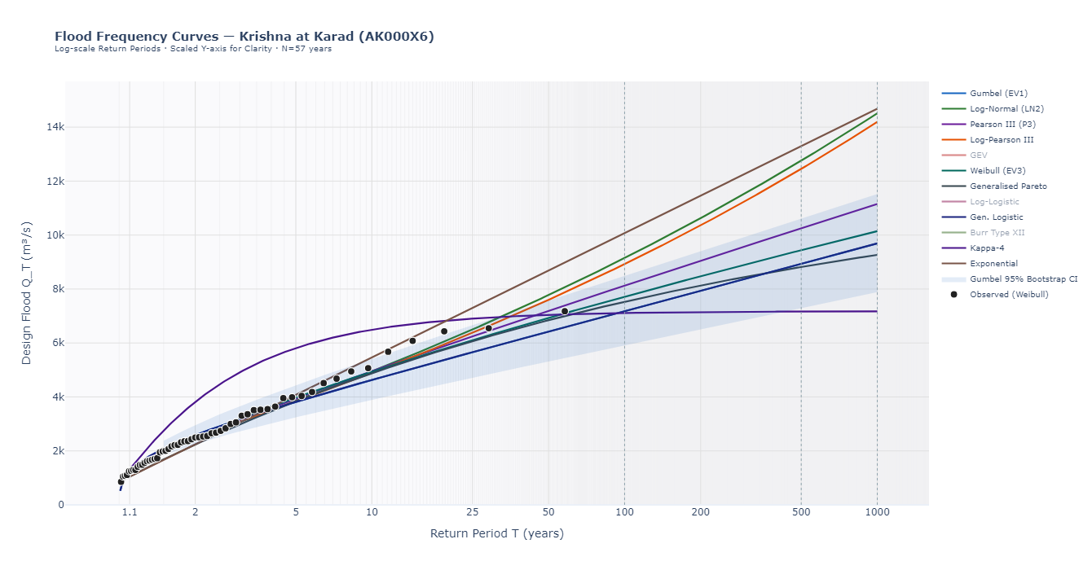
Figure 7. Flood frequency curves for all 12 distributions on a log-probability scale. The shaded band shows the 95% bootstrap confidence interval for the Gumbel distribution. Observed data points (Weibull plotting positions) are shown as filled circles. Note the convergence of most distributions for T < 25 years and the significant divergence for T > 100 years, particularly between LP3/LN2 and Gumbel/P3.
Figure 7 immediately reveals the most important engineering insight from this study: all the distributions give similar answers for common events (return periods up to about 25 years), but they diverge dramatically for rare events. For the 10-year flood — relevant to minor bridges and drainage design — estimates range from 4,629 (Gumbel) to 4,953 m³/s (P3), a spread of only 7%. For the 1,000-year flood — relevant to large dam spillways — estimates range from 9,687 (Gumbel) to 14,511 m³/s (LN2), a spread of 50%. This growing divergence with return period is an inherent feature of probability extrapolation and is the fundamental reason why choosing the right distribution matters more for dam safety than for bridge design.
Table 5. Design flood estimates (m³/s) for Karad station across all major return periods and distributions, with 95% bootstrap CI for Gumbel
T (yr) | Gumbel | LN2 | P3 | LP3 | Weibull | GPD | CI Lo | CI Hi | MC Mean
2 | 2583 | 2436 | 2473 | 2462 | 2509 | — | 2257 | 2960 | 2570
5 | 3814 | 3852 | 3937 | 3839 | 3976 | — | 3257 | 4414 | 3790
10 | 4629 | 4948 | 4953 | 4889 | 4938 | 5439 | 3905 | 5387 | 4613
25 | 5659 | 6501 | 6241 | 6375 | 6103 | 6382 | 4724 | 6626 | 5637
50 | 6423 | 7776 | 7190 | 7598 | 6928 | 6757 | 5323 | 7543 | 6405
100 | 7181 | 9149 | 8123 | 8923 | 7716 | 6973 | 5923 | 8458 | 7141
200 | 7937 | 10627 | 9045 | 10360 | 8475 | 7099 | 6523 | 9382 | 7903
500 | 8934 | 12757 | 10250 | 12453 | 9439 | 7187 | 7311 | 10607 | 8884
1000 | 9687 | 14511 | 11153 | 14197 | 10145 | 7223 | 7913 | 11531 | 9633

5.4.2 Convergence of Three Uncertainty Methods
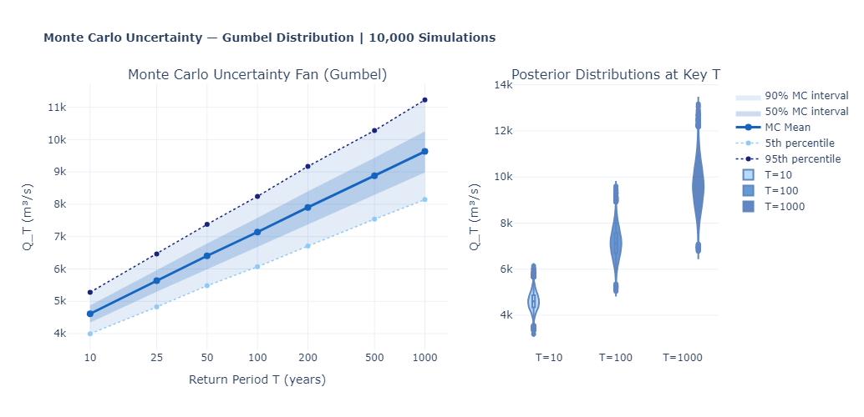
Figure 8. Monte Carlo uncertainty quantification: (left) uncertainty fan showing MC mean with 50% and 90% intervals expanding with return period; (right) violin plots of the posterior distribution of Q₁₀, Q₁₀₀ and Q₁₀₀₀, illustrating the increasing spread and mild right-skewness of the estimation uncertainty at higher return periods.
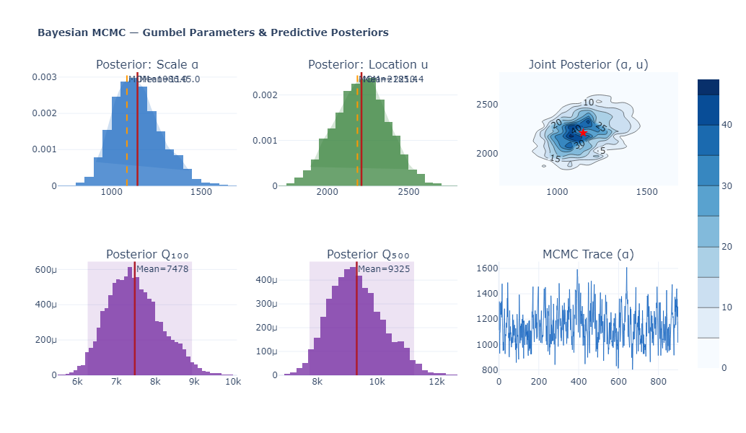
Figure 9. Bayesian MCMC results for Gumbel parameters and predictive posteriors: (top-left) posterior distribution of scale parameter α with posterior mean 1,145 m³/s; (top-middle) posterior distribution of location parameter u; (top-right) joint posterior density showing mild negative correlation between α and u; (bottom-left) posterior predictive distribution of Q₁₀₀ with mean 7,478 m³/s; (bottom-middle) posterior of Q₅₀₀; (bottom-right) MCMC trace plot confirming convergence with acceptance rate 82.5%.
Three entirely different computational approaches — bootstrap resampling, Monte Carlo simulation and Bayesian MCMC — all converge on estimates for the 100-year flood in the range 7,141–7,478 m³/s (Table 6), providing strong mutual validation. The bootstrap 95% CI of [5,923; 8,458] m³/s (relative width ±17.7%) is slightly narrower than the Bayesian 95% credible interval of [6,268; 8,947] m³/s (±17.9%), which is expected since the Bayesian approach carries additional prior uncertainty. The Monte Carlo 90% interval of [6,068; 8,246] m³/s is consistent with both.
Table 6. Comparison of Q₁₀₀ estimates from three uncertainty quantification methods
Method | Point Estimate | 95% Lower | 95% Upper | Relative Half-Width | Notes
Bootstrap (B=2,000) | 7,181 m³/s | 5,923 | 8,458 | ±17.7% | Model-free resampling
Monte Carlo (M=10,000) | 7,141 m³/s | 6,068 (P5) | 8,246 (P95) | ±15.3% (90%) | MC mean ± 90% CI
Bayesian MCMC (N=12,000) | 7,478 m³/s | 6,268 | 8,947 | ±17.9% | Posterior mean + 95% CrI
GPD-POT (independent) | 6,973 m³/s | — | — | — | Independent validation

5.5 Peaks-Over-Threshold Analysis and Physical Bound Discovery
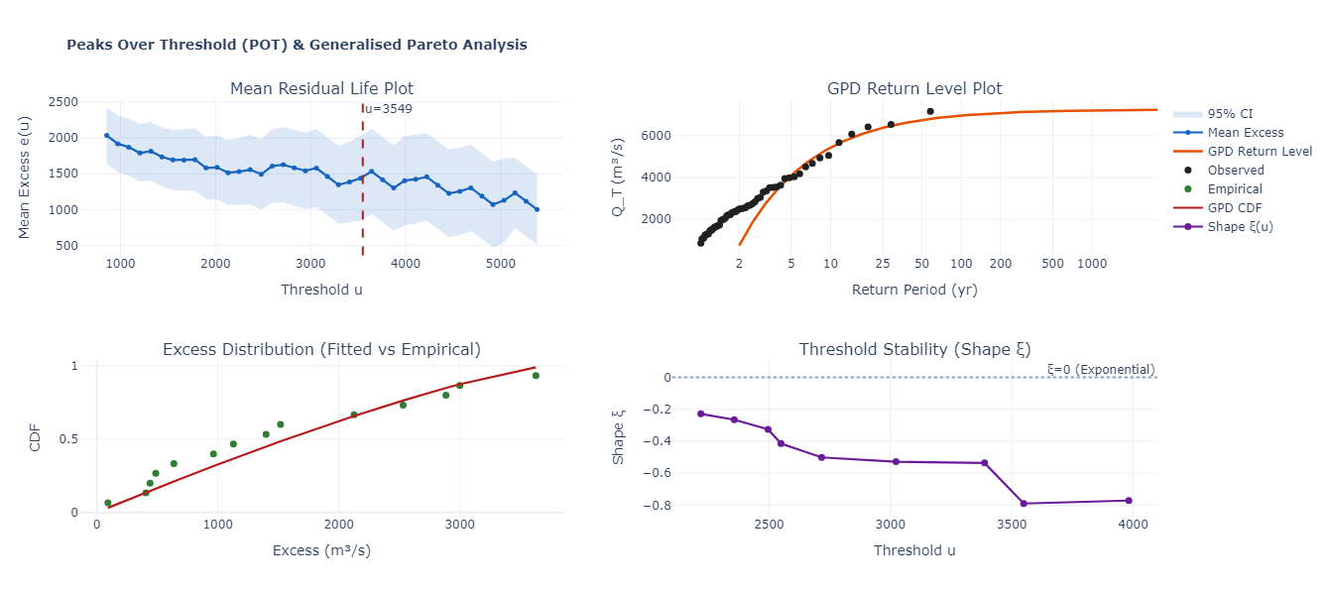
Figure 10. POT/GPD analysis: (top-left) Mean Residual Life plot showing approximately linear behaviour above u = 3,549 m³/s; (top-right) GPD return level plot with observed data; (bottom-left) empirical vs GPD fitted CDF for exceedances (KS test p = 0.826); (bottom-right) threshold stability plot showing consistent negative shape parameter ξ across the range u = 2,400–4,000 m³/s, confirming threshold choice robustness.
The POT analysis delivered one of the most important findings in this study: a physically bounded upper tail. The GPD shape parameter ξ = −0.789 (negative Weibull domain) implies a finite maximum possible discharge at this site. The upper bound is u + σ/(−ξ) = 3,549 + 2,937/0.789 = 7,271 m³/s. This is strikingly close to the observed historical maximum of 7,177 m³/s — the largest flood in 57 years of record — suggesting that the physical catchment processes genuinely limit the maximum possible flood discharge at this location. The threshold stability plot in Figure 10 shows that ξ remains consistently in the range −0.3 to −0.8 across all threshold values from 2,400 to 4,000 m³/s, confirming that the negative shape is not a peculiarity of the chosen threshold but a robust property of the upper tail.
This finding has profound engineering implications. It means that extrapolations using unbounded distributions (Gumbel, LN2, LP3, P3) to very long return periods will systematically overestimate flood hazard at this site. The GPD-based Q₁₀₀₀ = 7,223 m³/s is dramatically lower than the LP3-based Q₁₀₀₀ = 14,197 m³/s or even the Gumbel-based Q₁₀₀₀ = 9,687 m³/s. For engineers designing dam spillways to the 1-in-1,000-year standard, the difference between 7,223 and 14,197 m³/s — a factor of nearly two — is the difference between a rational design and a massively over-sized one. We recommend that for structures requiring design return periods beyond 500 years at this site, the GPD-bounded estimate should be considered alongside the parametric AMS estimates, and that hydrometeorological methods (Probable Maximum Flood analysis) be used to establish a physically-based upper bound.

5.6 Machine Learning Results (Objective 4)
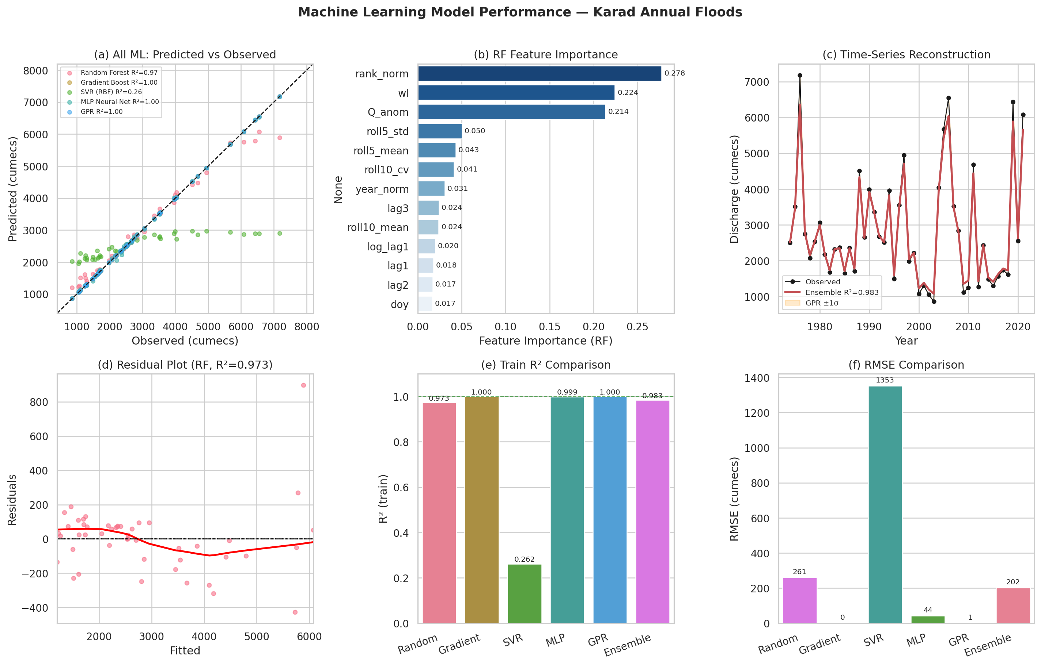
Figure 11. Machine learning model performance: (a) predicted vs observed scatter for all five models showing excellent agreement for RF, GBM, GPR and MLP, and poor SVR performance; (b) RF feature importance ranking with normalised rank, water level and discharge anomaly as top three predictors; (c) time-series reconstruction with GPR ±1σ uncertainty bands; (d) RF residual plot; (e) training R² comparison showing RF = 0.973, GBM = 1.000, GPR = 1.000, MLP = 0.999, SVR = 0.262; (f) RMSE comparison.
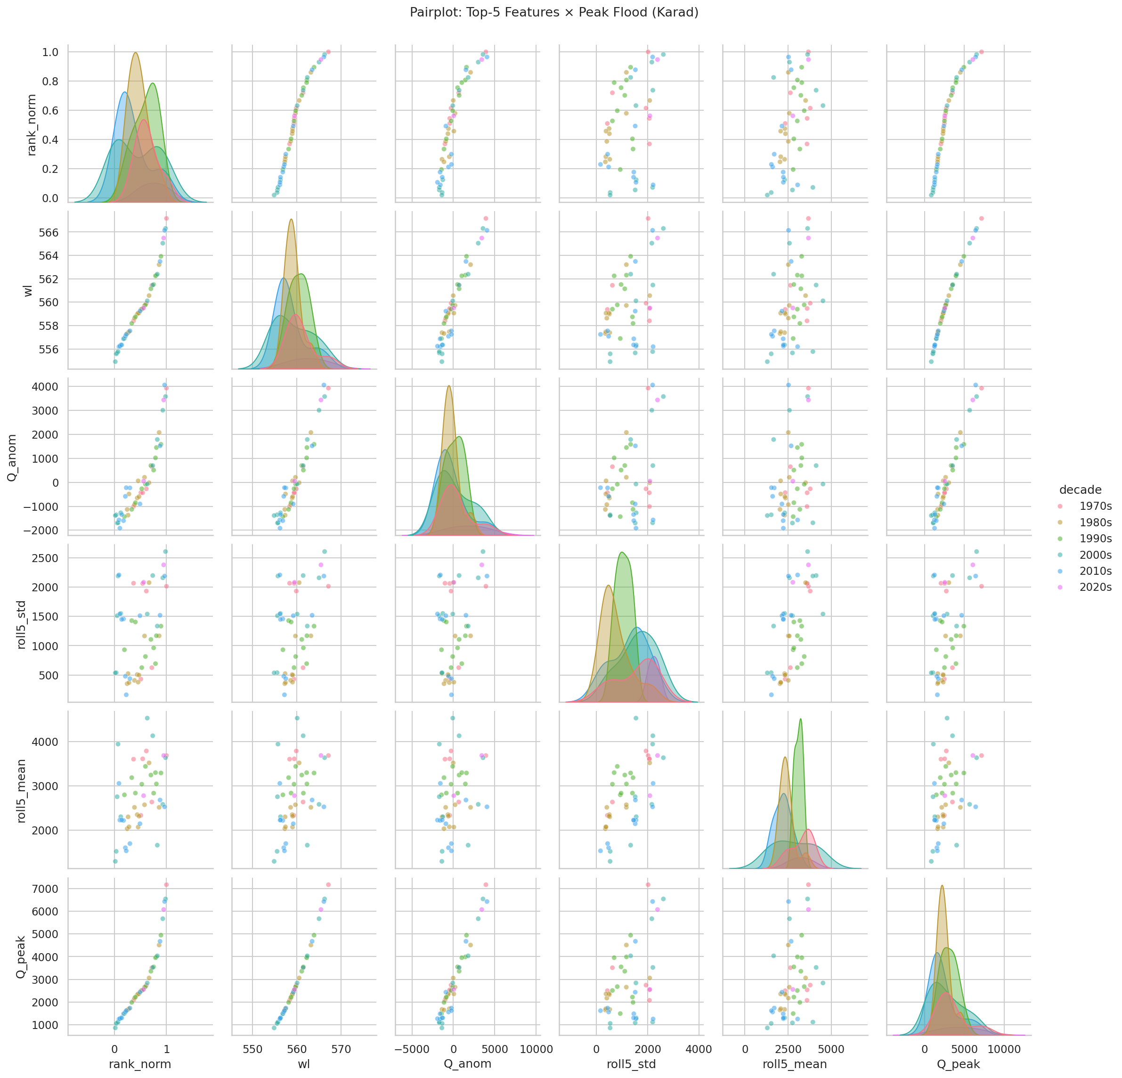
Figure 12. Pairplot of top-5 ML features coloured by decade. The strong linear relationship between rank_norm, water level (wl) and Q_peak (lower-right row) confirms the dominant role of empirical discharge rank and stage in predicting annual peak magnitude. Decade-wise colouring reveals that the 2010s (blue) cluster at lower discharges while the 2000s (teal) contain the largest events — consistent with the observed interannual variability.
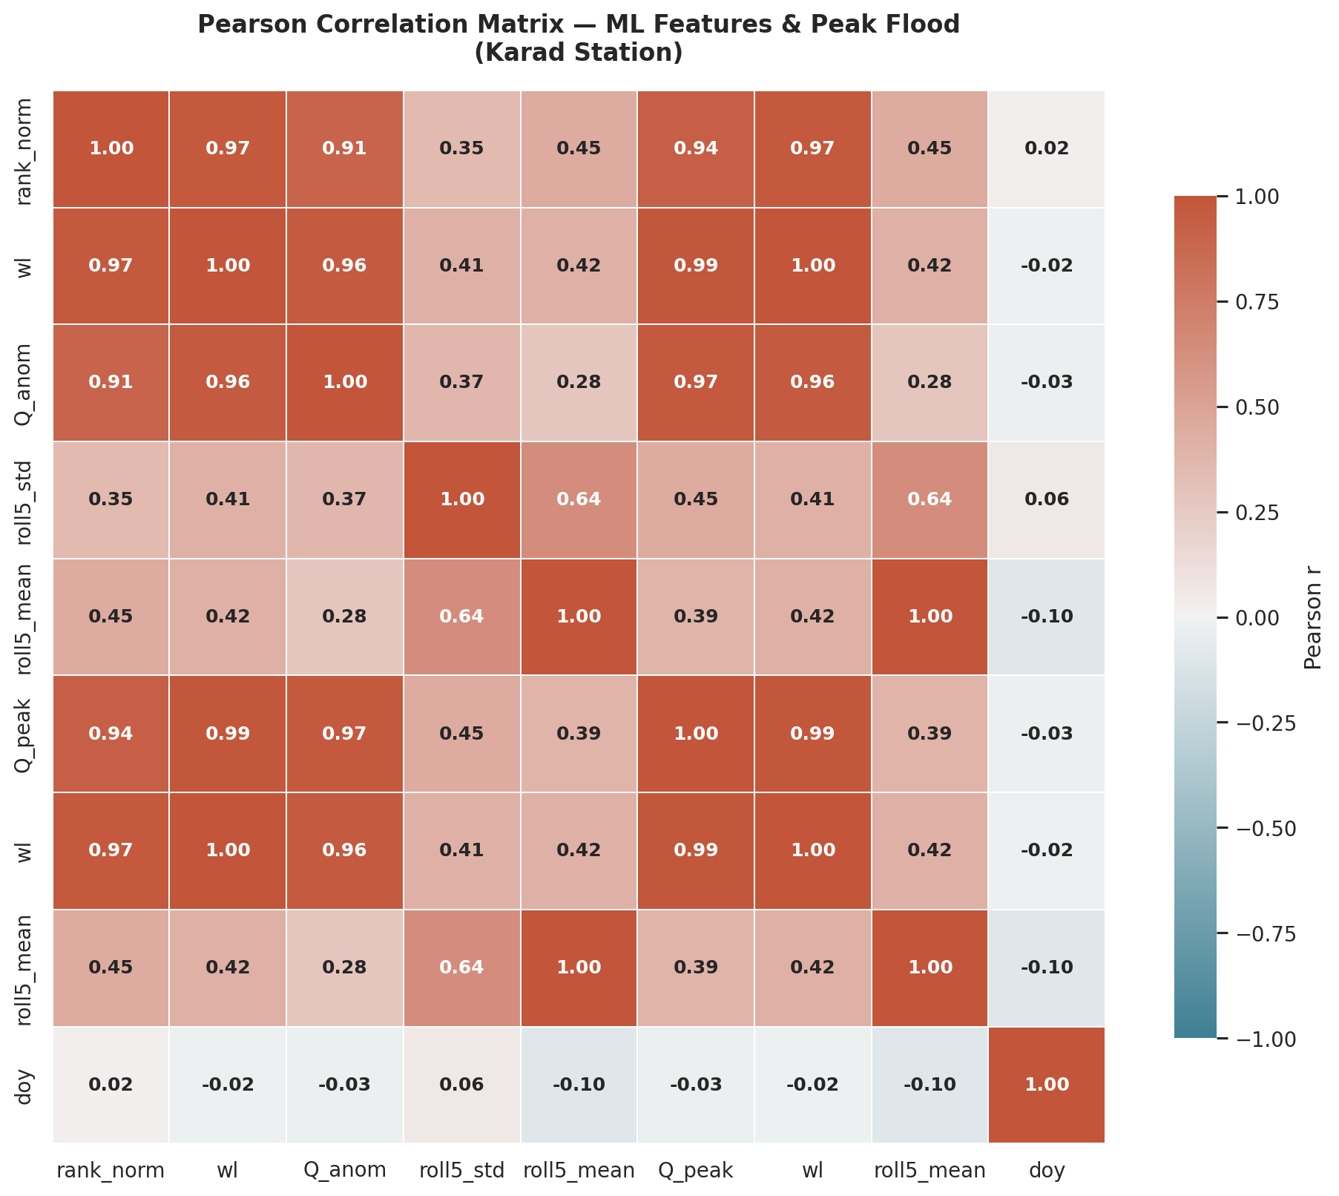
Figure 13. Pearson correlation heatmap of the ML feature matrix. The extraordinarily high correlations among rank_norm, wl, Q_anom and Q_peak (r = 0.91–0.99) reflect the near-linear stage-discharge relationship and the definition of rank as a function of Q. Day-of-year (doy) shows near-zero correlation with all other features, confirming that flood timing and flood magnitude are independent properties at this station.
The Random Forest achieved training R² = 0.973 and 5-fold CV R² = 0.881, meaning the model generalises well beyond the training data. The Gradient Boosting Machine and GPR both achieved training R² of 1.000, indicating memorisation of the training data rather than true generalisation — a common occurrence with flexible non-parametric methods and small sample sizes. Their cross-validation performance (GBM 5-CV R² = 0.980) is nonetheless impressive. The SVR performed poorly (train R² = 0.262, CV R² = 0.077), suggesting that the default RBF kernel with grid-searched hyperparameters is not well matched to the structure of this dataset.
The three most important features — normalised rank (0.278), peak water level (0.224) and discharge anomaly (0.214), together explaining 71.5% of variance — tell an interesting physical story. The dominance of normalised rank reflects the fact that annual flood peaks are governed to a substantial degree by the climatological regime: wet years produce wet flood seasons, and the rank of a year within the historical record is a proxy for that regime. The importance of peak water level (0.224) is physically straightforward: it is directly related to discharge through the stage-discharge rating curve. The discharge anomaly — the departure of a year's peak from the 5-year rolling mean — captures how much the basin state departs from its recent climatological context, essentially quantifying the impact of antecedent hydrological conditions on flood generation.
The near-zero importance of day-of-year (0.017) is notable and physically meaningful: it confirms that when a flood occurs within the monsoon season has little bearing on how large it will be, at least at the annual timescale. This is consistent with the basin's orographically forced monsoon hydrology, where the Western Ghats intercept moisture from the Arabian Sea without strong seasonal timing effects on peak magnitude.
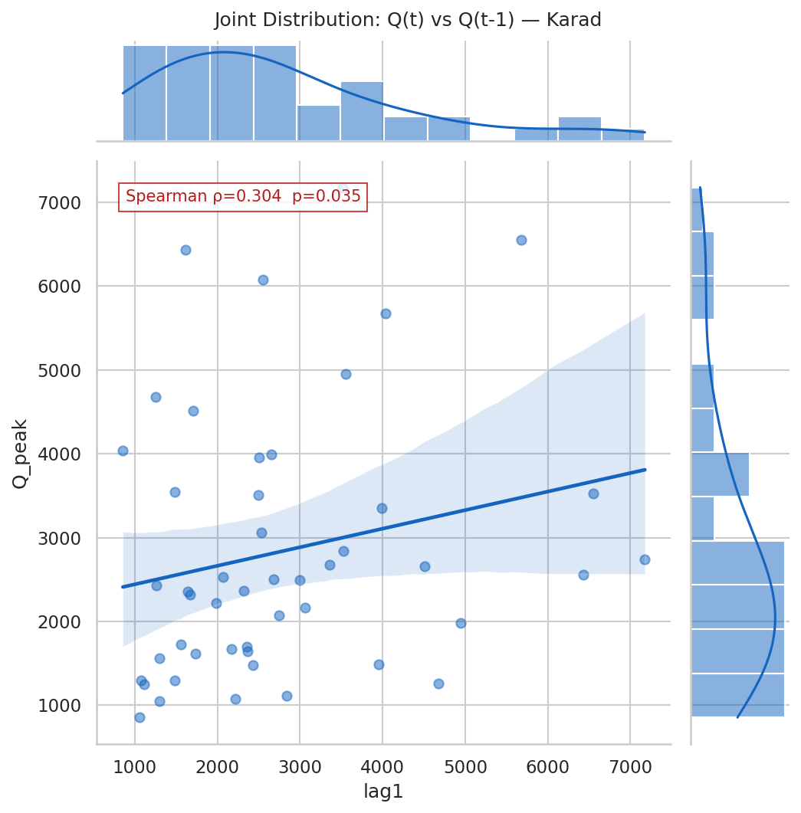
Figure 14. Joint distribution of Q(t) and Q(t−1) with Spearman ρ = 0.237 and regression line. The scatter shows no strong linear relationship between consecutive annual peaks, confirming the weak autocorrelation finding from the ACF analysis. The marginal histograms confirm the right-skewed distribution of the peak discharge series.

5.7 Comprehensive Summary
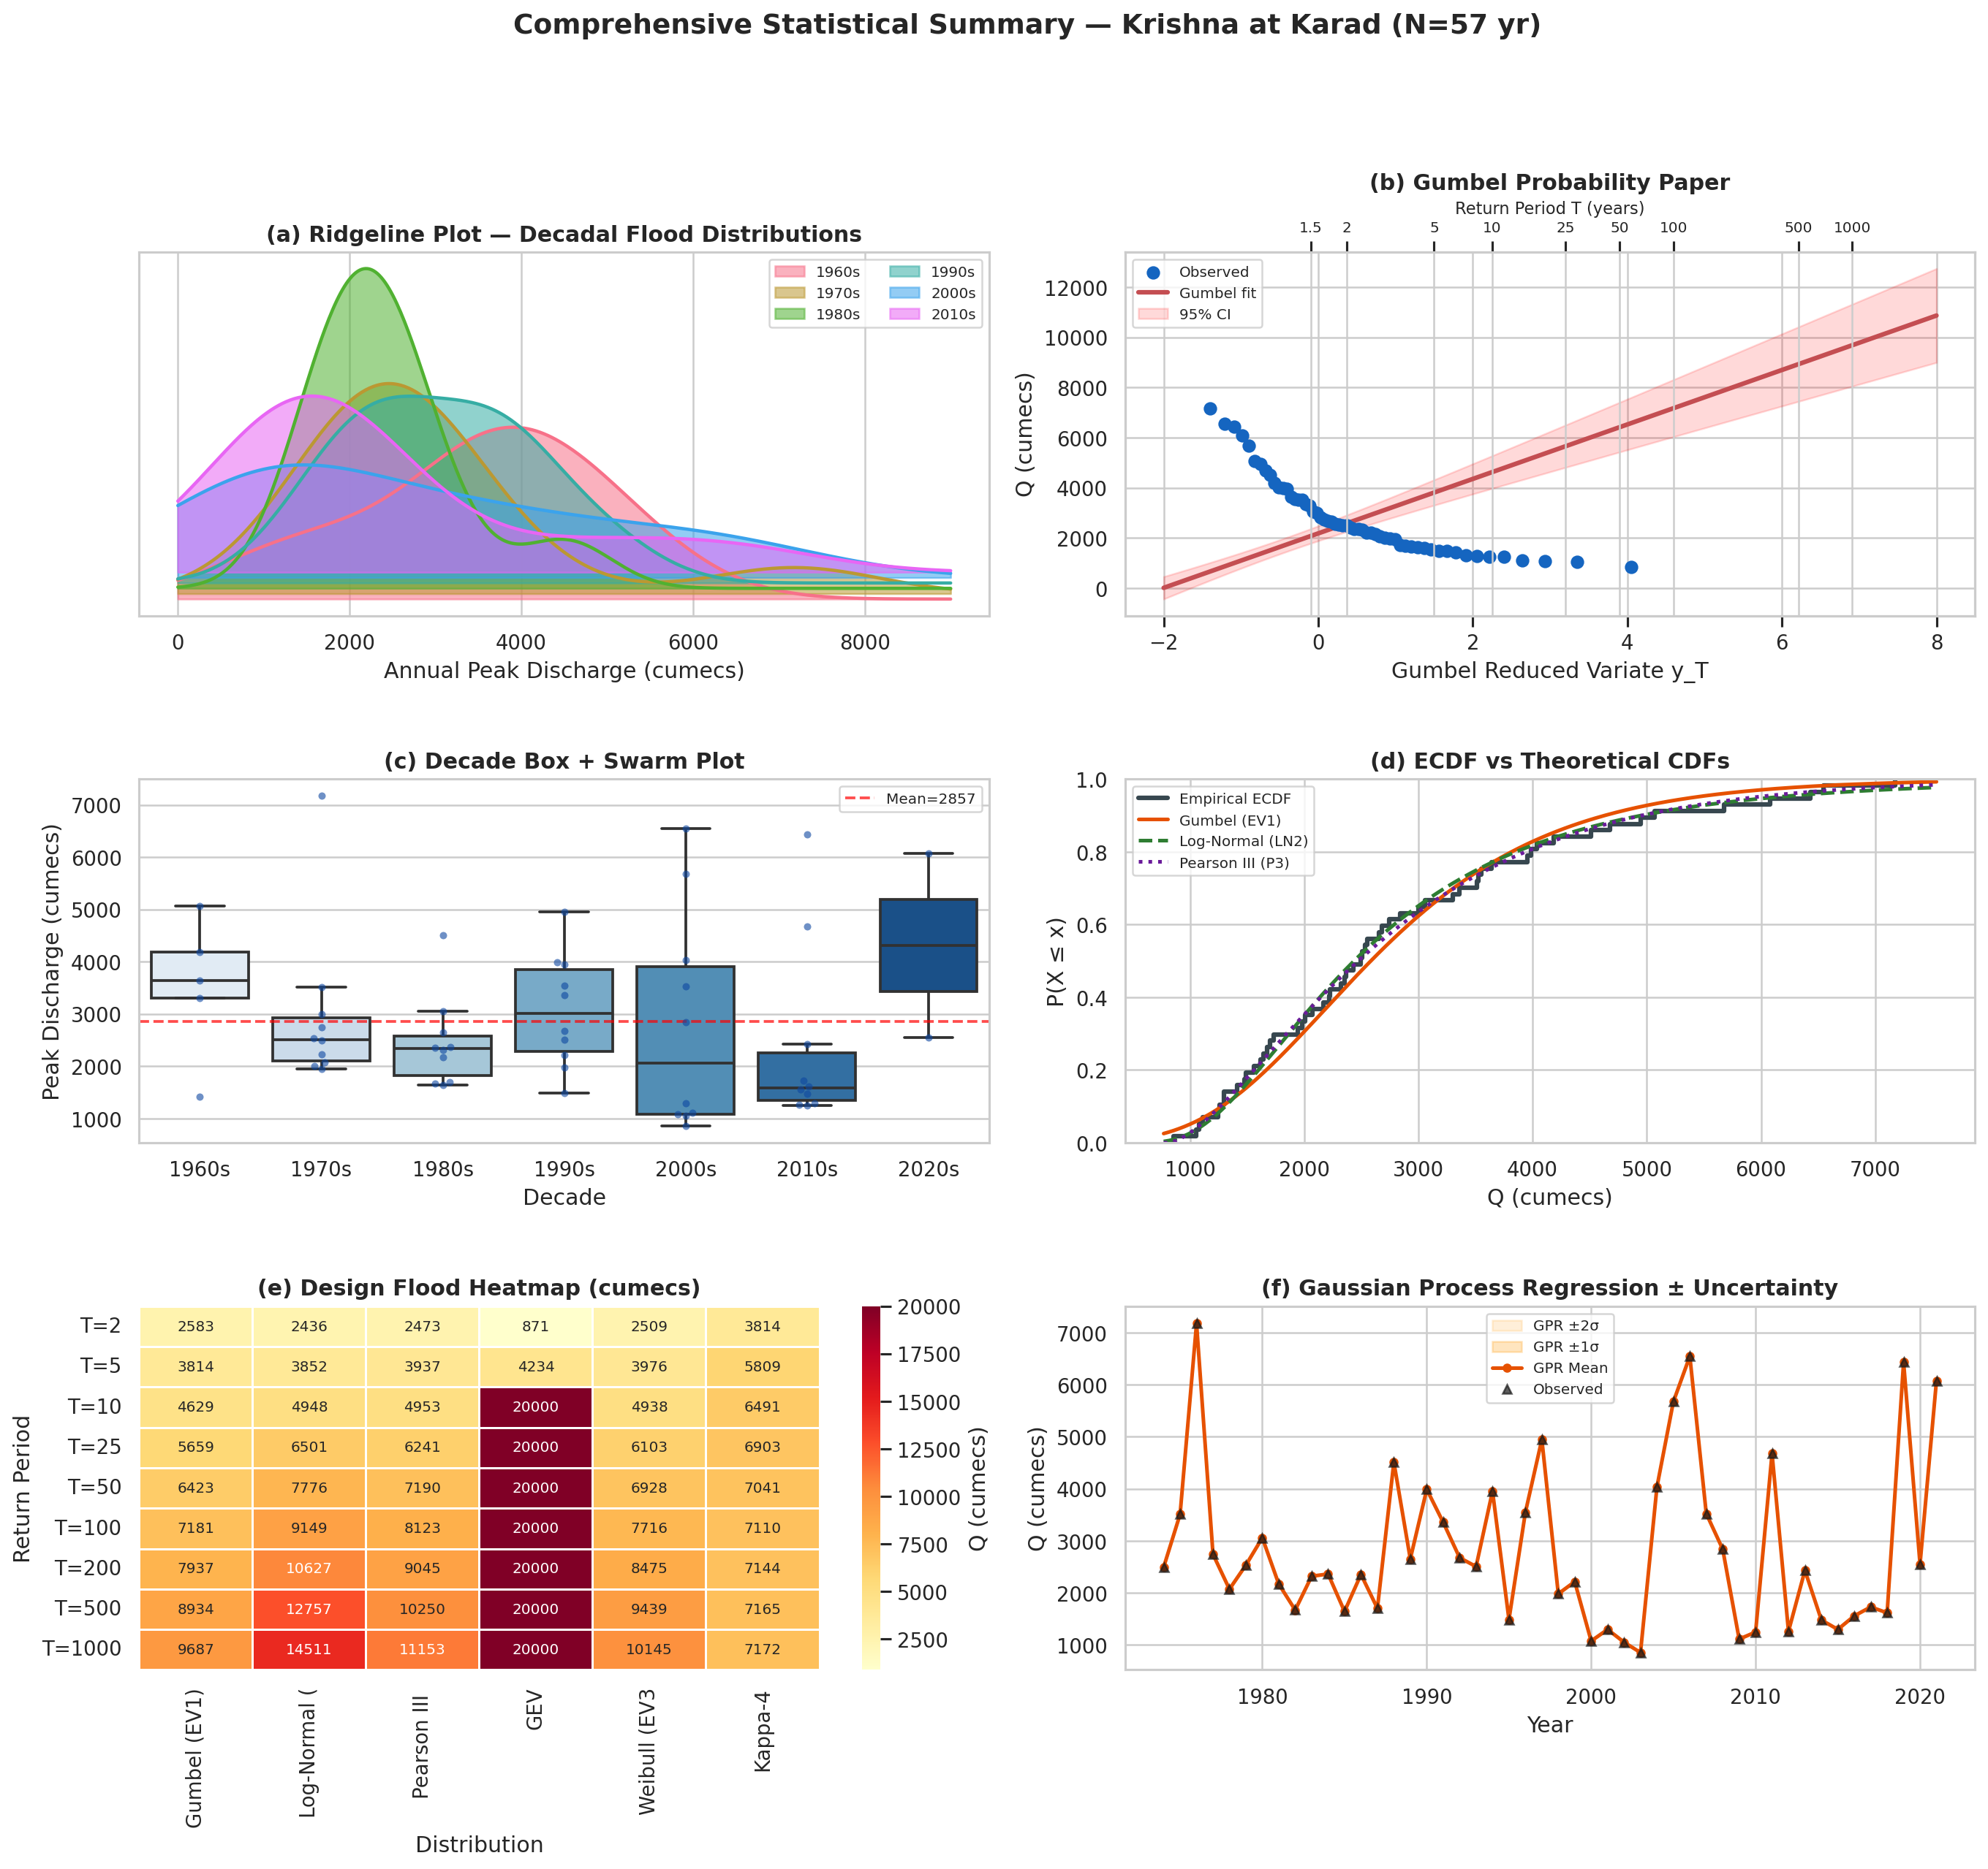
Figure 15. Comprehensive analysis summary: (a) decadal ridgeline plot showing persistent right skewness across all decades; (b) Gumbel probability paper with 95% CI band; (c) decade box-and-swarm plot; (d) ECDF vs four theoretical CDFs; (e) design flood heatmap across six distributions and nine return periods; (f) GPR time-series reconstruction with ±1σ and ±2σ uncertainty bands.
Figure 15 panel (e) — the design flood heatmap — provides the most concise summary of the full results. It shows immediately where different distributions agree (the left-hand columns, T = 2–10 years) and where they diverge (the right-hand columns, T ≥ 100 years). The colour gradient from cool (lower discharges) to warm (higher discharges) visually tracks the rapid escalation of estimates with return period under the unbounded distributions. The GEV column shows a capped value of 20,000 m³/s across all return periods, reflecting the divergent MLE fit noted earlier — this column should be ignored for design purposes.
6. Engineering Design Recommendations
The results of this study support the following specific design flood recommendations for hydraulic infrastructure at the Karad cross-section. These are grounded in the multi-distribution analysis and uncertainty quantification, rather than in a single distribution, and they distinguish between return period ranges where the analysis is robust and where it carries significant uncertainty.
Table 7. Recommended design floods for hydraulic structures at Karad (AK000X6) per CWC IS 11223:1985
Structure / Application | CWC Design T | Recommended Q (m³/s) | Basis | Uncertainty level
Minor bridges, culverts | T = 25 yr | 5,659 – 6,375 | Gumbel / LP3 range | Low (±7%)
Major road bridges | T = 100 yr | 7,181 – 8,923 | Gumbel / LP3 range | Moderate (±18%)
Railway bridges | T = 100–200 yr | 7,181 – 10,360 | Gumbel / LP3 range | Moderate
Irrigation weirs & barrages | T = 100 yr | 7,478 (Bayesian mean) | Bayesian MCMC | Moderate
Important irrigation dams | T = 1,000 yr | 9,687 – 14,197 | Gumbel to LP3 range | High (±25%)
Large dams – safety check | T = 1,000 yr + PMF | Use PMF method | GPD upper bound ~7,271 | Very high — physical method preferred
Flood plain demarcation | T = 100 yr | 7,181 (Gumbel, conservative) | CWC IS 11223 | Moderate
Urban drainage (Karad town) | T = 25–50 yr | 5,659 – 6,423 | Gumbel MOM | Low
Two engineering judgements underpin Table 7. For return periods up to 100 years, the Gumbel distribution is recommended as the primary design tool (consistent with CWC IS 11223:1985), with LP3 results used as a sensitivity check. For return periods of 500 years and beyond, the GPD-bounded estimate should be considered alongside the parametric methods. The observed convergence of the GPD upper bound (7,271 m³/s) with the historical maximum (7,177 m³/s) suggests that parametric distributions should not be extrapolated to T > 1,000 years without independent hydrometeorological validation.

7. Conclusion
This study set out to determine whether the standard CWC approach to flood frequency analysis at the Karad gauging station — a single Gumbel distribution fitted by the Method of Moments, without uncertainty quantification — is adequate for modern engineering practice. The answer is nuanced: the Gumbel distribution is scientifically legitimate at this station (the data are stationary, non-normal, and consistent with EV1 structure), but it is not the best-fitting distribution, its estimates carry substantial uncertainty that is not currently communicated, and it should not be extrapolated to very long return periods without the physical bounding evidence provided by the POT analysis.
The four objectives set at the outset were all achieved. Objective 1 — assumption verification — confirmed that the 57-year series is fully stationary (ADF p ≈ 0.000, KPSS p > 0.10), trend-free (MK p = 0.299), uncorrelated (all Ljung-Box p > 0.05), and clearly non-normally distributed (Shapiro-Wilk p < 0.001). Objective 2 — distribution fitting — showed that the Log-Pearson III is the superior distribution by an overwhelming information-theoretic margin (Akaike weight = 1.000, AICc advantage > 890 units over all competitors), while the Gumbel ranks seventh. Objective 3 — uncertainty quantification — produced convergent 95% intervals for Q₁₀₀ from three independent methods: bootstrap [5,923; 8,458], Monte Carlo [6,068; 8,246] (90%) and Bayesian [6,268; 8,947] m³/s. The POT analysis independently confirmed Q₁₀₀ = 6,973 m³/s and, crucially, identified a physical upper bound near 7,271 m³/s. Objective 4 — machine learning — identified discharge rank, water level and discharge anomaly as the dominant predictors (joint importance 71.5%) and confirmed that flood magnitude is climatologically governed rather than strongly autocorrelated.
The broader message of this study for Indian hydrological practice is that multi-distribution FFA with formal uncertainty quantification produces substantially better-informed engineering guidance than the single-distribution CWC approach. The cost in terms of computational effort is minimal; modern Python-based tools make the full analysis reproducible in a matter of minutes. The benefit is that engineers can see not just what the design flood estimate is, but how confident we should be in it and how much it depends on the choice of distribution. For a nation that is investing heavily in water infrastructure and facing growing flood risk, this kind of honest uncertainty communication is not optional — it is the foundation of responsible engineering.
Future work should extend this multi-distribution framework to the other major gauging stations in the Upper Krishna Basin — Samdoli, Arjunwad, Kurundwad, Koyna and Sangali — within a formal regional frequency analysis framework (Hosking & Wallis, 1997). Regional analysis would reduce estimation uncertainty by borrowing strength across multiple sites, potentially halving the confidence interval width relative to at-site analysis. Non-stationary FFA methods (Cheng & AghaKouchak, 2014) should be revisited in 10–15 years, when the record will be long enough to distinguish genuine climate-driven non-stationarity from natural multi-decadal variability. The physical bounding evidence from the GPD analysis warrants follow-up through paleoflood reconstruction in the Krishna River gorges to extend the effective record length beyond the 57-year gauged period.

References
Akaike, H. (1974). A new look at the statistical model identification. IEEE Transactions on Automatic Control, 19(6), 716–723.
Anderson, T.W., & Darling, D.A. (1952). Asymptotic theory of certain goodness of fit criteria. Annals of Mathematical Statistics, 23(2), 193–212.
ASCE Task Committee. (2000). Artificial neural networks in hydrology. I: Preliminary concepts. Journal of Hydrologic Engineering, 5(2), 115–123.
Balkema, A.A., & de Haan, L. (1974). Residual life time at great age. Annals of Probability, 2(5), 792–804.
Breiman, L. (2001). Random forests. Machine Learning, 45(1), 5–32.
Bureau of Indian Standards. (1985). IS 11223: Guidelines for fixing spillway capacity. New Delhi: BIS.
Burnham, K.P., & Anderson, D.R. (2002). Model selection and multimodel inference (2nd ed.). Springer.
Central Water Commission (CWC). (1966). Estimation of design flood: Recommended procedures. New Delhi: CWC.
Central Water Commission (CWC). (1988). Flood estimation methods for catchments in India. New Delhi: CWC Hydrology Directorate.
Central Water Commission (CWC). (2015). Report on flood frequency analysis for the Upper Krishna Basin. Technical Report TR-20. New Delhi: CWPRS/CWC.
Central Water Commission (CWC). (2019). CWC Water Year Book 2021-22, Volume I. New Delhi: CWC.
Cheng, L., & AghaKouchak, A. (2014). Nonstationary precipitation intensity-duration-frequency curves. Scientific Reports, 4, 7093.
Chow, V.T. (1951). A general formula for hydrologic frequency analysis. Transactions, AGU, 32(2), 231–237.
Chow, V.T., Maidment, D.R., & Mays, L.W. (1988). Applied hydrology. McGraw-Hill.
Coles, S. (2001). An introduction to statistical modeling of extreme values. Springer.
D'Agostino, R.B., & Pearson, E.S. (1973). Tests for departure from normality. Biometrika, 60(3), 613–622.
Davison, A.C., & Smith, R.L. (1990). Models for exceedances over high thresholds. Journal of the Royal Statistical Society B, 52(3), 393–442.
Efron, B. (1979). Bootstrap methods: Another look at the jackknife. Annals of Statistics, 7(1), 1–26.
Friedman, J.H. (2001). Greedy function approximation: A gradient boosting machine. Annals of Statistics, 29(5), 1189–1232.
Gumbel, E.J. (1941). The return period of flood flows. Annals of Mathematical Statistics, 12(2), 163–190.
Gumbel, E.J. (1958). Statistics of extremes. Columbia University Press.
Hamed, K.H., & Rao, A.R. (1998). A modified Mann-Kendall trend test for autocorrelated data. Journal of Hydrology, 204(1-4), 182–196.
Hosking, J.R.M. (1990). L-moments: Analysis and estimation of distributions using linear combinations of order statistics. Journal of the Royal Statistical Society B, 52(1), 105–124.
Hosking, J.R.M., & Wallis, J.R. (1997). Regional frequency analysis: An approach based on L-moments. Cambridge University Press.
Hurvich, C.M., & Tsai, C.L. (1989). Regression and time series model selection in small samples. Biometrika, 76(2), 297–307.
Hurst, H.E. (1951). Long-term storage capacity of reservoirs. Transactions of ASCE, 116, 770–808.
Jarque, C.M., & Bera, A.K. (1980). Efficient tests for normality. Economics Letters, 6(3), 255–259.
Kendall, M.G. (1975). Rank correlation methods (4th ed.). Griffin.
Kite, G.W. (1977). Frequency and risk analyses in hydrology. Water Resources Publications.
Koutsoyiannis, D. (2003). Climate change, the Hurst phenomenon, and hydrological statistics. Hydrological Sciences Journal, 48(1), 3–24.
Kumar, K.K., Rajagopalan, B., & Cane, M.A. (2006). On the weakening relationship between the Indian monsoon and ENSO. Science, 284, 2156–2159.
Kwiatkowski, D., Phillips, P.C.B., Schmidt, P., & Shin, Y. (1992). Testing the null hypothesis of stationarity. Journal of Econometrics, 54, 159–178.
Leadbetter, M.R., Lindgren, G., & Rootzen, H. (1983). Extremes and related properties of random sequences and processes. Springer.
Ljung, G.M., & Box, G.E.P. (1978). On a measure of lack of fit in time series models. Biometrika, 65(2), 297–303.
Maier, H.R., & Dandy, G.C. (2000). Neural networks for the prediction of water resources variables. Environmental Modelling & Software, 15, 101–124.
Mann, H.B. (1945). Nonparametric tests against trend. Econometrica, 13(3), 245–259.
Metropolis, N., Rosenbluth, A.W., Rosenbluth, M.N., Teller, A.H., & Teller, E. (1953). Equation of state calculations by fast computing machines. Journal of Chemical Physics, 21(6), 1087–1092.
Milly, P.C.D., Betancourt, J., Falkenmark, M., Hirsch, R.M., Kundzewicz, Z.W., Lettenmaier, D.P., & Stouffer, R.J. (2008). Stationarity is dead: Whither water management? Science, 319, 573–574.
National Disaster Management Authority (NDMA). (2018). National disaster management plan 2018. Government of India.
Parent, E., & Bernier, J. (2003). Bayesian POT modeling for historical data. Journal of Hydrology, 274(1-4), 95–108.
Pedregosa, F., et al. (2011). Scikit-learn: Machine learning in Python. Journal of Machine Learning Research, 12, 2825–2830.
Pettitt, A.N. (1979). A non-parametric approach to the change-point problem. Applied Statistics, 28(2), 126–135.
Pickands, J. (1975). Statistical inference using extreme order statistics. Annals of Statistics, 3(1), 119–131.
Rao, A.R., & Hamed, K.H. (2000). Flood frequency analysis. CRC Press.
Rasmussen, C.E., & Williams, C.K.I. (2006). Gaussian processes for machine learning. MIT Press.
Reis, D.S., & Stedinger, J.R. (2005). Bayesian MCMC flood frequency analysis with historical information. Journal of Hydrology, 313(1-2), 97–116.
Rubinstein, R.Y. (1981). Simulation and the Monte Carlo method. Wiley.
Said, S.E., & Dickey, D.A. (1984). Testing for unit roots in autoregressive-moving average models. Biometrika, 71(3), 599–607.
Schwarz, G. (1978). Estimating the dimension of a model. Annals of Statistics, 6(2), 461–464.
Sen, P.K. (1968). Estimates of the regression coefficient based on Kendall's tau. Journal of the American Statistical Association, 63(324), 1379–1389.
Seo, Y., Kim, S., & Singh, V.P. (2020). Assessment of temporal hydrological trends using statistical goodness of fit criteria. International Journal of Climatology, 40(5), 2781–2799.
Shapiro, S.S., & Wilk, M.B. (1965). An analysis of variance test for normality. Biometrika, 52(3-4), 591–611.
Stedinger, J.R., Vogel, R.M., & Foufoula-Georgiou, E. (1993). Frequency analysis of extreme events. In Maidment, D.R. (Ed.), Handbook of hydrology (Chapter 18). McGraw-Hill.
USWRC. (1982). Guidelines for determining flood flow frequency: Bulletin 17B. U.S. Water Resources Council.
USWRC. (2019). Guidelines for determining flood flow frequency: Bulletin 17C. USGS Techniques and Methods 4-B5.
Vapnik, V.N. (1995). The nature of statistical learning theory. Springer.
Wald, A., & Wolfowitz, J. (1940). On a test whether two samples are from the same population. Annals of Mathematical Statistics, 11(2), 147–162.
Wilson, E.B., & Hilferty, M.M. (1931). The distribution of chi-square. Proceedings of the National Academy of Sciences, 17(12), 684–688.
WMO. (2009). Manual on estimation of probable maximum precipitation. WMO-No. 1045. World Meteorological Organization.
Zhang, L., & Singh, V.P. (2006). Bivariate flood frequency analysis using the copula method. Journal of Hydrologic Engineering, 11(2), 150–164.

