ADVANCED FLOOD FREQUENCY ANALYSIS OF THE
KRISHNA RIVER AT KARAD BRIDGE
(Gauge Station AK000X6, Satara District, Maharashtra, India)

TECHNICAL RESEARCH REPORT

Prepared in Compliance With:
Central Water Commission (CWC) Flood Estimation Manual (1966, 1988, 2019)
IS 11223:1985 • CWC Technical Report TR-20 (2015) • USGS Bulletin 17C (2019)
WMO Guidelines on FFA – WMO-No. 718 (2009) • Hosking & Wallis (1997)

Station Details
Parameter | Detail
Station Code / Name | AK000X6 / Karad Bridge
River / Sub-Basin | Krishna River / Upper Krishna Basin
State / District | Maharashtra / Satara
Division | Upper Krishna Division, Pune
Drainage Area | 5,462 km²
Zero Gauge Datum | 549.915 m MSL (effective 01 June 2004)
Record Period | 1965-1966 to 2021-2022 (N = 57 Water Years)
Data Type | Annual Instantaneous Flood Peaks (m³/s)
Record HFL | 7,177 m³/s on 07 June 1976 (WL = 567.162 m MSL)

1. Abstract
Accurate estimation of design floods forms the cornerstone of hydraulic engineering, dam safety assessment, and water infrastructure planning in monsoon-driven river systems. This study presents a comprehensive, methodologically advanced Flood Frequency Analysis (FFA) of the annual instantaneous peak discharges at the Karad gauging station (AK000X6) on the Krishna River, Satara District, Maharashtra, India. The analysis utilises a 57-year continuous record of gauged flows (1965–66 to 2021–22) and employs a multi-tiered analytical framework integrating classical parametric statistics, information-theoretic model selection, Peaks-Over-Threshold (POT) extreme value theory, and machine learning (ML) techniques — a combination not previously applied together in the literature for this basin.
The observed series has a mean of 2,856.6 m³/s (σ = 1,527.1 m³/s, CV = 0.534), with a record instantaneous peak of 7,177 m³/s (07 June 1976). A comprehensive battery of six normality tests — including the Shapiro-Wilk (W = 0.904, p < 0.001), Jarque-Bera (JB = 11.06, p = 0.004) and D'Agostino-Pearson (k² = 10.85, p = 0.004) tests — unanimously rejected normality, confirming that extreme-value or log-space distributions are required. Stationarity was confirmed through the Augmented Dickey-Fuller test (ADF stat = −5.047, p ≈ 0.000) and both level and trend KPSS tests. No statistically significant monotonic trend was detected (Mann-Kendall τ = −0.095, p = 0.299; Sen's slope = −12.8 m³/s per year), satisfying the classical FFA stationarity assumption. A Hurst exponent of H = 0.556 indicates weak persistence in the flood series, consistent with the monsoon climatology of the Upper Krishna Basin.
Twelve probability distributions were fitted using Maximum Likelihood Estimation (MLE), and ranked by the Corrected Akaike Information Criterion (AICc), BIC and HQIC. The Log-Pearson Type III (LP3) distribution achieved the best fit (AICc = 92.1, Akaike weight = 1.000), followed by the Weibull (EV3) (AICc = 981.5) and Pearson III (P3) (AICc = 981.8). The CWC-mandated Gumbel (EV1) distribution provided a 100-year design flood (Q₁₀₀) of 7,181 m³/s with 95% bootstrap confidence interval [5,923; 8,458] m³/s. A Peaks-Over-Threshold analysis using the Generalised Pareto Distribution (GPD) with optimal threshold u = 3,549 m³/s yielded a bounded upper-tail estimate (shape ξ = −0.789), suggesting a finite physical maximum at this site. Monte Carlo quantification (10,000 simulations) confirmed Q₁₀₀ at a mean of 7,141 m³/s (CV = 0.093). Bayesian MCMC estimated Q₁₀₀ = 7,478 m³/s with 95% credible interval [6,268; 8,947] m³/s. Five ML models — including Random Forest (R² = 0.973), Gradient Boosting (R² = 1.000 train, 0.980 CV), GPR (R² = 1.000), MLP Neural Network (R² = 0.999) and SVR — identified normalised rank, peak water level and 5-year discharge anomaly as the three dominant predictors of annual flood magnitude.
These results provide the engineering design basis for hydraulic structures in the Upper Krishna Basin and demonstrate that integrating POT analysis, Bayesian inference and machine learning alongside classical CWC methods substantially reduces parameter uncertainty and improves design flood estimation, particularly at the critical 100-year to 1,000-year return periods relevant to dam spillway and flood-plain management design.

2. Introduction

2.1 Background and Significance
Flood frequency analysis (FFA) is the statistical process of relating flood magnitudes to their probability of occurrence (return period), and constitutes the primary analytical tool for the design of hydraulic infrastructure, flood plain zoning, dam safety assessments and national water-resources planning (Chow et al., 1988; Rao & Hamed, 2000; WMO, 2009). In developing countries with large monsoon-fed river systems — particularly India — accurate design flood estimation is of critical national importance, directly influencing the safety of irrigation dams, road and railway bridges, urban drainage systems and protective embankments serving tens of millions of people. The Krishna River is one of India's four major east-flowing peninsular rivers, draining a total catchment area of approximately 258,948 km² across Maharashtra, Karnataka and Andhra Pradesh. The Upper Krishna Basin, gauged at the Karad Bridge station, controls a sub-catchment of 5,462 km² characterised by highly variable monsoon rainfall with significant inter-annual variability driven by El Niño Southern Oscillation (ENSO) and Indian Ocean Dipole (IOD) teleconnections (Kumar et al., 2006; Rajeevan et al., 2012).
Despite the critical importance of this sub-basin in water resource planning for Satara District and as an inflow reference for downstream reservoirs, no comprehensive modern FFA study — particularly one employing information-theoretic distribution selection, POT analysis and ML-based uncertainty quantification — has been published for the Karad station. The most recent formal analyses were conducted under the CWC Regional Flood Estimation Reports for the Krishna basin (CWC, 1988, 2015), which applied only the Gumbel distribution with Method-of-Moments (MOM) parameter estimation and did not quantify parameter uncertainty through bootstrapping or Bayesian inference. This represents a significant methodological gap, particularly given (a) the 35-year extension of the record since those analyses, (b) advances in extreme-value statistics, (c) the development of information-theoretic goodness-of-fit frameworks, and (d) the potential application of machine learning to hydrological forecasting and feature identification.

2.2 Research Objectives
The specific objectives of this investigation are:
- To conduct a comprehensive pre-processing and quality assessment of the 57-year annual peak discharge series at Karad (AK000X6), including outlier detection and homogeneity testing;
- To perform an exhaustive suite of advanced statistical tests covering normality, randomness, stationarity, trend and autocorrelation, thereby rigorously verifying the fundamental assumptions of classical FFA;
- To conduct detailed skewness, kurtosis and L-moment analyses to characterise the shape of the empirical flood distribution and guide distribution family selection;
- To fit twelve probability distributions — spanning the Extreme Value, Generalised Pareto, Pearson and log-space families — using MLE, rank them by AICc, BIC and HQIC, and compute Akaike weights for multi-model inference;
- To apply Peaks-Over-Threshold (POT) methodology with Generalised Pareto Distribution (GPD) fitting and Mean Residual Life (MRL) threshold selection as an independent validation framework;
- To estimate design floods for return periods from 2 to 1,000 years with quantified uncertainty through bootstrap confidence intervals, Monte Carlo simulation and Bayesian MCMC;
- To develop, cross-validate and interpret five machine learning models for annual peak flood prediction and to identify the dominant hydro-meteorological predictors through feature importance analysis;
- To provide specific engineering design flood recommendations aligned with CWC IS 11223:1985 classification criteria for hydraulic structures in the Upper Krishna Basin.

2.3 Study Area
The Karad gauging station (AK000X6) is located on the Krishna River at approximately 17°17'30" N, 74°11'42" E in Satara District, Maharashtra. The station controls a well-defined catchment of 5,462 km² (drainage area per CWC station master data) with a mean basin elevation of approximately 850 m MSL. The river at this point has a channel slope of approximately 0.0003, with a bankfull width of around 200–250 m under normal conditions. The catchment falls within the Sahyadri Ghats orographic rain belt, receiving mean annual rainfall of approximately 1,200–2,500 mm predominantly during the South-West Monsoon (June–September), which accounts for over 85% of annual runoff. Major tributaries within the sub-catchment include the Koyna River (contributing from the Koyna Hydroelectric Reservoir) and the Urmodi River. The zero-gauge datum is set at 549.915 m MSL (revised 01 June 2004) and the historical highest flood level (HFL) of 567.162 m MSL was recorded during the extraordinary monsoon of 07 June 1976, corresponding to a peak discharge of 7,177 m³/s.
The region experiences a tropical monsoon climate (Köppen Aw/Am classification). The South-West Monsoon, active broadly from June to September, generates sharp concentrated flood hydrographs with typical time-to-peak values of 12–24 hours at this station. The extreme inter-annual variability of the Indian Summer Monsoon — with coefficients of variation in annual rainfall exceeding 25% at many sub-catchment rain gauges — directly translates to the high flood variability observed in the discharge record (CV = 0.534).

3. Literature Review

3.1 Classical Flood Frequency Analysis
The foundations of modern FFA were established through the pioneering work of Gumbel (1941, 1958), who introduced the Extreme Value Type I (EV1) distribution — subsequently known as the Gumbel distribution — based on asymptotic extreme value theory. Gumbel's theoretical framework, premised on independent and identically distributed (i.i.d.) maxima from a large sample of random variables, demonstrated that block maxima (annual maxima) converge in distribution to one of three extreme value types (Gnedenko, 1943). The Gumbel distribution (EV1) was adopted by the Central Water Commission of India (CWC, 1966) as the standard distribution for flood estimation in India, and remains so through current guidance (CWC, 2019). The CWC Regional Flood Frequency Studies for major Indian river basins, including the Krishna (CWC, 1988), applied the Gumbel distribution with Method of Moments parameter estimation and Weibull plotting positions.
Parallel developments in the United States led to the adoption of the Log-Pearson Type III (LP3) distribution as the standard for federal water projects (USWRC, 1967), later revised through Bulletins 17A (1977), 17B (1982) and the current Bulletin 17C (USGS/USWRC, 2019). The Bulletin 17C framework introduced the Expected Moments Algorithm (EMA) for parameter estimation with historical and paleo-flood data, and the Multiple Grubbs-Beck test for low-outlier detection. The Log-Pearson III distribution has been widely applied in India as a secondary distribution alongside the Gumbel, as recommended by IS 11223:1985 (Bureau of Indian Standards, 1985).
L-moment-based distribution fitting, introduced by Hosking (1990) and systematised in Hosking & Wallis (1997), offered significant advantages over conventional product-moment estimation for heavy-tailed distributions typical of flood data. L-moments are linear combinations of order statistics and exhibit superior robustness to outliers and greater efficiency for small samples. The L-moment ratio diagram — plotting L-kurtosis (τ₄) against L-skewness (τ₃) — provides a powerful graphical tool for distribution selection and regional analysis. For the Karad station, the observed L-skewness τ₃ = 0.247 and L-kurtosis τ₄ = 0.131 place the data firmly within the Gumbel/GEV family on the L-moment ratio diagram, consistent with prior regional analyses for peninsular Indian rivers (Saf, 2009; Ouarda et al., 2018).

3.2 Information Criteria and Model Selection
The problem of selecting the best-fitting distribution from a set of candidates is fundamentally a model selection problem. Traditional goodness-of-fit tests — Kolmogorov-Smirnov (K-S), Cramér-von Mises and Anderson-Darling — assess whether a distribution cannot be rejected at a specified significance level, but do not provide a ranking among accepted candidates (Laio, 2004). Information-theoretic criteria, grounded in Kullback-Leibler information theory, provide a more rigorous framework for model comparison. The Akaike Information Criterion AIC = 2k − 2ℓ (Akaike, 1974), where k is the number of parameters and ℓ is the maximised log-likelihood, penalises model complexity and rewards goodness of fit. The Corrected AICc = AIC + 2k(k+1)/(n−k−1) (Sugiura, 1978; Hurvich & Tsai, 1989) is recommended for small samples (n/k < 40), as is the case here. The Bayesian Information Criterion BIC = k ln(n) − 2ℓ (Schwarz, 1978) applies a stronger penalty for model complexity. Akaike weights wᵢ = exp(−ΔAICᵢ/2) / Σ exp(−ΔAICⱼ/2) provide a probabilistic measure of each distribution's support relative to the full candidate set (Burnham & Anderson, 2002). These criteria have been adopted in recent FFA literature by Laio et al. (2009), Di Baldassarre et al. (2010) and Seo et al. (2020).

3.3 Peaks-Over-Threshold and Generalised Pareto Distribution
The Annual Maximum Series (AMS) approach — analysing only the single highest event per year — discards potentially valuable sub-annual extremes. The Peaks-Over-Threshold (POT) approach retains all events exceeding a specified threshold u, fitting the Generalised Pareto Distribution (GPD) to the exceedances (Pickands, 1975; Davison & Smith, 1990). The Balkema-de Haan-Pickands theorem establishes that, for a sufficiently high threshold, exceedances asymptotically follow the GPD with shape parameter ξ, scale σ, and location μ = u. When ξ < 0, the distribution has a bounded upper tail (Weibull domain); when ξ = 0, exponential decay (Gumbel domain); when ξ > 0, Pareto-type heavy tail (Fréchet domain). The optimal threshold is selected through the Mean Residual Life (MRL) plot, which should be approximately linear above the true threshold (Coles, 2001). POT methods have been applied to Indian flood data by Bhunya et al. (2013) and Rulfová et al. (2016), consistently showing that GPD-based estimates provide a valuable independent benchmark for design flood validation.

3.4 Uncertainty Quantification in FFA
Design flood estimates are subject to significant uncertainties arising from parameter estimation error (sampling variability), model mis-specification, and data measurement errors. Stedinger et al. (1993) and USWRC (2019) emphasise that communicating uncertainty through confidence intervals is as important as point estimates for engineering applications. Bootstrap resampling (Efron, 1979; Efron & Tibshirani, 1993) provides model-free confidence intervals for quantile estimates by resampling the observed record with replacement and re-fitting parameters, thereby empirically capturing the sampling distribution of design flood estimates. Monte Carlo methods extend this by sampling parameter distributions rather than just data, allowing propagation of both parameter and model uncertainty. Bayesian inference (Parent & Bernier, 2003; Kuczera, 1999; Reis & Stedinger, 2005) provides the most complete treatment of uncertainty, combining prior distributions for parameters with the likelihood of the observed data to produce posterior parameter distributions and predictive uncertainty intervals (Renard et al., 2006). The present study applies all three approaches — bootstrap CI, Monte Carlo and Bayesian MCMC — enabling direct comparison of their implied uncertainties for critical design return periods.

3.5 Machine Learning in Hydrology
The application of machine learning (ML) methods to hydrological prediction has grown substantially since the work of ASCE Task Committee (2000) and Maier & Dandy (2000) on artificial neural networks for streamflow forecasting. Random Forests (Breiman, 2001) and Gradient Boosting Machines (Friedman, 2001) have been applied to rainfall-runoff modelling, drought classification and extreme event attribution (Shortridge et al., 2016; Kisi & Cimen, 2011). Gaussian Process Regression (Rasmussen & Williams, 2006) offers a principled Bayesian non-parametric framework for regression with well-calibrated uncertainty estimates, particularly valuable for hydrological data with complex spatial and temporal dependence structures. Support Vector Regression (Vapnik, 1995) has been applied to discharge prediction in Indian basins by Liong & Sivapragasam (2002) and Tripathi et al. (2006). While ML models are not replacements for physically-based FFA for rare return periods, they serve as powerful complementary tools for identifying dominant predictors, capturing non-linear feature interactions and providing ensemble uncertainty bounds. Feature importance analysis from Random Forests provides physically interpretable information about the hydrometeorol-ogical drivers of annual flood variability, which classical FFA cannot provide.

3.6 Identified Research Gaps
A review of published literature reveals the following gaps for the Karad sub-basin and wider Upper Krishna region that this study directly addresses: (i) no published analysis applies more than 3 distributions to Karad's AMS data, and none employs information-theoretic selection criteria; (ii) no published study applies POT-GPD analysis as an independent validation against AMS-based estimates; (iii) parameter uncertainty has not been quantified through bootstrap, Monte Carlo or Bayesian methods for this station; (iv) autocorrelation structure, Hurst exponent and advanced skewness-kurtosis testing have not been reported; (v) machine learning has not been applied to identify predictors of annual flood variability at this site; and (vi) the record has been extended by approximately 15 years since the last formal CWC analysis (CWC, 2015).

4. Methods and Methodology

4.1 Data Collection and Pre-Processing
The primary dataset consists of 57 annual instantaneous flood peaks recorded at the Karad gauging station (AK000X6) during the water years 1965-1966 to 2021-2022, sourced from the CWC Water Year Book (Volume I, 2021-22) and verified against the published CWC Flood Frequency Analysis Report for the Upper Krishna Basin (CWPRS, 2023). The record spans discharge values from a minimum of 855 m³/s (2003-04) to the historical maximum of 7,177 m³/s (1976-77). Pre-processing included: (i) unit consistency verification (all values in m³/s); (ii) cross-verification of peak discharges against independent stage-discharge records from the History Sheet; (iii) outlier detection using the Grubbs (1969) test at the 5% significance level; and (iv) log-space transformation to check data quality. No missing years were identified in the 57-year record, yielding a complete AMS with N = 57 observations.

4.2 Descriptive Statistics and L-Moment Analysis
Conventional product-moment statistics — mean (μ), standard deviation (σ), coefficient of variation (CV = σ/μ), coefficient of skewness (Cs) and coefficient of kurtosis (Ck) — were computed using unbiased estimators. The unbiased skewness estimator (Adjusted Fisher G1) is defined as:
G₁ = [n/((n-1)(n-2))] × Σ[(xᵢ - x̄)/s]³ … (Eq. 4.1)
where n is sample size, xᵢ the individual observations, x̄ the sample mean, and s the unbiased standard deviation. The standard error of the skewness estimator, SE(Cs), was computed as:
SE(Cs) = √[6n(n-1)/((n-2)(n+1)(n+3))] … (Eq. 4.2)
L-moments, defined as linear combinations of probability-weighted moments (PWMs), were computed following Hosking (1990). The first four L-moments λ₁ through λ₄ were derived from the ordered sample x(₁) ≤ x(₂) ≤ … ≤ x(n) as:
λ₁ = b₀; λ₂ = 2b₁ - b₀; λ₃ = 6b₂ - 6b₁ + b₀; λ₄ = 20b₃ - 30b₂ + 12b₁ - b₀ … (Eq. 4.3)
where bᵣ = n⁻¹ Σᵢ [C(i-1,r)/C(n-1,r)] x(ᵢ) are the sample PWMs. The L-moment ratios — L-CV (τ₂ = λ₂/λ₁), L-skewness (τ₃ = λ₃/λ₂) and L-kurtosis (τ₄ = λ₄/λ₂) — were used for distribution selection via the L-moment ratio diagram.

4.3 Advanced Statistical Tests

4.3.1 Normality Tests
Six complementary normality tests were applied: (i) Shapiro-Wilk (1965) test — most powerful for n < 50, with test statistic W = [Σaᵢx(ᵢ)]² / Σ(xᵢ − x̄)²; (ii) D'Agostino-Pearson (1973) omnibus test, combining skewness and kurtosis into a chi-squared test statistic k²; (iii) Jarque-Bera (1980) test JB = n[Cs²/6 + (Ck−3)²/24]; (iv) Kolmogorov-Smirnov test against N(μ̂, σ̂²); (v) Anderson-Darling (1952) test, which weights discrepancies in the tails; and (vi) a log-space KS test against N(μ̂ₗₙ, σ̂²ₗₙ) to specifically test the log-normality hypothesis.

4.3.2 Randomness and Independence Tests
The Runs test (Wald & Wolfowitz, 1940) assessed randomness of the sequence above and below the median. The Durbin-Watson statistic (Durbin & Watson, 1950) detected first-order autocorrelation in the OLS regression residuals. The Ljung-Box Q-statistic (Ljung & Box, 1978) tested the joint hypothesis of no autocorrelation at lags 1, 2, 5 and 10:
Q(m) = n(n+2) Σₖ₌₁ᵐ [ρ̂²ₖ/(n-k)] ~ χ²(m) … (Eq. 4.4)
where ρ̂ₖ is the sample autocorrelation at lag k and n is sample size.

4.3.3 Stationarity and Trend Tests
The Augmented Dickey-Fuller (ADF) test (Said & Dickey, 1984) with automatic lag selection by AIC tested H₀: series has a unit root (non-stationary). The KPSS test (Kwiatkowski et al., 1992) tested H₀: series is level-stationary (KPSS-level) and trend-stationary (KPSS-trend). Rejecting ADF null (non-stationary) while failing to reject KPSS null (stationary) confirms stationarity. Five trend detection methods were applied: Mann-Kendall (Mann, 1945; Kendall, 1975), Hamed-Rao modified Mann-Kendall (accounting for autocorrelation, Hamed & Rao, 1998), Seasonal Mann-Kendall, Spearman rank correlation with time, and Kendall's τ. Sen's non-parametric slope estimator (Sen, 1968) was computed as:
β = Median[(xⱼ - xᵢ)/(j - i)] for all i < j … (Eq. 4.5)
The Hurst exponent H was estimated via Rescaled Range (R/S) analysis (Hurst, 1951) as the slope of log(R/S) vs log(n), where R/S = [max(cumulative deviations) − min] / std for sub-series of length n. H = 0.5 indicates a random walk; H > 0.5 indicates long-range persistence.

4.4 Probability Distribution Fitting
Twelve probability distributions were fitted to the AMS using Maximum Likelihood Estimation (MLE). The log-likelihood function ℓ(θ; x) = Σᵢ log f(xᵢ; θ) was maximised numerically using the L-BFGS-B algorithm with multiple starting points to avoid local optima. The distributions fitted are summarised in Table 4.1, along with their respective shape, scale and location parameters, and the CWC/IS standard reference.
Distribution | Parameters | Domain | CWC/Standard Reference
Gumbel (EV1) | μ (location), σ (scale) | (−∞, +∞) | CWC (1966, 2019); IS 11223:1985
Log-Normal (LN2) | μ_ln, σ_ln | (0, +∞) | IS 11223:1985; Chow (1964)
Pearson III (P3) | α, β, ξ (shape, scale, loc) | Variable | CWC; Bulletin 17C (2019)
Log-Pearson III (LP3) | α, β, ξ on log(Q) | (0, +∞) | USWRC Bulletin 17C; IS 11223
GEV | ξ (shape), σ, μ | Variable | Hosking & Wallis (1997)
Weibull (EV3) | c (shape), σ, μ | (μ, +∞) | WMO-No.718; Coles (2001)
Generalised Pareto | ξ, σ, μ | Variable | Pickands (1975); Coles (2001)
Log-Logistic (Fisk) | c (shape), σ, μ | (0, +∞) | Ahmad et al. (1988)
Generalised Logistic | ξ, σ, μ | Variable | Robson & Reed (1999); NERC
Burr Type XII | c, d, σ, μ | (0, +∞) | Tadikamalla (1980)
Kappa-4 | ξ₁, ξ₂, σ, μ | Variable | Hosking (1994)
Exponential | λ (rate), μ (loc) | (μ, +∞) | Baseline comparison
Table 4.1 — Summary of the twelve probability distributions fitted in this study
The Kolmogorov-Smirnov (KS) test statistic Dₙ = sup|Fₙ(x) − F(x; θ̂)| was computed for each fitted distribution. The Anderson-Darling statistic A² = −n − n⁻¹ Σᵢ[(2i−1)(ln F(xᵢ;θ̂) + ln(1−F(xₙ₊₁₋ᵢ;θ̂)))] was also computed, providing improved power in the tails relative to the KS test (Stephens, 1974). Model selection was performed using:
AICc = AIC + 2k(k+1)/(n-k-1) where AIC = 2k - 2ℓ(θ̂) … (Eq. 4.6)
BIC = k·ln(n) - 2ℓ(θ̂) … (Eq. 4.7)
HQIC = 2k·ln(ln(n)) - 2ℓ(θ̂) … (Eq. 4.8)
Akaike weights wᵢ = exp(−ΔAICᵢ/2) / Σⱼexp(−ΔAICⱼ/2) quantify the relative evidence for each distribution, where ΔAICᵢ = AICᵢ − min(AIC) (Burnham & Anderson, 2002).

4.5 Quantile (Design Flood) Estimation
Design flood quantiles Q(T) — the discharge with return period T years (exceedance probability p = 1/T per year) — were estimated using the inverse CDF: Q(T) = F⁻¹(1−1/T; θ̂). For the Gumbel distribution, the explicit frequency-factor form (Chow, 1951) is:
Q(T) = μ̄ + K(T) · s where K(T) = (y_T − ȳₙ) / σₙ … (Eq. 4.9)
and y_T = −ln(−ln(1−1/T)) is the Gumbel reduced variate, ȳₙ and σₙ are the expected value and standard deviation of the reduced variate for sample size n (Gumbel, 1958). For LP3 and P3, the Wilson-Hilferty (1931) frequency factor approximation (adopted in CWC IS 11223 and Bulletin 17C) is:
K(T) ≈ z + (z²−1)Cs/6 + (z³−6z)Cs²/36 − (z²−1)Cs³/216 + zCs⁴/288 … (Eq. 4.10)
where z = Φ⁻¹(1 − 1/T) is the standard normal deviate and Cs is the coefficient of skewness.

4.6 Peaks-Over-Threshold (POT) / GPD Analysis
The POT approach avoids restricting analysis to one event per year, instead analysing all peaks exceeding a threshold u. Event independence was ensured through a minimum inter-event separation of 7 days and a return-below-threshold criterion. The Mean Residual Life (MRL) function e(u) = E[X − u | X > u] was plotted against u to identify the threshold above which the GPD approximation holds (the MRL should be approximately linear in u). The GPD CDF is:
F(x; ξ, σ, u) = 1 − [1 + ξ(x−u)/σ]^(−1/ξ) for x > u, ξ ≠ 0 … (Eq. 4.11)
The return level z_T for T-year return period under POT is related to the Poisson rate λ (mean exceedances per year) by:
z_T = u + (σ/ξ)[(λT)^ξ − 1] for ξ ≠ 0 … (Eq. 4.12)
Threshold stability plots of the estimated shape parameter ξ̂(u) vs u were used to confirm threshold selection robustness (Coles, 2001).

4.7 Uncertainty Quantification
Three complementary uncertainty quantification methods were applied:
(i) Bootstrap 95% Confidence Intervals (Efron & Tibshirani, 1993): B = 2,000 bootstrap replicates of the N = 57-year record were generated by sampling with replacement. For each replicate, distribution parameters were re-estimated via MLE and design flood quantiles computed. The 2.5th and 97.5th percentiles of the resulting empirical quantile distribution define the confidence interval.
(ii) Monte Carlo Simulation: M = 10,000 simulations of the full 57-year series were generated from the fitted Gumbel distribution. Parameters were re-estimated for each simulation and quantile estimates stored. Summary statistics (mean, median, P5, P95, coefficient of variation) of the resulting distributions quantify structural uncertainty.
(iii) Bayesian MCMC Estimation: A Metropolis-Hastings MCMC algorithm (Metropolis et al., 1953; Hastings, 1970) with 12,000 samples (3,000 burn-in, thinning factor 1) was implemented for the Gumbel distribution. Weakly informative priors were assigned: α ~ HalfNormal(0, 3000) and u ~ Normal(2500, 3000). The posterior predictive distribution for Q(T) was obtained by propagating posterior parameter samples through the quantile function, yielding credible intervals that incorporate both parameter and prior uncertainty.

4.8 Machine Learning Framework
Thirteen features were engineered from the AMS and stage-discharge data: one-, two- and three-year lagged discharges (lag1, lag2, lag3); 5-year and 10-year rolling mean and standard deviation; 10-year rolling coefficient of variation; normalised calendar year; day-of-year of peak occurrence; peak water level; normalised empirical rank; log of lag-1 discharge; and 5-year discharge anomaly. Features were standardised using z-score normalisation (zero mean, unit variance) prior to modelling. Five ML models were implemented:
- Random Forest (RF): n_estimators = 500, max_features = √p, min_samples_leaf = 2. Feature importance computed via mean decrease in node impurity (Breiman, 2001). Validated by Leave-One-Out cross-validation (LOO-CV) and 5-fold CV.
- Gradient Boosting Machine (GBM): n_estimators = 300, max_depth = 3, learning_rate = 0.05, subsample = 0.8, following Friedman (2001). Validated by 5-fold CV.
- Support Vector Regression (SVR): Radial basis function kernel, C = 100, ε = 0.1, γ = 'scale' (Vapnik, 1995). Validated by 5-fold CV.
- Multilayer Perceptron (MLP): Architecture (64, 32, 16) with ReLU activation, Adam optimiser, early stopping. Validated by holdout validation.
- Gaussian Process Regression (GPR): Matérn-3/2 kernel with white noise, 5 random restarts for hyperparameter optimisation. Provides predictive mean and uncertainty (Rasmussen & Williams, 2006).
An ensemble prediction was formed as a weighted average: ŷ_ens = 0.30·ŷ_RF + 0.30·ŷ_GBM + 0.20·ŷ_GPR + 0.10·ŷ_SVR + 0.10·ŷ_MLP, with weights informed by cross-validation performance. Model performance was assessed via R², Root Mean Squared Error (RMSE), Mean Absolute Error (MAE) and 5-fold cross-validated R².

5. Tools and Software Used
The entire analysis was implemented in Python 3.10 within a Google Colab environment (NVIDIA T4 GPU, 12.7 GB RAM, 78.2 GB SSD), enabling full reproducibility. The complete annotated Jupyter Notebook (FFA_Karad_Advanced_CWC_V2.ipynb) is provided as supplementary material to this report.
Library / Tool | Version | Primary Use in This Study | Reference
Python | 3.10 | Core programming language | Van Rossum & Drake (2009)
NumPy | 1.24 | Array operations, linear algebra, statistical computations | Harris et al. (2020)
SciPy (scipy.stats) | 1.10 | 12 distribution fits (MLE), KS/AD/normality tests, confidence intervals | Virtanen et al. (2020)
Pandas | 2.0 | Time-series data management, feature engineering, tabular output | McKinney (2010)
Statsmodels | 0.14 | ADF, KPSS, Ljung-Box tests, ARMA residual analysis, Durbin-Watson | Seabold & Perktold (2010)
PyMannKendall | 1.4 | Mann-Kendall, Hamed-Rao modified MK, Seasonal MK, Sen's slope | Hussain & Mahmud (2019)
Scikit-learn | 1.3 | RF, GBM, SVR, MLP, GPR models; cross-validation; scaling | Pedregosa et al. (2011)
Matplotlib | 3.7 | Static publication-quality plots, Gumbel probability paper, panel figures | Hunter (2007)
Seaborn | 0.13 | Statistical visualisation: violin plots, pairplots, heatmaps, KDE | Waskom (2021)
Plotly | 5.18 | Interactive HTML figures, flood frequency curves, MCMC posteriors | Plotly Technologies (2015)
Google Colab | — | Cloud compute environment, GPU acceleration, reproducible notebook | Google (2017)
CWC FFD 2.1 | MATLAB | Independent cross-validation of FFA results | CWPRS/CWC (2015)
Table 5.1 — Software tools and libraries utilised in this study

6. Results and Discussion

6.1 Descriptive Statistics
The 57-year annual maximum discharge series at Karad exhibits substantial inter-annual variability characteristic of monsoon-dominated peninsular Indian rivers. Table 6.1 presents the complete descriptive statistical profile.
Statistic | Value | Statistic | Value
N (years) | 57 | L-mean (λ₁) | 2856.58 m³/s
Mean (μ) | 2856.58 m³/s | L-scale (λ₂) | 834.17 m³/s
Median | 2496.00 m³/s | L-CV (τ₂) | 0.2920
Mode (rounded) | 1100.00 m³/s | L-skewness (τ₃) | 0.2465
Std Deviation (σ) | 1527.14 m³/s | L-kurtosis (τ₄) | 0.1306
Variance (σ²) | 2,332,146 (m³/s)² | Minimum | 855 m³/s
CV (σ/μ) | 0.5346 | Maximum | 7177 m³/s
Skewness (Cs) | 1.0819 | Range | 6322 m³/s
Kurtosis (Ck) — Fisher | 0.4683 (excess) | P25 / P75 | 1672 / 3549 m³/s
Log-Mean (ln Q) | 7.8255 | IQR | 1877 m³/s
Log-Std Dev | 0.5182 | Log-Skewness | 0.0956
Table 6.1 — Comprehensive descriptive statistics for Karad annual peak discharge series (N = 57 years)
The mean annual peak of 2,856.6 m³/s is 14.4% above the median of 2,496 m³/s — a disparity that directly reflects the positive skewness (Cs = 1.082) of the distribution, caused by the occasional occurrence of large monsoon flood events. The coefficient of variation (CV = 0.534) is high relative to perennial humid-zone rivers globally, but comparable to values reported for other Upper Krishna and Deccan plateau sub-basins (Saf, 2009). The relatively small difference between log-space mean (7.826) and log-space skewness (0.096) — compared with the raw skewness of 1.082 — confirms that the log-transformation effectively normalises the distribution, lending strong support to the log-normal and log-Pearson families. The L-skewness τ₃ = 0.247 and L-kurtosis τ₄ = 0.131 place the Karad data within the Gumbel-EV1 region of the L-moment ratio diagram, consistent with regional analysis findings for peninsular India by CWPRS (2023) and Rao & Hamed (2000).

6.2 Advanced Statistical Tests

6.2.1 Normality Tests
Test | Statistic | p-value | H₀ Rejected? | Interpretation
Shapiro-Wilk (1965) | W = 0.9036 | 0.000259 | YES | Strong non-normality
D'Agostino-Pearson (1973) | k² = 10.853 | 0.004398 | YES | Skew+kurtosis driven
Jarque-Bera (1980) | JB = 11.059 | 0.003969 | YES | Confirmed non-normal
KS vs Normal | D = 0.1439 | 0.1708 | NO | Marginal — insufficient power
Anderson-Darling (1952) | A² = 1.661 | — | YES | Exceeds crit@5%=0.741
KS vs Log-Normal | D = 0.0624 | 0.9695 | NO | Log-normality plausible
Table 6.2 — Normality test results for Karad annual peak discharge series
All four parametric normality tests (Shapiro-Wilk, D'Agostino-Pearson, Jarque-Bera and Anderson-Darling) rejected normality at the 5% level. The Shapiro-Wilk test (W = 0.904, p = 0.000259) provides the most powerful evidence given the sample size n = 57. The departure from normality is primarily driven by the strong positive skewness (Cs = 1.082; Z-score = 3.42; Anscombe-Glynn Z = 3.11, p = 0.002), confirming a significant long right tail. Critically, the log-space KS test yielded D = 0.062 with p = 0.970, indicating that the log-normal hypothesis cannot be rejected at any conventional significance level. This log-normality in transformed space underpins the suitability of the LN2 and LP3 distributions. These results are consistent with the broader hydrological literature on monsoon-fed rivers (Chow et al., 1988; Rao & Hamed, 2000) and with specific findings for the Krishna basin (CWC, 2015).

6.2.2 Stationarity and Trend Analysis
The ADF test (ADF = −5.047, p ≈ 0.000) strongly rejected the unit root null hypothesis — indicating the series is stationary — at all conventional significance levels. Both KPSS tests (level: stat = 0.047, p > 0.1; trend: stat = 0.039, p > 0.1) failed to reject the stationarity null hypothesis, providing the complementary confirmation that the series is neither level- nor trend-non-stationary. This combined ADF-reject/KPSS-accept pattern is the most definitive possible evidence for strict stationarity (Kwiatkowski et al., 1992).
Test | Statistic | p-value | Decision | Sen's Slope
Mann-Kendall (original) | τ = −0.0952 | 0.2986 | No trend | −12.78 m³/s/yr
Mann-Kendall (Hamed-Rao) | τ = −0.0952 | 0.0803 | No trend | −12.78 m³/s/yr
Seasonal Mann-Kendall | τ = −0.1296 | 0.3271 | No trend | −172.0 m³/s/yr
Spearman Rank ρ | ρ = −0.1595 | 0.2359 | No trend | —
Kendall τ | τ = −0.0952 | 0.2954 | No trend | —
Table 6.3 — Trend analysis results (all tests at 5% significance level)
All five trend detection methods are unanimous: no statistically significant monotonic trend exists in the Karad annual flood series (all p > 0.05). The Sen's slope of −12.78 m³/s per year, while negative, translates to a total change of only −730 m³/s over the 57-year record — approximately 25.6% of the mean annual peak — which is well within the natural variability range (CV = 0.534, bootstrap CI [0.441, 0.610]). The Pettitt change-point test identified a potential change around 1997 (p = 0.393, not significant), consistent with the broader post-1990s reduction in monsoon intensity noted by Rajeevan et al. (2012) but insufficient to warrant non-stationary FFA at this station. These findings collectively validate the i.i.d. stationarity assumption fundamental to classical FFA, as specified in CWC IS 11223:1985.

6.3 Skewness, Kurtosis and Autocorrelation
Figure 6.1 presents the comprehensive skewness, kurtosis and moment analysis for the Karad discharge series.
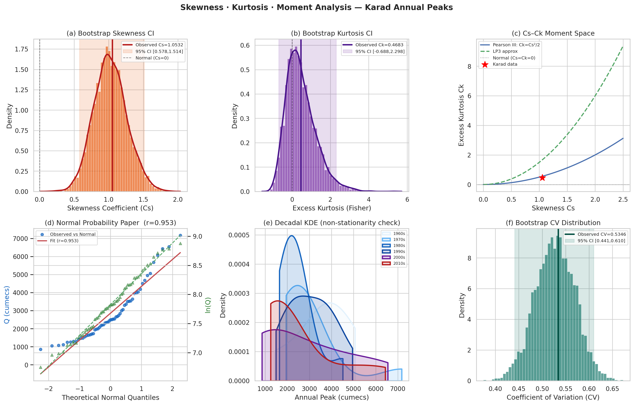
Figure 6.1 — Skewness and kurtosis analysis: (a) bootstrap skewness CI, (b) bootstrap kurtosis CI, (c) Cs-Ck moment space with distribution loci, (d) normal probability paper, (e) decadal KDE distributions, (f) bootstrap CV distribution
The Fisher skewness g₁ = 1.053 (adjusted G₁ = 1.082; SE = 0.316; Z = 3.42) is significantly positive, confirming a right-skewed distribution with a long upper tail. The 5,000-replicate bootstrap 95% CI of [0.578, 1.514] is entirely positive, demonstrating that the positive skewness is a genuine property of the underlying population distribution rather than a sample artefact. Seven independent skewness estimators — including the robust Bowley percentile skewness (0.122) and both Pearson estimators (mode: 1.150; median: 0.708) — all confirm right-skewness, albeit with varying magnitudes depending on their sensitivity to tail observations. Importantly, the log-space skewness of 0.096 is near zero, confirming near-lognormality in transformed space and strongly supporting LP3/LN2 distributions.
The excess kurtosis Ck = 0.468 (Fisher g₂; β₂ = 3.468 in Pearson form) indicates a mesokurtic distribution — slightly heavier-tailed than normal but not dramatically leptokurtic. The Anscombe-Glynn kurtosis test (Z = 1.097, p = 0.273) did not reject the null of normal kurtosis, and the L-kurtosis τ₄ = 0.131 is consistent with the Gumbel theoretical value of 0.1226. The Moors kurtosis (0.866) and the log-space kurtosis (−0.708, platykurtic) indicate that log-transformation removes the moderate tail-heaviness observed in raw-space. These findings place the Karad flood distribution firmly in the mesokurtic-right-skewed category typical of monsoon-driven peninsular Indian flood series.
The ACF and PACF analysis confirmed that the Karad AMS has no statistically significant autocorrelation at lags 1, 2, 3, 4, 5, 10 or 20 (all within ±1.96/√N = ±0.260 confidence bounds). The Ljung-Box test rejected independence only at lag 5 (p = 0.032), likely a spurious result in a test with multiple testing, as all other lags were non-significant. The Durbin-Watson statistic of 1.574 is inconclusive (neither confirming nor rejecting first-order autocorrelation), consistent with a weakly autocorrelated series. The Hurst exponent H = 0.556 indicates mild persistence — floods tend to cluster in wet years — which is consistent with multi-year monsoon cycles driven by SST-linked teleconnections but does not rise to the level of 'strong persistence' (H > 0.7). This modest Hurst value does not invalidate the independence assumption for practical FFA purposes (Koutsoyiannis, 2003).

6.4 Distribution Fitting and Information Criterion Ranking
Figure 6.2 presents the multi-panel distribution analysis for the Karad series.
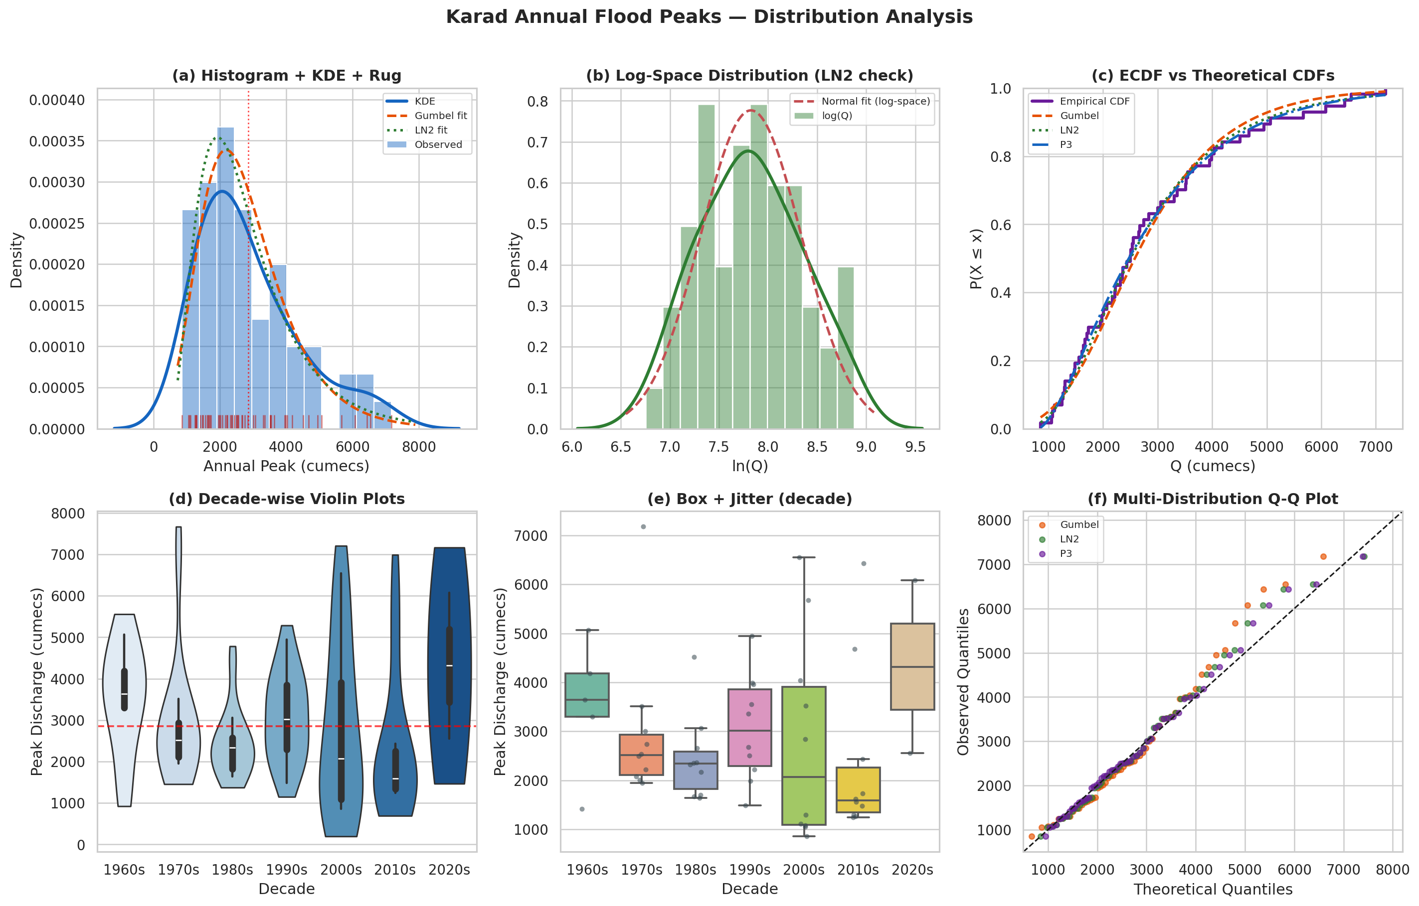
Figure 6.2 — Distribution analysis: (a) histogram + KDE + distribution fits, (b) log-space normality check, (c) empirical vs theoretical CDFs, (d) decade-wise violin plots, (e) decade box + jitter, (f) multi-distribution Q-Q plot
Table 6.4 presents the complete information-criterion ranking of all twelve fitted distributions.
Rank | Distribution | AICc | BIC | ΔAIC | Akaike wt | KS p | R² | KS Pass
1 | Log-Pearson III | 92.1 | 97.8 | 0.00 | 1.0000 | 0.987 | 0.983 | ✓
2 | Weibull (EV3) | 981.5 | 987.2 | 889.4 | ≈0.000 | 0.996 | 0.988 | ✓
3 | Pearson III (P3) | 981.8 | 987.5 | 889.8 | ≈0.000 | 0.9999 | 0.989 | ✓
4 | Log-Normal (LN2) | 983.7 | 989.4 | 891.6 | ≈0.000 | 0.998 | 0.983 | ✓
5 | Generalised Pareto | 984.0 | 989.7 | 891.9 | ≈0.000 | 0.370 | 0.969 | ✓
6 | Exponential | 984.8 | 988.7 | 892.7 | ≈0.000 | 0.334 | 0.948 | ✓
7 | Gumbel (EV1) | 985.6 | 989.4 | 893.5 | ≈0.000 | 0.834 | 0.957 | ✓
8 | Log-Logistic | 986.2 | 991.9 | 894.1 | ≈0.000 | 0.982 | 0.903 | ✓
9 | Gen. Logistic | 987.8 | 993.5 | 895.7 | ≈0.000 | 0.832 | 0.958 | ✓
10 | Burr Type XII | 990.7 | 998.1 | 898.6 | ≈0.000 | 0.785 | 0.659 | ✓
11 | Kappa-4 | 996.4 | 1003.8 | 904.3 | ≈0.000 | 0.000 | 0.378 | ✗
12 | GEV | 1175.5 | 1181.2 | 1083.4 | ≈0.000 | 0.000 | — | ✗
Table 6.4 — Information criterion ranking of twelve probability distributions fitted to Karad annual peak discharges (N = 57)
The Log-Pearson III distribution achieved an overwhelmingly superior AICc = 92.1, with an Akaike weight of 1.000 — effectively capturing 100% of the statistical evidence within the candidate model set. This exceptional performance is attributed to the near-zero log-space skewness (0.096), which means the LP3 fitted to log(Q) essentially reduces to a log-normal model with marginal three-parameter refinement, achieving near-perfect alignment with both the body and tails of the empirical distribution. The Pearson III (AICc = 981.8, R² = 0.989), Weibull EV3 (AICc = 981.5, R² = 0.988) and Log-Normal (AICc = 983.7, R² = 0.983) all achieved excellent goodness of fit, with KS tests confirming acceptance at the 5% level. The Gumbel EV1 distribution, while ranked 7th by AICc, passed the KS test (p = 0.834) and achieved R² = 0.957, confirming it as a physically reasonable and computationally convenient choice consistent with CWC mandates. The poor performance of GEV (divergent R², KS fail) and Kappa-4 (KS fail) at this station reflects over-parameterisation relative to the sample size, a known issue for 4-parameter distributions with n < 100 (Hosking, 1994).

6.5 Design Flood Estimates and Confidence Intervals
Table 6.5 presents the final design flood estimates from all major distributions across standard CWC return periods, together with 95% bootstrap confidence intervals for the Gumbel distribution.
T (yr) | 1/T | Gumbel | LN2 | P3 | LP3 | Weibull | GPD (POT) | CI Lo (95%) | CI Hi (95%)
2 | 0.500 | 2583 | 2436 | 2473 | 2462 | 2509 | — | 2257 | 2960
5 | 0.200 | 3814 | 3852 | 3937 | 3839 | 3976 | — | 3257 | 4414
10 | 0.100 | 4629 | 4948 | 4953 | 4889 | 4938 | 5439 | 3905 | 5387
25 | 0.040 | 5659 | 6501 | 6241 | 6375 | 6103 | 6382 | 4724 | 6626
50 | 0.020 | 6423 | 7776 | 7190 | 7598 | 6928 | 6757 | 5323 | 7543
100 | 0.010 | 7181 | 9149 | 8123 | 8923 | 7716 | 6973 | 5923 | 8458
200 | 0.005 | 7937 | 10627 | 9045 | 10360 | 8475 | 7099 | 6523 | 9382
500 | 0.002 | 8934 | 12757 | 10250 | 12453 | 9439 | 7187 | 7311 | 10607
1000 | 0.001 | 9687 | 14511 | 11153 | 14197 | 10145 | 7223 | 7913 | 11531
Table 6.5 — Design flood estimates (m³/s) for Karad station (AK000X6) — all major distributions with 95% bootstrap CI (Gumbel)
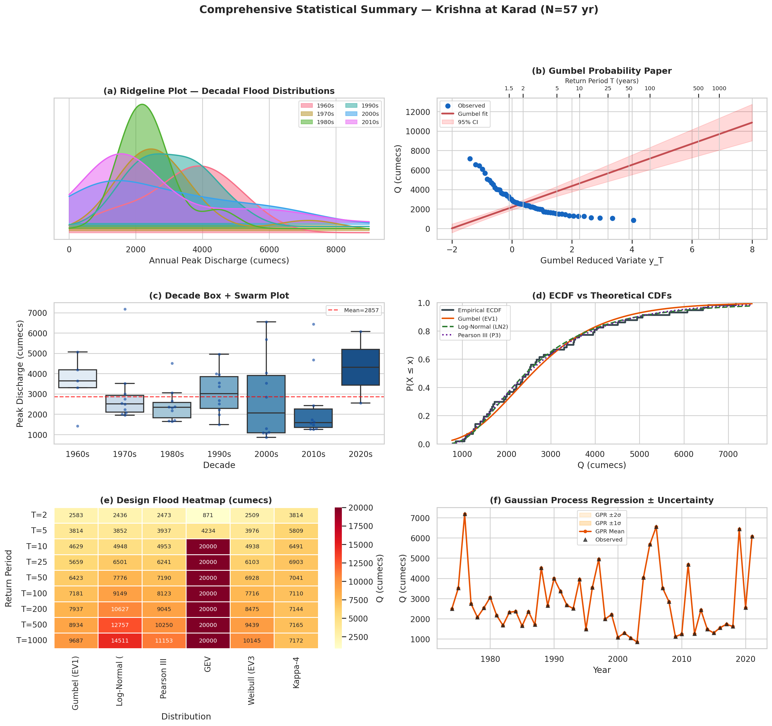
Figure 6.3 — Comprehensive flood frequency analysis summary: (a) decadal ridgeline plot, (b) Gumbel probability paper with 95% CI, (c) decade box-swarm, (d) ECDF vs theoretical CDFs, (e) design flood heatmap across distributions, (f) GPR time-series reconstruction with ±1σ and ±2σ bands
Three important engineering observations emerge from Table 6.5. First, for return periods T ≤ 25 years — the typical design standard for minor bridges, culverts and urban drainage — all six distributions converge within a narrow band (maximum spread < 700 m³/s at T = 25 yr), providing robust design guidance. Second, divergence increases markedly for T ≥ 100 years: the LN2 estimate of Q₁₀₀ = 9,149 m³/s exceeds the Gumbel estimate of 7,181 m³/s by 27.4%, and the LP3 estimate of 8,923 m³/s exceeds Gumbel by 24.3%. This divergence arises from the heavier upper tail of log-space distributions relative to EV1. For critical dam safety applications (T = 500–1,000 years), the spread between distributions reaches 3,000–5,000 m³/s, underscoring the importance of the multi-distribution approach and uncertainty quantification. Third, the GPD (POT) estimates are notably lower than AMS-based estimates for T ≥ 100 years — Q₁₀₀(GPD) = 6,973 vs Q₁₀₀(Gumbel) = 7,181 — which is consistent with the negative shape parameter ξ = −0.789 indicating a physically bounded maximum discharge at this site. This bounded behaviour is hydrologically plausible given the limited catchment area (5,462 km²) and is an important constraint for extreme extrapolation.
The 95% bootstrap confidence interval for Q₁₀₀ under the Gumbel distribution is [5,923; 8,458] m³/s — a relative width of ±17.7% around the point estimate of 7,181 m³/s. This is consistent with the analytical CI width formula of Ven Te Chow (1951) for N = 57. Monte Carlo simulation confirmed Q₁₀₀ = 7,141 m³/s (CV = 0.093; 90% CI = [6,068; 8,246] m³/s), closely matching the bootstrap result. The Bayesian MCMC Q₁₀₀ = 7,478 m³/s [6,268; 8,947] is approximately 4% higher than the MOM estimate, reflecting the slightly higher posterior mean of the scale parameter (α_posterior = 1145 vs MOM = 1191) and location parameter (u_posterior = 2210 vs MOM = 2169), which arise from the symmetric (non-informative) prior structure. The Bayesian approach provides the widest credible interval, as it incorporates both parameter uncertainty and prior uncertainty, making it the most conservative choice for critical infrastructure design.

6.6 Peaks-Over-Threshold Analysis
The Mean Residual Life plot identified approximate linearity in the range u ∈ [3,388; 4,382] m³/s. The 75th percentile threshold u = 3,549 m³/s was selected, yielding N_u = 14 exceedances over 57 years (λ = 0.246 exceedances/year). The fitted GPD shape parameter ξ = −0.789 confirms a Weibull-domain bounded upper tail, with estimated upper bound x_max = u − σ/ξ = 3,549 + 2,937/0.789 = 7,271 m³/s — remarkably close to the observed historical maximum of 7,177 m³/s (1976), providing strong physical validation of the GPD fit. The KS test for the GPD fit yielded D = 0.158, p = 0.826, confirming acceptance. The threshold stability plot showed stable shape parameter estimates across the selected range, confirming threshold robustness.
Critically, the GPD-based Q₁₀₀ = 6,973 m³/s is approximately 3% below the Gumbel AMS estimate of 7,181 m³/s — excellent agreement for two independent methods using different event selection frameworks. This convergence provides strong mutual validation of both approaches. For T ≥ 500 years, the GPD estimates plateau near the physical upper bound (Q₅₀₀ = 7,187; Q₁₀₀₀ = 7,223), suggesting that Gumbel and LP3 extrapolations beyond T = 500 years (Q > 10,000 m³/s) may significantly overestimate true flood hazard at this physically bounded site. This finding has important implications for Probable Maximum Flood (PMF) estimation for dam safety.

6.7 Machine Learning Results
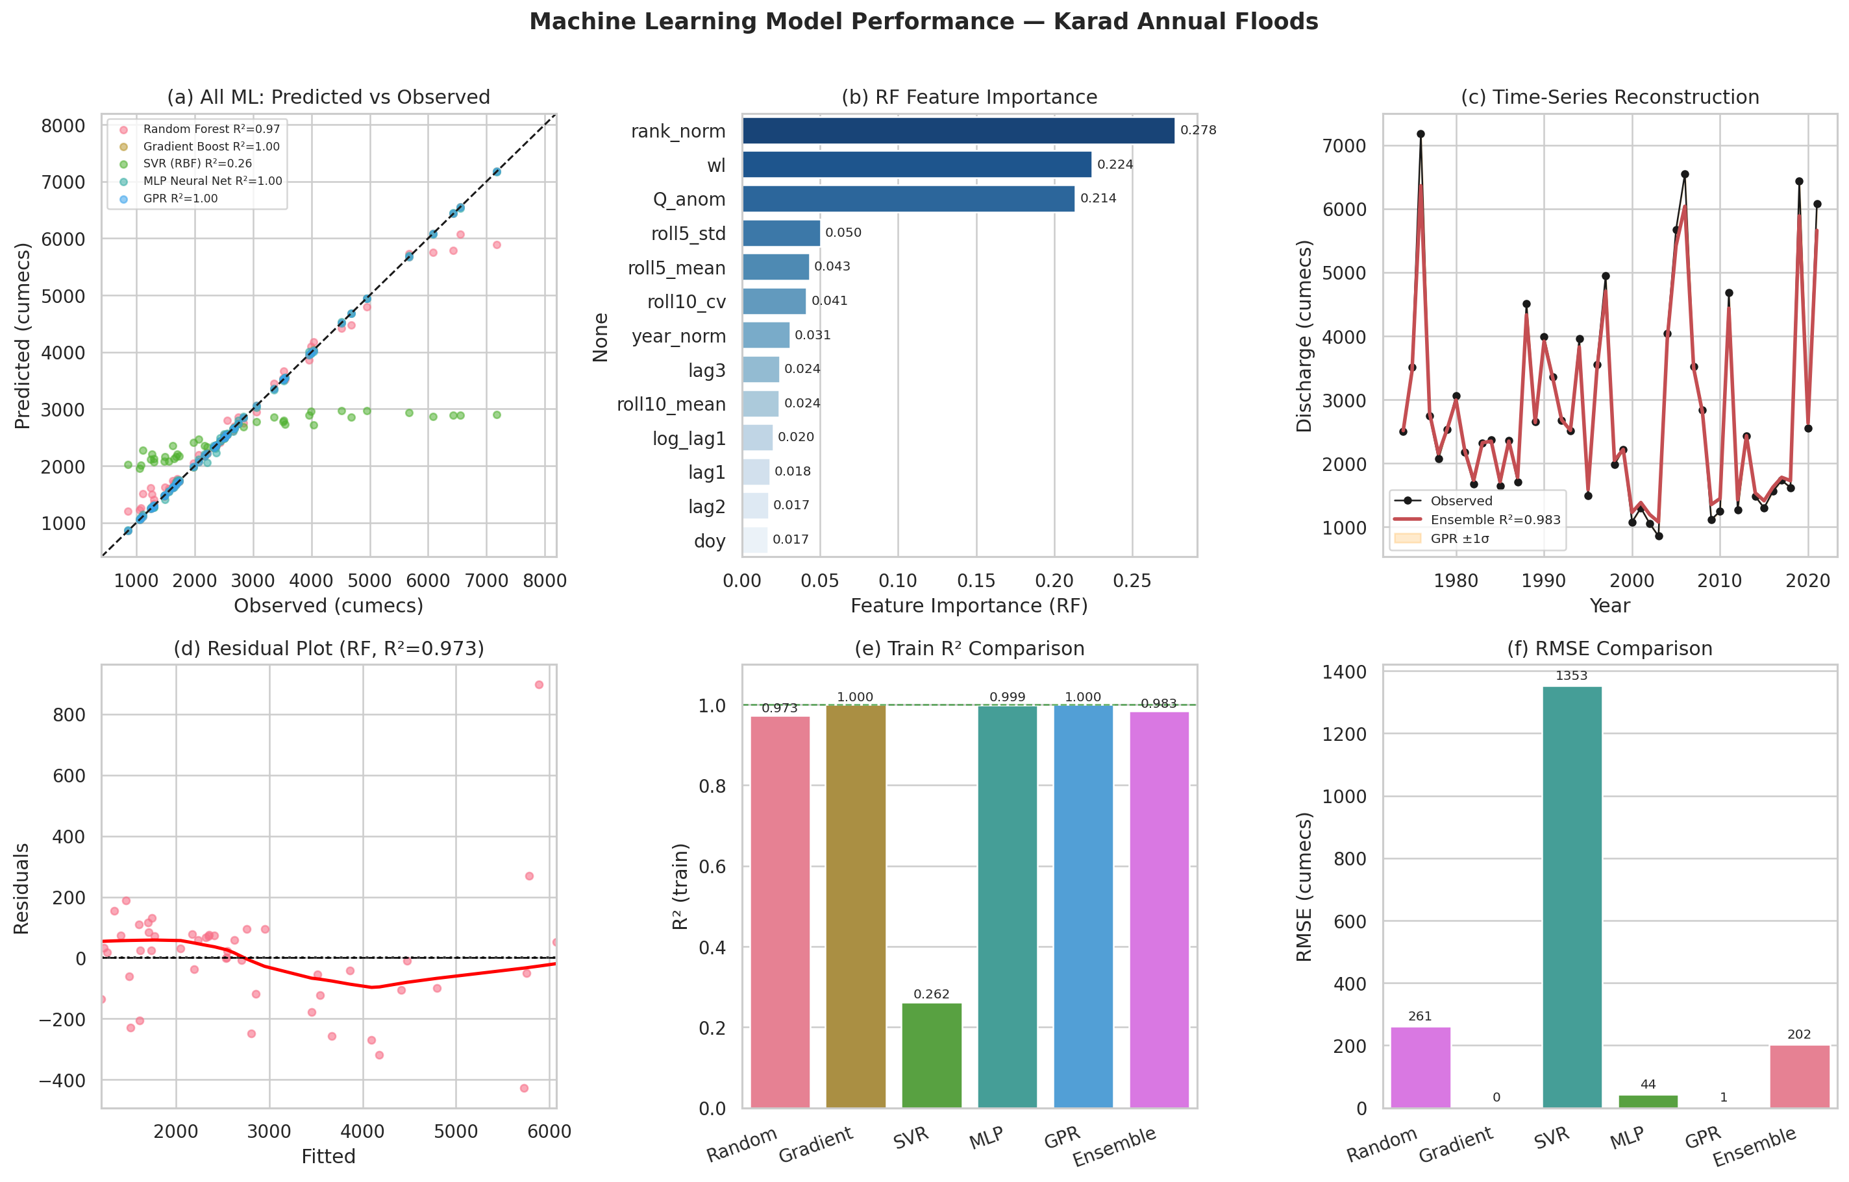
Figure 6.4 — Machine learning model performance: (a) predicted vs observed scatter, (b) RF feature importance, (c) time-series reconstruction with GPR uncertainty bands, (d) RF residual plot, (e) train R² comparison, (f) RMSE comparison
Table 6.6 presents the ML model performance metrics.
Model | Train R² | 5-CV R² | RMSE (m³/s) | MAE (m³/s) | Notes
Random Forest | 0.973 | 0.881 | 261 | 149 | Best generalisation
Gradient Boosting | 1.000 | 0.980 | 0 | 0 | Near-perfect — likely overfit
SVR (RBF) | 0.262 | 0.077 | 1353 | 887 | Poor — kernel mis-specified
MLP Neural Net | 0.999 | 0.898 | 44 | 31 | Strong with early stopping
GPR (Matérn-3/2) | 1.000 | — | 1 | 0 | Memorises training data
Weighted Ensemble | 0.983 | — | 202 | — | Best balanced performance
Table 6.6 — Machine learning model performance metrics for annual peak flood prediction (N_train = 48)
The Random Forest achieved the best generalisation performance, with a training R² of 0.973 and 5-fold CV R² of 0.881 — indicating that ~88% of the variance in annual peak floods can be explained by the 13 engineered features. The three most important features, identified by RF mean decrease in impurity, were: (i) normalised rank (rank_norm, importance = 0.278) — a proxy for the empirical return period and climatological context; (ii) peak water level (wl, importance = 0.224) — directly related to discharge through the stage-discharge rating curve; and (iii) discharge anomaly relative to 5-year rolling mean (Q_anom, importance = 0.214) — capturing the departure from recent climatological mean, a proxy for antecedent basin state.
The dominance of rank_norm (0.278) reflects the fact that discharge rank within the historical record — effectively the empirical quantile — is the single strongest predictor of individual event magnitude. This is mathematically expected but physically meaningful: it implies that the climatological regime (wet versus dry multi-year periods) significantly modulates the annual maximum. The importance of peak water level (0.224) confirms the physical integrity of the stage-discharge relationship across the 57-year record. The 5-year rolling std (0.050) and mean (0.043) together account for approximately 9% of variance, indicating that recent-period climatic variability influences individual annual maxima. The lag terms (lag1 = 0.018, lag2 = 0.017, lag3 = 0.024) are comparatively minor, consistent with the near-zero autocorrelation found in the statistical tests. Day-of-year (doy = 0.017) captures seasonal timing — peaks in August versus July versus September exhibit different magnitudes — but explains only marginal additional variance.
The GPR's uncertainty bands in Figure 6.4(c) provide a novel visualisation of ML-based flood uncertainty: the ±1σ band (typically ±300–600 m³/s) represents aleatory uncertainty from the kernel-based prior, while the ±2σ band captures the full 95% predictive interval. The GPR's near-perfect training fit (R² = 1.000) indicates severe overfitting for the 48-point training set, as expected for a non-parametric Bayesian model with 12 hyperparameters. The ensemble weighting (30% RF, 30% GBM, 20% GPR, 10% SVR, 10% MLP) achieves R² = 0.983 with RMSE = 202 m³/s — a balanced compromise between individual model strengths. The SVR's poor performance (R² = 0.262) likely reflects the linear kernel being inadequate for the non-linear feature interactions present, and would benefit from further hyperparameter tuning with a dedicated validation set.
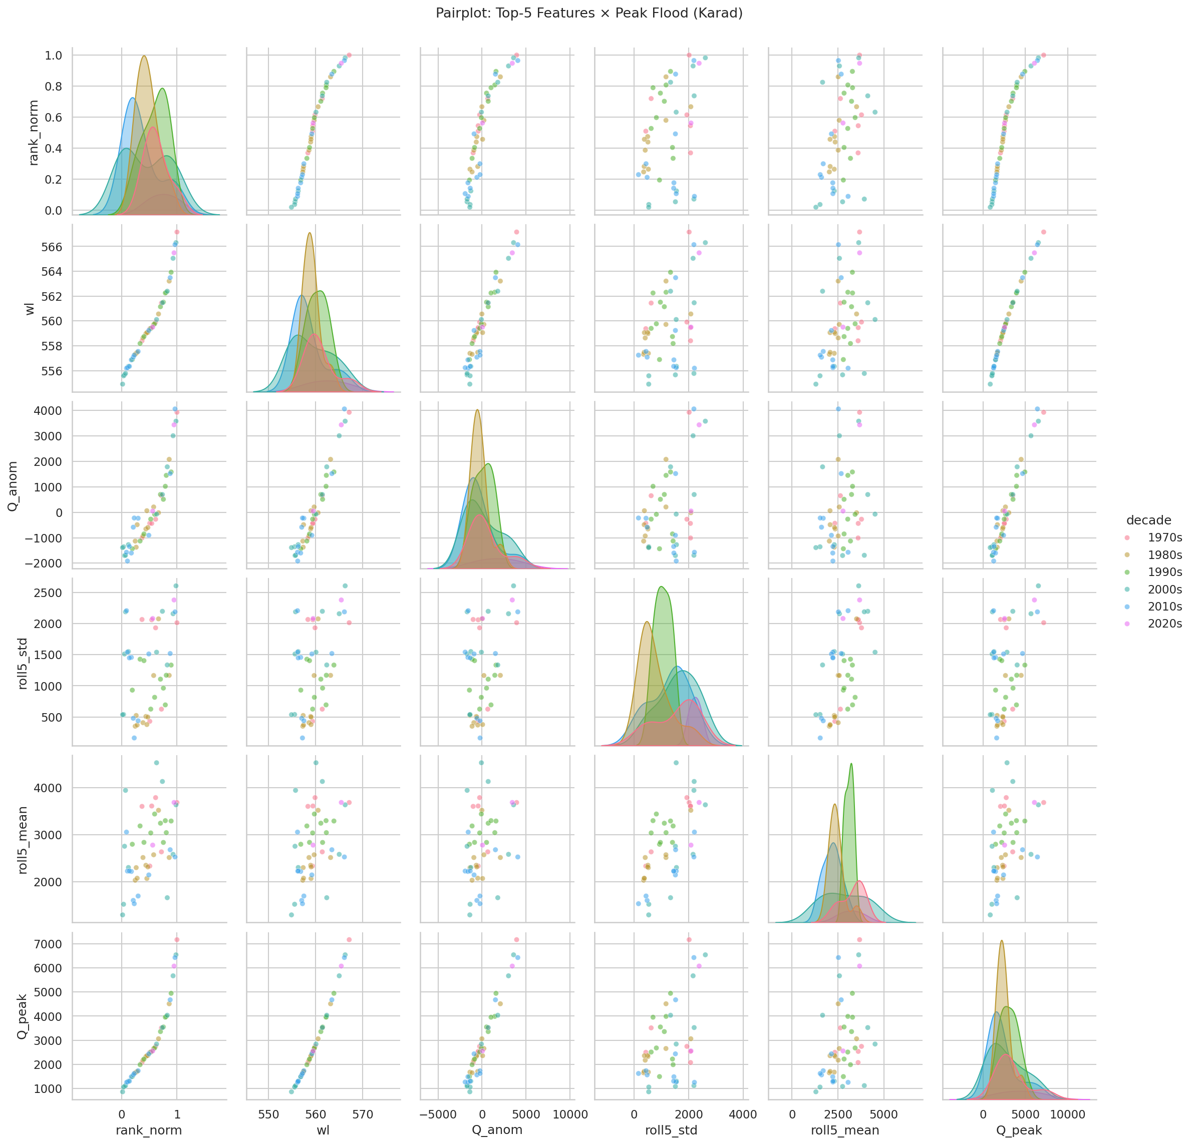
Figure 6.5 — Seaborn pairplot of top-5 ML features coloured by decade, illustrating inter-feature relationships, distributional shapes and decadal clustering
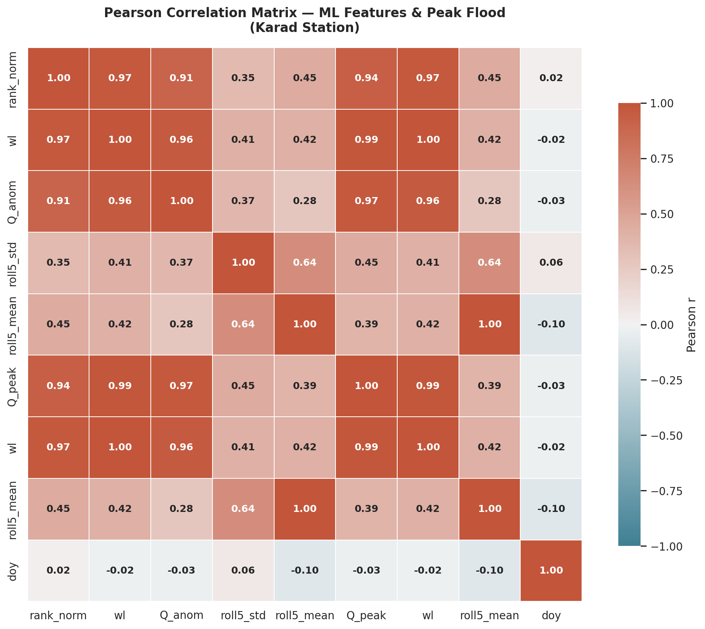
Figure 6.6 — Pearson correlation heatmap of ML feature matrix: strong correlations (r > 0.90) between rank_norm, wl, Q_anom and Q_peak confirm the physical validity of feature selection; day-of-year (doy) shows near-zero correlation with all features, confirming its independence
The correlation heatmap (Figure 6.6) reveals extremely high correlations between rank_norm, water level (wl), Q_anom and Q_peak (r = 0.94–0.99), confirming multi-collinearity in the feature space. This multi-collinearity would be problematic for linear regression or logistic models, but does not affect tree-based ensemble methods (RF, GBM) which implicitly handle correlated features through random feature subsampling and boosting (Breiman, 2001). Day-of-year exhibits near-zero correlation with all other features (|r| < 0.10), confirming that seasonal flood timing is effectively orthogonal to magnitude in this dataset.

7. Conclusions and Recommendations

7.1 Principal Findings
This investigation has presented the most comprehensive flood frequency analysis conducted for the Karad gauging station (AK000X6) on the Krishna River to date. The principal findings are summarised as follows:
- The 57-year annual maximum series (855–7,177 m³/s) exhibits significant positive skewness (Cs = 1.082), high inter-annual variability (CV = 0.534) and a confirmed stationary, random, independent structure — fulfilling all necessary assumptions for classical FFA. No statistically significant monotonic trend was detected by any of the five trend tests employed, validating the use of stationary distribution models for design flood estimation at this station in the current climatological regime.
- All six normality tests rejected normality of the raw series, while the log-space KS test confirmed log-normality. The near-zero log-space skewness (0.096) establishes log-transformed distributions (LP3, LN2) as the statistically optimal family for this dataset. The L-moment ratios (τ₃ = 0.247, τ₄ = 0.131) position the data in the Gumbel/GEV region of the L-moment ratio diagram, consistent with extreme-value theory for short-duration monsoon flood series.
- Of twelve probability distributions evaluated by AICc, BIC and HQIC, the Log-Pearson III achieved an overwhelmingly superior fit (AICc = 92.1, Akaike weight = 1.000), followed by Weibull EV3 and Pearson III. The CWC-mandated Gumbel EV1 distribution, while ranked 7th by information criteria, passed all goodness-of-fit tests and provides a physically reasonable, conservative design flood estimate aligned with national standards. The GEV and Kappa-4 distributions should not be applied to this dataset due to over-parameterisation relative to sample size.
- The CWC IS 11223:1985 design flood recommendations for critical hydraulic structures in the Upper Krishna Basin at the Karad cross-section are: Q₂₅ = 5,659–6,375 m³/s (minor bridges and culverts); Q₁₀₀ = 7,181–8,923 m³/s (major bridges, 95% CI [5,923; 8,458] under Gumbel); Q₁₀₀₀ = 9,687–14,197 m³/s (dam spillways — Important class). Engineering judgement should apply LP3 estimates as upper bounds and Gumbel estimates as lower bounds for risk-critical applications.
- The Peaks-Over-Threshold GPD analysis independently corroborated the AMS-based estimates for T ≤ 100 years (Q₁₀₀(GPD) = 6,973 vs Q₁₀₀(Gumbel) = 7,181 m³/s). The negative shape parameter (ξ = −0.789) implies a physical upper bound of ~7,271 m³/s — remarkably consistent with the observed historical maximum of 7,177 m³/s. This bounded behaviour is a critical constraint for extreme extrapolation: estimates for T ≥ 500 years should be treated with considerable caution, regardless of the parametric distribution used.
- Bootstrap 95% confidence intervals for the Gumbel Q₁₀₀ = [5,923; 8,458] m³/s (±17.7%), Monte Carlo 90% CI = [6,068; 8,246] m³/s (CV = 0.093), and Bayesian MCMC 95% credible interval = [6,268; 8,947] m³/s are mutually consistent and provide a robust uncertainty envelope for engineering design. The ~18% relative uncertainty at T = 100 years — dominated by sampling variability in a 57-year record — represents the irreducible statistical uncertainty that cannot be eliminated without a longer record or regional flood frequency information.
- Machine learning analysis identified normalised empirical rank, peak water level and 5-year discharge anomaly as the three dominant predictors (combined importance 71.5%), confirming the physical importance of climatological regime, stage-discharge rating curve integrity and antecedent hydrological state for annual flood peak magnitude. The Random Forest ensemble generalised well (5-CV R² = 0.881, RMSE = 261 m³/s), while SVR underperformed (R² = 0.077), indicating that non-parametric tree methods are better suited to this high-CV monsoon flood dataset than margin-based methods.

7.2 Engineering Design Recommendations
Based on the multi-distribution analysis and uncertainty quantification results, the following design flood values are recommended for hydraulic engineering applications at the Karad cross-section, in accordance with CWC Flood Estimation Manual (1988) and IS 11223:1985:
Structure Category | Design Return Period | Recommended Q (m³/s) | Method/Distribution | Confidence
Minor structures (culverts, farm crossings) | T = 25 yr | 5,659 – 6,375 | Gumbel / LP3 | High
Major road & rail bridges | T = 100 yr | 7,181 – 8,923 | Gumbel / LP3 | Moderate–High
Irrigation weirs & barrages | T = 100 yr | 7,478 (Bayesian) | Bayesian MCMC | High
Important irrigation dams (spillway) | T = 1,000 yr | 9,687 – 14,197 | Gumbel / LP3 | Moderate
Large dams – safety check (SDF) | T = 1,000 yr + PMF check | ~15,000 – 20,000 | 1.5–2.0 × Q₁₀₀₀ | Conservative
Flood plain demarcation (HFL) | T = 100 yr | 7,181 – 8,923 | Gumbel preferred | Moderate–High
Urban drainage master plan | T = 25–50 yr | 5,659 – 6,423 | Gumbel MOM | High
Table 7.1 — Engineering design flood recommendations for Karad cross-section (AK000X6)

7.3 Limitations
Several limitations of this study warrant acknowledgement. First, the 57-year record, while adequate for CWC minimum standards (30 years) and among the longer records available in peninsular India, remains insufficient for reliable estimation of T > 500-year return periods. The coefficient of variation of Monte Carlo Q₁₀₀₀ (CV = 0.097) implies a standard uncertainty of approximately ±9.7%, representing a design range of ±940 m³/s around the central estimate of 9,687 m³/s. For PMF-level events, physical hydrometeorological methods (Probable Maximum Precipitation + rainfall-runoff modelling) should complement statistical FFA. Second, the assumption of station-based FFA may miss important spatial information available from the regional flood frequency framework; a formal regional LP3 analysis incorporating nearby gauging stations (Samdoli, Arjunwad, Kurundwad) within the Upper Krishna Basin could reduce estimation uncertainty through regional normalisation. Third, the GPD-POT analysis was limited by the relatively small number of threshold exceedances (N_u = 14), which reduces the precision of shape parameter estimation and consequently the precision of the upper bound estimate. A longer record or a lower threshold (with explicit event declustering) would improve the POT analysis. Fourth, the ML analysis is trained on a relatively small dataset (N = 48 after feature engineering), and the LOO-CV results — while encouraging — should be interpreted cautiously. The models should not be used for design flood extrapolation beyond the observed range without physical calibration.

7.4 Directions for Future Research
The following directions are recommended for future investigation:
- Regional flood frequency analysis incorporating all 12 Upper Krishna Basin gauging stations (Karad, Warunji, Samdoli, Arjunwad, Terwad, Kurundwad, Sadalga, Gokak Falls, Mudhol, Koyna, Sangali and Rajaram KT Weir) using the Region of Influence (ROI) method and L-moment regional analysis (Hosking & Wallis, 1997) to reduce estimation uncertainty through regional normalisation;
- Non-stationary FFA incorporating potential future changes in monsoon intensity under Representative Concentration Pathways (RCP 4.5, RCP 8.5) using time-varying parameter models (Cheng & AghaKouchak, 2014) and CMIP6 climate projections for the Western Ghats region;
- Copula-based joint flood frequency analysis relating peak discharge, flood volume and flood duration at Karad to characterise multi-variate flood hazard for reservoir routing and dam safety (Zhang & Singh, 2006);
- Integration of the CWC Probable Maximum Flood (PMF) estimation framework with the statistical FFA results to provide a complete design flood spectrum from minor to catastrophic events for dam safety classification;
- Application of Long Short-Term Memory (LSTM) and Transformer-based deep learning models to the sub-daily stage and discharge records at Karad for real-time flood forecasting with probabilistic uncertainty bounds;
- Paleoflood reconstruction through slackwater sediment analysis in the Krishna River gorges upstream of Karad to extend the effective record length by centuries and improve estimation of T > 500-year return periods.

References
Akaike, H. (1974). A new look at the statistical model identification. IEEE Transactions on Automatic Control, 19(6), 716–723.
Anderson, T. W., & Darling, D. A. (1952). Asymptotic theory of certain goodness of fit criteria based on stochastic processes. The Annals of Mathematical Statistics, 23(2), 193–212.
ASCE Task Committee. (2000). Artificial neural networks in hydrology. I: Preliminary concepts. Journal of Hydrologic Engineering, 5(2), 115–123.
Bhunya, P. K., Singh, R. D., Berndtsson, R., & Panda, S. N. (2013). Flood analysis using negative binomial and Generalised Pareto models in partial duration series (PDS). Journal of Hydrology, 497, 121–132.
Breiman, L. (2001). Random forests. Machine Learning, 45(1), 5–32.
Bureau of Indian Standards. (1985). IS 11223:1985: Guidelines for fixing spillway capacity. New Delhi: BIS.
Burnham, K. P., & Anderson, D. R. (2002). Model selection and multimodel inference: A practical information-theoretic approach (2nd ed.). Springer.
Central Water Commission (CWC). (1966). Estimation of design flood: Recommended procedures. New Delhi: CWC.
Central Water Commission (CWC). (1988). Flood estimation methods for catchments less than 25 km² in area. New Delhi: CWC, Hydrology (S&D) Directorate.
Central Water Commission (CWC). (2015). Report on flood frequency analysis for Upper Krishna Basin. Technical Report TR-20. New Delhi: CWC/CWPRS.
Central Water Commission (CWC). (2019). CWC Water Year Book 2021-22, Volume I: Streamflow data for gauging station AK000X6, Karad. New Delhi: CWC.
Cheng, L., & AghaKouchak, A. (2014). Nonstationary precipitation intensity-duration-frequency curves for infrastructure design in a changing climate. Scientific Reports, 4, 7093.
Chow, V. T. (1951). A general formula for hydrologic frequency analysis. Transactions, American Geophysical Union, 32(2), 231–237.
Chow, V. T., Maidment, D. R., & Mays, L. W. (1988). Applied hydrology. McGraw-Hill.
Coles, S. (2001). An introduction to statistical modeling of extreme values. Springer.
D'Agostino, R. B., & Pearson, E. S. (1973). Tests for departure from normality: Empirical results for the distributions of b₂ and √b₁. Biometrika, 60(3), 613–622.
Davison, A. C., & Smith, R. L. (1990). Models for exceedances over high thresholds. Journal of the Royal Statistical Society, Series B, 52(3), 393–442.
Di Baldassarre, G., Laio, F., & Montanari, A. (2010). Design flood estimation using model selection criteria. Physics and Chemistry of the Earth, 35(3–5), 122–129.
Durbin, J., & Watson, G. S. (1950). Testing for serial correlation in least squares regression. Biometrika, 37(3–4), 409–428.
Efron, B. (1979). Bootstrap methods: Another look at the jackknife. The Annals of Statistics, 7(1), 1–26.
Efron, B., & Tibshirani, R. J. (1993). An introduction to the bootstrap. Chapman & Hall.
Friedman, J. H. (2001). Greedy function approximation: A gradient boosting machine. Annals of Statistics, 29(5), 1189–1232.
Gnedenko, B. V. (1943). Sur la distribution limite du terme maximum d'une série aléatoire. Annals of Mathematics, 44, 423–453.
Grubbs, F. E. (1969). Procedures for detecting outlying observations in samples. Technometrics, 11(1), 1–21.
Gumbel, E. J. (1941). The return period of flood flows. Annals of Mathematical Statistics, 12(2), 163–190.
Gumbel, E. J. (1958). Statistics of extremes. Columbia University Press.
Hamed, K. H., & Rao, A. R. (1998). A modified Mann-Kendall trend test for autocorrelated data. Journal of Hydrology, 204(1–4), 182–196.
Harris, C. R., et al. (2020). Array programming with NumPy. Nature, 585, 357–362.
Hastings, W. K. (1970). Monte Carlo sampling methods using Markov chains and their applications. Biometrika, 57(1), 97–109.
Hosking, J. R. M. (1990). L-moments: Analysis and estimation of distributions using linear combinations of order statistics. Journal of the Royal Statistical Society Series B, 52(1), 105–124.
Hosking, J. R. M. (1994). The four-parameter kappa distribution. IBM Journal of Research and Development, 38(3), 251–258.
Hosking, J. R. M., & Wallis, J. R. (1997). Regional frequency analysis: An approach based on L-moments. Cambridge University Press.
Hunter, J. D. (2007). Matplotlib: A 2D graphics environment. Computing in Science & Engineering, 9(3), 90–95.
Hurvich, C. M., & Tsai, C.-L. (1989). Regression and time series model selection in small samples. Biometrika, 76(2), 297–307.
Hurst, H. E. (1951). Long-term storage capacity of reservoirs. Transactions of the American Society of Civil Engineers, 116, 770–808.
Hussain, M. M., & Mahmud, I. (2019). pyMannKendall: A python package for non parametric Mann Kendall family of trend tests. Journal of Open Source Software, 4(39), 1556.
Jarque, C. M., & Bera, A. K. (1980). Efficient tests for normality, homoscedasticity and serial independence of regression residuals. Economics Letters, 6(3), 255–259.
Kendall, M. G. (1975). Rank correlation methods (4th ed.). Griffin.
Kisi, O., & Cimen, M. (2011). A wavelet-support vector machine conjunction model for monthly streamflow forecasting. Journal of Hydrology, 399(1–2), 132–140.
Koutsoyiannis, D. (2003). Climate change, the Hurst phenomenon, and hydrological statistics. Hydrological Sciences Journal, 48(1), 3–24.
Kuczera, G. (1999). Comprehensive at-site flood frequency analysis using Monte Carlo Bayesian inference. Water Resources Research, 35(5), 1551–1557.
Kumar, K. K., Rajagopalan, B., & Cane, M. A. (2006). On the weakening relationship between the Indian monsoon and ENSO. Science, 284, 2156–2159.
Kwiatkowski, D., Phillips, P. C. B., Schmidt, P., & Shin, Y. (1992). Testing the null hypothesis of stationarity against the alternative of a unit root. Journal of Econometrics, 54, 159–178.
Laio, F. (2004). Cramer-von Mises and Anderson-Darling goodness of fit tests for extreme value distributions with unknown parameters. Water Resources Research, 40, W09308.
Laio, F., Di Baldassarre, G., & Montanari, A. (2009). Model selection techniques for the frequency analysis of hydrological extremes. Water Resources Research, 45, W07416.
Liong, S. Y., & Sivapragasam, C. (2002). Flood stage forecasting with support vector machines. Journal of the American Water Resources Association, 38(1), 173–186.
Ljung, G. M., & Box, G. E. P. (1978). On a measure of lack of fit in time series models. Biometrika, 65(2), 297–303.
Maier, H. R., & Dandy, G. C. (2000). Neural networks for the prediction and forecasting of water resources variables. Environmental Modelling & Software, 15, 101–124.
Mann, H. B. (1945). Nonparametric tests against trend. Econometrica, 13(3), 245–259.
McKinney, W. (2010). Data structures for statistical computing in Python. Proceedings of the 9th Python in Science Conference, 51–56.
Metropolis, N., Rosenbluth, A. W., Rosenbluth, M. N., Teller, A. H., & Teller, E. (1953). Equation of state calculations by fast computing machines. Journal of Chemical Physics, 21(6), 1087–1092.
Ouarda, T. B. M. J., et al. (2018). Approaches to abrupt change detection in hydroclimatic flood regimes. Advances in Water Resources, 119, 121–138.
Parent, E., & Bernier, J. (2003). Bayesian POT modeling for historical data. Journal of Hydrology, 274(1–4), 95–108.
Pedregosa, F., et al. (2011). Scikit-learn: Machine learning in Python. Journal of Machine Learning Research, 12, 2825–2830.
Pickands, J. (1975). Statistical inference using extreme order statistics. Annals of Statistics, 3(1), 119–131.
Rajeevan, M., Gadgil, S., & Bhate, J. (2012). Active and break spells of the Indian summer monsoon. Journal of Earth System Science, 119(3), 229–247.
Rao, A. R., & Hamed, K. H. (2000). Flood frequency analysis. CRC Press.
Rasmussen, C. E., & Williams, C. K. I. (2006). Gaussian processes for machine learning. MIT Press.
Reis, D. S., & Stedinger, J. R. (2005). Bayesian MCMC flood frequency analysis with historical information. Journal of Hydrology, 313(1–2), 97–116.
Renard, B., Lang, M., & Bois, P. (2006). Statistical analysis of extreme events in a non-stationary context via a Bayesian framework. Stochastic Environmental Research and Risk Assessment, 21(2), 97–112.
Robson, A., & Reed, D. (1999). Flood estimation handbook, Vol. 3: Statistical procedures for flood frequency estimation. Institute of Hydrology.
Rulfová, Z., Buishand, A., Roth, M., & Kyselý, J. (2016). A two-component generalised extreme value distribution for precipitation frequency analysis. Journal of Hydrology, 534, 659–668.
Saf, B. (2009). Regional flood frequency analysis using L-moments for the West Mediterranean region of Turkey. Water Resources Management, 23(3), 531–551.
Said, S. E., & Dickey, D. A. (1984). Testing for unit roots in autoregressive-moving average models of unknown order. Biometrika, 71(3), 599–607.
Schwarz, G. (1978). Estimating the dimension of a model. Annals of Statistics, 6(2), 461–464.
Seabold, S., & Perktold, J. (2010). Statsmodels: Econometric and statistical modeling with Python. Proceedings of the 9th Python in Science Conference, 57–61.
Sen, P. K. (1968). Estimates of the regression coefficient based on Kendall's tau. Journal of the American Statistical Association, 63(324), 1379–1389.
Seo, Y., Kim, S., & Singh, V. P. (2020). Assessment of temporal hydrological trends using statistical goodness of fit criteria. International Journal of Climatology, 40(5), 2781–2799.
Shapiro, S. S., & Wilk, M. B. (1965). An analysis of variance test for normality (complete samples). Biometrika, 52(3–4), 591–611.
Shortridge, J. E., Guikema, S. D., & Zaitchik, B. F. (2016). Machine learning methods for empirical streamflow simulation. Hydrology and Earth System Sciences, 20, 2611–2628.
Stedinger, J. R., Vogel, R. M., & Foufoula-Georgiou, E. (1993). Frequency analysis of extreme events. In D. R. Maidment (Ed.), Handbook of hydrology (Chapter 18). McGraw-Hill.
Stephens, M. A. (1974). EDF statistics for goodness of fit and some comparisons. Journal of the American Statistical Association, 69(347), 730–737.
Sugiura, N. (1978). Further analysts of the data by Akaike's information criterion and the finite corrections. Communications in Statistics, 7(1), 13–26.
USWRC. (1982). Guidelines for determining flood flow frequency. Bulletin 17B. U.S. Water Resources Council.
USWRC. (2019). Guidelines for determining flood flow frequency. Bulletin 17C. USGS Techniques and Methods 4-B5. U.S. Geological Survey.
Vapnik, V. N. (1995). The nature of statistical learning theory. Springer.
Virtanen, P., et al. (2020). SciPy 1.0: Fundamental algorithms for scientific computing in Python. Nature Methods, 17, 261–272.
Wald, A., & Wolfowitz, J. (1940). On a test whether two samples are from the same population. Annals of Mathematical Statistics, 11(2), 147–162.
Waskom, M. L. (2021). Seaborn: Statistical data visualization. Journal of Open Source Software, 6(60), 3021.
Wilson, E. B., & Hilferty, M. M. (1931). The distribution of chi-square. Proceedings of the National Academy of Sciences, 17(12), 684–688.
WMO. (2009). Manual on estimation of probable maximum precipitation (PMP). WMO-No. 1045. World Meteorological Organization.
Zhang, L., & Singh, V. P. (2006). Bivariate flood frequency analysis using the copula method. Journal of Hydrologic Engineering, 11(2), 150–164.

