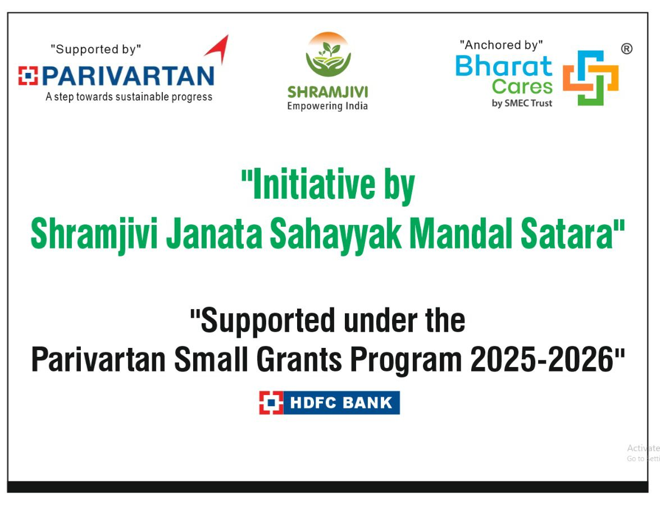

Annual Report
2025-26

Project Report

Project Status Report
- Project Name: Integrated Watershed Management for Climate Resilience and Sustainable Livelihoods
- Implementing Organization: Shramjivi Janata Sahayyak Mandal Satara
- Project Manager: Mr. Suresh Kadam
- Reporting Period: February-March 2026

Executive Summary
The project has reached a critical milestone during the February-March 2026 reporting period, with all proposed primary activities fully executed. The structural and earthwork interventions have successfully met their primary targets, resulting in immediate agricultural benefits for the local farming community.
Progress Against Targets
Significant progress was made across all key physical interventions:
- Gabion Structures: 1 structure was targeted and 1 structure has been successfully completed.
- Loose Boulders (LB): A total of 15 structures were targeted and all 15 have been completed.
- Staggered Contour Trenches (SCT): 4,500 cubic meters were targeted and the full 4,500 cubic meters have been achieved.
- Desilting of small ENB: 19,000 cubic meters were targeted and the full 19,000 cubic meters have been successfully achieved.
- Nala Deepening and Widening: Out of a targeted 19,000 cubic meters, 19500 cubic meters have been completed.
- Exposure Visit: 1 visit was targeted, but 1 have been completed to date
Key Impacts and Beneficiaries
The earthwork and desilting activities have yielded immediate, tangible results for the local environment and community:
- Land Reclamation: By utilizing the nutrient-rich desilted soil extracted during the project, 18 acres of previously barren land have been successfully transformed into cultivable agricultural land.
- Direct Beneficiaries: A total of 39 farmers have directly benefited from the distribution and application of this desilted soil.

Pending Works
- The only remaining earthwork is 1,500 cubic meters of nala deepening and widening, which is scheduled to be concluded by March 12.

Achievement:
Sr. No | Activity | Total Target | Total Achievement
1 | Gabion | 1 No. | 1 No.
2 | Loose Boulders(LB) | 15 No | 15 No.
3 | Staggered Contour Trench (SCT) | 4500 Cum. | 4500 Cum.
4 | Desilting of small ENB- in cubic meter | 19000 Cum. | 19000 Cum
5 | Nala Deepening and widening in cubic meter | 19000 Cum. | 17500 Cum.
6 | Exposure Visit | 1 | 0

Photograph:

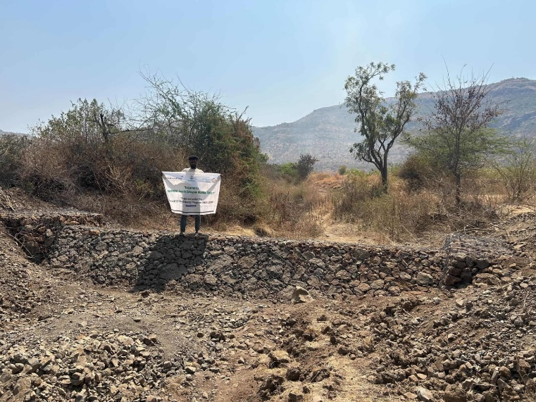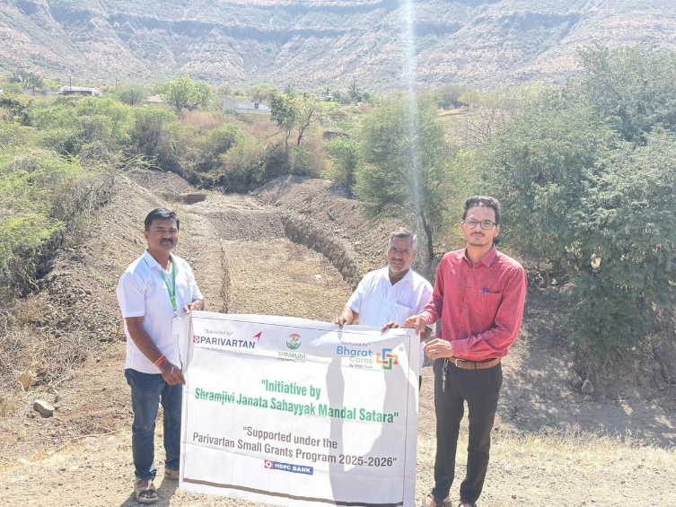
Nala Deepening & Widening
Gabion Stucture
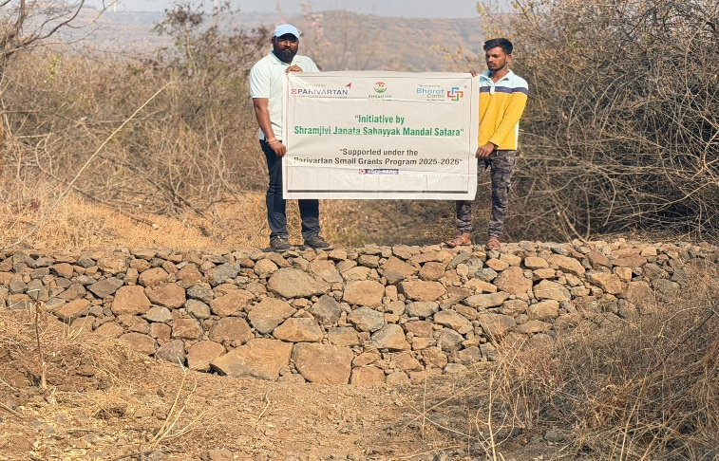
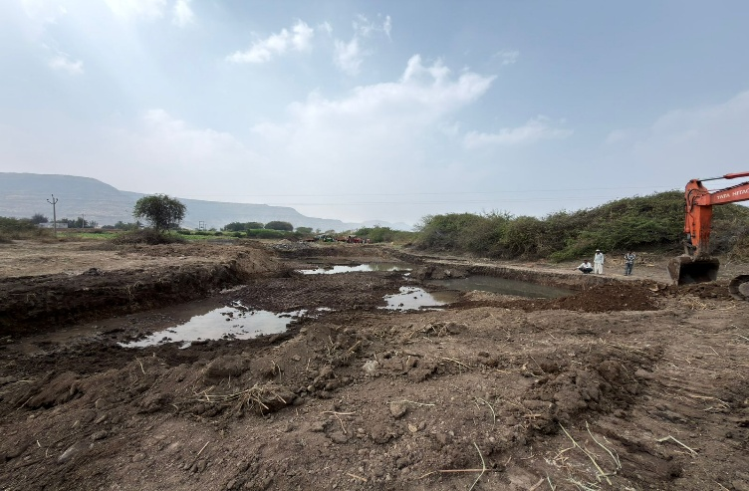

Loose Boulder Structure
Rejuvenation of Existing Water Bodies

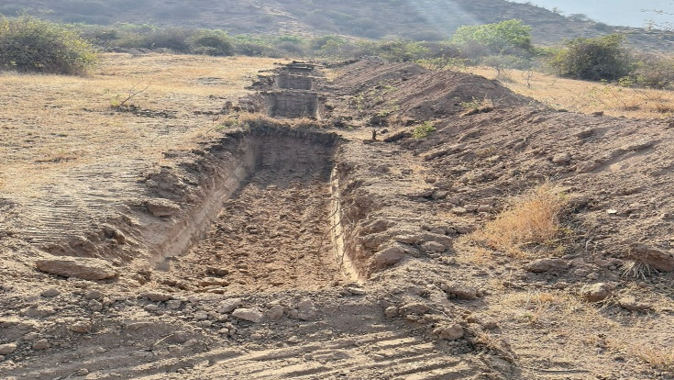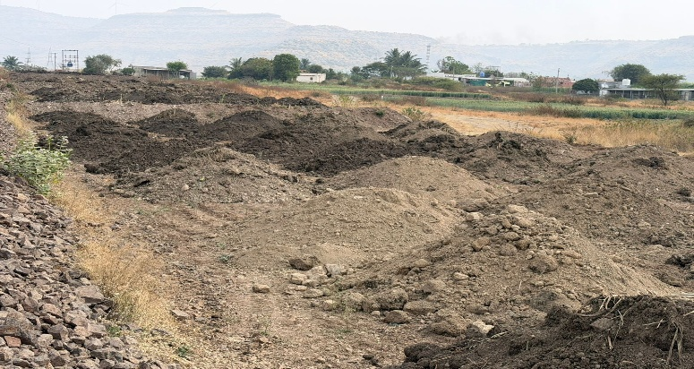

Land Preparation from Desilted Soil
Deep SCT

Annual Report 2025-2026: Updated Final Status
Based on your update that the remaining earthwork is now finished, here is the finalized project report for Shramjivi Janata Sahayyak Mandal Satara.

Cover Page
Field | Details
NGO Name | Shramjivi Janata Sahayyak Mandal Satara
Report Title | Project Status Report
Project Name | Integrated Watershed Management for Climate Resilience and Sustainable Livelihoods
Project Location(s) | Satara
Implementation Period | 2025-2026
Reporting Period | February-March 2026
Contact Details | Project Manager: Mr. Suresh Kadam
Date of Submission | March 2026

Executive Summary
The project reached a final milestone during the February-March 2026 reporting period with the 100% execution of all proposed primary activities. All structural and earthwork interventions have met their targets, providing immediate agricultural benefits such as land reclamation and enhanced water storage for the local farming community.

Project Overview & Background
- Project Scope: Geographic and thematic coverage focused on watershed management and climate resilience.
- Beneficiary Profile: Local farmers receiving nutrient-rich desilted soil to improve land productivity.
- Total Beneficiaries: A total of 39 farmers have directly benefited from the project interventions.

Key Achievements & Milestones
Activity/Target | Planned/Target | Achieved | Remarks/Notes
Gabion Structures | 1 No. | 1 No. | Successfully completed.
Loose Boulders (LB) | 15 No. | 15 No. | All 15 structures completed.
Staggered Contour Trenches (SCT) | 4500 Cum. | 4500 Cum. | Full achievement reached.
Desilting of small ENB | 19000 Cum. | 19000 Cum. | Successfully completed.
Nala Deepening and Widening | 19000 Cum. | 19000 Cum. | Final target fully achieved.
Exposure Visit | 1 | 1 | Completed to date.

Outcomes & Impact
- Land Reclamation: 18 acres of previously barren land have been successfully transformed into cultivable agricultural land.
- Soil Productivity: Transformation was achieved by utilizing nutrient-rich desilted soil extracted during the project.
- Water Resource Improvement: The completion of nala deepening, widening, and desilting has improved local water infrastructure for climate resilience.

Appendices: Project Photographs
- Water Infrastructure: Nala Deepening & Widening and Rejuvenation of Existing Water Bodies.
- Soil Conservation: Gabion Structures and Loose Boulder Structures.
- Land Development: Land Preparation from Desilted Soil and Deep Staggered Contour Trenches (SCT).

Would you like me to generate a formal summary of the 18 acres of reclaimed land to include as a specific "Success Story" for this report?

