TECHNICAL CONSULTANCY & GIS ATLAS DELIVERABLE
COMPREHENSIVE GEOSPATIAL ATLAS &
WATERSHED CHARACTERIZATION REPORT
Physiographic, Hydrogeological, Climatological & Land Resource Assessment for
Tuljapur and Lohara Blocks, Dharashiv District, Maharashtra
Study Area Extent | Tuljapur Block (1,500.72 km²) & Lohara Block (543.20 km²) | Total AOI: 2,043.93 km²
Administrative Units | 177 Cadastral Villages (Tuljapur: 130 | Lohara: 47), Dharashiv District, MH
Coordinate Reference System | WGS 84 / UTM Zone 43N (EPSG: 32643) | Baseline Survey of India Toposheets
Primary Data Repositories | NRSC / ISRO Bhuvan, Survey of India, Copernicus GLO-30 DEM, CHIRPS, CGWB
Specialized Focus | Rajiv Gandhi National Drinking Water Mission (RGNDWM) 250K Ground Water Prospects
Report Version & Date | Version 2.0 (Final Deliverable) | October 2026

EXECUTIVE SUMMARY
This comprehensive GIS and Environmental Atlas presents an exhaustive physiographic, hydrogeological, climatological, and land resource assessment for Tuljapur and Lohara blocks in Dharashiv (formerly Osmanabad) district, Maharashtra. Encompassing a total geographical area of 2,043.93 km² across 177 cadastral villages, the study area represents a critical rural agricultural tract within the drought-prone Deccan Trap basalt plateau. The primary purpose of this atlas is to synthesize multi-satellite remote sensing observations, national geospatial databases, and ground truth hydrogeological records into an actionable framework for watershed planning, sustainable irrigation development, and site-specific artificial recharge under the Jal Jeevan Mission (JJM) and Rajiv Gandhi National Drinking Water Mission (RGNDWM).
★ GEOGRAPHICAL NEXUS & RGNDWM FRAMEWORK
The study area occupies an extraordinary geographic nexus where four Survey of India 1° × 1° quadrangles (56C, 56B, 47O, and 47N) converge at exactly 76°00'00"E and 18°00'00"N. Approximately 70.1% of the AOI (1,433.9 km²) falls within Sheet 56C (Osmanabad/Sholapur), 16.6% (340.1 km²) within Sheet 56B (Bidar/Latur), 12.9% (262.8 km²) in Sheet 47O (Solapur/Sina Basin), and 0.4% (7.1 km²) in Sheet 47N. Ten Survey of India 1:50,000 toposheet tiles provide the foundational cadastral basis for all ground water prospects and recharge structures.

Master Study Area KPI Summary
Thematic Parameter | Tuljapur Block | Lohara Block | Combined Study Area | Source Authority
Total Geographical Area | 1,500.72 km² (73.4%) | 543.20 km² (26.6%) | 2,043.93 km² (100.0%) | MahaGIS / SOI Cadastre
Cadastral Village Units | 130 Villages | 47 Villages | 177 Villages Total | Census of India 2011
Total Population | 279,720 Persons | 116,211 Persons | 395,931 Persons | Census 2011 Data
Elevation Range (m a.s.l.) | 435.5 – 711.0 m | 514.8 – 669.2 m | 435.5 – 711.0 m | Copernicus GLO-30 DEM
Mean Surface Elevation | 554.6 m a.s.l. | 617.2 m a.s.l. | 560.6 m a.s.l. | Zonal DEM Extraction
Mean Topographic Slope | 1.62° (Very Gentle) | 1.42° (Nearly Level) | 1.57° (Regional Mean) | DEM Slope horn Algorithm
Primary River Basins | Bori River (Sina / Bhima) | Terna River (Manjra) | Bhima & Godavari Divides | CWC Basin Directory
Total Stream Length | 1,608.74 km | 582.98 km | 2,191.73 km | Strahler Orders 1–5
Drainage Density (Dd) | 1.07 km / km² | 1.07 km / km² | 1.07 km / km² | Hydrological Metric
34-Yr Mean Rainfall | 762.5 mm / year | 786.1 mm / year | 768.4 mm / year | CHIRPS (1991–2024)
Monsoon Share (JJAS) | 81.4% (620.7 mm) | 82.8% (650.9 mm) | 81.8% (628.5 mm) | IMD Monsoon Window
Predominant Soil Depth | Very Shallow (<25 cm | 70.0%) | Very Shallow (57.7%) & Shallow (33.3%) | Very Shallow (66.8% AOI) | NBSS & LUP Soil Survey
Predominant Soil Texture | Clay (Vertisols | 93.5%) | Clay (Vertisols | 92.4%) | Clay / Black Soil (93.2%) | OpenLandMap USDA TT
Cultivated Agricultural Land | 72.4% (1,086.5 km²) | 76.8% (417.2 km²) | 73.5% (1,503.7 km²) | NRSC 1:250k LULC
Current Fallow Land | 428.65 km² (28.6%) | 146.61 km² (27.0%) | 575.26 km² (28.2%) | Multi-temporal Crop Dynamics
Forest & Plantation Cover | 9.50 km² (0.6%) | 1.95 km² (0.4%) | 11.45 km² (0.6%) | FSI Forest Cover Matrix
Surface Waterbodies | 62.93 km² (4.2%) | 22.74 km² (4.2%) | 85.67 km² (4.2%) | NRSC Waterbodies Layer
Road Transport Network | 1,328.45 km | 433.13 km | 1,761.58 km | NH-52 & State Roads (OSM)
Major Lithology | Deccan Basalt (Pahoehoe) | Deccan Basalt & Alluvium | Upper Cretaceous Basalts | Geological Survey of India
RGNDWM 1° × 1° Quads | 56C, 47O, 56B, 47N | 56C, 56B | Quad Nexus (76°E, 18°N) | NRSC Ground Water Mission
SOI 1:50k Toposheet Tiles | 8 Sheets (56C/1, 56C/2, etc.) | 5 Sheets (56C/2, 56B/14, etc.) | 10 Sheets Total | Survey of India Topo Index

CHAPTER 1: GEOGRAPHIC SETTING & ADMINISTRATIVE FRAMEWORK
Tuljapur and Lohara talukas are located in the southern and eastern sectors of Dharashiv district in the Marathwada division of Maharashtra. The study area extends from Longitude 75°50'13"E to 76°34'33"E and Latitude 17°39'24"N to 18°05'57"N. Tuljapur is the larger taluka, covering 1,500.72 km² (73.42% of the AOI) with its administrative headquarters at Tuljapur, an ancient temple town perched on the Balaghat plateau scarp. Lohara taluka covers 543.20 km² (26.58% of the AOI) with its headquarters at Lohara (BK), situated on an extensive plateau tableland.
Together, the two talukas encompass 177 revenue villages (130 in Tuljapur and 47 in Lohara). The district is bordered by Solapur district to the south and west, Latur district to the east and north-east, and Beed district to the north. Major connectivity is provided by National Highway 52 (Solapur–Dhule Highway), traversing central Tuljapur, alongside key State Highways linking Tuljapur to Naldurg, Osmanabad, Omerga, and Aland.

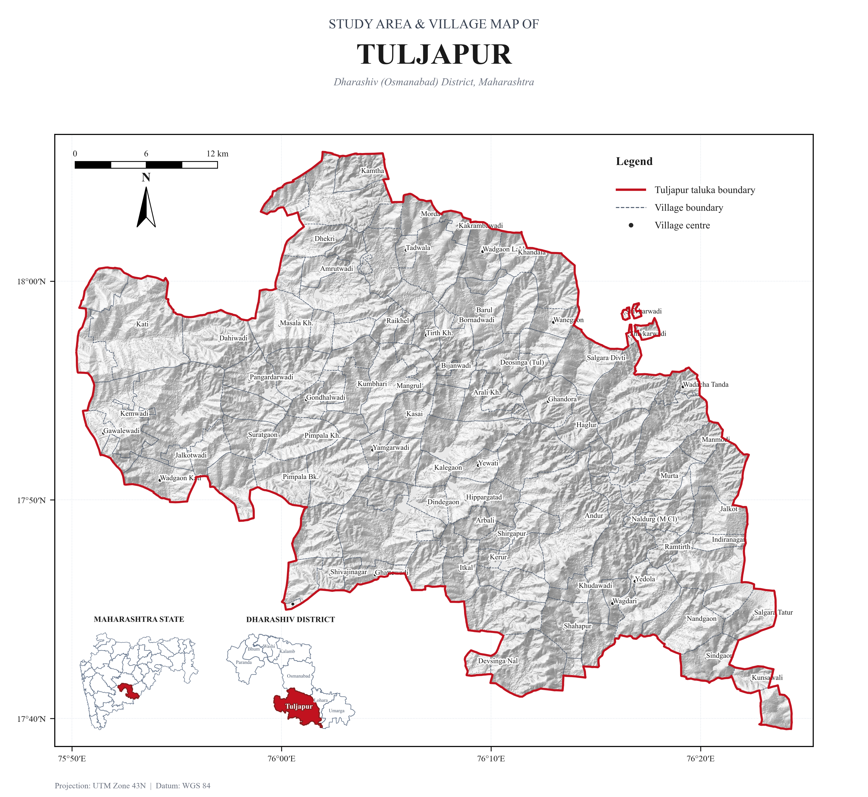
Figure 1.1: Cartographic Study Area Location and Administrative Boundary Map of Tuljapur Block (1,500.72 km²).

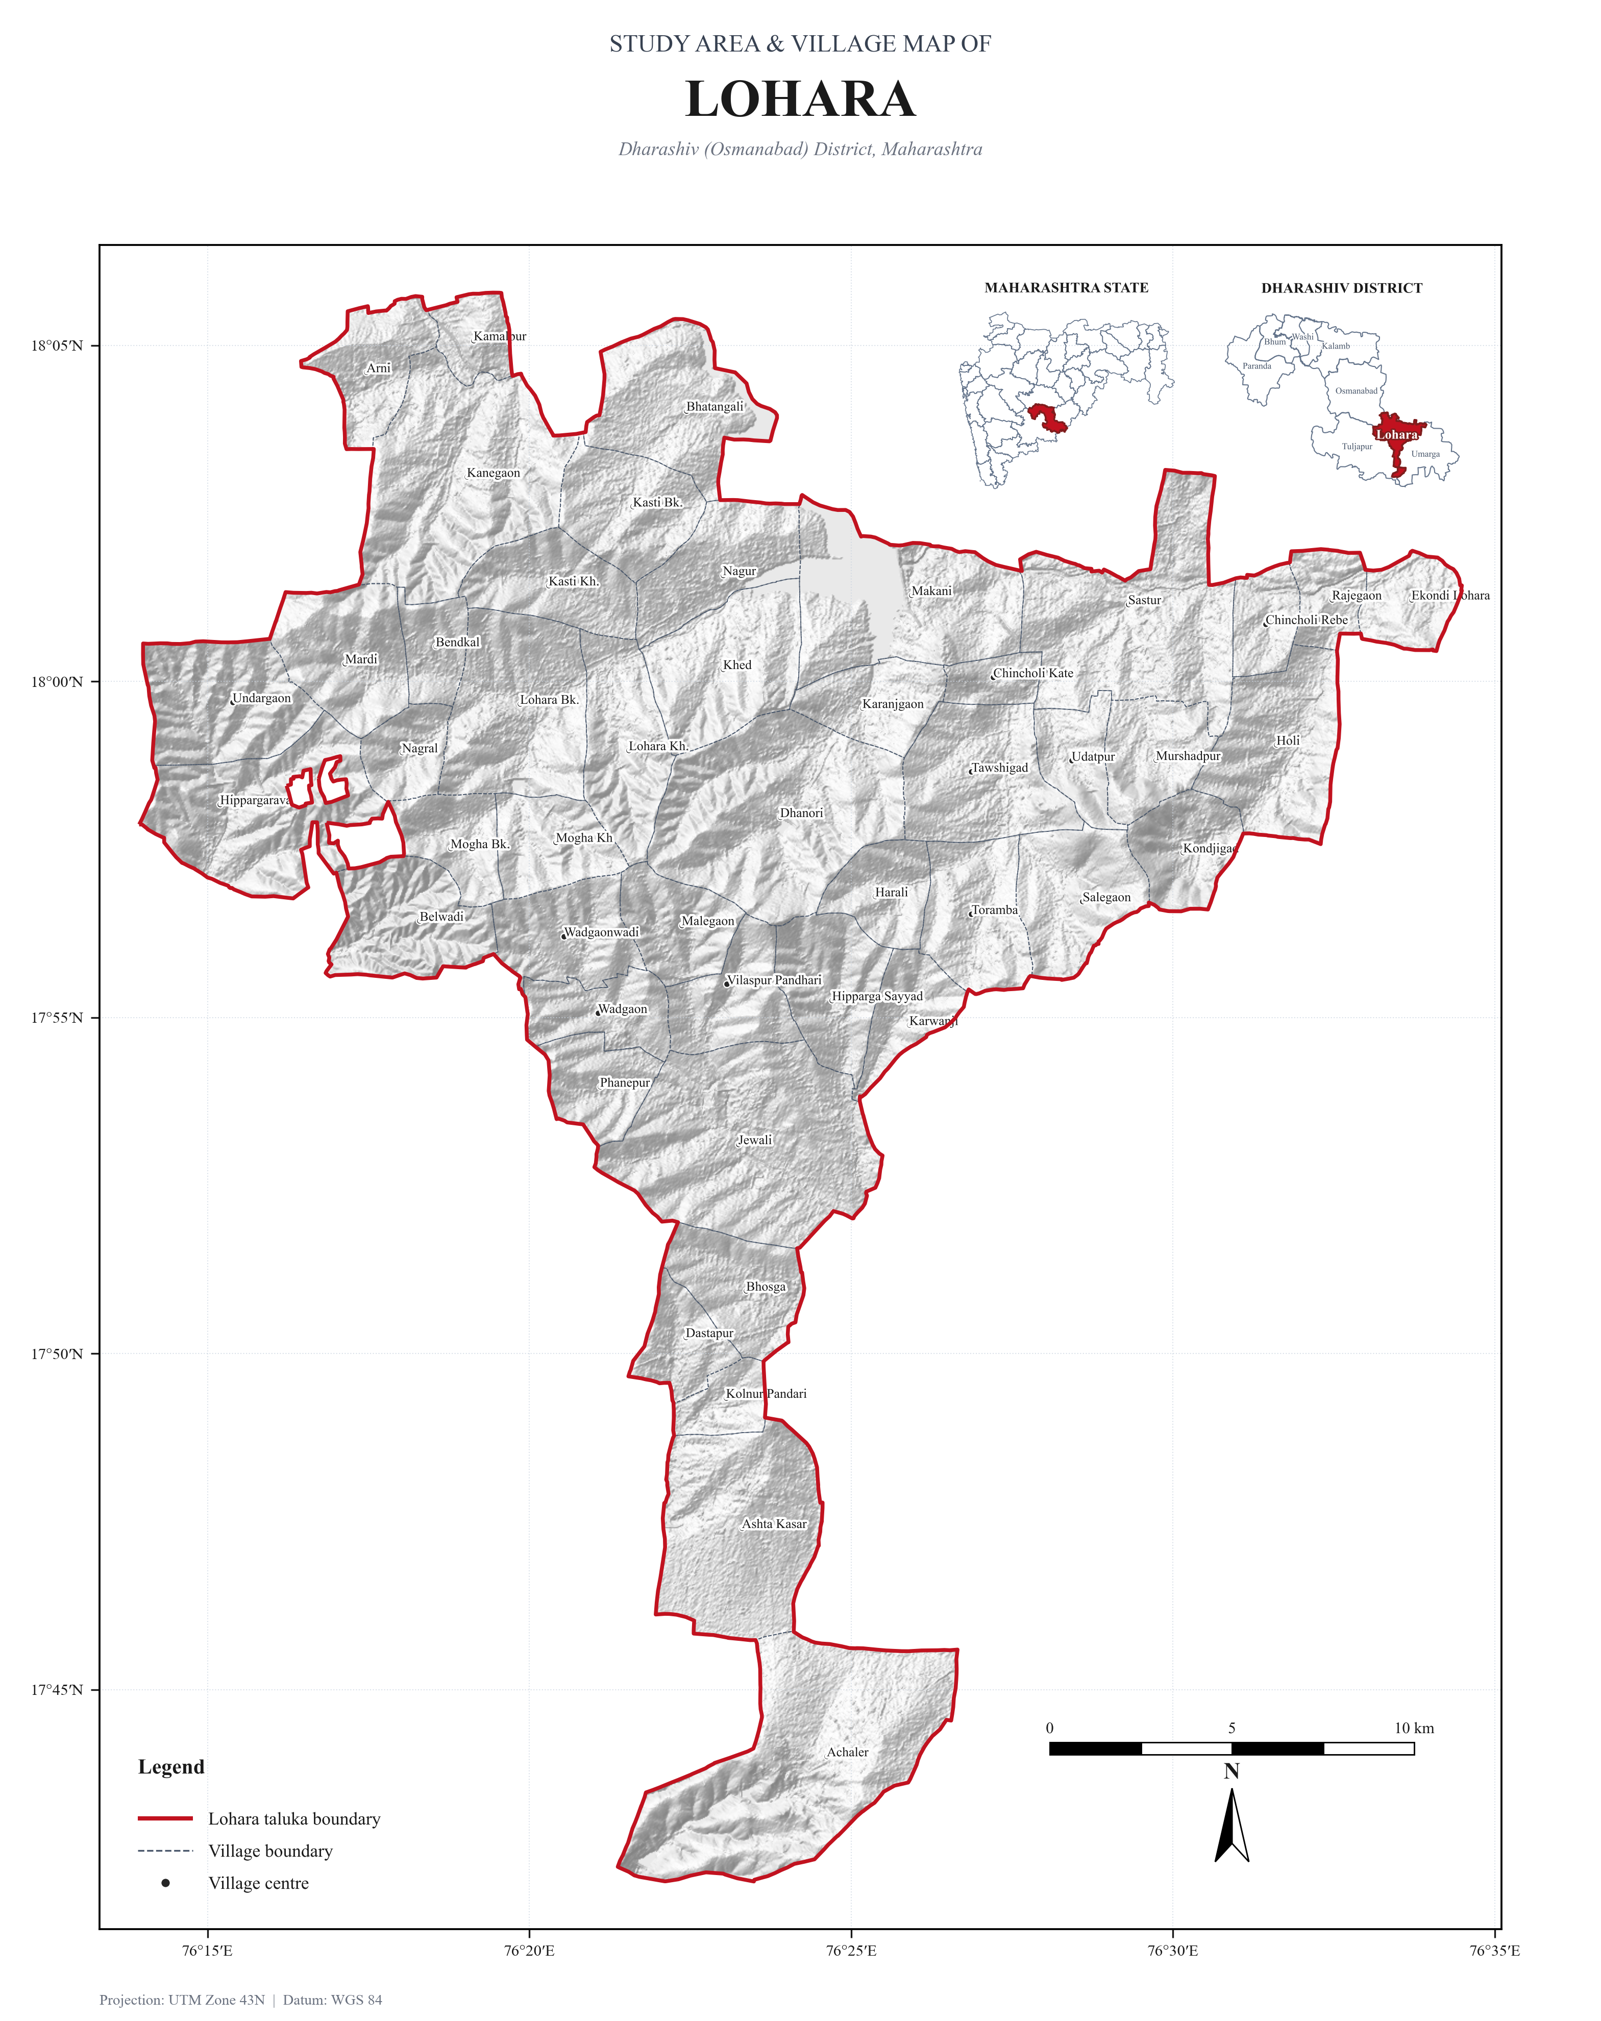
Figure 1.2: Cartographic Study Area Location and Administrative Boundary Map of Lohara Block (543.20 km²).

CHAPTER 2: PHYSIOGRAPHY & DIGITAL ELEVATION MODELING
Physiographically, the study area forms an integral part of the Balaghat Range—a major east-west trending spur of the Western Ghats that acts as a structural water divide between the Godavari basin to the north and the Bhima (Krishna) basin to the south. Based on the Copernicus GLO-30 Digital Elevation Model (30 m spatial resolution), elevations across the AOI span from a minimum of 435.5 m a.s.l. in the incised Bori river valley near Naldurg to a maximum of 711.0 m a.s.l. on the northern structural ridges near Apsinga and Kamtha in northern Tuljapur.
Lohara block sits at a substantially higher average elevation (mean 617.2 m a.s.l.) compared to Tuljapur (mean 554.6 m a.s.l.), as over 73.7% of Lohara occupies the flat tableland between 600 m and 650 m. Tuljapur displays greater physiographic diversity, with broad undulating pediplains between 500 m and 550 m covering 45.6% of the taluka.

Hypsometric Elevation Distribution by Block
Elevation Range | Hypsometric Classification | Tuljapur (km²) | Tuljapur (%) | Lohara (km²) | Lohara (%)
400 – 450 m | Lowest Valley Depressions | 0.00 | 0.0% | 0.00 | 0.0%
450 – 500 m | Lower Valley Plains & Depressions | 146.30 | 9.7% | 0.00 | 0.0%
500 – 550 m | Middle Undulating Pediplain | 684.70 | 45.6% | 3.60 | 0.7%
550 – 600 m | Upper Pediment & Plateau Flanks | 344.80 | 23.0% | 107.20 | 19.7%
600 – 650 m | Balaghat Main Plateau Tableland | 272.70 | 18.2% | 400.20 | 73.7%
> 650 m | High Residual Ridges & Escarpments | 52.22 | 3.5% | 32.20 | 5.9%
TOTAL | Total Block Geographical Area | 1,500.72 | 100.0% | 543.20 | 100.0%

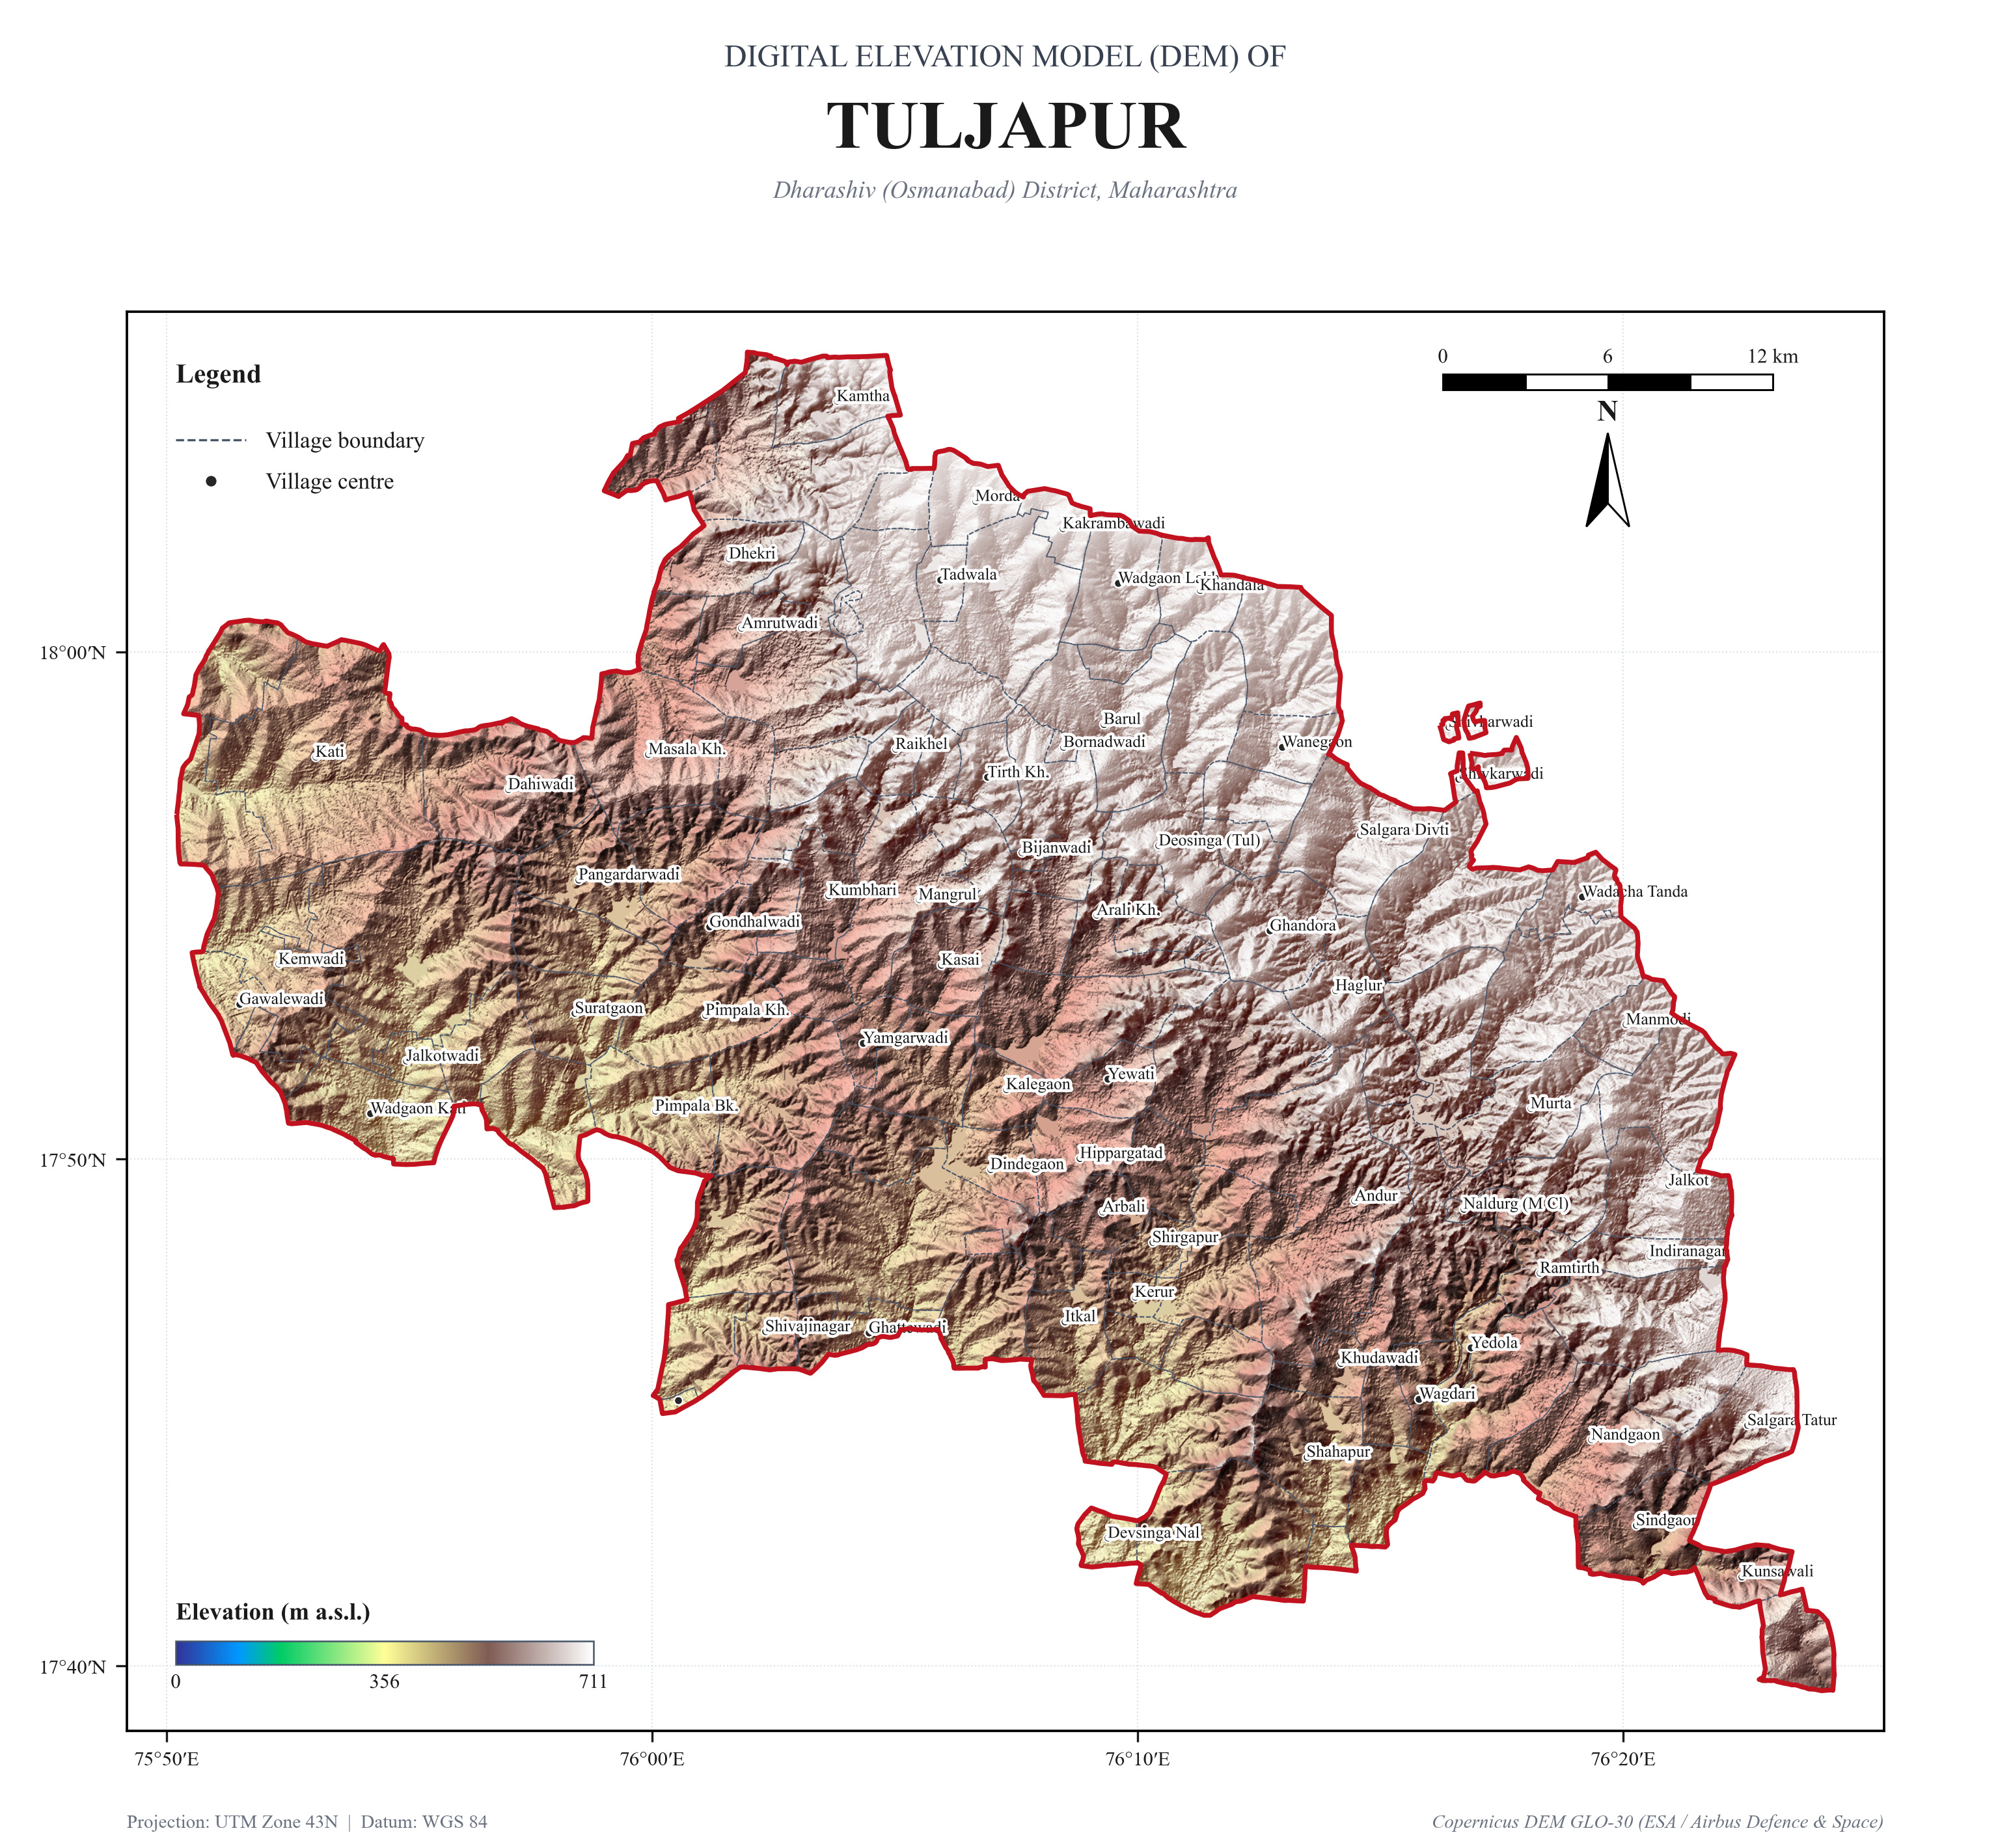
Figure 2.1: Digital Elevation Model (Copernicus GLO-30) and Shaded Relief of Tuljapur Block.

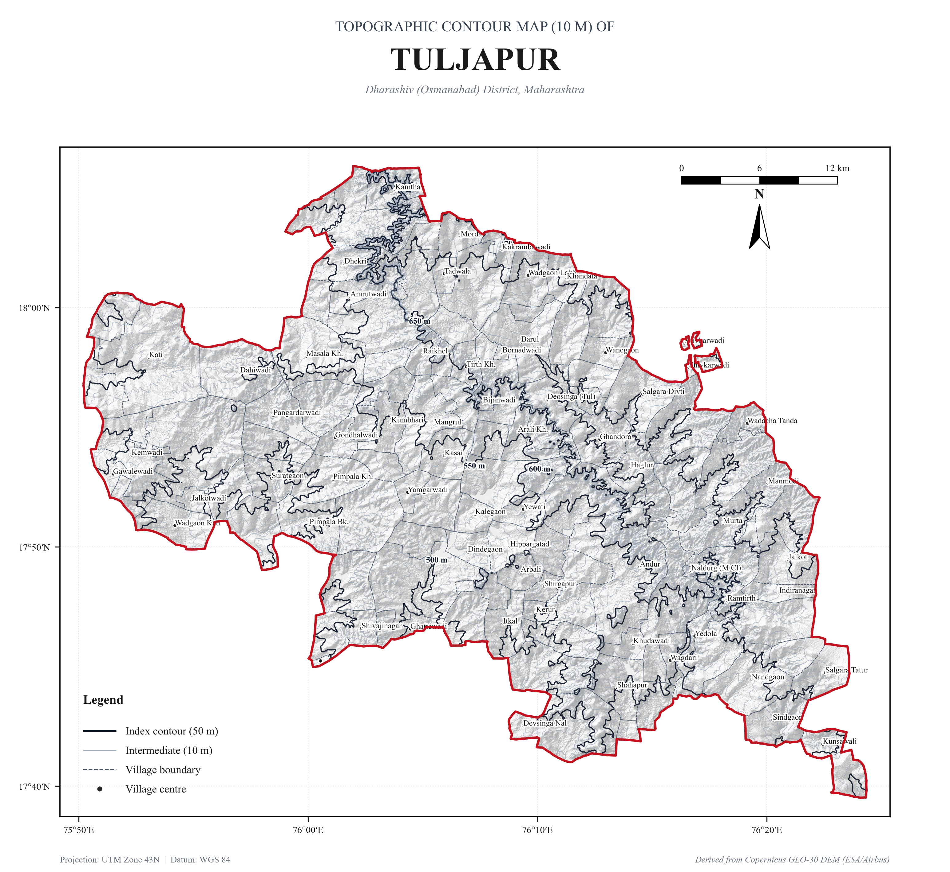
Figure 2.2: Cartographic 10-Meter Topographic Contour Map of Tuljapur Block.

CHAPTER 3: SLOPE & TERRAIN RUGGEDNESS
Topographic slope exerts a decisive control over overland runoff velocity, soil erosion susceptibility, and infiltration capacity. The regional terrain is dominated by flat to very gentle slopes: 84.2% of Tuljapur and 95.7% of Lohara exhibit gradients below 3° (0–5% slope). Nearly level tablelands (0–1°) cover 458.8 km² (30.6%) in Tuljapur and 260.7 km² (48.0%) in Lohara, presenting optimal conditions for agricultural cultivation and low soil erosion risk.
Steep escarpments (>10° slope) are confined to the northern Balaghat plateau scarp in Tuljapur (27.0 km² | 1.8%) around Apsinga and Dhekri, and along incised stream gorges. These steep scarp zones act as major runoff-generating source catchments that require strict mechanical soil conservation measures such as Continuous Contour Trenches (CCT) and vegetative barriers.

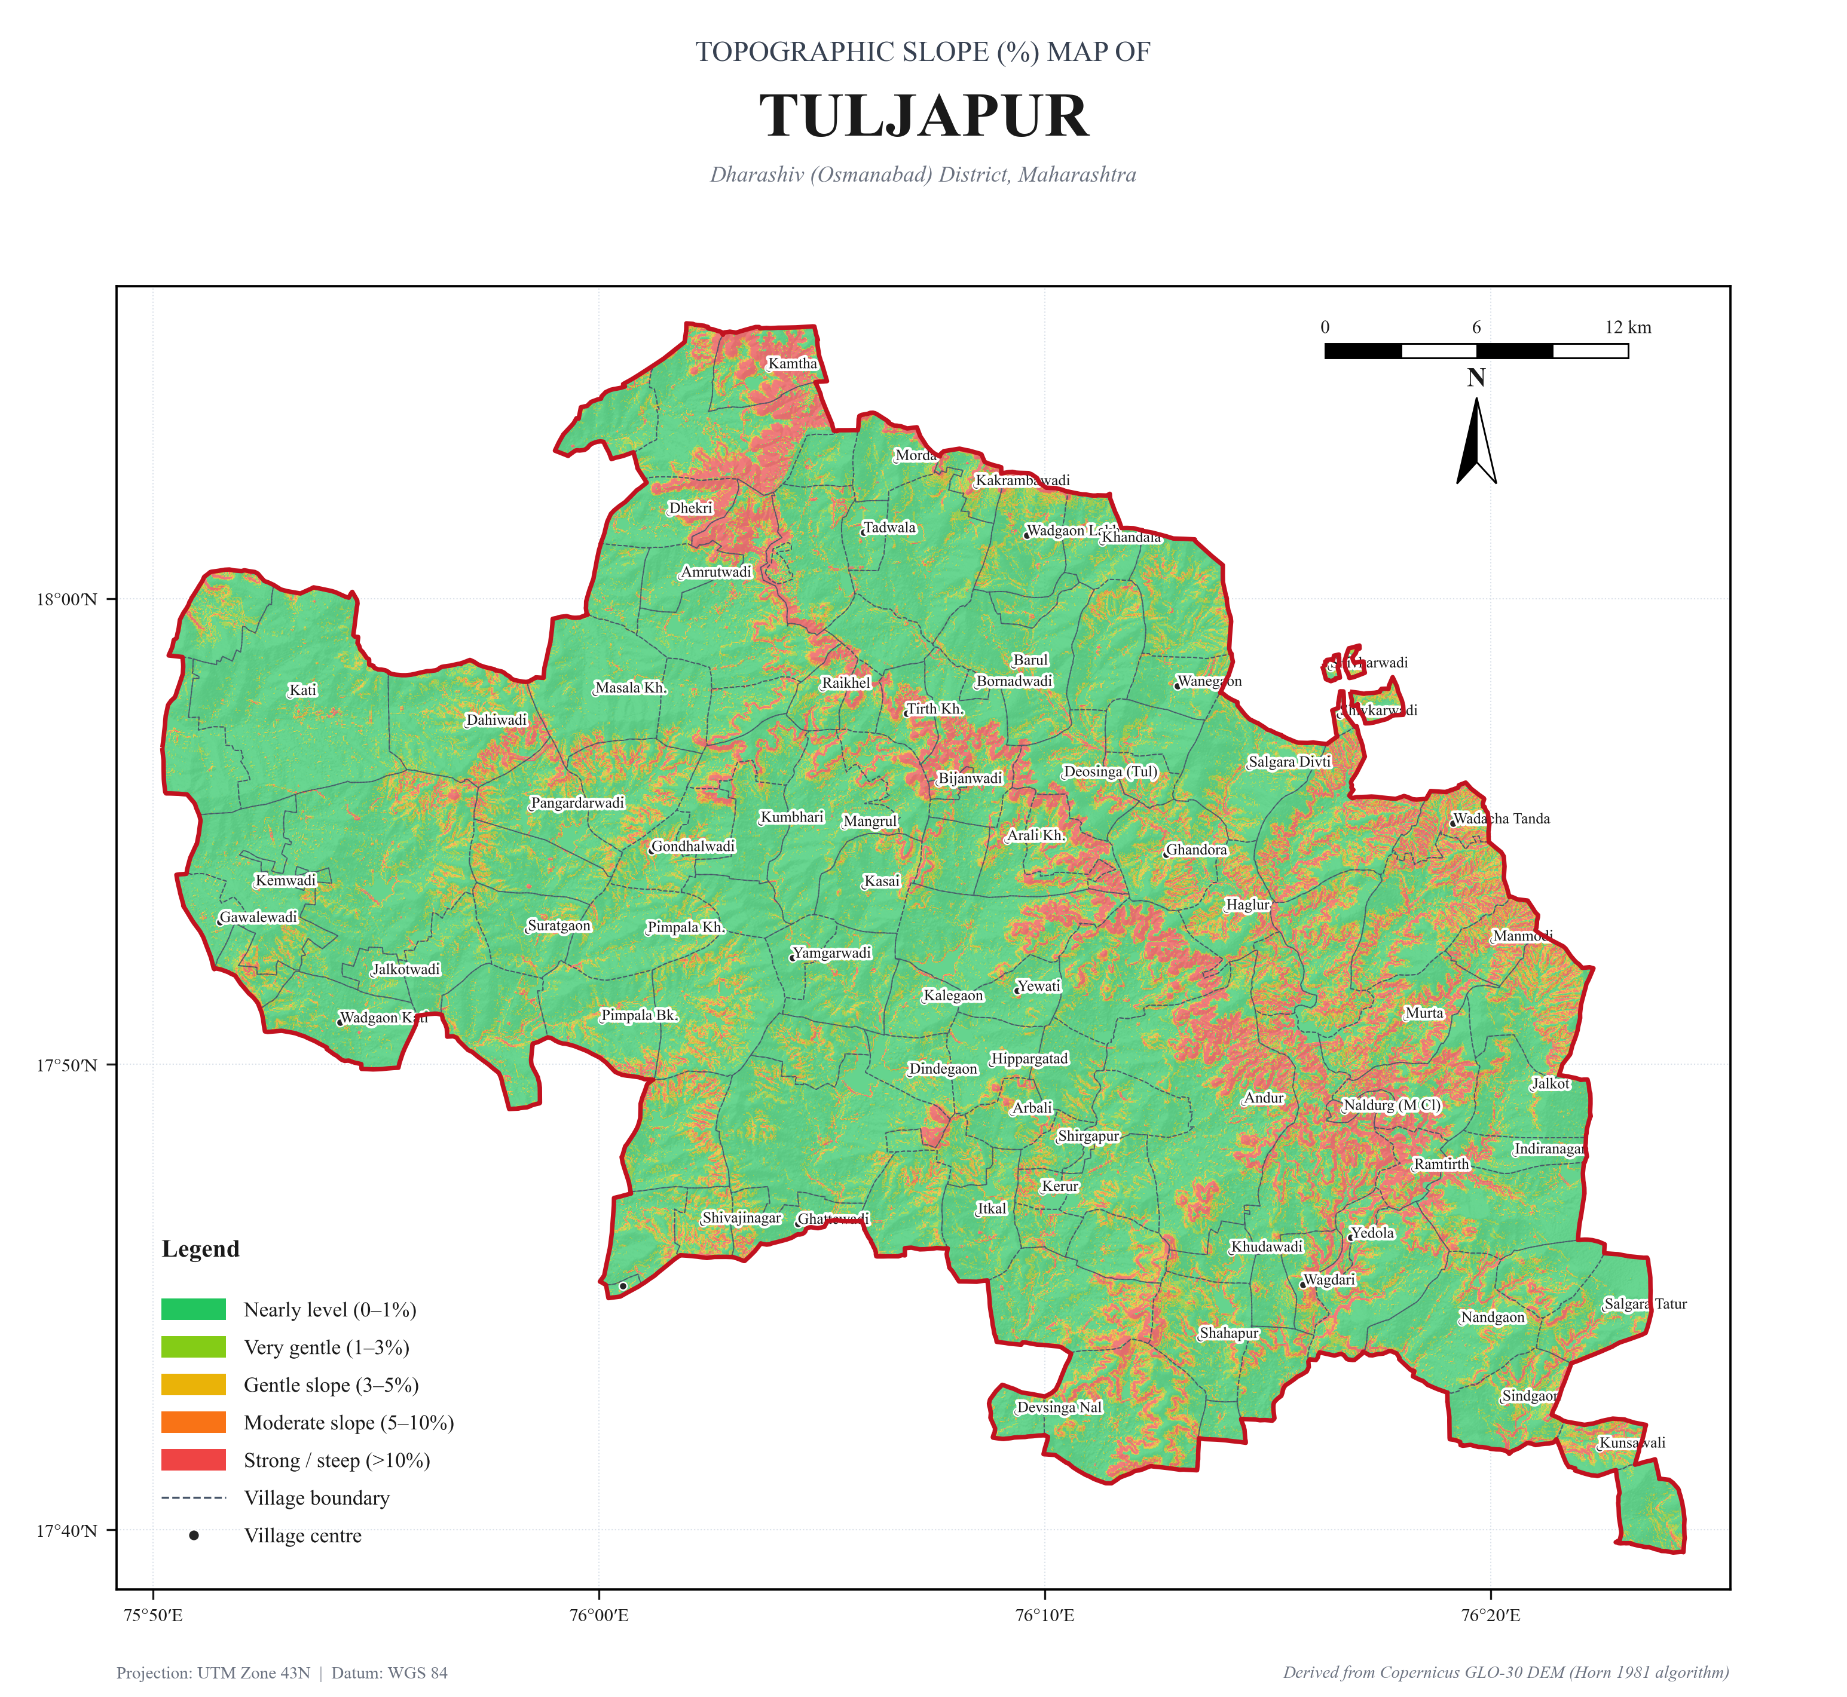
Figure 3.1: Topographic Slope Classification Map of Tuljapur Block.

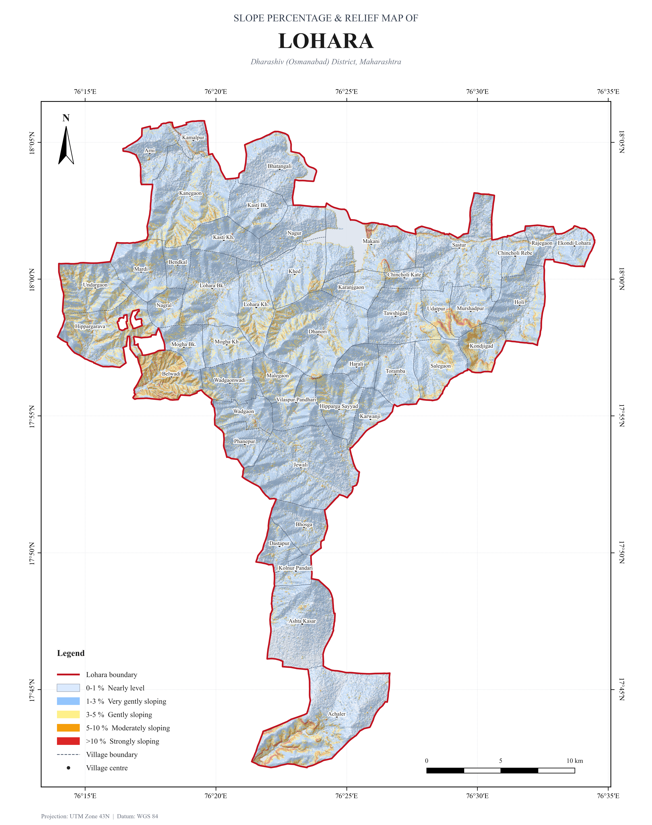
Figure 3.2: Topographic Slope Classification Map of Lohara Block.

CHAPTER 4: HYDROLOGY & DRAINAGE NETWORK MORPHOMETRY
The drainage architecture of the study area is bifurcated across two major river sub-basins:
1. Bori River Sub-basin (Sina / Bhima / Krishna Basin): Drains the entirety of central, western, and southern Tuljapur, flowing south-eastwards past Naldurg where the historic Naldurg fort impounds a major perennial reservoir.
2. Terna River Sub-basin (Manjra / Godavari Basin): Drains northern Tuljapur and the whole of Lohara block, flowing eastwards towards the Lower Terna Project and contributing to the Godavari river system.
A rigorous Strahler stream order analysis derived from the hydrologically conditioned 30 m DEM reveals a total stream network length of 2,191.73 km comprising 2,230 segments across Orders 1 to 5. The drainage density (Dd) is remarkably uniform at 1.07 km/km² across both blocks, reflecting mature dendritic drainage developed over horizontally bedded basalt flows.

Strahler Stream Hierarchy Breakdown by Block
Order | Stream Classification | Tuljapur (Seg) | Tuljapur (km) | Lohara (Seg) | Lohara (km) | Total (km)
Order 1 | Headwater Ephemeral Gully | 827 | 843.66 | 310 | 305.71 | 1,149.37
Order 2 | Secondary Tributary | 359 | 400.71 | 153 | 146.96 | 547.67
Order 3 | Major Drainage Stream | 280 | 236.73 | 96 | 75.76 | 312.49
Order 4 | Sub-Basin Trunk River | 125 | 109.93 | 52 | 40.37 | 150.30
Order 5 | Major Confluence Reach | 22 | 17.72 | 24 | 14.18 | 31.90
TOTAL | Complete Stream Network | 1,613 | 1,608.75 | 635 | 582.98 | 2,191.73

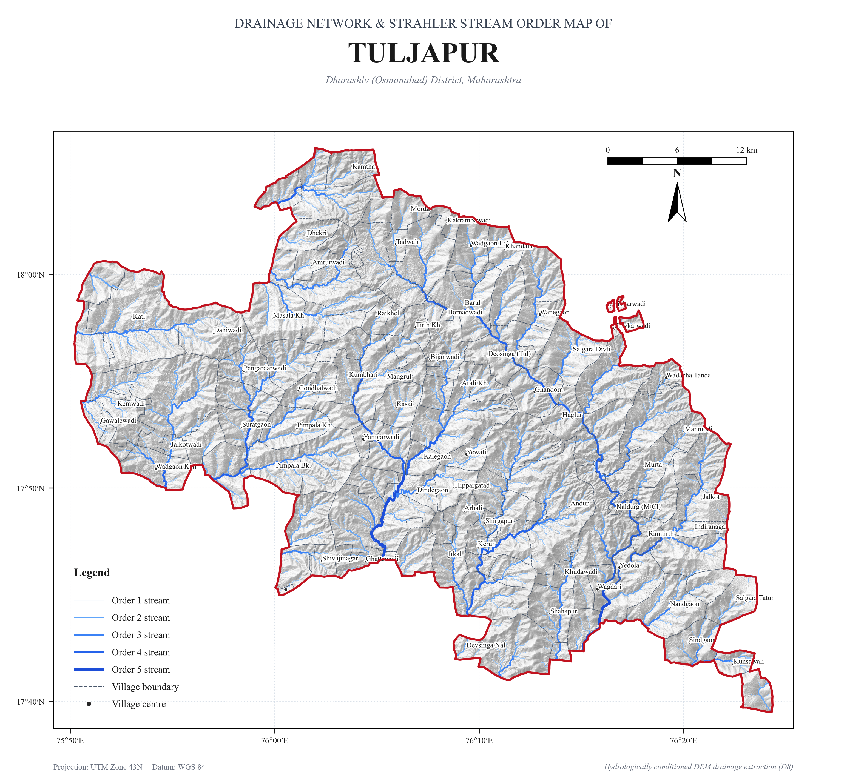
Figure 4.1: Strahler Stream Order Classification Map of Tuljapur Block (Orders 1 to 5).

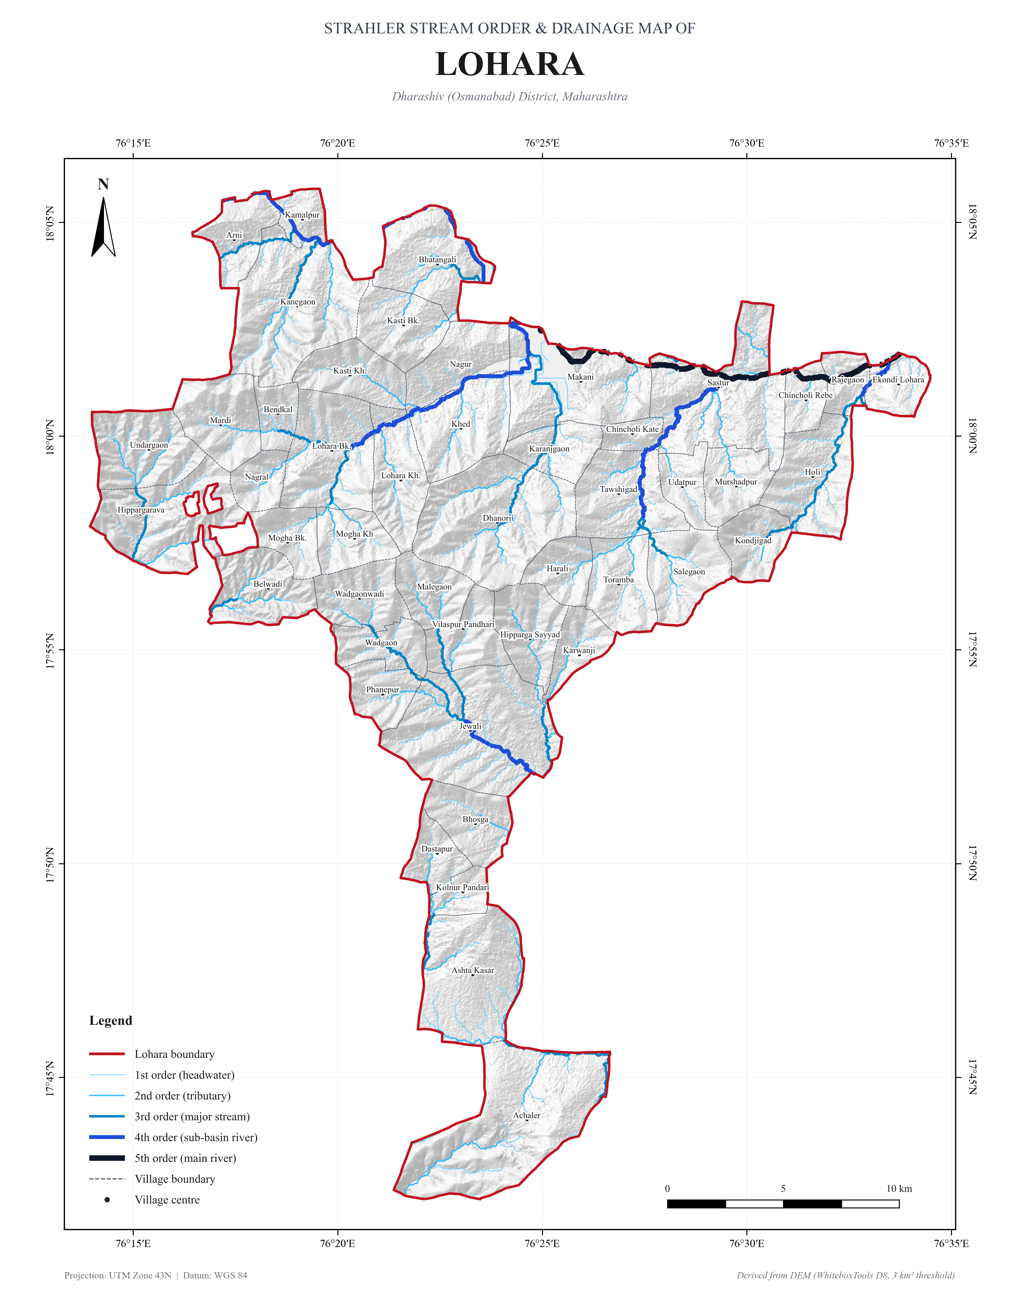
Figure 4.2: Strahler Stream Order Classification Map of Lohara Block (Orders 1 to 5).

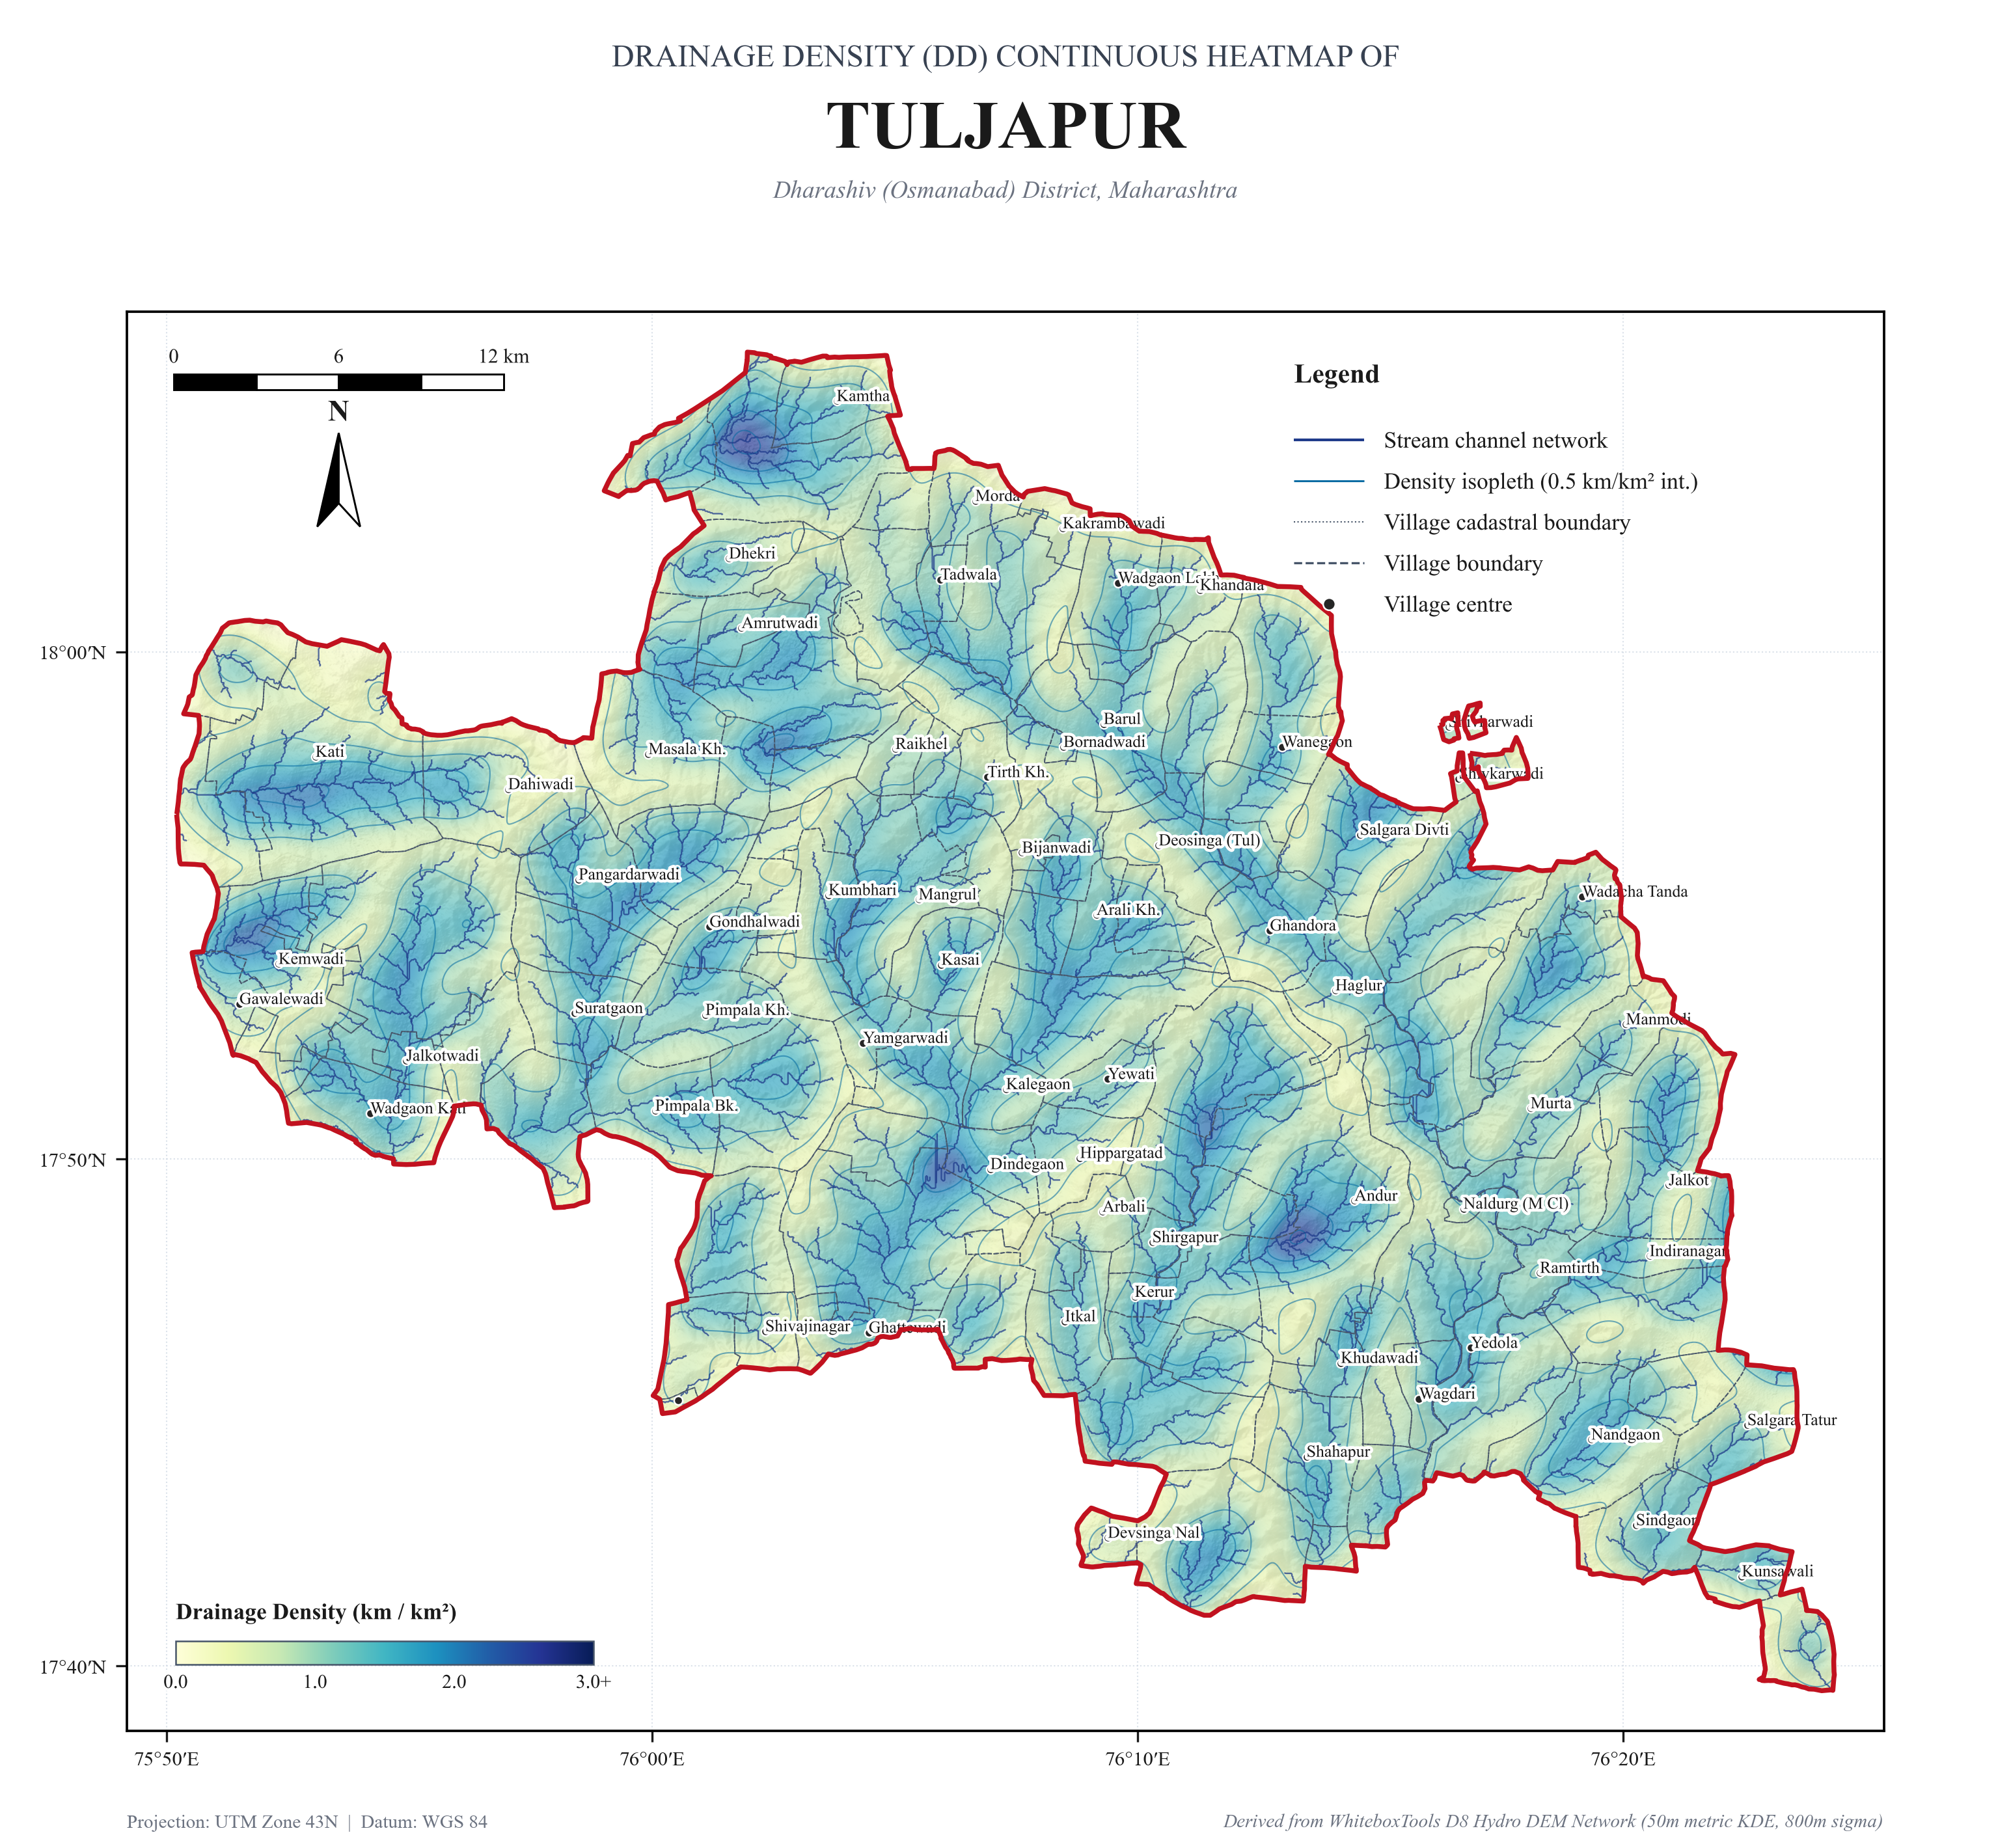
Figure 4.3: Continuous Drainage Density (Dd) Heatmap of Tuljapur Block (50m Metric KDE Stream Concentration).

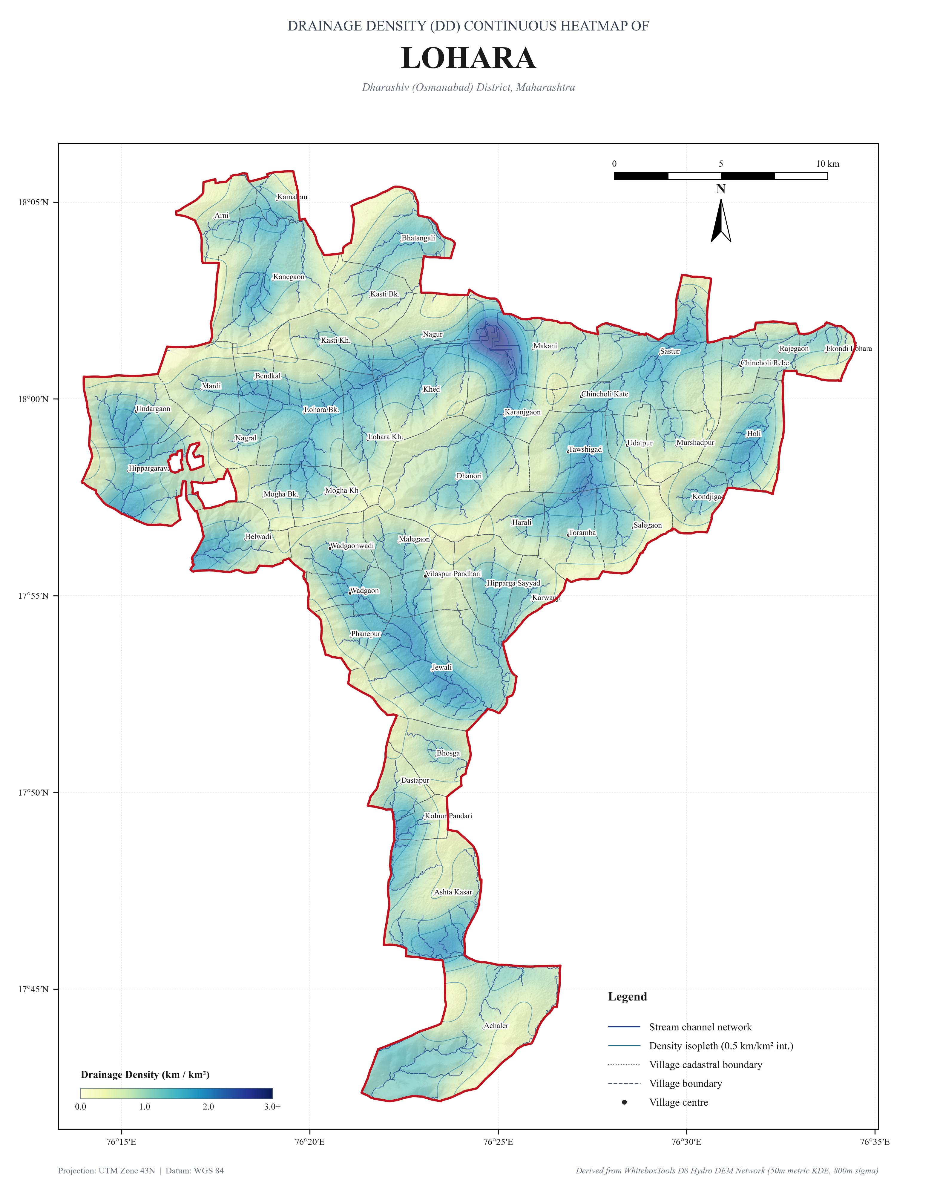
Figure 4.4: Continuous Drainage Density (Dd) Heatmap of Lohara Block (50m Metric KDE Stream Concentration).

CHAPTER 5: CLIMATOLOGY & PRECIPITATION DYNAMICS
The climate of Dharashiv district is semi-arid, characterized by hot dry summers, general dryness throughout the year except during the southwest monsoon, and erratic precipitation. Analysis of a 34-year gridded precipitation timeseries (CHIRPS 5.5 km resolution, 1991–2024) indicates a long-term mean annual rainfall of 768.4 mm across the AOI (762.5 mm in Tuljapur and 786.1 mm in Lohara).
Precipitation is highly seasonal: over 81.8% (628.5 mm) is received during the four southwest monsoon months (June to September). Post-monsoon retreating rains (October–November) contribute 13.5% (103.8 mm), while pre-monsoon thunderstorms (March–May) and winter rains (December–January) contribute 4.4% (34.0 mm) and 0.3% (2.1 mm), respectively.
The coefficient of variation (CV) is 23.4%, denoting significant inter-annual rainfall variability. Drought anomaly analysis identifies recurring meteorological deficit years (such as 1997, 2012, and 2015, where precipitation dropped below 500 mm), underscoring the absolute necessity for decentralized rainwater harvesting and artificial aquifer recharge.

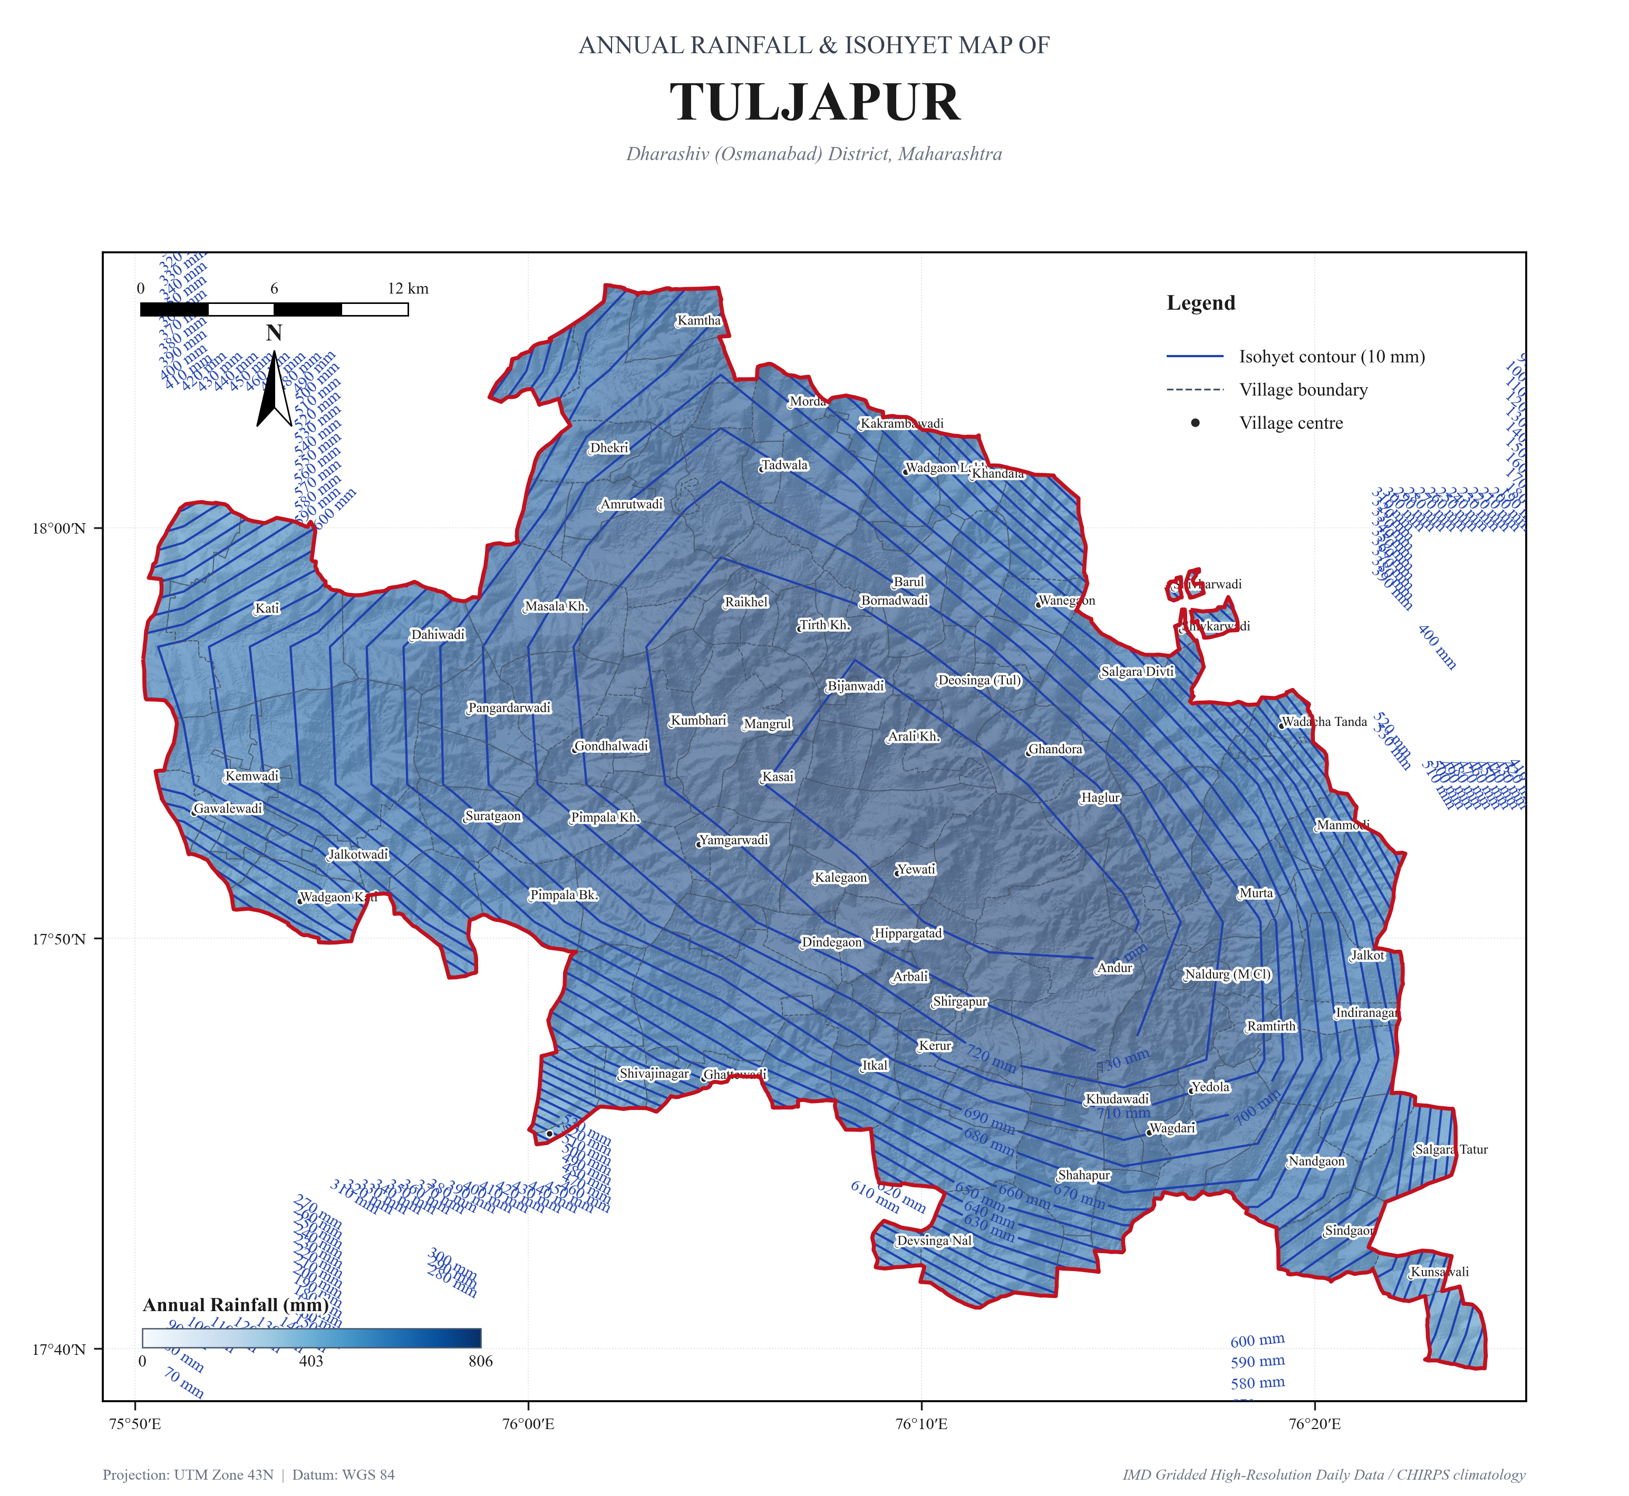
Figure 5.1: 34-Year Mean Annual Rainfall Isohyets and Precipitation Gradient across Tuljapur Block.

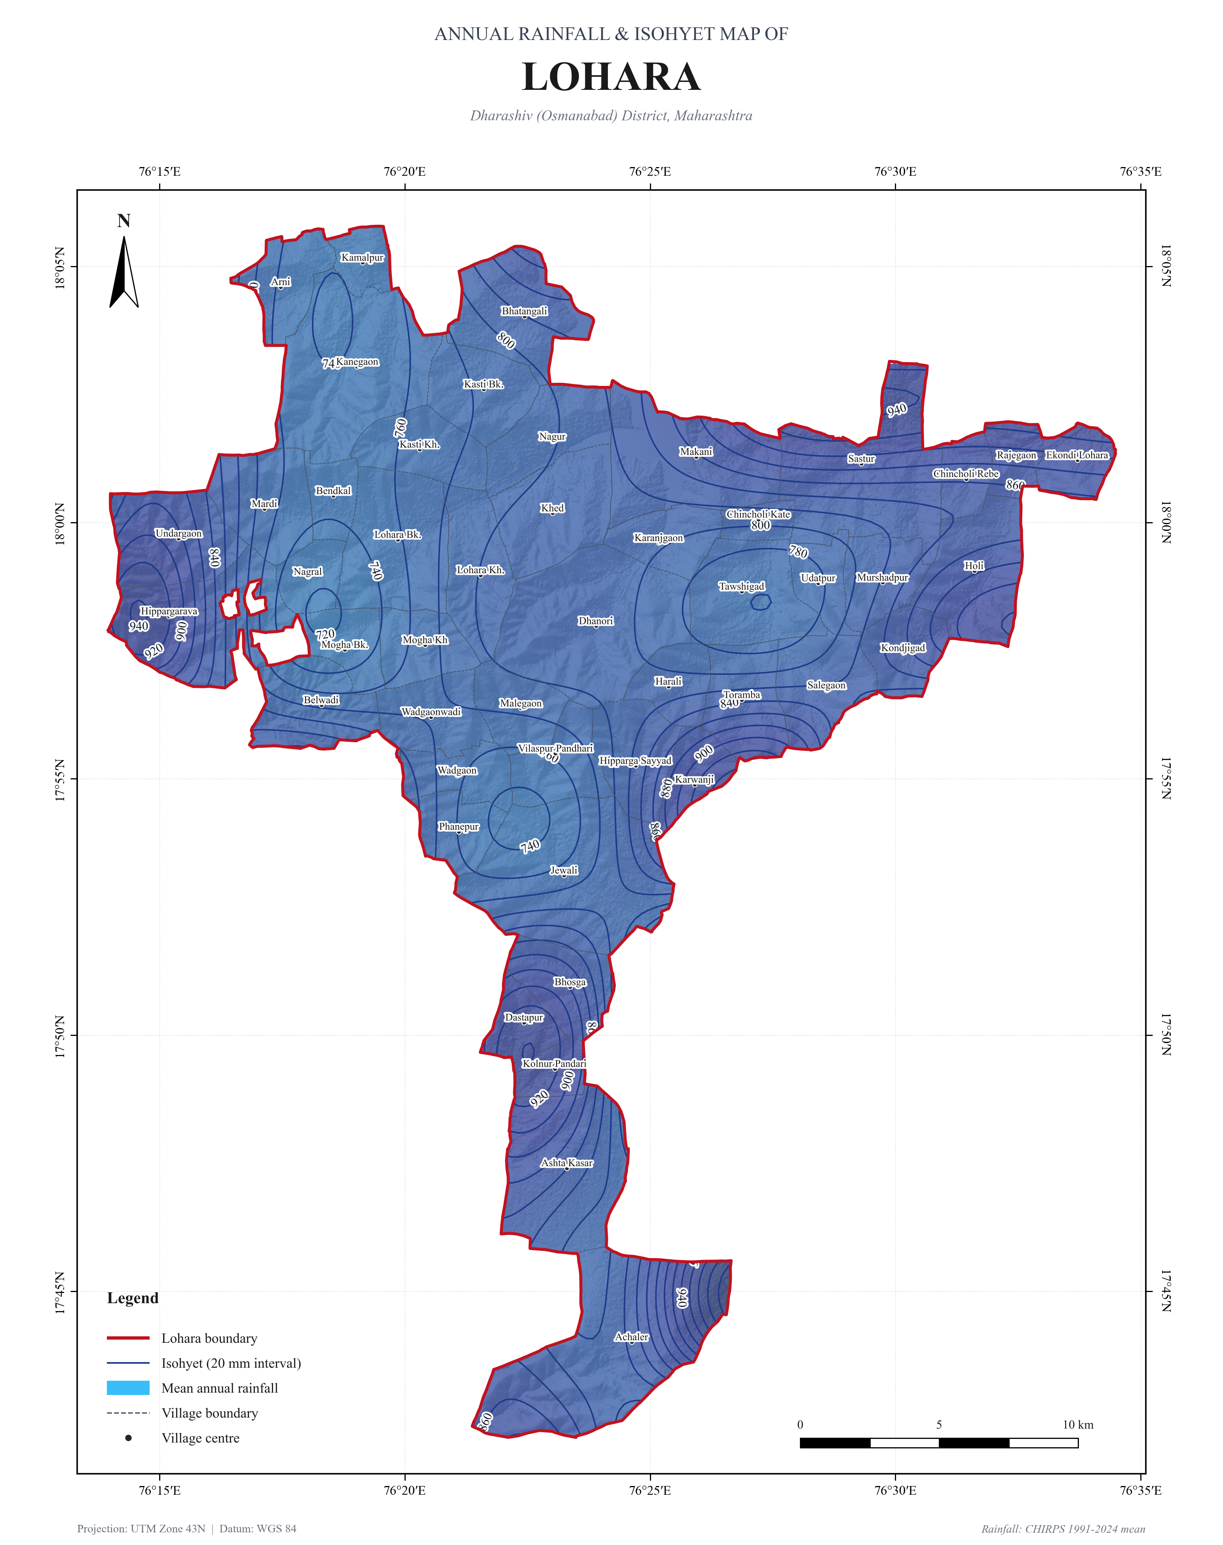
Figure 5.2: 34-Year Mean Annual Rainfall Isohyets and Precipitation Gradient across Lohara Block.

CHAPTER 6: PEDOLOGY, SOIL TEXTURE & INFILTRATION
The pedological mantle across the study area has developed entirely through in-situ weathering of Deccan basalt rock under alternating wet and dry semi-arid regimes. Based on National Bureau of Soil Survey & Land Use Planning (NBSS&LUP) and ISRIC SoilGrids datasets, the soils exhibit extreme depth contrasts:
1. Very Shallow Soils (10–25 cm depth | Lithic Ustorthents): Cover 1,049.92 km² (70.0%) in Tuljapur and 312.56 km² (57.7%) in Lohara. These soils are gravelly, highly permeable but possess negligible moisture retention capacity, leaving crops extremely vulnerable to mid-season dry spells.
2. Shallow Soils (25–50 cm depth | Lithic Haplustepts): Cover 131.55 km² (8.8%) in Tuljapur and 180.74 km² (33.3%) in Lohara, occupying mid-plateau positions.
3. Deep to Moderately Deep Soils (>50 cm depth | Typic Chromusterts): Cover 317.60 km² (21.2%) in Tuljapur and 48.73 km² (9.0%) in Lohara, restricted to low-lying river plains and alluvial terraces.
Textural classification according to the USDA Soil Texture Triangle indicates an overwhelming dominance of Heavy Clay (Vertisols) covering 93.2% of the AOI. These montmorillonite-rich clays expand upon wetting and develop deep vertical cracks during dry periods. Infiltration is rapid when cracks are open but drops drastically to 1.0–5.0 mm/hr once soils become saturated.

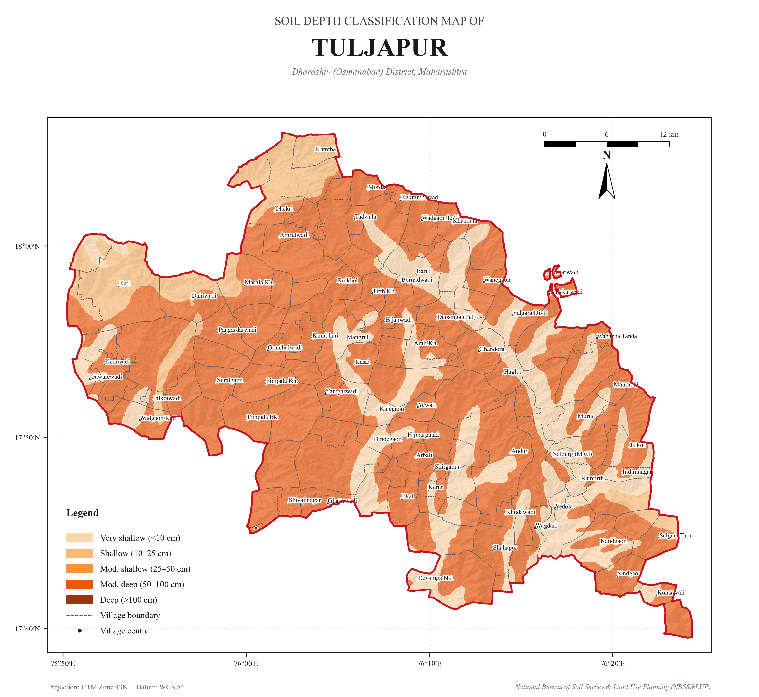
Figure 6.1: NBSS & LUP Soil Depth Profile Classification Map of Tuljapur Block.

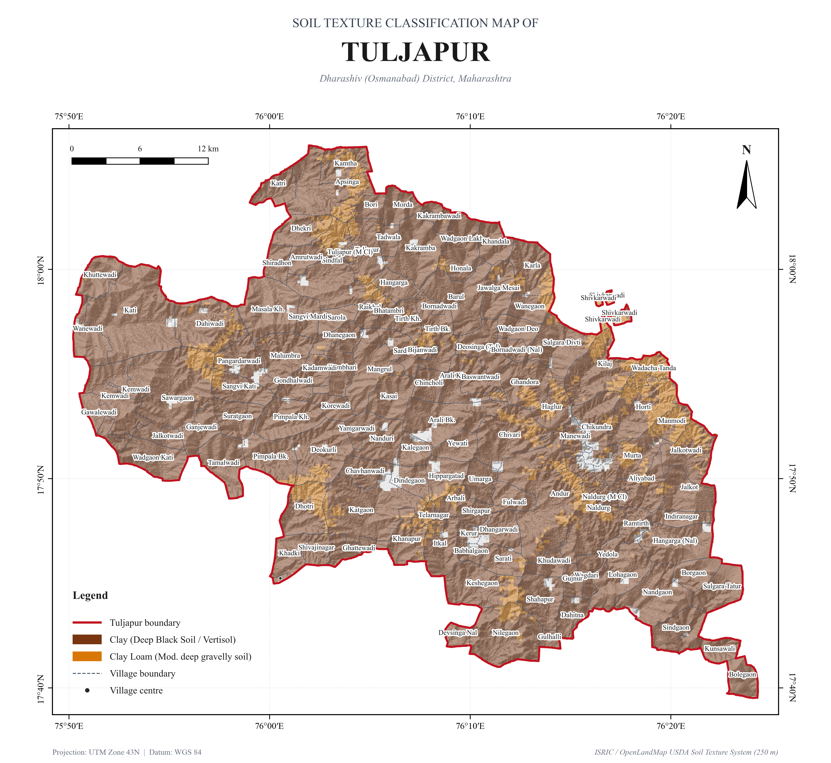
Figure 6.2: USDA Soil Texture Classification Map (OpenLandMap TT 250m) of Tuljapur Block.

CHAPTER 7: LAND USE / LAND COVER & VEGETATION DYNAMICS
Agriculture is the primary economic livelihood across both blocks, occupying 73.5% (1,503.7 km²) of the total mapped land. According to NRSC 1:250,000 multi-temporal LULC data:
• Kharif Cropland (27.8% | 566.9 km²): Characterized by rainfed soybean, cotton, pigeonpea (tur), and kharif sorghum.
• Rabi Cropland (3.5% | 72.2 km²): Winter chickpea (gram), rabi jowar, and wheat supported by residual moisture and well irrigation.
• Double / Triple Cropping (14.0% | 285.5 km²): High-intensity cash crops (sugarcane, horticulture, vegetables) along river channels.
• Current Fallow (28.2% | 575.3 km²): Arable lands resting due to monsoon rainfall deficits or lack of irrigation access.
• Wastelands & Rocky Scrub (20.1% | 410.0 km²): Stony basalt plateau ridges and barren pasture lands.
Seasonal vegetation dynamics evaluated using Sentinel-2 L2A 10m NDVI composites reveal dramatic seasonal contraction. Mean NDVI reaches 0.476 in the Kharif season (September 2024 peak biomass), with 38.1% of the land exceeding 0.45 NDVI. By post-monsoon winter (Rabi season, January 2025), mean NDVI contracts to 0.354, with dense vegetation shrinking to 17.8%, highlighting intense dependence on groundwater draft during dry winter months.

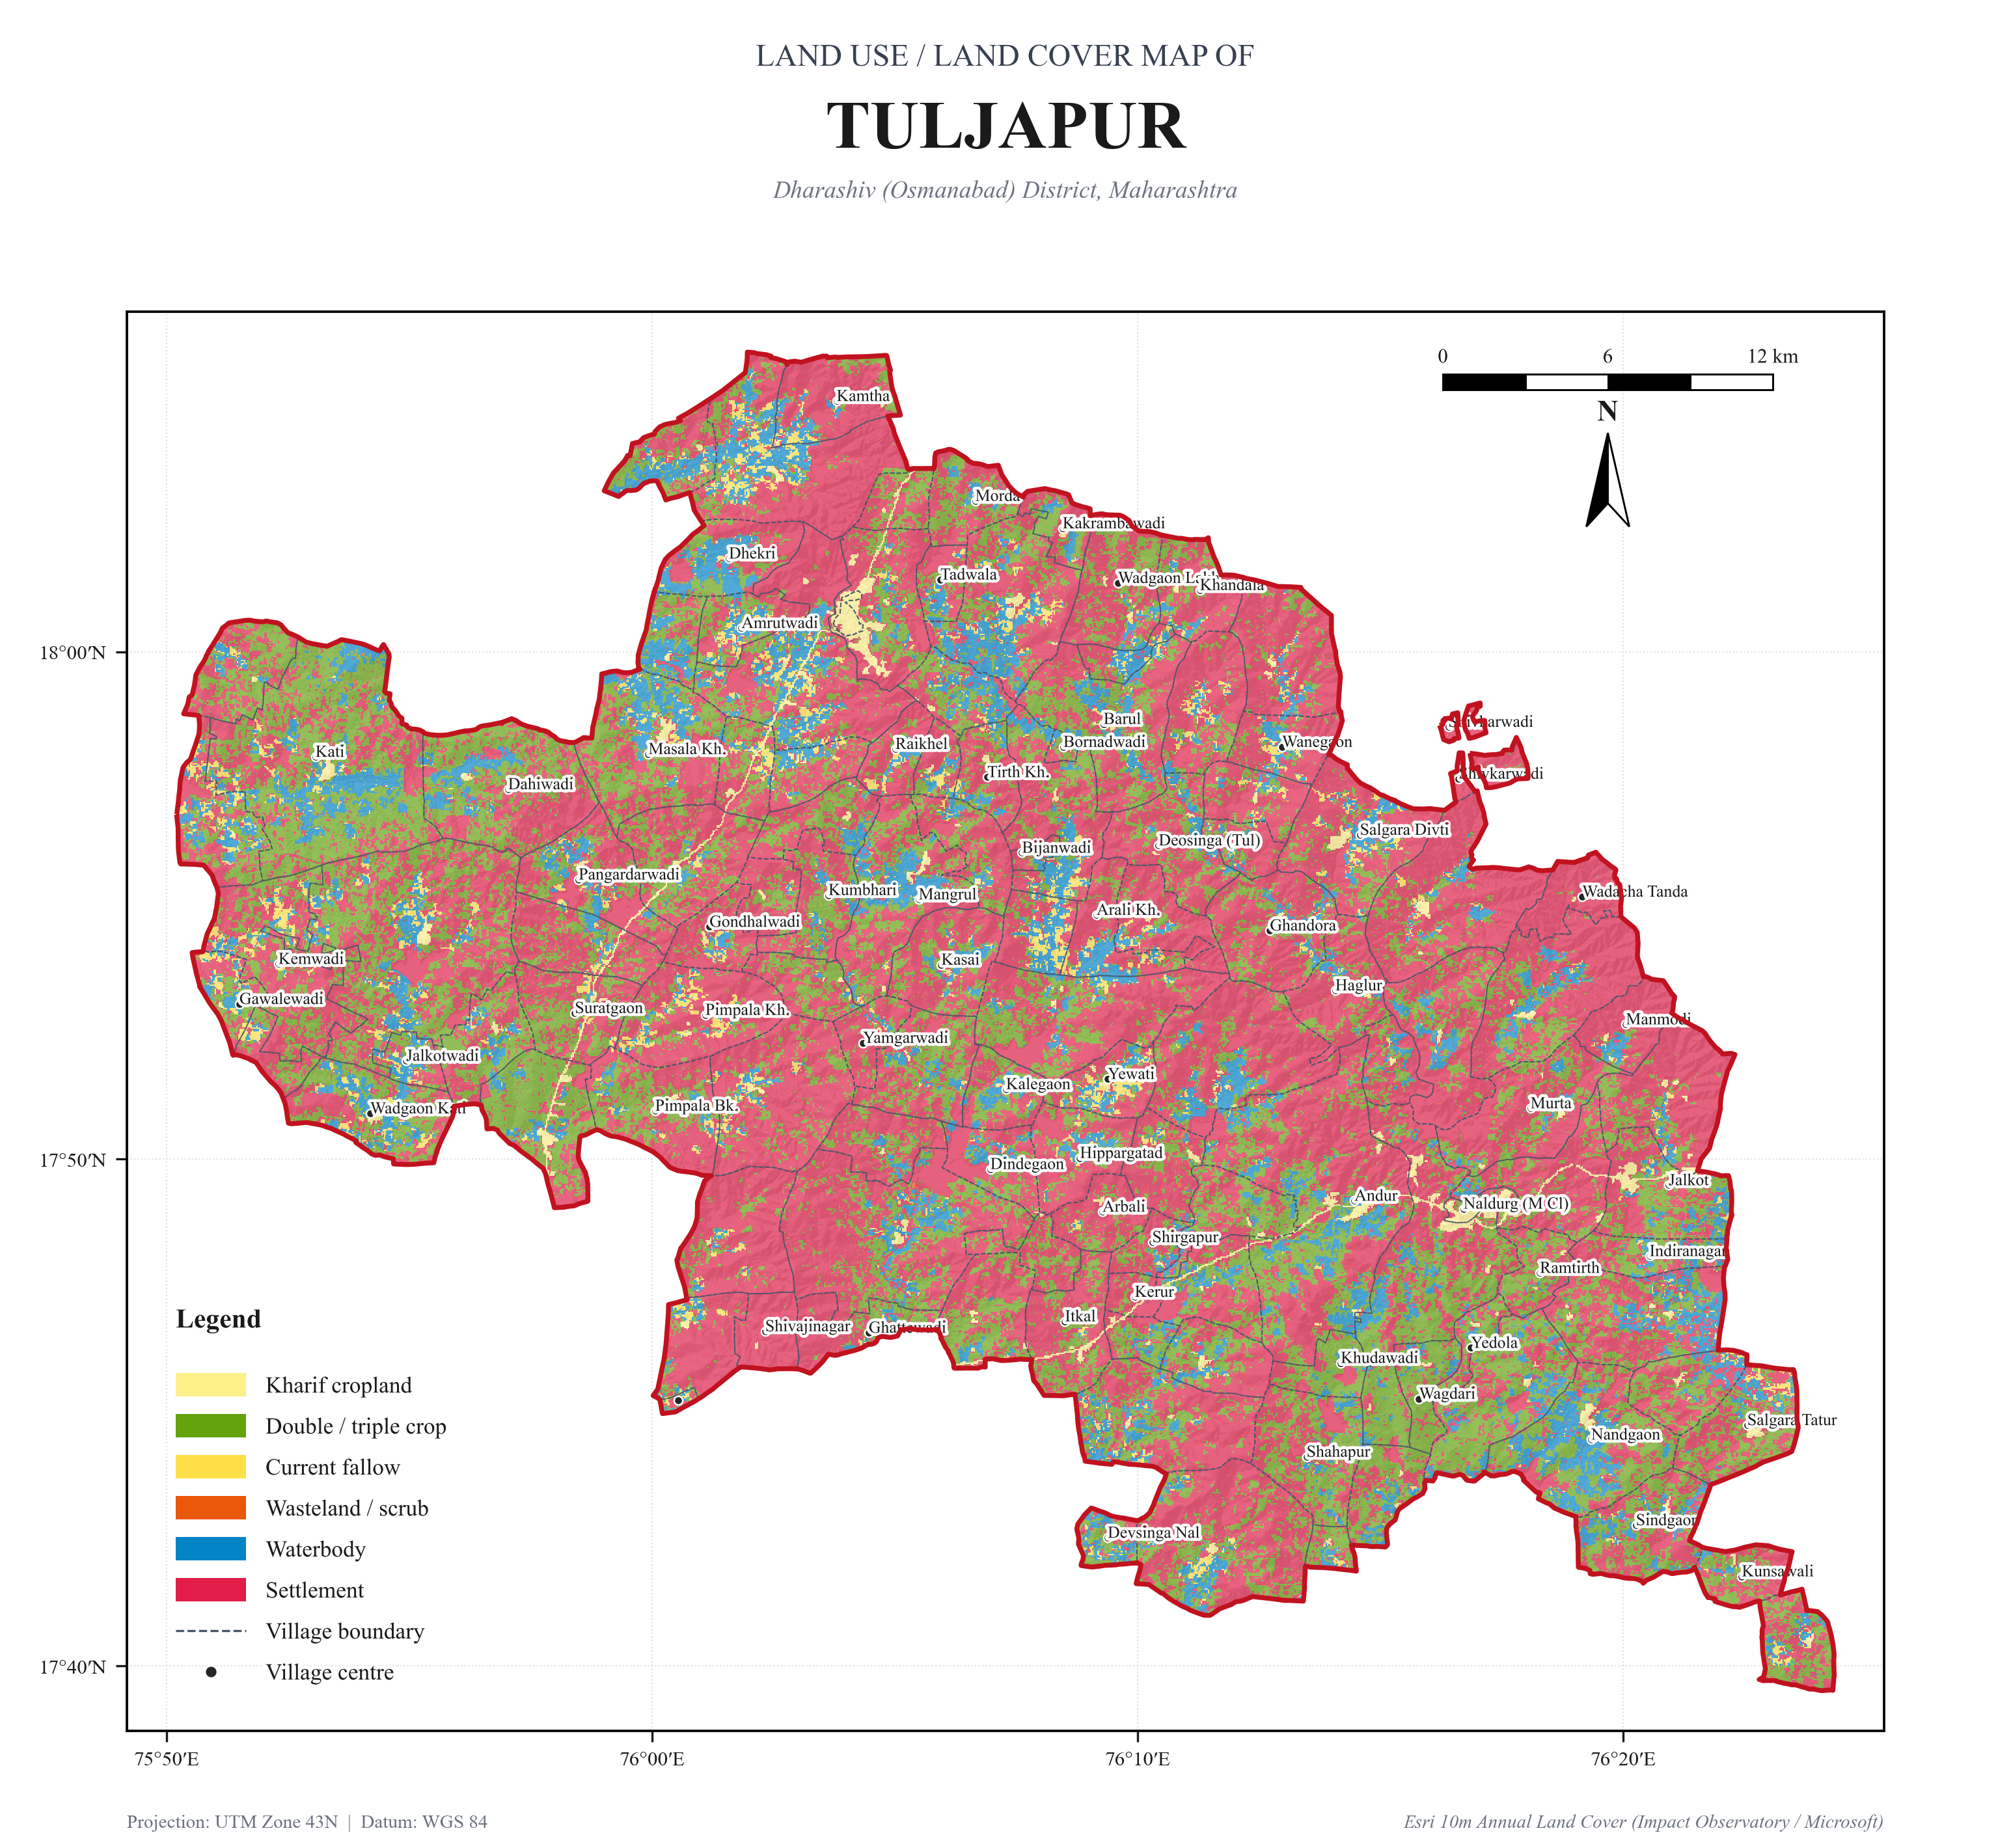
Figure 7.1: NRSC Land Use / Land Cover (LULC 1:250,000) Classification Map of Tuljapur Block.

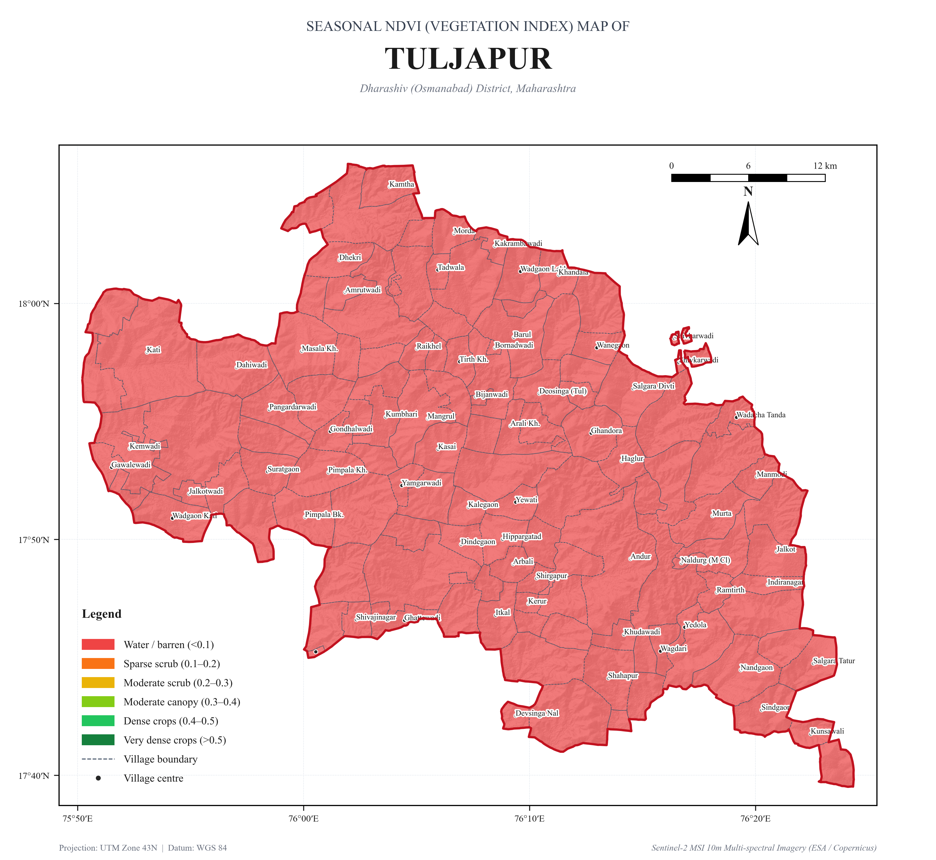
Figure 7.2: Sentinel-2 10m Seasonal NDVI Crop Biomass Dynamics (Kharif vs Rabi 2024–2025) of Tuljapur Block.

CHAPTER 8: GEOMORPHOLOGY & HYDROGEOLOGICAL LANDFORMS
Hydrogeomorphological mapping based on NRSC Bhuvan 1:50,000 data reveals four primary landform complexes that dictate ground water storage and movement:
1. Plateau Top Tableland (51.8% | 1,058.4 km²): Flat, elevated basaltic plateaus that generate rapid overland sheet wash. Ground water prospects are poor to moderate; suitable for continuous contour trenches and surface farm ponds.
2. Weathered Pediplain (30.6% | 624.5 km²): Gently sloping undulating plains with saprolitic weathering mantles (3–10 m depth). Acts as the primary unconfined aquifer zone; excellent siting for percolation tanks and masonry check dams.
3. Dissected Escarpment Slopes (8.6% | 175.2 km²): Steep step-like basalt scarp edges with high runoff velocity; requires gully plugs.
4. Valley Fill Alluvial Corridors (6.2% | 125.8 km²): Depositional gravel-sand-silt corridors along the Bori and Terna rivers. Presents the highest groundwater yields in the region; priority zone for subsurface dykes to arrest summer baseflow escape.

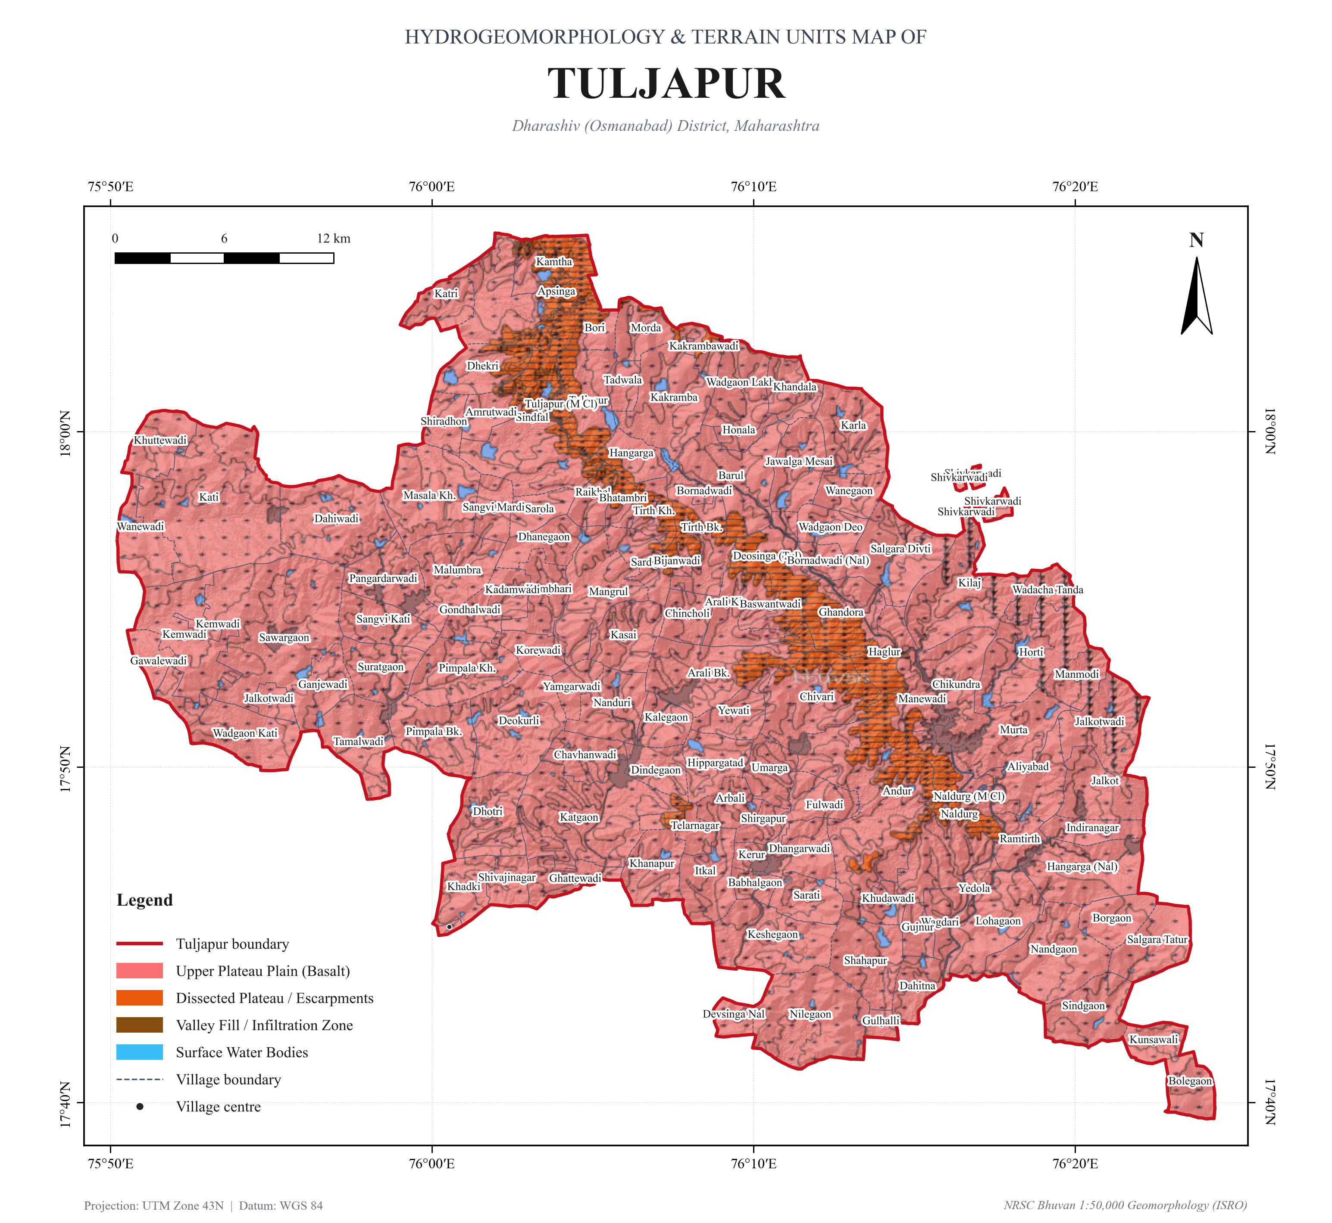
Figure 8.1: NRSC Bhuvan 1:50,000 Geomorphology and Hydrogeomorphic Landforms Map of Tuljapur Block.

Figure 8.2: NRSC Bhuvan 1:50,000 Geomorphology and Hydrogeomorphic Landforms Map of Lohara Block.

CHAPTER 9: HARD-ROCK LITHOLOGY & REGIONAL WELLS
Geologically, the entire study area is underlain by the Deccan Volcanic Province (Upper Cretaceous to Eocene basalt flows). The stratigraphy comprises horizontally bedded lava flows varying from 10 m to 35 m in individual thickness, classified into:
• Pahoehoe Flows: Characterized by highly vesicular flow tops, ropy structures, and zeolitic infillings (stilbite, heulandite). The upper vesicular zones form prime localized aquifers when weathered.
• 'Aa' Flows: Characterized by dense, hard, massive basalt cores bounded by fragmented, brecciated flow tops. Groundwater movement is strictly controlled by vertical cooling joints and regional tectonic lineaments.
Exploratory well telemetry from the Central Ground Water Board (CGWB) network across 45 regional wells shows static water levels (SWL) typically fluctuating between 5.5 m and 22.0 m below ground level (mbgl). Well discharge yields vary widely from 0.5 lps in massive unjointed basalt to over 7.5 lps in fractured vesicular interflow contacts, demonstrating the secondary porosity-controlled nature of hard-rock hydrogeology.

Figure 9.1: Geological Lithology and Regional CGWB Well Network Map of Tuljapur Block.

CHAPTER 10: RGNDWM 250K GROUND WATER PROSPECTS FRAMEWORK
The Rajiv Gandhi National Drinking Water Mission (RGNDWM) Ground Water Prospects Mapping project was executed by the National Remote Sensing Centre (NRSC / ISRO) in collaboration with state groundwater agencies. Its primary goal is to provide space-based hydrogeomorphological and structural information for locating sustainable rural drinking water sources and identifying recharge structure locations on 1:50,000 Survey of India toposheet scales.
As established in this investigation, Tuljapur and Lohara blocks straddle the intersection of four Survey of India 1° × 1° master quadrangles (Sheets 56C, 56B, 47O, and 47N) converging at 76°00'00"E and 18°00'00"N. The exact 1:50,000 toposheet matrix encompasses ten tiles, led by Sheet 56C/1 (699.1 km² | 34.2%) and Sheet 56C/2 (551.0 km² | 27.0%).

Figure 10.1: Master RGNDWM 250K Ground Water Prospects Grid Framework & 1:50,000 Toposheet Matrix Map for the AOI.

Figure 10.2: RGNDWM 250K & 1:50,000 Toposheet Grid Framework Map for Tuljapur Block.

Figure 10.3: RGNDWM 250K & 1:50,000 Toposheet Grid Framework Map for Lohara Block.

CHAPTER 11: WATERSHED RECHARGE SITING & RECOMMENDATIONS
Based on the integration of all 15 thematic layers, terrain slopes, stream orders, soil textures, and hydrogeomorphology, a strategic artificial recharge structure siting matrix has been established to guide field engineering investments under the Jal Jeevan Mission and watershed development programs:
Intervention Type | Siting Criteria (Stream / Slope / Unit) | Expected Hydrological Impact | Priority Target Zones
Percolation Tanks (PT) | 3rd to 4th order streams; slope 1–3°; weathered pediplain with >3m saprolite depth | Augments regional shallow water table (50,000–150,000 m³ storage per tank) | Andur, Kati, Mangrul, Chikundra, Karla, Tirth
Masonry Check Dams (CD) | 2nd to 3rd order streams; slope 1–5°; fractured basalt bedrock bed | Decelerates flash runoff; creates post-monsoon pooling (10,000–30,000 m³) | Bori river secondary tributaries, Terna sub-basin
Subsurface Dykes (SSD) | 4th to 5th order streams; slope <1°; alluvial valley fill over bedrock bar | Arrests dry-season subsurface flow egress; maintains dugwell yields till summer | Naldurg downstream, Bori alluvial neck, Terna channel
Continuous Contour Trenches (CCT) | Upper catchment ridges; slope 5–15°; hard basalt escarpment flanks | Intercepts overland sheet wash, enhances slope infiltration, prevents siltation | Apsinga ridge, Kamtha scarp, Balaghat plateau divide
Farm Ponds (FP) | Overland drainage swales; slope <2°; deep black cotton soils (Vertisols) | Provides critical protective irrigation during mid-monsoon dry spells (2,000–5,000 m³) | Extensive cultivated plains of central Tuljapur & Lohara
Well Recharge Shafts | Direct well recharge; existing depleted dugwells across settlements | Bypasses impermeable surface clay; injects filtered rainwater into basalt aquifers | All 177 Gram Panchayats with critical drinking water wells

ANNEXURE I: COMPLETE 177-VILLAGE CADASTRAL DIRECTORY
Complete enumeration of all 177 cadastral revenue village units across Tuljapur Block (130 villages) and Lohara Block (47 villages), documenting calculated GIS areas in hectares and square kilometers:
S.No | Taluka / Block | Cadastral Village Name | Area (Hectares) | Area (km²)
1 | Lohara | Achaler | 3,477.8 | 34.78
2 | Lohara | Arni | 791.9 | 7.92
3 | Lohara | Ashta kasar | 2,196.4 | 21.96
4 | Lohara | Belwadi | 1,159.8 | 11.60
5 | Lohara | Bendkal | 466.7 | 4.67
6 | Lohara | Bhatangali | 1,443.8 | 14.44
7 | Lohara | Bhosga | 916.7 | 9.17
8 | Lohara | Chincholi kate | 326.5 | 3.26
9 | Lohara | Chincholi rebe | 478.5 | 4.79
10 | Lohara | Dastapur | 553.5 | 5.54
11 | Lohara | Dhanori | 2,815.2 | 28.15
12 | Lohara | Ekondi lohara | 568.0 | 5.68
13 | Lohara | Harali | 646.4 | 6.46
14 | Lohara | Hipparga sayyad | 993.0 | 9.93
15 | Lohara | Hippargarava | 1,832.3 | 18.32
16 | Lohara | Holi | 1,467.6 | 14.68
17 | Lohara | Jewali | 3,098.7 | 30.99
18 | Lohara | Kamalpur | 418.8 | 4.19
19 | Lohara | Kanegaon | 2,661.9 | 26.62
20 | Lohara | Karanjgaon | 737.5 | 7.37
21 | Lohara | Karwanji | 587.6 | 5.88
22 | Lohara | Kasti Bk. | 1,034.4 | 10.34
23 | Lohara | Kasti Kh. | 948.5 | 9.48
24 | Lohara | Khed | 1,400.0 | 14.00
25 | Lohara | Kolnur pandari | 397.0 | 3.97
26 | Lohara | Kondjigad | 743.0 | 7.43
27 | Lohara | Lohara Bk. | 1,765.1 | 17.65
28 | Lohara | Lohara Kh. | 1,131.3 | 11.31
29 | Lohara | Makani | 2,104.6 | 21.05
30 | Lohara | Malegaon | 753.5 | 7.53
31 | Lohara | Mardi | 1,164.0 | 11.64
32 | Lohara | Mogha bk. | 636.0 | 6.36
33 | Lohara | Mogha kh | 763.5 | 7.63
34 | Lohara | Murshadpur | 785.5 | 7.86
35 | Lohara | Nagral | 504.1 | 5.04
36 | Lohara | Nagur | 1,032.2 | 10.32
37 | Lohara | Phanepur | 666.9 | 6.67
38 | Lohara | Rajegaon | 460.0 | 4.60
39 | Lohara | Salegaon | 1,103.5 | 11.04
40 | Lohara | Sastur | 2,503.8 | 25.04
41 | Lohara | Tawshigad | 1,413.6 | 14.14
42 | Lohara | Toramba | 1,039.7 | 10.40
43 | Lohara | Udatpur | 544.1 | 5.44
44 | Lohara | Undargaon | 1,328.9 | 13.29
45 | Lohara | Vilaspur pandhari | 831.0 | 8.31
46 | Lohara | Wadgaon | 698.2 | 6.98
47 | Lohara | Wadgaonwadi | 929.5 | 9.29
48 | Tuljapur |  | 69.9 | 0.70
49 | Tuljapur | Aliyabad | 1,367.6 | 13.68
50 | Tuljapur | Amrutwadi | 697.7 | 6.98
51 | Tuljapur | Andur | 4,740.1 | 47.40
52 | Tuljapur | Apsinga | 2,681.2 | 26.81
53 | Tuljapur | Arali Bk. | 2,346.7 | 23.47
54 | Tuljapur | Arali Kh. | 888.6 | 8.89
55 | Tuljapur | Arbali | 663.6 | 6.64
56 | Tuljapur | Babhalgaon | 371.5 | 3.71
57 | Tuljapur | Barul | 2,053.3 | 20.53
58 | Tuljapur | Baswantwadi | 872.0 | 8.72
59 | Tuljapur | Bhatambri | 364.9 | 3.65
60 | Tuljapur | Bijanwadi | 119.6 | 1.20
61 | Tuljapur | Bolegaon | 772.8 | 7.73
62 | Tuljapur | Borgaon | 867.6 | 8.68
63 | Tuljapur | Bori | 481.7 | 4.82
64 | Tuljapur | Bornadwadi | 103.8 | 1.04
65 | Tuljapur | Bornadwadi (Nal) | 434.4 | 4.34
66 | Tuljapur | Chavhanwadi | 827.9 | 8.28
67 | Tuljapur | Chikundra | 1,650.7 | 16.51
68 | Tuljapur | Chincholi | 689.2 | 6.89
69 | Tuljapur | Chivari | 2,377.7 | 23.78
70 | Tuljapur | Dahitna | 765.0 | 7.65
71 | Tuljapur | Dahiwadi | 2,365.6 | 23.66
72 | Tuljapur | Deokurli | 2,256.8 | 22.57
73 | Tuljapur | Deosinga (Tul) | 1,290.1 | 12.90
74 | Tuljapur | Devsinga Nal | 377.2 | 3.77
75 | Tuljapur | Dhanegaon | 789.7 | 7.90
76 | Tuljapur | Dhangarwadi | 993.4 | 9.93
77 | Tuljapur | Dhekri | 1,083.3 | 10.83
78 | Tuljapur | Dhotri | 1,590.5 | 15.90
79 | Tuljapur | Dindegaon | 774.4 | 7.74
80 | Tuljapur | Fulwadi | 880.0 | 8.80
81 | Tuljapur | Ganjewadi | 939.3 | 9.39
82 | Tuljapur | Gawalewadi | 516.8 | 5.17
83 | Tuljapur | Ghandora | 1,541.5 | 15.41
84 | Tuljapur | Ghattewadi | 754.1 | 7.54
85 | Tuljapur | Gondhalwadi | 649.9 | 6.50
86 | Tuljapur | Gujnur | 449.5 | 4.49
87 | Tuljapur | Gulhalli | 242.9 | 2.43
88 | Tuljapur | Haglur | 1,104.2 | 11.04
89 | Tuljapur | Hangarga | 735.7 | 7.36
90 | Tuljapur | Hangarga (Nal) | 1,930.2 | 19.30
91 | Tuljapur | Hippargatad | 1,021.1 | 10.21
92 | Tuljapur | Honala | 310.5 | 3.11
93 | Tuljapur | Horti | 2,243.0 | 22.43
94 | Tuljapur | Indiranagar | 667.9 | 6.68
95 | Tuljapur | Itkal | 1,189.3 | 11.89
96 | Tuljapur | Jalkot | 1,377.5 | 13.77
97 | Tuljapur | Jalkotwadi | 1,620.6 | 16.21
98 | Tuljapur | Jalkotwadi | 364.5 | 3.65
99 | Tuljapur | Jawalga Mesai | 1,214.9 | 12.15
100 | Tuljapur | Kadamwadi | 546.4 | 5.46
101 | Tuljapur | Kakramba | 2,163.0 | 21.63
102 | Tuljapur | Kakrambawadi | 461.4 | 4.61
103 | Tuljapur | Kalegaon | 681.3 | 6.81
104 | Tuljapur | Kamtha | 1,148.1 | 11.48
105 | Tuljapur | Karla | 1,544.9 | 15.45
106 | Tuljapur | Kasai | 1,233.5 | 12.34
107 | Tuljapur | Katgaon | 3,572.6 | 35.73
108 | Tuljapur | Kati | 4,720.0 | 47.20
109 | Tuljapur | Katri | 814.3 | 8.14
110 | Tuljapur | Kemwadi | 1,964.0 | 19.64
111 | Tuljapur | Kemwadi | 11.2 | 0.11
112 | Tuljapur | Kerur | 280.9 | 2.81
113 | Tuljapur | Keshegaon | 2,028.2 | 20.28
114 | Tuljapur | Khadki | 915.7 | 9.16
115 | Tuljapur | Khanapur | 1,120.4 | 11.20
116 | Tuljapur | Khandala | 876.9 | 8.77
117 | Tuljapur | Khudawadi | 545.2 | 5.45
118 | Tuljapur | Khuttewadi | 994.9 | 9.95
119 | Tuljapur | Kilaj | 2,331.4 | 23.31
120 | Tuljapur | Korewadi | 643.8 | 6.44
121 | Tuljapur | Kumbhari | 935.4 | 9.35
122 | Tuljapur | Kunsawali | 601.3 | 6.01
123 | Tuljapur | Lohagaon | 1,787.0 | 17.87
124 | Tuljapur | Malumbra | 1,519.7 | 15.20
125 | Tuljapur | Manewadi | 568.3 | 5.68
126 | Tuljapur | Mangrul | 1,938.2 | 19.38
127 | Tuljapur | Manmodi | 743.5 | 7.44
128 | Tuljapur | Masala kh. | 2,214.6 | 22.15
129 | Tuljapur | Morda | 807.7 | 8.08
130 | Tuljapur | Murta | 1,627.5 | 16.27
131 | Tuljapur | Naldurg | 2,793.1 | 27.93
132 | Tuljapur | Naldurg (M Cl) | 97.1 | 0.97
133 | Tuljapur | Nandgaon | 2,206.1 | 22.06
134 | Tuljapur | Nanduri | 1,267.0 | 12.67
135 | Tuljapur | Nilegaon | 2,737.4 | 27.37
136 | Tuljapur | Pangardarwadi | 1,375.8 | 13.76
137 | Tuljapur | Pimpala Bk. | 1,550.7 | 15.51
138 | Tuljapur | Pimpala Kh. | 1,638.2 | 16.38
139 | Tuljapur | Raikhel | 559.6 | 5.60
140 | Tuljapur | Ramtirth | 629.6 | 6.30
141 | Tuljapur | Salgara Tatur | 1,245.3 | 12.45
142 | Tuljapur | Salgara divti | 1,826.0 | 18.26
143 | Tuljapur | Sangvi Kati | 1,116.2 | 11.16
144 | Tuljapur | Sangvi Mardi | 661.8 | 6.62
145 | Tuljapur | Sarati | 835.1 | 8.35
146 | Tuljapur | Sardewadi | 817.2 | 8.17
147 | Tuljapur | Sarola | 608.0 | 6.08
148 | Tuljapur | Sawargaon | 4,987.4 | 49.87
149 | Tuljapur | Shahapur | 1,500.0 | 15.00
150 | Tuljapur | Shiradhon | 614.5 | 6.15
151 | Tuljapur | Shirgapur | 399.7 | 4.00
152 | Tuljapur | Shivajinagar | 572.6 | 5.73
153 | Tuljapur | Shivkarwadi | 58.8 | 0.59
154 | Tuljapur | Shivkarwadi | 48.6 | 0.49
155 | Tuljapur | Shivkarwadi | 211.8 | 2.12
156 | Tuljapur | Shivkarwadi | 70.7 | 0.71
157 | Tuljapur | Sindfal | 2,826.2 | 28.26
158 | Tuljapur | Sindgaon | 1,376.8 | 13.77
159 | Tuljapur | Suratgaon | 1,132.6 | 11.33
160 | Tuljapur | Tadwala | 431.0 | 4.31
161 | Tuljapur | Tamalwadi | 1,480.1 | 14.80
162 | Tuljapur | Telarnagar | 542.6 | 5.43
163 | Tuljapur | Tirth Bk. | 1,674.3 | 16.74
164 | Tuljapur | Tirth kh. | 656.7 | 6.57
165 | Tuljapur | Tuljapur | 1,502.7 | 15.03
166 | Tuljapur | Tuljapur (M Cl) | 99.1 | 0.99
167 | Tuljapur | Umarga | 829.2 | 8.29
168 | Tuljapur | Wadacha Tanda | 664.5 | 6.64
169 | Tuljapur | Wadgaon Kati | 1,466.0 | 14.66
170 | Tuljapur | Wadgaon deo | 726.9 | 7.27
171 | Tuljapur | Wadgaon lakh | 1,319.0 | 13.19
172 | Tuljapur | Wagdari | 592.8 | 5.93
173 | Tuljapur | Wanegaon | 775.1 | 7.75
174 | Tuljapur | Wanewadi | 1,102.1 | 11.02
175 | Tuljapur | Yamgarwadi | 509.1 | 5.09
176 | Tuljapur | Yedola | 360.6 | 3.61
177 | Tuljapur | Yewati | 753.5 | 7.53

