Safe Work Procedure
Sodium Hydrosulphide
SWP-OPR-OPR-000-000

DOCUMENT HISTORY AND STATUS
Document: | Sodium Hydrosulphide Safe Work Procedure |  |  | Version No.: | 1
Document No: | SWP-OPR-OPR-000-000 |  |  | Owner: | Processing
Issue Date: | Dd/mm/20yy |  |  | Date Reviewed: | Dd/mm/2026
History:
Date Reviewed: | Version No.: | Written by: |  | Reviewed by: |  | Authorised by:
Dd/mm/20yy | #
Revision Description:
Changes:
X
Action: | Name: |  | Position: |  |  |  | Date:
Prepared by | Steve Cocks |  | Processing & Training Specialist |  |  |  | 29/09/2026
Reviewed by
Reviewed by
Authorised by

This document is controlled electronically as part of Heritage Minerals Pty Limited’s Health & Safety Management System. Please refer to Heritage Minerals Controlled Document Register for the current version.

Table of Contents
1. Purpose and Scope 4
2. Responsibilities 4
3. Procedure 5
3.1 Overview 5
3.2 Transport Information 5
4. STORAGE 6
4.1 Solid NaHS 70% Flake. 6
4.2 Sodium Hyrdrosulphide solution (35% w/w) 6
4.3 Storage in Storage Tanks 7
5. Bunding 7
5.1 Signage 7
5.2 Construction Materials for Storage and Transport of Liquid NaHS 8
5.3 Safety Equipment 8
5.4 Maintenance of NaHS Facilities 8
6. Working with Sodium Hyrdrosulphide: 9
6.1 Handling 9
6.2 Personal Protective Equipment (PPE). 9
6.3 Transferring Liquid NaHS 10
6.4 HEALTH HAZARDS From Handling Sodium Hydrosulphide Solutions: 10
6.4.1 Inhalation 10
6.4.2 Skin or Eye Contact 11
6.4.3 Ingestion 11
6.4.4 First Aid 11
6.4.5 Inhalation 11
6.4.6 Eye Contact 11
6.4.7 Skin Contact 11
6.4.8 Ingestion 12
6.5 Flammability 12
6.6 Fire Response 12
7. Emergencies: 12
7.1 Spillage 12
7.1.1 Advice For Firefighters 13
7.1.2 Extinguishing Media 13
7.2 Large Spills/Leaks 13
7.3 Disposal Considerations 14
8. Review Criteria 14
9. Legislation & References 14
10. Appendices: 14
10.1 Appendix A – Toxicity Chart for NaHS 16
10.2 Appendix B – Freezing Points of NaHS 17
10.3 Appendix C – Viscosity of NaHS at 45% w/w solution 18

Purpose and Scope
The purpose of this Procedure is to define the minimum requirements for NaHS (Sodium Hydrosulphide) management within the Heritage Minerals Plant operations. This Procedure will cover all aspects of the supply, storage, use and disposal of the reagent must be controlled to ensure that all personnel and contractors are aware of the dangers associated with this reagent.

Responsibilities
Staff | Responsibilities
Site Senior Executive
Manager
Supervisors
Employees & Business Partners

    - Sodium Hydrosulphide
Warning: | Sodium hydrosulphide is supplied as a yellow-colored liquid with a strong rotten egg odour. It causes severe burns to the skin, eyes, and digestive tract. Mist or vapour is extremely irritating to the eyes and respiratory tract. It may affect the pH (base) in water, posing a risk of toxicity to aquatic organisms. Always wear safety goggles and face shields, PCL gauntlets, PCL apron, and chemically resistant safety boots when working with sodium hydrosulphide

Transport Information
Sodium hydrosulphide is supplied in liquid form (38% w/w) in a 23MT bulk tanker. The transfer process involves utilising an air-operated diaphragm pump for unloading and transferring to the sodium hydrosulphide storage tank (107-TK-041) and using a helical rotor pump for dosing into the copper reactor tank (107-PP-094/095).
Ensure that -
- Operator Training in NaHS SWP and SDS.
- Stock rotation (first in / first out)
- Monitor H₂ S levels before removing stock from the Storage Shed with a personal monitor.
- Area Inspection standards/programs (e.g. labels, housekeeping, separation etc)

Classifications of NaHS
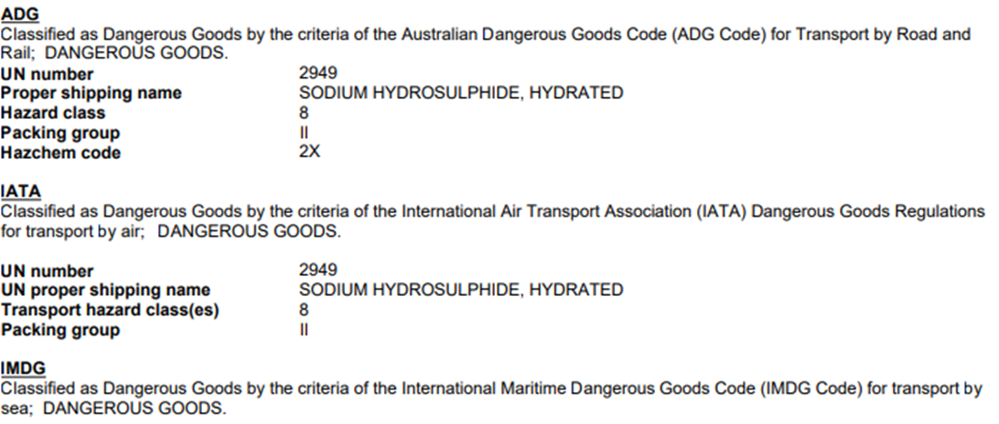

STORAGE

NaHS 38%.
Sodium Hydrosulphide solution is made from combining sodium, hydrogen and sulphur to form the compound. It is mining and flotation chemical. It is typically a yellow to gold colouredsolution.
NaHS is classified as a dangerous goods due to it being poisonous, particularly to aquatic species.
General Information
- Contact with acids liberates toxic gas (H₂S).
- Although stable at room temperature, Sodium hydrosulphide can explode with rapid heating or percussion (avoid fires).
- Avoid generating dust.
- NaHS is hygroscopic - Avoid exposure to moisture/humidity. Keep away from heat and sources of ignition.
- Incompatible/reactive with water, acid, oxidising materials, Carbon dioxide and non-ferrous metals ((aluminum, copper, zinc).
- Products decomposes on heating and in contact with acid or water, emitting flammable and toxic gases, including Hydrogen sulfide and Sulfur dioxide.
- Hazardous polymerisation will not occur.
Storage of Solution NaHS
- Store in a cool, dry and well-ventilated place, out of direct sunlight. Keep transport containers tightly closed.
- Hygroscopic - Avoid exposure to moisture/humidity.
- Keep away from heat and sources of ignition - No smoking.
- Keep away from food/feedstuffs and incompatible materials (water, oxidising materials, Carbon dioxide and non-ferrous metals).
- Recommend being stored with restricted access.
Acute and chronic health consequences may result from exposure to the solids. It may cause severe burns to the skin and damage to eyes.

Sodium Hydrosulphide solution (38% w/w)
Sodium hydrosulphide, NaHS, is a highly alkaline liquid with a pH range of 11.5 to 12.5. The liquid solution is typically yellow to dark green in colour and has a strong hydrogen sulphide (rotten egg) odour. Solutions of NaHS are considered stable in normal transportation. Flotation solutions are generally prepared in the range from 20 to 45% strength by weight and weigh 1.15 - 1.306 g/ml.

Storage in Storage Tanks
Locate storage vessels in open, well-ventilated areas away from any combustible materials or potential sources of heat. If storage is in a containment area, the containment area should not include storage of flammable or acidic products. Storage vessels should be pressurized or closed from the atmosphere with tank vapours vented through a sodium hydroxide (caustic) scrubber.
Small containers (drums, pails) should be stored in cool, dry, well-ventilated areas out of direct sunlight. Small containers, 200l drums or less, can develop very high hydrogen sulphide vapour pressures if left exposed to direct sunlight for very long periods. Such exposure can place the drums integrity in question or place personnel opening such drums in a deadly atmosphere as soon as the drum seal is broken.
All storage tanks and containers should be electrically grounded during storage and during product loading or unloading.
The freezing point of high strength solutions is quite high (See Appendix B), about 16.7ºC (62ºF). Where lower temperatures may be encountered, the tanks should be insulated and equipped with a temperature controlled stainless steel steam heater.
Corrosion in mild steel storage vessels occurs more rapidly when the tank is only partially full because the reaction of hydrogen sulphide vapours with moisture will form weak acidic solutions.

Bunding
All bunds around bulk liquid storage areas shall be constructed to confirm to AS 3470 – 2008 (Storage and Handling of Corrosive Substances) from an impervious material and capable of containing a minimum of 110% of the capacity of the bulk storage tanks.
Bunding shall be capable of containing liquid discharge from any tank rupture e.g., a spurt from a small hole that could flow over a bund built close into a tank.
Bunds shall be regularly inspected for integrity with particular attention paid to seals around plugs, joins and where the bund is breached by pipework etc.

Signage
Bulk storage containers shall be clearly marked with the manufacturer’s details and an up-to-date Emergency Information Panel complying with the appropriate Standard and Material Safety Data. (NOTE: Information is available in ChemAlert on sharepoint).
Intrinsically safe lighting, of sufficient luminance to enable a person to easily read all markings on storage tanks, signs, instruments, and other necessary items, shall be available in all areas in the vicinity of a bulk storage facility where people may be working.

Construction Materials for Storage and Transport of Liquid NaHS
Solutions of NaHS are only slightly corrosive to mild steel at moderate temperatures and in the absence of moist air. Product solutions have been successfully stored in mild steel, stainless steel and lined mild steel storage tanks and drums. Storage tanks of carbon steel, 10- 12.5mm thick, should last at least 10 years. Specialised SPC (fiberglass) tanks are now in service with NaHS and are performing well. Consult with tank manufacturers to confirm whether a specific resin is acceptable for NaHS service.
Copper (including brass and bronze), Zinc (including galvanized materials) and Aluminum or any of their other alloys are not resistant to NaHS solutions. None of these materials of construction should ever be used for storage or anywhere in the product handling system (piping, valves and pumps) where they would come in direct contact with NaHS.
Ancillary Equipment used in Storage:
Valves
The following types of valves will provide good service in NaHS use:
- Plug valves with Teflon seats,
- Ball valves with Teflon seats,
- Teflon-lined plug or ball valves are also acceptable.
- For good long term service, 316 stainless steel is recommended for these valves.
- Brass or bronze valves should not be use in NaHS service.

Piping
Carbon steel piping can be used for most applications. Welded and flanged connections are preferred over threaded connections. Schedule 80 piping is preferred for lines in continuous service. Buna-n or EPDM gaskets are recommended for flanged fittings.
Protection of lines against low temperature will depend upon location of the line, amount of exposure to low temperatures, and whether the line will be self-draining.

Safety Equipment
A safety shower, with eye wash, should be located in the immediate area of transfer points and any other locations where there is a possible exposure to the product.

Maintenance of NaHS Facilities
No part of the NaHS mixing circuit will be modified without adequate Change Management and the written approval of the General Manager / SSE or delegate.
Only personnel with current Hazardous Chemical training competency may work on the NaHS Mixing circuit.
Written preventative maintenance procedures shall be developed and maintained to ensure that all equipment and structures necessary for the plant to be operated as designed, including pumps, back-up pumps and diversions.
The maintenance procedures will include:
- Personal Protective Equipment
- Permits required
- Site Preparation
- Training required
When maintenance work is carried out in any pipework, tank or equipment and especially where there is confined spaces, e.g., mixing vessels or storage tanks, the equipment shall be drained, and the surface areas detoxified before maintenance work proceeds. The use of a piping and vessel clearance procedure should be implemented, and a permit completed with the JSA for the maintenance tasks.
Other precautions required are:
- A written confined space entry permit shall be implemented
- No person shall enter the tank until H₂S gas levels are negligible unless wearing approved breathing apparatus
- The area shall be force ventilated,
- A sentry shall be positioned outside of the confined space area but in visual contact with the workers inside the area - safety rope shall be available
- Personnel inside vessels shall wear a personal H₂S gas detection alarm and shall have a H₂S filter-type respirator available for immediate escape use
- The sentry shall have available a radio to raise the alarm in an emergency.
Records shall be kept of all monitoring, inspection and preventative maintenance activities, and these records shall be kept current.

Working with Sodium Hyrdrosulphide:

Handling
Solutions of NaHS should be handled with two criteria in mind.
- Avoid any solution contact with the skin and/or eyes.
- Secondly minimize personal exposure to product vapours (hydrogen sulphide) by avoiding product exposure to heat and/or acids or acidic materials.

Personal Protective Equipment (PPE).
Contact with the skin or eyes can be largely prevented by wearing the correct PPE. It is recommended that DIPHOTERINE® solution be included in the basic PPE.
For routine handling of small quantities, minimum PPE consists of
- a neoprene apron, gloves, chemical boots, chemical goggles and full-face shield.
When larger quantities are handled or where the likelihood of splashes or releases under pressure may occur (i.e. uncoupling hoses or breaking into pipelines)
- the apron should be replaced with a complete chemical suit.
- A self-contained breathing apparatus (SCBA) or airline supplied respirator, with 5 minute escape pack, should be readily available at solution transfer points.
If duties require opening the dome of a tank truck or railcar containing NaHS or work is to be performed near an open storage tank cover,
- an SCBA or airline supplied respirator, with 5 minute escape pack, must be worn to prevent personnel exposure to hydrogen sulphide vapours.

Transferring Liquid NaHS
A vapour return system should be used for all bulk solution transfers to prevent releasing hydrogen sulphide vapours to the atmosphere. Hydrogen sulphide vapours are highly flammable and all storage tanks and tank trucks must be properly grounded before any transfer is started.
Carefully inspect all connections (including hoses) which use seals, gaskets or packing to make certain that they are in good condition and correctly positioned. Replace any defective units prior to starting the transfer.

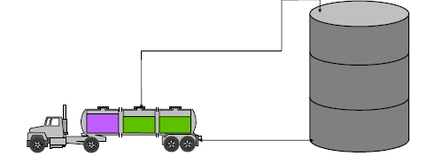

Health Hazards
Avoid contact with skin, eyes, and clothing. Do not breathe dust or the solution vapours. Use personal protection equipment. Wash thoroughly after handling. Do not eat, drink or smoke when using this product.
Take precautionary measures against static discharges. Ground and bond all lines and equipment associated with product system. All equipment should be non-sparking and explosion proof (Intrinsically Safe)
The primary health hazards associated with sodium hydrosulphide are the inhalation of highly toxic H₂S vapours and the corrosiveness of the solution in contact with human tissue.

Inhalation
Inhalation of product vapours, hydrogen sulphide, is very dangerous.
- Hydrogen sulphide is a colourless gas with a rotten egg odour. The gas has an odour threshold of 0.13 ppm (possibly less).
- Exposure to low concentrations of the gas may result in the loss of sense of smell, coughing, choking, eye irritation, headache, dizziness, weakness and difficulty in breathing.
- Continued exposure to low concentrations (100 - 200 ppm) or short-term exposure to high concentrations (greater than 700 ppm) can result in unconsciousness, respiratory paralysis and death.

Skin or Eye Contact
Skin contact with NaHS solutions may cause first degree burns but, depending on solution strength and duration of contact, could cause second and third degree burns to the skin.
Eye contact with mist or solution may result in pain, sensitivity to light, conjunctivitis (inflammation of the eyelids) and possible severe corneal injury.

Ingestion
Ingestion of NaHS may cause burns to all portions of the gastrointestinal tract. Pain may occur in the throat and abdomen followed by nausea, vomiting and diarrhea.
Severe cases may result in collapse, unconsciousness and death due to respiratory paralysis.

First Aid
Treatment of personnel exposed to solutions of sodium hydrosulphide begins with the removal of the victim to an uncontaminated atmosphere. Always wear the correct Personal Protective Equipment (PPE) to avoid exposure to other personnel. SCBA gear should be worn when rescuing personnel overcome by known exposure to product vapours. All Personnel should carry a personal gas monitor for H₂S when working on NaHS infrastructure.

Inhalation
Remove the victim from contaminated atmosphere to fresh air.
Wear necessary PPE. SCBA gear should be worn when rescuing personnel overcome by known exposure to product vapours. All Personnel should carry a personal gas monitor for H₂S when working on NaHS infrastructure.
If victim’s breathing is laboured, administer oxygen. If breathing has ceased, clear airway and start CPR. If heart has stopped beating, external heart massage should be applied. Obtain immediate medical attention.

Eye Contact
Immediately flush eyes with large quantities of water for 15 minutes. Hold eyelids open during irrigation to insure thorough flushing of the entire eye and lids with water. Obtain immediate medical attention.
The use of DIPHOTERINE® solution is recommended.

Skin Contact
Immediately flush the exposed area with large quantities of water. Remove contaminated clothing under a safety shower.
The use of DIPHOTERINE® solution is recommended.
Obtain immediate medical attention.

Ingestion
DO NOT INDUCE VOMITING. If victim is conscious, immediately give two to four glasses of water to dilute ingested material. If vomiting does occur, repeat fluid administration. Obtain immediate medical attention.

Flammability
Solutions of sodium hydrosulphide are not flammable. HOWEVER, the hydrogen sulphide vapours in the vapour space above the liquid may be highly flammable.
Hydrogen sulphide has a flammable range from 4% by volume in air up to 46%. The H₂S gas is heavier than air and may travel a considerable distance before finding an ignition source and flashing back to its source.
Combustion of hydrogen sulphide yields sulphur dioxide, a severe respiratory hazard.
If H₂S vapor is burning above a solution of NaHS, all efforts should be made to eliminate the source of ignition before attempting to put out the hydrogen sulphide fire.
Failure to do so could result in a fire flash back from the ignition source.

Fire Response
If vessels containing NaHS are involved in a fire, firefighting personnel should be equipped with SCBA gear because of the potential of hydrogen sulphide and sulphur dioxide vapours and necessary PPE to prevent bodily contact with the solution.
Use extinguishing media suitable for the combustible materials involved in the fire. Firefighting personnel should approach the fire from the upwind direction.
Vessels of sodium hydrosulphide should be kept cool with water spray to preclude the evolution of large quantities of H₂S gas. Be aware that pressurized containers exposed to high heat may rupture from excessive pressure.

Emergencies:
In the event of any emergency situation - No smoking or naked lights within 50 meters. Move people from the area; keep upwind. Check for spills or leaks. Consider initial evacuation distance of 100 meters in all directions. Notify ERT.

Spillage
Contact emergency services where appropriate.
Use personal protective equipment. Clear area of all unprotected personnel.
Ventilate area where possible.
Contain spillage, then cover / absorb spill with non-combustible absorbent material (vermiculite, sand, or similar), collect and place in suitable containers for disposal.
Prevent spill entering drains or waterways. (NaHS is acutely toxic to marine life)
Only trained personnel should undertake clean up.

Advice For Firefighters
Evacuate area and contact ERT. Toxic gases may be evolved in a fire situation. Remain upwind and notify those downwind of hazard. Wear full protective equipment including Self Contained Breathing Apparatus (SCBA) when combating fire.
Use waterfog to cool intact containers and nearby storage areas.

Extinguishing Media
Use an extinguishing agent suitable for the surrounding fire.

Large Spills/Leaks
Contain the release to as small an area as possible by diking with earth, sand or other available materials. Do not allow product into sewers or drains because of the toxicity and flammability of hydrogen sulphide vapours (which may be evolved).
Do not allow product to discharge into surface waterways because of potential aquatic toxicity.
If hydrogen sulphide is evolved in undesirable quantities, evacuate non-essential personnel to a safe upwind position, then use a water spray (not too effective) in a wide-angle, fog or fine mist pattern to help reduce the vapours.
Use only sufficient water to minimize vapours without adding significantly to the size of the spill.
Once product is contained, use a pump or vacuum truck and recover as much of the product as possible back into enclosed containers (drums or storage tank). Cover the remaining material with a dilute solution of an oxidizer to oxidize any potential reactive sulphides to environmentally safe sulphates (stops the evolution of H₂S).
Hydrogen peroxide (3 - 5%) is a preferred oxidizer or a weak solution of sodium hypochlorite may be used. The effectiveness of the oxidation can be checked with lead acetate strips which are located in the PPE kit at the entrance to the reagent Mixing Plant. The lead acetate strips are highly sensitive to sulphides (changing from a light beige to a brown, to a solid black as the concentration of sulphides increases) and provide a quick, non-quantitative indication.
After the oxidation, neutralize with a very dilute, weak acid (i.e. acetic) only if the oxidation did not sufficiently neutralize the spilled solution. Both the oxidizer and acid solution used should be weak solutions because strong solutions will react violently evolving heat and toxic hydrogen sulphide vapours in substantial quantities.
Place contaminated soil in sealed containers and dispose of in a chemical waste landfill in accordance with all governmental regulations.

Disposal Considerations
The generation of waste should be avoided or minimized wherever possible.
Disposal of this product, solutions and any by-products should at all times comply with the requirements of environmental protection and waste disposal legislation and any regional local authority requirements.
Dispose of surplus and non-recyclable products via a licensed waste disposal contractor. Waste should not be disposed of untreated to the sewer unless fully compliant with the requirements of all authorities with jurisdiction. Waste packaging should be recycled. Incineration or landfill should only be considered when recycling is not feasible. This material and its container must be disposed of in a safe way. Care should be taken when handling emptied containers that have not been cleaned or rinsed out. Empty containers or liners may retain some product residues.
Avoid dispersal of spilled material and runoff and contact with soil, waterways, drains and sewers. Very toxic to aquatic life.

Review Criteria
This Procedure shall be reviewed as follows:
- Two (2) yearly; or
- When there is a change in business process or management strategy that may affect the accuracy of this document; or
- When there has been a significant event to which this document was relevant; or
- As a result of an audit finding (either internal or external).

Legislation & References
- Queensland Mining and Quarrying Safety and Health Act 1999
- Queensland Mining and Quarrying Safety and Health Regulation 2017

Appendices:
- Appendix A: Toxicity Chart for NaHS
- Appendix B: Freezing Points of NaHS

Appendix A – Toxicity Chart for NaHS

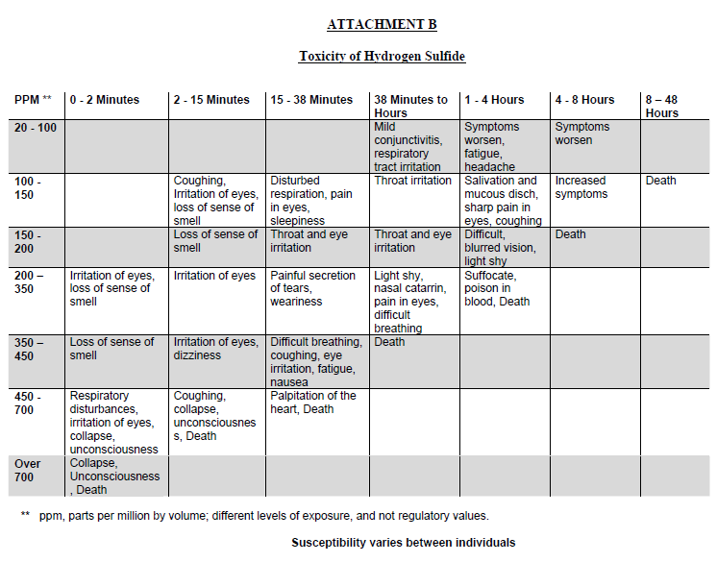

Appendix B – Freezing Points of NaHS
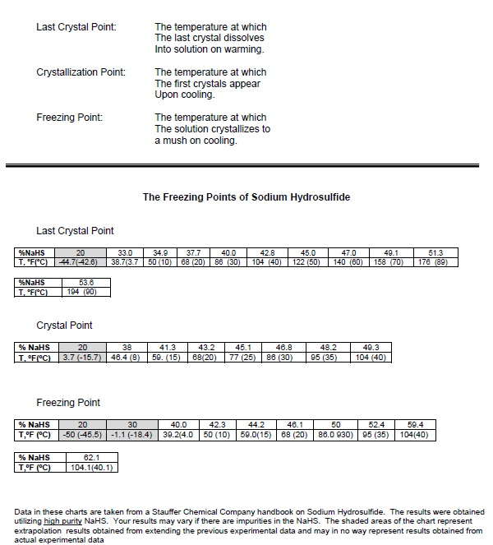

Appendix C – Viscosity of NaHS at 45% w/w solution
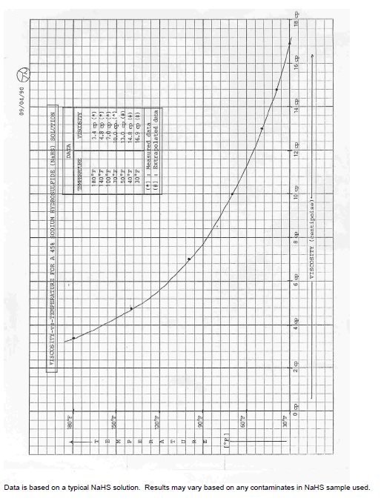
The decomposition of Sodium Hydrosulphide results in the generation of Hydrogen Sulphide gas
