Methods for Supporting Distributed 3D Virtual Environments in Java

Kevin Gorman
University of Vermont
1000 River Rd.
Essex Junction, VT 05452
1-802-769-0429
kwgorman@uvm.edu
Yuichi Motai, Ph.D.
University of Vermont
315 Votey Bldg., 33 Colchester Ave. Burlington, VT 05405
1-802-656-9660
ymotai@uvm.edu
Daneyand Singley
University of Vermont
1000 River Rd.
Essex Junction, VT 05452
1-802-769-1690
dsingley@zoo.uvm.edu

ABSTRACT
This paper presents a virtual environment that is designed in a cost effective manner to support easy maintenance and extension across a variety of computing platforms. The environment is intended to allow multiple users to collaboratively interact in, and communicate about, a virtual world. This virtual environment has been used to support a flight simulator application, complete with a full communications package, and a robust networking infrastructure. Much of the effort in developing the application was devoted to providing communications routines and determining the best method to provide networking support, particularly synchronization between the client and the server, using Java. Four synchronization methods were developed and compared: 1) Server based synchronization with threads, 2) Client based synchronization with threads, 3) Server based synchronization with non-blocking I/O, and 4) Transparent synchronization with non-blocking I/O. The method of transparent synchronization with non-blocking I/O was found to be the best method overall. This method maintains the most synchronized environments and allows for the display of fluid animations in the virtual environment and supports the fact that Java, with the addition of non blocking I/O API’s, can be successfully used to create high performance distributed 3D virtual environments.
Categories and Subject Descriptors
C.2.4 [Computer-Communication Networks]: Distributed Systems – client/server; D.3.3 [Programming Languages]: Language Constructs and Features – Input/Output.
General Terms
Design, Experimentation, Human Factors, Languages, Measurement, Performance.

Keywords
Java, Non-blocking I/O, Networking, Synchronization, Virtual Reality, Virtual Environments, Portability.

INTRODUCTION
Distributed virtual environments enable geographically diverse users to communicate about and collaborate on various aspects of a virtual world [20]. A distributed 3D virtual environment can find many applications, and an environment that is cost effective, portable, maintainable and extensible would be of particular use in both entertainment and academia [5, 7, 15]. However, for applications to be successful in either of these fields they need to be immersive and interactive, and as such should be founded on a distributed virtual environment infrastructure that provides extensive graphic, control, communication, and networking support [4, 5, 19]. Construction of such virtual environments with these features is a non-trivial task.
Copyright notice here.

The one attribute of such a distributed virtual environment that will be especially necessary for success is excellent networking support that is essential to enabling cooperation and/or collaboration between various participants. Many different models for building a distributed virtual environment with strong performance across a network have been presented [7, 8, 11, 14, 15]. A particular difficulty in dealing with network communication between distributed virtual environments is maintaining synchronization between the server and the client applications [2, 6, 17]. Users must have a consistent worldview and their actions must have concrete effects on their environment with minimal lag. Multi-user applications that do not provide for consistent and synchronized worldviews run the risk of losing their interactivity and immersion [17].
A method and a group of programming tools to create a distributed 3D virtual environment that provides good network performance along with the many other attributes mentioned above would be highly desired. Java, with its original lack of support for non-blocking I/O was not necessarily the best choice as a programming solution for the creation of such an environment. Java does have many aspects which makes it very attractive for this sort of work, but its deficiencies in supporting possibly the most important aspect of a distributed virtual environment, networking, has somewhat limited its usefulness.
However, Java (SDK 1.4.1), the Java 3D API (version 1.3.1) [22], and VRML97 [24] were chosen to support the development work on a new virtual environment because of the new Java.NIO.channels API, which provides support for non-blocking I/O. These tools allow a 3D virtual environment to be created in a cost effective manner to support easy maintenance and extension across a variety of computing platforms, along with hopefully addressing Java’s previous issues with networking support. The current release of Java, it is believed, now provides everything necessary to support the creation of a high performance distributed virtual environment. A virtual environment was created to explore Java’s suitability to the task.
The environment that was created is intended to allow multiple users to collaboratively interact in, and communicate about, a virtual world. Java and Java 3D were chosen as the programming tools for creating this environment for a variety of reasons. Their object-oriented nature allows for more easily extensible and maintainable programs [9]. The tools are freely available and a large open source movement exists to support the tools, reducing the overall cost of the project and accelerating the development schedule. In fact, much of the initial graphical engine [16] was obtained via open source code, reducing much of the early work to simply handling the integration of the graphical engine with basic communications and networking frameworks. The largest amount of effort was devoted to expanding these frameworks into robust elements that would allow for a full-featured networked virtual environment to be developed. In addition to these benefits of using Java, Java is being taught as a first programming language in many academic settings, which means that the code base will be understood and easily usable and modifiable by a large percentage of researchers and/or game developers [21], extending the usefulness of the virtual environment. Finally, the fact that programs written in Java and Java 3D can be easily compiled and run on a variety of computing platforms, allows the virtual environment’s applications to be ported to a number of systems [22].
Described in detail in this paper is a distributed virtual environment, complete with a communications package and robust networking routines, which supports many easily modifiable applications. The virtual environment, dubbed Whiskey, is designed to primarily support an application that can be used in an academic setting to allow for the collaborative exploration of Digital Elevation Maps (DEMs) [12] through a flight simulator-like interface. This particular application of the Whiskey environment allows for a number of users to simultaneously investigate geographic phenomena in an open ended learning environment, communicate about their impressions and adapt their viewpoint and orientation in response to other users’ inputs in real time. Alternatively, via the same application, a group of users can be provided with a guided tour of a DEM to obtain education about a particular geographic area for a more directed educational experience. A possibly more entertaining use of the virtual environment would be a modification to the application that allowed various users to compete in aerial dogfights above the realistic landscape provided by the DEM. The foundation the Whiskey distributed virtual environment provides is sufficient to easily enable both of these applications together with a wide range of other uses.
The aspect of the primary application of the Whiskey environment that is described in detail in this paper will be the use of the virtual environment to provide a guided tour of a DEM. The networking issues related to using Java for creating distributed virtual environments will be examined. The communication and networking support necessary for creating an environment that can enable this application will be the main focus of the description of the design of the distributed virtual environment. The performance of the various methods used for networking synchronization will be compared qualitatively and quantitatively. Finally, conclusions will be drawn on the current suitability of Java to the creation of distributed virtual environments, and the best methods for maintaining client-server synchronization in a Java based environment will be recommended.
Users interested in partaking in a tour of a particular geographical area simply need to obtain the source code, install Java and Java 3D on their system, and compile the code. The user would then start the program, modify any settings (such as selecting an avatar, choosing a DEM for exploration, etc.), and begin exploring. If the user wishes to lead a guided tour they would designate their system as the server, and any other participants would simply designate their systems as clients of that server. Details on available options and the location of the open-source Whiskey code will be disclosed.

JAVA AND DISTRIBUTED VIRTUAL ENVIRONMENTS
Java has been used to provide support for the creation of distributed 3D virtual environments in the past [7] and the Java Adaptive Dynamic Environment (JADE) has even been proposed to provide support for dynamic extensibility for virtual environments in run-time [10]. Today, application developers, especially those concerned with entertainment oriented distributed virtual environments, readily appreciate the many benefits of using Java. Java provides many standard extensions and API’s that enhance developer’s abilities to create graphics, control, and communication routines for supporting their applications [13].
However, there have been issues with using Java to support distributed virtual environments related to Java’s networking abilities. Java originally did not support non-blocking I/O. An attempt to recreate a virtual environment in Java that was originally created using C++ highlighted this issue. The best solution found to provide networking support was to implement non-blocking and polled socket I/O in C++ and to simply provide Java with a Channel class to communicate with the C++ networking support code. The difficulties encountered during this conversion attempt directly led to the conclusion that networking services that are only capable of blocking calls are not sufficient in complex real-time applications [1].
The Java networking support issues led to the development of custom non-blocking I/O API’s which seemed to address many of the obvious deficiencies with the original Java implementation [3]. The official Java standard has since been updated to provide support for non-blocking I/O starting with the Java 1.4 release. However, limited work has been done to test and compare and contrast threaded (blocking) networking services with the new non-blocking I/O API’s.

DESIGN OF THE WHISKEY VIRTUAL ENVIRONMENT IN JAVA
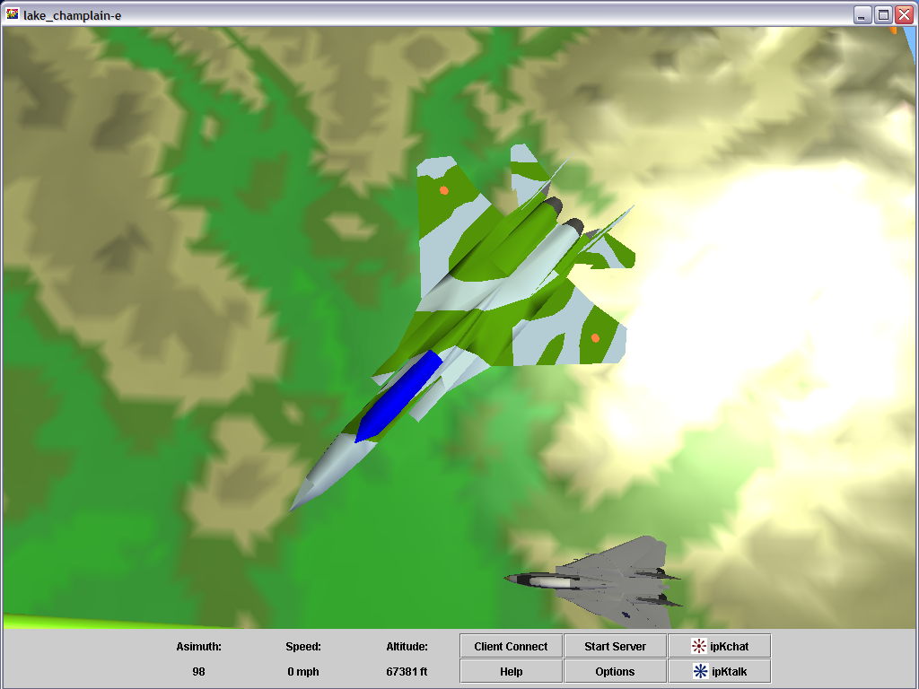
The environment can be broken into four main pieces: graphical engine, control system, user communications, and networking support. Thread based client-server interaction is used for the communication system. Networking support for the virtual environment, which is much more performance critical, was explored via multiple thread and non-blocking I/O based client-server systems to determine the most optimum method.
Figure 1. Application screenshot showing GUI.

Graphical Engine
The graphical engine is constructed in Java3D. The example application for the exploration of DEMs, currently imports 1⁰ DEMs to provide the geographical landscape that can be examined via the application. A user can select from a variety of VRML97 airplane models, which will serve as the user’s avatar in the virtual environment. The avatar is useful because it provides orientation and movement cues for the user in a form that is familiar to most people and requires little explanation. To aid in navigation around the geographical model a simple box is used to represent the atmospheric boundaries of the simulation world along with navigation posts that are placed at the corners of the DEM. No physics model is currently included, but the object oriented nature of the tools and the modularity of the environment would allow for the easy addition of such a feature. A single light source is used to represent the sun with a fixed location. The 3D environment is displayed in a re-sizeable window that offers a simple GUI for selecting avatars/DEMs via the “Options” button, displaying help information (including avatar controls) via the “Help” button, enabling networking features via the “Client Connect” and “Start Server” buttons, activating communication features via the “ipKchat” and ipKtalk” buttons, and reporting on avatar movement speed and location via the “Speed” and “Azimuth”/“Altitude” fields (see Figure 1).

Control System
The control system allows the users to drive the simulation with the mouse, the keyboard, or a combination of the two devices. Many specialized devices such as 3D mice, data gloves, and other tracking devices support keyboard or mouse emulation modes, which allow for the simple integration of new devices into the environment. The control system has a straightforward construction that could be easily modified to take advantage of the Java interface API’s to allow for direct integration of drivers that support all the features of 3D input devices. The current mouse/keyboard based interface provides simple pitch/roll/yaw controls along with a method for increasing or decreasing forward speed. The controls have a built in damping effect such that the motion of the avatar due to pitch/roll/yaw will decrease over time until the avatar’s orientation has stabilized. This was determined to be necessary because of the propensity for many of the application’s users to overcompensate for motion in the 3D environment until they become familiar with the controls. Finally, a method for stopping all avatar motion and a reset to initial orientation/position are included to prevent the user from becoming lost in the virtual world due to disorientation.

User Communications
The user communications system is activated via buttons on the main GUI. The user can launch either a text-messaging window that runs the ipKchat routine or a voice based discussion window that runs the ipKtalk routine. From the newly launched window the user connects their client system to the server and then begins communicating. A user may engage in a text messaging based discussion with all other simulation users if desired, or they can limit their discussion to a particular person or group of persons. A user may also engage in a discussion via voice provided their local client machines are supplied with the requisite speakers and microphones. Two people may engage in a conversation at a time (see Figure 2).

ipKtalk Routine
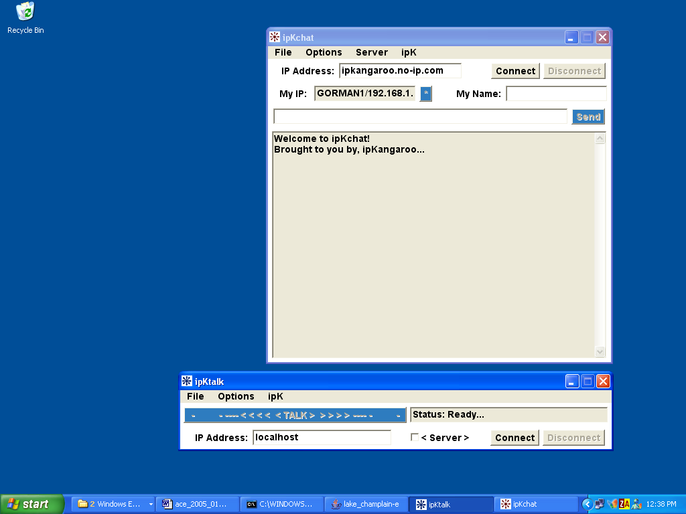
This routine supports walkie-talkie type communication over the network. The audio format used is 8 bit, 8 KHz, mono, signed Pulse Code Modulation (PCM). Two machines are needed to support this communication method: a client that initiates the connection and a server that waits for the connection. Once a connection is made between the client and server a user can press the “Talk” button to record a voice note. Pressing the “Talk” button again will first zip the audio stream and then send it to the other party for immediate playback. There is an audio stream playback buffer running on both the client and the server to cache incoming audio streams for playback. A “Compatibility Mode” can be enabled via the “Options” menu. This mode addresses audio errors that occur on certain hardware configurations. Finally, a "Reset Line" action can be chosen from the “Options” menu. This action reinitializes all classes and resets the server/client connection if a serious error is detected due to audio encoding, a zip compression malfunction, or any other extraneous errors. The “Reset Line” action was added during early development of the ipKtalk routine using Java 1.3. Java audio support seems to have become more robust with later releases, but the “Reset Line” action has been left active in the event that a user experiences any issues.
Figure 2. ipKtalk and ipKchat GUI’s.

ipKchat Routine
This routines supports text based chat communication over the network. At minimum, two machines are needed to support this communication method: a client that initiates the connection and a server that waits for the connection. Once a connection is made between the client and server a simple GUI, along with text base commands, is used to issue instructions to the server. The number of client connections to a particular server is only limited by the server system’s processing capacity. When a client connects to the server a thread is spawned on the server to listen for and communicate to the client. Each thread associated with a particular client, contains the client's socket the client’s name, the time when the connection was established, and either the chat room or client with which the user is interacting. The threads are tracked by the unique client name they are associated with in the server system. The client name corresponds to the user name of the person invoking that particular client connection, and the user name is how that client’s user is identified to other users. All communication threads are actively managed and optimized for performance via general garbage collection and the closing of terminated connections. The chat application supports both general chat rooms, in which any number of connected users can talk to each other, or private chat rooms can be established for any two users. A status of “Available” or “Unavailable” is associated with each client. An audio alert is also provided to notify the user that another application user is trying to establish a chat session with them. This alert can be customized to play any wave file that the user supplies to their client application.

Networking Support
Buttons on the main GUI also activates the networking support. The user specifies the server they would like to connect to and their simulation environments are connected and synchronized. Much effort was spent in making sure that the networking capabilities were easy to use, robust and scaleable. The network relies on communication via a TCP/IP link. Changes in the server environment are communicated to the clients via a simple multicast transmission. The main issue is maintaining synchronization between the clients and the server. To enable this, a number of different options were considered.
public class flightPacket implements Serializable
{
public Point3d m_newPos = new Point3d(0,0,0);
public Vector3d m_travel = new Vector3d(0,0,0);
public double m_distanceTraveled = 0;
public boolean sync = false; //command type
public int fps = 0;
}
Figure 3. Flight data packet describing an avatar.

Server Based Synchronization with Threads
The first synchronization method implemented to provide networking support was a server based scheme that uses threads. The server periodically collects information (including position, direction of travel, distance traveled, command type, and update rate) about each avatar into a class used for flight data management and transmits the class directly as a packet of information, with no re-formatting, to a client machine via Java’s support for object input/output streams (see Figure 3). The frames per second setting in the GUI determine the frequency at which the packets are sent. The client machine is running a thread that is constantly reading from the machine’s socket. As data arrives it is read by the thread, which returns the packet data, which is then copied to a FIFO, referred to as the “syncQ” buffer on the client end, which is filled with flight data management classes as they are populated with data from the server. Whenever the client machine updates its display it simply pulls the next packet of data from the FIFO and uses the data in the packet to update the local avatar information.
The issue with this method is that the thread will wait until data is available prior to returning and allowing the syncQ FIFO to update. This allows the client application’s environment to seriously diverge from the server’s environment over time. Synchronization is maintained by a re-sync command that the server can issue. A re-sync command is periodically transmitted to each client that indicates which packet they should be using to update the display. If the client is not properly synchronized the client’s FIFO is emptied and the packet that they received with the re-sync command is drawn immediately. Figure 4 illustrates the client-server interaction in detail.
The result of this synchronization scheme is that the client and server environments can diverge over time until a re-sync command is issued. If the applications are running on networks with minimal latency and systems with evenly matched computing power the number of display frames that client and server will diverge by is kept to a minimum. In non-ideal conditions, however, either a number of packets will be queued while waiting for a re-sync command to be issued or the thread will be left waiting for new packets to display as frames. Both of these circumstances will cause the objects in the client’s virtual environment to move in a periodic jumping/stuttering fashion when the display is updated after an in-opportunely timed re-sync, or a long wait for data.

Client Based Synchronization with Threads
The second synchronization method implemented to provide networking support operates very similarly to the first. However, instead of allowing the server to direct the re-synchronization of the client environment, the client handles this directly. The client machine is still running a thread that is constantly reading from the machine’s socket. The thread is used to transfer data from the socket to the FIFO and whenever the client machine updates its display it simply pulls the next packet of data from the FIFO and uses the data in the packet to update the local avatar information.
Screen Redraw
User Input
SERVER
I/O Handler
Network Interface
Flight Engine
TCP Connection
Flight Data sent via object I/O stream

CLIENT0
TCP Connection
Yes
No
Clear syncQ
Add data to buffer
Flight Data read via object I/O stream using a blocking thread
Re-sync?
syncQ Buffer
Network Interface
Flight Engine
I/O Handler
User Input
Screen Redraw

CLIENT1
TCP Connection
Yes
No
Clear syncQ
Add data to buffer
Flight Data read via object I/O stream using a blocking thread
Re-sync?
syncQ Buffer
Network Interface
Flight Engine
I/O Handler
User Input
Screen Redraw
Figure 4. Server based synchronization with threads.
String send = "/*" + toSend.m_newPos + toSend.m_travel + toSend.m_distanceTraveled + "," + toSend.sync + "," + toSend.fps + "*/";
Figure 5. Marshalling of flight data packet into string form for non-blocking I/O. synchronization method.

To maintain synchronization between the client and the server the client periodically issues re-sync commands to itself. The re-sync command causes the client’s FIFO to be emptied and the next packet that is received will be drawn immediately. Since the client is handling the synchronization the re-sync command is asserted on a more regular basis, as it is not subject to network lag. However, the final result is much the same as the first method. Under non-ideal conditions a number of packets can be queued prior to the periodic re-sync being issued and the displayed scene will still appear to stutter as avatar locations are updated by large amounts when the re-sync is finally asserted. The converse case of the thread waiting for data to arrive will also have deleterious consequences identical to the issues described under the first synchronization method. This particular method was not explored in detail.

Server Based Synchronization with Non-Blocking I/O
The next synchronization method that was examined as a way to provide networking support takes advantage of a new feature of Java, support for non-blocking I/O. The non-blocking I/O provides a method of obtaining data from the socket without the cost of waiting for a threaded read of the socket to return with data. Non-blocking I/O, instead, allows for the transfer of data from the socket into a buffer whenever data is available on the socket, supporting the ability to immediately terminate the socket read and return if there is no data available. Periodically, an update is requested via the non-blocking I/O, and, regardless of whether data is available or not, the client’s environment is allowed to continue executing the application immediately afterwards. Like the previous thread based methods, synchronization is still maintained via a re-sync command.
However, non-blocking I/O does not support the transmission of data in discrete packets of flight data management classes, because object input/output streams are not available. Instead, due to the requirements of the non-blocking I/O standard, the flight data must be marshaled into a sequence of bytes that can then be transmitted from the server to the client. The method chosen to marshal the data for transmission is to transform the data into a string of a particular format (see Figure 5), which is then divided into bytes. The non-blocking I/O on the client system reads the data from the socket into a byte buffer as soon as the data is available. The byte buffer, referred to as the “dst” buffer, is a piece of memory of constant size located at a fixed address. The contents of the byte buffer are in turn decoded into a string buffer, and the string buffer is parsed into a FIFO that consists of a linked list of strings, which is referred to as the “syncQ” buffer. Each string in the list contains the information that was previously transmitted in a packet. When new data is required to update the client’s environment the next link in the list is accessed and the string contents are transferred back into the normal packet of the flight data management class (as described previously in Figure 3), completing the un-marshalling of the transmitted data.
Screen Redraw
User Input
SERVER
I/O Handler
Network Interface
Flight Engine
TCP Connection
Flight Data converted to string, string encoded in bytes (Marshalling)
Multicast Transmission

CLIENT0

TCP Connection
Clear syncQ
Flight Data read via non-blocking I/O
Re-sync?
syncQ Buffer
Network Interface
Flight Engine
I/O Handler
dst Byte Buffer
String buffer
String parsed
User Input
Screen Redraw
String decoded

Un-marshalling of data
Add data to buffer
Yes
No

CLIENT1

TCP Connection
Clear syncQ
Flight Data read via non-blocking I/O
Re-sync?
syncQ Buffer
Network Interface
Flight Engine
I/O Handler
dst Byte Buffer
String buffer
String parsed
User Input
Screen Redraw
String decoded

Un-marshalling of data
Add data to buffer
Yes
No
Figure 6. Server based synchronization with non-blocking I/O.
Occasionally, the group of bytes transmitted will only constitute a partial packet of information. In this event, the bytes are returned to the dst buffer, where they will reside until the next successful read of the socket. Only, after enough bytes have been stored in the dst buffer to enable re-constitution of a full packet of flight data will the data be decoded into a string buffer. Periodically, the server issues a re-sync command, which causes the syncQ to be cleared, and the next string of data to be processed immediately and used to update the display. Figure 6 illustrates the client-server interaction in detail.
The non-blocking I/O addresses the main issue of waiting for data to arrive at the socket, which is inherent in the threaded approach, at the small expense of needing to maintain a number of buffers for handling the marshalling and un-marshalling of data for exchange between the server and the client. However, this method is not perfect, because in a non-ideal system there is still the chance that a number of packets will be queued while waiting for a re-sync command to arrive. After the arrival of the re-sync command, a number of packets will still be dropped, which will cause the displayed image to jump or stutter. So, while this method does offer a distinct improvement over the threaded methods in that it addresses the issue of waiting for data, it is not the most ideal solution.

Transparent Synchronization with Non-Blocking I/O
The final synchronization method that was developed also used non-blocking I/O. The non-blocking I/O was used to provide a synchronization method that did not rely upon a discrete re-sync command, but instead operated continuously to maintain synchronization between the client and server environments in a more transparent fashion. Data transmission and transformation from packet into byte and byte back into packet still follows the steps illustrated in Figure 6.
Synchronization is maintained in this method by simply replacing all data in the syncQ string buffer with new data whenever it arrives at the socket. If no new data arrives the client application continues to update its environment based on the information contained in the syncQ buffer. As soon as new data appears an automatic re-sync-like operation takes place that enables the application to immediately begin using the new data and discard any remaining, unused packets. Figure 7 illustrates the changes to the client system.

CLIENT0

TCP Connection
Clear syncQ
Flight Data read via non-blocking I/O
syncQ empty?
syncQ Buffer
Network Interface
Flight Engine
I/O Handler
dst Byte Buffer
String buffer
String parsed
User Input
Screen Redraw
String decoded

Un-marshalling of data
Add data to buffer
No
Yes
Figure 7. Transparent synchronization with non-blocking I/O, client only.
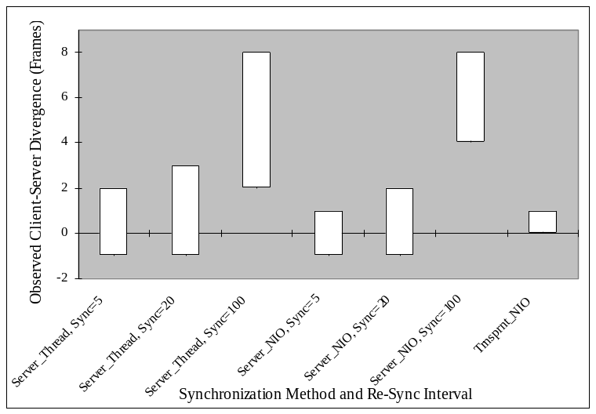
This method essentially allows for re-sync to occur only at optimal points in time, since it is most advantageous to re-sync whenever data has arrived before all the previous data has been used to update the display. When this is coupled with the fact that the non-blocking I/O allows for socket access that avoids waiting for data to appear on the socket (unlike the threaded method), the foundation for a solid networking support system is established.

COMPARISON OF SYNCHRONIZATION METHODS
The four network synchronization methods described above each provide a means of maintaining synchronization between the server and client environments. To determine which method is best suited for creating a Java based 3D virtual environment with networking support, a number of experiments were run and both qualitative and quantitative results were recorded.
Figure 8. Client-Server divergence in frames for a variety of synchronization methods and re-sync intervals.
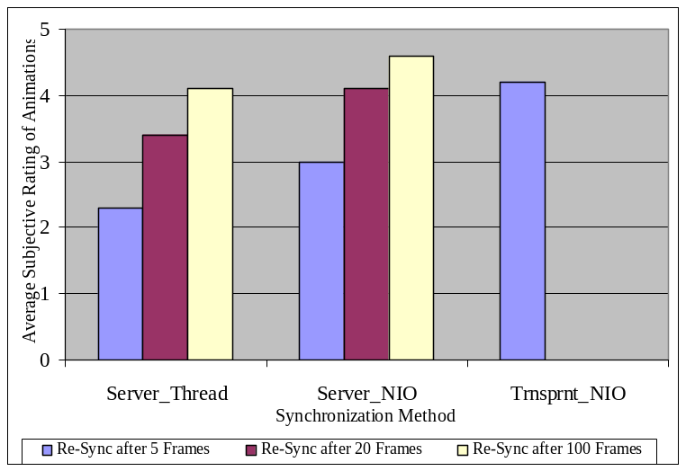
A number of procedures were implemented to facilitate the collection of data under all modes. A means of easily switching the synchronization method was installed. For the methods that rely on an explicit re-sync signal, a data collection routine was established that recorded the server’s currently drawn frame number the re-sync command corresponded to, along with the client’s local frame that was being processed and drawn when the re-sync command was received. For the method that uses the transparent (or automatic) re-sync method the number of frames that were dropped when the new packet of data arrived was recorded. This data provides a quantitative means of comparing the synchronization methods by allowing for the contrasting amounts of divergence between the client and the server environments to be recorded. These measurements were taken using various re-sync intervals.
In addition to the quantitative comparison, a qualitative comparison was also performed. Users of the client’s virtual environment were asked to rate the smoothness or fluidness of the motion of the avatars and environments in the graphical display on a scale of 1 to 5, with 5 being the best. The subjective ratings were averaged and recorded for each synchronization method and re-sync interval in order to record users’ subjective impressions.
Figure 9. Subjective rating of fluidness of animations for a variety of synchronization methods and re-sync intervals.
Each simulation on the client system consisted of a standard test that guided the user’s avatar through a set sequence. The client and server frames per second were both set to 30. The simulation was started in full screen mode. From the starting position the avatar’s speed is increased to a simulated 300 MPH as displayed by the GUI. The control key corresponding to a yaw to the left is pressed and held to cause the avatar to turn to the left. The re-sync command is set to occur after every 5, 20, or 100 frames. These test sequences were video captured. The application users taking part in the qualitative comparison were allowed to explore the simulation for 5 minutes, but were then asked to rate the application’s performance using the pre-recorded sequence. This helped guarantee that all application users were rating the exact same events to help enable a more valid comparison.
This sequence of tests was performed using a dual processor 700MHz Intel Pentium 3 class machine with 1GB of memory as the client. The second processor and extra RAM were instrumental in enabling correct video capture of the test sequences. The server was running on a 700MHz AMD Athlon system with 256MB of memory. Both machines were running Windows XP and communicated via a 10Mb/s LAN. The tests were performed on these machines and the maximum number of frames discarded between re-sync commands was recorded. This data was then compared (see Figure 8). A video of the test events was recorded while the tests were being run and users were asked to observe the video of the client display and record their impression of the avatar and landscape animations. Their ratings were recorded and compared (see Figure 9).
The two graphs clearly show that the synchronization methods that rely upon an active re-sync command produce the most fluid and subjectively pleasing graphic animations when the re-sync interval is maximized. Fewer re-syncs result in fewer jarring updates to the objects being displayed. It should be noted that the use of the non-blocking I/O alone minimizes discarded frames and optimizes processing cycles when compared to the threaded approach. This does provide better results. However, the transparent method for synchronization that utilizes non-blocking I/O maintains the most consistently synchronized environment and receives the second highest average score for fluidity of graphical display animations. This method is the most ideal way of maintaining synchronization while minimizing the overhead required to support networking, resulting in very fluid animations.
It should be noted that arguments have been made that a user’s subjective experience is more important than the virtual environments objective reality [18]. It is thus possible to relax synchronization in order to optimize a user’s subjective experience. This would make the synchronization approaches that rely upon a discrete re-sync interval more viable. A better subjective experience can be obtained by simply increasing the re-sync interval at the expense of maintaining synchronization. However, in all cases a method that provides a very good subjective experience while still maintaining excellent synchronization is most desired. The method of using transparent synchronization with non-blocking I/O provides the best subjective and objective experience in Java based distributed virtual environments.

CONCLUSION
Construction of a distributed 3D virtual environment that is cost-effective, portable, maintainable and extensible is a non-trivial task. Such environments must provide acceptable graphic, control, communications, and networking support. A method and a group of programming tools to create a distributed 3D virtual environment that provides good network performance along with the other attributes mentioned would be highly desired. The work on the Whiskey distributed virtual environment has shown that Java is now a useful tool to enable the creation of an environment that contains these features. Java, until recently, did not provide adequate networking support, making effective synchronization between network and client system difficult, but the release of the official support for non-blocking I/O has addressed this issue.
The simplification of early effort provided validation for the decision to develop the project in a Java based programming environment because of its broad open source support. The development work on graphical support for the Whiskey environment was greatly minimized due to the solid foundation provided by the open source work. Much early project work was devoted to simply integrating the disparate code sources together into a working whole. This provided more time for developing all of the features necessary to transform the virtual environment into the desired application. The graphic engine was updated to provide the level of detail and feature support that was preferred, the control system was adjusted to enhance usability, and the communication package’s infrastructure was developed. Finally, a networking support system was established to tie various user environments together.
A great deal of effort was expended to determine what the best method was for maintaining synchronization of virtual environments across a network using a Java based toolset. The transparent method for synchronization that utilizes non-blocking I/O loses the fewest number of frames and receives the excellent average subjective scores for the fluidness of graphical display animations. This transparent synchronization method, via both qualitative and quantitative measurements, was found to be the best. This result corresponds well with expectations of the designers and further supports the fact that Java can be used to provide the foundation for a networked 3D virtual environment.
The four aspects of the environment, when functioning together, provide a stable base for the collaborative geo-exploration flight simulator application that was developed. The platform requires minimal network/computing overhead, but provides maximum collaborative functionality via 3D graphics, intuitive controls and multiple communication avenues.
Thus, the non-blocking I/O support now available in Java 1.4 and later, allows for the easy development of virtual environments that can support a variety of networked applications. Java’s many benefits that make it an attractive language to develop environments for educational and entertainment purposes are now bolstered by an API that makes the promise of robust networking support an easily realized actuality. This networking support can now be used to provide real time interaction among multiple users, finally allowing Java to become a good tool with which to develop real-time networked virtual environments.
The source code for the Whiskey application is open source and freely available [25]. It is the developers’ hope that future users will both learn from and improve upon the framework that has been developed. ipKtalk and ipKchat can actually be used as stand-alone applications instead of just as sub-routines. They are simple, yet full featured programs, which can be easily expanded and/or modified (with permission) to fulfill many different requirements. They are packaged with the Whiskey application. All code is available under the General Public License (GPL).

ACKNOWLEDGEMENTS
We would like to thank Sergei Grichine who provided the open source Java code that served as the foundation for the graphical engine [16].
We would also like to thank Soji Yamakawa for his many VRML97 models that helped to populate our environment [23].
Finally, the authors would like to thank IBM for their continuing support of our studies.

REFERENCES
- Bangay, S. Experiences in porting a virtual reality system to Java. In Proceedings of the 1st International conference on computer graphics, virtual reality, and visualization (Cape Town, South Africa, 2001). ACM Press, New York, NY, 2001, 33-37.
- Benford, S., Greenhalgh, C., and Vaghi, I. Coping with inconsistency due to network delays in collaborative virtual environments. In Proceedings of the ACM symposium on Virtual reality software and technology (London, UK, December 1999). ACM Press, New York, NY, 1999, 42-49.
- Brewer, E., Culler, D., Welsh, M. SEDA: An architecture for well-conditioned scalable Internet services. In Proceedings of the Eighteenth ACM Symposium on Operating Systems Principles (Banff, Alberta, CA, October, 2001). ACM Press, New York, NY, 2001, 230-243.
- Bricken, M. Virtual reality learning environments: Potentials and challenges. ACM Computer Graphics: SIGGRAPH, 25(3):187-184, 1991.
- Burdea, G. C., and Coiffet, P. Virtual Reality Technology. John Wiley and Sons, Inc., Hoboken, NJ (2003).
- Cai, W., Lee, B. S., Turner, S. J., and Zhou, S. Time-space consistency in large-scale distributed virtual environments. ACM Transactions on Modeling and Computer Simulation, 14(1):31-47, 2004.
- Campbell, B., Collins, B., Hadaway, H., Hedley, N. and Stoermer, M. Web3D in Ocean science learning environments: Virtual big beef creek. In Proceedings of the 7th International Conference on 3D Web Technology (Tempe, AZ, 2002). ACM Press, New York, NY, 2002, 24-28.
- Cook, J. Marsh, J., Pettifer, S., and West, A. Collaborative Virtual Environment: DEVA3: Architecture For a Large Scale Distributed Virtual Reality System. In Proceedings of the ACM Symposium on Virtual Reality Software and Technology (Seoul, Korea, October 2000). ACM Press, New York, NY, 2000, 33-40.
- Cox, B. J., and Novobilski, A. Object-Oriented Programming: An Evolutionary Approach. Addison-Wesley Publishing, Boston, MA (1991).
- Crowcroft, J., Oliveira, M., Slater, M. Component framework infrastructure for virtual environments. In Proceedings of the third international conference on collaborative virtual environments (San Francisco, CA, 2000). ACM Press, New York, NY, 2000, 139-146.
- DeFanti, T. A., Johnson, A. E., and Leigh, J. Issues in the design of a flexible distributed architecture for supporting persistence and interoperability in collaborative virtual environments. In Proceedings of the 1997ACM/IEEE conference on Supercomputing (CDROM) (San Jose, CA, November 1997). ACM Press, New York, NY, 1997, 1-14.
- DEM Standard, http://rockyweb.cr.usgs.gov/nmpstds/demstds.html (accessed January 20, 2005).
- Goldberg, A., Kesselman, J., Melissinos, C., Petersen, D., Soto, J. C., Twilleager, D. Java Technologies for Games. ACM Computers in Entertainment, 2(2):Article 8, 2004.
- Han, S., Lee, D., and Lim, M. ATLAS: a scalable network framework for distributed virtual environments. In Proceedings of the 4th international conference on Collaborative virtual environments (Bonn, Germany, September 2002). ACM Press, New York, NY, 2002, 47-54.

- Hughston, R., Mine, M. R., Shochet, J. Building a massively multiplayer gamer for the million: Disney’s Toontown Online. ACM Computers in Entertainment, 1(1):Article 6, 2003.
- Java Flight Simulator, http://www.earthquakemap.com/javaflight/what-is-javaflight.html (accessed January 20, 2005).
- Lau, R. W. H., Li, F. W. B., and Li, L. W. F.: Supporting continuous consistency in multiplayer online games. In Proceedings of the 12th annual ACM international conference on Multimedia, Technical poster session 2: multimedia networking and system support (New York, NY, October 2004). ACM Press, New York, NY, 2004, 388-391.
- Pettifer, S., West, A. Subjectivity and the relaxing of synchronization in networked virtual environments. In Proceedings of the ACM symposium on virtual reality software and technology (London, UK, 1999). ACM Press, New York, NY, 1999, 170-171.
- Roussou, M. Learning by doing and Learning through play: An exploration of interactivity in virtual environments for children. ACM Computers in Entertainment, 2(1):Article 1, 2004.
- Singhal, S. and Zyda, M. Networked Virtual Environments Design and Implementation. Addison-Wesley, Reading, MA (1998).
- Stephenson, C. and West, T. Language Choice and Key Concepts in Introductory Computer Science Courses. Journal of Research on Computing in Education, 31(1): 89-95, 1998.
- Sun Java Technology, http://java.sun.com/ (accessed January 20, 2005).
- VRML97 Airplane Models, http://ciel.me.cmu.edu/soji/aircraft/aircrafte.html (accessed January 20, 2005).
- VRML97 Standard, http://www.web3d.org/x3d/specifications/vrml/ISO-IEC-14772-IS-VRML97WithAmendment1/ (accessed January 20, 2005).
- Whiskey Source Code, http://www.emba.uvm.edu/%7Emedialab/Fall04/ee214/Java3D/ (accessed January 20, 2005).

