SALES ANALYST PROJECT REPORT
Data-Driven Insights & Strategic Recommendations | 2022 – 2023

Prepared By  Data Analyst | Tool Stack  Python + PostgreSQL | Period  2022 – 2023

EXECUTIVE SUMMARY

This report presents a comprehensive analysis of sales performance across regions, categories,
sub-categories, and time periods using data filtered in Jupyter Notebook and analysed via pgAdmin SQL.

Confidential | Internal Use Only

1. Project Aim

The aim of this project is to perform a comprehensive sales analysis on order-level transactional data to uncover actionable revenue insights across product categories, sub-categories, geographic regions, and time dimensions. By leveraging Python (Jupyter Notebook) for data cleaning and PostgreSQL (pgAdmin) for analytical querying, the project seeks to identify growth trends, high-performing products, and strategic opportunities to boost sales and customer reach.

2. Objectives

- Identify the top 10 highest revenue-generating products overall.
- Determine the top 10 sub-categories by total revenue.
- Find the top 5 best-selling products in each geographic region.
- Perform month-over-month (MoM) growth comparison between 2022 and 2023 sales.
- Identify the highest-sales month for each product category.
- Determine which sub-category had the highest profit growth in 2023 vs 2022.
- Recommend actionable strategies to improve product sales and customer reach.
- Suggest targeted offers to increase sales for both new and existing inventory.

3. Tools & Technology Stack

Tool | Purpose
Python (Jupyter Notebook) | Data loading, filtering, cleaning and preprocessing
Pandas | DataFrame manipulation and exploratory data analysis
PostgreSQL / pgAdmin | Advanced SQL queries, CTEs, window functions
SQLAlchemy | Python-to-PostgreSQL database connection
psycopg2 | PostgreSQL database adapter for Python

4. Analysis & Insights

Q1. Top 10 Highest Revenue-Generating Sub-Categories
The query aggregated total sale_price by sub_category and ranked results in descending order. Phones lead with over $318K in revenue, closely followed by Chairs at $316K. Technology and Furniture sub-categories dominate the top positions.

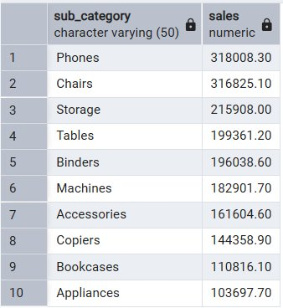
Figure 1: Top 10 Sub-Categories by Revenue
📌 Key Insight — Q1: Phones and Chairs are the top revenue drivers. Appliances rank 10th, indicating untapped potential. Storage and Tables show strong mid-tier performance worth further investment.

Q2. Top 5 Highest-Selling Products per Region
Using a CTE with ROW_NUMBER() window function partitioned by region, the top 5 products were identified for each of the four regions: Central, East, South, and West. Product TEC-CO-10004722 appears at rank 1 across Central, East, and West regions.

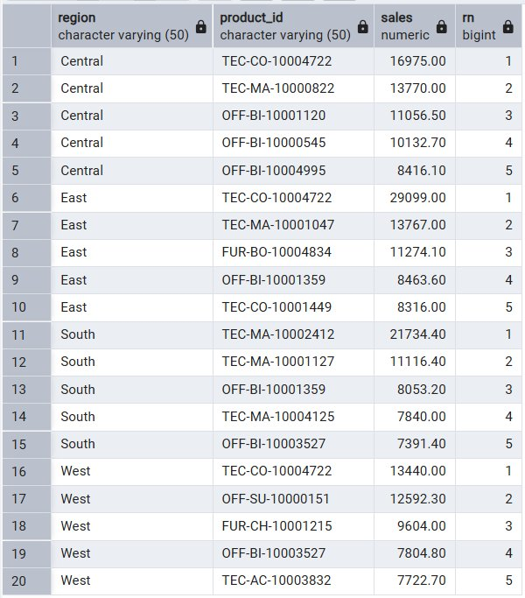
Figure 2: Top 5 Products by Sales in Each Region
📌 Key Insight — Q2: TEC-CO-10004722 is a star product appearing in the top position across 3 out of 4 regions. East region shows the highest single-product sales ($29,099). Regional product preferences vary — customised regional promotions can maximise impact.

Q3. Month-over-Month Sales Comparison: 2022 vs 2023
Sales were aggregated by month and pivoted using CASE WHEN statements to display 2022 and 2023 side-by-side. This enables direct monthly performance comparison across both years.

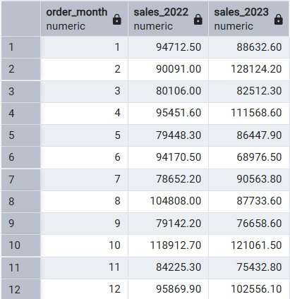
Figure 3: Monthly Sales Comparison — 2022 vs 2023
📌 Key Insight — Q3: February 2023 saw a significant jump (+42%) over 2022 ($90K vs $128K). October had the highest 2022 sales ($118K). June 2023 dipped below 2022 levels, suggesting a mid-year slump that requires targeted promotions.

Q4. Sub-Category Profit Growth: 2022 vs 2023
Sales by sub-category were compared across both years to identify the highest-growth segments. This analysis helps identify which product lines gained traction and which declined.

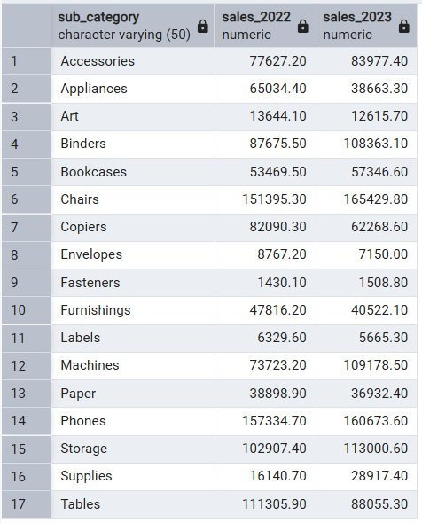
Figure 4: Sub-Category Sales — 2022 vs 2023 Comparison
📌 Key Insight — Q4: Machines saw dramatic growth in 2023 ($73K → $109K, +48%). Binders and Chairs also posted strong growth. Appliances declined sharply ($65K → $38K, -41%), warranting a full review. Supplies and Tables also contracted — discount strategies may help clear inventory.

5. Strategic Recommendations to Improve Sales

5.1 Product & Category Strategy
- Double down on Phones and Chairs — allocate higher marketing budgets to the top-performing sub-categories.
- Revive Appliances with targeted promotions and bundled deals to reverse the 41% decline in 2023.
- Invest in Machines and Binders inventory ahead of Q1/Q4 when growth peaks based on historical data.
- Conduct SKU rationalisation for Supplies and Fasteners — consider clearance pricing to free up capital.

5.2 Regional Strategy
- Launch TEC-CO-10004722 as a flagship product in the South region where it is absent from the top 5.
- Design region-specific promotional campaigns based on top-selling product patterns per region.
- Explore cross-selling opportunities — pair high-performing tech products with accessories.
- Establish regional warehouses near East region to capitalise on its high per-product sales volume.

5.3 Seasonal & Time-Based Strategy
- October is historically the strongest sales month — plan early inventory build-up and ad campaigns.
- Address the June slump with mid-year flash sales and loyalty programme double-point incentives.
- Use February 2023 growth patterns to replicate campaigns in Q1 of future years.
- Launch post-holiday (January) clearance events to move excess Q4 stock quickly.

6. Offer Suggestions to Boost Sales

The following targeted offers are recommended for both new and existing inventory:

Offer Type | Target Products | Expected Impact
Bundle Deal | Phones + Accessories / Chairs + Furnishings | Increase average order value by 20–30%
Clearance Sale (15–25% off) | Appliances, Supplies, Tables (declining) | Reduce dead stock, recover cash flow
Buy 2 Get 1 Free | Binders, Fasteners, Labels, Envelopes | Move low-ticket items in high volume
New Customer Offer (10% off) | All categories — first purchase | Grow customer base and market reach
Loyalty Reward Points | Repeat buyers across all sub-categories | Improve retention and lifetime value
Flash Sale (Weekend Only) | Machines, Bookcases — June/July slump | Counter seasonal slump with urgency
Free Shipping Threshold | Orders above $500 in Tech/Furniture | Incentivise higher cart value
Seasonal Bundle (Q4 Oct) | Phones, Chairs, Storage — peak season | Capitalise on October sales spike

7. Conclusion

This sales analysis project successfully leveraged Python and PostgreSQL to extract meaningful business intelligence from transactional order data spanning 2022 and 2023. The analysis revealed clear leaders in revenue generation (Phones, Chairs, Machines), identified regional product champions, and uncovered seasonal trends critical for strategic planning.

The month-over-month comparison highlighted strong growth periods (February, October) and underperforming months (June), providing a data-driven foundation for campaign scheduling. The sub-category profit comparison identified both high-growth opportunities (Machines, Binders) and areas needing intervention (Appliances, Supplies).

By implementing the recommended strategies — including regional targeting, bundle offers, clearance promotions, and loyalty programmes — the business can significantly improve sales performance, reduce excess inventory, and expand its customer base in a sustainable, data-backed manner.

Key Takeaway
Data-driven decision making transforms raw transactional data into competitive advantage. Continue quarterly analysis cycles to stay ahead of market trends and customer demands.

End of Report | Sales Analyst Project | 2022–2023

