NRSC-DPA SDPEG- -XXXXXXXXXXXXXX

NRSC | NISAR L & S band comparison on GCOV Products



nrsc

National Remote Sensing Centre
Indian Space Research Organisation

Hyderabad-500 037

October 2026

Control Sheet

 | Security Classification | Classified
 | Distribution | ISRO/DOS
 | Document | (a) Issue 1.0 |  | (b) Revision  & Date |  |  | 1.0  14th Oct 2026
 | Report / Document Type | Technical Report
 | Report / Document No | NRSC-DPA SDPEG -XXXXXXXXXXXXXX
 | Title | NISAR L & S band comparison on GCOV Products
 | Collation | Pages  10 | Figures/plots  1/6 |  | Tables  1 | Annexure References  -
 | Project | NISAR L & S band GCOV comparison over three radiometric sites
 | Analysis Team | S.Srisudha , Anupam Das
 | Compiled by  Reviewed by  Approved by | S.Srisudha  RVG Anjaneyulu, GH,ADPG
 | Affiliation of authors | NRSC
 | Originating unit | DPA
 | Sponsor(s)  Name  Type | N.A
 | Date of Project Initiation | October, 2026
 | Date of Publication | October, 2026
 | Abstract: This report summarizes the comparisons of sigma0 and gamma0 of NISAR L & S band GCOV products over 3 radiometric sites

NISAR L & S band GCOV comparison over three radiometric sites

Introduction

NISAR mission
NISAR, the NASA–ISRO Synthetic Aperture Radar, is a joint mission of the American and Indian space agencies, and it is unusual in carrying two radars at two wavelengths on one spacecraft. NASA contributed the L-band instrument, ISRO the S-band one, and that division runs all the way through to the files: the L-band products examined here carry the Jet Propulsion Laboratory as their originating organisation, while the S-band products name ISRO as their generating agency. The satellite revisits the same ground on a 12-day repeat cycle, so a scene is reimaged on a fixed schedule rather than opportunistically.
Most radar satellites carry a single radar at a single wavelength, so comparing wavelengths normally means comparing two spacecraft, on two dates, over ground that has changed in between, through two unrelated processing chains. NISAR carries both at once. Every site in this report was imaged by the L-band and the S-band instrument within seconds of each other, from the same orbit, at incidence angles matching to within 0.03°. This removes the factors that normally confound a band comparison: weather, season, growth stage, look angle and calibration epoch. What is left to differ is the instrument and its processing.

Backscatter
A synthetic aperture radar illuminates the ground with its own microwave pulse and records how much energy returns. That returned fraction, normalised for the size and orientation of the patch it came from, is backscatter, and it is the quantity every number in this report gives, in decibels. Backscatter is not brightness in the ordinary sense: backscatter responds to roughness at the scale of the radar's own wavelength, to moisture, and to structure within and beneath the surface. Calm water reflects the pulse away from the radar and sends almost nothing back; a forest canopy scatters it in all directions and sends back a great deal. This report measures the gap between those two extremes, and the point at which an instrument can no longer tell them apart.

Product level
The products used here are Level-2: the raw radar signal has already been focused, calibrated into backscatter, corrected for terrain against a Copernicus GLO-30 elevation model and laid onto a UTM grid on the WGS-84 ellipsoid. A pixel therefore has a position on the Earth rather than a position in the radar's own viewing geometry, so the same region of interest can be measured in two different products. Across the three sites the regions of interest fall between 33.7° and 47.2° of incidence, which is the span the swath covers from its near edge to its far edge.

Scope
This report compares the two radars as GCOV products over three sites, chosen for the surfaces they contain. It sets out what the two bands are and what a GCOV product carries, states the criteria the sites were selected against and how the measurement was made, works through each site class by class, and closes with the findings that take more than one site to see.

LSAR and SSAR
The two radars share the platform, the orbit and the pass, so every site in this report was imaged by both of them seconds apart:
Table 1: LSAR and SSAR configurations
 | LSAR | SSAR
Centre frequency | ~1.24 GHz | ~3.2 GHz
Wavelength | ~24 cm | ~9.4 cm
A longer wavelength penetrates further into dry snow, ice and vegetation canopy and responds more to scattering from within a volume; a shorter one is weighted more toward the surface and toward smaller-scale roughness. Because both radars look at the same ground on the same pass, a radiometric difference between them isolates that wavelength dependence from everything else.
Each is sensitive to different things and each pays for that sensitivity somewhere. The table below is what the wavelength difference is expected to buy and to cost, stated as prior expectation from the physics rather than as anything measured here.
Table 2: Expected L- and S-band characteristics
 | L-band, ~24 cm | S-band, ~9.4 cm
Response | structure of order a wavelength and larger — trunks, branches, the inside of an ice volume | smaller-scale roughness — leaves, twigs, surface texture
Penetration | further into dry snow, ice and canopy, so more of the return comes from within the volume | less far; the return is weighted towards the surface
Expected strength | deep and structurally complex targets, and dark surfaces where there is little return to begin with | bright rough surfaces and fine-scale texture, from a smaller antenna for the same beam
Expected cost | a larger antenna for the same beamwidth, and far more Faraday rotation through the ionosphere, which scales with the square of the wavelength | saturates sooner over dense canopy, and sees less of what lies beneath a surface

Polarisation
A radar transmits its pulse with the electric field oriented in one direction and can listen for the return in the same direction or the perpendicular one. HH means transmitted horizontally and received horizontally, VV means vertically both ways; these are the co-polarised channels. HV and VH are transmitted one way and received the other, and are called cross-polarised. Which of them a scene offers is fixed when the acquisition is planned, not chosen afterwards.

a. Cross-polarised channels
HV and VH are produced mainly by multiple or volume scattering, which returns far less energy than the direct surface return in HH or VV, typically 6 to 10 dB less. A cross-pol channel is therefore the first to run into the instrument's noise floor, which makes it the most sensitive test of sensitivity available here.

b. Acquisition modes
The polarimetric mode is fixed when the scene is planned and is recorded in the granule name: DHDH, SHSH, DVNA, NASV, SHNA in the six products used here. S prefixes a single-pol acquisition, D a dual-pol one. This is why the sites below do not offer matching channel sets: the Antarctic pair is single-pol HH on both bands, so there is no cross-pol there to fall back on.

GCOV products
GCOV is the Level-2 geocoded polarimetric covariance product. Level-2 means the data have been processed past the raw radar signal into a calibrated geophysical quantity; geocoded means they have been laid onto a map grid, so a pixel has a position on the ground rather than a position in the radar's own viewing geometry. Three properties of it matter for everything below:
- It carries the covariance matrix's diagonal terms as power: HHHH, HVHV, VHVH, VVVV on a map grid, already terrain-corrected. A term name doubles the polarisation letters because it is an autocovariance: HHHH is the HH channel's power.
- It is radiometrically terrain-corrected to gamma0, and ships an rtcGammaToSigmaFactor layer, so sigma0 is recoverable per pixel without leaving the product. This comparison uses sigma0 throughout.
- It is multilooked, unlike a single-look GSLC. That is what makes ENL a meaningful number here and what makes the looks difference between the two bands something worth reporting.
Which polarisations a granule carries varies by acquisition mode, which is why the sites below do not all offer the same channels: the delta and Antarctica pairs are co-polarised HH on both bands, while at the Amazon the comparable channel is VV.
Three details of the GCOV format bear directly on the numbers below:
The diagonal terms: The covariance matrix holds cross-products of every polarisation pair. Its off-diagonal terms are complex and carry the phase relationships that polarimetric decomposition needs; its diagonal terms are real and are simply each channel's power. A radiometric comparison is about how much energy came back, so only the diagonal is measured here: HHHH, HVHV, VVVV. The off-diagonal terms are in the products and are a separate study.
Terrain correction: GCOV is radiometrically terrain-corrected: the processor has already divided out the illuminated area each pixel represents, which over a slope is not the flat-earth area. The result is gamma0, referenced to the area perpendicular to the look direction. Sigma0, referenced to the ground area, is recovered by multiplying by the rtcGammaToSigmaFactor layer the product ships. The factor is per-pixel, because terrain is. Measured across these six products it runs −0.80 to −1.75 dB, median −1.20 dB at the delta and Amazon and −1.65 dB (L) and −1.71 dB (S) over Antarctica. The factor is neither negligible nor constant, so one convention has to be fixed before any cross-band figure is quoted.
Multilook: A GSLC is single-look: each pixel is one realisation of the speckle, and ENL is 1 by definition, so the statistic carries no information. GCOV is multilooked, with several independent samples averaged per output pixel, and the number of effective looks is then a real property of the product that varies with how the processor was configured. This is what makes the looks comparison later in this report possible, and it is the main advantage of GCOV over GSLC for an assessment of this kind.
GCOV is the first product in the chain whose numbers are physically meaningful on their own: calibrated to backscatter, terrain-corrected, geocoded onto a map grid and multilooked. Two instruments can therefore be compared at this level without reprocessing either of them, and without the comparison depending on choices an analyst would otherwise have to make. The lower-level products would each need those choices made again, identically, for the comparison to mean anything.
L and S operate on a single platform, so each site is one pass, the two bands seconds apart with incidence angles matching to within 0.03°. Nothing on the ground changed between them and the geometry is shared, so a difference can only be the band, the instrument or the processing, and not weather, season or look angle.
Site selection: A site had to be a single pass carrying both bands. Within that constraint the three were chosen to span the backscatter range between them: one bright distributed target to serve as a radiometric control, one land–water boundary with a cross-polarised channel on both bands, and one scene whose surfaces sit near the dark end of the range. Matched posting in both bands was available at two of the three.
Table 3: Radiometric sites and the basis for selecting each
Site | Date | Surfaces | Selection rationale
Sundarban delta | 2026-08-24 | vegetation, water | land–water contrast, and cross-pol
Amazon | 2026-07-26 | vegetation, water | dense canopy, the brightest distributed target
Antarctica | 2026-09-12 | new ice, old ice, water | three surfaces across a wide range, two of them dark

1. Sundarban delta: vegetation against water, the land–water boundary that flood mapping and shoreline monitoring depend on. Water is specular and returns almost nothing, so the quantity of interest is the contrast between the two classes; the dark end of that contrast is where an instrument's noise floor would show itself. Selected also as the only site here carrying a cross-polarised channel on both bands.
2. Amazon: dense closed canopy, about the brightest distributed target a spaceborne SAR encounters. Selected as the radiometric control: where there is ample signal, agreement between the two instruments separates calibration from sensitivity. Disagreement here would point at calibration; agreement here alongside a difference elsewhere would point at sensitivity.
3. Antarctica: new ice, old ice and open water, three surfaces across a wide range, two of them dark. Selected for the operational task of ice-type classification, which turns on separating old ice from open water, two surfaces that sit close together and both near the bottom of the range.

Methodology
Measurements were made with RADIAL, an in-house QGIS-based tool written for this assessment: regions of interest are drawn over a loaded GCOV, classified by the classes, and every band's statistics are computed per ROI and exported as a shapefile with CSVs beside it. One ROI set is drawn once and measured against both products, so the two exports differ only by what the products say and never by where the ROIs fell. Both backscatter conventions come out of one read of the pixels, through each product's own rtcGammaToSigmaFactor, so gamma0 and sigma0 are available for the same ROI without reprocessing anything. Statistics are computed on linear power at the raster's full resolution.

Regions of interest
a) ROI types. RADIAL offers a rectangle, a free polygon and a point buffer, where one click becomes a square of a stated side in metres of the working CRS. The buffer is square rather than circular because an ROI is rasterised by whether a pixel centre falls inside it. Every exported ROI carries a kind column recording which method produced it.
b) Constant geometry. Holding shape and size fixed removes ROI geometry as an explanation for anything measured:
- Equal pixel counts give equal ENL precision across every ROI. At Antarctica's 900 pixels that is ±7.3% for all 213 ROIs in both bands, so no comparison between ROIs or between classes is an artifact of one ROI being larger than another.
- Equal pixel counts give equal weight when ROIs are pooled, which is how the noise floor is formed, by pixel count in linear power.
- A side stated in metres makes the sampled ground area explicit and reproducible, and lets the sizing tool convert a target ENL precision into the side length that supports it.
- The same ROI set is reloaded and re-measured against the second product, so ROI placement cannot explain a band difference. Identical per-ROI pixel counts between the two bands at the delta and Antarctica confirm the geometry really was shared.
c) Incidence and position
Incidence rises across the swath, so ordering ROIs by incidence also orders them by position along the across-track direction. Fitting each site's ROI incidence angles against its ROI coordinates gives a gradient of about 0.054° per kilometre at all three sites, the same number the geometry requires. The rise runs east–west at the delta and the Amazon, where 79% and 83% of it lies along that axis, and north–south at Antarctica, where 83% of it is. At the two sites with a wide span this means any trend against incidence is also a trend across the scene; the same ROIs measured in both bands are what separates the two, since the geography is common to both products and the instrument is not.
d) The point buffer
An ROI drawn by hand takes several clicks and comes out a different size every time; a point buffer takes one click and a side length typed once, so a thousand ROIs can be placed quickly and every one of them is identical. The Antarctic set is therefore 213 ROIs of exactly 900 pixels, not 213 approximations of one. The side can also be set from the precision it has to support rather than by eye: a Suggest control converts a target ENL precision into the side length that delivers it on the raster currently loaded.
Table 4: ROI geometry and channels at each site
Site | Band | Posting | Polarisations | ROIs
delta | L | 10 m | HHHH, HVHV | 1034
delta | S | 10 m | HHHH, HVHV | 1034
Amazon | L | ~68 m | VVVV | 192
Amazon | S | ~37 m | VHVH, VVVV | 192
Antarctica | L | 10 m | HHHH | 213
Antarctica | S | 10 m | HHHH | 213

e) Statistics
- Everything on linear power, converted once from what the raster holds (roi_statistics). The mean of dB pixels sits ~2.5 dB low over single-look speckle; zero is fill in power but a real value in dB; noise-subtracted GCOV pixels can be negative and belong in the linear mean.
- sigma0, through each product's own rtcGammaToSigmaFactor. Both conventions are exported for every ROI. The class figures and every noise-floor result fix sigma0, because a cross-band comparison must fix one convention and the floor is defined against sigma0; the incidence-angle work is read in gamma0, for the reason given in that section.
- Per class (class_summary): mean of the ROI means; spread is brightest ROI mean minus darkest, within one class.
- Noise floor (nesz_estimate): pooled mean sigma0 over that band's water ROIs, weighted by pixel count in linear power. This is an upper bound on NESZ rather than a measurement, since an ROI records scene plus noise. The same export also carries the darkest single water ROI, a stricter bound quoted alongside it below.
- Margin = a class's mean minus its own band's floor. Never the other band's: the comparison is how far each instrument lifts a surface clear of its own noise.
f) Equivalent number of looks
Per ROI, on linear power, ENL = (mean / std)² over the ROI's valid pixels: finite, not nodata, fill zeros excluded, noise-subtracted negatives retained. A constant rescaling moves the mean and the standard deviation together, so an ROI's ENL is the same number in gamma0 and in sigma0; only a spatially varying factor would move it, and that would be terrain rather than an error. The figure quoted for a class is the median of its ROI ENLs, not the mean, because ENL is a ratio of moments and one heterogeneous ROI should not drag a class figure.
i) Precision: The relative standard error of ENL goes as √(2/N) in the number of independent samples, inflated by 1.1 to match the spread actually realised in simulation, with two posted pixels taken to make one independent sample. For a 900-pixel ROI that is N = 450 and 1.1·√(2/450) = ±7.3%, the figure quoted throughout. The divisor of two is the one rule of thumb in that chain, and every precision here scales with its square root.
ii) Interpretation: ENL as measured here is the ROI's own homogeneity, not the product's look count. Over a uniform distributed target the two coincide; over an ROI that straddles a boundary the scene's own variation is counted as speckle and ENL reads low. The comparison it supports is therefore between products over the same ROI, which is the comparison made in this report, and not between one ROI and another.

From gamma0 to sigma0
The two conventions. A GCOV pixel holds gamma0, radar brightness normalised by the illuminated area projected perpendicular to the look direction. Sigma0 normalises by the area projected onto the ground instead. The two differ by a factor set by the local terrain and the viewing geometry, so converting between them is not a constant offset over a scene.
The conversion. Each product carries its own rtcGammaToSigmaFactor layer, produced by the processor from the same elevation model it used for terrain correction. RADIAL multiplies pixel power by that factor before any statistic is taken, so the conversion is per-pixel and carries the terrain with it rather than applying one number to a whole scene.
Effect on the statistics. It is a multiplication on linear power, so it shifts an ROI's mean in dB and leaves cv and ENL where they were wherever the factor is constant across that ROI. Where the terrain varies inside an ROI it moves those too, and that variation is the terrain rather than an error.
Noise floor convention. NESZ is defined against sigma0. A gamma0 figure carrying that name would be wrong by the factor, and since the factor varies across a scene the error would not even be constant.

Sundarban delta

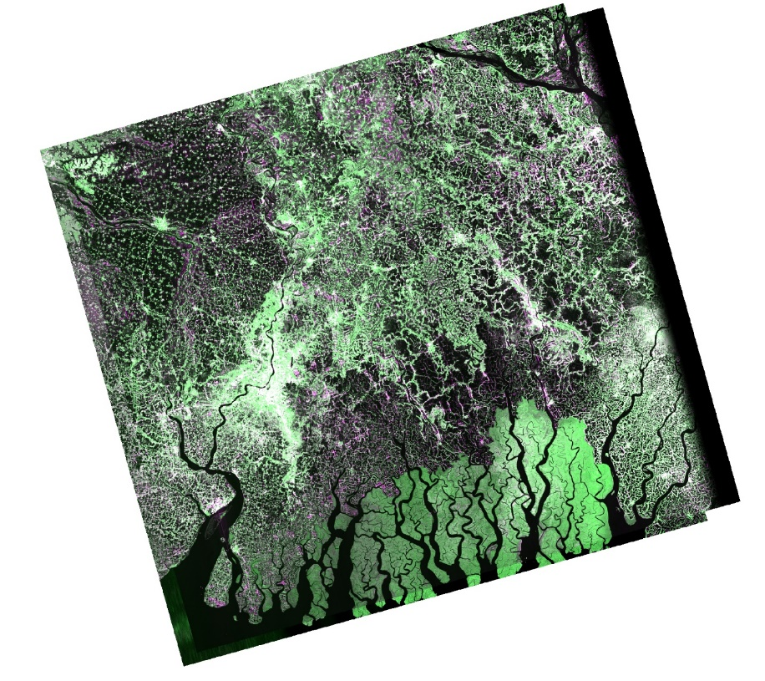

Fig 1. Overlap between the LSAR and SSAR GCOV products, pols HH and HV
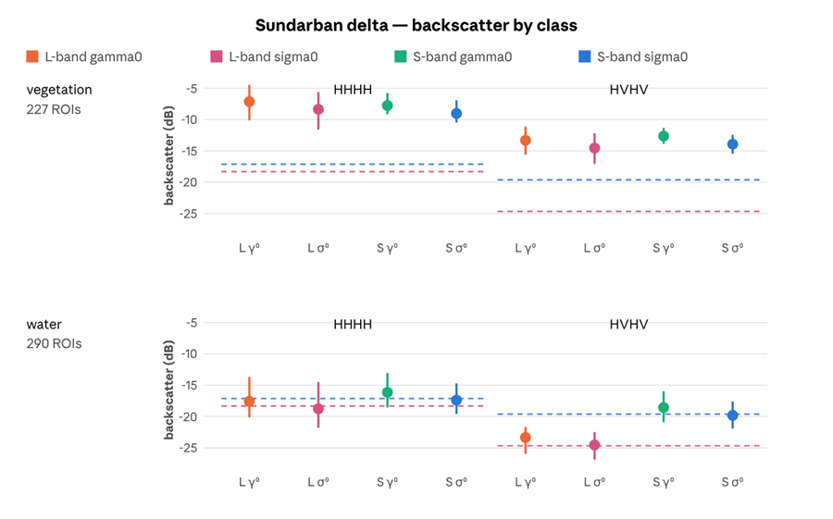
Fig 2. Mean and spread of gamma0 and sigma0 over vegetation and water in HH and HV, both bands. The dashed line is each band’s own sigma0 noise floor.

Table 5: Sigma0 statistics by class, Sundarban delta
Band | Pol | Class | ROIs | Mean dB | Spread dB | ENL | Margin
L | HHHH | vegetation | 227 | −8.37 | 5.98 | 3.40 ±11% | +9.96
S | HHHH | vegetation | 227 | −9.03 | 3.56 | 2.20 ±11% | +8.10
L | HVHV | vegetation | 227 | −14.56 | 4.88 | 4.05 ±11% | +10.12
S | HVHV | vegetation | 227 | −13.93 | 3.03 | 2.44 ±11% | +5.70
L | HHHH | water | 290 | −18.77 | 7.30 | 4.88 ±11% | −0.44
S | HHHH | water | 286 | −17.39 | 4.88 | 2.65 ±11% | −0.26
L | HVHV | water | 290 | −24.55 | 4.42 | 5.17 ±11% | +0.13
S | HVHV | water | 286 | −19.82 | 4.35 | 2.75 ±11% | −0.19

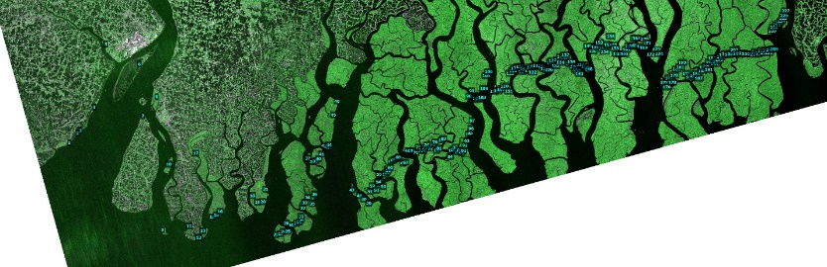
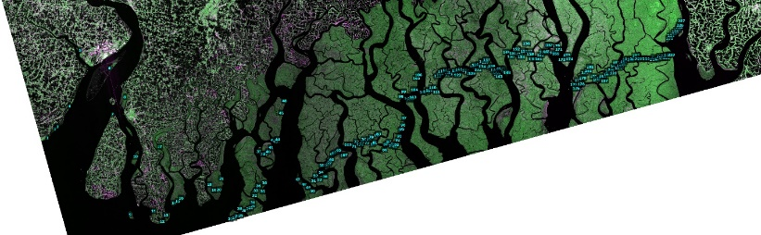
Vegetation
Fig 3. ROIs over mangrove vegetation. L-band left, S-band right.

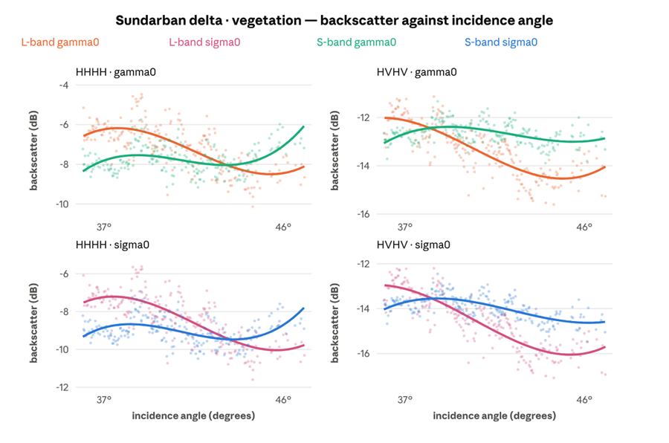
Fig 4. Sigma0 and gamma0 against incidence angle, vegetation.

Key observations:
a) Swath trend: From the near edge of the ROI set to the far edge, L's gamma0 falls 1.7 dB in HH and 1.9 dB in HV, while S's moves by +1.1 and −0.1. Each band's sigma0 trace runs below its gamma0 trace and falls about 0.7 dB further still; that extra is the cos θ term of the conversion, not a property of the canopy.
b) Crossover: In HH, L starts 1.7 dB above S and ends 1.1 dB below it. Any single-number comparison of these two products over this class therefore depends on where in the swath it is taken, which is why the regression below is reported at all.
c) Cross-pol: L's HV gamma0 starts 0.6 dB above S's and ends 1.2 dB below, so the separation grows with angle in the dimmest channel, the one closest to each instrument's noise floor.

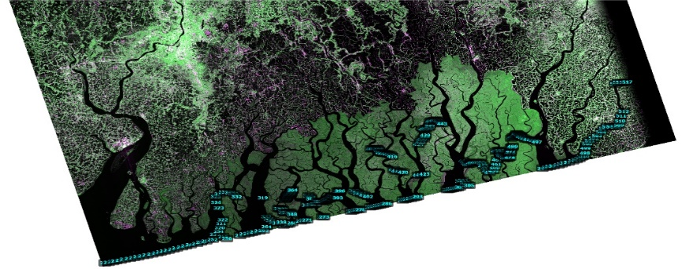
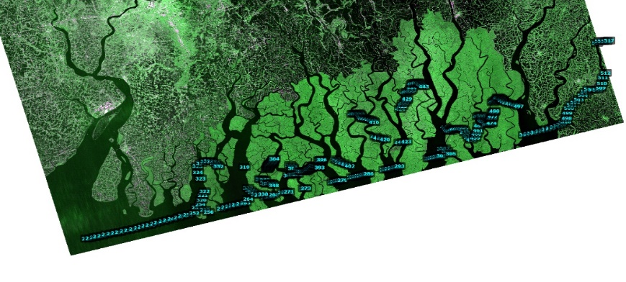
Water

Fig 5. ROIs over water. L-band left, S-band right.

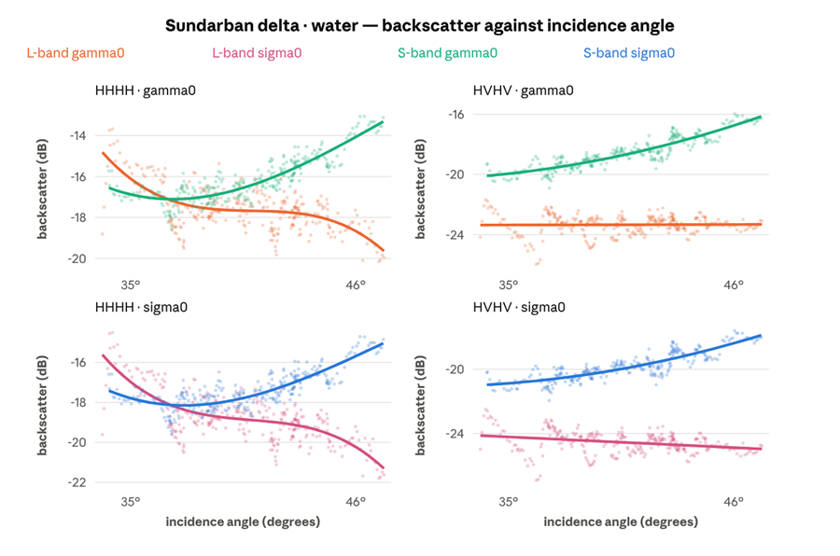
Fig 6. Sigma0 and gamma0 against incidence angle, water.

Key observations:
a) reverse trend: Across the swath L's gamma0 over water falls 3.3 dB in HH and is flat in HV, while S's rises 3.4 dB in HH and 3.6 dB in HV. A specular surface should darken or stay flat as the radar looks further off nadir, so L behaves as the physics predicts and S does not.
What rises across the swath would then be the floor rather than the surface. This is offered as an interpretation and not as a measurement: nothing in this data separates the two, and a NESZ profile against incidence angle would settle it.
b) Cross-pol separation: At the near edge L's HV gamma0 sits 3.1 dB below S's; at the far edge, 7.1 dB below. Cross-pol is the dimmest channel and the first to reach a floor, so it is where the two instruments diverge most over dark ground.
c) Incidence angle. The delta ROI set spans 36.3° to 47.1° of incidence, which is wide enough to fit a trend. Each ROI mean was regressed on that ROI’s own incidence angle, within the vegetation class. A sigma0 slope carries a −0.066 dB/deg geometric term contributed by the RTC conversion itself, demonstrated below, and so overstates every surface’s angular response by that much.
Table 6: Incidence-angle regressions, Sundarban vegetation
Pol | Band | gamma0 slope | R² | Across the 10.8° span | sigma0 slope
HHHH | L | −0.283 dB/deg | 0.48 | 3.0 dB | −0.348
HHHH | S | +0.025 dB/deg | 0.01 | 0.3 dB | −0.041
HVHV | L | −0.306 dB/deg | 0.64 | 3.3 dB | −0.372
HVHV | S | −0.038 dB/deg | 0.06 | 0.4 dB | −0.104

d) dB levels: Within-class spread is reported in the cross-site section as 5.98 dB against 3.56 dB in HH. Removing the incidence trend drops L's gamma0 standard deviation by 28% (1.14 → 0.82) and S's by 1% (0.67 → 0.66). Most of L's extra spread is neither noise nor scene; it is the swath.
e) ROIs at different incidence angles are also at different places on the ground, so the two are confounded in principle. Here they are separable, because the same ROIs, over the same ground, on the same pass were measured in both bands. If the trend were geography it would appear in both. It appears in one, at eight times the slope and eleven times the R² in cross-pol, and with the opposite sign in co-pol. At this site, the difference is the instrument's response to angle.

Amazon
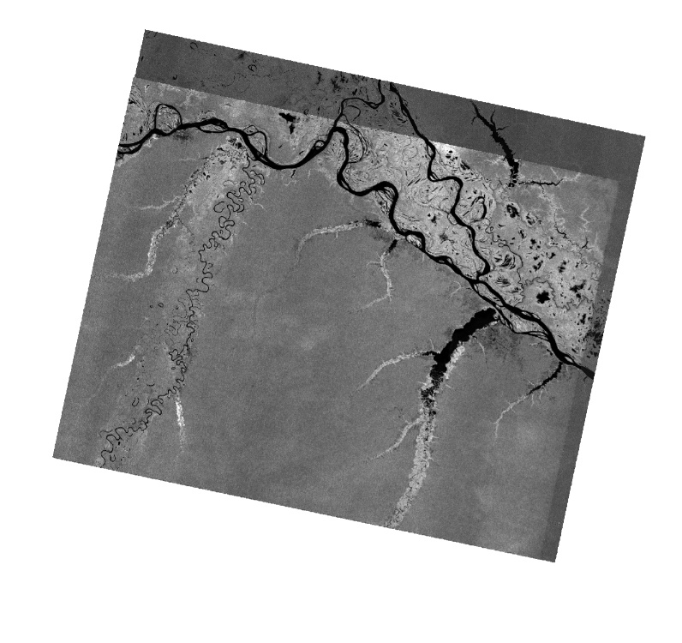

Fig 7. Overlap between the LSAR and SSAR GCOV products, pols VV and VH

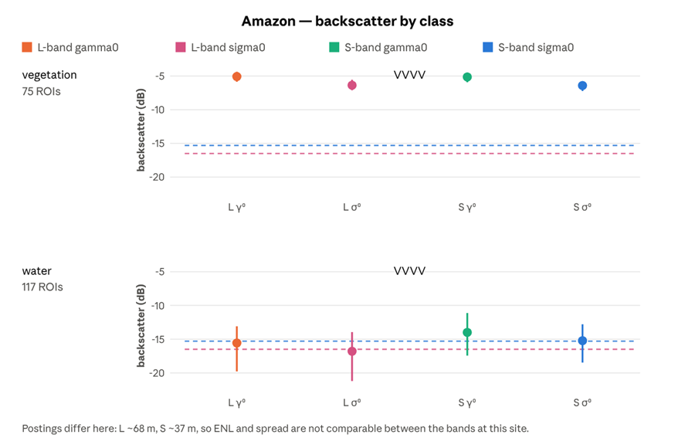
Fig 8. Mean and spread of gamma0 and sigma0 over vegetation and water in VV, both bands. The dashed line is each band’s own sigma0 noise floor.

Across both classes the two bands land on the same canopy value to within 0.04 dB, and that agreement is the radiometric control the rest of this report is read against. In Fig 8 each point is the mean of the ROI means, the whisker spans the brightest to the darkest ROI in the class, and the dashed line is that band’s own sigma0 noise floor. VV is the only channel both bands carry here.
ENL and spread are not comparable between bands here: L is posted at ~68 m, S at ~37 m. The L ENL figures are struck as artefacts of ROIs of only 15 to 48 pixels.
Table 7: Sigma0 statistics by class, Amazon
Band | Pol | Class | ROIs | Mean dB | Margin
L | VVVV | vegetation | 75 | −6.37 | +10.13
S | VVVV | vegetation | 75 | −6.41 | +8.89
S | VHVH | vegetation | 75 | −12.46 | +6.89
L | VVVV | water | 117 | −16.80 | −0.30
S | VVVV | water | 116 | −15.22 | +0.08
S | VHVH | water | 116 | −19.32 | +0.03
The co-polarised vegetation means differ by 0.04 dB, −6.37 against −6.41, across two radars, two wavelengths and two postings. On a bright distributed target the two instruments are radiometrically interchangeable to well inside any useful tolerance. It is the closest agreement in the set, and it is what allows the disagreements elsewhere to be read as real differences rather than as calibration error.

Vegetation
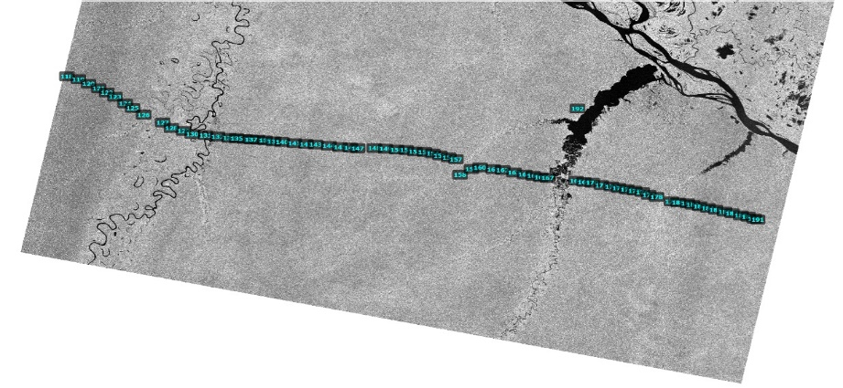
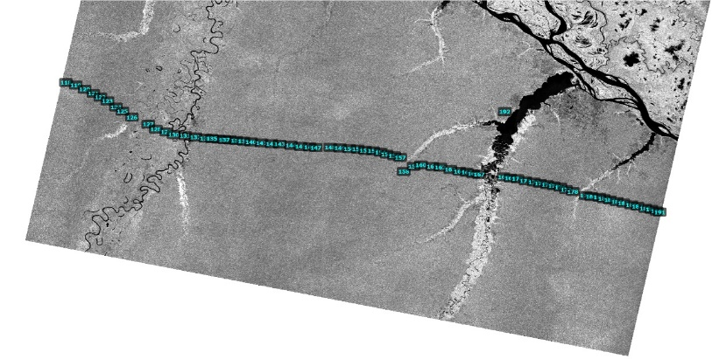

Fig 9. ROIs over vegetation. L-band left, S-band right.

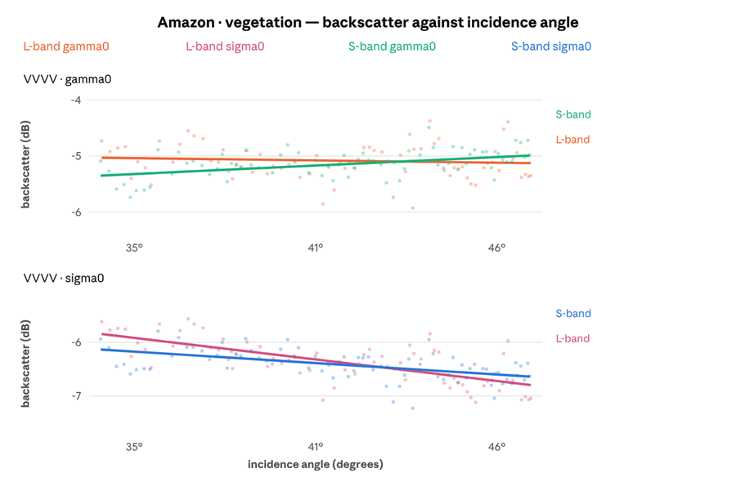
Fig 10. Sigma0 and gamma0 against incidence angle, vegetation.
dB levels. Across 13° of incidence L's gamma0 moves by −0.1 dB and S's by +0.4, and the two fitted traces stay within about 0.3 dB of each other the whole way. Over the brightest distributed target in this study the two instruments are interchangeable, and this is the control the rest of this report is read against. The two conventions sit about 0.9 dB apart and separate very slightly with angle, which is the same geometric term that appears in every panel.
No L-band trend: The steep fall L shows over Sundarban vegetation does not repeat: regressing every ROI gives L −0.007 dB/deg at R² 0.01 against S's +0.028 at R² 0.17. Whatever produces the delta trend, it is not a property of the band that travels between sites.

Water
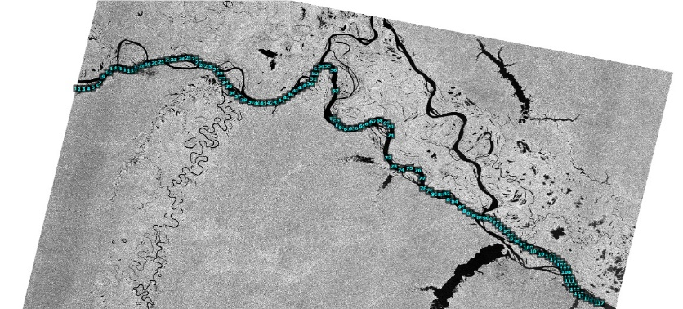
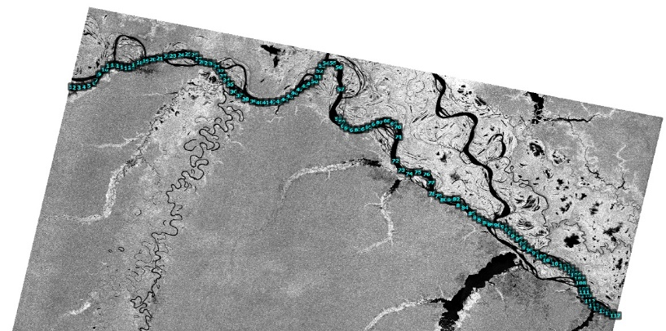
Fig 11. ROIs over water. L-band left, S-band right.

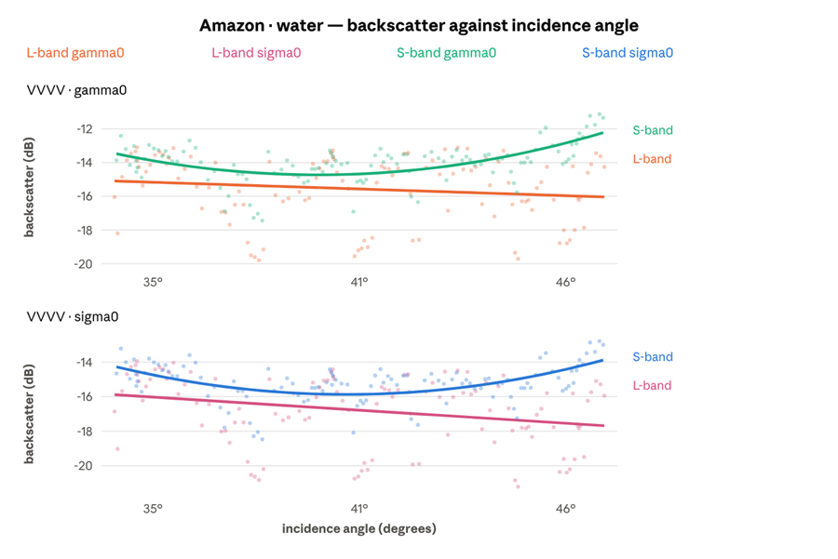
Fig 12. Sigma0 and gamma0 against incidence angle, water.

Repeat of the delta: L's gamma0 over Amazon water falls 2.2 dB across the swath while S's rises 1.1 dB, the same opposition of sign seen over delta water, and open to the same reading: S-band water is on its own floor at this site too.
Widening gap: Over the darkest class at this site, the gap between the two instruments opens with incidence angle, from about 0.4 dB at the near edge of the swath to 2.7 dB at the far edge: L darkens by 0.9 dB end to end while S brightens by 1.3 dB.
Sampling noise: Water ROIs here are free rectangles with a median of 15 pixels in L, so each binned median rests on few samples; bin-to-bin scatter of a decibel or two is sampling, not structure.

Antarctica

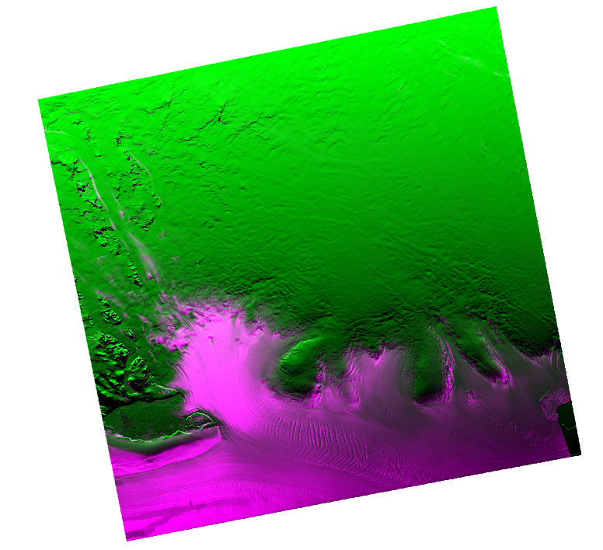
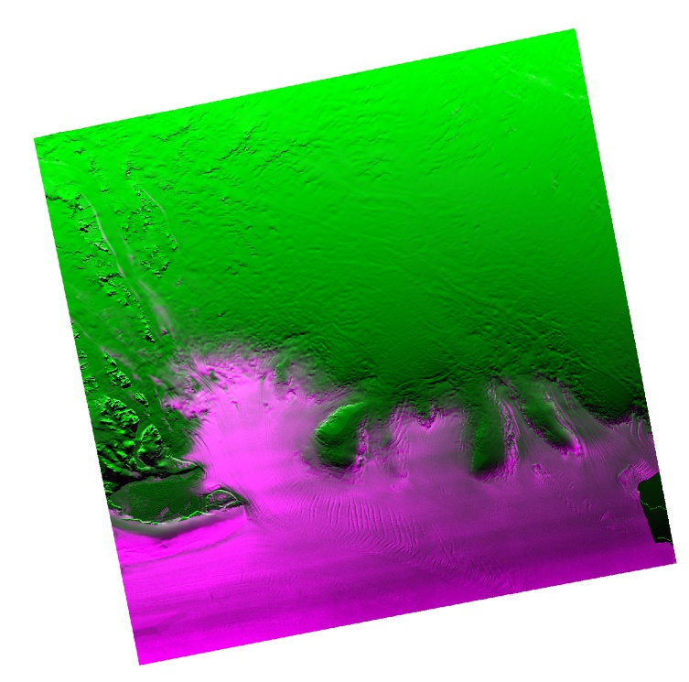
Fig 13. Overlap between the LSAR and SSAR GCOV products, pol HH

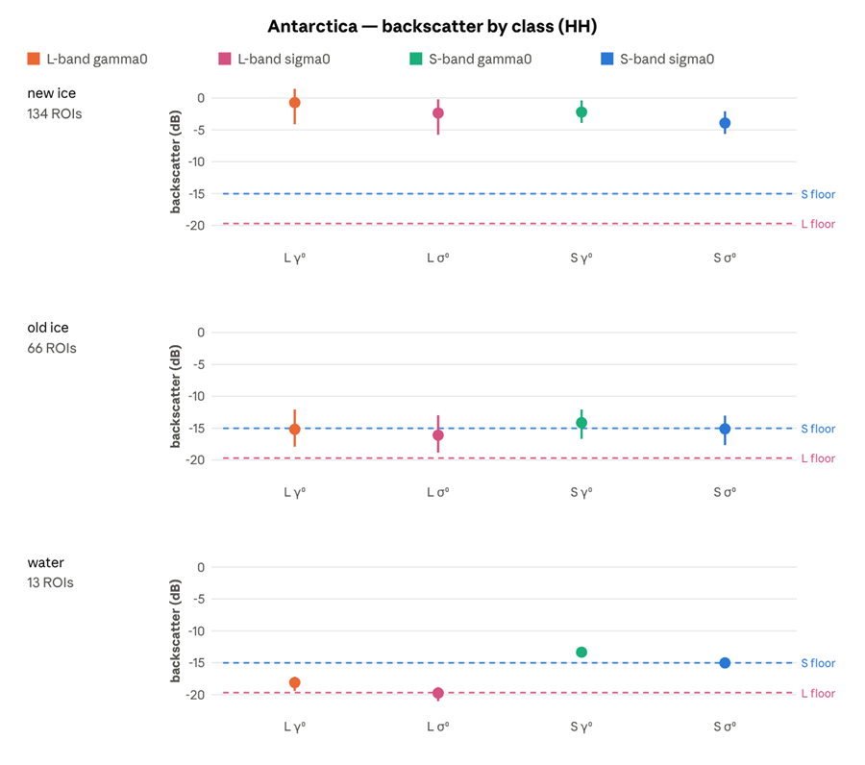
Fig 14. Mean and spread of gamma0 and sigma0 over new ice, old ice and water in HH, both bands. The dashed line is each band’s own sigma0 noise floor.

New ice sits well clear of both bands’ floors, old ice sits on S-band’s, and open water is what defines them. In Fig 14 each point is the mean of the ROI means, the whisker spans the brightest to the darkest ROI in the class, and the dashed line is that band’s own sigma0 noise floor. HH was the only channel acquired at this site.
Table 8: Sigma0 statistics by class, Antarctica
Band | Class | ROIs | Mean dB | Spread dB | ENL | Margin
L | new ice | 134 | −2.37 | 5.57 | 5.02 ±7.3% | +17.33
S | new ice | 134 | −3.93 | 3.56 | 2.70 ±7.3% | +11.09
L | old ice | 66 | −16.10 | 5.87 | 3.90 ±7.3% | +3.59
S | old ice | 66 | −15.10 | 4.64 | 2.28 ±7.3% | −0.09
L | water | 13 | −19.74 | 2.17 | 5.23 ±7.3% | −0.04
S | water | 13 | −15.02 | 0.97 | 2.77 ±7.3% | −0.01

All 900-pixel point-buffer ROIs, identical in both bands. The old-ice row is the main result of this study and is treated separately below.

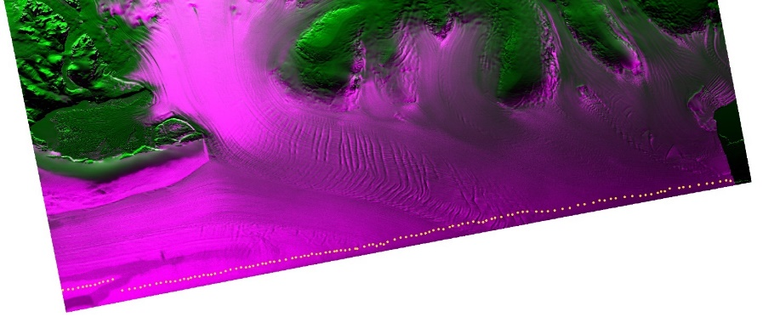
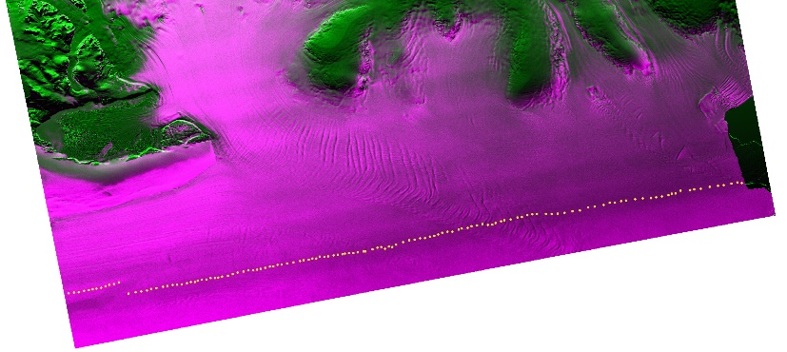
New ice

Fig 15. ROIs over new ice. L-band left, S-band right.

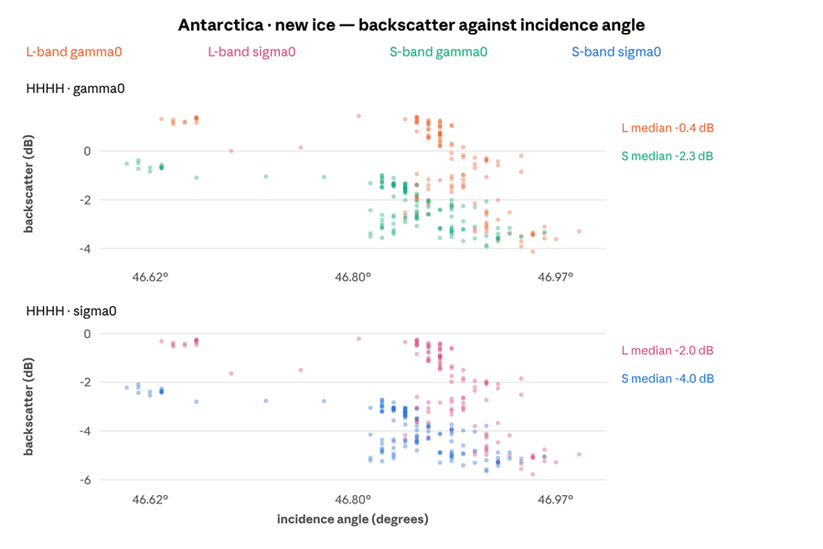
Fig 16. Sigma0 and gamma0 against incidence angle, new ice.

Key observations:
a) dB Levels: The class sits near 0 dB in L gamma0 and between −1 and −3 dB in S, more than ten decibels clear of either noise floor. Nothing here tests sensitivity. The two bands agree to within about 1.5 dB and move together bin for bin, which is further evidence that the variation is in the scene rather than in either radar.
b) Spatial variance: All 134 ROIs lie inside 0.39° of incidence, and no surface changes by 4 dB over four tenths of a degree of look angle. The axis is therefore ordering position rather than look angle. At this site incidence rises from north to south, so reading the axis left to right is reading down the scene, and the ROIs at one end are over different ice from those at the other. Both bands show the same fall, which is what a real spatial gradient looks like and what an instrument artefact would not.

Old ice

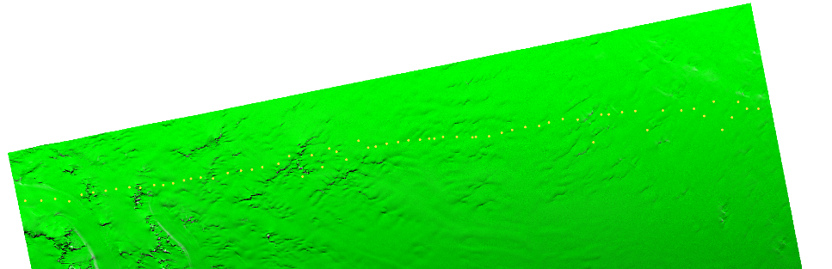
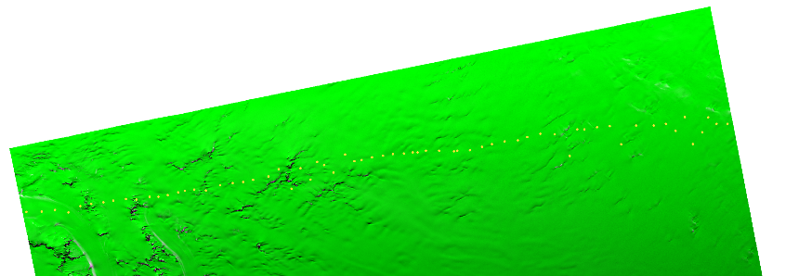
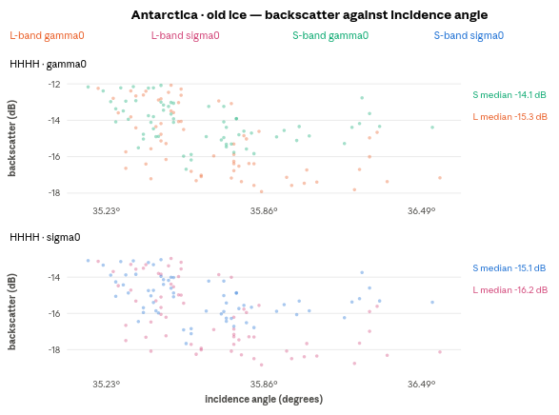
Fig 17. ROIs over old ice. L-band left, S-band right.

Fig 18. Sigma0 and gamma0 against incidence angle, old ice.
Key observations:
a) Divergence: At the low-incidence end of the patch L and S gamma0 are within 0.2 dB of each other; by the far end L has fallen about 4.4 dB and S about 1.4, leaving them roughly 3 dB apart. As with new ice, the axis spans only 1.4° and cannot carry an angular trend; this is a north–south gradient across the ice, not a response to geometry.
b) dB levels: Old ice is the darkest surface either instrument was pointed at in this study, and the question is whether each band can still detect it. The rest of this section sets out that measurement.
Table 9: Old ice against open water and the noise floor, Antarctica
 | L-band | S-band
Noise floor (HHHH) | −19.69 dB | −15.02 dB
Old ice | −16.10 dB | −15.10 dB
Margin above own floor | +3.59 dB | −0.09 dB
Open water | −19.74 dB | −15.02 dB
Old ice minus water | +3.64 dB | −0.08 dB
New ice | −2.37 dB | −3.93 dB
New ice minus old ice | 13.73 dB | 11.17 dB

c) In L-band, old ice sits 3.6 dB above open water and 3.6 dB above the noise, which makes it a separable class. In S-band, old ice, open water and the noise floor all fall within 0.1 dB of each other. To the measurement, all three are the same value.
d) One class in one band, and more than half of its ROIs are indistinguishable from that band's noise. Every other combination measured here (vegetation at two sites, new ice, both polarisations, both bands, 1,100-odd ROI measurements) returns zero. The failure is confined to that one combination, affects the majority of its ROIs, and has no counterpart elsewhere in the set.
This is not a marginal result that better statistics would resolve. The ROIs are 900 pixels each, 66 of them for old ice, 13 for water, and the two bands' ENL precisions are both ±7.3%. The separation L finds is an order of magnitude larger than the uncertainty; the separation S finds is an order of magnitude smaller.
e) An ice-type classifier given the S-band HH channel alone over this scene has no basis for distinguishing old ice from open water: both return the floor. The same classifier on L-band has 3.6 dB to work with. New ice is bright enough that both bands see it easily (+17.3 dB and +11.1 dB of margin), so the failure is specific to the dark end of the ice range, which is where the discrimination problem actually lives.
f) Old ice is a weak scatterer at both wavelengths; what differs is where each instrument's noise sits beneath it. S's floor is 4.67 dB higher here, and old ice falls inside that difference. This is a sensitivity limit, not a statement that S-band is blind to old ice physics: a quieter S-band channel, or one of its other polarisations, could place the same surface above its own floor. Only HHHH was acquired at this site.
g) Open water in forming ice: It is the obvious challenge to this result. The scene was imaged in September, when the surface is freezing, and frazil or grease ice roughens water at centimetre scales, which brightens a 9.4 cm radar far more than a 24 cm one. If S-band were reading a real return from forming ice rather than its own noise, the floor derived from these ROIs would be too high and the old-ice result would be overstated. Two things in the ROI statistics bear on it:
- The S-band water ROIs barely vary. Across the 13 of them S's sigma0 has a standard deviation of 0.28 dB, the tightest figure of any class in this study. Delta water scatters 0.92 dB in the same band and Amazon water 1.11 dB; classes both instruments clearly resolve scatter 0.7 to 1.7 dB. A surface returns different values from place to place, whereas a noise floor returns much the same number everywhere; 0.28 dB is consistent with the latter.
- L-band over the same ROIs is darker here than anywhere else, at −19.81 dB against −18.88 at the delta and −16.24 at the Amazon. Roughening strong enough to lift S 4.8 dB above L at this site should lift L somewhat as well. Instead L falls.
Neither point settles it, since a uniformly frozen surface would also vary little, but together they favour S genuinely sitting on its floor over this water. The caveat still bounds the result in a useful direction: if any part of S's −15.0 dB is forming ice rather than noise, S's true floor is lower than quoted, and old ice clears it by more than the table shows, not less. The failure reported here is in that sense a conservative one.
Antarctic old ice: In the three-class figure at the head of this section, the S sigma0 point for old ice lies on the blue dashed line, and the S point for open water lies on that same line at the same height. L's old-ice point is clearly above its own floor line, while L's water point sits on it. One band separates those two surfaces; the other does not.

Open water
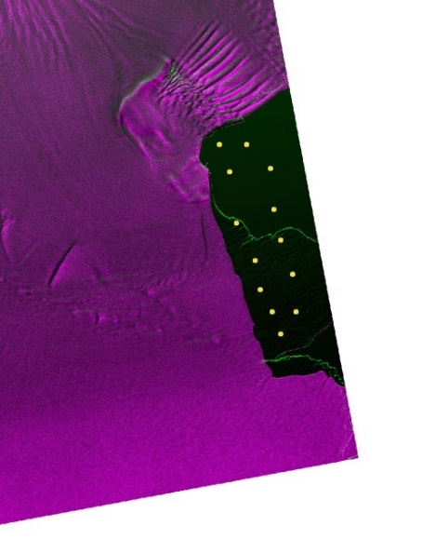
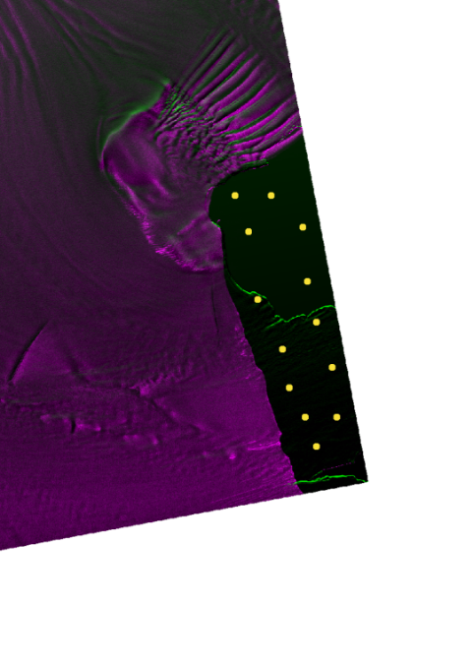

Fig 19. ROIs over open water. L-band left, S-band right.
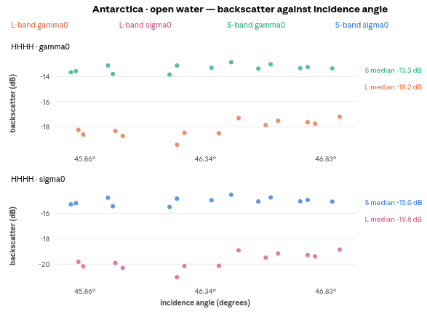
Fig 20. Sigma0 and gamma0 against incidence angle, open water.

The offset: Across the 1.09° this class spans, L's gamma0 moves by +1.1 dB and S's by −0.2, and the separation between them runs from about 4.7 dB at one end of the patch to 3.9 at the other. Over a specular surface that returns almost nothing, a gap that size between two instruments looking at the same water on the same pass is not a property of the water.
The two floors. Open water is what defines each band's floor in this study, so these two traces are, to within their scatter, the floors themselves. The water margins reported later are therefore near zero by construction and carry no information.
Sample size. Only 13 water ROIs are available here, and the bin-to-bin scatter of about a decibel in L reflects that rather than any structure in the water.

Across the three sites
These are the findings that take more than one site to see. Everything here is sigma0 unless a line says otherwise, and margin means a class's mean minus its own band's noise floor, never the other band's; the comparison is how far each instrument lifts a surface clear of its own noise.
Bright surfaces: In the Amazon vegetation panel the L and S co-polarised points are indistinguishable at the plotted scale. In the Sundarban vegetation panel they are within half a bar width, 0.04 dB apart at the Amazon and 0.66 dB at the delta. The two canopies differ from each other by more than the two instruments differ over either: Amazon vegetation sits about 2.0 dB above Sundarban vegetation in L and 2.6 dB above it in S, which is what a closed, saturating canopy should do against the delta's mixed tidal vegetation. These are two different surface types, acquired in different polarisations, so that comparison is indicative rather than like-for-like. Where there is plenty of signal, the two instruments agree.
Dark surfaces: S-band's floor sits higher than L-band's in every panel where both are drawn. In the delta water panel L's cross-pol point is well clear of its own dashed floor line while S's sits on its own. In the Amazon water panel both bands are already at their own floors.

Noise floor, per band and polarisation
Table 10: Sigma0 noise floor by band and polarisation
Site | Polarisation | L floor | S floor | S higher by
Sundarban delta | HHHH | −18.33 dB | −17.13 dB | 1.20 dB
Sundarban delta | HVHV | −24.68 dB | −19.63 dB | 5.05 dB
Amazon | VVVV | −16.50 dB | −15.30 dB | 1.20 dB
Antarctica | HHHH | −19.69 dB | −15.02 dB | 4.67 dB

A stricter bound: The same nesz_estimate export also records the darkest single water ROI in each product, which is where the floor could lie if the pooled mean is still carrying scene: −21.80 dB and −26.91 dB for delta L in HH and HV against −19.59 and −21.94 for delta S, −21.21 dB for Amazon L in VV against −18.47 for S, and −21.02 dB for Antarctica L against −15.49 for S. Read that way the S-band penalty is wider still, 5.53 dB at Antarctica against the 4.67 dB the pooled means give, because pooling lifts a floor that one quiet ROI shows to be lower. Every result below uses the pooled figure, which is the conservative choice.
S-band's floor is higher in every comparable channel, and the gap widens in cross-pol and over ice. S's own cross-pol channel at the Amazon (VHVH, −19.35 dB) is its best floor anywhere in this set, so the penalty is not uniform across its channels.

Looks
At the two sites where posting is identical, L's ENL is consistently 1.7–1.9× S's, in every class and polarization:
Table 11: Equivalent number of looks at the matched-posting sites
Site | Pol | Class | L ENL | S ENL | Ratio
delta | HHHH | vegetation | 3.40 | 2.20 | 1.55×
delta | HHHH | water | 4.88 | 2.65 | 1.84×
delta | HVHV | vegetation | 4.05 | 2.44 | 1.66×
delta | HVHV | water | 5.17 | 2.75 | 1.88×
Antarctica | HHHH | new ice | 5.02 | 2.70 | 1.86×
Antarctica | HHHH | old ice | 3.90 | 2.28 | 1.71×
Antarctica | HHHH | water | 5.23 | 2.77 | 1.89×

At ±7.3% to ±11% per figure, a ratio of 1.5× or more is well outside the error. L's spread within a class is also consistently larger, 5.98 dB against 3.56 dB for Sundarban vegetation, 5.57 against 3.56 for new ice. The apparent reading is that L resolves more real variation, being also the less speckled of the two. The next section shows that most of that extra spread has a simpler cause.
The two conventions: The two conventions of a given band sit in the same order in every panel, offset by 1.20–1.29 dB at the delta and the Amazon but by 0.93 dB over Antarctic old ice and 1.62–1.72 dB over Antarctic new ice and water. The factor is per-pixel, so the offset follows the terrain rather than being one number. The spread moves with it too, between 0.86× and 1.18× the gamma0 spread, because the brightest and darkest ROIs in a class feel a varying factor most. The RTC conversion shifts a whole class and reorders nothing, which is why fixing one convention is sufficient, and why the class figures and the noise-floor results below are all sigma0.
The cos θ check: Fitting the two conventions separately against incidence and subtracting gives the same number in every series with enough span to support a fit, fourteen of them, spanning all three sites, both bands and every class: between −0.0648 and −0.0669 dB/deg, mean −0.0659. Regressing 10·log₁₀(cos θ) on those same ROIs' incidence angles predicts −0.0658 on the same average, and no individual series departs from its own prediction by more than 0.0013 dB/deg. Both processors are applying σ⁰ = γ⁰·cos θ exactly. This validates the RTC factor from the ROI exports alone, and it is why the gamma0 column above is the one that carries surface information.
The other two sites: The Antarctic classes each span under 1.4° of incidence (new ice 0.36°, old ice 1.37° and water 1.06° within a single band, 0.39°, 1.40° and 1.09° pooling the two), and a slope fitted over that range returns a large number that is fitting scene variation, not an angle effect. The three Antarctic figures therefore plot their points without fitting anything to them; anyone recomputing the regressions from the CSVs will get −13 to +1 dB/deg, artifacts of a short lever arm.
Site specific: In the delta vegetation figure, L's gamma0 trace falls steadily while S's stays flat; regressing every ROI gives −0.283 dB/deg in HH and −0.306 in HV, against S's +0.025 and −0.038. Over Amazon canopy, with 13.0° of span to work with, the same regression gives L −0.007 dB/deg at R² 0.01 against S's +0.028 at R² 0.17, so L is the flatter of the two. One site shows it, the other does not. The polarisation pair differs between them and so does the canopy, and this data cannot say which is responsible.
Water slopes: Water should darken or stay flat as incidence grows, and L's does. S's does the opposite. Regressing every ROI: +0.280 dB/deg in delta HH at R² 0.66, +0.300 in delta HV at R² 0.81, and +0.099 over Amazon water in VV, where L falls at −0.072. S-band water sits on its own floor at both sites, so the leading reading is that what rises across the swath is the floor rather than the surface. This is offered as an interpretation, not as established: a NESZ profile against incidence angle would settle it and is not in this data.

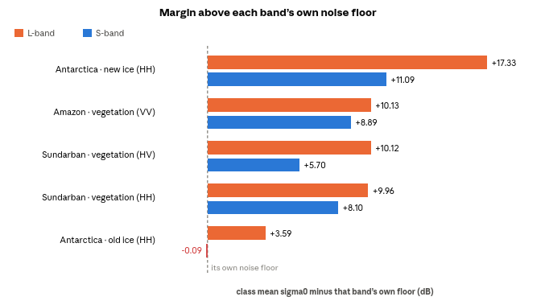
Margin above each band's own noise floor
Fig 21. Sigma0 margin above each band’s own noise floor
Bars run from each band's own floor, so length is usable dynamic range over that surface. Four of the five surfaces clear both floors comfortably and the two bands track each other within about 2 dB. The fifth does not: Antarctic old ice sits 3.59 dB above L's floor and 0.09 dB below S's.

Conclusion
On bright distributed targets the two instruments are radiometrically interchangeable: Amazon co-pol canopy differs by 0.04 dB, Sundarban vegetation by 0.66 dB in HH and 0.63 dB in HV. Any of those is inside what a calibration campaign would call agreement. Two sensors that differed everywhere would suggest a calibration problem; two that agree on bright ground and diverge on dark ground are describing a difference in noise floor.

Real band differences
L-band's noise floor is lower in every comparable channel: by 1.20 dB in delta HH and Amazon VV, 4.67 dB in Antarctic HH, 5.05 dB in delta HV. That single fact produces every other result here:
- Antarctic old ice is separable in L (+3.59 dB) and not in S (−0.09 dB).
- Land–water contrast is 10.40 dB in L against 8.36 dB in S (HH), and 9.99 against 5.89 in cross-pol.
- The advantage grows as the surface darkens and is largest in cross-pol, which is the dimmest channel and therefore the one the floor reaches first.
This is dynamic range at the dark end, not penetration. The data here cannot show a volume-scattering advantage, because the surfaces where L and S were both well above their floors gave nearly identical means. Any penetration effect is masked by a sensitivity effect that is much larger.
L-band's response to incidence angle is real at the delta and absent at the Amazon, which makes it a site result, not the second band difference. Over Sundarban vegetation L's gamma0 falls 0.283 dB per degree in HH and 0.306 in HV, against S's +0.025 and −0.038: roughly 3 dB across the 10.8° the ROI set spans, against under half a dB for S, with the same ROIs on the same pass showing the trend in one band and not the other, which is what rules out geography there. Over Amazon canopy the same regression gives L −0.007 dB/deg at R² 0.01 and S +0.028 at R² 0.17. Two things differ between the sites: the polarisation pair (HH/HV against VV/VH) and the canopy (the delta's mixed tidal vegetation against closed, saturating Amazon forest). This data cannot say which is responsible. The practical reading for anyone mosaicking L-band GCOV across a swath is that the correction can reach several dB and has to be measured per scene rather than assumed from the band. All slopes here are gamma0; a sigma0 slope carries a further −0.066 dB/deg of pure cos θ.
L carries 1.55–1.89× S's looks at the two sites where both are posted at 10 m, consistently across every class and polarisation, at ±7.3–11% precision. Equal posting with unequal ENL is a multilooking difference, a choice made in the processor, not a property of the wavelength. It is worth separating from the floor result because the remedy differs: more looks can be bought by averaging, whereas a lower noise floor cannot.
It may also partly explain the floor gap. A product with fewer looks has a noisier estimate of anything near its floor, so some of S's 1.2–4.7 dB could be looks rather than raw sensitivity. This data cannot separate those two, and a measurement over a calibrated dark target would be needed to.

Limits of the measurement
- Water margins: The floor is the pooled mean over water, so every water margin comes out near zero. The range it actually spans is reported with the results. Only the other classes' margins carry information.
- Amazon ENL: Its ROIs are free rectangles rather than a fixed square, spanning 4 to 1,548 pixels; the median is 15 px (L water) and 48 px (L vegetation), which is 2 to 24 independent samples, where the estimator is heavily biased high. The dB means from those ROIs remain usable, since a mean converges where a ratio of moments does not.
- Amazon posting: L is posted at ~68 m against S at ~37 m, so pixel counts, ENL and spread are not comparable between the bands there. Only the dB means are. The delta and Antarctica are 10 m in both bands and compare fully.
- Three sites. Enough to establish a pattern that repeats across surfaces; not enough to characterise either instrument.

Next steps
The single most valuable addition would be S-band cross-pol over the Antarctic site. S's best floor anywhere in this set is its Amazon VHVH channel at −19.35 dB, lower than its Antarctic HH floor by 4.3 dB, and low enough that old ice at −15.10 dB would clear it by 4 dB. The failure reported here is specific to the channel that was acquired, and a different S-band channel might not fail at all.

Appendix: an independent check on two GSLC products
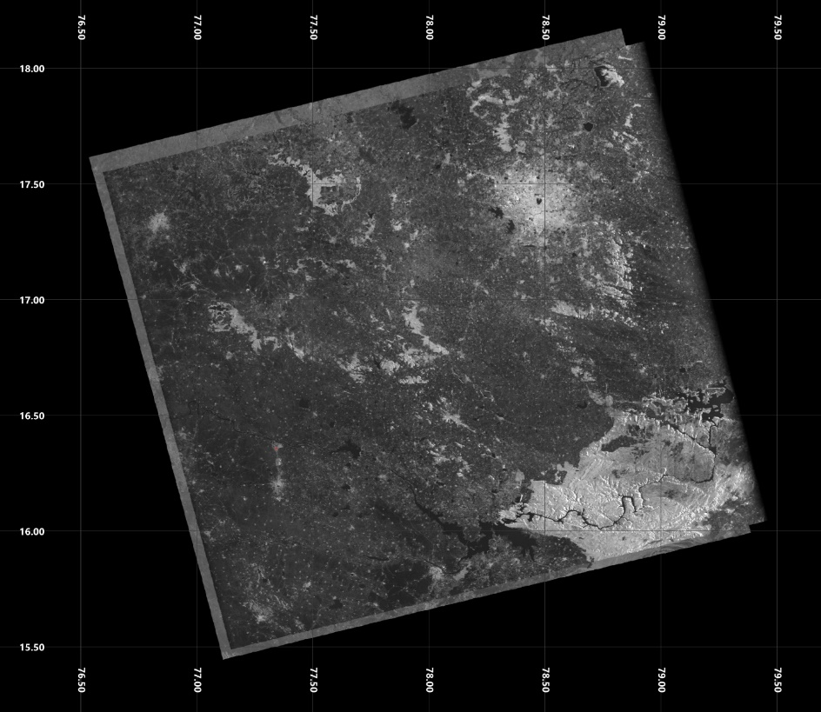
Fig 22. LSAR and SSAR GSLC products over Hyderabad
The S-band swath is about 250 km in range and 248 km in azimuth; the L-band swath is 256 km in range and 236 km in azimuth.
Because of that difference, S-band covers more ground in azimuth for the same track and frame, while the L-band scene starts and ends later in range.
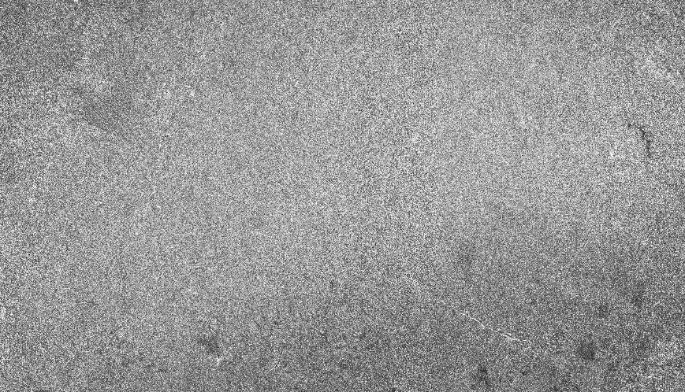
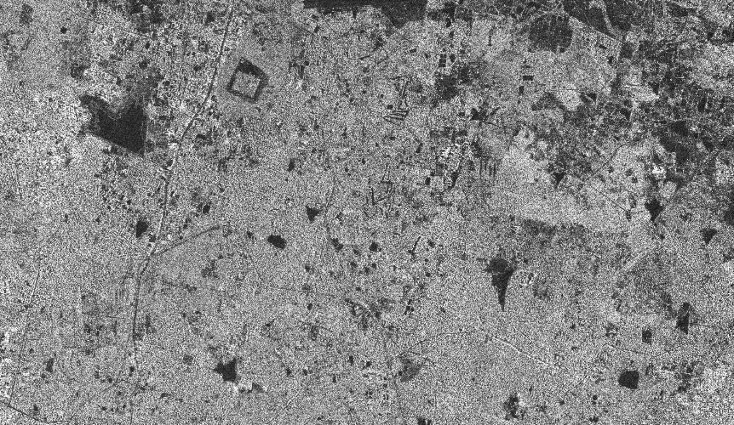
L-band is sharper and crisper with more identifiable features, whereas the S-band looks to be full of speckle and blur at some places. Most of the features are not visible in S-band.

Fig 23. LSAR and SSAR GSLC products over north Hyderabad
From the figure above, it can be seen that several lakes are blurred out in S-band and most of the roads vanished which are clearly seen in the L-band. To quantify these differences, the GCOV comparison reported above was carried out.
An independent check. The same two instruments were compared as GSLC products over Hyderabad. That study cannot measure the quantities reported above, but it reaches a compatible conclusion: S-band delivers less usable detail.
Table 12: GSLC product details
Products | NISAR_L2_PR_GSLC_… and NISAR_S2_PR_GSLC_…, frame 028/084
Acquired | 2026-08-19, L 00:17:34–00:18:08, S 00:17:33–00:18:10 — one pass
Posting | 5 m both, EPSG:32644
Sampled | five windows, two layers per product — 20 measurements

Different ground, a different date, and above all a different product level. GSLC is geocoded single-look complex, detected to amplitude, so:
- the values are uncalibrated amplitude, not sigma0, so no dB figure here is backscatter, and no brightness comparison is possible;
- it is single-look, so ENL is 1 by construction and carries no information about the processor;
- there is no RTC factor, no noise floor and no margin. None of the machinery used above applies.
What GSLC does support is a comparison of image quality: how much ground a pixel really represents, how much of the variation is speckle, and whether scene structure stands above that speckle.

The measurements
aniso is effective resolution across ÷ along
tex@40m is variation surviving averaging to 40 m over what speckle alone would leave, where 1.0 means nothing is there
cv_floor is the coefficient of variation of the most homogeneous sub-block, 0.52 being fully developed single-look speckle
cv_scene is scene contrast with speckle removed
cnr@40m is how many speckle sigmas a feature stands out by at 40 m.

Table 13: GSLC image-quality factors
Metric | L-band | S-band | Reading
aniso | 0.83–1.28 | 0.59–0.83 | all ten S layers coarser in y than x; L scatters either side of 1.0
tex@40m | 2.07–2.91 | 1.49–2.14 | L carries more scene texture at every window
cv_floor | 0.521–0.605 | 0.507–0.527 | S sits on the single-look figure; L runs above it
ENL | 0.75–1.01 | 0.99–1.06 | both single-look, as GSLC should be
cv_scene | 0.458, 0.497 | 0.166, 0.262 | S recorded a third to a half of L's scene contrast
cnr@40m | 5.13, 6.56 | 1.67, 2.61 | L clears the Rose criterion; S does not reach it

The last two rows are one window, the only one where the contrast block was computed. Against the Rose criterion (5 or more reliably visible, 3 marginal, below 2 invisible however the image is stretched), the tool's own verdict was features clearly visible for both L layers and nothing discernible above speckle for both S layers.
S-band is consistently coarser along one map axis, by about 7 m against 5 m where L is near-isotropic. The direction is the same in every window of both S layers, which is the signature of a sampling or processing choice rather than of terrain, since terrain does not favour one map axis across 150 km.
Table 14: Comparison of the two studies
 | GCOV, three sites | GSLC, Hyderabad
What was measured | calibrated sigma0 per ROI | uncalibrated amplitude per window
S-band shortfall | noise floor 1.2–4.7 dB higher; about half the looks | smoothed along one axis; a third to a half the scene contrast
Sharpest consequence | old ice inseparable from water | nothing discernible above speckle
Neither study can observe the other's quantity. A noise floor cannot be measured on an uncalibrated single-look product, and scene contrast against speckle is not what an ROI mean reports. The two nevertheless agree.

