NRSC-DPA-DE&ADPG-MPAD-OCT 2026-TR-0003323-V1.0

NRSC | NISAR L & S band comparisonsover three Radiometric Sites



nrsc

National Remote Sensing Centre
Indian Space Research Organisation

Hyderabad-500 037

October 2026

Control Sheet

 | Security Classification | Classified
 | Distribution | ISRO/DOS
 | Document | (a) Issue 1.0 |  | (b) Revision  & Date |  |  | 1.0  14th Oct 2026
 | Report / Document Type | Technical Report
 | Report / Document No | NRSC-DPA-DE&ADPG-MPAD-OCT 2026-TR-0003323-V1.0
 | Title | NISAR L & S band comparison on GCOV Products
 | Collation | Pages  10 | Figures/plots  1/6 |  | Tables  1 | Annexure References  -
 | Project | NISAR L & S band GCOV comparison over three radiometric sites
 | Analysis Team | S.Srisudha , Anupam Das
 | Compiled by  Reviewed by  Approved by | S.Srisudha  RVG Anjaneyulu, GH,ADPG
 | Affiliation of authors | NRSC
 | Originating unit | DPA
 | Sponsor(s)  Name  Type | N.A
 | Date of Project Initiation | October, 2026
 | Date of Publication | October, 2026
 | Abstract: This report summarizes thecomparisons of sigma0 and gamma0 of NISAR L & S band GCOV products over three radiometric sites

NISAR L & S band GCOV comparison over three radiometric sites

Introduction

NISAR mission
NISAR (NASA–ISRO Synthetic Aperture Radar) is a joint mission of NASA and ISRO. It carries two radar instruments: the L-band system provided by NASA and the S-band system provided by ISRO. This division is also reflected in the product metadata: the L-band products examined here identify the Jet Propulsion Laboratory as the originating organisation, while the S-band products identify ISRO. The mission has a 12-day repeat cycle, allowing the same areas to be observed at regular intervals.[1, 2]
A comparison between radar wavelengths often involves different satellites, acquisition dates and processing chains. These differences can make it difficult to attribute observed changes to wavelength alone. NISAR avoids many of these limitations because both instruments observe the same site during the same pass. Every site in this report was imaged by the L-band and the S-band instrument within seconds of each other, from the same orbit, at incidence angles matching to within 0.03°. Conditions on the ground and the viewing geometry are therefore effectively common to these datasets; remaining differences may arise from the instruments, their wavelengths or their processing.

Backscatter
A synthetic aperture radar illuminates the ground with its own microwave pulse and records how much energy it returns. That returned fraction, normalised for the size and orientation of the patch it came from, is backscatter, and it is the quantity is reported in decibels for the subsequent sections. Backscatter is not brightness in the ordinary sense: backscatter responds to roughness at the scale of the radar's own wavelength, to moisture, and to structure within and beneath the surface. For example, calm water reflects the pulse away from the radar and sends almost nothing back; whereas vegetation can scatter energy from leaves, branches and other parts of the canopy and sends back to a certain extent. The analysis examines how well the two bands distinguish surfaces with strong and weak returns, particularly where the return approaches the instrument noise floor.

Product level
The products used here are Level-2: the raw radar signal has already been focused, calibrated into backscatter, corrected for terrain against a Copernicus GLO-30 elevation model and laid onto a UTM grid on the WGS-84 ellipsoid[3–5, 9]. A pixel therefore has a position on the Earth rather than a position in the radar's own viewing geometry, so the same region of interest can be measured in two different products. Across the three sites the regions of interest fall between 33.7° and 47.2° of incidence, which is the span the swath covers from its near edge to its far edge.

Scope
This report compares L- and S-band GCOV products at three sites selected to represent different surface conditions. It describes the two radar bands and the relevant GCOV product characteristics, explains the site-selection criteria and measurement procedure, and presents the results for each surface class. The final sections bring together the findings that are common across the sites.
LSAR and SSAR
Both radar instruments share the same spacecraft and orbit. Consequently, each site considered in this report was acquired by the two bands during a single pass but by only seconds apart.
Table 1: LSAR and SSAR configurations
 | LSAR | SSAR
Centre frequency | ~1.24 GHz | ~3.2 GHz
Wavelength | ~24 cm | ~9.4 cm

A longer L-band wavelength penetrates further into dry snow, ice and vegetation canopy and responds more to scattering from within a volume; a shorter S-band wavelengthis generally more responsive to smaller-scale roughness and near-surface structure. Since the two instruments observe the same ground under nearly identical geometry, a radiometric difference between them isolates that wavelength dependence from other factors [2, 6].
The expected differences between the bands follow from their wavelengths, although each characteristic also has limitations. Table 2 summarises these physical characteristics:
Table 2: Expected L- and S-band characteristics
 | L-band, ~24 cm | S-band, ~9.4 cm
Response | structure of order a wavelength and larger — trunks, branches, the inside of an ice volume | smaller-scale roughness — leaves, twigs, surface texture
Penetration | further into dry snow, ice and canopy, so more of the return comes from within the volume | less far; the return is weighted towards the surface
Expected strength | complex targets with internal structure, as well as dark surfaces with weak returns | bright rough surfaces and fine-scale texture, from a smaller antenna for the same beam
Expected cost | a larger antenna for the same beamwidth, and far more Faraday rotation through the ionosphere, which scales with the square of the wavelength | saturates sooner over dense canopy, and sees less of what lies beneath a surface

Polarisation
A radar transmits its pulse with the electric field oriented in one direction and can recieve the return in the same or different direction. HH stands for transmitted horizontally and received horizontally, VV means vertically both ways; these are the co-polarised channels. HV and VH are transmitted one way and received the other, and are called cross-polarised. The available channels are determined at acquisition planning and cannot be selected after the data have been collected [5, 6].

a. Cross-polarised channels
HV and VH are produced mainly by multiple or volume scattering, which returns far less energy than the direct surface return in HH or VV, typically 6 to 10 dB less. A cross-pol channel is therefore likely to approach the instrument's noise floor, which makes it the most sensitive test of sensitivity available in this report.

GCOV products
GCOV is the Level-2 geocoded polarimetric covariance product. Level-2 data are processed past the raw radar signal into a calibrated geophysical quantity which places the pixels on a map grid, so a pixel has a position on the ground rather than a position in the radar's own viewing geometry. These three properties are particularly relevant to this assessment [3–5]:
- It carries the covariance matrix's diagonal terms as power: HHHH, HVHV, VHVH, VVVV on a map grid, after terrain correction. A term name doubles the polarisation letters because it is an autocovariance: HHHH is the HH channel's power.
- It is radiometrically terrain-corrected to gamma0, and ships an rtcGammaToSigmaFactor layer, thus it allows sigma0 to be derived for each pixel. This study uses sigma0 throughout.
- GCOV is multilooked, whereas GSLC is a single-look product. This distinction matters because the equivalent number of looks (ENL) can be meaningfully estimated from multilooked data and compared between the two bands[5, 7].
The polarisation channels available in each product depend on the selected acquisition mode. The Sundarban delta and Antarctic pairs both contain HH for the two bands; the comparable co-polarised channel at the Amazon site is VV.
GCOV products were considered for the study for three of these confounding factors:
i) The diagonal terms: The covariance matrix holds cross-products of every polarisation pair. Its off-diagonal terms are complex and retain phase information used in polarimetric analysis, while the diagonal terms are real-valued channel powers. Because this report compares return power, the analysis uses the diagonal terms HHHH, HVHV and VVVV. The off-diagonal terms are not evaluated here.
ii) Terrain correction: GCOV has already undergone radiometric terrain correction. The processor accounts for the illuminated area represented by a pixel, which can differ from the corresponding flat-ground area on sloping terrain. This results in gamma0, referenced to the area perpendicular to the look direction. Sigma0, referenced to the ground area, is recovered by multiplying by the rtcGammaToSigmaFactor layer the product ships. Across the six products examined, the factor ranges from −0.80 to −1.75 dB. Its median is −1.20 dB at the delta and Amazon sites, and −1.65 dB for L-band and −1.71 dB for S-band over Antarctica. Because these adjustments vary across a scene and is not negligible, one backscatter convention must be used consistently in cross-band comparisons.
Multilook: A GSLC is single-look: each pixel is one realisation of the speckle, and ENL is 1 by definition, so the statistic carries no information. GCOV is multilooked, with several independent samples averaged per output pixel, and the number of effective looks is then a real property of the product that varies with how the processor was configured. This is what makes the looks comparison later in this report possible, and is the main advantage of GCOV over GSLC for an assessment of this kind.
GCOV provides a consistent basis for radiometric comparison because it is calibrated, terrain-corrected, geocoded and multilooked. The products can therefore be compared at this level without repeating the processing steps independently. Comparisons made at a lower product level would require equivalent calibration, terrain correction and geocoding choices to be applied to both datasets.
The two instruments acquire each site on the same pass, with only seconds between observations and incidence-angle variance below 0.03°. Nothing on the ground changed between them and the geometry is shared, so a difference can only be the band, the instrument or the processing, and not weather, season or look angle.
Site selection: A site had to be a single pass carrying both bands. The selected sites were chosen to cover a broad range of backscatter: a bright distributed target for radiometric control, a land–water boundary with cross-polarised data in both bands, and surfaces near the dark end of the measurement range.
Table 3: Radiometric sites and the basis for selecting each
Site | Date | Surfaces | Selection rationale
Sundarban delta | 2026-08-24 | vegetation, water | land–water contrast, and cross-pol
Amazon | 2026-07-26 | vegetation, water | dense canopy, the brightest distributed target
Antarctica | 2026-09-12 | new ice, old ice, water | three surfaces across a wide range, two of them dark

1. Sundarban delta: This site was selected to compare vegetation and water classes across a land–water boundary relevant to flood mapping and shoreline monitoring. As water is a specular scatterer and returns almost nothing, the quantity of interest is the contrast between the two classes; the dark end of that contrast is where an instrument's noise floor can be computed. This site is the only site in this analysis that carries a cross-polarised channel on both the bands.
2. Amazon: This site consists of a dense closed canopy, which categorizes as the brightest distributed target a spaceborne SAR encounters. Where the signal is strong, agreement between the bands provides evidence of radiometric consistency. If a difference were also present over this target, calibration would need closer examination; agreement here combined with disagreement over darker surfaces would instead indicate a sensitivity limitation.
3. Antarctica: This site consists of new ice, old ice and water classes. These classes cover a wide backscatter range, with old ice and water at the darker end. The site is relevant to ice-type classification, where separating old ice from open water is an important operational requirement.

Methodology
Measurements were made with RADIAL, an in-house QGIS-based tool written for this assessment: regions of interest are drawn over a loaded GCOV, classified by the classes, and every band's statistics are computed per ROI and exported as a shapefile with CSVs beside it. One ROI set is drawn once and measured against both products, so the two exports differ only by what the products offer and never by where the ROIs fell. Both backscatter conventions come out once, through each product's own rtcGammaToSigmaFactor, gamma0 and sigma0 are calculated from the same pixel read, using the rtcGammaToSigmaFactor belonging to each product. Statistics are computed on linear power at the raster's full resolution.

Regions of interest
a) ROI types. RADIAL supports rectangular ROIs, manually drawn polygons and point buffers. A point buffer is created with one click and a side length specified in metres in the working CRS. The buffer is square rather than circular because an ROI is rasterised by whether a pixel centre falls inside it. The exported data include a 'kind' field identifying how each ROI was defined.
b) Constant geometry. Keeping the ROI shape and size fixed reduces the possibility that the measurements are affected by differences in the sampled area:
- With the same number of pixels in each ROI, the expected ENL precision is also the same. For the 900-pixel Antarctic ROIs, the estimated precision is ±7.3% for all 213 ROIs in both the bands. Differences between these ROIs are therefore not attributable to different ROI sizes.
- Equal pixel counts also give each ROI the same weight when the water samples are pooled to estimate the noise floor. The pooling is performed using linear power and weighted by pixel count.
- Specifying the side length in metres makes the sampled ground area reproducible and it allows the sizing tool to calculate a suitable ROI dimension from a target ENL precision.
- The same ROI set is applied to the second band, so a difference in placement cannot account for a cross-band discrepancy. At the delta and Antarctic sites, the pixel count for each corresponding ROI is identical in both products, confirming that the geometry is matched.
c) Incidence and position
Incidence rises across the swath, so ordering ROIs by incidence also orders them by position along the across-track direction. A fit between ROI coordinates and incidence angle gives a gradient of about 0.054° per kilometre at all three sites, consistent with the acquisition geometry. The variation is mainly east–west at the delta and Amazon sites, where 79% and 83% respectively lie along that axis; at Antarctica, 83% lies north–south. At the two sites with such a wide span indicates that any trend against incidence is also a trend across the scene. Applying the same ROIs to both bands helps assess the difference because the ground locations are common even when the instrument responses are not.
d) The point buffer
An ROI drawn by hand takes several clicks and comes out a different size every time; a point buffer takes one click and a side length typed once, so a thousand ROIs can be placed quickly and every one of them is identical. The Antarctic analysis therefore uses 213 point-buffer ROIs containing exactly 900 pixels each. ROI dimensions can also be selected to meet a required precision: the Suggest function estimates a side length for the target ENL precision and the raster currently loaded.
Table 4: ROI geometry and channels at each site
Site | Band | Polarisations | ROIs
delta | L | HHHH, HVHV | 1034
delta | S | HHHH, HVHV | 1034
Amazon | L | VVVV | 192
Amazon | S | VHVH, VVVV | 192
Antarctica | L | HHHH | 213
Antarctica | S | HHHH | 213

e) Statistics
- All statistics are calculated in linear power after converting the stored pixel values in roi-statistics. The mean of dB pixels sits ~2.5 dB low over single-look speckle. A stored zero represents fill in the power domain but is a valid numerical value in dB, while noise-subtracted GCOV data can contain negative values that must be retained in the linear-power calculation.
- Both gamma0 and sigma0 are exported for each ROI, with sigma0 calculated using the relevant product's rtcGammaToSigmaFactor. Class statistics and noise-floor estimates use sigma0 so that the cross-band comparison follows one convention and the floor is defined consistently. The incidence-angle work is read in gamma0, for the reason given in that section.
- For each class, class_summary reports the average of the ROI means. The class spread is the difference between the highest and lowest ROI means within that class.
- Noise floor (nesz_estimate): pooled mean sigma0 over that band's water ROIs, weighted by pixel count in linear power. This is an upper bound on NESZ rather than a measurement, because the observed water signal contains both scene return and noise. The same export also carries the darkest single water ROI, a stricter bound quoted alongside it below [8].
- Margin is a class's mean minus its own band's floor. The margin indicates how far the surface return lies above that instrument's own floor.
f) Equivalent number of looks (ENL)
ENL is calculated for each ROI using linear power: ENL = (mean / standard deviation)² over valid pixels. Non-finite values and nodata are excluded, as are fill zeros. A constant rescaling moves the mean and the standard deviation together, so an ROI's ENL is the same number in gamma0 and in sigma0. A spatially varying factor can affect ENL through terrain variation. The figure quoted for a class is the median of its ROI ENLs, not the mean, because ENL is a ratio of moments and one heterogeneous ROI should not drag a class figure.
g) Precision: The relative standard error of ENL is approximated by √(2/N), where N is the number of independent samples. A factor of 1.1 is applied to match the variation observed in simulation, and two posted pixels are treated as one independent sample. For a 900-pixel ROI that is N = 450 and 1.1·√(2/450) = ±7.3%, the figure quoted throughout. The divisor of two is the one rule of thumb in that chain, and every precision here scales with its square root. It is tested against a measurement in the Appendix, which returns a smaller value, so the precisions quoted here are the conservative ones.
h) Interpretation: ENL as measured here is the ROI's own homogeneity, not the product's look count. Over a uniform distributed target the two coincide; over an ROI that straddles a boundary the scene's own variation is counted as speckle and ENL reads low. The comparison it supports is therefore between products over the same ROI, which is the comparison made in this report, and not between one ROI and another.

From gamma0 to sigma0:
The two conventions. A GCOV pixel holds gamma0, radar brightness normalised by the illuminated area projected perpendicular to the look direction. Sigma0 normalises by the area projected onto the ground instead. The two differ by a factor set by the local terrain and the viewing geometry, so converting between them is not a constant offset over a scene.
The conversion. Each product carries its own rtcGammaToSigmaFactor layer, produced by the processor from the same elevation model it used for terrain correction. RADIAL multiplies pixel power by that factor before any statistic is taken, so the conversion is per-pixel and carries the terrain with it rather than applying one number to a whole scene.
Effect on the statistics. It is a multiplication on linear power, so it shifts an ROI's mean in dB and leaves cv and ENL where they were wherever the factor is constant across that ROI. Where the terrain varies inside an ROI it moves those too, and that variation is the terrain rather than an error.
Noise floor convention. NESZ is defined against sigma0. A gamma0 figure carrying that name would be wrong by the factor, and since the factor varies across a scene the error would not even be constant.

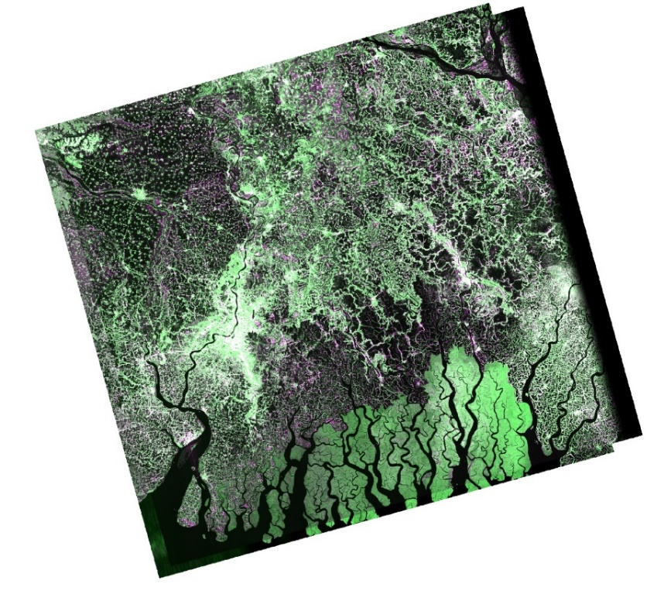
Sundarban delta

Fig 1. Overlap between the LSAR and SSAR GCOV products, pols HH and HV
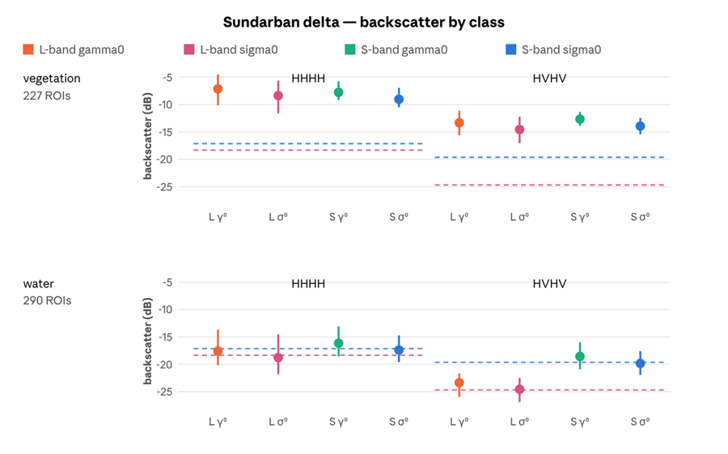
Fig 2. Mean and spread of gamma0 and sigma0 over vegetation and water in HH and HV, both bands. The dashed line is each band’s own sigma0 noise floor.

Table 5: Sigma0 statistics by class, Sundarban delta
Band | Pol | Class | ROIs | Mean dB | Spread dB | ENL | Margin
L | HHHH | vegetation | 227 | −8.37 | 5.98 | 3.40 ±11% | +9.96
S | HHHH | vegetation | 227 | −9.03 | 3.56 | 2.20 ±11% | +8.10
L | HVHV | vegetation | 227 | −14.56 | 4.88 | 4.05 ±11% | +10.12
S | HVHV | vegetation | 227 | −13.93 | 3.03 | 2.44 ±11% | +5.70
L | HHHH | water | 290 | −18.77 | 7.30 | 4.88 ±11% | −0.44
S | HHHH | water | 286 | −17.39 | 4.88 | 2.65 ±11% | −0.26
L | HVHV | water | 290 | −24.55 | 4.42 | 5.17 ±11% | +0.13
S | HVHV | water | 286 | −19.82 | 4.35 | 2.75 ±11% | −0.19

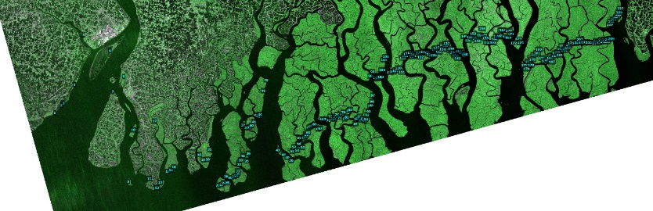
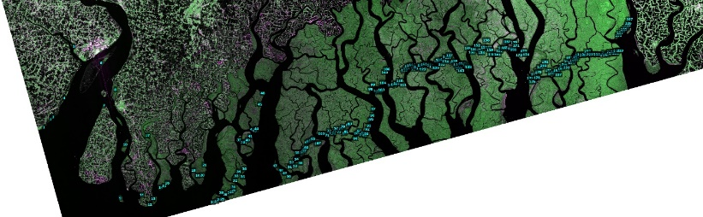
Vegetation
Fig 3. ROIs over mangrove vegetation. L-band left, S-band right.

Key observations:
a) Swath trend: From the near edge of the ROI set to the far edge, L's gamma0 falls 1.7 dB in HH and 1.9 dB in HV, while S's moves by +1.1 and −0.1. Each band's sigma0 trace runs below its gamma0 trace and falls about 0.7 dB further still; that extra is the cos θ term of the conversion, not a property of the canopy.
b) Crossover: In HH, L starts 1.7 dB above S and ends 1.1 dB below it. Any single-number comparison of these two products over this class therefore depends on which part of the swath it is taken, thus resulting in regression.
c) Cross-pol: L's HV gamma0 starts 0.6 dB above S's and ends 1.2 dB below, so the separation grows with angle in the dimmest channel, the one closest to each instrument's noise floor.
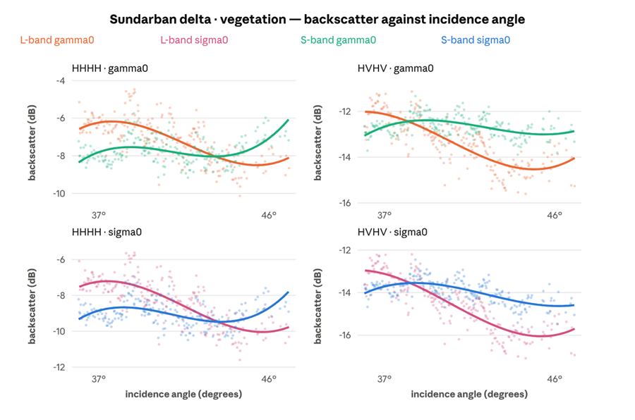
Fig 4. Sigma0 and gamma0 against incidence angle, vegetation.

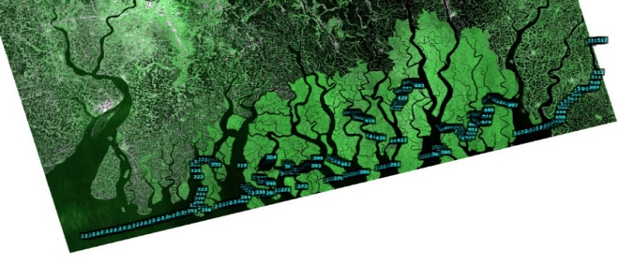
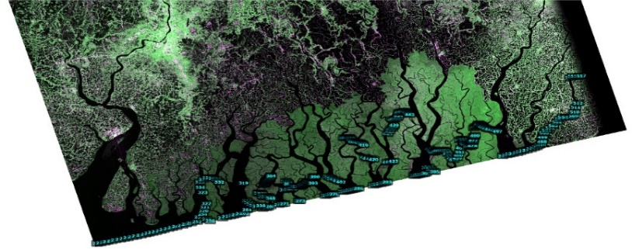
Water

Fig 5. ROIs over water. L-band left, S-band right.

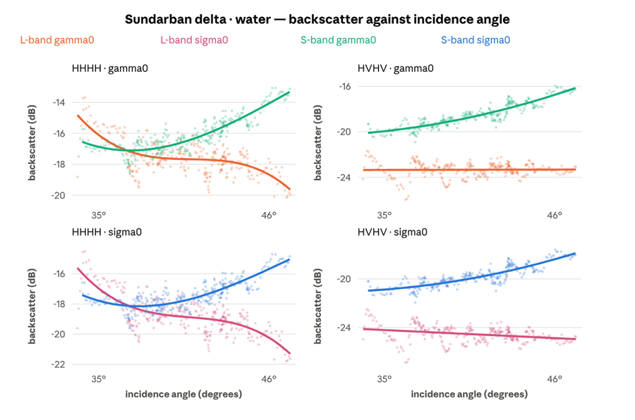
Fig 6. Sigma0 and gamma0 against incidence angle, water.
Key observations:
a) Reverse trend: Across the swath L's gamma0 over water falls 3.3 dB in HH and is flat in HV, while S's rises 3.4 dB in HH and 3.6 dB in HV. A specular surface should darken or stay flat as the radar looks further off nadir, so L behaves as the physics predicts and S does not.
What rises across the swath would then be the floor rather than the surface. This is offered as an interpretation and not as a measurement: nothing in this data separates the two, and a NESZ profile against incidence angle would settle it.
b) Cross-pol separation: At the near edge L's HV gamma0 sits 3.1 dB below S's; at the far edge, 7.1 dB below. Cross-pol is the dimmest channel and the first to reach a floor, so it is where the two instruments diverge most over dark ground.
c) Incidence angle. The delta ROI set spans 36.3° to 47.1° of incidence, which is wide enough to fit a trend. Each ROI mean was regressed on that ROI’s own incidence angle, within the vegetation class. A sigma0 slope carries a −0.066 dB/deg geometric term contributed by the RTC conversion itself, demonstrated below, and so overstates every surface’s angular response by that much.
d) dB levels: Within-class spread is reported in the cross-site section as 5.98 dB against 3.56 dB in HH. Removing the incidence trend drops L's gamma0 standard deviation by 28% (1.14 → 0.82) and S's by 1% (0.67 → 0.66). Most of L's extra spread is neither noise nor scene; it is the swath.

Table 6: Incidence-angle regressions, Sundarban vegetation
Pol | Band | gamma0 slope | R² | Across the 10.8° span | sigma0 slope
HHHH | L | −0.283 dB/deg | 0.48 | 3.0 dB | −0.348
HHHH | S | +0.025 dB/deg | 0.01 | 0.3 dB | −0.041
HVHV | L | −0.306 dB/deg | 0.64 | 3.3 dB | −0.372
HVHV | S | −0.038 dB/deg | 0.06 | 0.4 dB | −0.104

e) ROIs at different incidence angles are also at different places on the ground, so the two are confounded in principle. Here they are separable, because the same ROIs fall over the same ground, on the same pass were measured in both bands. If the trend were geography it would appear in both. It appears in one, at eight times the slope and eleven times the R² in cross-pol, and with the opposite sign in co-pol. At this site, the difference is the instrument's response to angle.

Amazon
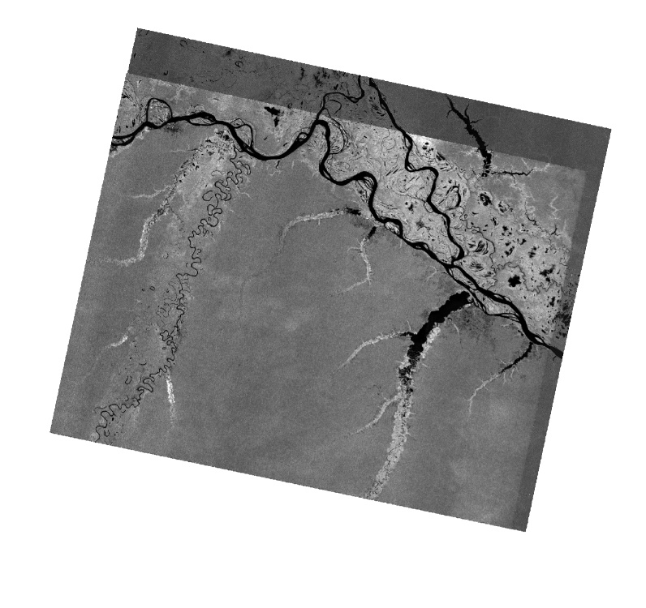

Fig 7. Overlap between the LSAR and SSAR GCOV products, pols VV and VH

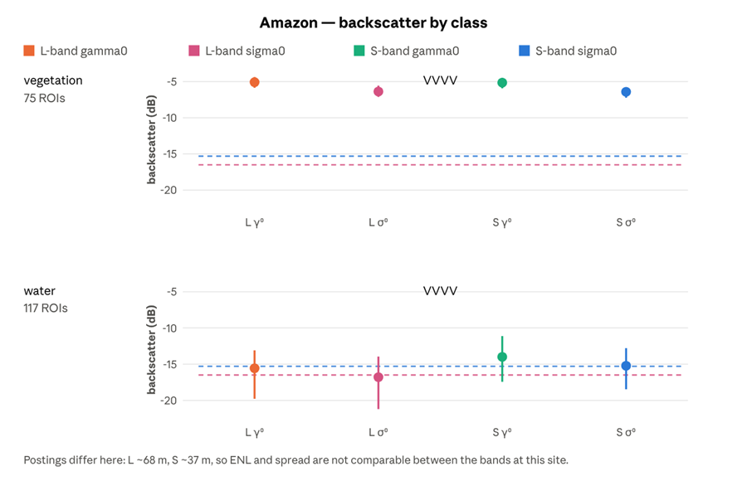
Fig 8. Mean and spread of gamma0 and sigma0 over vegetation and water in VV, both bands. The dashed line is each band’s own sigma0 noise floor.
Across both classes the two bands land on the same canopy value to within 0.04 dB, and that agreement is the radiometric control the rest of this report is read against. In Fig 8 each point is the mean of the ROI means, the whisker spans the brightest to the darkest ROI in the class, and the dashed line is that band’s own sigma0 noise floor. VV is the only channel available with both the bands.
Table 7: Sigma0 statistics by class, Amazon
Band | Pol | Class | ROIs | Mean dB | Margin
L | VVVV | vegetation | 75 | −6.37 | +10.13
S | VVVV | vegetation | 75 | −6.41 | +8.89
S | VHVH | vegetation | 75 | −12.46 | +6.89
L | VVVV | water | 117 | −16.80 | −0.30
S | VVVV | water | 116 | −15.22 | +0.08
S | VHVH | water | 116 | −19.32 | +0.03

The co-polarised vegetation means differ by 0.04 dB, −6.37 against −6.41, across two radars and two wavelengths. On a bright distributed target the two instruments are radiometrically interchangeable to well inside any useful tolerance. It is the closest agreement in the set, and it is what allows the disagreements elsewhere to be read as real differences rather than as calibration error.

Vegetation
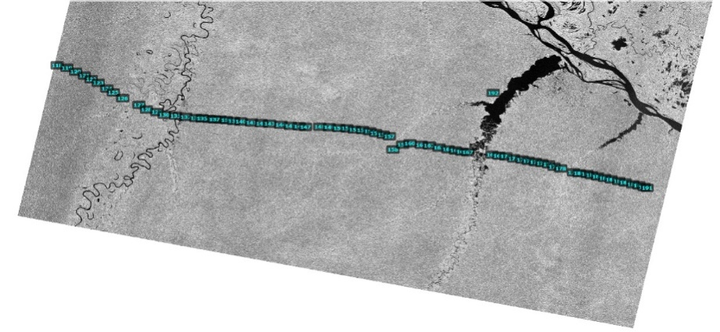
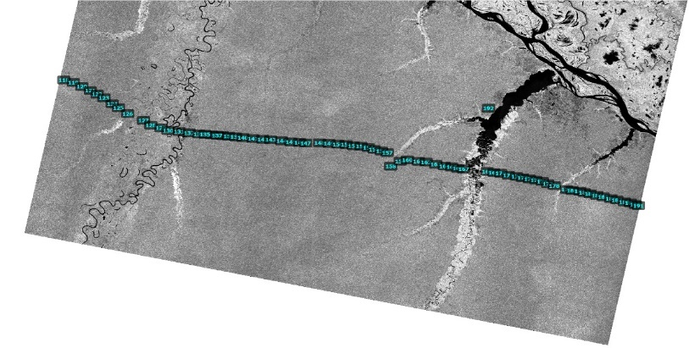

Fig 9. ROIs over vegetation. L-band left, S-band right.

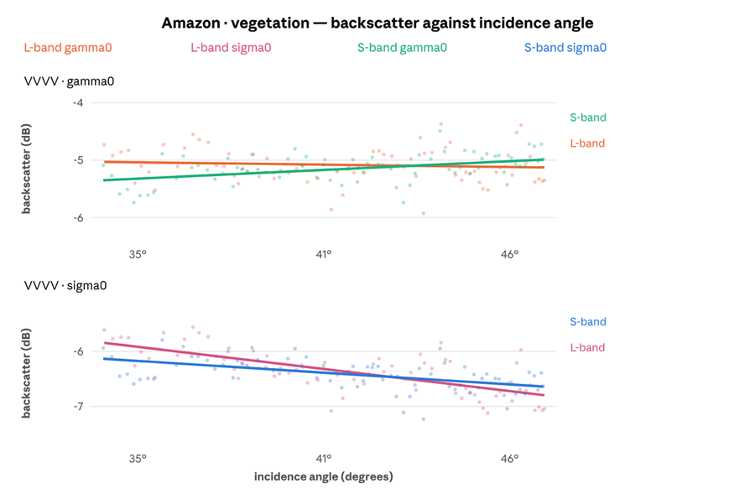
Fig 10. Sigma0 and gamma0 against incidence angle, vegetation.
Backscatter levels. Across 13° of incidence L's gamma0 moves by −0.1 dB and S's by +0.4, and the two fitted traces stay within about 0.3 dB of each other the whole way. Over the brightest distributed target in this study the two instruments are interchangeable, and this is the control the rest of this report is read against. The two conventions sit about 0.9 dB apart and separate very slightly with angle, which is the same geometric term that appears in every panel.
No L-band trend: The steep fall L shows over Sundarban vegetation does not repeat: regressing every ROI gives L −0.007 dB/deg at R² 0.01 against S's +0.028 at R² 0.17. Whatever produces the delta trend, it is not a property of the band that travels between sites.

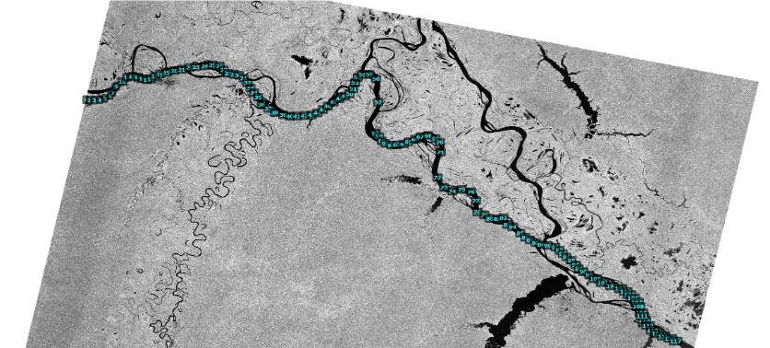
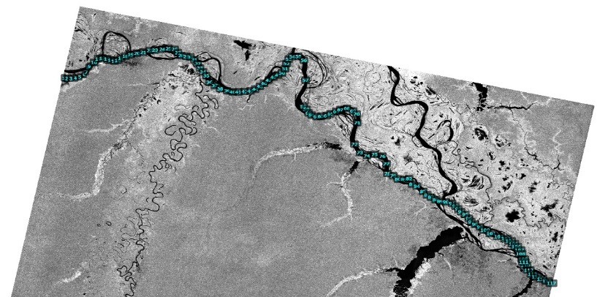
Water
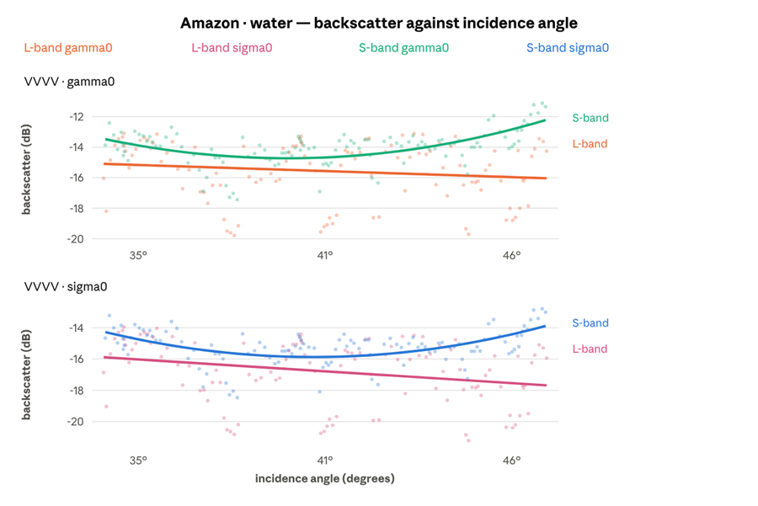
Fig 11. ROIs over water. L-band left, S-band right.
Fig 12. Sigma0 and gamma0 against incidence angle, water.
Repeat of the delta: L's gamma0 over Amazon water falls 2.2 dB across the swath while S's rises 1.1 dB, the same opposition of sign seen over delta water, and open to the same reading: S-band water is on its own floor at this site too.
Widening gap: Over the darkest class at this site, the gap between the two instruments opens with incidence angle, from about 0.4 dB at the near edge of the swath to 2.7 dB at the far edge: L darkens by 0.9 dB end to end while S brightens by 1.3 dB.
Sampling noise: Water ROIs here are free rectangles with a median of 15 pixels in L, so each binned median rests on few samples; bin-to-bin scatter of a decibel or two is sampling, not structure.

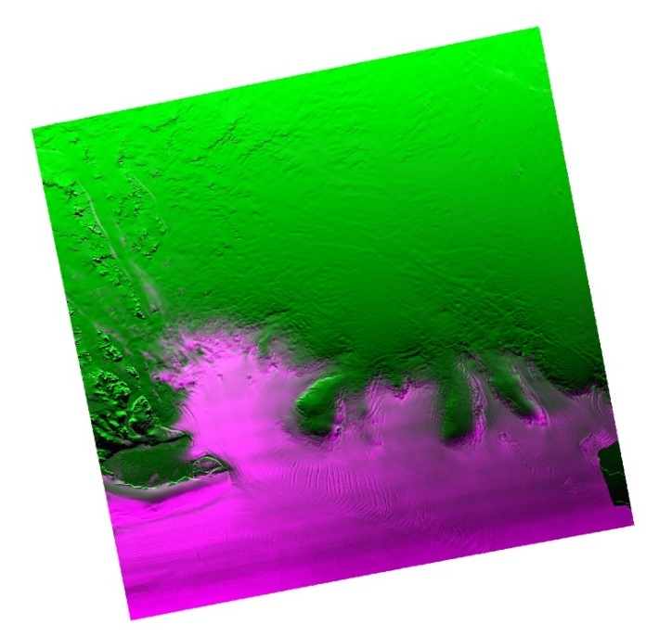
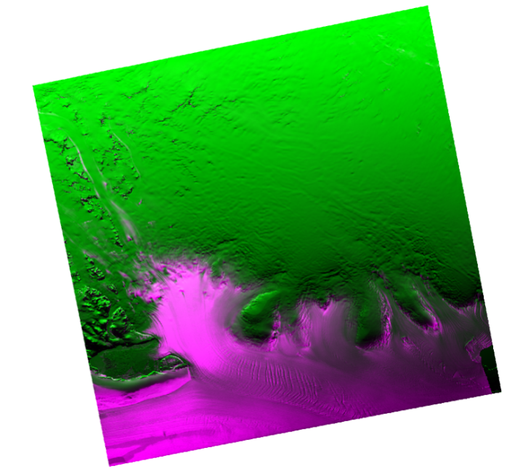
Antarctica
Fig 13. Overlap between the LSAR and SSAR GCOV products, pol HH
New ice sits well clear of both bands’ floors, old ice sits on S-band’s, and open water is what defines them. In Fig 14 each point is the mean of the ROI means, the whisker spans the brightest to the darkest ROI in the class, and the dashed line is that band’s own sigma0 noise floor. HH was the only channel acquired at this site.
All 900-pixel point-buffer ROIs, identical in both bands. The old-ice row is the main result of this study and is treated separately below.
Table 8: Sigma0 statistics by class, Antarctica
Band | Class | ROIs | Mean dB | Spread dB | ENL | Margin
L | new ice | 134 | −2.37 | 5.57 | 5.02 ±7.3% | +17.33
S | new ice | 134 | −3.93 | 3.56 | 2.70 ±7.3% | +11.09
L | old ice | 66 | −16.10 | 5.87 | 3.90 ±7.3% | +3.59
S | old ice | 66 | −15.10 | 4.64 | 2.28 ±7.3% | −0.09
L | water | 13 | −19.74 | 2.17 | 5.23 ±7.3% | −0.04
S | water | 13 | −15.02 | 0.97 | 2.77 ±7.3% | −0.01

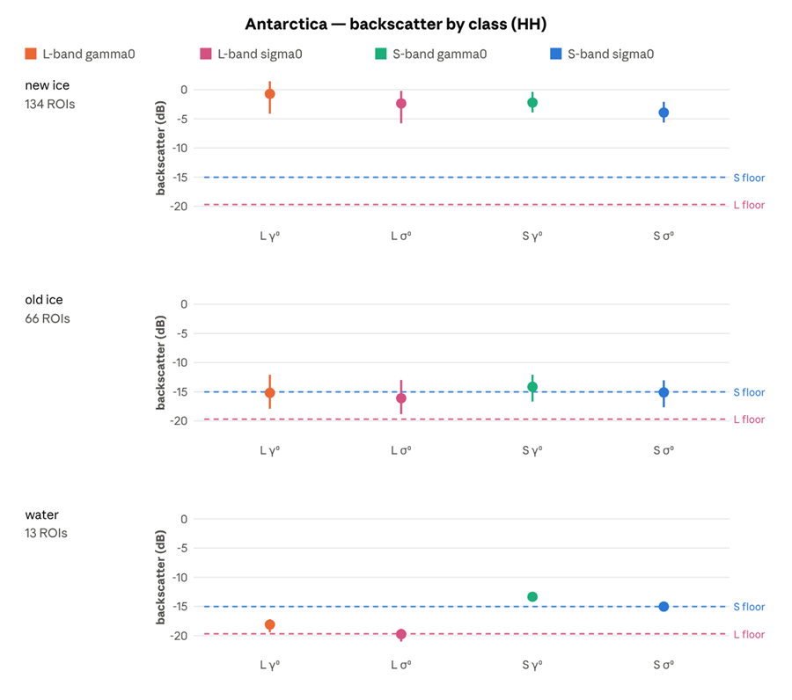
Fig 14. Mean and spread of gamma0 and sigma0 over new ice, old ice and water in HH, both bands. The dashed line is each band’s own sigma0 noise floor.

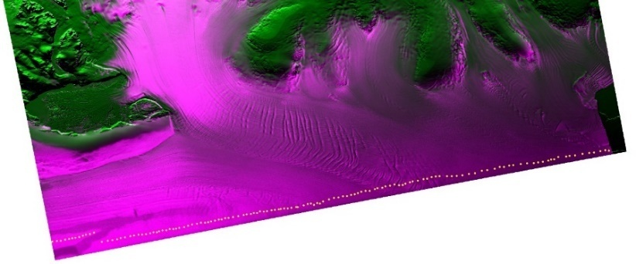
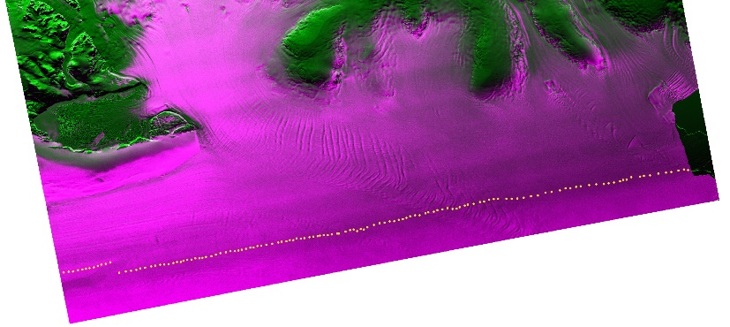
New ice

Fig 15. ROIs over new ice. L-band left, S-band right.

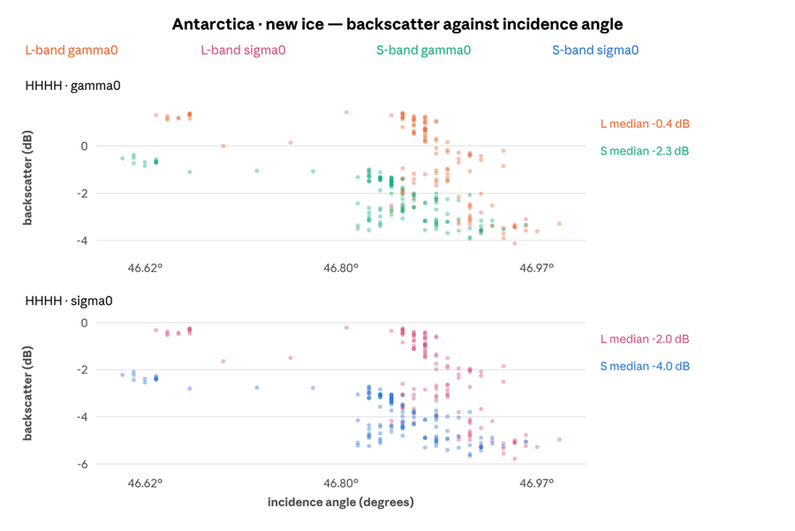
Fig 16. Sigma0 and gamma0 against incidence angle, new ice.
Key observations:
a) dB Levels: The class sits near 0 dB in L gamma0 and between −1 and −3 dB in S, more than ten decibels clear of either noise floor. Nothing here tests sensitivity. The two bands agree to within about 1.5 dB and move together bin for bin, which is further evidence that the variation is in the scene rather than in either radar.
b) Spatial variance: All 134 ROIs lie inside 0.39° of incidence, and no surface changes by 4 dB over four tenths of a degree of look angle. The axis is therefore ordering position rather than look angle. At this site incidence rises from north to south, so reading the axis left to right is reading down the scene, and the ROIs at one end are over different ice from those at the other. Both bands show the same fall, which is what a real spatial gradient looks like and what an instrument artefact would not.

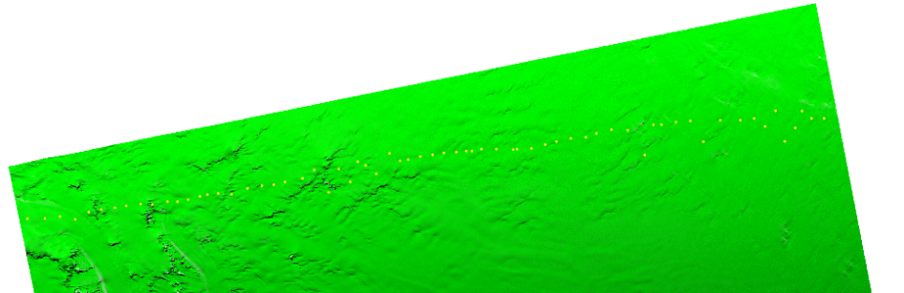
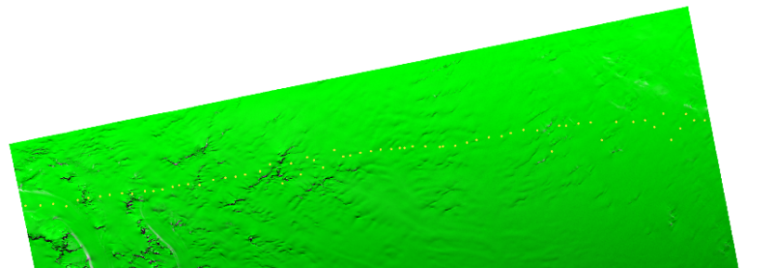
Old ice

Fig 17. ROIs over old ice. L-band left, S-band right

Key observations:
a) Divergence: At the low-incidence end of the patch L and S gamma0 are within 0.2 dB of each other; by the far end L has fallen about 4.4 dB and S about 1.4, leaving them roughly 3 dB apart. As with new ice, the axis spans only 1.4° and cannot carry an angular trend; this is a north–south gradient across the ice, not a response to geometry.
b) Backscatter levels: Old ice is the darkest surface either instrument was pointed at in this study, and the question is whether each band can still detect it. The rest of this section sets out that measurement.
c) In L-band, old ice sits 3.6 dB above open water and 3.6 dB above the noise, which makes it a separable class. In S-band, old ice, open water and the noise floor all fall within 0.1 dB of each other. To the measurement, all three are the same value.
d) One class per band, and more than half of its ROIs are indistinguishable from that band's noise. Every other combination measured (vegetation at two sites, new ice, both polarisations, both bands, 1,100-odd ROI measurements) returns zero. The failure is confined to that one combination, which affects the majority of its ROIs, and has no counterpart elsewhere in the set.
This is not a marginal result which would be resolved in better statistics. The ROIs are 900 pixels each, 66 of them for old ice, 13 for water, and the two bands' ENL precisions are both ±7.3%. The separation L finds is an order of magnitude larger than the uncertainty; the separation S finds is an order of magnitude smaller.
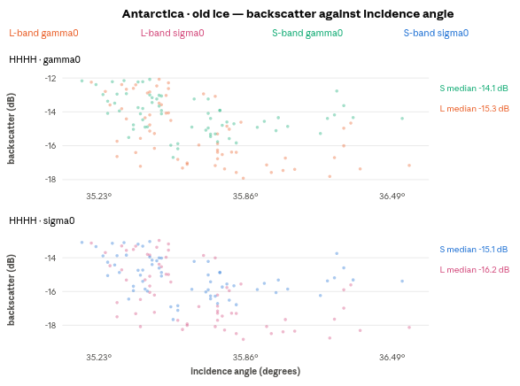

Fig 18. Sigma0 and gamma0 against incidence angle, old ice.

Table 9: Old ice against open water and the noise floor, Antarctica
 | L-band | S-band
Noise floor (HHHH) | −19.69 dB | −15.02 dB
Old ice | −16.10 dB | −15.10 dB
Margin above own floor | +3.59 dB | −0.09 dB
Open water | −19.74 dB | −15.02 dB
Old ice minus water | +3.64 dB | −0.08 dB
New ice | −2.37 dB | −3.93 dB
New ice minus old ice | 13.73 dB | 11.17 dB

e) An ice-type classifier given the S-band HH channel alone over this scene has no basis for distinguishing old ice from open water as both return the floor. The same classifier on L-band has 3.6 dB to work with. New ice is bright enough that both bands see it easily (+17.3 dB and +11.1 dB of margin), so the failure is specific to the dark end of the ice range, which is where the discrimination problem actually lives.
f) Old ice is a weak scatterer at both wavelengths; what differs is where each instrument's noise lie. S's floor is 4.67 dB higher, and old ice falls inside that difference. This is a sensitivity limit, not a statement that S-band is blind to old ice physics: a quieter S-band channel, or one of its other polarisations, could place the same surface above its own floor.
g) Open water in melting ice: It is the obvious challenge to this result. The scene was imaged in September, when the surface is melting, and frazil or grease ice roughens water at centimetre scales, which brightens a 9.4 cm radar far more than a 24 cm one. If S-band were reading a real return from forming ice rather than its own noise, the floor derived from these ROIs would be too high and the old-ice result would be overstated. Two things in the ROI statistics shows significant variations:
- The S-band water ROIs barely vary. Across the 13 of them S's sigma0 has a standard deviation of 0.28 dB, the tightest figure of any class in this study. Delta water scatters 0.92 dB in the same band and Amazon water 1.11 dB; classes both instruments clearly resolve scatter 0.7 to 1.7 dB. A surface returns different values from place to place, whereas a noise floor returns much the same number at every site. Backscatter of 0.28 dB is consistent with the latter.
- L-band over the same ROIs is darker here than anywhere else, at −19.81 dB against −18.88 at the delta and −16.24 at the Amazon. Roughening strong enough to lift S 4.8 dB above L at this site should lift L somewhat as well. Instead L falls.
Neither point settles it, since a uniformly frozen surface would also vary little, but together they favour S-band as it is genuinely sitting on its floor over water. The caveat still bounds the result in a useful direction: if any part of S's −15.0 dB is forming ice rather than noise, S's true floor is lower than quoted, and old ice clears it by more than the table shows. The failure reported here is in that sense a conservative one.
Antarctic old ice: In the three-class figure at the head of this section, the S sigma0 point for old ice lies on the blue dashed line, and the S point for open water lies on that same line at the same height. L's old-ice point is clearly above its own floor line, while L's water point sits on it. One band separates those two surfaces.

Open water
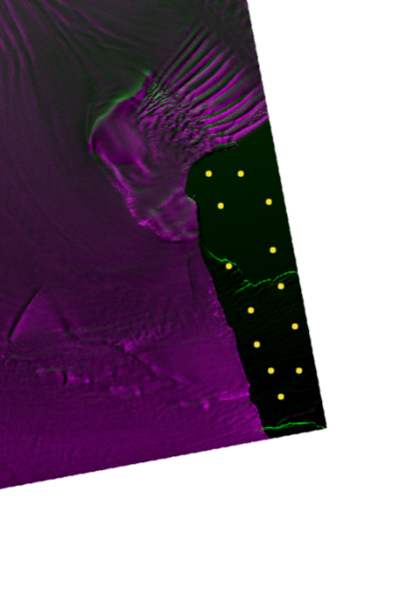
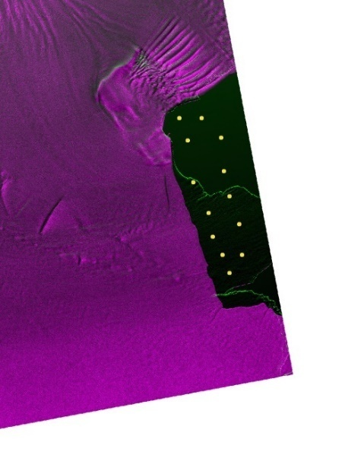

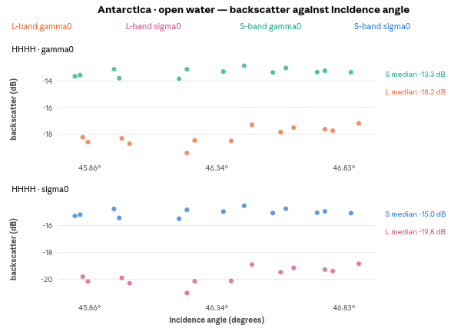
Fig 19. ROIs over open water. L-band left, S-band right.
Fig 20. Sigma0 and gamma0 against incidence angle, open water.
The offset: Across the 1.09° span of this class, L's gamma0 moves by +1.1 dB and S's by −0.2, and the separation between them runs from about 4.7 dB at one end of the patch to 3.9 at the other. Over a specular surface that returns almost nothing, a gap that size between two instruments looking at the same water on the same pass is not a property of the water.
The two floors. Open water is what defines each band's floor in this study, so these two traces are, to within their scatter, the floors themselves. The water margins reported later are therefore near zero by construction and carry no information.
Sample size. Only 13 water ROIs are available here, and the bin-to-bin scatter of about a decibel in L reflects that rather than any structure in the water.

Across the three sites
These are the findings that are observed in all the sites. The cross-site summary below uses sigma0 unless stated otherwise. For each class, the margin is calculated relative to the noise floor of the same band. This shows how far each surface return lies above the floor of the instrument used to measure it.
Bright surfaces: In the Amazon vegetation plot, the L- and S-band co-polarised means are nearly identical: the difference is 0.04 dB. For Sundarban vegetation, the HH and HV differences are 0.66 dB and 0.63 dB, respectively. The two vegetation sites differ more from each other than the two bands differ over either site: Amazon canopy is about 2.0 dB brighter than Sundarban vegetation in L-band and 2.6 dB brighter in S-band. This is consistent with the difference between closed Amazon forest and mixed tidal vegetation, but the sites and polarisations are not identical, so this cross-site comparison is indicative rather than strictly controlled. Over bright surfaces, the two instruments agree closely.
Dark surfaces: In every comparison, the S-band noise floor is higher than the L-band floor. Over delta water, the L-band cross-polarised return lies clearly above its floor, whereas the S-band return is close to its own floor. At the Amazon site, both bands' water measurements lie near their respective floors.

Noise floor, per band and polarisation
Table 10: Sigma0 noise floor by band and polarisation
Site | Polarisation | L floor | S floor | S higher by
Sundarban delta | HHHH | −18.33 dB | −17.13 dB | 1.20 dB
Sundarban delta | HVHV | −24.68 dB | −19.63 dB | 5.05 dB
Amazon | VVVV | −16.50 dB | −15.30 dB | 1.20 dB
Antarctica | HHHH | −19.69 dB | −15.02 dB | 4.67 dB

A second, stricter floor bound is available from the darkest individual water ROI in the nesz_estimate output. The corresponding values are −21.80 dB and −26.91 dB for delta L-band HH and HV, compared with −19.59 dB and −21.94 dB for delta S-band; −21.21 dB for Amazon L-band VV compared with −18.47 dB for S-band; and −21.02 dB for Antarctic L-band compared with −15.49 dB for S-band. Using these darkest-ROI values increases the apparent S-band penalty: at Antarctica it becomes 5.53 dB rather than 4.67 dB from the pooled means. Pooling raises the floor estimate relative to the quietest individual ROI, so the pooled values are retained for the comparisons below as the more conservative choice.
The estimated S-band floor is higher in every channel that can be compared directly, with the largest differences in cross-polarisation and over ice. However, the penalty varies by channel. S-band VHVH over the Amazon has the lowest estimated floor in this dataset at −19.35 dB.

Looks
At the two sites where the products have the same posting, the measured L-band ENL is consistently 1.7–1.9 times the S-band value across the classes and polarisations examined.
Table 11: Equivalent number of looks at the matched-posting sites
Site | Pol | Class | L ENL | S ENL | Ratio
delta | HHHH | vegetation | 3.40 | 2.20 | 1.55×
delta | HHHH | water | 4.88 | 2.65 | 1.84×
delta | HVHV | vegetation | 4.05 | 2.44 | 1.66×
delta | HVHV | water | 5.17 | 2.75 | 1.88×
Antarctica | HHHH | new ice | 5.02 | 2.70 | 1.86×
Antarctica | HHHH | old ice | 3.90 | 2.28 | 1.71×
Antarctica | HHHH | water | 5.23 | 2.77 | 1.89×

The reported ENL uncertainty is ±7.3% to ±11%, so ratios of 1.5 or greater are larger than the expected estimation error. The within-class spread is also larger for L-band in the reported examples: 5.98 dB compared with 3.56 dB for Sundarban vegetation, and 5.57 dB compared with 3.56 dB for new ice. These results may indicate that L-band retains more spatial variation, but the next analysis shows that incidence-angle trends account for much of the difference in spread.
The two conventions: Gamma0 and sigma0 retain the same relative ordering within each band across the panels. Their differences are 1.20–1.29 dB at the delta and Amazon sites, 0.93 dB over Antarctic old ice, and 1.62–1.72 dB over Antarctic new ice and water. The variation reflects the per-pixel RTC factor and the terrain sampled by each ROI. Class spread can also change, to between 0.86 and 1.18 times the gamma0 spread, because the factor is not uniform over every ROI. The conversion shifts the class statistics but does not change which convention is used for the reported class means and noise-floor estimates; sigma0 is used for both.
The cos θ check: To verify the geometric conversion, the gamma0 and sigma0 trends were fitted separately against incidence angle and the slopes were differenced. Fourteen series with sufficient angular span, covering both bands and all three sites, gave values from −0.0648 to −0.0669 dB/degree, with a mean of −0.0659. Regressing 10·log₁₀(cos θ) against the same incidence angles gives a mean of −0.0658 dB/degree; each series differs from its own prediction by no more than 0.0013 dB/degree. The ROI results are therefore consistent with the conversion σ⁰ = γ⁰·cos θ. This check also supports using gamma0 for the surface incidence-angle analysis.
The other two sites: The Antarctic classes each cover less than 1.4° of incidence: 0.36° for new ice, 1.37° for old ice and 1.06° for water within a single band. When both bands are pooled, the spans are 0.39°, 1.40° and 1.09°, respectively. These ranges are too narrow to distinguish an angular trend reliably from spatial variation. The Antarctic figures therefore show the ROI values without fitted trend lines. Regressions calculated from the CSVs can yield slopes from −13 to +1 dB/degree because the short incidence span makes the estimates unstable.
Site dependence: Over Sundarban vegetation, the L-band gamma0 curve declines while the S-band curve is nearly flat. The ROI regressions give −0.283 dB/degree in HH and −0.306 dB/degree in HV for L-band, compared with +0.025 and −0.038 dB/degree for S-band. The Amazon canopy gives a different result across its 13.0° incidence span: −0.007 dB/degree for L-band (R² = 0.01) and +0.028 dB/degree for S-band (R² = 0.17). The trend seen at the delta is not reproduced over the Amazon canopy. Because the sites differ in both polarisation and vegetation structure, the present data cannot establish which factor explains the difference.
Water trends: As incidence angle increases, a specular water surface would normally become darker or remain approximately unchanged. L-band follows that pattern, but S-band backscatter increases. The ROI slopes are +0.280 dB/degree for delta HH (R² = 0.66), +0.300 dB/degree for delta HV (R² = 0.81), and +0.099 dB/degree for Amazon VV; the corresponding L-band Amazon-water slope is −0.072 dB/degree. Since S-band water is close to its estimated floor at both sites, one possible explanation is that the floor rises across the swath. This interpretation cannot be confirmed from the present data; a NESZ profile against incidence angle is needed.
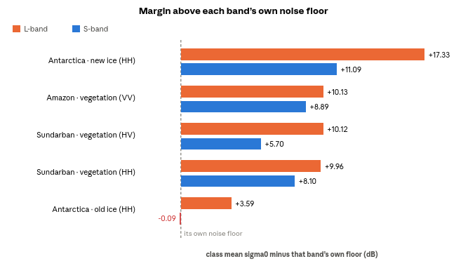
Margin above each band's own noise floor
Fig 21. Sigma0 margin above each band’s own noise floor
Each bar is referenced to its own band's noise floor, so its length indicates the available backscatter margin for that class. Four of the five surfaces lie comfortably above both floors, with the two bands differing by about 2 dB or less. Antarctic old ice is the exception: it is 3.59 dB above the L-band floor but 0.09 dB below the S-band floor.

Conclusion
Over bright distributed targets, the two bands give closely matching radiometric values. The Amazon co-polarised canopy means differ by 0.04 dB, while the Sundarban vegetation values differ by 0.66 dB in HH and 0.63 dB in HV. These differences are consistent with good agreement. The pattern changes over dark surfaces: agreement on bright targets alongside larger differences near the noise floor indicates a sensitivity limitation rather than a general calibration offset.

Real band differences
L-band noise-floor estimate: The estimated floor is lower in each directly comparable channel: by 1.20 dB for delta HH and Amazon VV, 4.67 dB for Antarctic HH, and 5.05 dB for delta HV. The main consequences are summarised below:
- Antarctic old ice is separated from the floor in L-band, with a margin of +3.59 dB, but not in S-band, where the margin is −0.09 dB.
- The land–water contrast is 10.40 dB in L-band and 8.36 dB in S-band for HH. In cross-polarisation, the corresponding values are 9.99 dB and 5.89 dB.
- The difference becomes more pronounced as backscatter decreases, and is largest in cross-polarisation, the weaker channel that is most likely to be limited by the noise floor.
The observed advantage is at the low-backscatter end of the range and should not be interpreted as evidence of greater penetration. For surfaces well above both noise floors, the measured means are very similar, so this dataset does not isolate a volume-scattering advantage. Any such effect is difficult to assess while the sensitivity difference remains larger.
Incidence-angle response: The trend observed in L-band is present over Sundarban vegetation but absent over the Amazon canopy. At the delta, L-band gamma0 decreases by 0.283 dB/degree in HH and 0.306 dB/degree in HV, whereas S-band changes by +0.025 and −0.038 dB/degree. Across the 10.8° ROI span, this amounts to about 3 dB for L-band and less than 0.5 dB for S-band. Since the same ROIs were used for both bands, the contrasting trends cannot be explained by location alone. Over the Amazon canopy, the slopes are −0.007 dB/degree for L-band (R² = 0.01) and +0.028 dB/degree for S-band (R² = 0.17). The two sites differ in polarisation (HH/HV versus VV/VH) and canopy type (tidal vegetation versus dense closed forest), and the available data do not identify which difference is responsible. For L-band GCOV mosaics, the practical implication is that any across-swath correction should be assessed for the specific scene rather than assumed to be constant. All slopes quoted here use gamma0; sigma0 includes an additional geometric term of −0.066 dB/degree.
ENL comparison: At the two sites with 10 m posting in both bands, L-band ENL is 1.55–1.89 times the S-band value for every class and polarisation reported, with estimated precision of ±7.3–11%. Since the posting is matched, the difference points to the multilooking configuration rather than wavelength itself. This distinction matters because additional looks can be obtained by averaging, whereas the instrument noise floor cannot be reduced in the same way by changing the averaging alone.
The difference in ENL may also contribute to the apparent noise-floor gap. With fewer looks, estimates close to the floor are less stable, so part of the 1.2–4.7 dB S-band difference may be related to multilooking rather than to intrinsic sensitivity. The present measurements cannot separate these effects; a calibrated dark target would be needed for that assessment.

Limits of the measurement
- Water margins: The pooled water mean is used to estimate each band's floor, so the water-class margin is close to zero by definition. The observed range is included with the results, but the margins for the other classes are more informative for assessing separability.
- Amazon ENL: The Amazon ROIs are manually drawn rectangles rather than equal-sized squares and contain between 4 and 1,548 pixels. The median is 15 pixels for L-band water and 48 pixels for L-band vegetation, equivalent to only about 2–24 independent samples. ENL estimates from such small ROIs are strongly biased. The mean backscatter values remain useful, because the mean is more stable with limited sampling than a ratio of moments such as ENL.
- Amazon posting: The L-band posting is about 68 m and the S-band posting about 37 m. Pixel count, ENL and within-class spread are therefore not directly comparable at this site; the mean backscatter values can still be compared. At the delta and Antarctica sites, both bands have 10 m posting, so the comparison is more complete.
- Three sites: The results show a consistent pattern across several surface types, but they are not sufficient to characterise the overall performance of either instrument.

Next steps
The next priority should be to acquire S-band cross-polarised data over the Antarctic site. The lowest S-band floor in this study is from the Amazon VHVH channel, at −19.35 dB, about 4.3 dB below the Antarctic HH floor. At that level, the old-ice return of −15.10 dB would sit roughly 4 dB above the floor. The result reported here therefore applies to the acquired HH channel; it does not establish that old ice would remain undetectable in every S-band polarisation.

Appendix: a measured check on the pixels-per-sample assumption
Every ENL precision quoted in this report rests on one assumption that was not measured. Section (g) of the Methodology treats two posted pixels as one independent sample, which converts an ROI pixel count into the sample count N that the precision formula needs. That divisor was taken as a conservative default for a product posted at about its resolution, and it was identified there as the one rule of thumb in the chain. Since every quoted precision scales with its square root, it was tested directly on a separate GCOV pair.
The test uses a GCOV pair over Hyderabad, acquired on a single pass in the same way as the three study sites. The pair is suitable because its processing configuration matches that of the delta and Antarctic products, so the posting and the multilooking are the same as those for which the precision is quoted.
Table 12: Products used for the oversampling check
 | L-band | S-band
Product | NISAR_L2_PR_GCOV_028_084_A_010_4005_DHDH | NISAR_S2_PR_GCOV_028_084_A_010_3700_DHNA
Acquired | 2026-08-19, 00:17:34–00:18:08 | 2026-08-19, 00:17:33–00:18:10
Posting | 10 m | 10 m
Polarisations | HHHH, HVHV | HHHH, HVHV
Windows | 4 centres × 7 window sizes | 4 centres × 7 window sizes

The quantity measured is the effective resolution of each product, taken as the lag at which the amplitude autocorrelation falls to 1/e of its peak, multiplied by the pixel size. Divided by the posting this gives the oversampling factor on each map axis, and the product of the two axes is the number of posted pixels in one independent sample. That is the figure the assumption fixes at two.
The autocorrelation is computed over the whole sample window, so any structure in the scene widens it and the effective resolution reads coarser than it is. A single window therefore cannot distinguish a soft product from a window containing fields or buildings. The window was instead reduced in stages from 512 to 64 pixels at each centre. The oversampling falls as scene structure leaves the window and then stops changing once only the impulse response and speckle remain, and the value at which it settles is taken as the product figure. Windows in which strong scatterers dominate were excluded, identified by the ratio of the maximum to the 99th percentile exceeding 15. Three of the four centres were over built-up ground and were excluded at every window size. The results below are from the remaining centre, at 78.3578° E, 17.3251° N, where that ratio stays between 2 and 3 at the three smallest windows.
Table 13: Oversampling at the homogeneous centre, by window size
Window | L-band HHHH | S-band HHHH | L-band HVHV | S-band HVHV
64 px | 1.52 | 1.77 | 1.43 | 1.48
96 px | 1.61 | 1.69 | 1.45 | 1.48
128 px | 1.64 | 1.81 | 1.46 | 1.50
192 px | 3.19 | 3.20 | 213.67 | 7.76
256 px | 4.78 | 2.56 | 233.46 | 11.36

Values are posted pixels per independent sample, the product of the two axes’ oversampling factors. The 192 px and 256 px rows are listed for completeness; the maximum-to-percentile ratio reaches 134 and 97 there, so those windows measure the brightest targets rather than the product and are excluded from the result.
The three smallest windows agree to within a few per cent in every channel, which is the condition for the figure to be a property of the product. The measured value is 1.5 to 1.8 posted pixels per independent sample, against the two the report assumes. The assumption is therefore conservative, and the precisions quoted throughout are slightly wider than the data requires.
Table 14: Effect on the quoted ENL precisions
Channel | Pixels per sample | Quoted ±7.3% | Quoted ±11%
L-band HHHH | 1.59 | ±6.5% | ±9.8%
S-band HHHH | 1.76 | ±6.9% | ±10.3%
L-band HVHV | 1.45 | ±6.2% | ±9.4%
S-band HVHV | 1.49 | ±6.3% | ±9.5%

Since the correction makes every interval narrower, no result in this report changes. The separations reported for Antarctic old ice, and the ENL ratios between the two bands, were already larger than the quoted uncertainty and remain so. The figures quoted in the body of the report are retained, as the conservative choice.
Two further observations follow from the same measurement.
- Anisotropy: The L-band product is close to isotropic on the two map axes, with an across-to-along ratio of 1.00 to 1.05 at the three smallest windows, while the S-band product is consistently coarser along one axis, at 0.88 to 0.91. The direction is the same in every window and in both polarisations. Terrain does not favour one map axis, so this is a sampling or processing characteristic rather than a property of the scene. The effect is a loss of detail along that axis only, and it is not visible in any figure in this report, which is why it is reported here as a measurement rather than as an observation.
- Looks: The equivalent number of looks estimated from the same windows is 4.9 and 5.2 for the L-band channels and 2.7 and 2.9 for the S-band channels, giving L-to-S ratios of 1.85 and 1.80. Both postings are 10 m. The scene is a different one, acquired on a different date and analysed with a different tool, and the ratios fall inside the range of 1.55 to 1.89 reported for the two matched-posting study sites. This is an independent confirmation of the looks result.

Image-quality parameters
The same windows support the image-quality parameters reported for these instruments at GSLC level, and those are given below for the two centres where the measurement is valid. The first is over water. The second is over medium-dark terrain where S-band speckle is visibly stronger, which is the condition these parameters quantify. Both are read at the 128-pixel window, where the maximum-to-percentile ratio stays between 2 and 3 in every channel. The two built-up centres are excluded, their ratios reaching 44 to 73.
Table 15: Image-quality parameters at the 128-pixel window
Centre | Channel | Mean dB | cv | cv_floor | ENL | tex@40m | aniso
Water | L HHHH | −13.0 | 0.48 | 0.450 | 4.93 | 1.33 | 1.03
 | S HHHH | −15.5 | 0.67 | 0.612 | 2.67 | 1.34 | 0.88
 | L HVHV | −21.8 | 0.47 | 0.438 | 5.22 | 1.17 | 1.05
 | S HVHV | −20.0 | 0.63 | 0.587 | 2.90 | 1.13 | 0.91
Medium-dark | L HHHH | −8.7 | 0.73 | 0.558 | 3.22 | 1.28 | 1.02
 | S HHHH | −10.1 | 0.74 | 0.677 | 2.18 | 1.36 | 0.88
 | L HVHV | −14.5 | 0.85 | 0.561 | 3.17 | 1.03 | 1.21
 | S HVHV | −15.0 | 0.78 | 0.672 | 2.22 | 1.54 | 0.89

cv is the coefficient of variation over the whole window and cv_floor that of the most homogeneous sub-block within it, which is the closest the window comes to bare speckle. For a multilooked power product the speckle coefficient of variation is the reciprocal of the square root of the number of looks, so cv_floor and ENL are two statements of the same measurement. tex@40m is the variation that survives averaging to 40 m divided by what that window’s own speckle would leave, so 1.0 means nothing but speckle is present. aniso is the effective resolution across divided by that along.
The S-band speckle is stronger in every channel at both centres. Its cv_floor is 0.59 to 0.68 against 0.44 to 0.56 for L-band, and its ENL is 2.2 to 2.9 against 3.2 to 5.2. This is a direct measurement of what is visible in the imagery, and it is the same shortfall the body of this report records as a looks difference at the delta and Antarctic sites. The ratio over water, 1.80 to 1.85, is within the 1.55 to 1.89 reported there; over medium-dark terrain it is lower, 1.43 to 1.47, because both bands’ ENL is depressed where the window carries real variation, which the estimator counts as speckle. The water figures are therefore the better estimate of the products, and the terrain figures show how much a textured window costs.
tex@40m is near 1.0 for both bands over water, as it should be where there is nothing but speckle to average, and the two bands differ little at either centre. On this evidence the texture surviving to 40 m does not separate the two instruments; the anisotropy and the looks do.

Limits of this check
- Two centres of four: Two of the four centres gave measurements free of strong scatterers, one over water and one over medium-dark terrain; the other two were over built-up ground. The oversampling figure in Table 13 rests on the water centre, measured at three window sizes in four channels, since that is the only centre where the sweep settles. A scene with more homogeneous terrain would support both results better.
- Channel identification: The converted products did not carry band descriptions, so the channels were identified from the acquisition mode recorded in the granule names. The cross-polarised channels return lower figures than the co-polarised ones in both bands, which is the expected effect of a channel closer to the noise floor, since noise is uncorrelated between neighbouring pixels and narrows the measured autocorrelation. The co-polarised figures are therefore the ones used above.
- Parameters not reported: Of the parameters reported at GSLC level, two are absent above. Scene contrast, and the contrast-to-noise ratio derived from it, both need a speckle reference, and neither can be obtained from these windows for two separate reasons. The tool caps that reference at the coefficient of variation of single-look amplitude, 0.523, which is below the speckle figure of any power product with fewer than 3.7 looks, so it binds on S-band everywhere and on L-band over terrain. Independently of that, the quiet sub-region the reference is taken from requires a window of at least 160 pixels; below that the whole window is used instead, which makes the scene contrast identically zero. A window here satisfies one condition or the other and never both, since at 128 pixels the reference is the whole window and at 192 pixels and above every centre is dominated by strong scatterers. These two figures therefore need a larger patch of homogeneous ground than this scene offers, together with the speckle constant for power. The parameters in Table 15 are unaffected: cv and cv_floor are measured directly, tex@40m is referred to the window’s own speckle floor rather than to a constant, the equivalent number of looks follows from cv_floor, and aniso is a ratio.

Acknowledgement
The authors gratefully acknowledge the encouragement and institutional support provided by the Director, NRSC, and the guidance received from the concerned Group Directors and Division Heads. The authors thank the NISAR project and payload teams, along with the teams responsible for data processing and product generation, for technical clarifications on mission configuration, payload characteristics, product specifications and processing aspects. The authors also appreciate the discussions and assistance provided by colleagues involved in NISAR calibration, validation and data-product evaluation. Finally, the authors thank the staff of the Data Processing Area and associated analysis teams at NRSC for their support throughout this activity.

References
[1] Indian Space Research Organisation (ISRO), “NASA-ISRO SAR (NISAR) Satellite.” Available: https://www.isro.gov.in/NISARSatellite.html. Accessed 22 October 2026.
[2] NASA Science, “Mission Overview – NISAR Quick Facts.” Available: https://science.nasa.gov/mission/nisar/mission-overview/. Accessed 22 October 2026.
[3] G. H. X. Shiroma, “Level-2 Geocoded Polarimetric Covariance,” NASA SDS Product Specification, JPL D-102274, Revision F. NASA Jet Propulsion Laboratory, 2026. Available: https://cumulus.asf.earthdatacloud.nasa.gov/PUBLIC/DATA/NISAR/NISAR_D-102274_RevF_NASA_SDS_Product_Specification_L2_GCOV_w-esigs.pdf.
[4] Space Applications Centre (SAC), ISRO, “NISAR L & S Band Level-1 & Level-2 Data Product Format Document,” Version 1.2.1, document ISRO-SAC-PR-NISAR-2024-051. Available: https://bhoonidhi.nrsc.gov.in/NISAR/NISAR_Data_Product_Format_Document_V1.2.1_digisigned.pdf.
[5] Alaska Satellite Facility, “Geocoded Polarimetric Covariance (GCOV),” NISAR Data User Guide. Available: https://nisar-docs.asf.alaska.edu/gcov/. Accessed 22 October 2026.
[6] NASA/JPL, “Polarimetry,” Get to Know SAR – NISAR Mission. Available: https://nisar.jpl.nasa.gov/mission/get-to-know-sar/polarimetry/. Accessed 22 October 2026.
[7] S. N. Anfinsen, A. P. Doulgeris and T. Eltoft, “Estimation of the Equivalent Number of Looks in Polarimetric Synthetic Aperture Radar Imagery,” IEEE Transactions on Geoscience and Remote Sensing, vol. 47, no. 11, pp. 3795–3809, November 2009. doi: 10.1109/TGRS.2009.2019269.
[8] European Space Agency (ESA), “Sentinel-1 Product Definition,” document S1-RS-MDA-52-7440, Issue/Revision 2/7, 25 March 2016. Available: https://sentinels.copernicus.eu/documents/247904/1877131/Sentinel-1-Product-Definition.pdf.
[9] Airbus Defence and Space, “Copernicus DEM: Product Specification,” document GEO1988-CopernicusDEM-SPE-002, Issue 5.0. Copernicus Data Space Ecosystem, 2024. Available: https://dataspace.copernicus.eu/sites/default/files/media/files/2024-06/geo1988-copernicusdem-spe-002_producthandbook_i5.0.pdf.

