Durgesh
(2012CS50286)

a).
For T = 510.24 (T > T_{c})

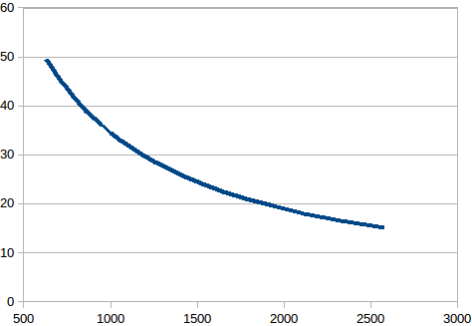

T = 390 (T < T_{c})

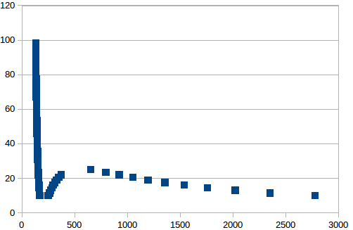
Both graphs are as expected (given in fig 3.4)

b)
T = 510.4 (T > T_{c})

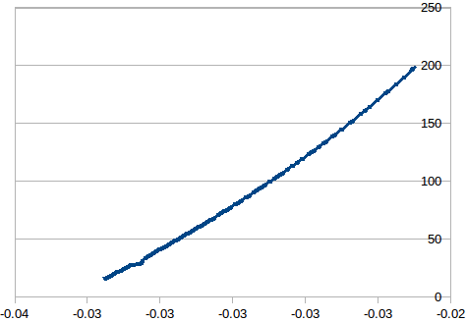

T = 390 (T < T_{c})

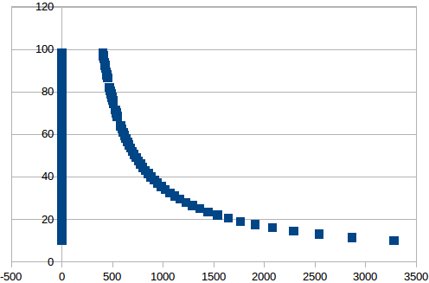

c)

T = 510.24 (T > T_{c})

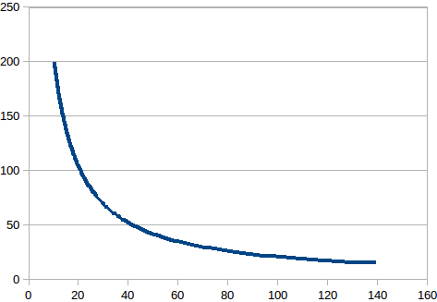

T = 390 (T < T_{c})

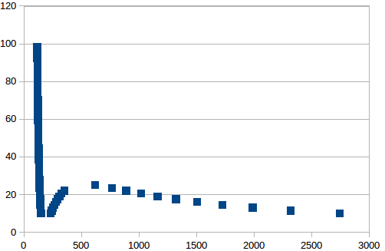

d)

T = 510.24

T = 390

