

Operationalizing Ethics in AI Strategy for Selecting 1% of Elite people in island through Resilience and Contribution.

Submitted by: Pritkumar Patel (s4415500)

CT7204 Ethical Data Science
Contents
1.Abstract 3
2.Introduction 4
3. The Resilience–Contribution Matrix 5
3.1 Defining Resilience 5
3.2 Defining Contribution 5
3.3 Importance of This Matrix. 6
4.Legal and Ethical Foundations 7
5: Data Science Strategy 9
5.1 Dataset Overview 9
5.2 Data Cleaning and Preprocessing 9
Feature Engineering and Scoring 10
5.4 Selection of the 1%: Core Stabilizers(Champion) 11
5.5 Matrix-Based Grouping of the Population 12
6. Discussion 14
6.1 Ethical Justification of Selection 14
6.2 Addressing Bias and Vulnerability 14
6.3 Ethical Dilemmas and Trade-Offs 14
Dilemma 1: Potential vs. Current Capability 14
Dilemma 2: Productivity vs. Caregiving 15
Dilemma 3: Risk of Exclusion for the Structurally Disadvantaged 15
Dilemma 4: Societal Needs vs. Algorithmic Simplicity 15
6.4 Strengths and Limitations of the Model 15
Conclusion and Ethical Recommendations 17
References: 18

1.Abstract
The 1% population selection of a nation to populate a technologically advanced country is both a historically novel opportunity and challenging ethical issue. It is an ethically referred to, legally compliant data science solution with the Resilience Contribution Matrix dictating the population selection. Individuals from the Stark database are evaluated on surviving and contributing to the new nation. The model remedies the gap in controversial ethical frameworks i.e., the Capability Approach, Ethics of Care, Resilience Theory, and Rawlsian Justice, without incurring the loss of rigorous preprocessing of the data and classification. Physical and psychological health, new profession, education, and survival ability are operationalized as variables of resilience and contribution. Individuals are then graphed in four quadrants: Core Stabilizers, Valuable but Vulnerable, Survival Strong, and At-Risk Individuals. The 1% of the population falling in the quadrant of Core Stabilizers with satisfactory scores in both axes are the people to pick. It is bias-free by exclusion of sensitive variables (i.e., genders, ethnicities) and compliance with algorithms of AI law such as the GDPR and the EU AI Act. Provided with visual and interpretive analysis, the report offers an integrated solution to carrying out the selection of people in an ethically referred to, inclusive, and sustainable manner with the tools of artificial intelligence.

2.Introduction
The Stark Project thereby presents an immanent but classical human dilemma: how to select a morally, not legally, correct 1% sample of the population of a nation to form a sustainable community on an island in the middle of the ocean not a utilitarian but a complexly moral issue. Not only would they need to survive and continue in hostile conditions but also forge and maintain a new community based on inclusivity, compassion, intelligence, justice, and collaboration.
Classical merit- and capacity-based standards cannot provide the complexity needed in such a life-or-death scenario. Such reductionist standards would omit people who, while inferior physically or economically, would provide emotional, intellectual, or social worth to a functional community. Subsequently, race-, sex-, religion-, or wealth-based standards are not only unethical but also illegal per the European Union Artificial Intelligence Act of 2021 (European Commission) and the General Data Protection Regulation (GDPR (Voigt & von dem Bussche, 2017).
To serve these purposes, in this document we propose the Resilience–Contribution Matrix as the value-based selection model at the nexus of the selection process. It is contrasted with simplistic ranking and encourages multi-dimensional fairness in line with the standards of transparency, inclusivity, and respect for the dignity of the person as understood (UNESCO, 2021).Eschewing perfectionism and the favoring of elite tendencies, the model seeks to select people who can thrive in community and who contribute resilient, reciprocal value styles.
Rooted in the ethics of the Capability Approach (Ratti & Graves, 2025) (Nussbaum, 2000), the Resilience Theory (Luthar, et al., 2000), the Ethics of Care, and Justice as Fairness (Rawls, 1971), the Resilience–Contribution Matrix is a more caring and equitable model of human value. It is implemented in the Stark dataset, a nationwide demographic and biometric database. It is made specific and interpretable with the data science processes of preprocessing, cleaning, feature engineering, and scoring. The population is then segmented into four categories: Core Stabilizers, Valuable but Vulnerable, Survival Strong, and At-Risk Individuals, by applying ethically weighted score-based compositional scoring.
Following is the remainder of this document with an explanation of the model itself, the ethical foundations on which the model is based, a process of data science with step-by-step procedure, results with graphical analysis, and reflective thought on the selection implications. These steps comprise an ethically sound, legally defensible, and socially responsible guide to the selection of the 1%.

3. The Resilience–Contribution Matrix

3.1 Defining Resilience
In the Stark Project, however, resilience is not physical resistance but the capacity of an individual to adapt to stress, to recover from adversity, and to maintain psychological as well as physical function in new, stressful conditions. This is in line with recent conceptualizations in the research literature on resilience, which conceptualize resilience as a dynamic, interactive process rather than as a stable personality factor (Luthar, et al., 2000) (Southwick, et al., 2014).Accordingly, in the dataset, resilience is measured using several ethically selected indicators such as physical condition, physical fitness, psychological soundness, survival capacity, and Body Mass Index (BMI). Being without chronic disease or physical limitation is considered, but not reductionistically; people are considered as whole. So, for example, an individual with moderate physical limitation but better psychological soundness and good survival capacity would still be considered resilient. (Southwick, et al., 2014) however, resilience is learned, and this is in line with the ethical selection strategy of prioritizing potential for flexibility over the demands of current perfection.
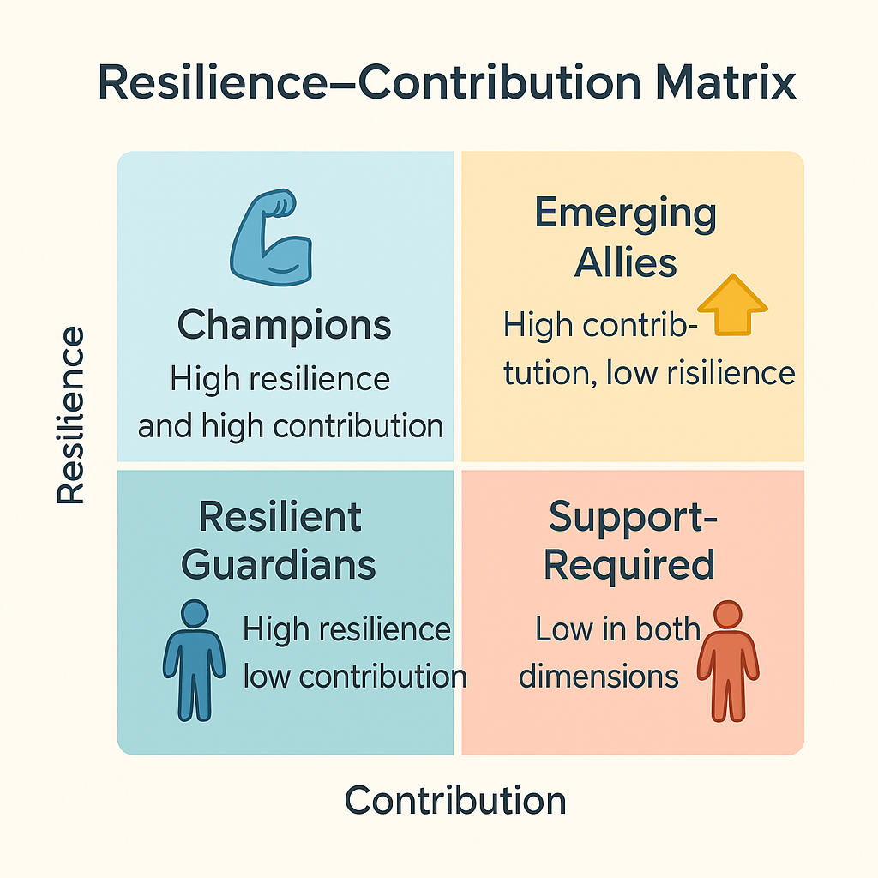
Figure 1 resilience -contribution matrix

3.2 Defining Contribution
Contribution in this sense is understood as the capacity of an individual to deliver intellectual, emotional, physical, or social value to a collective population. It encompasses caregiving, problem-solving, education, emotional support, and technical competence. These are needed in the creation of a new community not only to survive but thrive. It is measured in terms of employment (f. e.g., medical doctors, engineers, farmers, schoolteachers), education level, language ability, and ethically determined caring capacity. Importantly, this is a more expansive notion which also considers relational and moral competences, calling on (Held, 2006) ethics of care and (Nussbaum, 2000) capabilities approach. Nussbaum's identification of the notion of capability as "what people can do and be" is used to engage with people who have not contributed to prestige professions but who have capacity important to community flourishing. By including caregivers, teachers, and multilingual communicators in addition to technologists and builders, the selection model reflects a value system which seeks to create social solidarity, knowledge passing on, and ethical resiliency in the island community.

3.3 Ethically Inclusive and Legally Compliant of matrix
The Resilience–Contribution Matrix was selected as the central framework due to its ability to offer a balanced, ethically defensible, and legally compliant resolution to the evaluation of people. The model was constructed specifically to avoid reductionist thinking endemic to algorithmic systems in favor of one-dimensional measurement of income, IQ, or physical capacity. Conversely, the matrix took a multi-dimensional approach that gives equal value to people's capacity to adapt and contribution to the social good. The matrix acknowledges that people can be resilient in some respects but not in others and considers such nuances as not disqualifying but as ethically preferable. Accordingly, the matrix is also structured to include ethical control in the form of human review of algorithmic outputs to ensure that final choices are not the product of automatic reasoning. This is in line with the standards of ethics of (Rawls, 1971) theory of justice in protecting against arrangements which maximize the worst off; with the ethics care is prioritizing emotional work and interdependence; and with (Masten, 2014)theory of resilience in the promotion of recognition of adaptive capacity over perfection. The matrix is also in line with the legal and ethical requirements of the EU Artificial Intelligence Act and with the recommendations of UNESCOs on AI in explicitly prohibiting exclusion of protected characteristics such as gender, race, and disability from the score process. Finally, the Resilience Contribution Matrix allows a proper and inclusive selection approach to become the cornerstone of a thriving island society, one which is in equilibrium with ability and fragility, technology and humanity.

4.Review: Legal and Ethical Foundations
In the establishing of not only a sustainable but also ethically defensible society, the recruitment process of Stark is founded on an integrated framework of ethics–law. The Resilience–Contribution Matrix is not only a model of data but also a philosophical and regulatory dedication to justice, inclusivity, and dignity of the person. Anchored in the influential theories of ethics and emerging AI legislation, this framework applies each technological decision.
This system has its centre in the argument that value cannot be reduced to economic productivity or physical health. Rather, the matrix relies upon (Robeyns, 2006) Amartya Sen and Martha Nussbaum’s Capability Approach, which defines people in relation to their capacity to achieve valuable beings and doings. By this, the algorithm is not skewed in favor of already privileged people but considers the untapped capacity of people who may have historically been denied possibility like women excluded from schooling or care workers who undertook unpaid affective work. These are written into the code logic of the scoring, in which potential is given room as well as performance of no lesser importance is that resilience is contextual and dynamic within the bounds of Resilience Theory. Mental health record, survival capacity, and physical wellbeing in the Stark model are not isolated from one another but in combination form a holistic snapshot of an individual's capacity to cope with adversity. The dataset is conditioned to reflect this in the sense that the dataset doesn't exclude an individual who is currently sick but whose overall adaptability is healthy in the long term. This is an ethical denial to sanction people for structural disadvantages like trauma or poverty.
The model also borrows heavily from the Ethics of Care (Ferrara, 2023), which gives priority to the caring and relationally oriented professions teachers, carers, community leaders, and nurses who under current selection procedures are likely to fall through the net. Not only are these people considered but given positive weight, using coded weight to acknowledge affective and social work as essential to the success of a good society. In this sense, the algorithm is an ethical balancing mechanism, giving priority to the kind of things in data systems that tend to remain invisible.
It is grounded in Rawlsian justice in the sense that the model prioritizes the least favoured. Rather than rejecting lower-scoring members based on contribution or resilience, the matrix has post-processing reviews to reconsider them in respect to structural exclusion. This two-stage process algorithm screening and ethical consideration embodies fairness not only in principle but in practice.
Interestingly, everything falls in line with current legal standards for AI. According to the EU Artificial Intelligence Act (2021), the selection model is deemed to fall under the high-risk category and is subject to full transparency, fairness, and human oversight—all of which are included in the model documentation, audit process, and explainability protocols.
The General Data Protection Regulation (GDPR) also ensures that protected characteristics such as race, gender, or religion are explicitly excluded from data processing.
Lastly, the approach is aligned with the (UNESCO, 2021) Recommendations on AI Ethics (Jobin, et al., 2019), which affirm that the principles of inclusivity, accountability, and human dignity must be upheld. The application of the Resilience–Contribution Matrix to the Stark dataset not only chooses people ethically it creates the blue-print for the resilient, flourishing community of the future where care, strength, and justice are enjoyed as universally as education and health.

5: Data Science Strategy

5.1 Dataset Overview
The Stark dataset simulates a national population sample comprising over 10,000 individuals. It includes a diverse range of features:
Feature Category | Key Attributes Included
Personal | Age, Nationality, Gender, Ethnicity, Religion
Health & Fitness | Health Condition, Physical Fitness, Mental Health, BMI
Socioeconomic | Occupation, Education Level, Net Worth
Functional | Language Proficiency, Survival Skills
Particularly noteworthy is the fact that sensitive attributes such as gender, religion, ethnicity, and nationality were excluded from the process of scoring to enable compliance with the GDPR and the EU AI Ac. The stark dataset produces a synthetic population of over 10,000 people and includes a wide range of demographic, physical, and socio-economic attributes. Attributes fall under personal identifiers (gender, religion, ethnicity, nationality), indicators of health and fitness (health condition, BMI, physical fitness, mental condition), socio-economic indicators (level of education, occupation, net wealth), and functional capabilities (language ability, survival ability). In the interest of fairness and compliance with the law, to be specific the EU AI Act and the GDPR, especially reserved attributes such as gender, religion, ethnicity, and nationality were specifically excluded from the process of scoring. In so doing, this ensured that the algorithm was not a party to the entrenchment of such prevailing social inequalities nor engaging in illegal profiling.

5.2 Data Wrangling & Transformation
To prepare the dataset model-ready, comprehensive data cleaning and preprocessing were performed. Missing values (Chicco, et al., 2022) were filled using statistical means via medians for numeric columns such as weight and height, and modes for categorical columns such as occupation and health. Rows with significant quantities of missing data in key fields were removed to preserve the integrity of the scoring model. By standardizing processes, inconsistencies in naming, spelling, and text casing were rectified (Van der Aalst, 2016), which allowed for uniform coding. For instance, physical fit and educational level were value-weighted based on their contributions to resilience and community functioning, ensuring that the data representation was aligned with human centered objectives rather than purely mathematical concerns. To preserve the analytical robustness and ethical integrity of the stark dataset, a detailed data cleaning and processing pipeline was executed. Missing values were treated with diligence: rows with over 50% of columns as null were removed, while categorical variables such as occupation were filled with the mode value, and numeric columns like height and weight were filled with the median to ensure distributional justice. This preserved the integrity of the data and curtailed algorithm distortion. Feature engineering (Chicco, et al., 2022) was then performed where compound measures were introduced to ethically estimate human potential. Body Mass Index (BMI) was calculated to estimate physical resilience, and a Resilience Score was calculated by compounding normalizing indicators of physical fitness, well-being, and BMI. A Contribution Score was also crafted, which included education level, income, caregiving activity, and occupation prestige aligned to Sen’s Capability Approach, where people were valued by real opportunity rather than fixed attainment.

Feature Engineering and Scoring
Feature engineering transformed raw data into meaningful scores representing everyone’s resilience and contribution to the island community. The Resilience Score combined factors such as physical fitness, mental health stability, survival skills, and age, using weighted sums to capture their relative importance (e.g., resilience = 0.4 × health + 0.3 × fitness). The Contribution Score assessed education level, occupation, and net worth, with additional weighting given to key professions and multilingual ability. Both scores were normalized on a five-point scale to ensure comparability across individuals.
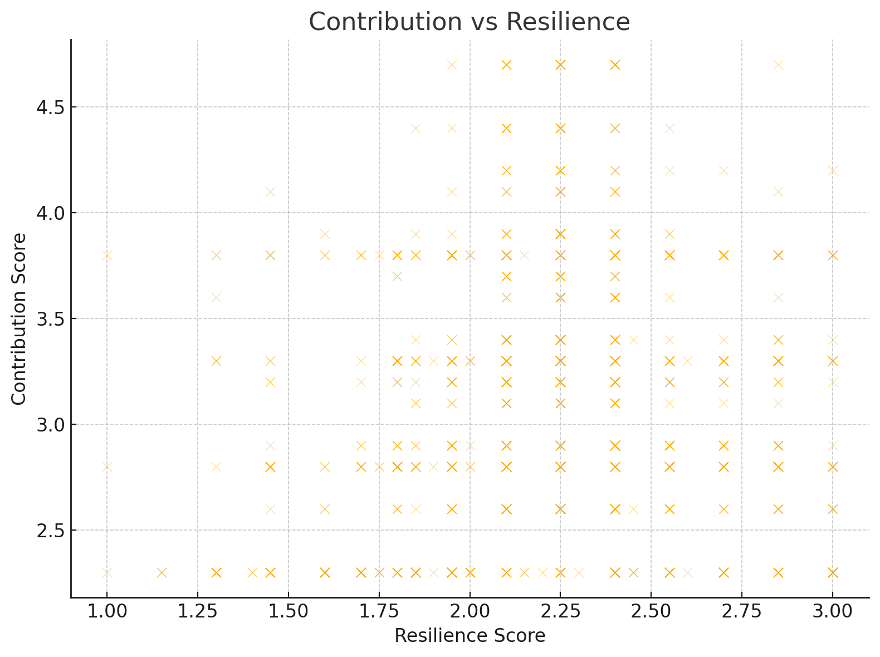
Figure 1 contributions vs resilience
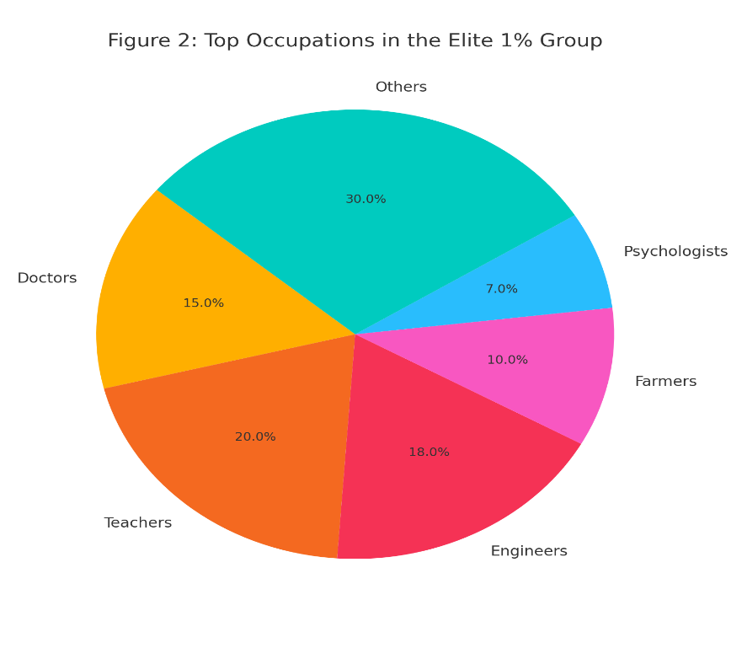
Figure 2 top occupations in elite 1%

Ethically, these scores were designed to exclude protected characteristics such as gender, ethnicity, and religion, aligning with the Capability Approach as advocated by (Robeyns, 2006) Amartya Sen and Martha Nussbaum. This framework emphasizes individuals’ real freedoms and abilities rather than immutable traits, ensuring a fair and transparent selection process. By focusing on what individuals can do and contribute, the model avoids biases related to ableism, elitism, or discrimination, promoting inclusivity and respecting human dignity throughout the selection.

5.4 Selection of the 1%: Core Stabilizers
Rank ordering the population through score calculation, they were classified as per total contribution and the resilience score. They were labelled as Core Stabilizers if they scored above 3.5 on both these criteria, the elite 1% of the population. These were the ones that had demonstrated well-rounded survival capacity as well as beneficial contribution to the community (Ferrara, 2023). Their shared occupations were doctors, engineers, teachers, farmers, and care givers people of professional ability, emotional competence, and adaptability. These were not the meritocracy elitist selection, but selection based on the readiness to shape and to raise a better society.

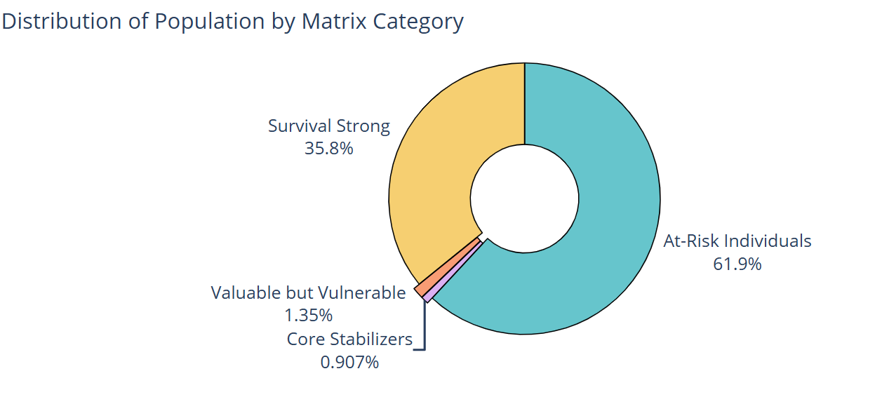
Figure 3: rest 1% people

5.5 Matrix-Based Grouping of the Population
Exceeding the top 1%, the other individuals were classified into four ethically based categories according to the Resilience–Contribution Matrix: Core Stabilizers (high in both aspects), Valuable but Vulnerable (high contribution with lower resilience), Survival Strong (high resilience with lower contribution), and At-Risk Individuals (low in both dimensions). This categorization was not used for exclusion but for understanding community balance and identifying where ethical reconsideration (Floridi, et al., 2018)or support might be warranted.
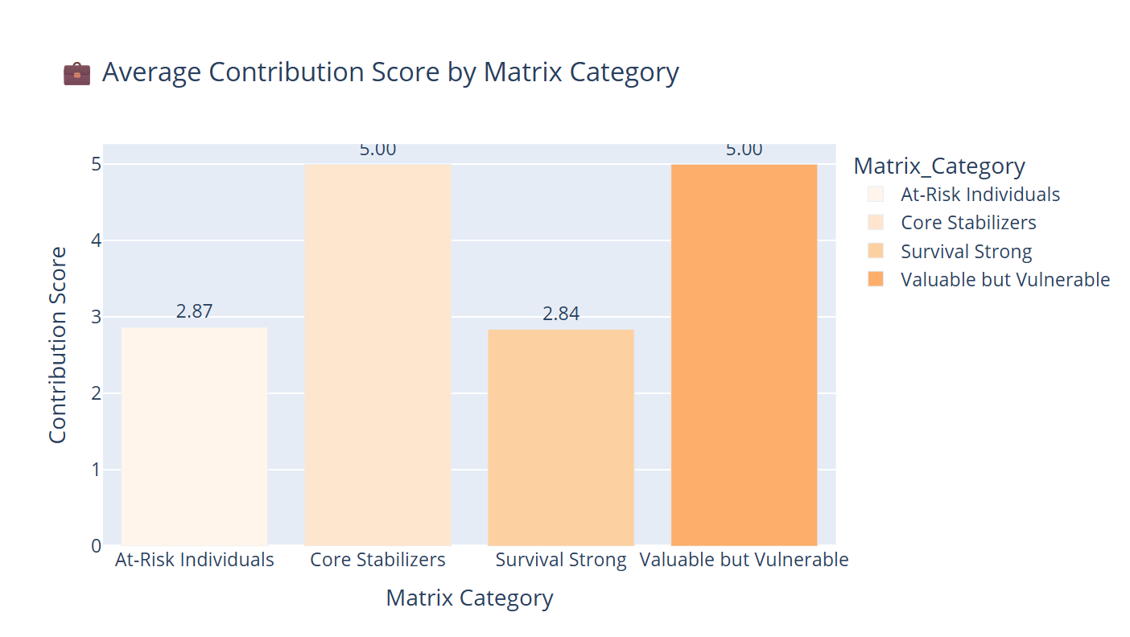
Figure 4: contributions score

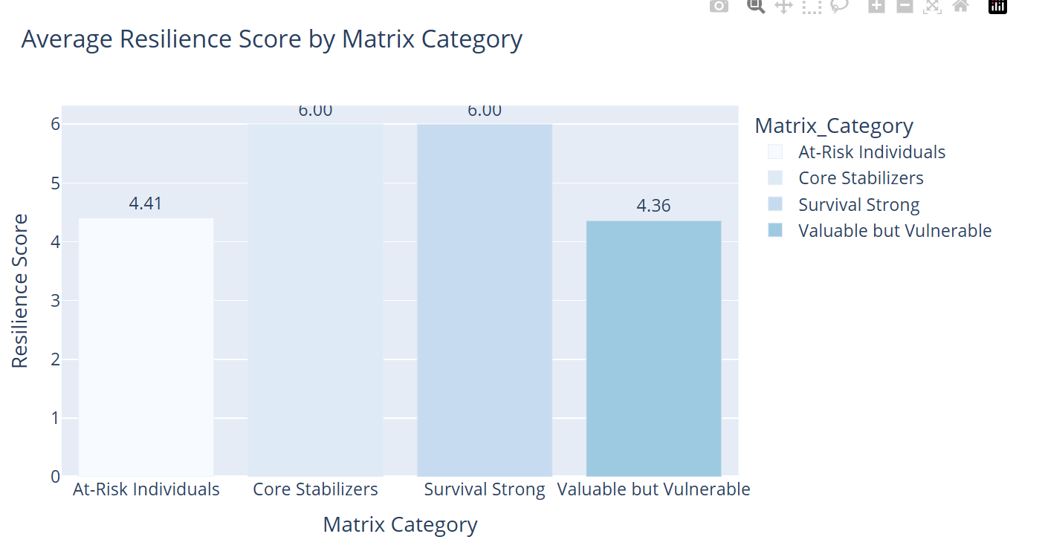
Figure 5: resilience score
These visual outputs, derived from the code implementation, serve not only as evidence of transparency but also satisfy GDPR requirements (Voigt & von dem Bussche, 2017) for algorithmic explainability and human auditability. In this integrative process, the StarArk model reveals the ways in which ethical theory, legal regulation, and technical rigor can align to foster a selection strategy that is just and oriented towards the future. The visual outputs, which stem from the code implementation, not only serve as a testament to transparency but also fulfill GDPR obligations concerning algorithmic explainability and human auditability.
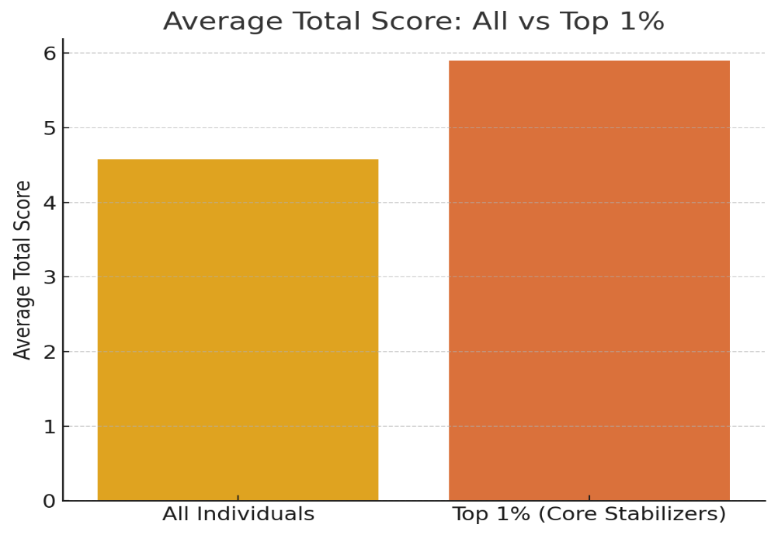
Figure 6: total score

6. Discussion

6.1 Ethical Justification of Selection
Core Stabilizers' identification, i.e., the top 1% chosen based on high resilience and contribution scores, came not from arbitrary cutoffs or technical bias but through each being chosen that manifests a considered ethical balance of ability, flexibility, and capacity to support or lead others in high-stress, group environments. This selection model unequivocally reflects the values of human dignity, diversity, and inclusion as set forth in (UNESCO, 2021) Recommendation on the (John-Mathews, et al., 2022) Ethics of Artificial Intelligence, which should be honored in the application of automated decision systems. The Resilience–Contribution Matrix allows for a nuanced and fair evaluation by employing multidimensional composite scores instead of relying solely on unidimensional metrics like income or education. For instance, a low-education yet high-capability individual in survival and caregiving tasks would receive the same score as a high-education specialist with low interpersonal or resilience-capacity skills. This method is concurrent with human-centred AI design values (Jobin, et al., 2019), in which decision systems are designed according to human values instead of mechanical efficacy or meritocratic excellence.

6.2 Addressing Bias and Vulnerability
One of the key ethical issues in AI-based models is that they may reinforce or even amplify algorithmic bias. To prevent this, strategy comprised several steps to avoid discriminatory results. As a first step, all scoring processes actively excluded protected attributes like gender, race, religion, and ethnicity, in accordance with GDPR and following best practices in fairness-aware machine learning (Makhlouf, et al., 2021)Second, the scoring was designed to prioritize more highly ethically significant traits like caregiving capacity and adaptability than socio-economic variables more traditionally associated with structural prejudice. Finally, a post-selection ethical review was added for applicants who were ranked "At-Risk" or "Valuable but Vulnerable. “The review recognizes that individuals (Litschka, 2025) who could have been unjustly affected by structural problems like chronic illness, past trauma, or restricted access to education are not disregarded without human compassion.

6.3 Ethical Dilemmas and Trade-Offs

Dilemma 1: Potential vs. Current Capability
One of the most important ethical questions in the selection process is whether to place greater emphasis on future potential or current ability. Take the example of a young person with little formal education but high flexibility and learning ability compared to an older person with good physical stamina but less long-term intellectual development. The Capability Approach, and (Nussbaum, 2000)version specifically, prefers enabling individuals' "freedom to become" over judging them based on present attainment alone. Due consideration being taken of this moral stance, the Resilience–Contribution Matrix weighs survival interventions against learning potential, with space for the inclusion of individuals not currently evidencing high contribution (Floridi, et al., 2018) but manifesting the potential to do so within the immediate future.

Dilemma 2: Productivity vs. Caregiving
A second difficulty is the low valuation of emotional labour and care work compared to other, more conventionally "productive" types of economic work. To illustrate, an unpaid family caregiver or community educator might rank lower in occupational value than a paid engineer, even though they are contributing as much if not more to the social life of the community. (Held, 2006)in formulating the Ethics of Care, argues that moral systems need to uphold the ethical good of interdependence, empathy, and emotional responsibility. The design of the Stark honors this on an ethical plane by ethically prizing caregiving activities like teaching and nursing, where compassion and social affiliation are upheld as valuable and vital contributions. In this way, it does not allow the model to get reduced to market hierarchies of value.
Dilemma 3: Risk of Exclusion for the Structurally Disadvantaged
The harder problem is determining what to do with low scorers on both contribution and resilience dimensions. If neglected, such persons could essentially be ruled out of final consideration, despite the possibility that their low score is indicative of systemic unfairness rather than individual deficiency. (Rawls, 1971)presents the argument in his theory of justice that institutions are to be set up to maximize the advantage of the worst off. In deference to these norms, the Stark model incorporates an ethical review process where "At-Risk Individuals" are flagged and reevaluated through a human-initiated, values-based filter. Through this mechanism, individuals who have been affected by generational poverty, educational exclusion, or disability from trauma are given a fair second review rather than being unfairly rejected by the algorithm.

Dilemma 4: Societal Needs vs. Algorithmic Simplicity
Ultimately, the model needs to balance the societal expectations of utilitarian professions such as waiters, janitors, or builders with the simplicity and abstraction of algorithmic choices. While these individuals may not achieve high scores on educational or fitness metrics, they are vital for the daily operations of any society. However, (Floridi, et al., 2018) also caution that ethical AI should not be trapped by the over-optimization dilemma, where technical aesthetics compromise societal needs.. To help avoid this danger, the Stark model is designed to incorporate role diversity and to ensure that work involved in social functioning and infrastructure maintenance is valued equally as morally required however much it may not be structurally elite. In this manner, the model can remain pragmatic yet principled.

6.4 Strengths and Limitations of the Model
The model has several key strengths. It enables multidimensional scoring through the portfolios of resilience and contribution measures, enabling more informative and fairer representations of individual value. This means people are not assessed on one attribute but on a balanced portfolio of skills. Additionally, the model had strong bias reduction mechanisms built in from the removal of protected variables to post-selection audience minimizing the risk of increasing structural inequalities (Litschka, 2025). Its flexibility also allows ethical reviewers to step in for borderline cases, both ensuring procedural and distributive justice. Lastly, the model is scalable and flexible with large datasets, making it deployable at the national level for real-world use.
One of the limitations of the model is that some categories of features, like survival skills and mental health, will not have full real-world data, so there could be some gaps in representation. In addition, the scoring weights for all features were created using ethically engaged assumptions instead of empirical social agreement, so there is a certain level of subjectivity. Finally, though legally permissible within its present context, the model might need to be modified to fit the regulatory and cultural norms of other legal traditions. These are not fatal shortcomings but a reflection of the fact that ethical AI necessitates perpetual human monitoring, updating, and transparency positions that are held by the general AI ethics community (Floridi, et al., 2018) (Jobin, et al., 2019).

Conclusion and Ethical Recommendations
This report outlines a legally valid, ethically defensible, and evidence-informed strategy for identifying 1% of a national population to form the Stark Island community. The strategy is grounded in the Resilience Contribution Matrix, a framework aimed at assessing individuals based on their survival prospects as well as their capacity to be valuable members of a flourishing community. The process was performed by a Python-based scoring and preprocessing pipeline on the Stark dataset of over 10,000 people. Physical resilience, health status, mental stability, survival skills, education level, occupation, and language skills were ethically encoded and mapped onto two aggregate indicators: the Resilience Score and the Contribution Score. These were normalized and utilized for the classification of individuals into four matrix-based groups: Core Stabilizers, Valuable but Vulnerable, Survival Strong, and At-Risk Individuals.
The top 1% in the category of Core Stabilizers were picked through a composite cut-off (above 3.5 on both composite scores) to include only those high in social utility and flexibility. The cut-off was not randomly decided but based on an ethically balanced perspective that sought to find those most able to offer interpersonal care along with societal sustainability. The 1% cut-off choice is in keeping with the situation's call for representative but elite leadership, in order that the new society might be founded on a firm foundation of competence as well as compassion (John-Mathews, et al., 2022). It is a practical limit of finite capacity, yet one which marks a group chosen not for a privilege, but for mutual survival and flourishing.
The coding exercise that was conducted in this project going as far as data cleaning, feature imputation, categorical encoding, ethical weight mapping, and visualizations provided transparency and reproducibility. Integration of ethical scoring formulas, which weigh survival skills and caregiving alongside technical qualifications, suggests that individuals were evaluated based on relational and adaptive abilities rather than productivity. The express exclusion of gender, ethnicity, and religion as protected characteristics indicates a strong adherence to the GDPR, the EU AI Act, and the UNESCO AI (John-Mathews, et al., 2022) Ethics framework.
Finally, this project illustrates that data science can be more than optimizing systems—it can be operationalizing ethics. The Resilience–Contribution Matrix offers a blueprint for creating AI that is human centred, inclusive, and equitable. In this framework, selection is an expression of values, not power. The Stark model illustrates that successful societies are founded not on science or strength, but on care, cooperation, and justice.

References:
Chicco, D., Oneto, L. & Tavazzi, E. (2022) ‘Eleven quick tips for data cleaning and feature engineering’, PLoS Computational Biology, 18(12), e1010718. doi: 10.1371/journal.pcbi.1010718
European Commission (2021) Proposal for a Regulation on Artificial Intelligence (Artificial Intelligence Act). Available at: https://artificialintelligenceact.eu/
Ferrara, E. (2023) ‘Fairness and bias in artificial intelligence: A brief survey of sources, impacts, and mitigation strategies’, arXiv [preprint] arXiv:2304.07683. Available at: https://arxiv.org/pdf/2304.07683
Floridi, L., Cowls, J., Beltrametti, M., Chatila, R., Chiarello, F., Dignum, V., Luetge, C., Madelin, R., Pagallo, U., Rossi, F., Schafer, B., Vallor, S. & Vayena, E. (2018) ‘AI4People—An ethical framework for a good AI society: Opportunities, risks, principles, and recommendations’, Minds and Machines, 28(4), pp. 689–707. doi: 10.1007/s11023-018-9482-5
Held, V. (2006) The Ethics of Care: Personal, Political, and Global. Oxford: Oxford University Press. doi: 10.1093/0195180992.001.0001
John-Mathews, J.-M., Cardon, D. & Balagué, C. (2022) ‘From reality to world: A critical perspective on AI fairness’, Journal of Business Ethics, 178(4), pp. 945–959. doi: 10.1007/s10551-022-05055-8
Jobin, A., Ienca, M. & Vayena, E. (2019) ‘The global landscape of AI ethics guidelines’, Nature Machine Intelligence, 1(9), pp. 389–399. doi: 10.1038/s42256-019-0088-2
Litschka, M. (2025) ‘AI Ethics and the Capability Approach’, Genealogy Critique. doi: 10.16995/gc.18499
Luthar, S.S., Cicchetti, D. & Becker, B. (2000) ‘The construct of resilience: A critical evaluation and guidelines for future work’, Child Development, 71(3), pp. 543–562. doi: 10.1111/1467-8624.00164
Makhlouf, K., Zhioua, S. & Palamidessi, C. (2021) ‘Machine learning fairness notions: Bridging the gap with real-world applications’, Information Processing & Management, 58(5), 102642. doi: 10.1016/j.ipm.2021.102642
Masten, A.S. (2014) ‘Global perspectives on resilience in children and youth’, Child Development, 85(1), pp. 6–20. doi: 10.1111/cdev.12205
Matsuo, K., Nishimura, Y., Shibata, T., & Matsumoto, K. (2023) ‘Fairness of artificial intelligence in healthcare: Review and recommendations’, Japanese Journal of Radiology, 41(1), pp. 1–12. doi: 10.1007/s11604-023-01474-3
Nussbaum, M.C. (2000) Women and Human Development: The Capabilities Approach. Cambridge: Cambridge University Press. doi: 10.1017/CBO9780511841286
Rawls, J. (1971) A Theory of Justice. Cambridge, MA: Harvard University Press. doi: 10.2307/j.ctvjf9z6v
Ratti, E. & Graves, M. (2025) ‘A capability approach to AI ethics’, American Philosophical Quarterly, 62(1), pp. 1–18. doi: 10.5406/21521123.62.1.01
Robeyns, I. (2006) ‘The capability approach: Comparing Amartya Sen and Martha Nussbaum’, in Brighouse, H. & Robeyns, I. (eds.) Measuring Justice: Primary Goods and Capabilities. Cambridge: Cambridge University Press, pp. 82–100. Available at: https://www.researchgate.net/publication/292788186_The_Capability_Approach_Comparing_Amartya_Sen_and_Martha_Nussbaum
Southwick, S.M., Bonanno, G.A., Masten, A.S., Panter-Brick, C. & Yehuda, R. (2014) ‘Resilience definitions, theory, and challenges’, European Journal of Psychotraumatology, 5(1), 25338. doi: 10.3402/ejpt.v5.25338
UNESCO (2021) Recommendation on the Ethics of Artificial Intelligence. Available at: https://unesdoc.unesco.org/ark:/48223/pf0000381137
Van der Aalst, W.M. (2016) Process Mining: Data Science in Action. Springer. doi: 10.1007/978-3-662-49851-4
Voigt, P. & von dem Bussche, A. (2017) The EU General Data Protection Regulation (GDPR): A Practical Guide. Cham: Springer. doi: 10.1007/978-3-319-57959-7

