# Office AMS: Connected App parts using SignalR

|  |  |
| --- | --- |
| Summary: | Applies to: |
| This sample shows how to inject custom CSS to the host web using SP App | * Office 365 Multi Tenant (MT) * Office 365 Dedicated (D) (2014 April CU) * SharePoint 2013 on-premises (2014 April CU) |
| Solution: | Core.ConnectedAppParts, version 1.0 |
| Author: | Vesa Juvonen (Microsoft) |
| //*********************************************************  // THIS CODE IS PROVIDED *AS IS* WITHOUT WARRANTY OF  // ANY KIND, EITHER EXPRESS OR IMPLIED, INCLUDING ANY  // IMPLIED WARRANTIES OF FITNESS FOR A PARTICULAR  // PURPOSE, MERCHANTABILITY, OR NON-INFRINGEMENT.  //********************************************************* | |

# Sample: Connected App parts using server side connection

This sample shows how to connect app parts using ASP.ne SignalR technique.

[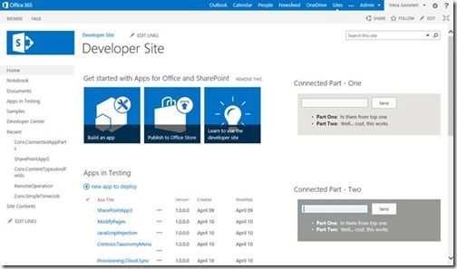](http://blogs.msdn.com/cfs-file.ashx/__key/communityserver-blogs-components-weblogfiles/00-00-00-81-08-metablogapi/0827.clip_5F00_image001_5F00_57A85A21.jpg)

Check detailed documentation with video demonstration from <http://blogs.msdn.com/b/vesku/archive/2014/05/14/connected-sharepoint-app-parts-with-signalr.aspx>