# Office AMS: Profile Property Migration

|  |  |
| --- | --- |
| Summary: | Applies to: |
| A set of migration console applications used to export single and multi-valued user profile properties from an on-premises deployment and write those properties to an intermediate store. Secondly, we then update SharePoint Online Tenant via that intermediate store. | * Office 365 Multi Tenant (MT) * Office 365 Dedicated (D) * SharePoint 2013 on-premises * SharePoint 2010 on-premises |
| SolutionS: | Contoso.ProfileProperty.Migration.Import, version 1.0  Contoso.ProfileProperty.Migration.Extract, version 1.0 |
| Author: | Mark Franco (Microsoft) |
| //*********************************************************  // THIS CODE IS PROVIDED *AS IS* WITHOUT WARRANTY OF  // ANY KIND, EITHER EXPRESS OR IMPLIED, INCLUDING ANY  // IMPLIED WARRANTIES OF FITNESS FOR A PARTICULAR  // PURPOSE, MERCHANTABILITY, OR NON-INFRINGEMENT.  //********************************************************* | |

# General comments

Updating and reading of user profile properties happens via the user profile web service (userprofileservice.asmx). If you’re using Office 365 Multi-Tenant you can launch this service from the my-site host (e.g. <https://contoso-my.sharepoint.com/_vti_bin/userprofileservice.asmx>) or from tenant administration (e.g. <https://contoso-admin.sharepoint.com/_vti_bin/userprofileservice.asmx>). It’s important that if you want to update **all** user profile properties for **all** users that you use the user profile web service in combination with the tenant administration site.

Typical use cases for this are:

* These tools are architected with a simple migration mechanism (XML serialization), making the process of bringing on premises profile data to SPO a two-step process for robustness.
  + Extracting user profile information from an on premises SP2010/SP2013 environment and persist the data to disk via XML serialization. In the case of this example “Ask me about”, and “About me” Properties are used only.
  + Updating user profile properties in SPO using the import tool’s output (XML File with user profile data).

Important:

Use this capability with care as this allows you to override “system properties” such as workemail which contain data coming from Exchange Online in a typical Office 365 MT or D deployment.

# Scenario 1: Extract user profile properties from SP2010/Sp2013

This scenario shows how to read single and multi-value user profile properties. To make this work you need to run the code on a server on your on-premises farm with farm level permissions. This tool’s code base uses server side OM.

Note: the SharePoint Server does not require connectivity as we are pulling data and persisting to disk as part of a two-step process.

This scenario is handles by the Contoso.ProfileProperty.Migration.Extract, version 1.0 console application.

Note: you will have to change the following values in the app.config file to suit your environment before proceeding further:

|  |  |  |
| --- | --- | --- |
| Setting | Current Value | Description |
| MYSITEHOSTURL | http://my.contoso.com/ | This is the url to your my site host of your on premises SP 2010/2013 deployment. |
| PROPERTYSEPERATOR | | | The separator used for isolating Multi-valued properties in a string. |
| USERPROFILESSTORE | c:\temp\UPSProfileData.xml | This is the output file for which user profile data is stored. (This is the input file for the Import tool) |
| LOGFILE | c:\temp\Contoso.ProfileProperty.Migration.Extract.log | The Tools log file to log events |
| ENABLELOGGING | true | Enable logging to Disk |
| TESTRUN | true | Allows you to only process the first user the tool enumerates. Used to verify your settings are configured correctly in the app.config. Set this to false when you are ready to process all users registered in UPS. |

## initialization

1. We must add the reference ‘Microsoft.Office.Server.UserProfiles.dll’ so we have access to the UserProfileManager class and connect as follows:

SPServiceContext svcContext = SPServiceContext.GetContext(mySite);

UserProfileManager profileManager = new UserProfileManager(svcContext);

1. Enumerate all user profiles as follows:

foreach (UserProfile spUser in profileManager)

{ … }

## Read a simple user profile property

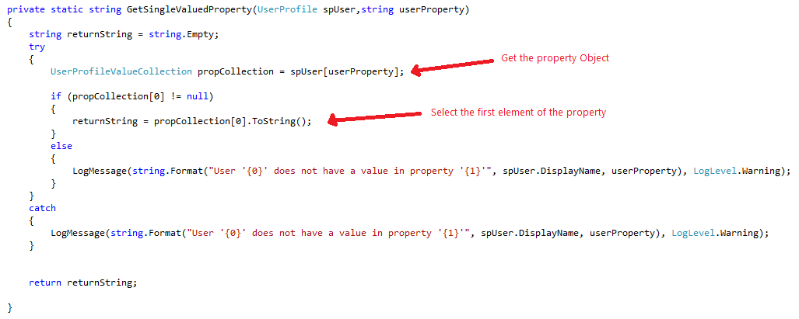

## Read a complex user profile property

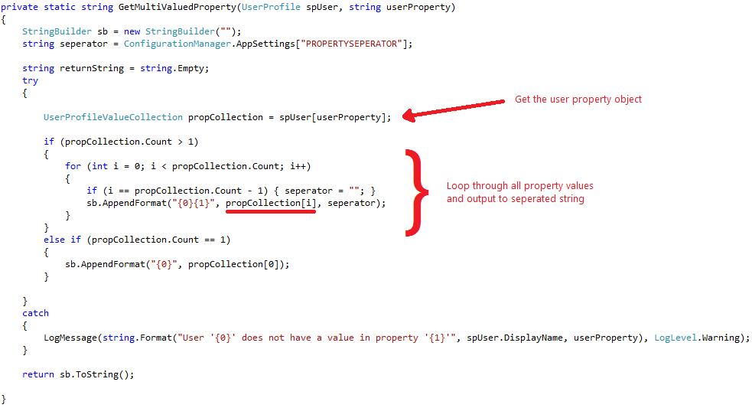

## Output

Program Output:

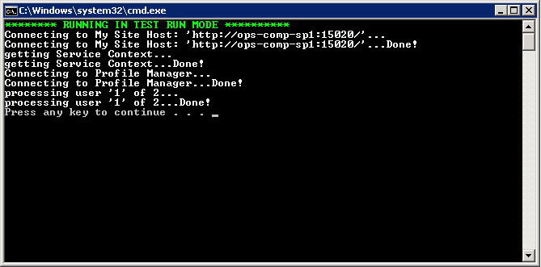

Output file:

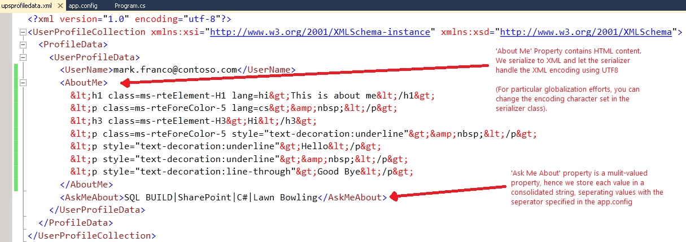

# Scenario 2: Import user profile properties to SPO

This scenario shows how to user profile properties via an XML file. To make this work you need to specify tenant administration credentials: if you specify regular user credentials you’ll not be able to update the user profile properties of other users.

This scenario is handled by the Contoso.ProfileProperty.Migration.Import, version 1.0 console application.

Note: you will have to change the following values in the app.config file to suit your environment before proceeding further:

|  |  |  |
| --- | --- | --- |
| Setting | Current Value | Description |
| tenantName | contoso.onmicrosoft.com | This is the tenant url replace Contoso with your tenant name. |
| PROPERTYSEPERATOR | | | The separator used for isolating Multi-valued properties in a string. |
| USERPROFILESSTORE | c:\temp\UPSProfileData.xml | This is the output file for which user profile data is stored. (This is the input file for the Import tool) |
| LOGFILE | c:\temp\Contoso.ProfileProperty.Migration.Extract.log | The Tools log file to log events |
| ENABLELOGGING | true | Enable logging to Disk |
| SPOAdminUserName | *** | SPO Admin User Name |
| SPOAdminPasword | *** | SPO Admin Password |

## initialization

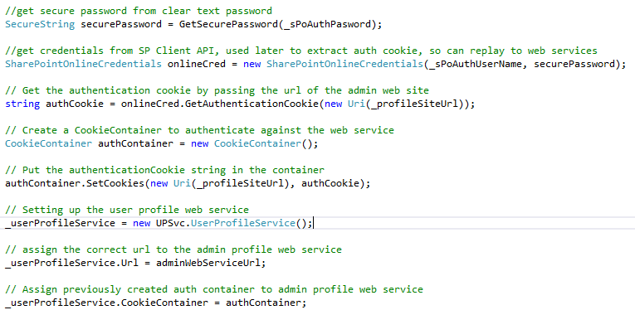

## Write a simple user profile property

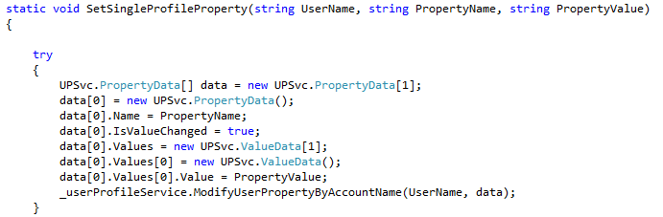

## Write a complex user profile property

