# Office AMS: SharePoint List MAnager

|  |  |
| --- | --- |
| Summary: | Applies to: |
| This sample shows how to access list information in a SharePoint website from your app by using the cross domain library in SharePoint 2013. | * Office 365 Multi Tenant (MT) * Office 365 Dedicated (D) * SharePoint 2013 on-premises |
| Solution: | Core.SPListManager, version 1.0.0.0 |
| Author: | Tom Van Gaever (Microsoft) |
| //*********************************************************  // THIS CODE IS PROVIDED *AS IS* WITHOUT WARRANTY OF  // ANY KIND, EITHER EXPRESS OR IMPLIED, INCLUDING ANY  // IMPLIED WARRANTIES OF FITNESS FOR A PARTICULAR  // PURPOSE, MERCHANTABILITY, OR NON-INFRINGEMENT.  //********************************************************* | |

# Scenario 1: View the lists on the SharePoint web and view every property.

This scenario shows how to review the properties of the lists in a SharePoint website. The app retrieves the information of the host web by using the cross domain library and the REST API.

It is very easy to review and learn the actual values of the available properties on the lists.  
  
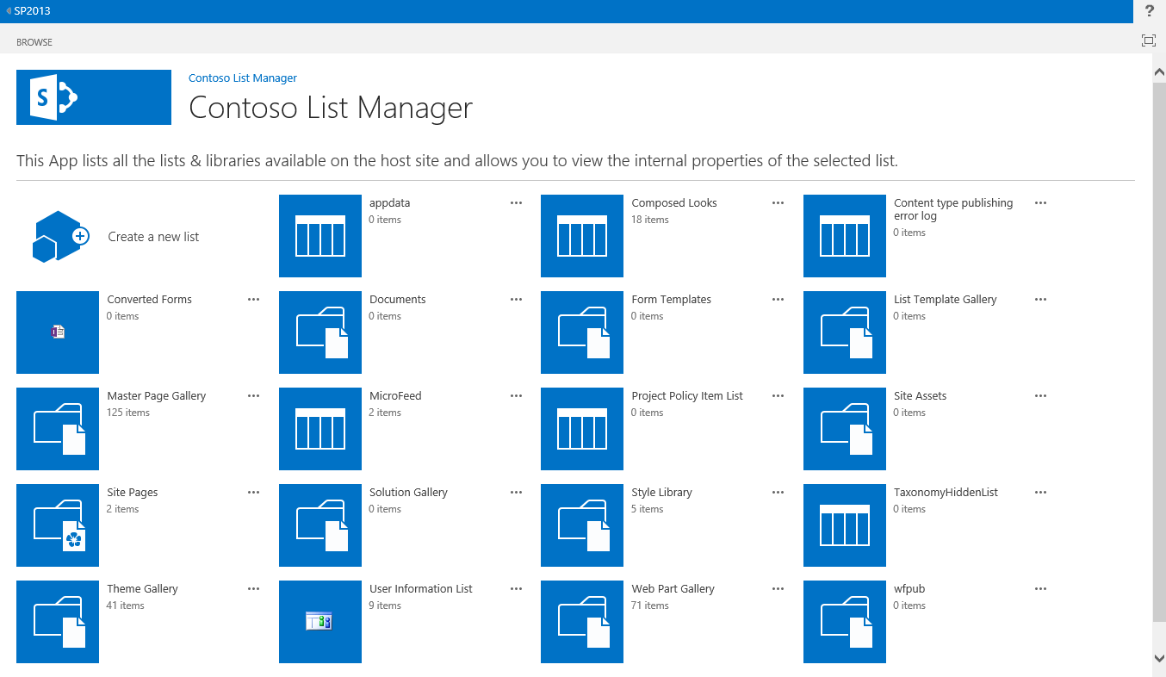  
  
Simply click on the icon representing the list or library you would like to investigate

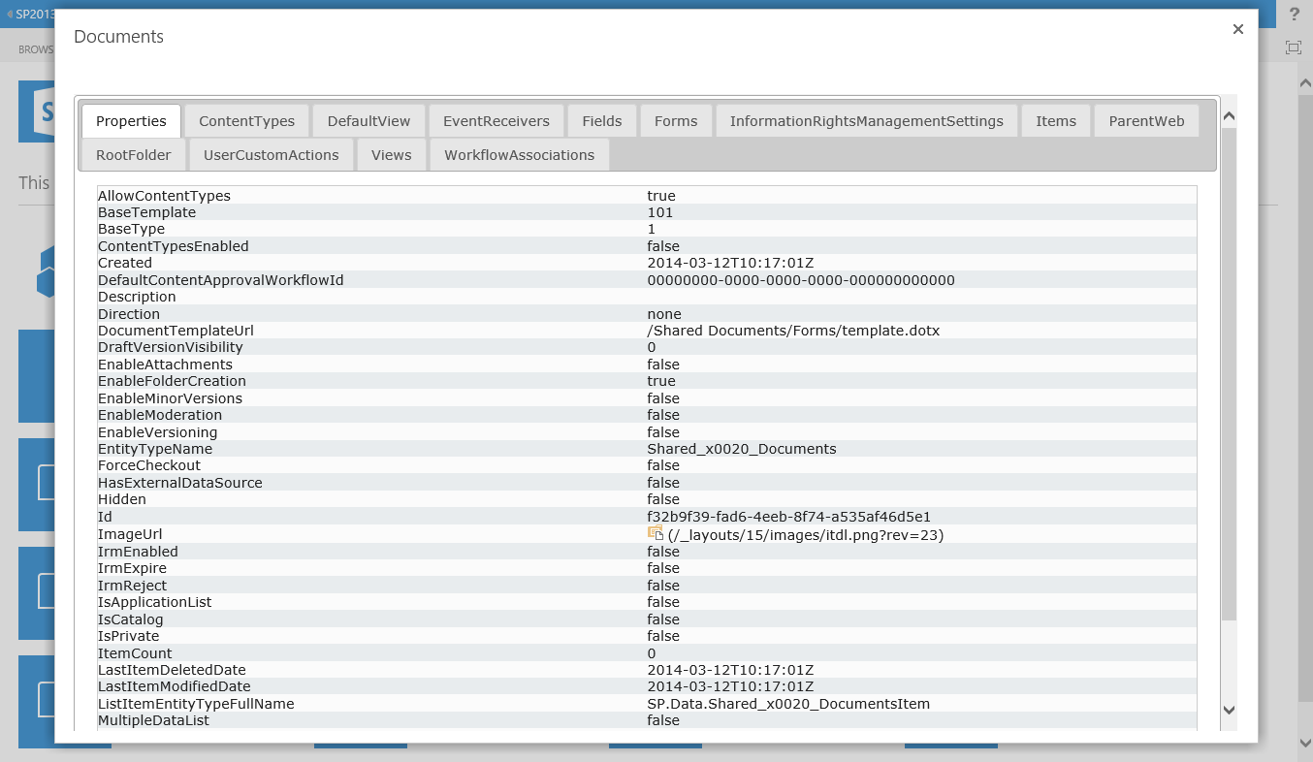  
  
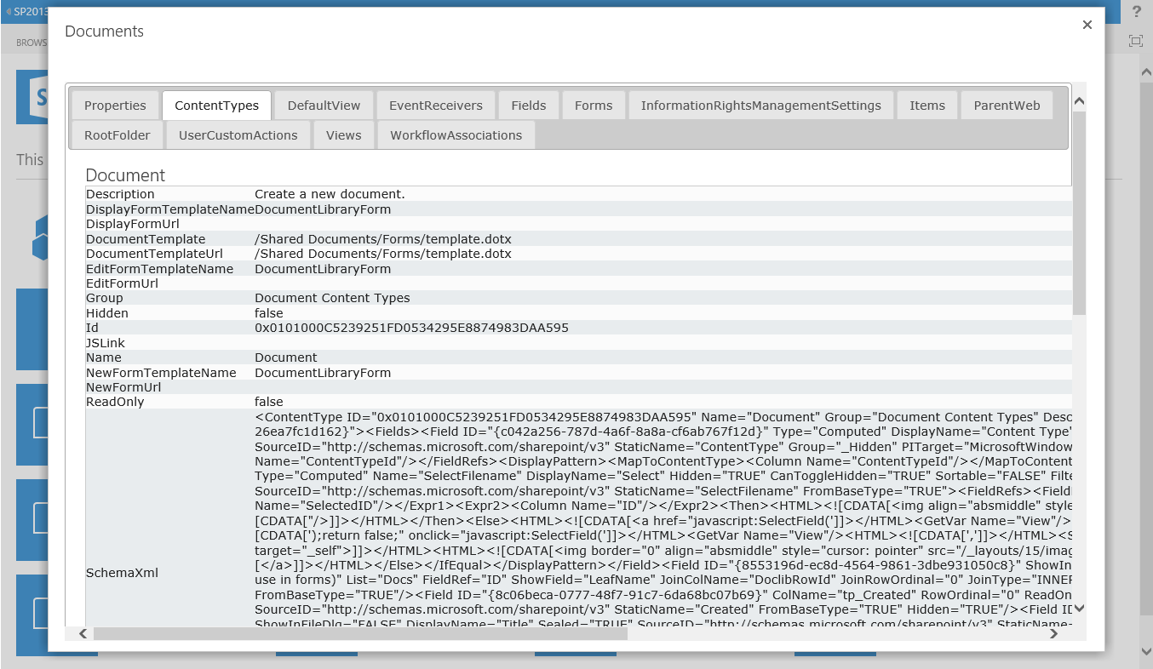

## Using the cross Domain Library to retrieve information from the SharePoint Web

All used code has been encapsulated by SPListmanager, which exposes all the functionalities for each specific page.

var executor = new SP.RequestExecutor(SPListmanager.appweburl);

executor.executeAsync(

{

url: SPListmanager.appweburl + **"/_api/SP.AppContextSite(@target)/web/lists?@target**='" + SPListmanager.hostweburl + "'",

method: "GET",

headers: { "Accept": "application/json; odata=verbose" },

success: SPListmanager.Default.initSuccessHandler,

error: function (data) {

alert(jQuery.parseJSON(data.body).error.message.value);

}

}

);

initSuccessHandler: function ($result) {

var data = jQuery.parseJSON($result.body);

SPListmanager.Default.lists = data.d.results;

}

# Scenario 2: Create a new list in the Sharepoint web via the app

This scenario further extends scenario 1 by creating a new list in the host web by using the cross domain library. In this case we are providing a custom form that is 100% under our control that will create a new list based on the input of the user.

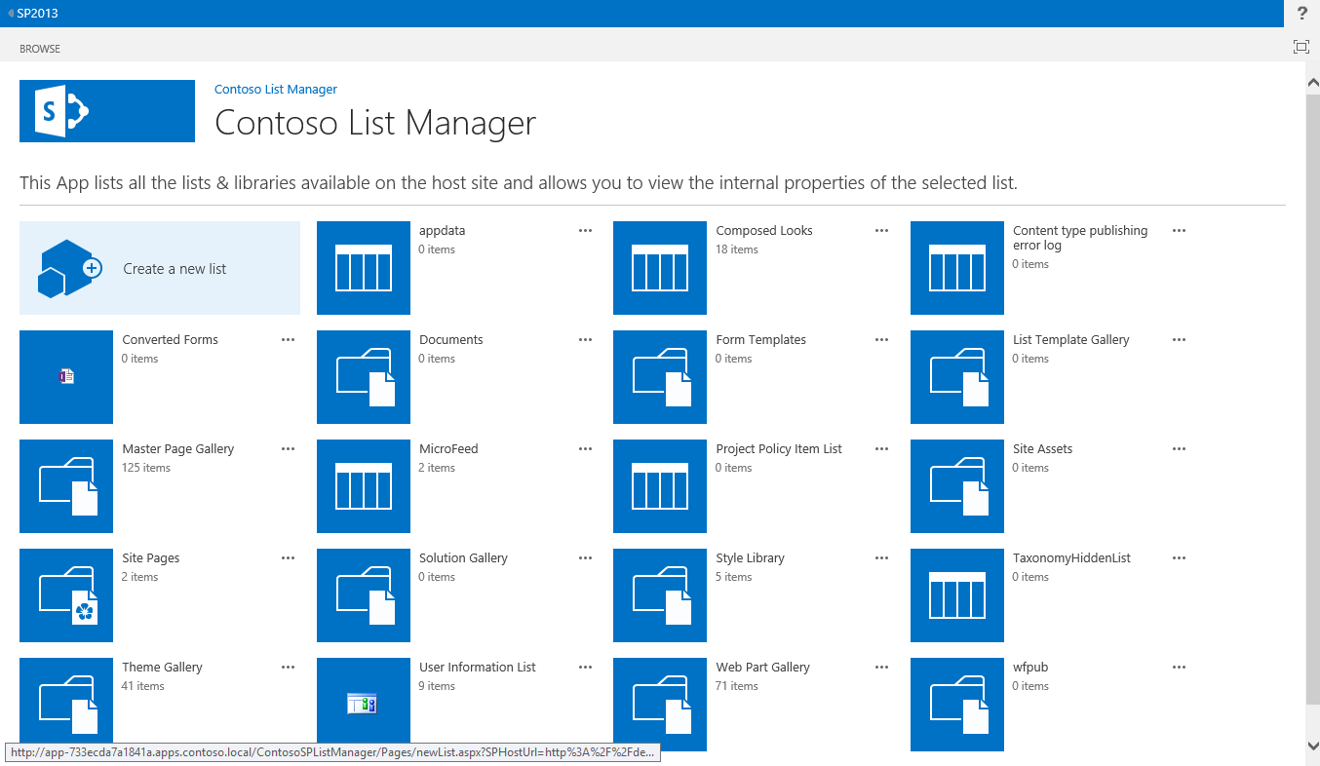

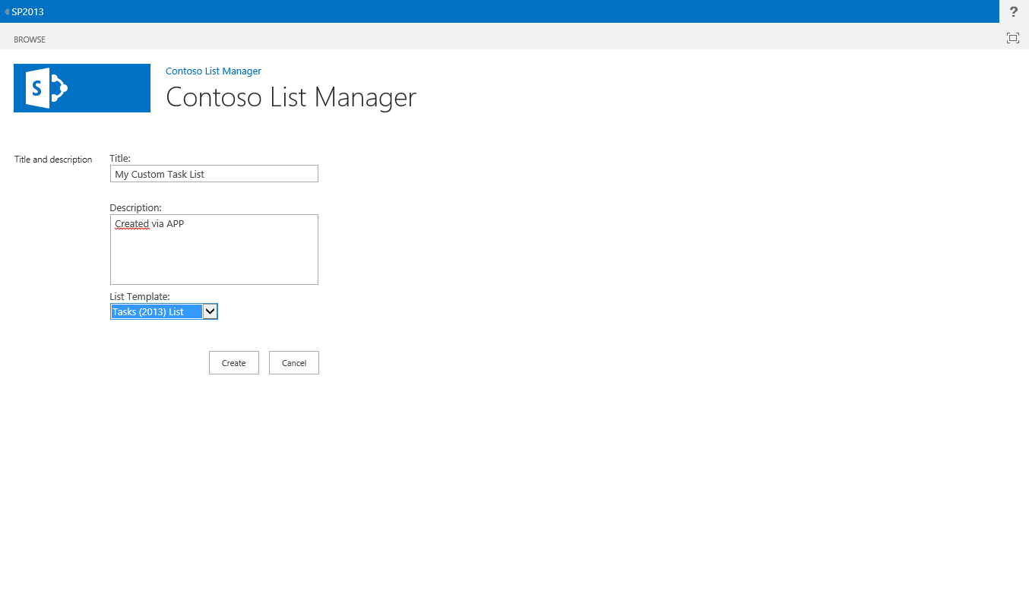

Here’s how the new created list will be available on the SharePoint host web.

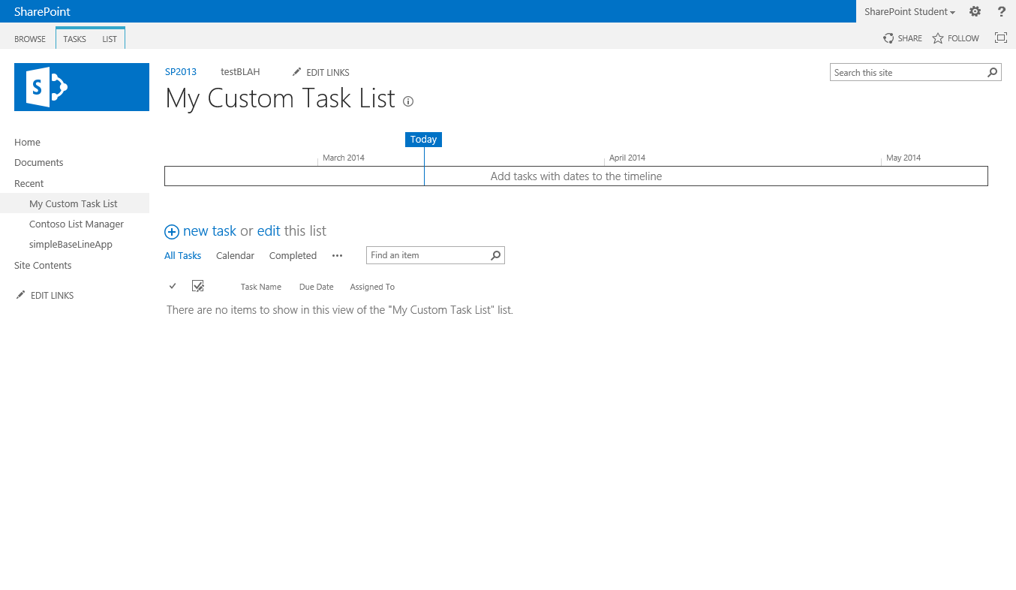

## Using the cross Domain Library to a new liston the SharePoint Web

SPListmanager.NewList = {

init: function () {

console.info('init started');

//provision create list logic

$("#btnCreateList").click(function () {

$(".s4-bodypadding :input").attr("disabled", true);

console.info('btnCreateList clicked');

// Get the new name of the list from the textbox

var newListName = $("#txtNewListTitle").val();

var description = $("#txtNewListDescription").val();

var listTemplateType = $("#cmbNewListTemplate").val();

console.info('btnCreateList action with params ' + newListName + "|" + description + "|" + listTemplateType);

// get the context from the hostweb where the app is installed

var hostwebContext = new SP.AppContextSite(SPListmanager.context, SPListmanager.hostweburl);

var web = hostwebContext.get_web();

// create the listinstance of the new SPList

var listCreationInfo = new SP.ListCreationInformation();

listCreationInfo.set_title(newListName); // list name

listCreationInfo.set_description(description); // list description

listCreationInfo.set_templateType(listTemplateType); //list type

// add the listinstance to the lists on the parentweb

var list = web.get_lists().add(listCreationInfo);

SPListmanager.context.load(list);

// execute the action

SPListmanager.context.executeQueryAsync(onQuerySucceeded, onQueryFailed);

});

};