# Office AMS: YAmmer group creation and discussion replacement

|  |  |
| --- | --- |
| Summary: | Applies to: |
| This sample shows how to inject custom CSS to the host web using SP App | * Office 365 Multi Tenant (MT) * Office 365 Dedicated (D) * SharePoint 2013 on-premises |
| Solution: | Provisioning.Yammer, version 1.0 |
| Author: | Vesa Juvonen (Microsoft) |
| //*********************************************************  // THIS CODE IS PROVIDED *AS IS* WITHOUT WARRANTY OF  // ANY KIND, EITHER EXPRESS OR IMPLIED, INCLUDING ANY  // IMPLIED WARRANTIES OF FITNESS FOR A PARTICULAR  // PURPOSE, MERCHANTABILITY, OR NON-INFRINGEMENT.  //********************************************************* | |

# Scenario: Create sub site and replace news feed with YAmmer group

This sample shows how to use the newly added Yammer capabilities in the core component to create new Yammer group as part of site provisioning and to associate that as the discussion feed for the newly created collaborations site.

To be able to use the sample, follow guidance for this URL to register access token for your Yammer app. This access token in updated to the web.config of the provider hosted app.

* Get the access token from here: <https://developer.yammer.com/authentication>

Update access token to the web.config of the provider hosted app for the key called YammerAccessToken.

<!-- Details on how to get your access token - check following https://developer.yammer.com/authentication -->

<add key="YammerAccessToken" value="PutYourOwnYammerKeyHere" />

Sample provides simple provisioning UI for sub sites where you are able to define if you want to use OpenGraph or Group feed. If group feed option is selected, you can choose to associate the feed to any existing group or to create a new group for the site.

|  |
| --- |
| **Notice**. We do recommend usage of OpenGraph objects with the team site feeds rather than using groups. If you automatically provision groups for each of the created team site, you will end up having massive amount of groups which will pollute your solution story in Yammer. Usage of the REST APIs for creating groups is also not documented and could have unexpected issues.  By default we recommend you to use OpenGraph objects as the default feed technique in future. |

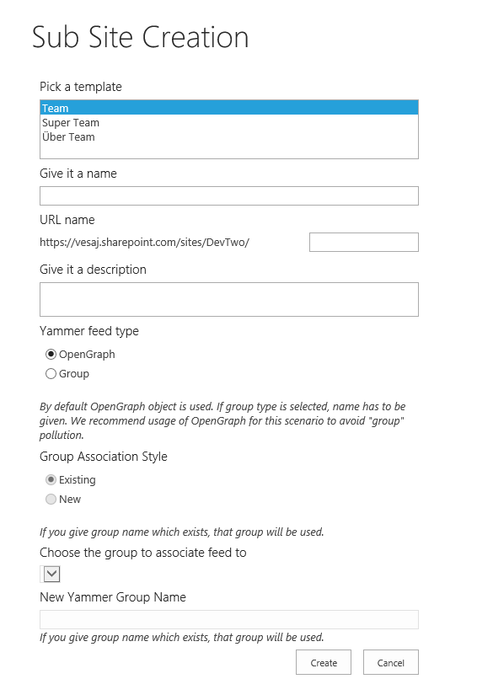

Once the provisioning is completed, you will see the following type of a site with associated Yammer feed running in it. Notice that you will need to be logged to the particular Yammer network in the browser session to show the newsfeed, since integration of the yammer feed happens in browser side.

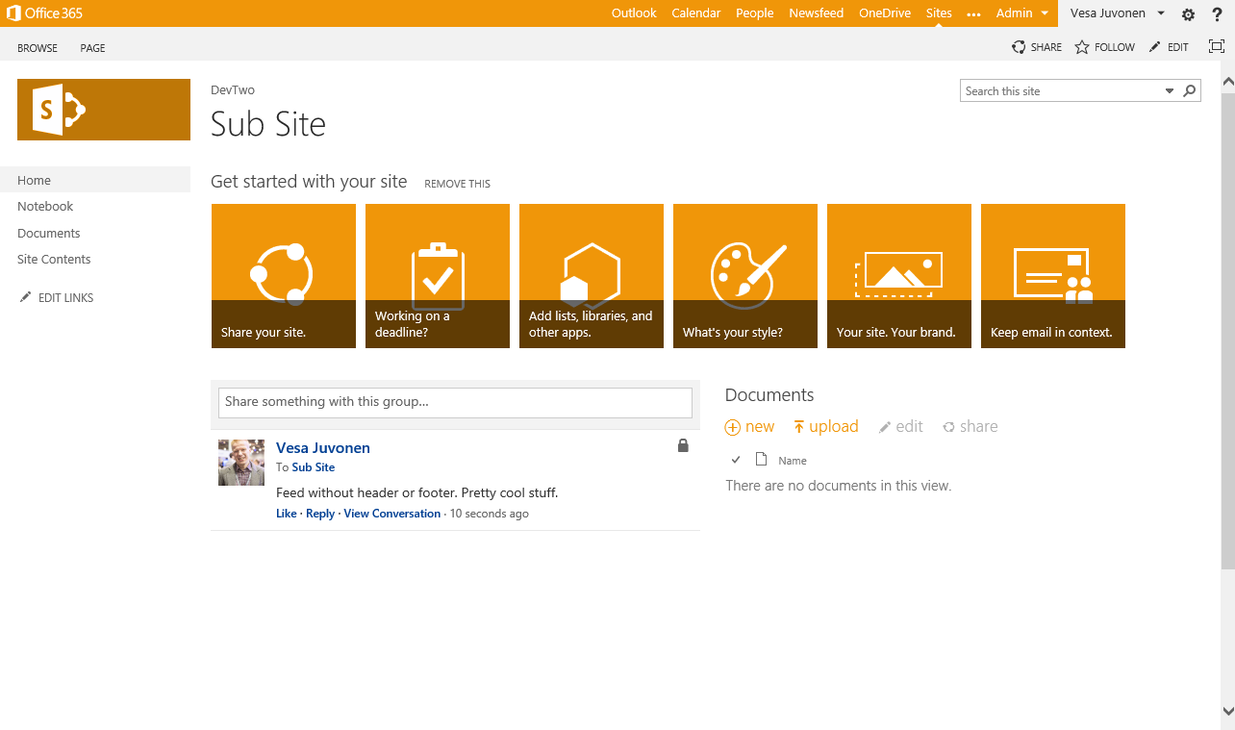

*Notice that by default feed is added without header or footer elements from the Yammer, but that can be controlled from the code which is calling the embed capability.*

This is how the UI looks if you have not signed to the Yammer network. You can click the login button, which will make the yammer feed to work again as expected.

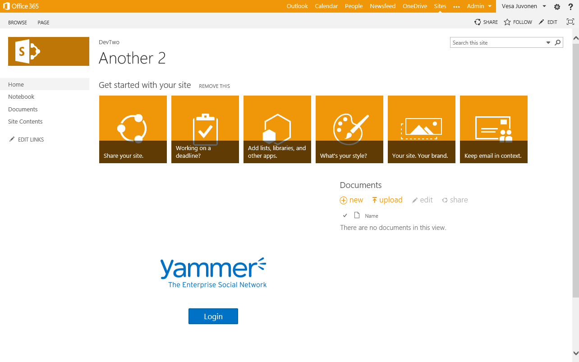

This example creates new Yammer group for each of the team site. We could actually also create new OpenGraph objects if that’s preferred. Either way the group or OpenGraph object is visible also on the Yammer side as follows and any updates from either side is updated to the feed. Here’s what gets created to the Yammer side as result of the site provisioning.

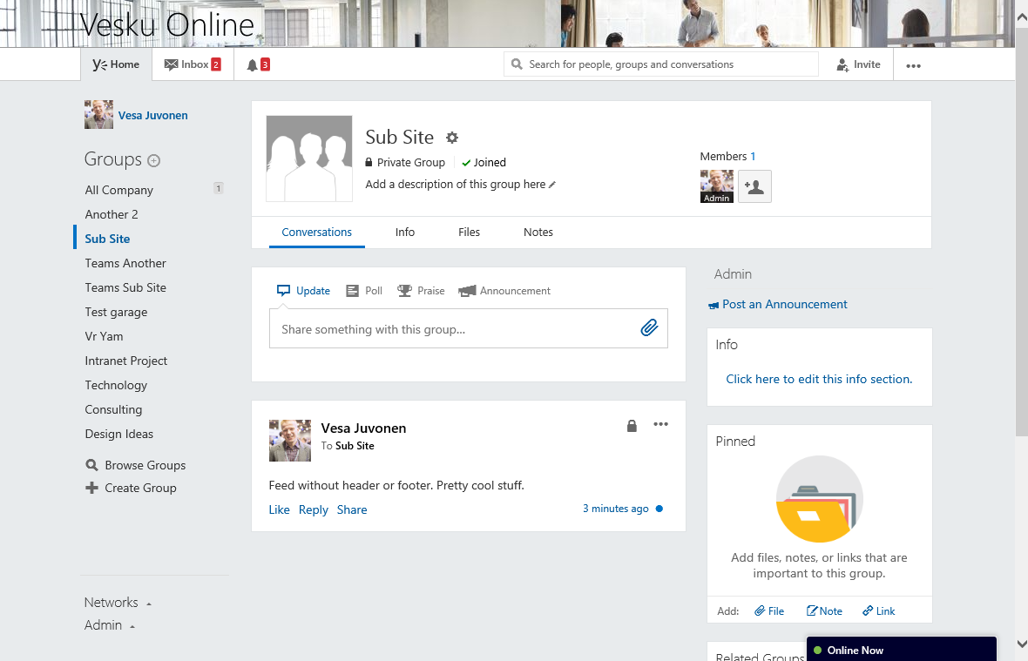

Notice also that since this configuration is dynamically applied during provisioning time, there’s no impact on removing the provisioning app away from the SharePoint side.

## Used core component extensions

Actual provisioning logic and site modifications are using core component extension methods. As you can see we can perform the required actions with only few lines of code due the encapsulated reusable methods from the core component.

public void CreateSubSite(Web hostWeb, string url, string template,

string title, string description, string yammerGroupName)

{

// Create new sub site

Web newWeb = hostWeb.CreateSite(title, url, description, template, 1033);

// Set theme for the site

newWeb.SetThemeToSubWeb(hostWeb, "Orange");

//Remove the "NewsFeed" web part

newWeb.DeleteWebPart("SitePages", "Site feed", "home.aspx");

// Get Yammer Group - Creates if does not exist

YammerGroup group =

YammerUtility.CreateYammerGroup(yammerGroupName, true, ConfigurationManager.AppSettings["YammerAccessToken"]);

// Get Yammer web part

WebPartEntity wpYammer = YammerUtility.GetYammerGroupDiscussionPart(group.network_name, group.id, false, false);

// Add Yammer web part to the page

newWeb.AddWebPartToWikiPage("SitePages", wpYammer, "home.aspx", 2, 1, false);

}