# SharePoint G-APPS: SPO Site Provisioning

|  |  |
| --- | --- |
| Summary: | Applies to: |
| This sample shows how to customize the site and site collection provisioning forms with custom UI modules. The sample has two sample modules:   * Yammer Integration Module allows Yammer groups to be provisioned with sites and displayed on the site landing page (via Yammer embed) * Business Impact Module allows a user to mark a site with a sensitivity attribute that is set in the sites property bag after provisioning | * Office 365 Multi Tenant (MT) * Office 365 Dedicated (D) *(all except site collection provisioning)* * SharePoint 2013 on-premises *(all except site collection provisioning)* |
| Solution: | Provisioning.Cloud.Sync, version 1.0 |
| Author: | Richard diZerega, Vesa Juvonen |
| //*********************************************************  // THIS CODE IS PROVIDED *AS IS* WITHOUT WARRANTY OF  // ANY KIND, EITHER EXPRESS OR IMPLIED, INCLUDING ANY  // IMPLIED WARRANTIES OF FITNESS FOR A PARTICULAR  // PURPOSE, MERCHANTABILITY, OR NON-INFRINGEMENT.  //********************************************************* | |

# General comments

This solution extends upon the SubSiteTemplates solution to allow for custom provisioning modules based on the selected site configuration. You should be familiar with the concepts used in the SubSiteTemplates solution, as it uses the same. It also builds upon the SubSiteTemplates sample to include site collection provisioning (currently only available for SharePoint Online Multi-Tenant). Both these enhancements caused a second branch of the DeployManager.cs and Configuration.xml that we hope to merge in the near future.

# Configuring Provisioning Modules

Provisioning Modules allow user controls to be dynamically displayed in a site creation form depending on the selected template configuration. The provisioning module user controls need to inherit from the BaseProvisioningModule.cs file which has a single virtual “Provision” method as seen below. This is called after the site provisioning has completed and all other configurations have been applied for the template.

public class BaseProvisioningModule : UserControl

{

public virtual void Provision(ClientContext context, Web web)

{

}

}

## Sample Provisioning Module

The following is a sample provisioning module for setting a metadata property in the new sites property bag. Note the inheritance of BaseProvisioningModule and implementation of the Provision method below:

namespace Contoso.SPOSiteProvisioningWeb.Modules

{

public partial class BusinessImpactProvisioningModule : BaseProvisioningModule

{

protected void Page_Load(object sender, EventArgs e)

{

if (cboSensitivity.Items.Count == 0)

{

cboSensitivity.Items.Add(new ListItem("Low Business Impact (LBI)"));

cboSensitivity.Items.Add(new ListItem("Medium Business Impact"));

cboSensitivity.Items.Add(new ListItem("High Business Impact (HBI)"));

}

}

public override void Provision(ClientContext context, Web web)

{

//get the web's property bag

var props = web.AllProperties;

context.Load(props);

context.ExecuteQuery();

//set the ContosoBusinessImpact property and update

props["ContosoBusinessImpact"] = cboSensitivity.SelectedValue;

web.Update();

context.ExecuteQuery();

//call the base

base.Provision(context, web);

}

}

}

## Template Configuration

Provisioning Modules are configured using the xml configuration introduced in the SubSiteTemplates solution. It extends that schema with a Modules element as seen below:

<Template Name="ContosoTeam" Title="Contoso Team" Enabled="Yes" RootTemplate="STS#0" Description="Super Team Site" RootWebOnly="false" SubWebOnly="false" ManagedPath="teams" StorageMaximumLevel="100" UserCodeMaximumLevel="100">

<Modules>

<Module CtrlSrc="~/Modules/BusinessImpactProvisioningModule.ascx" />

<Module CtrlSrc="~/Modules/YammerProvisioningModule.ascx" />  
 </Modules>

Also note the template attributes for RootWebOnly, SubWebOnly, ManagedPath, StorageMaximumLevel, and UserCodeMaximumLevel, which new to the configuration schema to support both sub site and site collection provisioning.

# Site Collection Provisioning

The SPOSiteProvisioning solution supports the creation of site collection, but currently only for Multi-Tenant SharePoint Online. We hope to provide a solution for On-Premises and SharePoint Online Dedicated in the future.

## Configuration.xml Changes

The Site Collection Provisioning component of this solutions leverages five new attributes on the Template element of the Configuration.xml. These are described below:

* RootWebOnly: true/false to make the template available as site collections only
* SubWebOnly: true/false to make the template available as subsites only
* ManagedPath: managed path to create the site collection under (ex: teams or sites)
* StorageMaximumLevel: default storage quota in MB
* UserCodeMaximumLevel: default user code quota

Here is a sample configurations:

<Template Name="ContosoTeam" Title="Contoso Team" Enabled="Yes" RootTemplate="STS#0" Description="Super Team Site" RootWebOnly="false" SubWebOnly="false" ManagedPath="teams" StorageMaximumLevel="100" UserCodeMaximumLevel="100">

<Modules>

<Module CtrlSrc="~/Modules/BusinessImpactProvisioningModule.ascx" />

<Module CtrlSrc="~/Modules/YammerProvisioningModule.ascx" />  
 </Modules>

## Wiring into “New Site” Link

The SPOSiteProvisioning solution is configured to create site collections when it is launched from the “New Site” link in the “Sites” area of SharePoint. The default form can be overwritten inside the SharePoint admin portal. First, you should launch the creation form from the host site to capture full URL (including the standard token url parameters).

Next, paste the site creation form URL into notepad and remove all the URL parameters except the following:

* SPHostUrl
* SPAppWebUrl
* IsDlg (change this value from 0 to 1)

You should end up with a url similar to the following (replace elements in brackets with the values from your deployment:

https://*{hostdomain}/*Pages/Default.aspx?SPHostUrl=*{HostWebUrl}*&SPAppWebUrl=*{AppWebUrl}*&IsDlg=1

Settings tab of the SharePoint admin portal:

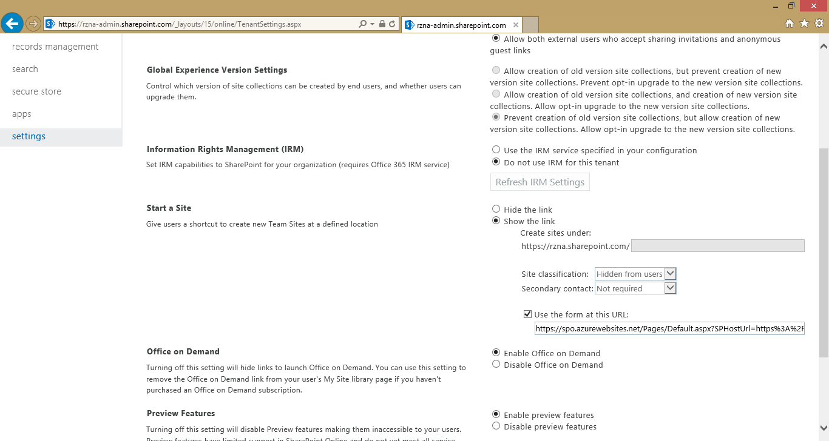

Custom Provisioning Form launched from “new site” link for self-service site collections:

