VLSI System Design (Graduate Level)

Fall 2023

HOMEWORK IV

REPORT

Must do self-checking before submission:

Compress all files described in the problem into one tar

All SystemVerilog files can be compiled under SoC Lab environment

All port declarations comply with I/O port specifications

Organize files according to File Hierarchy Requirement

No waveform files in deliverables

Student name: ___________ ___________

Student ID: ___________ ___________

|  |  |  |  |
| --- | --- | --- | --- |
| Performance & Area | | | |
|  | rtl | syn | pr |
| Prog0 time |  | 2583700000 |  |
| Prog1 time |  |  |  |
| Prog2 time |  |  |  |
| Prog3 time |  |  |  |
| Area(um^2)  In APR |  | | |
| CPU cycle | 10ns | | |

Refer to the figure to fill in the simulation time !!

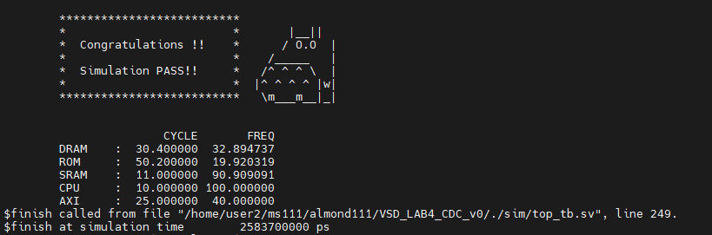

// Initiate your report from this point.

1. Cache read miss:

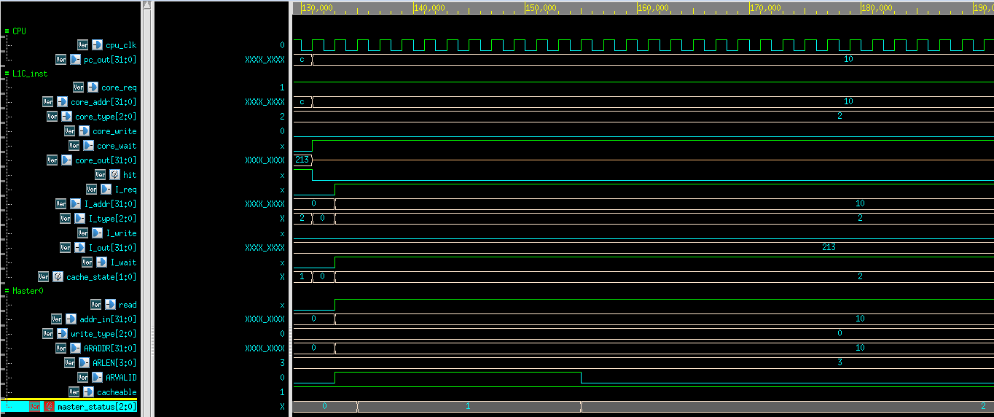

在pc_out為10時,CPU對L1C_inst發出core_req請求指令,core_wait設為1直到正確資料回傳給CPU , core_write為0因為此時為請求instruction指令並且core_addr為10,所以是去ROM讀取指令,可以看到此時hit為0代表L1C_inst中並沒有暫存這個指令,所以cache_state = 2轉為read_miss狀態,設定送往master0的資料來透過AXI讀取ROM,此時將read設為1因為是要讀取資料,將ARADDR設為10來讀取ROM,ARLEN設為3因為一個block有4個word需要讀出連續4筆資料傳回cache,ARVALID設為1開始透過AXI存取資料,cacheable一直設為1因為master0只會讀取ROM或IM並不會讀取sensor_wrapper , master_status = 2為讀取資料狀態

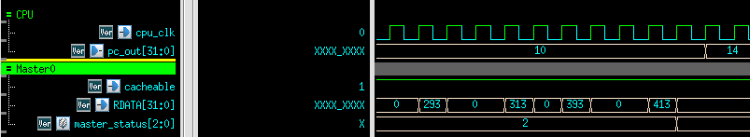

Master0等待4筆資料(293,313,393,413)回傳後將資料傳給cache存進Data_array以及Tag_array

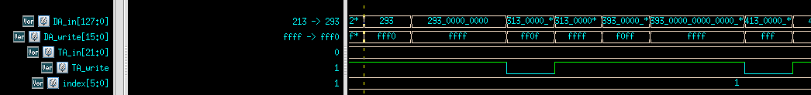

依照DA_in及DA_write將四筆資料存入Data_array後,

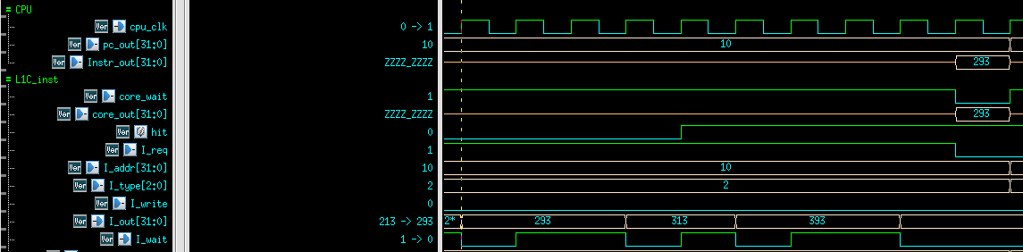

最後透過core_out將指令傳給CPU中的IF-stage。

1. Cache read hit

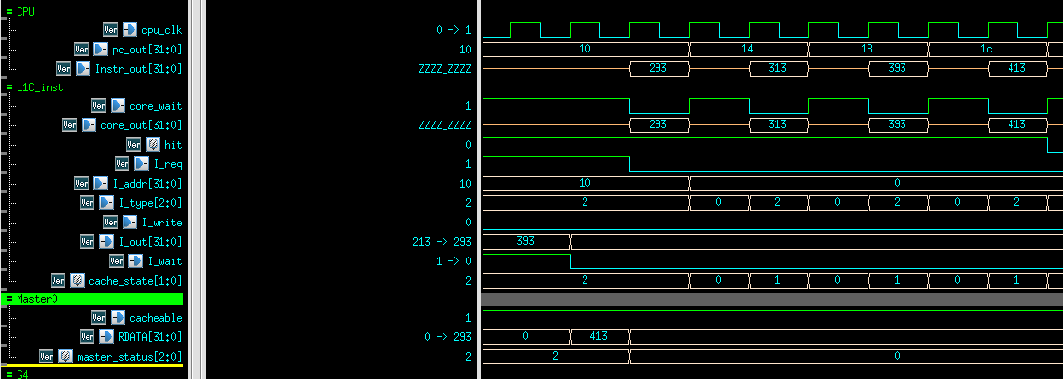

在經過pc_out為10 的指令後,因為指令是連續讀取的,所以後面的三個指令都已經暫存在L1C_cache中,所以可以看到後面三個指令hit都為1代表資料在cache中,不需要透過master0去讀取memory中的指令,所以會將I_req設為0表示不需要去存取memory,可以看到core_out直接將暫存的指令輸出給CPU中的IF-stage。

1. Cache write (write through)

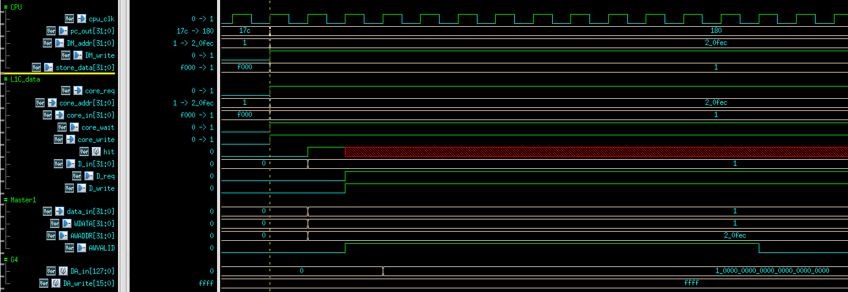

當pc_out為180時,MEM-stage要對DM_addr為20fec寫入資料store_data為1,所以CPU會發出core_req並將core_addr設為20fec , core_in為要寫入的資料設為1,因為現在為hit所以必須對master1下指令去寫入AWADDR為20fec, WDATA為1

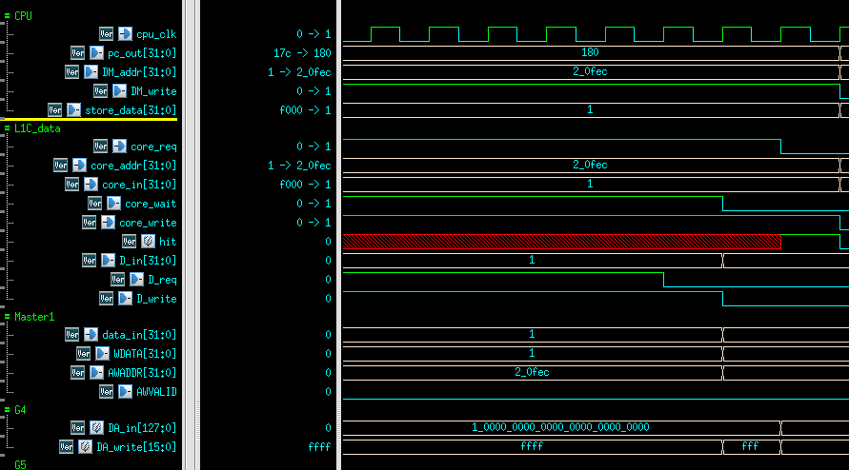

因為是hit所以cache中也有資料所以必須更新Data_array中的資料。