Project in c++
Banking management system



Developed BY:
vinod verma
REG.-10804863

ACKNOWLEDGEMENT

First and foremost I thank everyone who helped me to while creating this project and bring out my creative capabilities.

I express my gratitude to my parents for being a continuous source of encouragement for all their financial aid.
.
My heartfelt gratitude to my brother for helping me to complete my work in time.

VINOD VERMA
Contents:-

Introduction
About the bank
Header files
Architectural View
Starting Page
Main Page
Activities

INTRODUCTION
The program starts by displaying banner “Bank Mangement system” and wait for the user to input . When user types Our main main shows where different options are there like creation of new account, modification of existing account and many more.

The program is developed in c++ programming language which is one of most popular language for computer . I used the language in my language because it has many features like oops , exception handling etc. Some of the functions in my program are below :

//***************************************************************
// ****** function declaration *****
//****************************************************************vvoid write_account(); //function to write record in binary file
void display_sp(int); //function to display account details given by user
void modify_account(int); //function to modify record of file
void delete_account(int); //function to delete record of file
void display_all(); //function to display all account details
void deposit_withdraw(int, int); // function to desposit/withdraw amount for given account
void intro(); //introductory screen function

//***************************************************************

ABOUT THE BANK

A bank updates customer’s accounts at the end of each month. The bank offers two types of accounts: savings and checking. Every customer must maintain a minimum balance. If a customer's balance falls below the minimum balance, there is a service charge of $10.00 for savings accounts and $25.00 for checking accounts. If the balance at the end of the month is at least the minimum balance, the account receives interest as follows:

a) Savings accounts receive 4% interest.
b) Checking accounts with balances up to Rs. 1,000 more than the minimum balance receive 3% interest; otherwise, the interest is 5%.

The customer's account number (int type), account type (char; s for savings, c for checking), and current balance are input from the keyboard.

Output is the account number, account type, current balance (including any interest earned), and the amount of interest earned, if any.

The interest will be calculated in a separate function. The balance and interest rate are passed to the function. The function returns the interest earned.

The minimum account balance, for checking and savings accounts, are 500 and 1000. This must be declared as a constant.

DIFFERENT COMPONANT OF CODE

//***************************************************************
// ****** HEADER FILE USED IN PROJECT ******
//****************************************************************
#include<iostream>
#include<fstream>
#include<cctype>
#include<iomanip>
//***************************************************************

//***************************************************************
// *** ***** CLASS USED IN PROJECT *** *******
//****************************************************************

class account
{
int acno;
char name[50];
int deposit;
char type;
public:
void create_account(); //function to get data from user
void show_account() const; //function to show data on screen
void modify(); //function to add new data
void dep(int); //function to accept amount and add to balance amount
void draw(int); //function to accept amount and subtract from balance amount
void report() const; //function to show data in tabular format
int retacno() const; //function to return account number
int retdeposit() const; //function to return balance amount
char rettype() const; //function to return type of account
};

//***************************************************************
// THE MAIN FUNCTION OF PROGRAM
//****************************************************************

int main()
{
char ch;
int num;
intro();
do
{
system("cls");
cout<<"\n\n\n\tMAIN MENU";
cout<<"\n\n\t1. NEW ACCOUNT";
cout<<"\n\n\t2. DEPOSIT AMOUNT";
cout<<"\n\n\t3. WITHDRAW AMOUNT";
cout<<"\n\n\t4. BALANCE ENQUIRY";
cout<<"\n\n\t5. ALL ACCOUNT HOLDER LIST";
cout<<"\n\n\t6. CLOSE AN ACCOUNT";
cout<<"\n\n\t7. MODIFY AN ACCOUNT";
cout<<"\n\n\t8. EXIT";
cout<<"\n\n\tSelect Your Option (1-8) ";
cin>>ch;
system("cls");
switch(ch)
{
case '1':
write_account();
break;
case '2':
cout<<"\n\n\tEnter The account No. : "; cin>>num;
deposit_withdraw(num, 1);
break;
case '3':
cout<<"\n\n\tEnter The account No. : "; cin>>num;
deposit_withdraw(num, 2);
break;
case '4':
cout<<"\n\n\tEnter The account No. : "; cin>>num;
display_sp(num);
break;
case '5':
display_all();
break;
case '6':
cout<<"\n\n\tEnter The account No. : "; cin>>num;
delete_account(num);
break;
case '7':
cout<<"\n\n\tEnter The account No. : "; cin>>num;
modify_account(num);
break;
case '8':
cout<<"\n\n\tThanks for using bank managemnt system";
break;
default :cout<<"\a";
}
cin.ignore();
cin.get();
}while(ch!='8');
return 0;
}

STARTING PAGE

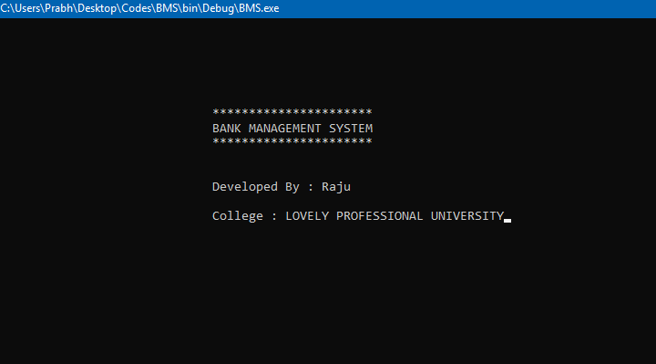

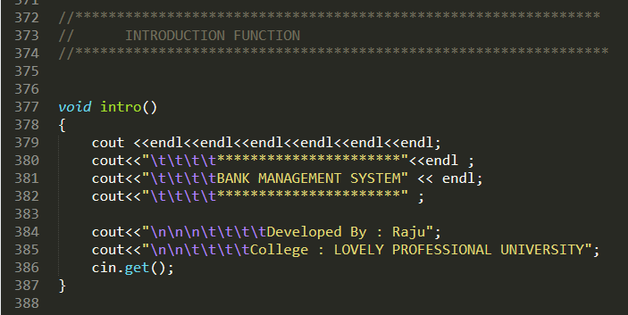
Main Menu

