Performing Brain Tumor Classification and Segmentation
Kgosi Katlego Reuben, Mishi Makade

201802440@spu.ac.za
201902668@spu.ac.za
Sol Plaatje University

Abstract— A brain tumor is the growth of abnormal cells in the brain. There are many types of brain tumors, but this study will focus on meningioma, pituitary, and glioma tumor. Deep learning algorithms and Machine learning techniques have been playing a big role in early detection of brain tumors, many efforts have been created to make a highly accurate solution for the automatic classification and segmentation of brain tumors. To overcome these issues this study proposes the use of various pre-trained deep convolutional neural networks (CNNs) to extract features, classify and segment the tumors. VGG16 and EfficientNetB7 are popular pre-trained models that achieve good results in Image classification.

Keywords— Brain tumor, Classification, VGG-16, EfficientNetB7
- Introduction

Cancer according to the WHO is the second leading cause of death(Badža et al.2020:1). If the cancer is detected early death can most likely be prevented. A tumour, unlike cancer can be benign, pre-carcinoma malign(Badža et al.2020:1). Benign tumors are different from malign in that benign tumor does not spread to other organs and tissues and they can be surgically removed(Badža et al.2020:1).
Primary brain tumors are gliomas, meningiomas, and pituitary tumors(Badža et al.2020:1). This study will focus on these 3 primary tumors. The term Gliomas is a general term for tumors that start from brain tissues other than nerve cells and blood vessels(Badža et al.2020:1).
Meningiomas start from the membranes that surrounds the brain and surrounds the central nervous system while pituitary tumors are lumps that are inside the skull(Badža et al.2020:1).

Brain tumor can cause brain damage and can also be fatal. Early detection plays a serious role as doctors can treat the tumor early. Brain tumor classification has a very important role in clinical diagnosis and effective treatment(Badža et al.2020:1).
Manually evaluating Magnetic Resonance Imaging (MRI) images is time-consuming, and inclined to error due to the excess number of patients(Kang et al. 2021:2). And it is not good to only depend on the doctors for detection as they can miss-interpret and not detect it early.

Various machine learning methods for image segmentation and classification are applied in MRI image processing to give radiologists a second opinion(Badža et al.2020:2). This study proposes the implementation of EfficientNetB7 that has never been applied to brain tumor classification and comparing of the results of the model with those of previously used models vgg-16 in terms of accuracy and complexity.
Deep learning models require a large amount of data for training and that much data is not always available. To overcome this problem this study proposes the use of pretrained deep-learning models.

- Literature Review

Numerous techniques have been applied to brain tumor classification. One of those techniques is machine learning which was later on replaced by deep learning(Irmak, 2021:2). Deep learning and artificial intelligence have made a big impact in the field of medical image analysis, more specifically in the field of disease diagnosis((Mehmood et al. 2020, 2021; Yaqub et al. 2020 cited in Irmak, 2021:2). This section focuses solely on the previous work done by other people and how they can be improved.

Kang, Ullah and Gwak (2021:6) presented a system that used pretrained deep learning models to extract features and then fed those features to machine learning models. They used numerous pretrained deep learning models including VGG-16, Resnet and others and they also used numerous machine learning models. They then studied the performance of each of those machine learning models. The results revealed that DenseNet-169 deep feature is a good option when the size of the MRI dataset is very small and the number of classes is 2, the ensemble of DenseNet-169, Inception V3, and ResNeXt-50 deep features is a good option when the size of MR images dataset is large and the number of classes is 2, and the ensemble of DenseNet-169, ShuffleNet V2, and MnasNet deep features is a good option when the size of MRI dataset is large and four classes are used. They also discovered that in many cases, SVM with RBF kernel performs better than other ML classifiers for the MRI-based brain tumor classification.

Then Badža and Barjaktarovi´c (2020:4) presented a new CNN architecture and the classification was performed using a T1-weighted contrast-enhanced MRI image database which has three tumor types. The CNN model created is simpler and it is possible to run on conventional modern personal computers. The performance of their network was evaluated using four approaches: combinations of two 10-fold cross-validation methods and two databases. The generalization capability of their network was tested with one of the 10-fold methods, subject-wise cross-validation, and the improvement was tested using an augmented image database. The best results for the 10-fold cross-validation obtained an accuracy of 96.56%. for the record-wise cross-validation using an augmented data set.

Chelghoum, Ikhlef, Hameurlaine, Jacquir (2020) show that VGG16, AlexNet and ResNet the classification accuracy is neither influenced by the epochs number, nor the deep architectures. Overall VGG16 outperforms AlexNet and ResNet in accuracy. They also help us to see and confirms that the deeper architectures do not achieve good result with small datasets. Seemendra, R. Singh, S. Singh (2020) and V. K. Waghmare, M. H. Kolekar(2021) say that brain tumor classification significantly affects accuracy as the best model is highly influenced by the number of data available, which rises the necessity of data augmentation to increase the dataset, when having a small dataset.

Accurate and fast diagnosis of brain tumor is crucial as it involves the selection of the most appropriate treatment method for saving a patient’s life (Irmak, 2021:2). Previously implemented deep learning models on brain tumor classification like vgg16, Resnet etc are complex and slow (Badža et al.2020:9). Performing real-time performance with these models requires dedicated hardware (Badža et al.2020:9). This may result in delayed diagnosis, treatment and therefore may increase the chances of a patient’s death. The models are also difficult and impossible to deploy on mobile devices due to their complexity (Anon 2021). The proposed Capstone project will address the problem of complexity by using pre-trained EfficientNetB7 model.
EfficientNetB7 is 8.4 times smaller than the best existing ConvNet (Tan & Le 2020:1). So, this study will implement the model in brain tumor classification along with vgg-16 then compare the results based on accuracy and complexity of the models.

- Methodology

  - Data acquisition & pre-processing

3.1.1 Image Database

The dataset for this study was obtained from Kaggle and is therefore publicly available. Navoneel Chakrabarty and Swati Kanchan along with the team members Sartaj Bhuvaji, Ankita Kadam, Prajakta Bhumkar and Sameer Dedge(2020) collected the dataset. The dataset is called Brain Tumor Classification (MRI). The dataset consists of 2 227 training MRIs and 429 test MRIs. There are 826 glioma tumor, 247 meningioma tumor, 827 pituitary tumor and 327 no tumor MRIs in the train dataset. The test dataset consists of 98 pituitary, 100 glioma, 127 meningioma, and 104 no tumor MRIs.

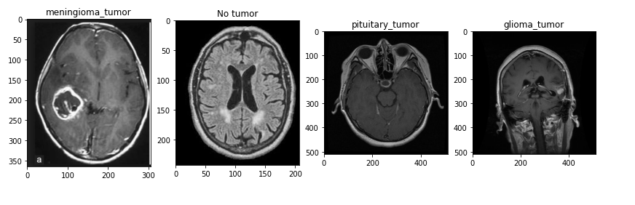
Figure.1 Examples of brain MRI for the 4 classes

    - Image Pre-Processing

The MRIs came in different sizes and were therefore resized to suit the different models presented in this study. The MRIs were also normalized. Normalization is very important because it ensures that each pixel has a similar data distribution to the other pixels (Nikhil 2017). Normalization makes the network converge fast (Nikhil 2017). The below figure shows a sample of a pre-processed image.
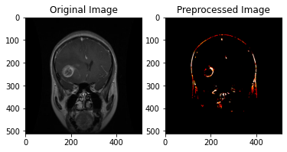

  - Data training and fine tunning

In this section, the models used for the project were originally trained with the ImageNet dataset that is comprised of 1.2 million images that belong to 1000 categories. We used transfer learning which aims to transfer knowledge from one or more domains and apply the knowledge to another domain with a different target task (V. Maeda-Gutiérrez, C.E. Galván-Tejada, L.A. Zanella-Calzada, J.M. Celaya-Padilla, J.I. Galván-Tejada, H. Gamboa-Rosales, H. Luna-García, R. Magallanes-Quintanar, C.A. Guerrero, M. and C. A. Olvera-Olvera 2020). The layers of the pretrained models VGG-16 and EfficientNetB7 were all frozen, and 5 classification layers were added on top of the model layers. The following figure depicts the layers and the number of output nodes corresponding to the number of classes for the classification.
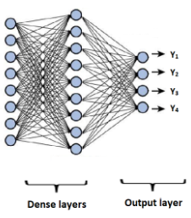
Figure 2: Structure of the out layer

    - Proposed Network

Tumor classification was done using transfer learning with EfficientNetB7. Transfer learning is a machine learning method that reuses a model trained on one task on another related task. Transfer learning can be described as a shortcut to saving time or getting best performance (Brownlee 2019).
Deep learning models need abundant data for better performance. In the absence of such data transfer learning can be used to develop good performing models. Transfer learning transfers weights and biases from a pre-trained network which therefore provides a backbone that detects basic edges (Liu, n.d :7).

Many pre-trained networks have been implemented to classify tumors.This study proposes a different approach by implmenting EfficientNetB7 to classify brain tumors into 4 classes namely meningioma, malignant, pituitary and no tumor.
Network architectures can be changed in many ways to increase the performance. Traditional networks were changed with respect to depth to increase the accuracy (Sachan n.d.). Deep networks are good at extracting complex features from images and the complex features help increase the classification accuracy (Sachan n.d.). But many layers may result in the saturation or degrading of accuracy (Sachan n.d.).
The other way traditionally used to increase network accuracy is to increase the resolution of the input image. High resolution images have more pixels representing simple features (Sachan n.d.). The higher detail in the image will result in increased accuracy (Sachan n.d.). But increasing the detail in the image requires an increase in the depth of the network (Sachan n.d.). Deeper networks are used to represent complex features (Sachan n.d.).So increasing image resolution and network depth may result to high accuracy (Sachan n.d.). But there is the problem of how deep the model should be for a particular increase in image resolution (Sachan n.d.).

The third way of modifying networks for better accuracy is increasing the number of channels along the way to classification (Sachan n.d.). The increasing of feature maps increases the information being extracted from image tensors. Threfore wider networks represent good features (Sachan n.d.).The problem with this method is that one has to figure out how wide the network should be and therefore requires manual tuning (Sachan n.d.). Merely increasing the number of channels may result in the decrease of training speed with no good accuracy (Sachan n.d.).
Developers of EfficientNet put forward a method called compound scaling. Compound scaling sugggests the use of a constant ratio to scale the network in all dimensions(width, resolution and depth) (Tan & Le 2020:1). Compound scaling also solves the problem of the extent to which the network should be scaled therefore increasing accuracy of the network and also decreasing the need for manual tuning (Tan & Le 2020:1).

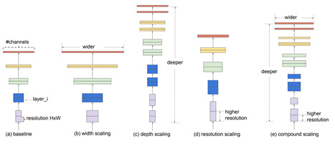
Figure.3 Unlike regular practices which are the figures (b) to (d), EfficientNets’ compound scaling method in figure (e) uniformly scales up all three dimensions: depth, width, and image resolution (Tan & Le 2020:2).

3.2.2. VGG16

VGG16 is a convolutional neural network model proposed by K. Simonyan and A. Zisserman from the University of Oxford in the paper “Very Deep Convolutional Networks for Large-Scale Image Recognition”. It was one of the famous models submitted to ILSVRC-2014. The figure below displays the architecture of a VGG16 model.
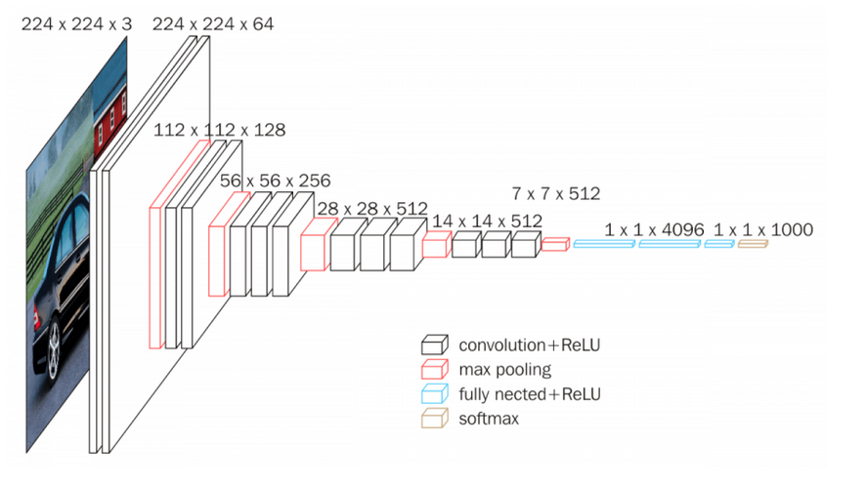
Figure 4: VGG16 architecture

Table 2 shows number of layers present in our models, and also the default layers of chosen pretrained models

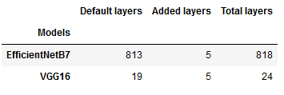
Table.2 Layers of models

3.2.3 Fine Tunning

For this phase we tuned the following hyperparameters of the models, batch size, epochs, optimization method, and dropout values. For optimizers, we used only 5 optimizers to see which one works best, namely, SGD, RMSprop, Adam, Adagrad, and Adadelta. For number of epochs, we used only 4 epochs to choose the best performer from namely, 1, 2, 5, 10. With Batch size we used these batch sizes to choose the optimum batch size, namely, 8 and 16. For dropout value we used the following values to optimise the dropout of the model, values 0.5, 0.6, 0.7, 0.8, and 0.9.

- Segmentation

Segmentation is the division of an image into significant structures. Segmentation divides an image into its essential regions or objects, and it is an important step in image analysis, object representation, visualization and numerous
other image processing tasks.

A huge number of segmentation methods have been used in the past decades for brain tumor segmentation like clustering methods, fuzzy logic approach, neuro-fuzzy approach, watershed segmentation, random walk, and many others, but all these methods produce unsatisfactory results because of unsharp edge boundaries, and more time consumed to produce wanted result.

This study uses python image processing to segment the tumors. The quality of the images is first enhanced by brightening the image. Then we use contrast enhancing to enhance local contrast of the brain MRI to help brighten the area with the tumor. Then the image was changed to a grayscale image. MRI images often have noise because of the equipment used to collect the images, so the noise was removed. Then thresholding is used to segment the part of the tumor. The thresholding makes the parts of the image that have pixel values that are above the threshold white while the parts of the image that have pixel values less than the threshold black. The area with the tumor will be the white region as the tumor is brighter than normal parts of the brain. The below image is an example of a segmented image.

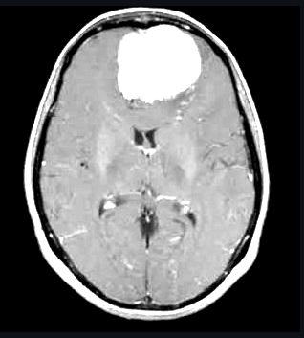
Figure 5: Segmented image

- RESULTS

  - Results Analysis of proposed model

This section presents the performance of the EfficientNetB7. Fine-tuning of hyperparameters was done to see which hyper-parameters give the best results. The optimum parameters were then used to train the final model. The model was trained using 5 different optimizers, 4 different epochs, 2 batch sizes and 5 dropouts. The time it took to train the model was retrieved. The model was first fitted using 4 epochs, a batch size of 8 and a dropout value of 0.5 and the optimizer used was the Adam optimizer. The model gave an accuracy of 95% and ran for 95 minutes.
Then, the model was fitted with the different optimizers with 4 epochs for each one and a dropout value of 0.5. The figure below shows the results obtained from each optimizer.

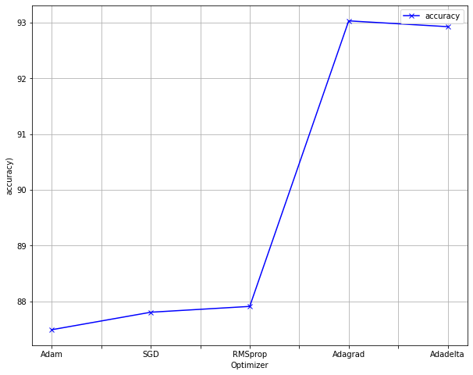
Figure 6: Accuracy obtained from each optimizer

The figure shows that Adagrad is the optimizer that got the highest accuracy of 93% and Adam got the lowest accuracy. Dropout values were also fine-tuned, the below figure shows the accuracy of each dropout value while the other hyper-parameters remained the same.

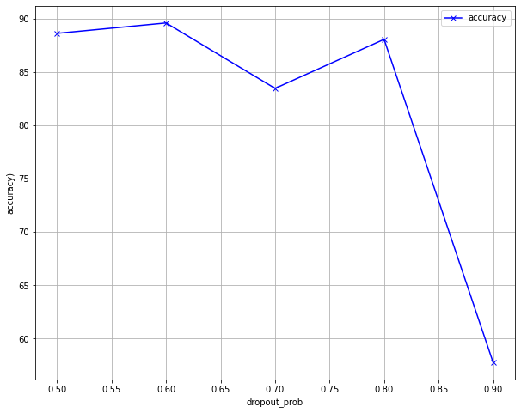
Figure 7: Accuracy obtained for each dropout value

The figure shows that the dropout value 0.6 got the highest accuracy while the dropout value of 0.9 got the lowest accuracy. The figure below shows the accuracy for each dropout value.

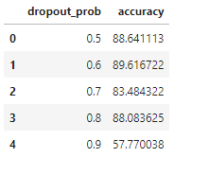
Table 5: Dropout values and their accuracies

Batch size and epochs were fine tuned at the same time. The below table shows the results for the 2 batch sizes and 4 epochs.
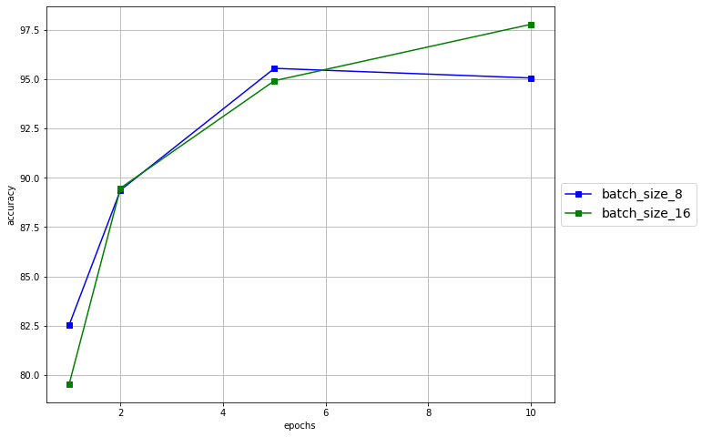
Figure 8: Results from batch size and epochs fine-tuning

The highest accuracy was obtained from using 10 epochs and a batch size of 16. The table below shows the results for each fine-tuning.
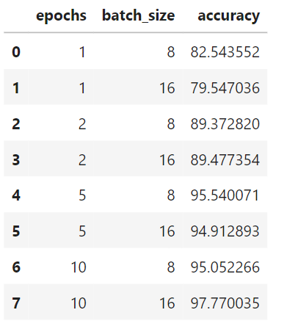

Figure 9: Results obtained from fine-tuning epochs and batch size

The EfficientNetB7 model was then fitted with the hyper-parameters that got the highest accuracies during fine-tuning. The accuracy of the model after running it with the fine-tuned parameters was 98%.

  - Comparison of proposed model with VGG-16

Transfer learning is one of the proven techniques for computer vision tasks like the classification of images. This study considered two pre-trained models namely VGG-16 and EfficientNetB7. The models were also trained with fine-tuned hyper-parameters namely batch size, epochs, and optimizers. The models were run with 5 different optimizers, 4 different epochs, and 2 different batch sizes. But they are all first fitted with 4 epochs, with optimizer Adam, batch size of 8 and a dropout value of 0.5.
The results for fine tuning optimizers for VGG-16 and Efficient Net are shown in the table below. The Vgg-16 model obtains an accuracy of 92%, and the EfficientNetB7 gets the highest accuracy of 95%. The results for the optimizers that gave the highest accuracy for each model are given in the table below.

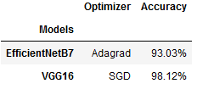
Table 10: Results of fine-tuning Optimizers

The table clearly shows that VGG-16 got the highest accuracy, followed by EfficientNetB-7. The below table shows the highest accuracy for each model and the hyper-parameters used to obtain the results.

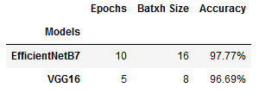
Table 8: Results of fine-tuning Batch size and epochs

The above table shows that EfficientNetB-7 gave the best accuracy for a batch size of 16 and 10 epochs, followed by VGG-16. Dropout value fine-tuning was also done and the results for that are shown in the table below.
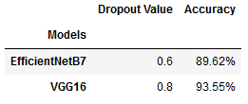
Table 9: Results of fine-tuning dropout value

The table shows that VGG16 got the highest accuracy of 94% while EfficientNetB7 got an accuracy of 89%.
The optimum hyper-parameters were then used to fit the final models. The table below gives the results obtained from the final models.
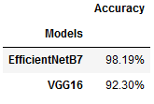
Table 10: accuracies of the models
- CONCLUSION

This paper proposed a pre-trained deep convolutional neural network namely, EfficientNetB7 and compared its complexity and performance on classification of brain tumor MRI images, In our study we used 6169 MRI images. The aim of this study was to compare the performance of VGG16 and EfficientNetB7 by accuracy and implement the best model in a Web Application. The goal was to find the more suitable model for our task. Both models were able to classify the tumors as glioma tumor, meningioma tumor, pituitary tumor and no tumor. The VGG16 with 16 layers achieved a 92.29% classification accuracy using transfer learning, and EfficientNetB7 achieved 98.18% classification accuracy using transfer learning. This study also shows the effectiveness of fine-tunning on performance.

- References

Prasad, V & Kalyani, M & Bharathi, A & Geethanjali, T & Pravanya, G & Sathish, T.2016. Detection of Brain Tumor and EDEMA using Image Segmentation. International Journal of Engineering Research & Technology (IJERT) 4(18):2.

Waghmare, V.K. and Kolekar, M.H., 2021. Brain Tumor Classification Using Deep Learning. In Internet of Things for Healthcare Technologies (pp. 155-175). Springer, Singapore.
Waghmare, V.K. and Kolekar, M.H., 2021. Convolutional Neural Network-Based Automatic Brain Tumor Detection. In Evolving Technologies for Computing, Communication and Smart World (pp. 463-474). Springer, Singapore.

Kang, J., Ullah, Z. and Gwak, J., 2021. MRI-Based Brain Tumor Classification Using Ensemble of Deep Features and Machine Learning Classifiers. Sensors, 21(6), p.2222.

Badža, M.M. and Barjaktarović, M.Č., 2020. Classification of brain tumors from MRI images using a convolutional neural network. Applied Sciences, 10(6), p.1999.

Badža, M.M. and Barjaktarović, M.Č., 2021. Segmentation of Brain Tumors from MRI Images Using Convolutional Autoencoder. Applied Sciences, 11(9), p.4317.

Chelghoum, R., Ikhlef, A., Hameurlaine, A. and Jacquir, S., 2020, June. Transfer learning using convolutional neural network architectures for brain tumor classification from MRI images. In IFIP International Conference on Artificial Intelligence Applications and Innovations (pp. 189-200). Springer, Cham.

Seemendra, A., Singh, R. and Singh, S., 2021. Breast Cancer Classification Using Transfer Learning. In Evolving Technologies for Computing, Communication and Smart World (pp. 425-436). Springer, Singapore.

Waghmare, V.K. and Kolekar, M.H., 2021. Brain Tumor Classification Using Deep Learning. In Internet of Things for Healthcare Technologies (pp. 155-175). Springer, Singapore.

Waghmare, V.K. and Kolekar, M.H., 2021. Convolutional Neural Network-Based Automatic Brain Tumor Detection. In Evolving Technologies for Computing, Communication and Smart World (pp. 463-474). Springer, Singapore.

Maeda-Gutierrez, V., Galvan-Tejada, C.E., Zanella-Calzada, L.A., Celaya-Padilla, J.M., Galván-Tejada, J.I., Gamboa-Rosales, H., Luna-Garcia, H., Magallanes-Quintanar, R., Guerrero Mendez, C.A. and Olvera-Olvera, C.A., 2020. Comparison of convolutional neural network architectures for classification of tomato plant diseases. Applied Sciences, 10(4), p.1245.

