**1)Window,screen and document in javascript:-**

**\*) window:-**

-> The Window is the first thing that gets loaded into the browser.

-> The Window object has a majority of properties like length,innerHeight,name,

open ,close,moveTo,resize etc...

-> The Window is the global object.

**Some of the Window object methods are:-**

-> Window.open()

-> Window.close()

-> Window.moveTo()

-> Window.resizeTo()

**\*) Screen:-**

-> The Screen describes the physical display’s dimensions of full screen.

-> The Screen has properties like width and height ,which are the dimensions of a full screen.

-> The portion of a screen displaying the rendered document,known as VIEWPORT in js.

**Some of the Screen object methods are:-**

-> Screen.height

-> Screen.width

**\*) Document:-**

-> The Documents in html,aspx,php or other documents that will be loaded into the browser.

-> The Document actually gets loaded inside the window object and has properties available

To it like title.URL,cookie and all properties related to Document object model(DOM).

**Some of the Document object methods are:-**

-> Window.document.getElementbyID() or document.getElementbyID()

-> Window.document.body.firstChild or document.body.firstChild

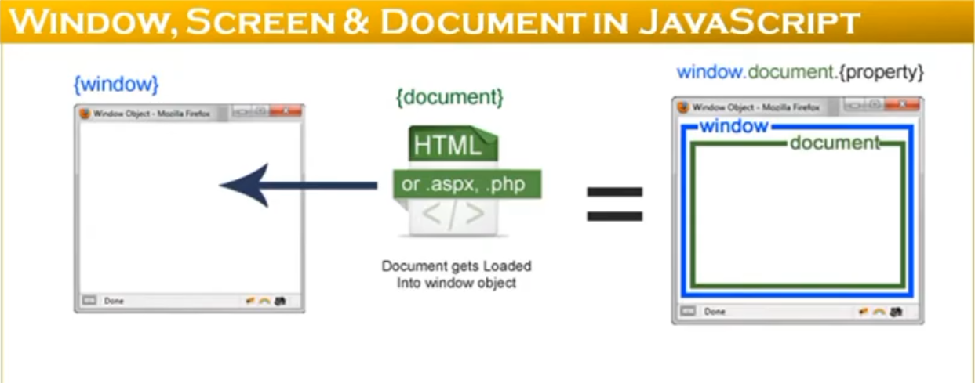

-> Window is the root of everything.

-> Screen just has display dimensions.

-> Document is the top Document object model(DOM) object in Window.

-> so you can think of it as Window being like a super Document.

**Function problem :-**

function s(index,arr)

{

var a = 100;

var b =20;

// code

var ans = arr[index](a,b);

return ans;

}

function add(x,y)

{

return x+y;

}

function sub(x,y)

{

return x-y;

}

function mul(x,y)

{

return x*y;

}

function div(x,y)

{

return x/y;

}

var aa =[add,sub,mul,div];

var d = s(0,aa);

console.log(d); //120

var e = s(1,aa);

console.log(e); //80

var f = s(2,aa);

console.log(f); //2000

var g = s(3,aa);

console.log(g); //5