Capstone Project Documentation
Dávid Szabados
My capstone project is about gathering mock company data and analyzing them to show my ability and capability to analyze relevant company data and to evaluate them. Multiple Key Performance Indicators (KPI) are chosen to show the different skills and evaluation problems I acquired during my studies.
Chosen Key Performance Indicators
Four KPIs are chosen to represent various indicators and risks a company has to face. Among these indicators, three of them will be analyzed by gathered mock data, while the fourth will be about the risks and problems the company acquire from it. These KPIs are:
- Energy- total consumption within the organization:
Every company must use some kind of energy, let it be electric, heat, gas etc. This KPI should be one of the most used indicator, that a company needs to track in order to effectively evaluate their operation cost and be able to improve their energy consumption quality in the future.
- Suppliers with risk of child labor
Despite that we are in the 21st century, many countries, especially third-world countries, still have work laws, which does not really restrict child labor, like in first-world countries. This KPI is really niche, while it may not directly affect the company, it is a good indicator to show, how the firm’s supply chain is sustainable about the rights of a child.
- Employee satisfaction
Employee satisfaction is one of the most important KPI for the current work culture. A satisfied employee not just works better, but also stays longer in the company, more loyal to it and saves the cost of constant hiring process. One part of the sustainability is to keep workers happy and to ensure that they are respected.
- Environmental fines
Fines are never a good sign for companies. Environmental fines decrease the sustainability score of a firm, making it less respectable and less ready to be a sustainable workplace. Due the difficulty of how often these kinds of fines can be achieved and their value, this KPI won’t be analyzed, instead it will be written about, how they influence the company and ways to improve (in other words, to not to get these fines).
The mock company’s nature
Based on the chosen KPIs and the difficulties/restrictions of gathering data for these indicators, the “company’s data” will be analyzed as for a wholesale company. The reasons are, that for a wholesale company, many of their products are coming from many different suppliers (being them from inland or outland), usually they are open every day, be it weekday or weekend (except in different countries, like in Austria, but the basic method should be applicable for any kind of wholesale company). Also, for this kind of company, employee satisfaction should be necessary, as its turnover rate are pretty high in average and should something be done, to keep these kind of workplace a bit more sustainable and desired for the workforce.
Data Gathering
In order, to be able to analyze data, first it must be gathered. As the project is about mock data analyzing, due the difficulty to get real and relevant company data for a university project, information is gathered through various sources. These sources include dummy data from Kaggle, a platform for data science competition, which often includes relevant dataset. Also, it includes AI generated data to represent some of the random variables and (kind of) random asset/inventory gathering of the company. As these data are usually not random generated, due the difficulty of data generating process for this project, I allow this kind of dissimilarity from real world data, to be able to somewhat represent a may real world scenario, in order to showcase my capabilities of analyzing.
Energy - total consumption within the organization
Suppliers with risk of child labor
https://www.mockaroo.com
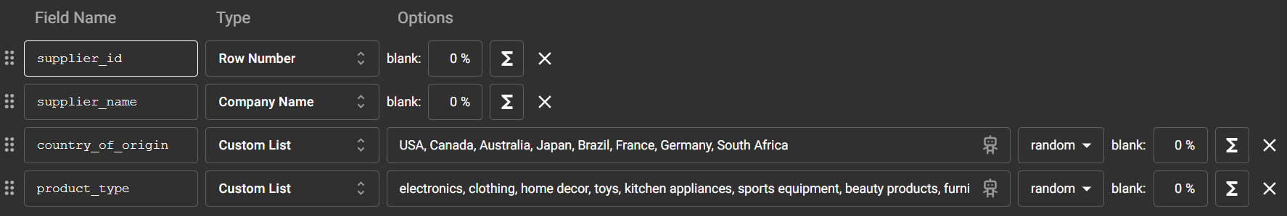
Employee satisfaction
https://www.kaggle.com/datasets/raminhuseyn/hr-analytics-data-set
Environmental fines

head of a company, operate in 5 countries (5 companies)
research countries’s external data
make up a company (mock up data)

