**Cars fuel consumption in the 1970s**

**by Dávid Szabados (ID: 2302806)**

**Introduction**

Currently we are living in a world, where the fossil fuel consumptions (e.g.: coal, oil) are still really high in some countries and have a problem to adapt to newer resources, like in Germany[1], where the fear of nuclear power plants lead to a negative trend, where instead of changing the fossil power plants to renewable ones, they are changing nuclear power plants instead. As fossil fuels, especially oil/petrol, are still one of the main resources that makes our economy running, it should be interesting to look at the cars of the past, and check, what influenced the fuel consumption for them.

**Data**

For my research, I will use the “Automotive Fuel Economy” dataset from Maven Analytics. This dataset includes the fuel economy in mpg (miles per gallon) for almost 400 cars, that have been sold in the US during the 70s and 80s, but we will only focus on one decade, the 70s’ sales. With this, we hopefully exclude time-series effects of the 80s, from our analysis.

The dataset includes one table with the following variables:

* mpg: The fuel economy of the car in terms of miles travelled per gallon of gasoline | *Dependent Variable*
* horsepower: Horsepower is a measure of power the engine produces | *Main Independent/Explanatory Variable*
* cylinders: The number of cylinders in the car's engine
* displacement: The volume of air displaced by all the pistons of a piston engine
* weight: The total weight of the car
* acceleration: The time in seconds it takes for the car to reach 60 miles per hour
* model year: The year (in the 20th century) the car model was released. For example: 75 means the car was released in 1975.
* origin: The region where the car was manufactured. 1 - USA. 2 - Europe. 3 - Japan
* car name: The name of the car model.

For the analysis, I will use mpg as the dependent variable and mainly horsepower as the independent variable to see, how they are related to each other, based on the given dataset. My first intuition is, that mpg and horsepower are positively related, which means, that if a car in the 70s has more horsepower, its fuel consumption (mpg) will also increase, because to achieve more power, more resources should be needed. On contrary, an engine which has more horsepower may mean, that it uses the fuel more efficiently, thus for the same amount of fuel, it can give back to use more power. In any case, I am sure there should be some kind of relationship between them and correlation of 0 (no relationship) should not happen!

**Model:**

**Generalization and external validity:**

**Causal interpretation:**

**Conclusion:**

**Appendix**

**App. 1a**

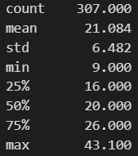

**App. 1b**

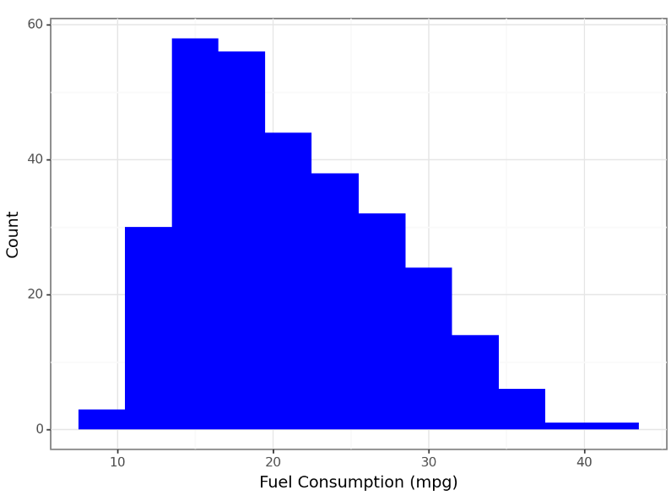

1. <https://www.voanews.com/a/german-finance-minister-casts-doubt-on-2030-coal-exit/7337035.html> [Accessed: 12/18/2023]